Reviewer 2.
Dear reviewer,
Thank you very much for your valuable remarks; we really appreciate them. The manuscript was strictly revised according to them.
Please find detailed comments to your remarks:
The submitted article is eligible for publication in Materials according to its subject and scope. Generally the paper has a clear idea, the experiment is performed in a sound way and discussion is meaningful. The paper is well written. Only a few technical improvements to be made:

Introduction
- Line 34: the formulation of the sentence »This is α-β that contains both phases and ....« is unclear and must be improved

The following was changed and added in Introduction section:
Ti-6Al-4V is of a most commonly applicable titanium alloy because of its outstanding properties [12]. This Ti alloy contains both, aluminum and vanadium, Al stabilizes α phase and has the HCP lattice and V stabilizes β phase and has the BCC lattice. Consequently, this alloy exhibits advanced mechanical properties as α phase provides a high strength while β phase provides high ductility. Moreover, Ti-6Al-4V alloy is one of the main metallic biomaterials due to its high biocompatibility [13-15]. Additional treatment of this alloy by MAO process will lead to production of an oxide coating with excellent corrosion resistance for applications in wide range of industries.
The following references were added:
- Santos-Coquillat, A.; Gonzalez Tenorio, R.; Mohedano, M.; Martinez-Campos, E.; Arrabal, R.; Matykina, E. Tailoring of antibacterial and osteogenic properties of Ti6Al4V by plasma electrolytic oxidation. Appl. Surf. Sci. 2018, 454, 157–172. 10.1016/j.apsusc.2018.04.267.
- Shah, F.A.; Trobos, M.; Thomsen, P.; Palmquist, A. Commercially pure titanium (cp-Ti) versus titanium alloy (Ti6Al4V) materials as bone anchored implants — Is one truly better than the other? Mater. Sci. Eng., C 2016, 62, 960–966. 10.1016/j.msec.2016.01.032.
- Durdu, S.; Usta, M.; Berkem, A.S. Bioactive coatings on Ti6Al4V alloy formed by plasma electrolytic oxidation. Surf. Coat. Technol. 2016, 301, 85–93. 10.1016/j.surfcoat.2015.07.053.

- Line 43, line 44: In the last two sentences of chapter the author should use paste tense instead present tense

The following was changed in Introduction section:

The obtained coating morphology, and the chemical and the phase compositions were also examined in details in the work. Furthermore, the influence of the current frequency on the corrosion resistance of the produced alloys’ surface was also examined.

- Line 45: the last part of the sentence »in the work« is superfluous

This part of the sentence was deleted.

Experimental
- Line 49 and 58: convert the unit »dm2« in »cm2«

Units were changed.

- Line 50: information about substrate surface roughness would be helpful

The following was added to Materials and Methods section:
The final roughness of the surface was Ra = 2.5.

Results and discussion
- Figure 1a,b: it is obvious that the abbrevation V and C are used for voltage and current but anyway they should be explain in figure caption

The following was added: V – voltage-time curve; C – current-time curve.

- Line 101: replace »Plateau« with »plateau«

This word was corrected.

- Line 108: replace »reformation« with »transformation«

This word was replaced.

- Line 139: replace »was detected« with »was determined«

This word was replaced.

- Figure 4: curves for various current pulsed must be put toghether one above the other (similar to Fig. 5 or Fig. 6)

Figure 4 was replaced:
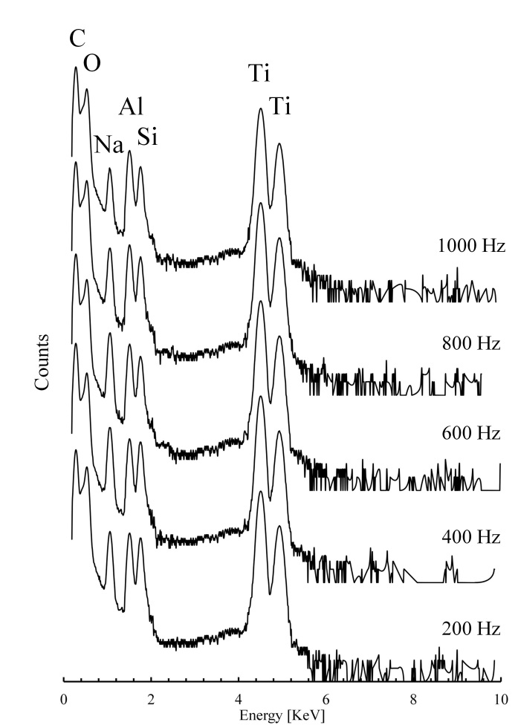

- Table 3: replace the units (mm/y) with (mm/year) and (mV/dec) with (mV/decade)

The units were replaced.

