January 2, 2020
Dear reviewer,
Thank you very much for the reviewer’s comments about our manuscript entitled “Fabrication and tribological properties of mesocarbon microbead-Cu friction composites” (Manuscript ID: materials-637944). We have carefully studied the reviewer’s comments and accepted all of the suggestions presented in the review comments. The manuscript was improved accordingly, and all the revised and added parts were high-lighted by red color in the revised version.
Yours Sincerely,
Jianfeng Yang

Tel.: +86-029-82667942-803;
E-mail: yang155@mail.xjtu.edu.cn (Jianfeng Yang);
Address: State Key Laboratory for Mechanical Behavior of Materials, Xi'an Jiaotong University, No. 28, Xianning West Road, Xi'an, Shaanxi, 710049, People’s Republic of China

Response to Reviewer 1

Thank you very much for your helpful suggestions and constructive comments. Below are our point-by-point responses to your comments.

Comment 1: The entire manuscript has some major grammar and style mistakes. In addition, several sentences are way too long and many phrases are repeated in consecutive sentences, making them hard to read and understand. English of the whole paper will require significant revision. Authors should take the help of some reliable professional agency to proofread their manuscript or of a native English speaker with some technical knowledge of the subject. The appropriate changes should be done.
Answer: We have invited native English speaker in this field to revise the language of the manuscript.

Comment 2: The output powders used in the presented work lack some basic information: purity, producer designation, morphology.
Answer: Content addressing the purity, producer designation and morphology of the raw material has been added. In this paper, the tribological behaviour of copper matrix composites containing mesocarbon microbeads (MCMB) as solid lubricant are evaluated and compared with that of copper matrix composites containing conventional flake graphite, therefore, SEM images of MCMB and flake graphite powders are added and shown in Fig. 1.
The specific modifications are as follows: the spherical atomized copper (mean particle size: 2 μm, Shanghai Chaowei Nanotechnology Co., Ltd.), elliptical reduced iron (mean particle size: 3 μm, Shanghai Chaowei Nanotechnology Co., Ltd.), and rod-like aluminum (mean particle size: 57 μm, Shanghai Chaowei Nanotechnology Co., Ltd.) of 99.9% purity were mixed, and the mixture was used as the matrix of the MCMB-Cu composites. The particle size of alumina (~100 μm magnitude) is frequently used as a reinforcement in metal matrix composites [1]. Therefore, clumpy alumina (mean particle size: 150 μm, Sinopharm Chemical Reagent Co., Ltd.) of 99.0% purity was employed as a reinforcement to improve the mechanical properties of the composites. Graphite flakes are the most common lubricant used in Cu matrix composites, and particle sizes of 30-50 μm are widely studied in metal matrix composites [2-4]. To reflect the improvement of the tribological properties of the MCMB-Cu composites developed in the present work, graphite flakes (mean particle size: 40 μm, Qingdao Jin Ri Lai Graphite Co., Ltd., China) of 99.0% purity were selected to prepare GrF-Cu composites as reference materials. MCMB (mean particle size: 40 μm, Tianjin Eminent Battery Material Co., Ltd., China) of 99.0% purity was used as the solid lubricant. In this case, the MCMB had a nearly spherical shape, while GrF had a cuboids shape with approximate dimensions of 40 μm×10 μm×1 μm. The micromorphologies of the two types of graphite particles are shown in Fig. 1.
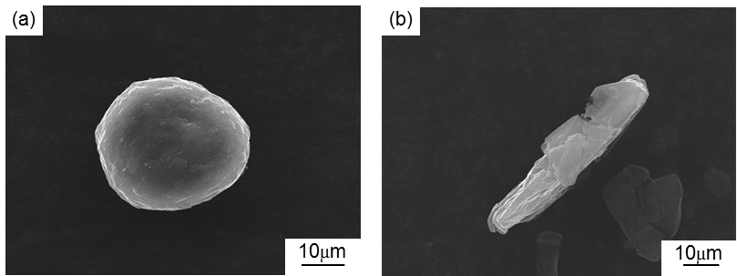
Fig. 1 Micromorphologies of the as-received graphite: (a) MCMB and (b) flake graphite.

Comment 3: Why both the aluminium and alumina powders used in this study had such a different mean particle size compared to copper, iron and GrF/MCMB?
Answer: As the hard phase, alumina plays an important role in increasing the friction coefficients of composites. The particles size of alumina (~100 μm magnitude) is frequently used as the reinforcement in metal matrix composites [1]. Therefore, in the current work, alumina of 150 μm is also selected as the hard phase to increase the friction in the composite.
Aluminum is used as a sintering additive and alloying element in the preparation of composite materials. During the preparation process of the composites, because the melting point of aluminum (650°C) is far lower than the sintering temperature of 980°C, the aluminum will form a liquid phase, and penetrate into the inter space of the Cu and/or Fe particles. The Al will increase the density of the composite, and diffuse into the copper to enhance the sinterability of Cu particles. Therefore, considering little effect on the sintering of the size of aluminum, the aluminum with mean particle size of 57 μm which is commercially available is selected.
To clarify this comment, the specific modifications are as follows: The particle size of alumina (~100 μm magnitude) is frequently used as a reinforcement in metal matrix composites [1]. Therefore, clumpy alumina (mean particle size: 150 μm, Sinopharm Chemical Reagent Co., Ltd.) of 99.0% purity was employed as a reinforcement to improve the mechanical properties of the composites.
The spherical atomized copper (mean particle size: 2 μm, Shanghai Chaowei Nanotechnology Co., Ltd.), elliptical reduced iron (mean particle size: 3 μm, Shanghai Chaowei Nanotechnology Co., Ltd.), and rod-like aluminum (mean particle size: 57 μm, Shanghai Chaowei Nanotechnology Co., Ltd.) of 99.9% purity were mixed, and the mixture used as the matrix of the MCMB-Cu composites.

Comment 4: Based on presented SEM images (Fig.1 a and c) and particle size of alumina, it is impossible to state if it is uniformly distributed within the matrix. Used magnification does not allow to conclude on possible voids/microcracks presence too. In addition, images in BSEM mode (Fig.1 b and d) are impossible to read. Higher quality SEM images should be attached with visible markers pointing out different phases.
Answer: To observe the distribution of Al₂O₃ particles in the metal matrix, SEM images of the composites at low magnification are shown in Fig. 2a and 2i in the revised manuscript. To observe the voids, SEM images of the composites at high magnification are shown in Fig. 2c and k in the revised manuscript. Additionally, we measured the densities and void fraction of the two groups of composites, as shown in Table 2. The results showed that the composite density is high, and the void fraction is low. This result indicates the successful preparation of these composites. BSEM images (Fig. 2 b and j) are taken using the backscattered electron imaging mode of a scanning electron microscope. The equipment used is the Phenom proX scanning electron microscope produced by Netherlands Phenom-World BV company.
The specific modifications are as follows: Fig. 2(a) shows the SEM image of a typical MCMB-25 sample surface. The MCMB and Al₂O₃ particles are uniformly distributed throughout the Cu matrix without aggregation. MCMB or Al₂O₃ particles are in tight contact with the matrix. There are no obvious defects, such as pores and cracks, at the interfaces between MCMB or Al₂O₃ particle and matrix, indicating sintering compaction of the sample. In addition, Fig. 2(i) shows the SEM image of a typical GrF-25 sample surface. GrF and Al₂O₃ particles are also distributed within the Cu matrix. The two kinds of composites exhibit similar structures.
To further prove the compactness of the sample, the densities and porosities of the two groups of composites are shown in Table 2. When the relative density of a composite is as high as 95%, it is a compact material [5]. It can be seen that when the MCMB or GrF content reached 25%, the relative density of the composite was still as high as 96%. This results showed that the sample was compact. This result also indicated the successfully preparation of these composites using the vacuum hot-press method.
Table 2. Densities and porosities of MCMB-Cu composites and GrF-Cu composites.
Samples | Theoretical density  (g/cm³) | Bulk density  (g/cm³) | Relative density  (%) | Porosity  (%)
MCMB-5 | 7.62 | 7.43 | 97.51 | 2.49
MCMB-15 | 7.03 | 6.95 | 98.72 | 1.28
MCMB-25 | 6.45 | 6.34 | 98.29 | 1.71
GrF-5 | 7.62 | 7.50 | 98.42 | 1.58
GrF-15 | 7.03 | 6.90 | 98.15 | 1.85
GrF-25 | 6.45 | 6.21 | 96.27 | 3.73
The matrix of MCMB-Cu composites is a compound made up of Cu, Fe and Al particles. During the preparation process, the carbon atoms in the MCMB may diffuse into the matrix and react with the iron phase to form pearlite [6]. The combination of pearlite, Cu, Fe and Al particles generates a complex matrix structure which plays a vital role in the mechanical and tribological properties of the composites. To analyze the structure, Fig. 2(b) displays the BSEM image of the MCMB-25 sample. Some pale gray and black laminar particles are distributed uniformly throughout the white matrix. During the BSEM imaging process, if an element in the sample has a higher atomic number, it has a higher brightness in the image. Cu has a higher brightness (i.e., the white region) due to its larger atomic number than those of the other elements. The lamellar pearlite is composed of the thin lamellas of ferrite and cementite oriented one over the other. This implies that the black/gray lamellar particles are pearlites. As the basic component of pearlites, both cementite and ferrite may be formed by the eutectoid reaction of iron and carbon during the cooling of the samples after sintering, and the carbon content of cementite is far higher than that of ferrite. Therefore, the cementite phase shows a darker color than that of the ferrite phase in the BSEM image. In this manner, the black parts in these lamellar particles are the cementite phase, and pale gray parts are ferrite. The remaining pure black particles in the matrix are aluminum.
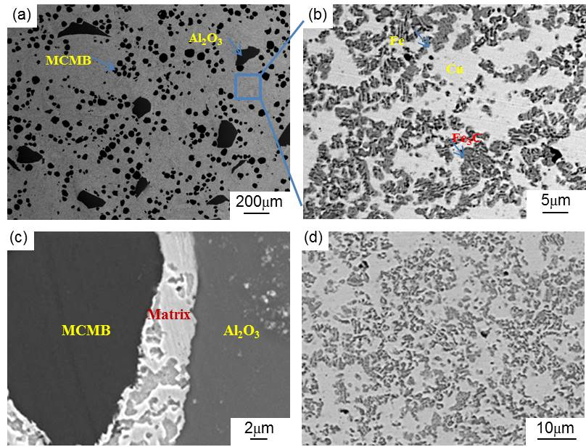
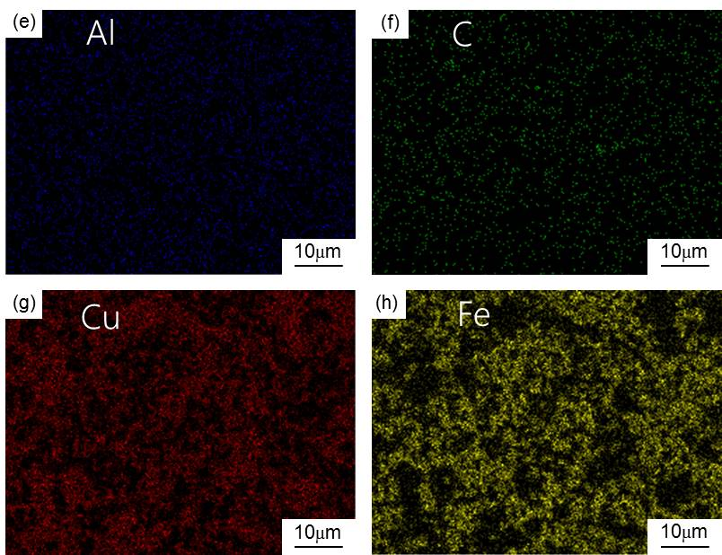
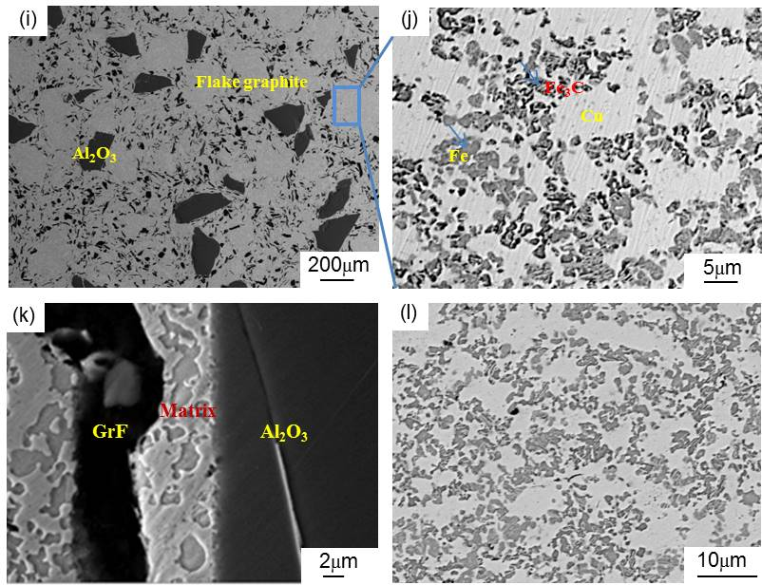
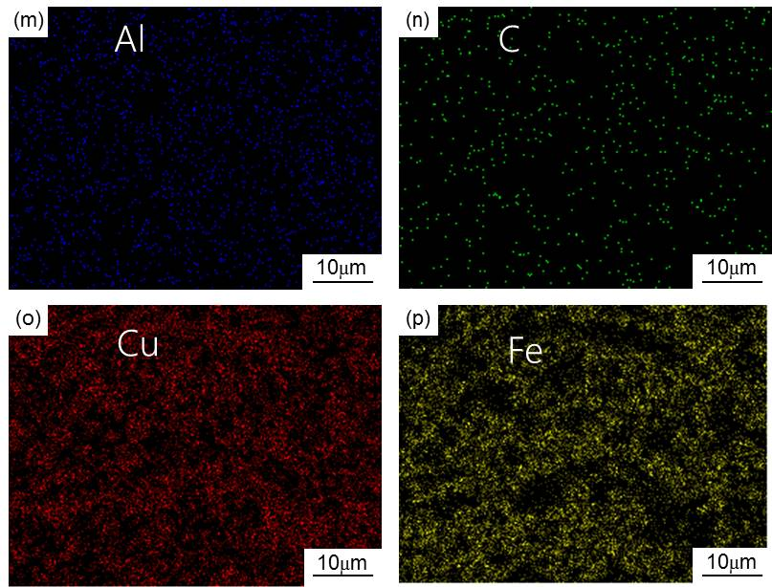
Fig. 2. SEM images of the (a, c) MCMB-25 and (i, k) GrF-25 composites, the BSEM of the matrices of the (b, d) MCMB-25 and (j, l) GrF-25 composites, and EDS maps of the matrices of the (e-h) MCMB-25 and (m-p) GrF-25 composites.

Comment 5: There are no comments for Si peaks on XRD pattern. There is also no diffraction analysis made from composite to prove the presence of additional phases.
Answer: Si is used as standard sample to measure the error in the testing process of MCMB and GrF in X-ray diffractometry. Then, this error is subtracted from the measured diffraction peak angle values of MCMB and GrF to obtain the actual angle values of the diffraction peaks. The discussion of the Si peak has been supplemented, and the specific process used is described in detail.
In the X-ray diffraction analysis of the two groups of composites, the contents of Cu and Fe are higher than that of Fe₃C. Meanwhile, compared with Fe₃C, Cu and Fe have stronger diffraction intensities in the XRD patterns due to the higher atomic number of Cu and Fe than that of Fe₃C. These factors lead to the absence of a diffraction peak of Fe₃C in the diffraction patterns of the composites.
To illustrate that more Fe₃C particles were generated in the MCMB-Cu composites compared with the GrF-Cu composites, we performed energy dispersive spectroscopy (EDS) analysis of two kinds of composites. Meanwhile, we prepared the MCMB(GrF)-Fe composite with a volume ratio (MCMBs or GrFs/Fe) of 1:3 by the preparation process used for the MCMB-Cu composites to confirm this conclusion.
The specific modifications are as follows: Fig. 4 shows the XRD patterns of the MCMB and GrF powders using silicon as an internal standard. From Fig. 4, the angles of the diffraction peaks of Si can be obtained. In fact, Si has standard angles of the diffraction peaks. The exact value of the measurement error was obtained by comparing the measurement angles of the diffraction peak with the angle of the diffraction peak standard. Then, this error was subtracted from the measured angles of the MCMB and GrF powders to obtain the actual angles of the diffraction peaks. It can be seen that the diffraction profile of the (111) reflection of silicon corresponds to the diffraction angle 2θ (28.438°). However, the true angle of the (111) diffraction peak is 28.443° [7]. The difference (i.e., measurement error) between the true and measured diffraction angles was obtained. There are some sharp peaks in the diffraction profiles, suggesting that both MCMB and GrF exhibit an ordered graphite crystal structure. In addition, the diffraction angles 2θ of the (002) crystal plane corresponding to the MCMB and GrF are 26.468° and 26.514°, respectively. Then, the correct angle of the (002) diffraction peak of the MCMB and GrF was obtained by eliminating the measurement error. Using Bragg equation, the interplanar spacings d002 of MCMB and GrF were calculated as 0.3367 nm and 0.3350 nm, respectively.
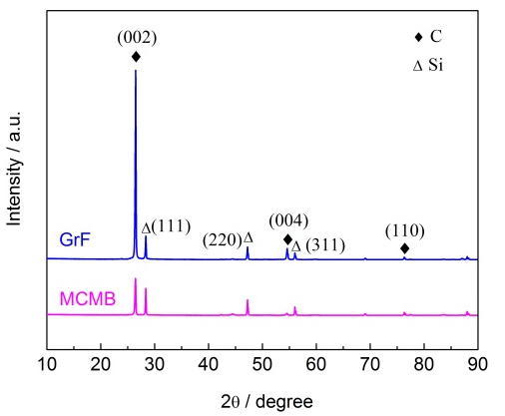
Fig. 4. X-ray diffraction patterns of the MCMB and GrF powders.
Compared with the GrF-25 composite, there are more black/gray laminar particles (i.e., pearlite) in the matrix of the MCMB-25 composite. Upon further observation, it turns out that the black parts of these laminar particles in the MCMB-25 composite have larger total areas than those of the GrF-25 composite, as shown in Fig. 2b and 2j. This implies that the former contains more cementite than does the latter. To further prove this conclusion, the matrices of the two groups of composites were investigated by energy dispersive spectroscopy (EDS). The EDS analysis results (i.e., chemical distribution maps) are shown in Fig. 2(e-h) and 2(m-p). As can be seen from these figures, the matrix carbon content of the MCMB-Cu composite is higher than that of the GrF-Cu composite. These findings suggest that during the preparation process of the MCMB-Cu composite, more carbon atoms diffuse from the MCMB into the matrix and react with the iron phase, thereby generating more cementite because MCMB might have higher carbon diffusion activity than that of GrF. To verify this conclusion, an MCMB(GrF)-Fe composite with a volume ratio (MCMBs or GrFs/Fe) of 1:3 was prepared by the preparation process used for the MCMB-Cu composites. The phases present in the composite could be identified by the Vickers microhardness test. Therefore, we measured the Vickers microhardness of the MCMB-Fe and GrF-Fe composites, and the corresponding microstructures are shown in Fig. 3. Specially, the Vickers hardness values of the S points, F points and remaining position are 978 Hv, 87 Hv and 200-250 Hv. The diffusion of carbon atoms into the iron generates the formation of cementite, pearlite and ferrite, and the corresponding the standard hardness values are about 800 Hv, 180-250 Hv and 80 Hv, respectively. Therefore, we concluded that MCMB-Fe composite mainly consists of pearlite and cementite, while the composition of the GrF-Fe composite mainly includes ferrite and pearlite. Additionally, the chemical compositions of the S and F points were analyzed by EDS. The EDS analysis results are shown in Table 3. It can be seen that the carbon content of the S points is higher than that of the F points. These results confirm that more carbon atoms diffuse from the MCMB into the iron phase and generate more cementite because MCMB have a higher carbon diffusion capacity than that of GrF.
Fig. 2. SEM images of the (a, c) MCMB-25 and (i, k) GrF-25 composites, the BSEM of the matrices of the (b, d) MCMB-25 and (j, l) GrF-25 composites, and EDS maps of the matrices of the (e-h) MCMB-25 and (m-p) GrF-25 composites.
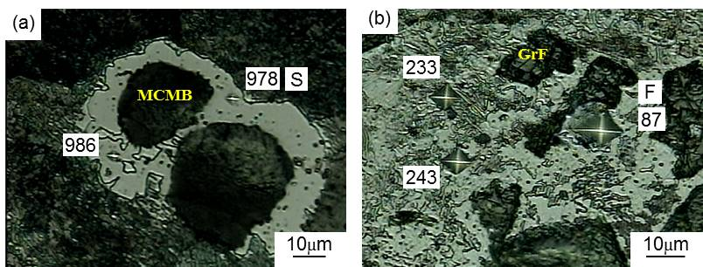
Fig. 3. Microstructures of the (a) MCMB-Fe composite and the (b) GrF-Fe composite.
Table 3 Chemical compositions of the different points.
Composition (S marker) | Element | Weight percent % | Atom percent %
 | C K | 6.59 | 24.71
 | Fe K | 93.41 | 75.26
 | total | 100 | 100
Composition (F marker) | C K | 0.01 | 0.05
 | Fe K | 99.99 | 99.95
 | total | 100 | 100

Comment 6: Authors conclude that there is formation of uniform and compact tribofilm, although there is no evidence of it in the study, except for reduced wear rate which is an outcome of cementite presence.
Answer: Many studies have found that lubricant-rich tribofilms are formed on the friction surfaces of metal matrix composites during the friction process. Chen et al.[8] reported that lubricants (graphite and BN) migrated to the worn surfaces and formed compact tribofilms during the friction process. Such transferred films mainly containing solid lubricants in metal matrix composites have also been reported by Xu et al. [9], who explored the migration mechanism of solid lubricants and calculated the thicknesses of tribofilms. Similarly, in the present work, graphite-rich tribofilms are also formed on the worn surface of the composites during the friction process. In addition, by comparing the worn surface of the MCMB-Cu composite with the worn surface of the GrF-Cu composite (Fig. 10a and 10c), it can be seen that the flaking in the MCMB-25 composite occurs in smaller areas and at shallower depths than does that of the GrF-25 composite. One cause of this phenomenon may be that the thinner and smaller MCMB debris more effectively filled in the holes of the worn surface of the composite than did the GrF debris, in addition to the smooth MCMB/matrix interface and greater cementite presence. This phenomenon also implies more uniform and compact tribofilms on the friction surfaces of MCMB-Cu composites in comparison to those of GrF-Cu composites.
The specific modifications are as follows: when the composites is subjected to the surface friction loads, plastic deformation of the metallic matrix occurs, and brittle MCMB or GrF around the matrix are extruded to break into small graphite debris, resulting in the formation of the graphite-rich tribofilm on the friction surface of the composites [10]. Chen et al. [8] have also proved that solid lubricant migrates from matrix to the worn surface and forms tribofilm mainly containing solid lubricant during the friction process of metal matrix composites.
As shown in Fig. 10a and 10c, it can be concluded that the flaking in the MCMB-25 composite occurs in smaller areas and at shallower depths compared to that of the GrF-25 composite. Compared with GrF debris, the thinner and smaller MCMB debris can effectively fill the holes of the worn surface of the MCMB-25 composite, which may also be a key factor behind the reduced flaking areas, in addition to the smooth MCMB/matrix interface and more cementite presence. This phenomenon also implies that more uniform and compact tribofilms can be formed on the friction surfaces of MCMB-Cu composites in comparison to GrF-Cu composites. Such a tribofilm facilitates the reduction of the adhesive wear between the MCMB-Cu composites and hard counters.
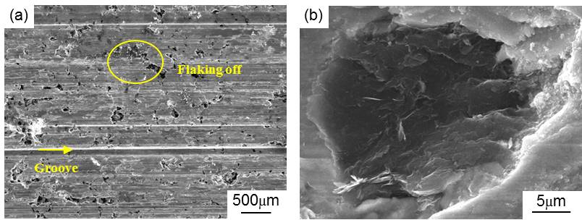
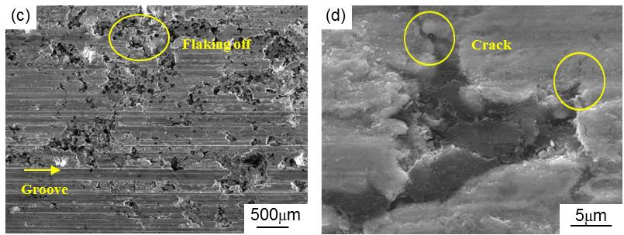
Fig. 10. Wear surface morphologies of the (a-b) MCMB-Cu composites and (c-d) GrF-Cu composites.

Comment 7: There is lack of consistency in the described results, authors use individual analysis to confirm their thesis.
Answer: In previous manuscripts, this problem does exist. According to this suggestion, in order to fully explain the relationship among phase composition (i.e., the Fe₃C content), mechanical properties (i.e., the hardness and strength) and wear resistance (i.e., wear rate), we have added the discussion of relevant contents in the present manuscript. For example, when it is shown that the higher mechanical properties of MCMB-Cu composite is due to its more cementite, we add the discussion of Ram Prabhu et al. on page 15：“The amounts of Fe₃C in the MCMB-25 composite are far higher than those of the GrF-25 composite, resulting in a higher hardness of the MCMB-25 composite. Similar result has also been reported by Ram Prabhu et al. [11] who have shown that the higher the volume fraction of the reinforcement in the metal matrix, the higher the hardness of the composite.”
When it is explained that the lower wear rate of MCMB-Cu composite is due to the better mechanical properties, this phenomenon is recounted on page 18: “The MCMB-Cu composites have a lower wear rate than that of the GrF-Cu composites under the same MCMB and GrF content. As mentioned before, compared to the GrF-Cu composites, the metal matrix of the MCMB-Cu composites contains more Fe₃C particles due to the higher carbon diffusion activity of MCMB than that of GrF. The high hardness of these Fe₃C particles contributes to a higher hardness of MCMB-Cu composites, showing higher deformation resistance, which results in a smaller compressive deformation of the composites subjected to an initial surface pressure during friction. Meanwhile, these Fe₃C particles also play an enhancing role in the strength of the MCMB-Cu composites. As the friction process continues, MCMB-Cu composites show higher shear resistance, leading to the formation of some shallower grooves on their friction surfaces, thus reducing the lower wear rate of MCMB-Cu composites. The high hardness and strength of MCMB-Cu composites play an important role in reducing wear rate of composites, which have been illustrated in the work of Ram et al [11]. ”
In addition to, we add the discussion of Ram Prabhu et al. on page 15: “The high hardness and strength of MCMB-Cu composites play an important role in reducing wear rate of composites, which have been illustrated in the work of Ram et al [20].”
Meanwhile, we quote the Archard's relation on page 15: “Based on Archard's relation [12], a high hardness value is correlated with a better wear resistance, these trends are of interest while examining the wear rate of the composites.”

References
[1] Boz M and Kurt A. The effect of Al₂O₃ on the friction performance of automotive brake friction materials. Tribol Int 2007; 40: 1161-1169.
[2] Chen WY, Yu Y, Cheng J, Wang S, Zhu SY, Liu WM, Yang J. Microstructure, mechanical properties and dry sliding wear behavior of Cu-Al₂O₃-graphite solid-lubricating coatings deposited by low-pressure cold spraying. J Therm Spray Tech 2018; 27: 1652-1663.
[3] Zhan YZ and Zhan GD. Graphite and SiC hybrid particles reinforced copper composite and its tribological characteristic. J Mater Sci Lett 2003; 22: 1087-1089.
[4] Rajkumar K and Aravindan S. Tribological performance of microwave sintered copper-TiC-graphite hybrid composites. Tribol Int 2011; 44: 347-358.
[5] Jiang XS, Liu WX, Li JR, Shao ZY, Zhu DG. Microstructures and mechanical properties of Cu/Ti3SiC2/C/MWCNTs composites prepared by vacuum hot-pressing sintering. J Alloys Compd 2015; 618: 700-706.
[6] Ram Prabhu T, Varma VK, Vedantam S. Effect of SiC volume fraction and size on dry sliding wear of Fe/SiC/graphite hybrid composites for high sliding speed applications. Wear 2014; 309: 1-10.
[7] Iwashita N, Park CR, Fujimoto H, Shiraishi M, Inagaki M. Specification for a standard procedure of X-ray diffraction measurements on carbon materials. Carbon 2004; 42: 701-714.
[8] Chen BM, Bi QL, Yang J, Xia YQ, Hao JC. Tribological properties of solid lubricants (graphite, h-BN) for Cu-based P/M friction composites. Tribol Int 2008; 41: 1145-1152.
[9] Xu ZS, Zhang QX, Huang XJ, Liu R, Zhai WZ, Yang K, Zhu QS. An approximate model for the migration of solid lubricant on metal matrix self-lubricating composites. Tribol Int 2016; 93: 104-114.
[10] Kováčik J, Emmer Š, Bielek J. Effect of composition on friction coefficient of Cu-graphite composites. Wear 2008; 265: 417-421.
[11] Ram Prabhu T, Varma VK, Vedantam S. Effect of SiC volume fraction and size on dry sliding wear of Fe/SiC/graphite hybrid composites for high sliding speed applications. Wear 2014; 309: 1-10.
[12] Archard JF. Contact and rubbing of flat surfaces. J. Appl Phys. 1953; 24: 981.

