26-Sep-2019

Journal: Molecules
Manuscript ID: molecules-594538
Title: "The power of LC-MS based multiomics: Exploring adipogenic differentiation of human mesenchymal stem/ stromal cells"
Author(s): Evelyn Rampler* , Dominik Egger, Harald Schoeny, Mate Rusz, Maria Pires Pacheco, Giada Marino, Cornelia Kasper, Thomas Naegele, Gunda Koellensperger

Response to the reviewers

Referee 2

Comments:
The manuscript by Rampler et al describes a very interesting work showing the integrative application of multiomics to provide a more holistic molecular perspective by integrating multiple types of omics, namely lipidomics, proteomics and metabolomics to give new insights in cell differentiation. The manuscript is well organized and technically sound but have some limitations including small sample size. Despite the low sample size, the study provide a novel approach for the proof of principle and some valuable information on the application of multiomics not only for follow-up studies but also its potential for understanding the complex pathophysiology of diseases, among other applications. However, the study suffers from other limitations that are not adequately acknowledged by the authors. The manuscript should be accepted for the publication after addressed major critique points listed below.
We thank the referee for this relevant review as it contained crucial points to be improved. We agree with the referee that the low sample size has to be stated as it might represent an issue for biological interpretation. We now stated the drawback of the low sample size more clearly (see also comments below) and the additional potential of the method to understand pathophysiology of diseases in the abstract and discussion as suggested by the referee.
1. The section 4.2 Multiomics of the methods should be improved. Authors should provide all necessary experimental details namely for proteomics analysis (column, solvent system for LC-MS/MS, etc). Also, how protein extraction was performed? It was used the pellet obtained with the adapted SIMPLEX two-phase extraction preparation (as reported in page 10, line 351) or proteins were (further) extracted using guanidine chloride/HEPES buffer followed by precipitation in methanol/chloroform/water mixture as reported in page 10, line 373 and 374? The parameters
of MS part should be also completed, namely the cycle structure, type of ions analyzed, etc.
Thank you for the useful comment, we included more detailed information in the new article version on (1) the HILIC-RP-MS dual injection setup (added in the supplementary Appendix B), (2) the extraction procedure and the LC-MS/MS shotgun proteomics (Material and methods, multiomics part) as well as (3) a detailed table on the lipids/metabolites analyzed (including ion types) and the proteins IDs (Supplementary Table S1). The proteins were analyzed by a state of the proteomics workflow as described using the additional precipitation/purification step with guanidine chloride/HEPES buffer and methanol/chloroform/water mixture. However, the referee is right that direct analysis of the protein pellet would have been possible after the sequential extraction. It is already planned that the direct use of the protein pellet will be investigated in future experiments.

Why MS data used for quantification was acquired only in positive ion mode? Particularly, in the case of lipidome, negative ion mode is usually required for PI class. Moreover, the authors should clarify the composition of metabolites and lipids present in the multi mixes and all the standards used, and the range of dilutions used for external calibrations.
One of our major research goals is high-throughput analysis for fully automated LC-MS based diagnostic assays, hence we performed dual-injection HILIC-RP separation followed by Full-MS quantification runs in positive mode for the analysis of MSCs and adipocytes. Our working group could recently show that the use of labeled metabolites/lipids for standardization offers the possibility to merge non-targeted screening with targeted quantification (Schwaiger et al, Anion-Exchange Chromatography Coupled to High-Resolution Mass Spectrometry: A Powerful Tool for Merging Targeted and Nontargeted Metabolomics, Anal. Chem. 2017, 89, 7667−7674, DOI: 10.1021/acs.analchem.7b01624; Rampler et al, A Novel Lipidomics Workflow for Improved Human Plasma Identification and Quantification Using RPLC-MSn Methods and Isotope Dilution Strategies, Anal Chem. 2018, 90, 6494-6501, doi: 10.1021/acs.analchem.7b05382). The presented workflows for MSC analysis also included identification runs (with sequential exclusion lists) for both negative and positive ion mode for sample pools as recommended for state of the art metabolomics/lipidomics workflows (Dudzik et al, Quality assurance procedures for mass spectrometry untargeted metabolomics, Journal of Pharmaceutical and Biomedical Analysis 147, 2018, 149–173, doi: 10.1016/j.jpba.2017.07.044; Sangster et al, A pragmatic and readily implemented quality control strategy for HPLC-MS and GC-MS-based metabonomic analysis, Analyst, 2006,131, 1075-1078. doi:10.1039/B604498K; Koemel et al, Expanding lipidome coverage using LC-MS/MS data-dependent acquisition with automated exclusion list generation, J Am Soc Mass Spectrom. 2017 May ; 28(5): 908–917. doi:10.1007/s13361-017-1608-0). The use of positive ion mode for our all-in-one-run workflow is ideally suited for lipid analysis as most lipids including non-polar and polar lipids ionize in positive mode using our settings, which is not possible in negative ion mode as the analysis of non-polar lipids like TAGs and DAGs is impeded. Although, the referee is right that negative mode is better suited for phospholipid analysis including PI leading to more potential identifications, positive ion mode of PI using NH₄ or Na adducts was possible in our samples (see Figure 1 and Table 1). We further confirmed this finding by the measurement of PI standards in positive ion mode (Figure 2).

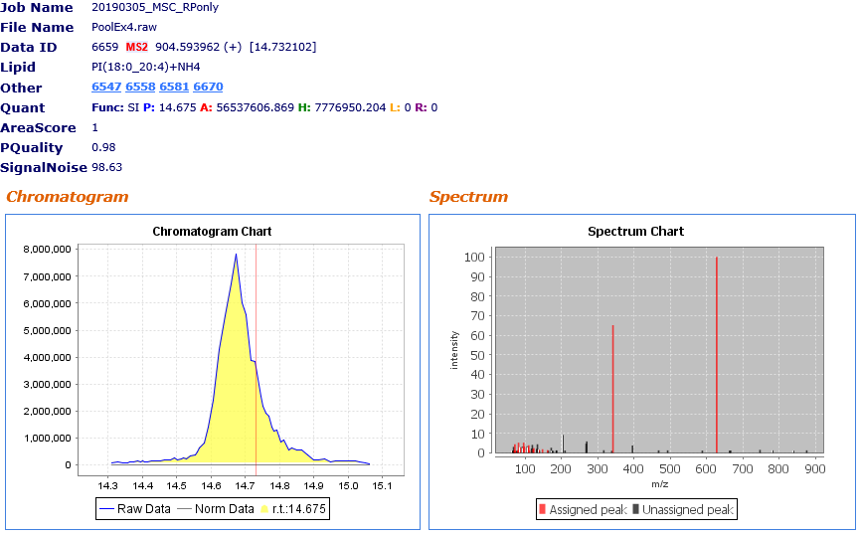
Figure 1. Lipid Search 4.2 output for an exemplary PI measured in positive mode. A. Chromatogram of PI(18:0_20:4). B. MS2 fragmentation spectra of PI(18:0_20:4).

Table 1. Observed MS2 fragments exported from Lipid Search 4.2. The table shows observed m/z, abundance of fragments in percentage (calculated setting the highest abundant fragment as 100%), fragments assigned by the in silico database, mass difference in Da.
ObsMz | Type | It.(%) | Fragment | Delta(Da)
63.2217 | MS2 | 1.153
66.5329 | MS2 | 1.136
66.9297 | MS2 | 1.085
67.0546 | MS2 | 3.141
69.0702 | MS2 | 1.072 | C5H9 | 0.0003
71.0857 | MS2 | 4.455 | C5H11 | 0.0002
71.9972 | MS2 | 1.055 | C5H11 [isotope] | 0.9117
75.1039 | MS2 | 1.018
77.3534 | MS2 | 1.118
79.0544 | MS2 | 1.422 | C6H7 | 0.0002
81.0702 | MS2 | 5.305 | C6H9 | 0.0003
83.0858 | MS2 | 1.533 | C6H11 | 0.0003
83.422 | MS2 | 1.135
85.1014 | MS2 | 2.917 | C6H13 | 0.0002
91.0546 | MS2 | 3.167
93.0702 | MS2 | 2.552 | C7H9 | 0.0003
95.0858 | MS2 | 5.299 | C7H11 | 0.0003
97.1015 | MS2 | 3.393 | C7H13 | 0.0003
105.0701 | MS2 | 3.468
107.0857 | MS2 | 3.001 | C8H11 | 0.0002
109.1016 | MS2 | 3.922 | C8H13 | 0.0004
111.1172 | MS2 | 1.264 | C8H15 | 0.0004
117.0702 | MS2 | 2.277
119.0858 | MS2 | 4.147
121.1013 | MS2 | 1.831 | C9H13 | 0.0002
123.1172 | MS2 | 2.495 | C9H15 | 0.0004
131.0859 | MS2 | 2.139
133.1015 | MS2 | 4.43
137.133 | MS2 | 1.693 | C10H17 | 0.0005
138.5383 | MS2 | 1.119
147.1172 | MS2 | 1.888 | C11H15 | 0.0003
161.1326 | MS2 | 1.467 | C12H17 | 0.0001
163.1478 | MS2 | 1.244
171.1173 | MS2 | 2.672
172.8861 | MS2 | 1.083
176.3995 | MS2 | 1.11
185.1327 | MS2 | 1.249
185.8718 | MS2 | 1.338
203.18 | MS2 | 9.203
209.1325 | MS2 | 1.289
267.2689 | MS2 | 4.795
269.2267 | MS2 | 5.934
315.9689 | MS2 | 1.43
337.9509 | MS2 | 1.1
341.3058 | MS2 | 65.187 | MG(18:0)-OH | 0.0007
395.3159 | MS2 | 3.805
467.4361 | MS2 | 1.359
492.2711 | MS2 | 1.321
587.8475 | MS2 | 1.245
627.5363 | MS2 | 100 | NL[PI,+NH4]+H | 0.0016
663.3145 | MS2 | 1.248
666.0008 | MS2 | 1.191
746.8816 | MS2 | 1.581
781.6358 | MS2 | 1.323
839.4292 | MS2 | 1.13
875.7505 | MS2 | 1.332

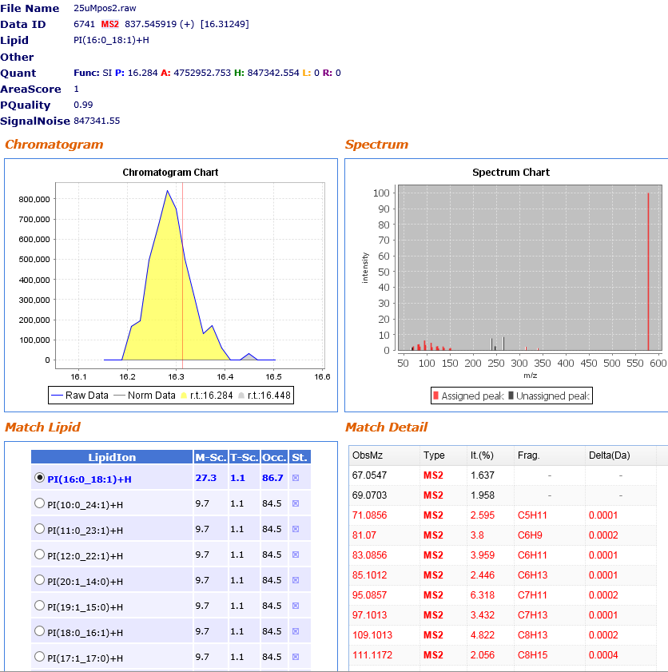
Figure 2. Lipid Search 4.2 output for an 25 µM PI (16:0/18:1) standard measured in positive mode. A. Chromatogram of PI(16:0_18:1). B. MS2 fragmentation spectra of PI(16:0_18:1).

An additional strategy represents the use of polarity switching methods, which is generally possible, however data points per peak are reduced (which are essential for quantification) and evaluation of data acquired in polarity switching mode is still challenging. As suggested by the referee, we added the information on the number (148 metabolites, 76 lipids) and composition of metabolites and lipids (Supplementary Table S1) present in the multi mixes and all the standards used, and the range of dilutions used for external calibrations (material and methods, multiomics).

2. As stated above, the number of samples analyzed is very small (n=5) and in some analysis only n=3 and n=2 are used. The n=3 used for targeted analysis of lipids and metabolites (section 2.2) and the n=2 used for proteomics analysis (section 2.4) are highly small sample sizes to statistical analysis and (analytical and biological) validation. In this way, with the data available is precocious to claim on biological and analytical validation. In the case of n=2, validation is not achievable.
The presented results are a proof of principle for the capability of LC-MS based multiomics workflows tested on the example of human adipogenesis. The experiments were performed on 6-well plates, including 5 samples and 1 blank extraction per condition for MSCs and adipocytes (differentiated for 21 days). 3 samples were spiked with the ¹³C labeled metabolite/lipid extract and used for targeted analysis with protein normalization (meaning that all three protein fractions were determined by Bradford and used for normalization). Our previous work revealed that ¹³C-labeled metabolites and lipids do not represent an issue for identification workflows (Schwaiger et al, Anion-Exchange Chromatography Coupled to High-Resolution Mass Spectrometry: A Powerful Tool for Merging Targeted and Nontargeted Metabolomics, Anal. Chem. 2017, 89, 7667−7674, DOI: 10.1021/acs.analchem.7b01624; Rampler et al, A Novel Lipidomics Workflow for Improved Human Plasma Identification and Quantification Using RPLC-MSn Methods and Isotope Dilution Strategies, Anal Chem. 2018 5;90(11):6494-6501. doi: 10.1021/acs.analchem.7b05382) so that merging non-targeted screening and targeted quantification is enabled. The remaining unspiked samples (n=2) were analyzed via shotgun proteomics. The referee is right that the sample size is too low for proper peptide quantification based on statistical analysis. However, the produced proteomics data was solely interpreted in combination with the Recon 2.4 – an up-to-date accepted consensus models for human genomic sequences- and/or the metabolite/lipid samples combining targeted (n=3) and non-targeted (n=5) information with sufficient sample size. In the new manuscript version, we also performed a comparison to a proteomics analysis of MSCs and adipocytes (DeLany et al, Proteomic Analysis of Primary Cultures of Human Adipose-derived Stem Cells, Molecular & Cellular Proteomics, 4:731–740, 2005, doi: 10.1074/mcp.M400198-MCP200). Matching protein regulation trends to our study were observed with upregulation of apolipoprotein, fatty acid binding protein, glycerol-3-phosphate dehydrogenase, fatty acid synthase, phosphoglycerate synthase and downregulation of platelet activating factor, acetylhydrolase 1B and annexin. The upregulation of glycerol-3-phosphate dehydrogenase and fatty acid synthase was also reported previously as a consequence of the increased triacylglycerol metabolism upon lipid droplet formation in adipocytes (Gregoire et al, Understanding adipocyte differentiation. Physiol. Rev. 1998, 78, 783–809, doi:10.1152/physrev.1998.78.3.783). These findings further support our proteomics data and show that our observed pathways are consistent with literature findings. Hence, we conclude that biological validation was successfully performed and the proteomics data can be still included in our proof of principle multiomics workflow despite the low sample size. Thorough analytical validation of the dual-injection HILIC-RP-MS setup was performed in our original publication (Schwaiger et al, Merging metabolomics and lipidomics into one analytical run, Analyst, 2019,144, 220-229, doi: 10.1039/C8AN01219A) and was further validated by (1) analytical figures of merit, (2) use of commercially available standards as well as in-house produced labeled metabolites and lipids, (3) database annotation based on RT, (4) accurate mass and fragmentation pattern, (5) additional manual curation in the presented multiomics study on adipogenic differentiation.

3. What were the 12 lipids and 54 metabolites used for targeted analysis? What was the criteria for their selection? Additionally, the MSC 21 samples were highly heterogeneous and disperse in the PC1 (44.9%) (Figure 2 A). In fact. MSC 0 and MSC 21 are only separated in PC 2, with 25.8% of the variance. Authors should provide further statistical analysis data since the PCA is not sufficient.
We thank the referee for the useful comment and referenced the information on the selected targeted analytes in Table S1 (panel: MetabolitesLipids_OmicsNet, green labeled metabolites/lipids). The selection of the analytes was performed on the compound presence in MSC/adipocyte samples and available standards mixes with corresponding ¹³C labeled lipids/metabolites. The reviewer is right in highlighting the necessity to discuss the PCA output in more detail. We have added a paragraph which explains that the low sample number reduces the statistical significance of our findings. However, we also highlighted that MSC differentiation might lead to a more diverse metabolome and lipidome (explained by PC1) and has to be statistically validated in future studies (Targeted lipidomics and metabolomics comparing MSCs and adipocytes).

4. What was the sample size used for non-targeted analysis? It was a n=3 samples? Did the authors performed any normalization of the chromatographic peak areas using non-endogenous internal standards to eliminate instrumental or analytical interferences in this case of non-targeted analysis? As stated in the section 4.2 Multiomics of the methods the MS data used for quantification was acquired only in positive ion mode. In this way, how did the authors quantified the variations in PI levels? What type of ions were analyzed?
The sample size used for non-targeted analysis was n=5 (as explained above). Normalization of the non-targeted data was performed using mean-centered and divided by standard deviation (auto-scaling option) in MetaboAanlyst 4.0. In this study the ¹³C labeled internal standards were applied for targeted quantification only if they were present as labeled counterparts of our endogenous standards (originating from our lipid and metabolite mixes) so that compound-specific isotope dilution is possible. However, the referee is right that the labeled metabolites/lipids can be potentially used for normalization of non-targeted data e.g. by class or retention-time specific quantification for large scale datasets (in the presented study only a small sample set was analyzed). This is also a hot research topic at the moment and there has been an interesting paper from June 2019 in Analytical Chemistry on how to perform such normalization approaches using labeled internal standards in non-targeted analysis in lipidomics (Drotleff and Lämmerhofer, Guidelines for Selection of Internal Standard-Based Normalization Strategies, Analytical Chemistry, 2029. 91, 9836-9843, doi: 10.1021/acs.analchem.9b01505) However, the rules and data evaluation programs of how to choose and apply such internal standards in non-targeted multiomics is challenging (e.g. RT-time or class-specific normalization, different strategies in metabolomics/lipidomics/proteomics, how to treat different cell types, etc.) and is ongoing research in our working group. We also state this possibility in the discussion part of the new article version.
The PI variation between the samples was determined using summed areas of the non-targeted analysis (Table S1) performed by Lipid Search 4.2. As stated above this is also possible using positive mode and ammonium or sodium adduct detection. In the case of our workflow for MSC and adipocyte analysis, only ammonium adducts were identified. Due to the higher variation within the adipocyte (MSC21) group (Figure A4)- despite decreased summed area of the PI class (Tables S1)- no significant differences in PI levels were determined (Figure 2). In the new manuscript version this is now indicated as a general trend towards phospholipid remodeling upon adipogenic differentiation/lipid droplet formation. The higher variation within the adipocyte samples indicates a diversification of the lipidome due to differentiation which remains to be tested for its significance in future studies and is also stated in the new manuscript version.

5. Did gangliosides were identified in the lipid fraction (upper phase) that corresponds to the organic layer or in the lower phase, which corresponds to the more polar layer? Gangliosides are complex and highly polar lipid compounds with relatively hydrophilic headgroups that are soluble in water and they are usually lost in the aqueous phase. Therefore, gangliosides analysis requires specialized lipid extraction methods since these lipids are not present in the organic layer where the other more simple lipids are recovered. In figure A7 A, the sphingosine d18:1-H2O (that should be assigned as [sphingosine d18:1-H2O+H]+) is not attributed to any peak in spectrum, and the ions at m/z 520.5090 should be assigned as [ceramide d18:1-H2O+H]+ since the loss of hexose is from ceramide moiety and not from the all ganglioside structure, which can lead to misunderstandings. Ions at m/z 264.2687 should be assigned as [sphingosine d18:1-2H2O+H]+. In spectrum A7 B, the ions at m/z 290.0878 should be assigned as [NeuACres-H]- and the m/z of the ions corresponding to deprotonated galactose ([galactose-H]-) should be identified. Please clarify the identification of ions at m/z 87.0087 (C3H3O3).
We thank the referee for the careful review of our data. We agree with the referee, that there are more specialized ganglioside sample preparation strategies available. Looking at our data from the sequential sub-ome extraction, we are certain that the identified molecules are gangliosides. The organic layer of the two-phase MTBE extraction was sufficient to extract at least the GM3 fraction of the gangliosides by the lipid part from MSCs/adipocytes. We are aware of the fact that highly glyosylated gangliosides are usually expected in the water layer. In our opinion one possible explaination for only identifying GM3 is that higher glyosylated gangliosides such as GM1 and GM2 would be extracted in the lower water fraction. As the ganglisoides were identified as being upregulated in adipocates compared to MSCs, we will also continue to work on optimized ganglioside extraction procedure in our future project to investigate this effect in more detail. Due to another referees comment, we further investigated ganglioside regulating proteins in our dataset and could successfully identify ganglioside GM2 activator (P17900). Ganglioside GM2 activator was upregulated (factor 2) in adipocytes compared to MSC and is linked to the identified GM3 pathway as it can extract GM2 from membranes and hydrolyze them to GM3 further supporting our observation of GM3 regulation in adipocytes.
As suggested by the referee we assigned the GM3 fragmentation more carefully to make Figure A7 (see below) easier to follow for the reader and also added the literature basis for our assignment (Domon and Castello, Structure Elucidation of Glycosphingolipids and Gangliosides Using High-Performance Tandem Mass Spectrometry, Biochemistry 1988, 27, 1534-1543). The identification of 87 m/z [fatty acid C₃H₃O₃]⁻ is coming from the ceramide backbone and an oxygen fragmentation series after C–C bond cleavage of long chain fatty acids.
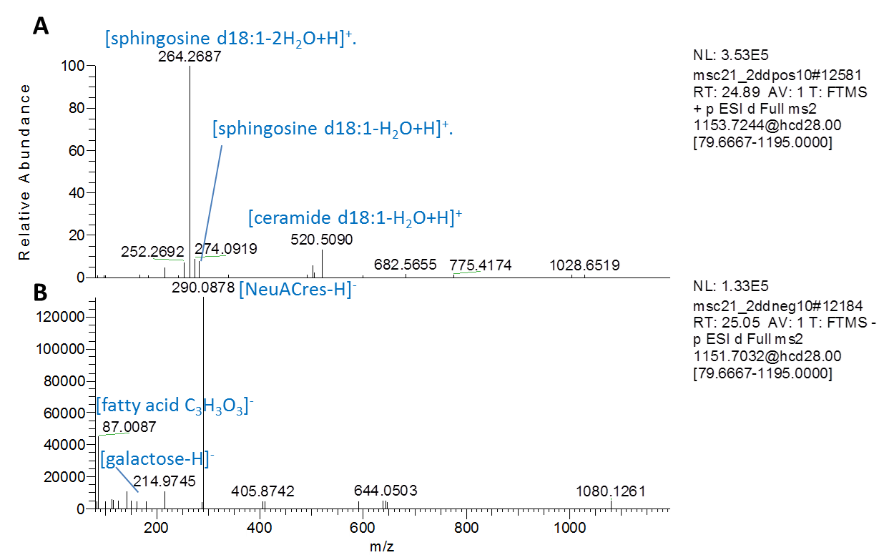Figure A7. MS2 spectra of predicted ganglioside. Fragmentation spectra (Thermo Xcalibur) of regulated ganglioside GM3(d18:1/16:0) (sum formula, C₅₇H₁₀₄N₂O₂₁) show characteristic lipid fragments[53] in the positive ion mode and characteristic glycan moieties in the negative ion mode.

