Dehumidification Potential of a Solid Desiccant based Evaporative Cooling System with an Enthalpy Exchanger Operating in Subtropical and Tropical Climates
Ramadas Narayanan^{1,*}, Edward Halawa^{1,2}, Sanjeev Jain³

- Central Queensland University, 6 University Drive Bundaberg, QLD 4670 – Australia
² Future Industries Institute, University of South Australia, Mawson Lakes, SA 5095, Australia
³ Indian Institute of Technology Delhi, Hauz Khas, New Delhi – 110 016, India
* Correspondence: r.narayanan@cqu.edu.au
Abstract
The technical and economic attractiveness of a solid desiccant based evaporative cooling system depend on several factors: configuration of the system components and their individual performance, availability of cheap but reliable regeneration heat source. In the tropical and subtropical regions, the air conditioning systems are expected to address not only the sensible loads but also – and most importantly - the loads due to higher outside humidity levels that can severely affect the thermal comfort of the building occupants. This paper reports on the dehumidification potentials of solid desiccant based evaporative cooling systems with an enthalpy exchanger operating in subtropical and tropical climates. In particular, the study presents the cooling and dehumidification capability of the enthalpy exchanger observed through the impact of its sensible and latent effectiveness on the thermal comfort of the conditioned space. The key performance indicators are split into two groups: (1) the thermal comfort of the conditioned space, and (2) the coefficient of performance. It is found that this cooling system with enthalpy exchanger performs better than that without enthalpy exchanger in terms of dehumidification however, the impact depends on the climate where the system operates.
Keywords: air conditioning; desiccant wheel; enthalpy exchanger; evaporative cooling; thermal comfort
Nomenclature

COP_{el} | Coefficient of Performance (Electrical)
COP_{th} | Coefficient of Performance (Thermal)
DEC | Direct Evaporative Cooling
DW | Desiccant Wheel
EC | Electrical Energy Consumption in kW
ERW | Energy recovery Wheel
HR | Heat for regeneration in kW
L | Cooling load in kW
m | Mass flow rate in kg/sec
REG | Regeneration
SDEAC | Solid desiccant based evaporative air conditioning system

Introduction
Solid desiccant based evaporative air conditioning system (SDEAC) combines the dehumidifying capability of solid desiccant system with the cooling capability of evaporative cooling system to provide thermal comfort to the occupants of a conditioned space. The system’s main appeal lies in the fact that - if properly designed - it consumes less electrical energy than the conventional refrigerative air conditioning systems. A recent optimisation study has indicated that an electrical coefficient of performance higher than 20 [1] could be attained. Low electrical energy consumption is made possible using thermal energy sources such as solar energy or waste heat as the regeneration heat source.
Recently, there have been several research works on solid desiccant evaporative air conditioning which investigates various related technical and economic performances of the systems and components [1-14]. Earlier, Henning [15] presented a review on various possible system configurations suitable for certain climatic conditions whilst Camargo and Ebinuma [16] presented thermodynamic equations of the system with focus on the humid climate applications.
To be able to compete technically and economically with the conventional refrigerative systems, SDEAC must be properly designed to achieve the following: (1) to minimise the parasitic energy consumption, (2) to minimise the use of regeneration heat, (3) to be on par with the conventional refrigerative systems in delivering the thermal comfort. To achieve the above goals, several system configurations have been proposed that are expected to suit certain climatic conditions [15]. Other configurations can be found in [5,7,18]. The standard desiccant cooling cycle mentioned in [15] was recently studied to investigate the system performance for the Brisbane climate zone in Australia [19] with mixed results; i.e. a slightly better electrical COP compared with the refrigerative system but with thermal comfort conditions of the conditioned spaces not fully satisfied.
While relatively comprehensive analyses have been carried out to study the performance of the SDEAC [1,6,7,8], these previous studies have largely overlooked the impact of such a system in terms of delivering the thermal comfort. For instance, the impact of outdoor humidity was mentioned in [8] but the air temperature and humidity level in the conditioned space was not discussed. The same observation is true for a very recent study on two-stage desiccant system [20-21].
The success of SDEAC largely depends of its dehumidification potential. This paper evaluates the dehumidification capability of a SDEAC equipped with an enthalpy exchanger. In the previous study [19], the performance of the single stage SDEAC reported in the earlier studies [5, 6, 7, 8] was evaluated. The findings [15] echoes the conclusions presented in [5]. However, no research work has been carried out on the performance analysis of SDEAC system for residential applications in tropical and subtropical climates where latent cooling load is an important factor. To develop this system as an alternative to the energy intensive vapor compression system, it is important to assess the dehumidification potential which will help the design of systems for these regions. So the current study focusses on dehumidification and cooling characteristics of SDEAC system for a residential building in the climate conditions in Australian cities of Brisbane (27.4698° S, 153.0251° E), Townsville (19.2590° S, 146.8169° E) and Darwin (12.4634° S, 130.8456° E), which represent three distinct sub-tropical and tropical humid regions, respectively.
The project investigates the effects of adding an enthalpy exchanger in the desiccant evaporative cooling system cycle for subtropical and tropical climates. This study targets an objective method of assessing the thermal performance of the SDEAC system with enthalpy exchanger, i.e. direct evaluation of its capability to the required air temperature and humidity levels in the conditioned space. The direct evaluation of the system capability to deliver acceptable thermal comfort condition is always essential to develop it as a potential alternative to energy intensive refrigerated air-conditioning systems. So, the paper is HVAC application oriented and includes the numerical models of SDAEC system using TRNSYS, which is a well-established software in the HVAC industry with all its components validated with experimental results.

An overview of SDEAC system configurations
A standard SDEAC system consists of a desiccant wheel, an energy recovery wheel, evaporative coolers (at supply and exhaust streams) and a regeneration (reactivation) source [15], as shown in Figure 1. The desiccant wheel dehumidifies the air but increases its temperature significantly (process 1 → 2). The first cooling of this supply air takes place in the energy recovery wheel (2 → 3), a constant humidity process. Before being supplied to the conditioned space, the air is further cooled in a direct (or indirect) evaporative cooler (3 → 4) where the air humidity may be slightly raised but kept well below the comfort requirement. As the supply air enters the conditioned space, its temperature and humidity increase due to the rooms sensible and latent heat gains (4 → 5).

CONDITIONED
SPACE

DW
ERW
D
EC
D
EC
RG
1
2
3
4
5
6
7
8
9
AMBIENT AIR
EXHAUST AIR
Figure 1: Solid desiccant evaporative cooling system – DW: desiccant wheel, ERW: energy recovery wheel, DEC: Direct Evaporative cooler, RG: regeneration source
The air leaving the air-conditioned space is directed to the exhaust where it undergoes several psychrometric processes starting with cooling in an evaporative cooler (5 → 6). This brings the air close to the saturation line with or without humidification – depending on the evaporative cooling process (direct or indirect). In the energy recovery wheel, the air is preheated (6 → 7) before it passes through the heater (7 → 8) where its temperature is further raised so that it will be able to desorb the water from the desiccant in the regeneration side of the desiccant wheel (8 → 9). The regeneration heat source (E) can be either a solar thermal system or waste heat. A typical wheel has a 50:50 split between dehumidification and regeneration area.
According to Henning [15] this configuration is suitable for the temperate climate only. For a more humid climate, the dehumidification capacity of such a system is not adequate to enable the evaporative cooling system to provide the cooling at an acceptable room humidity level. This observation is supported by a recent numerical study for the subtropical climate of Brisbane [199] where for significantly high number of hours the resulting humidity levels fall beyond the ASHRAE upper thermal comfort boundary. Thus, although according to [6,7,8] such a system has relatively high electrical and thermal coefficient of performance in Darwin and Brisbane, the system may not be able to provide the comfortable humidity levels in the conditioned spaces. In the previous studies [6,7,8] the room humidity level was not discussed.
Typical air temperature and humidity levels at the inlet and outlet of each component of this configuration extracted from [15] is given in Table 1.

Table 1 - Typical air temperature and humidity levels at the inlet and outlet of each component of SDEAC system whose configuration is shown in Figure 1 – DW: Desiccant wheel, ERW: energy recovery wheel, DEC: direct evaporative cooler, REG: regenerator (The green area represents the process on the supply side whilst the blue area represents the process on the exhaust side with the arrows indicating the flow directions)
°C | 35 |  | 53 |  | 27 |  | 20 | Temperature
→ |  | DW | → | ERW | → | DEC | → | Supply side
g/kg | 11 |  | 6 |  | 6 |  | 8.5 | Humidity ratio
°C | 48 |  | 75 |  | 45 |  | 20 |  | 27 | Temperature
 | ← | DW | ← | REG | ← | ERW | ← | DEC | ← | Exhaust side
g/kg | 19 |  | 13 |  | 13 |  | 13 |  | 11 | Humidity ratio

An alternative to the above configuration is shown in Figure 2 where an enthalpy exchanger (EE) is introduced to precool and pre-dehumidify the ambient air using the return air from the building [15].
Return air

CONDITIONED
SPACE

DW
ERW
D
EC
DEC
REG
1
2
3
4
5
6
7
8
9
AMBIENT AIR
EXHAUST AIR

EE

Exhaust air
10
11
Figure 2: Solid desiccant based evaporative cooling system for climate with high humidity – EE: enthalpy exchanger, DW: desiccant wheel, ERW: energy recovery wheel, DEC: Direct Evaporative cooler, REG: regeneration source
The enthalpy exchanger referred to in this paper is an air to air heat recovery device which allows heat and mass transfer between two air streams passing through the device as shown in Figure 3. The mass transfer is made possible through a permeable membrane separating the two streams [2323]. Two of the important parameters of the enthalpy exchanger are the latent and sensible effectiveness.
stream 1
m₁, T₁
stream 2
m₂, T₂
Figure 3 – Enthalpy Exchanger [22]

Typical air temperature and humidity ratio of this configuration extracted from [15] is given in Table 2, where the figures in the left of the component’s name represents the inlet values and those in the right represents the outlet values.

Table 2 – Typical (design) temperature and humidity ratio at each of the component’s inlet and outlet - extracted from [15] whose configuration is shown in Figure 2 – EE: Energy Exchanger, DW: Desiccant wheel, ERW: energy recovery wheel, DEC: direct evaporative cooler, REG: regenerator. (The green area represents the process on the supply side whilst the blue area represents the process on the exhaust side with the arrows indicating the flow directions.
°C |  | 32 |  | 30 |  | 60 |  | 30 |  | 25 | Temperature
 |  | → | EE | → | DW | → | ERW | → | DEC | → | Supply side
g/kg |  | 18 |  | 13.5 |  | 5.5 |  | 5.5 |  | 9.5 | Humidity ratio
°C | 25 |  | 29 | 27 |  | 25 |  | 50 |  | 100 |  | 60 | Temperature
 | → | EE | ↓ | → | DEC | → | ERW | → | REG | → | DW | → | Exhaust side
g/kg | 10.5 |  | 15 |  |  | 18 |  | 18 |  | 18 |  | 26 | Humidity ratio

Overview of Climates of Brisbane, Townsville and Darwin
Brisbane (and Queensland in general) has a climate with “relatively high temperatures and evenly distributed precipitation throughout the year” (i.e. subtype Cfa - humid subtropical according to Köppen Climate classification) [21]. Townsville is in the north eastern coast of Queensland; it has a tropical climate with a hot and humid summer but with relatively low rainfall compared with other tropical cities [24]. Darwin has a tropical wet and dry or savannah climate (Aw in the Köppen–Geiger climate classification) [25-26].
Figure 4 shows the plot of the humidity ratio against the dry bulb temperature of air in Brisbane, Townsville and Darwin during the cooling months. As shown, the number of points (hours) where humidity ratios are below ASHRAE’s [27] upper recommended value of 12 g/kg within 20 – 26°C range in the three cities, vary. Brisbane has the highest number of hours, followed by Townsville whilst numbers for Darwin are very low. The significance of this observation lies in the fact that these numbers reflect the duration during which the natural ventilation may be sufficient to provide the thermal comfort of the occupants. The higher this number the shorter the time when an air-conditioned system is required to provide thermal comfort.
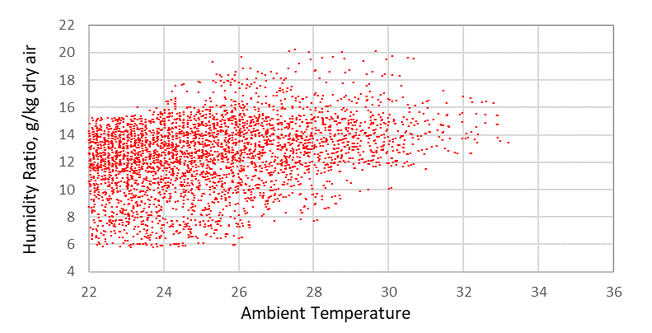
(a)
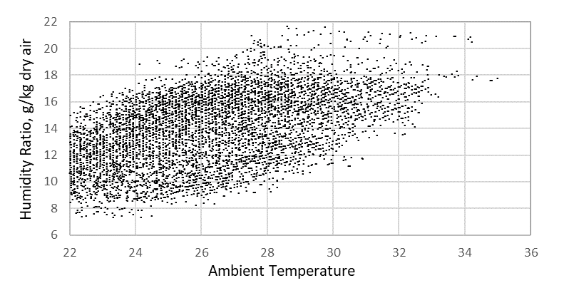
(b)
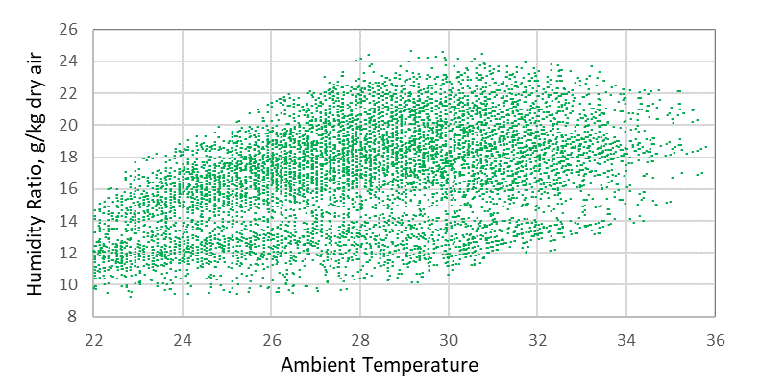
(c)
Figure 4 – Air Humidity Ratio vs Ambient Temperature for cooling months for (a) Brisbane, (b) Townsville, (c) Darwin
Another relevant quantity that emerges from Figure 4 is the number of points (hours) within the 26°C – 36°C range in which the humidity ratio is below 8 g/kg, appearing in the first configuration discussed in [15], presented in Table 1 and implemented in the control strategy discussed in [8]. That is, only very few points (hours) in Brisbane, fewer in Townsville and none in Darwin of the outside air humidity ratio below 8 g/kg mentioned in [8] that enable the control strategy to operate the system that would have saved the energy and increased the COP.
The above observation clearly indicates that for the three cities, the challenge to the SDEAC system to satisfy both the temperature and humidity levels for occupant comfort is obvious, with Darwin climate poses the biggest challenge, in particular during the build-up period [25].

Methodology
To evaluate the performance of the above configurations, TRNSYS [2323] models of the cooling systems installed in a house located in cities Brisbane, Townsville, Darwin were developed based on the models of following components detailed in [23]: enthalpy exchanger, desiccant wheel, energy recovery wheel, evaporative cooler and regenerator. In addition to these components, a supply fan, air mixers to model the mixing of return air and the fresh air that are conditioned before being supplied to the room form part of the system modelling. In the model, the system is installed in a three bed-room house whose specifications and thermal zoning was detailed and reported earlier in [19].
Figure 5 shows the interconnections between the components in the TRNSYS model.
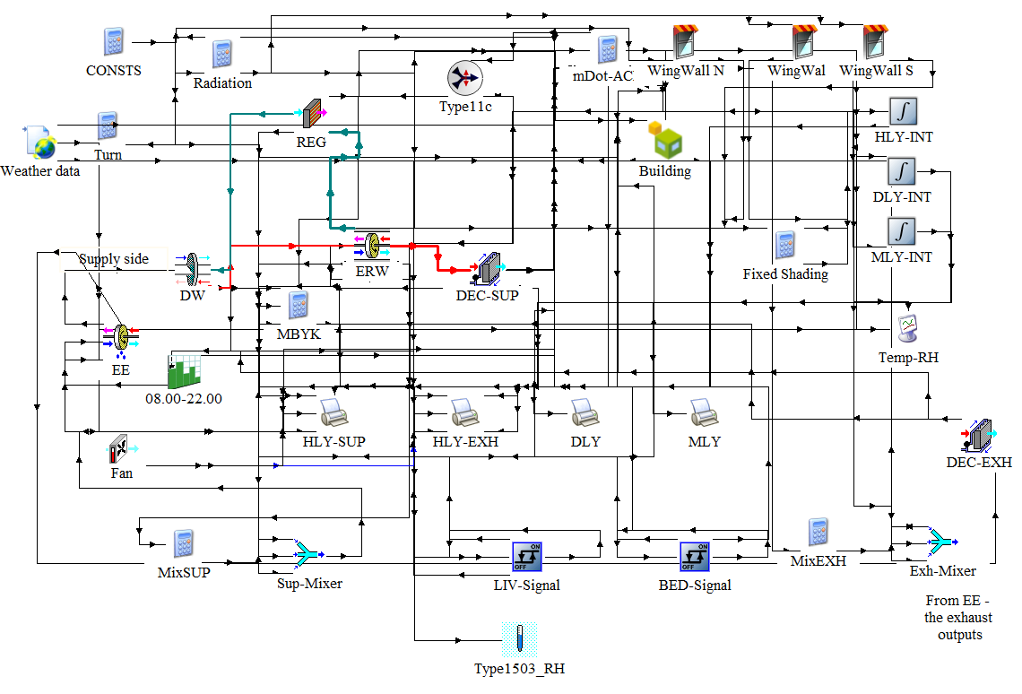
Figure 5 – TRNSYS model of the SDEAC system

The three bedrooms were conditioned from 23.00 to 07.00 and the combined living and kitchen room was conditioned from 07.00 to 23.00. The indoor temperature of both bed and living rooms was set to 26°C with temperature dead band of ±0.5 K. While the SDEAC system has evaporative cooler as one of its components, the system is treated equal to the normal refrigerative system in the model in terms of its thermal comfort delivery capability. That is, it is expected to cool and dehumidify the air and not rely on the high velocity air to deliver the cooling effect. As such, the desired room humidity level is set according to the ASHRAE/Fanger comfort chart [276] adapted for Australian homes in which the acceptable indoor design temperature range of 22.5 - 26°C with dew point at or below 13°C [28]. A simple ON/OFF control strategy with ± 0.5 K dead-band was applied to control the room temperature.
Since the outside air conditions in the three cities are different, it is expected that the system will respond accordingly; i.e. it is expected that the system operating in the least challenging ambient conditions – in this case Brisbane – will perform better in terms of attainment of the desired temperature and humidity ratio of the conditioned space.
Once the minimum specifications that enable the delivery of the desired temperature and humidity ratio in the least challenging environment has been established, the specification for the system operating in warmer and more humid cities – in this case Townsville and Darwin – are modified until they satisfy the thermal conditions of the conditioned spaces. The initial inputs to the TRNSYS models which satisfy the “baseline” Brisbane conditions are listed in Table 3.
Table 3 – Main inputs to the TRNSYS models
Room temperature set point | 26°C (±0.5)
Conditioned spaces | Living and bed rooms
Room air mass flowrate | 600 kg/hr (baseline – Brisbane)
Room conditioning schedule | Living: 07.00 – 23.00
 | Bedroom: 23.00 – 07.00
Number of occupants | 5
Other heat gain sources | 1 computer, kitchen appliances, television set
Infiltration | 0.5 ACH (air change per hour)
Regeneration temperature set point | 100°C
Regeneration heat input | 8.2 kW
Maximum outlet temperature of ERW | 30°C
Desiccant wheel | Power consumption 0.2 kW
Direct evaporative cooler | Power consumption 0.1 kW
Energy recovery wheel | Power consumption 0.1 kW
Fan power | Power consumption 0.1 kW
Range of flow rates of the SDEAC components on the supply and exhaust sides | 600 – 1000 kg/hr (see also accompanying text)
Weather data used | Brisbane, Townsville, Darwin
Range of latent effectiveness | 0.3 – 0.7
Range of sensible effectiveness | 0.6 – 0.8

Results of the Simulation

Rooms Temperature profiles
Figure 6 shows the air temperatures in the conditioned spaces in the three cities. The mass flow rate of supply air for these figures is set to 600 kg/hr – i.e. the baseline value for Brisbane.
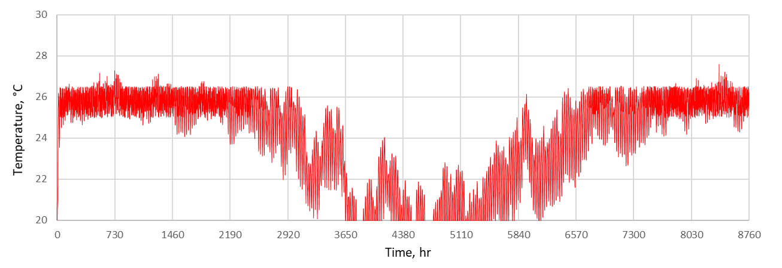
- - Brisbane
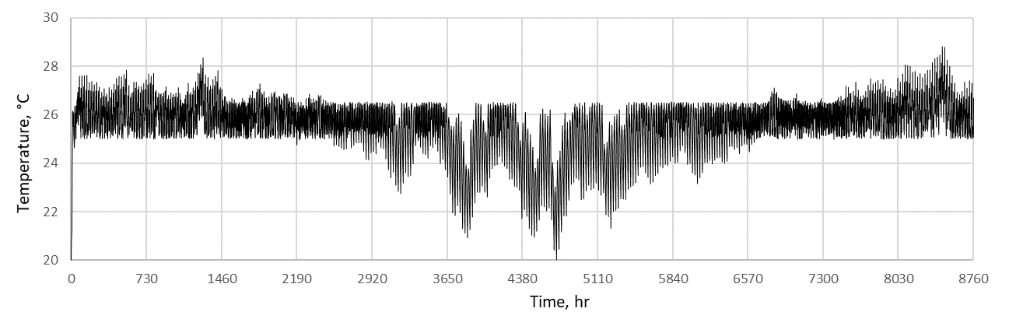
- – Townsville
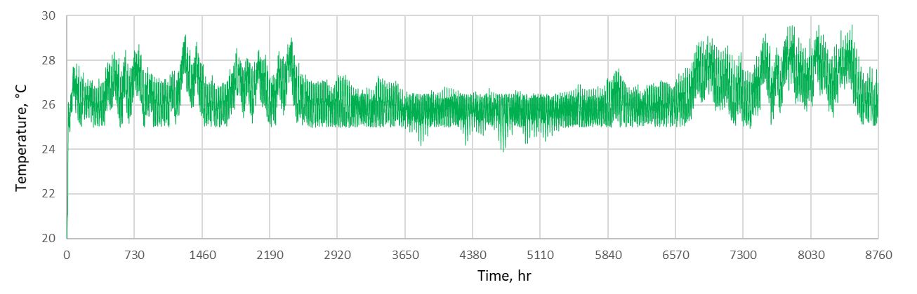
- – Darwin
Figure 6 – Room Temperature profiles for the three cities for the same mass flow rate of supply air, i.e. 600 kg/hr.

It is worth noting that given the same capacity (i.e. the same mass flow rate of supply air – 600 kg/hr), the cooling system is able to provide cooling relatively smoothly in Brisbane and fails for relatively insignificant hours in Townville and many hours in Darwin. The first two cities also experience some heating periods where cooling is not required, with heating period in Brisbane longer than in Townsville. On the other hand, Darwin always requires cooling (and dehumidification) all year round. In Darwin, the cooling system is able to maintain the room temperature within the set point during the “winter” months of June – July, coinciding with relatively low temperature and humidity ratio.

Cooling and Dehumidification characteristics of the Enthalpy Exchanger
To further lower the room temperatures for Townsville and Darwin so that most of the room temperatures during the cooling periods fall within the comfort zone, the mass flow rate of supply has to increase to 1000 kg/hr for Townsville and 900 kg/hr for Darwin. With these values set, the cooling and dehumidification capabilities of the enthalpy exchanger is examined. In particular, the characteristics of the following parameters are studied: latent effectiveness and sensible effectiveness. Referring to Figure 3, this two effectiveness is defined as the effectiveness of the device in transferring latent and sensible energy from one flow stream to another, respectively [23]. The thermal comfort zone in this section is based on the ASHRAE/Fanger comfort chart [27] for summer. In that Standard, the right boundary is a straight line which passes through two points, i.e. (27.4°, 8 g/kg and 27°C, 12 g/kg). The upper boundary is the 12 g/kg humidity ratio line.

Effect of Latent Effectiveness
Figure 7 through Figure 9 show the plots of the room temperature vs humidity ratio profiles for the three cities. For Brisbane – the city with the least humid climate – the system is able to produce the comfort conditions for approximately 92 - 94% of the time when the latent effectiveness is increased from 0.3 to 0.7 for a constant sensitive effectiveness of 0.8. In other words, in the case of Brisbane with less humid climate, the impact of effectiveness is marginal.

For Brisbane, to keep the room temperature mostly within the comfort zone up to 26.5°C, the mass flow rate of 600 kg/hr is used. Increasing the latent effectiveness from 0.3 to 0.5 increases the number of points that fall within the comfort zone. However, further increase to the latent effectiveness to 0.7 does not make significant difference.

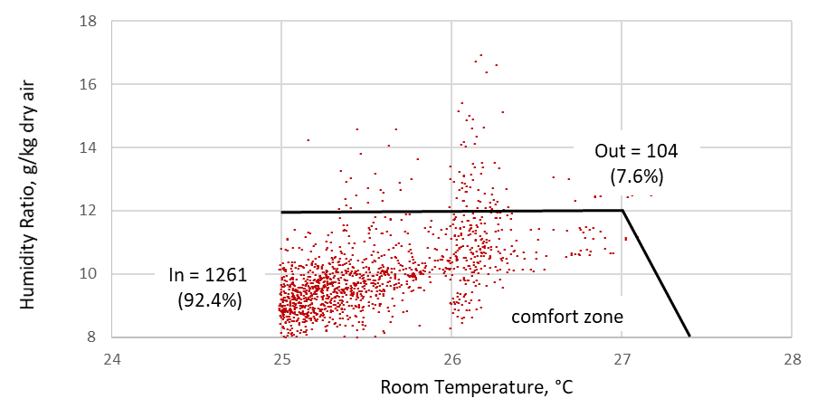
(a) EE latent effectiveness = 0.3
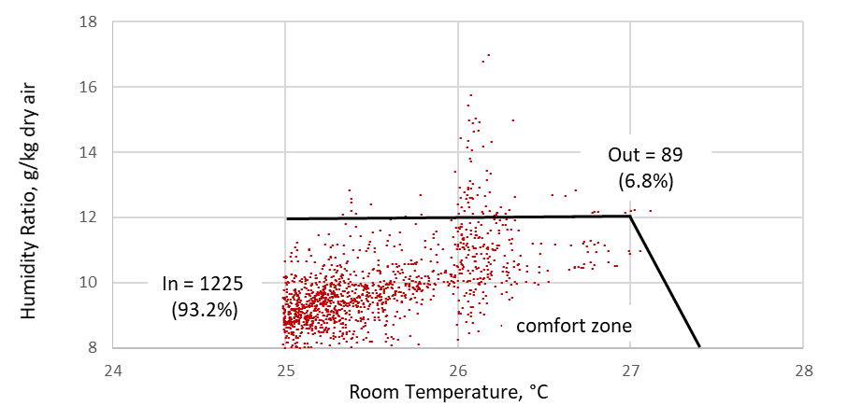
(b) EE latent effectiveness = 0.5 – Plots within comfort one:
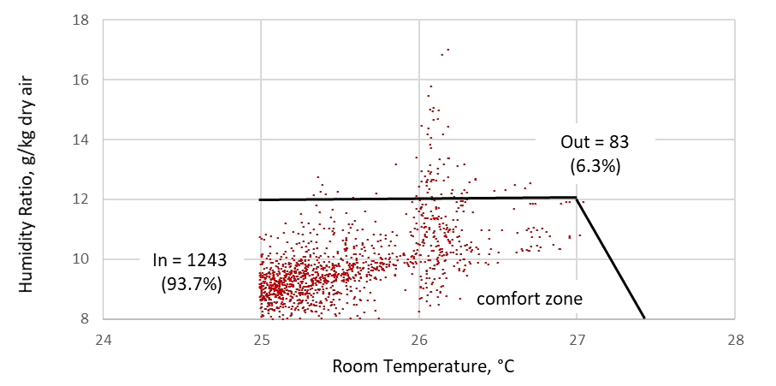
(c) EE latent effectiveness = 0.7
Figure 7 – Effect of latent effectiveness on the humidity level – Brisbane, m = 600 kg/hr

To attain the same effect in Townsville (i.e. to maintain the temperature within 26.5°C), the mass flow rate of 1000 kg/hr was used without affecting the humidity level. Therefore, it is decided to vary the latent effectiveness at the mass flow rate of 1000 kg/hr. As shown, there is a pull of humidity ratio down towards the comfort zone when the latent effectiveness is increased from 0.3 to 0.5 and 0.7 with very insignificant impact. The majority of points being pushed still reside within the 12 – 14 g/kg boundary. This can be explained as follows. The increase of mass flow rate from 600 to 1000 kg/hr to maintain the temperature below 26.5°C has resulted in the increase of humidity introduced by the evaporative cooler to the room. In other words, the impact of improvement in the latent effectiveness was neutralised by the evaporative cooling.
For the Townsville climate, the system is able to produce comfort conditions within 74% to 79% of the time when the latent effectiveness is increased from 0.3 to 0.7. As shown, an increase of latent effectiveness from 0.3 to 0.7 results only in marginal improvement of comfort conditions (i.e. increase of number of hours in which the humidity level (and temperature) fall within the comfort zone).
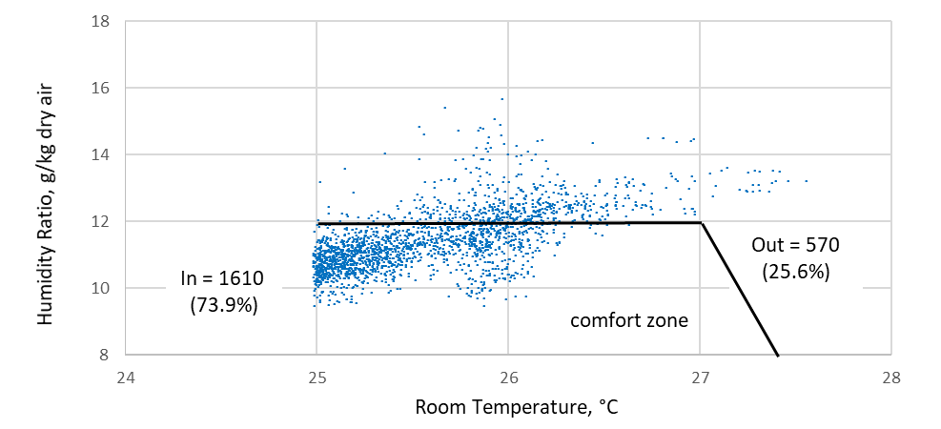
(a) EE latent effectiveness = 0.3
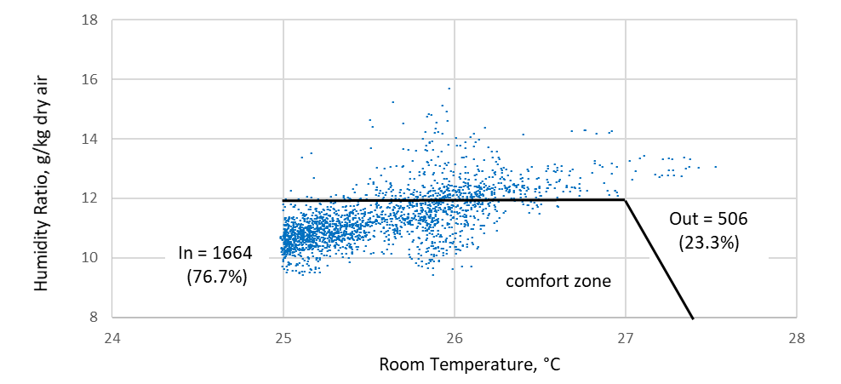
(b) EE latent effectiveness = 0.5
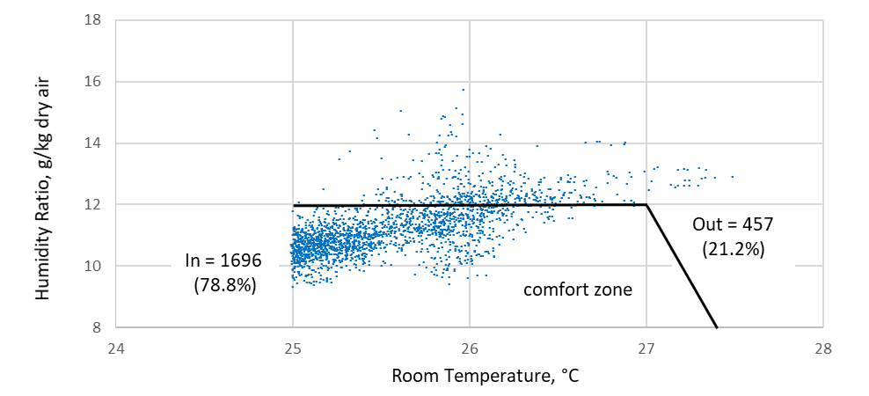
(c) EE latent effectiveness = 0.7
Figure 8 – Effect of latent effectiveness on the humidity level – Townsville, m = 1000 kg/hr
The situation for Darwin is similar to that of Townsville. The mass flow rate of 900 kg/hr improves the condition by decreasing the maximum temperature to about 29.5°C while the humidity ratio for some points are pulled down. However, further increase in mass flowrate (1200 – 1500 kg/hr) results in marginal cooling improvement but significant increase in the humidity ratio of air, the cause of which was explained previously.

Therefore, it was concluded that the optimum mass flow rate for Darwin for cooling purpose is 900 kg/hr. This value was then used to show the impact of varying the values of the latent effectiveness of the enthalpy exchanger on the humidity ratio of room air. As shown, for the Darwin climate, the system can only create the conditions where about 54% - 63% of the points are within the comfort zone and the remaining are outside the comfort zone.
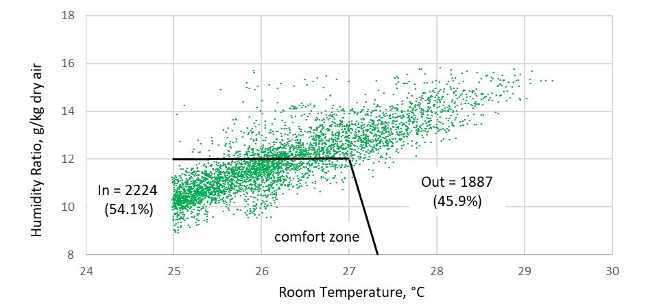
(a) EE latent effectiveness = 0.3

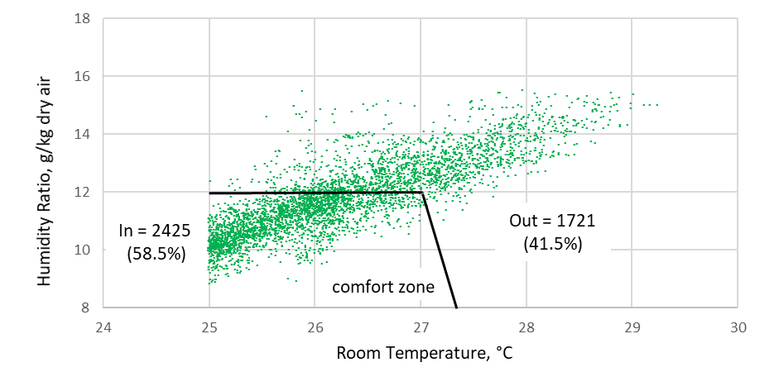
(b) EE latent effectiveness = 0.5

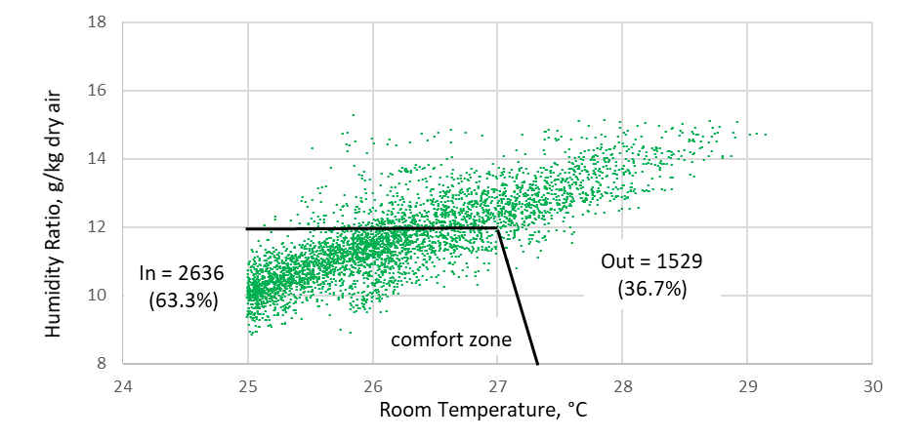
(c) EE latent effectiveness = 0.7

Figure 9 – Effect of latent effectiveness on the humidity level – Darwin, m = 900 kg/hr
sensible effectiveness of 0.6

Table 4 shows the summary of the impacts of the latent effectiveness on the room thermal comfort for the three cities.

Table 4 – The impact of the latent effectiveness on the room thermal comfort for the cities of Brisbane, Townsville and Darwin – LE: Latent Effectiveness; IN: number of hours air conditions are within thermal comfort zone; OUT: number of hours air conditions are outside thermal comfort zone; Total: total hours of system operation per year
City | LE | IN | % | OUT | % | Total
 | 0.3 | 1261 | 92.4 | 104 | 7.6 | 1365
Brisbane | 0.5 | 1225 | 93.2 | 89 | 6.8 | 1314
 | 0.7 | 1243 | 93.7 | 83 | 6.3 | 1326
 | 0.3 | 1610 | 73.9 | 570 | 25.6 | 2180
Townsville | 0.5 | 1664 | 76.7 | 506 | 23.3 | 2170
 | 0.7 | 1696 | 78.8 | 457 | 21.2 | 2153
 | 0.3 | 2224 | 54.1 | 1887 | 45.9 | 4111
Darwin | 0.5 | 2425 | 58.5 | 1721 | 41.5 | 4146
 | 0.7 | 2636 | 63.3 | 1529 | 36.7 | 4165

Effect of Sensible Effectiveness
The following graphs in Figure 10 show how the sensible effectiveness affects the overall performance of the system, in particular the temperature of the conditioned room for Darwin. It can be seen that the sensible effectiveness of the enthalpy exchanger does not have significant impact on the cooling capability of the whole system.
(a) EE sensible effectiveness = 0.6
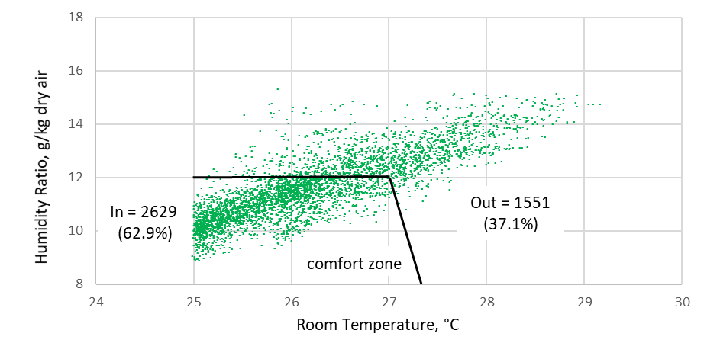
(b) EE sensible effectiveness = 0.7
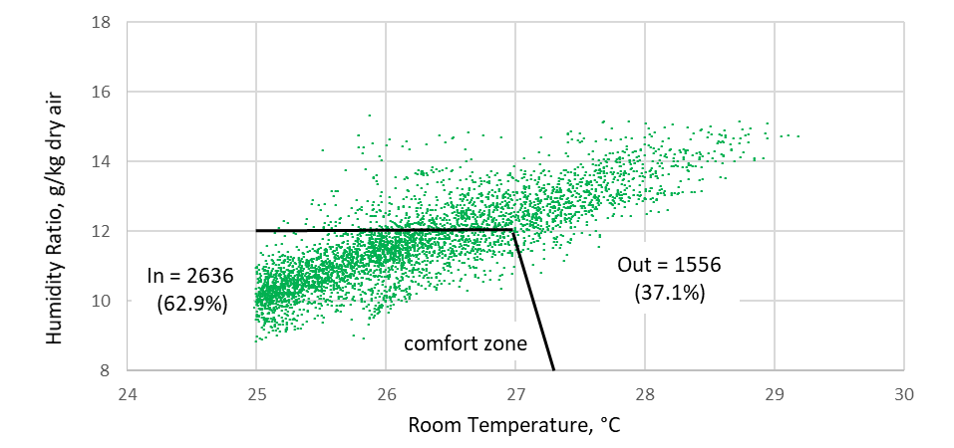
(c) EE sensible effectiveness = 0.8
Figure 10 – Effect of sensible effectiveness of the enthalpy exchanger, Darwin
m = 900 kg/hr, latent effectiveness = 0.7
The use of enthalpy exchanger to improve the dehumidification capability of the SDEAC system has been shown to have mixed impact, depending on location of system installation. For the climate of Brisbane, system overall thermal comfort capability delivery is quite impressive; around 93% of the time when the system operates, room thermal comfort is satisfied. For a more humid city of Townsville the SDEAC system with enthalpy exchanger can satisfy occupants’ thermal comfort for 74% – 79% of the system operating hours. For a hot and humid city of Darwin, this percentage drops down to 54 – 63%. In other words, for Darwin, the SDEAC system with enthalpy exchanger does not seem to be effective to bring the thermal comfort to the conditioned space. In a previous study [1919] it was found that admission of some of return air to the supply side can reduce some energy demand. However, in the exhaust side, this results in increased regeneration temperature. At all three cities studied, the impact of both latent and sensible effectiveness of the enthalpy exchanger are marginal.

These findings need to be contrasted with the conclusions of recent numerical models [6,7,8] which modelled a SDEAC system with configuration shown in Figure 1 with less dehumidification capability because it does not have the enthalpy exchanger component which precool and pre-dehumidify the air to enable it to cope with more humid climate such as Townsville and Darwin. In a numerical study, Dezfouli [5] presented the results of the simulation using the same configuration of Figure 1 for hot and humid weather of Kuala Lumpur, Malaysia. For a fair comparative analysis, the ambient temperature and humidity ratio of both Darwin (which represents the warmest and most humid city under investigation) and the Kuala Lumpur (which was the subject of the analysis in [5]) are shown in Figures 11 and 12, respectively. As seen, for most of the cooling months in Darwin, the ambient temperature profiles of both cities are similar. The values of ambient humidity ratio for Darwin during the cooling season are slightly higher with the annual hourly mean of 18.5 g/kg (hourly minimum: 13.1 and maximum: 24.2 g/kg) whilst for Kuala Lumpur, the annual hourly mean is 17.7 g/kg (hourly minimum: 13.0, hourly maximum: 23.4 g/kg).

Dezfouli et al.’s study [5] shows that the SDEAC system using the first configuration - Figure 1 – delivers the humidity ratio of supply air which always falls outside the comfort zone (i.e. above 12 g/kg) all year round and the resulting humidity values of the conditioned space even higher (i.e. around 15 g/kg) all year round for both the ventilation and recirculation mode. These findings are indirectly in agreement with the results obtained from the current study (which uses the second configuration - Figure 2 with slightly higher dehumidifying capability), and with an earlier study [19]. For Kuala Lumpur, Dezfouli [5] found that only through the use of two-stage SDEAC system did the values of resulting humidity ratio of the conditioned space fall within the comfort zone.
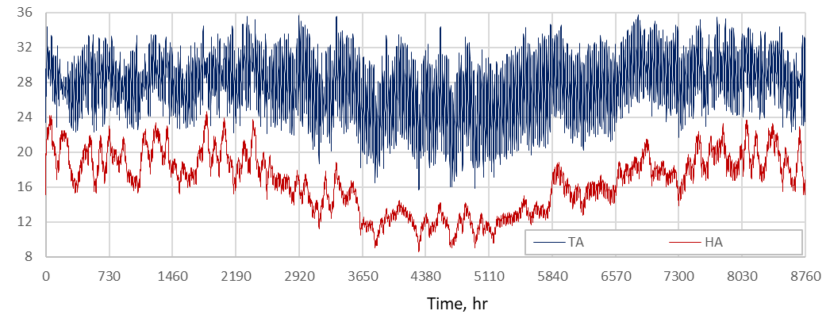
Figure 11 – Ambient air temperature and humidity ratio of Darwin
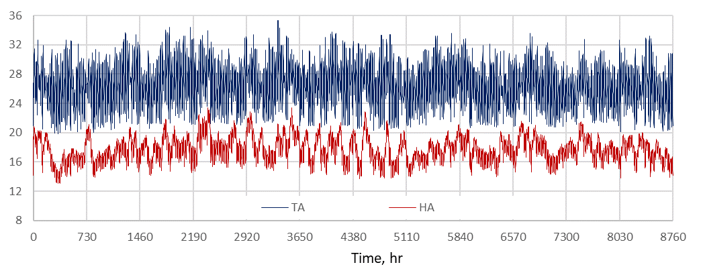
Figure 12 – Ambient air temperature and humidity ratio of Kuala Lumpur

The Coefficient of Performance
In the previous Section 5.1 and Section 5.2, the first key performance indicator, namely the ability to provide thermal comfort (cooling and dehumidification) to the conditioned space has been presented. Following up on this indicator – which have been shown to have mixed outcomes – this section presents the simulation results for the COP based on the values of the parameters used in the previous sections (see Table 3). In addition to the specifications given in Table 4, the values in Table 5 were used to calculate the COP of the cooling systems based on the results presented in Section 5.1 and Section 5.2. These values reflect the specifications which give the best results in terms of thermal comfort delivery (i.e. cooling and dehumidification) for the three cities.
Table 5 – The values of mass flow rate, latent and sensible effectiveness used to calculate the electrical and thermal COP.
Location | $\dot{m}$ (kg/hr) | Latent Effectiveness | Sensible Effectiveness
Brisbane | 600 | 0.7 | 0.8
Townsville | 1000 | 0.7 | 0.8
Darwin | 900 | 0.7 | 0.8

In this analysis, two types of coefficient of performance are presented, namely: electrical COP and thermal COP. Electrical COP is an indication of how much electrical energy the system consumes (EC) for a given conditioning (cooling and dehumidifying) load (L) and defined as:
COP_{EL} = L/EC.
This indicator is normally used to compare the cooling system eligibility as an alternative to the conventional refrigerative air conditioning systems.
The thermal COP, defined as the ratio of the conditioning load in kW (L) to the thermal energy required for regeneration in kW (HR):
COP_{TH} = L/HR
The electrical and thermal COP of the systems operating in the three cities is shown in Table 6. The table also include electrical energy consumption of the system based on the parasitic power of the components listed in Table 3. As seen, the system performs better where the conditioning load is less challenging. The hotter and more humid the location where the system serves, the less efficient the system. The systems operating in Townsville and Darwin work harder than that operating in Brisbane. This observation is in line with the work of [5] and [2020] but in very much contrast with the work of [6,7,8]. In [2020], the COP is expressed as a function of ambient humidity ratio where increase in the humidity ratio decreases the COP. The same conclusion can be found in [5] for both single-stage and two-stage systems.
Table 6 – Electrical energy consumption, thermal and thermal COP of the systems operating in Brisbane, Townsville and Darwin
City | EC (kWh) | COP_{EL} | COP_{TH}
Brisbane | 741 | 4.8 | 0.36
Townsville | 1846 | 3.8 | 0.28
Darwin | 3678 | 2.9 | 0.21

It is worth noting that the electrical COP depends very much on the actual electricity consumption of the components of the system and therefore depends on the actual manufacture specification. The main reason why the SDEAC system electrical COP is low, i.e. practically comparable with the conventional refrigerative system, is the presence of additional electrical consuming components (i.e. enthalpy exchanger, desiccant wheel and energy recovery wheel) to bring back the humidity to an acceptable level which is elevated during evaporative cooling process just before the air enters the conditioned space. It is also worth noting that the thermal COP of this type of system is quite low and therefore should only be considered when the heat source for generation is cheap. While solar energy can be a potential source, such a huge demand for regeneration heat (e.g. in this case study 8.2 kW is required for regeneration) requires a very careful design to ensure it is worth the switch to such a system. According to [29], desiccant wheel is the component with the greatest percentage of total exergy destruction of a desiccant system; therefore, improvement effort such as [1] needs to be prioritised.

The two-stage system was found to perform better in terms of both improved COP and improved satisfaction of conditioning load [5,2020]. However, two-stage system requires additional components which will add to the initial costs and increased space requirements.

Conclusions and recommendations
Based on the results of the SDAEC system model and subsequent discussion the following conclusions can be drawn.
- The SDEAC system with enthalpy exchanger performs better than that without enthalpy exchanger in terms of dehumidification and the impact depends on the climate where the system operates. Specifically, the following findings can be reported:
  - For Brisbane with less humid climate, the system can bring thermal comfort for around 93 – 94% of the operating hours.
  - For more humid city of Townsville, the system satisfies occupants’ thermal comfort for 74 – 79% of the operating hours.
  - For hot and humid city of Darwin, the system thermal comfort capability drops to around 54 – 63% of the operating hours.
  - For all the three cities, the impacts of latent and sensible effectiveness of the enthalpy exchanger are marginal.

- Cooling and humidification of the direct evaporative cooler results in the existence of the optimum mass flow rate of the air supply. In very humid location like Darwin, increasing flow rate further from the optimum will result in increase in the humidity ratio of conditioned space.

- The electrical and thermal COP of the system depends on the system conditioning load, i.e. the higher the conditioning load, the lower the COP. The values of electrical COP for the systems operating in Brisbane, Townsville and Darwin are 4.8, 3.8 and 2.9, respectively. Likewise, the values of the thermal COP are 0.36, 0.28 and 0.21, respectively.

- Like previous investigations, it can be concluded that the main drawbacks of a SDEAC system are: (1) the existence of main components with conflicting thermal capabilities, i.e. desiccant wheel and evaporative cooler, and (2) the requirement of significant regeneration heat, and consequently (3) the extra components that are required to deliver the cooling and dehumidification.

This study has presented a straightforward and objective method of assessing the thermal performance of the SDEAC system, i.e. direct evaluation of its capability to deliver the thermal comfort, namely: acceptable air temperature and humidity levels in the conditioned space. While performance evaluation of each of the SDEAC components is important - especially for optimisation of component thermal performance – direct evaluation of the system capability to deliver acceptable thermal comfort condition is always necessary, as this is the ultimate goal of any air conditioning system.

Acknowledgement
The funding for this project was provided by the Central Queensland University.

References
- Goldworthy S; White, S, 2011: Optimisation of a desiccant cooling system design with indirect evaporative cooler, International Journal of Refrigeration, Vol 34(1): 148-158.
- Narayanan, R.; Saman, W.Y.; White, S., 2011: Comparative study of different desiccant wheel designs, Applied Thermal Engineering, Vol. 31 (2), 1613-1620.
- Narayanan, R., 2012: Development of a Thermally-driven Solid Desiccant System for Dehumidification /Cooling, 2012, PhD Thesis - University of South Australia.
- Narayanan, R.; Saman, W.Y.; White, S., 2013: A non-adiabatic desiccant wheel: Modeling and experimental validation. Applied Thermal Engineering, Vol. 61, 178-185.
- Dezfouli, M. M. S.; Mat, S; Pirasteh, G; Sahari, K. S. M.; Sopian, K. and Ruslan, M. H. 2014: Simulation Analysis of the Four Configurations of Solar Desiccant Cooling System Using Evaporative Cooling in Tropical Weather in Malaysia, International Journal of Photoenergy, vol. 2014, Article ID 843617, 14 pages - http://dx.doi.org/10.1155/2014/843617.
- Ma, Y.; Guan, L., 2015: Performance analysis of solar desiccant-evaporative cooling for a commercial building under different Australian climates, Procedia Engineering 121(2015): 528 – 535.
- Ma, Y.; Guan, L.; Brown, R., 2015: Techno-economic Analysis of a Solar Desiccant-Evaporative Cooling System with Different Collector Types for Australian Office Buildings, 2015 Asia – Pacific Solar Research Conference.
- Ma, Y; Saha, S.C.; Miller, W.; Guan, L. Comparison of Different Solar-Assisted Air Conditioning Systems for Australian Office Buildings. 2017, 10, 1463.
- Narayanan, R. (2018). Solid- and gas-side resistances in a desiccant wheel. Energy Procedia 160 (2019) 139–146.
- Keleher, M., & Narayanan, R. (2018). Comparative study of alternative HVAC systems incorporating renewable energies in sub-tropical climates, Energy Procedia 160 (2019) 147–154.
- Pesaran, A.A. and Mills, A.F., Moisture transport in silica gel packed beds--I.Theoretical study. International Journal of Heat and Mass Transfer, 1987. 30(6): p. 1037-1049.
- Pesaran, A.A., Penny,R., Czanderna, A.W., Desiccant Cooling: State-of-the-art assessment. 1999.
- Narayanan, R. (2017). Investigation of geometry effects of channels of a silica-gel desiccant wheel. Energy Procedia, 110, 20-25.
- Narayanan, R. (2015). Theoretical modelling of silica gel desiccant wheels. Applied mechanics and materials, 787, 311-317.
- Henning, H-M., 2007: Solar assisted air conditioning of buildings – an overview. Applied Thermal Engineering 27 (2007) 1734–1749.
- Camargo, J.R.; Ebinuma, C.D., 2005: An evaporative and desiccant cooling system for air conditioning in humid climates, J. of the Braz. Soc. Of Mech. Sci. & Eng., Vol. XXVII(3) 243-247.
- Jain, S; Dhar, P.L., 1995: Evaluation of solid-desiccant-based evaporative cooling cycles for typical hot and humid climates. International Journal of Refrigeration, Vol. 18 (5), pp. 287-296.
- Das, R.S.; Jain, S., 2013: Simulation of potential standalone liquid desiccant cooling cycles. Energy, Vol. 81, pp.652-661.
- Narayanan, R.; Halawa, E; Jain, S., 2018: Performance Characteristics of Solid Desiccant Evaporative Cooling Systems in Australian Climate Zone of Brisbane – Energies 2018, 11, 2574; doi:10.3390/en11102574 -
- Tavakol, P.; Behbahaninia, A., 2018: Presentation of two new two-stage desiccant cooling cycles based on heat recovery and evaluation of performance based on energy and exergy analysis. Journal of Building Engineering - Available online 9 August 2018, in press accepted manuscript.
- Pandelidisa, D., Pacaka, A., Cichońa, A., Anisimova, S., Drągb, P.,Vagerc, B.,Vasilijevc, V. Multi-stage desiccant cooling system for moderate climate, Energy Conversion and Management 177 (2018) 77–90.
- Weatherbase website: Brisbane, Queensland: http://www.weatherbase.com/weather/weather-summary.php3?s=87549&cityname=Brisbane,+Queensland,+Australia&units= - accessed 14 April 2018.
- Thornton J.W., Bradley D.E., McDowell T.P., Blair N.J., Duffy M.J., LaHam N.D. and Naik A.V., 2014: TESSLibs 17 Component Libraries for the TRNSYS Simulation Environment Volume 11 - Storage Tank Library Mathematical Reference TESS – Thermal Energy Systems Specialists.
- Biro of Meteorology - Climate of Townsville - http://www.bom.gov.au/qld/townsville/climate_Townsville.shtml - accessed 14 July 2018.
- Safarova, S, Halawa, E., Campbell, A., van Hoof, J., Law, L., 2017: Pathways for optimal provision of thermal comfort and sustainability of residential housing in hot and humid tropics of Australia – A critical review - Indoor and Built Environment - https://doi.org/10.1177/1420326X17701805.
- Bureau of Meteorology. Climate Zones. Commonwealth of Australia, www.bom.gov.au/iwk/climate_zones/map.shtml - as cited in [25].
- ANSI/ASHRAE Standard 55, Thermal Environmental Conditions for Human Occupancy, ASHRAE Inc., Atlanta, 2010.
- AIRAH, 2017: Design Guide DA20 Humid Tropical Air Conditioning – The Australian Institute of Refrigeration Air Conditioning and Heating.
- Kanoglu M, Carpinlioglu MO, Yildirim M., 2004: Energy and exergy analysis of an experimental open-cycle desiccant cooling system. Applied Thermal Engineering, Vol. 24:919–93.

