Dear reviewer,
We sincerely thank you for your encouraging feedback and positive assessment. We are deeply appreciative of your support as well as the time for this review. In addition, we admire your thorough examination of our manuscript and provide us the helpful suggestions, and we endeavor to incorporate the corresponding revisions both into the review response and the manuscript. All changes were marked in red.

Comments 1: The journal requires a graphical abstract. You did not include it in the manuscript.

Response 1: Thank you to the reviewer for the reminder, we have added the graphical abstract.
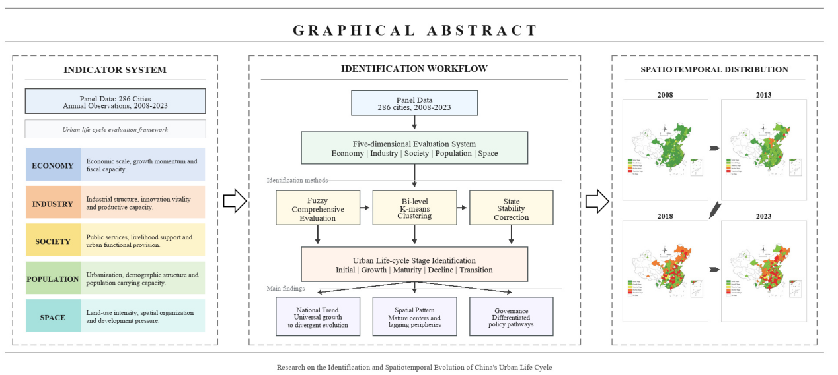
Figure 1 graphical abstract

Comments 2: The title is excessively long and does not clearly inform readers what the article is about. I recommend that the authors formulate another title, shorter and in the form of a newspaper headline. The title would be more inspiring if it mentioned the most important finding of the research.

Response 2: Based on your valuable suggestion that the paper's title should highlight the core focus and streamline the expression, we have repeatedly refined and condensed the original title. The original title, Research on the Identification of the Evolution of China's Urban Development Stages and Their Spatiotemporal Differentiation Characteristics from the Perspective of Organic Entities, has been revised to Research on the Identification and Spatiotemporal Evolution of China's Urban Life Cycle: From the Perspective of Organic Entities. This revision strictly follows the norms for academic paper titles, and the core rationale is reflected in three aspects: (1) “Identification and Spatiotemporal Evolution of China's Urban Life Cycle” is placed as the main title, directly indicating the research object and core analytical task, enabling readers to grasp the research focus immediately and resolving the problem of lengthiness and vagueness caused by modifiers in the original title; (2) “Life cycle” is used to replace “evolution of development stages” in the original title, precisely corresponding to the five-stage classification system constructed in the paper—initial stage, growth stage, maturity stage, decline stage, and Transition stage—while better embodying the theoretical foundation of the city as an organic entity, thus achieving a high degree of unity between the title and the internal logic of the paper; (3) The “main title + subtitle” format is adopted, with the subtitle “From the Perspective of Organic Entities” introduced by a dash, placing the theoretical innovation point as the subtitle. This approach not only fully preserves the core theoretical perspective of the paper but also makes the main title more concise and powerful, striking an optimal balance between completeness of information and conciseness of expression. The revised title has a clear theme and rigorous logic, fully conforming to the titling norms of high-level academic papers. This issue has been addressed in the revised title on p. 1, para. 2.

Comments 3: According to the journal's guidelines, the abstract should have a maximum of 200 words, for an obvious reason: an abstract should be a short text that objectively informs readers about the content of the article, its main results, and conclusions. Your abstract has more than 300 words and does not clearly inform readers why your article is worth reading.

Response 3: In accordance with your request for a more focused and concise abstract, we have carefully polished and compressed the text to under 200 words, ensuring all key academic information remains intact. The revised abstract is as follows:
Based on the characteristics of cities as organic entities, this paper constructs a five-dimensional evaluation framework encompassing economy, industry, society, population, and space. A three-stage process of "fuzzy comprehensive evaluation—bi-level K-means clustering—state stability correction" is adopted to identify the development stages and spatiotemporal evolution of 286 Chinese cities from 2008 to 2023. The study finds that China's urban development has shifted from "universal growth" to "divergent evolution," exhibiting multiple characteristics such as the decline of the initial-stage cities and differentiation in the growth stage. Significant regional spatial differentiation is observed, with notable development gaps among the eastern, central, western, and northeastern regions, as well as between the northern and southern regions. Furthermore, most urban agglomerations exhibit a "mature center–lagging periphery" structure. This issue has been addressed in the revised Abstract on p. 1, para. 15.

Comments 4: Add more keywords. They help readers understand the content of the paper. Furthermore, keywords make the article more visible to search engines like Google Scholar.

Response 4: In accordance with your valuable guidance that keywords should accurately reflect the research content and cover core innovations, we have re-examined our selection principles and comprehensively optimized the original keyword system. We revised the keywords from "organic entity; development stage; spatiotemporal evolution; FCEM-K-means" to "organic entity; urban development stage; spatiotemporal differentiation; bi-level K-means clustering; nonlinear evolution."
Specifically, we clarified "development stage" as "urban development stage" to precisely define the research object and effectively avoid ambiguity. We changed "spatiotemporal evolution" to "spatiotemporal differentiation" to more accurately correspond to the spatial differentiation pattern of urban development stages across the four major regions and between the North and South, which is a key focus of the paper. We replaced "fuzzy comprehensive evaluation" with "nonlinear evolution" to highlight our core theoretical finding that distinguishes this study from previous linear development stage assumptions—namely, that urban development stage transitions exhibit diverse nonlinear paths, which represents one of the most important academic contributions of this paper. Concurrently, we retained "organic entity" as the core theoretical perspective of the paper, and "bi-level K-means clustering" as the core methodological innovation.
Structurally, the revised set of five keywords achieves a balanced coverage across five dimensions: theoretical perspective, research object, pattern characteristics, methodological innovation, and evolutionary pattern. The terminology is standardized, the information is complete, and the logic is clear. This issue has been addressed in the revised Keywords on p. 1, para. 16.

Comments 5: The paragraphs are excessively long, which makes them difficult to read and, consequently, to understand. The introduction seems excessively long to me. I am not against a section of an article, e.g., its introduction, being a little longer if more text is needed for contextualization for the readers. Is that the case here?
There is no formal division, after the Introduction, into Materials & Methods, Results, and Discussion, which makes reading the manuscript more difficult and less understandable.

Response 5: Thank you for pointing out the issue regarding the structural organization of the paper. We have made the following improvements in the revised manuscript:
First, we added a paragraph outlining the paper's structure at the end of the introduction, explicitly stating: "The remainder of this paper is structured as follows: Section 2 reviews the literature, systematically examining research on urban development stage identification and coordinated regional development; Section 3 elaborates the theoretical connotations of the urban life cycle and constructs a stage identification indicator system covering five dimensions: economic vitality, industrial momentum, social services, population development, and spatial carrying capacity; Section 4 introduces the stage identification methodology based on fuzzy comprehensive evaluation, bi-level K-means clustering, and state stability correction; Section 5 analyzes the spatiotemporal evolution characteristics and regional differences of urban development stages across 286 prefecture-level and above cities in China from 2008 to 2023; Section 6 discusses the findings in dialogue with the existing literature; and Section 7 summarizes the research conclusions and proposes differentiated policy recommendations."
Second, we standardized the section headings to reinforce the standard academic paper logic of "Literature Review-Theoretical Framework and Indicator System-Research Methods-Empirical Results-Conclusions and Recommendations," enabling readers to clearly grasp the structural flow of the entire paper.
Through these revisions, the structural layout of the paper better aligns with academic conventions, significantly reducing the difficulty of reading and comprehension. This issue has been addressed by adding the article-structure paragraph on p. 3, para. 2 and standardizing the main section structure across pp. 3-26.

Comments 6: Where is Figure 5 (page 17)?
I leave here a recommendation that I make to the authors of all the manuscripts I review: make abundant use of any graphic elements-photos, maps, infographics, drawings-to enhance the readers' understanding of the various important information and messages in this manuscript. William Zinsser, in the excellent On Writing Well: The Classic Guide to Writing Nonfiction, says that the writer's task is to make life easier for the readers-so images are very welcome in this manuscript. For example, an infographic summarizing the main results of the study would facilitate the understanding of the text.

Response 6: Thank you for the helpful suggestion to include additional figures. We have added the relevant images to the manuscript, including a graphical abstract and other visual elements as recommended. These additions are intended to enhance the clarity and visual presentation of the study. This issue has been addressed by adding visual materials, including Figure 5 on p. 22, para. 2 and Figure 6 on p. 23, para. 5, with related explanations on p. 21, para. 5 and p. 23, para. 3.
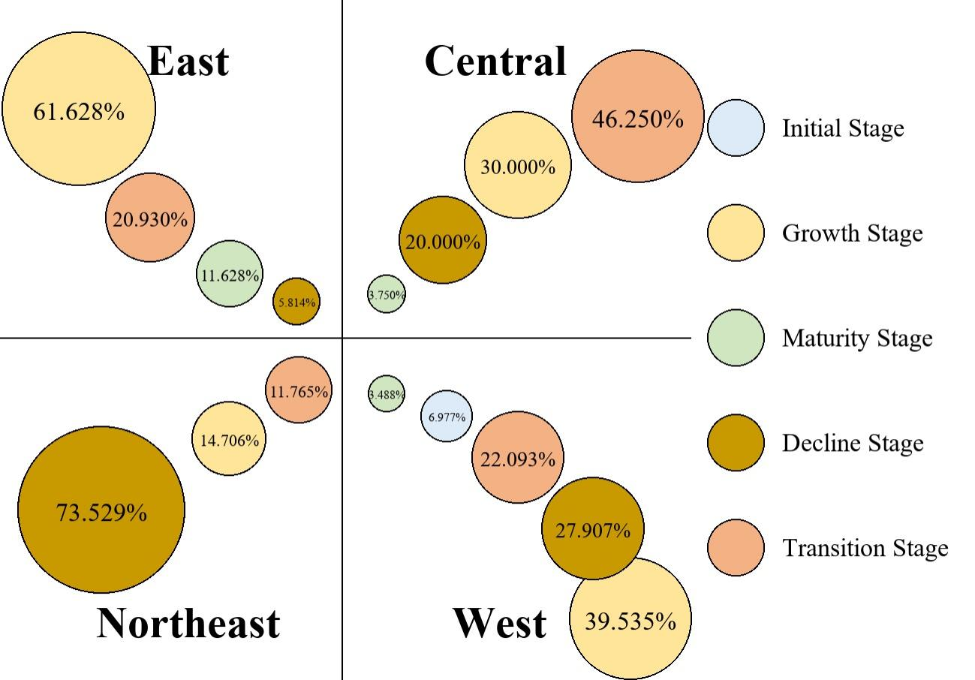
Figure2 Stage Composition of Urban Development in the Four Major Regions, 2023

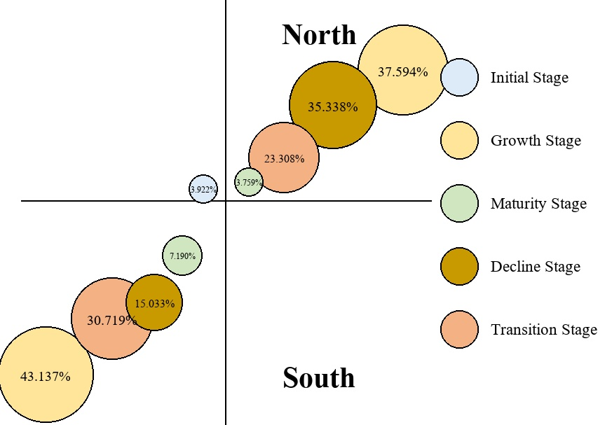
Figure3 Stage Composition of Urban Development in Southern and Northern Regions, 2023

Comments 7:Among other findings, the authors point out that the East is the most developed region of China, with 85.7% of cities in the mature or growth stages. On the other hand, according to the authors, the Northeast is the most critical region, with 73.5% of cities in recession and none in the mature stage. During my trip to China, I was able to observe these differences. In fact, there are several published articles that have quantified these regional inequalities concerning Chinese cities. The fact that these inequalities have been quantified in other studies is not necessarily a demerit, but you should delve deeper, in the Discussion, into a dialogue with the best available scientific literature on such inequalities, to present readers with a new perspective on them.

Response 7: We thank you for your insightful comments on the issue of regional development inequality in China. We fully agree with your observation that the development gap between the eastern coastal region and Northeast China has been quantified and discussed extensively in English-language academic literature. Our findings are not entirely novel, but rather aim to engage in a dialogue with existing research.
In the Discussion section of the revised manuscript, we have added the following dialogue with the existing literature:
First, the overarching pattern of regional inequality in China has been extensively documented. Kanbur and Zhang (2005) systematically reviewed the evolution of regional inequality since the founding of the PRC, noting that the coastal-inland gap widened sharply after the reform and opening-up; Démurger (2001) attributed this disparity to the spatial differentiation of infrastructure and locational advantages; and Wei (2015) further revealed the spatial characteristics of regional inequality from a multi-scalar perspective. Our finding that 85.7% of cities in the eastern region are in the maturity or growth stage is highly consistent with the coastal agglomeration advantage revealed in the aforementioned literature. However, our incremental contribution lies in measuring the gap not merely by the level of development, but by utilizing the concept of "development stages" to further disaggregate the advantages of eastern coastal cities into the structural characteristics of "steady expansion in the maturity stage" and "high-level differentiation in the growth stage." This reveals that the eastern region is not a monolithic block.
Second, the widespread decline in Northeast China has also garnered significant academic attention. Zhang (2008) systematically analyzed the trajectory and challenges of the revitalization policies for the Northeast Old Industrial Base; He et al. (2017) and Yang and Dunford (2018) focused on shrinking cities in Northeast China, identifying population outflow, industrial path lock-in, and institutional inertia as the core drivers of decline; and Xie et al. (2020) further delineated the spatial pattern of urban shrinkage in Northeast China from a multi-dimensional perspective. Our finding that 73.5% of cities in Northeast China are in the decline stage, with none having reached the maturity stage, strongly corroborates the aforementioned literature. However, unlike previous studies that focused on specific types of cities (e.g., resource-based or shrinking cities), this study situates Northeastern cities within a unified life-cycle framework encompassing 286 prefecture-level and above cities nationwide for comparative analysis. This more clearly reveals that the Northeast region is not an isolated case of "local distress," but rather the regional block closest to the systemic decline end of the national evolutionary spectrum of urban development stages. This perspective helps elevate the "Northeast Phenomenon" from a narrative of localized plight to a structural proposition within the evolution of national urban development stages.
Furthermore, the five-stage classification system constructed in this paper (Initial, Growth, Maturity, Decline, and Transition) provides a novel analytical tool for understanding regional inequality in China. Unlike existing literature that predominantly employs continuous inequality measures such as per capita GDP or comprehensive development indices, our stage-based classification method can simultaneously capture the configurational features of cities across three dimensions: scale, structure, and speed. This allows us to reveal the nonlinear dynamics wherein the same development level interval may correspond to different life cycle stages.This issue has been addressed in the Discussion on p. 25, paras. 3-5.

In addition to addressing the reviewer’s comments, we conducted further robustness tests on the fuzzy comprehensive evaluation method and cluster analysis. The results consistently support the main conclusions of this study, demonstrating the robustness and reliability of our findings.

References
1.Kanbur, R., & Zhang, X. (2005). Fifty years of regional inequality in China: A journey through central planning, reform, and openness. Review of Development Economics, 9(1), 87–106.
2. Démurger, S. (2001). Infrastructure development and economic growth: An explanation for regional disparities in China. Journal of Comparative Economics, 29(1), 95–117.
3. Wei, Y. D. (2015). Spatiality of regional inequality. Applied Geography, 61, 1–10.
4. Zhang, P. (2008). Revitalizing old industrial base of Northeast China: Process, policy and challenge. Chinese Geographical Science, 18(2), 109–118.
5. He, S. Y., Lee, J., Zhou, T., & Wu, D. (2017). Shrinking cities and resource-based economy: The economic restructuring in China's rust belt. Cities, 69, 1–9.
6. Yang, Z., & Dunford, M. (2018). City shrinkage in China: Scalar processes of urban and regional development. Urban Geography, 39(10), 1542–1561.
7. Xie, L., Zhang, J., & Liu, Z. (2020). Understanding urban shrinkage in China: The case of Northeast China. Journal of Urban Planning and Development, 146(2), 04020003.
8. Long, Y., & Wu, K. (2016). Shrinking cities in a rapidly urbanizing China. Environment and Planning A, 48(2), 220–222.

