For research article

Response to Reviewer 3 Comments

1. Summary
Thank you very much for taking the time to review this manuscript and for the positive evaluation. Please find the detailed responses below and the corresponding revisions highlighted in track changes in the re-submitted files.
2. Questions for General Evaluation | Reviewer’s Evaluation | Response and Revisions
Does the introduction provide sufficient background and include all relevant references? | Yes | Please see the point-by-point responses below.
Are all the cited references relevant to the research? | Yes
Is the research design appropriate? | Yes
Are the methods adequately described? | Yes
Are the results clearly presented? | Yes
Are the conclusions supported by the results? | Yes
3. Point-by-point response to Comments and Suggestions for Authors
Comments 1: The authors should define and test the dependence of the precipitation on observed and simulated inflows. The correlation between these values will be sufficient to gain insight into the problem. Conclusions will be more robust in this way.
Response 1: We fully agree that quantifying the precipitation–discharge dependence strengthens the conclusions. We computed the Pearson correlation coefficient between 7-day cumulative sub-basin-averaged precipitation and daily discharge at all five stations for 1972–1995. Sub-basin precipitation was calculated as the area-weighted mean of forcing grid cells within each station’s control area. The results are presented in a new Table 6 in Section 4.1, and a corresponding interpretive paragraph has been added.
Table 6. Pearson correlation coefficients (r) between 7-day cumulative sub-basin-averaged precipitation and daily discharge at five stations (1972–1995). All correlations are significant at p < 0.001.
Station | r (observed) | r (Routing) | r (Cama Flood) | r (Cama Flood with dam)
XX | 0.674 | 0.799 | 0.813 | 0.808
HB | 0.730 | 0.776 | 0.808 | 0.843
WJB | 0.755 | 0.776 | 0.681 | 0.846
JJJ | 0.696 | 0.768 | 0.789 | 0.800
BB | 0.538 | 0.407 | 0.450 | 0.543
The following paragraph was added to Section 4.1:
"To further examine the precipitation–discharge linkage, the Pearson correlation coefficient between 7-day cumulative sub-basin-averaged precipitation and daily discharge was computed at all five stations for 1972–1995 (Table 6). At the four upstream stations, Scheme I yields the closest agreement with observed correlations, while Scheme III systematically elevates r above observed values, suggesting that generic reservoir rules amplify the modelled precipitation–discharge coupling beyond realistic levels in less-regulated sub-basins. In contrast, at the heavily regulated outlet BB, Scheme III brings r closest to the observed value (0.543 vs. 0.538), confirming that the regulation module faithfully reproduces the actual precipitation–discharge relationship where anthropogenic controls dominate."
Comments 2: Authors should also write a comment about the application of the presented three schemes for other river catchments. Where are the limitations? For example, applications under different hydrogeological conditions, torrential watercourses, etc.?
Response 2: We have added a new paragraph at the end of Section 4.2 that discusses the transferability of our three-scheme framework and its limitations:
"The three-scheme comparison framework employed in this study may be applicable to other large, low-gradient regulated basins with similar settings, where floodplain connectivity and reservoir regulation jointly govern flood dynamics. However, in steep, torrential catchments with confined channels and minimal floodplain storage, the advantage of hydrodynamic modelling over linear routing may be less pronounced, as flood propagation is primarily controlled by channel slope rather than lateral exchange. Furthermore, the simplified reservoir operating rules derived from global datasets may not adequately represent the complex, real-time regulation strategies employed in basins with dense reservoir networks, and further investigation with locally calibrated parameters is needed."
Comments 3: Authors should enclose a larger map, i.e., a map with a scale that allows the geographical position of China to be determined. Readers outside China may not be familiar with the location under analysis.
Response 3: We have added an inset map to Figure 1 showing the geographical position of the Huai River Basin within China. The inset map includes the outline of China with the study area highlighted, allowing international readers to readily identify the study region’s location.
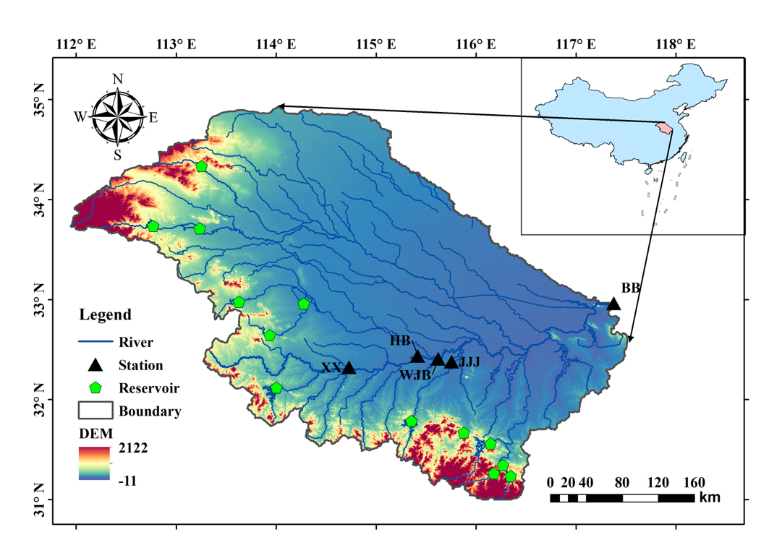
4. Response to Comments on the Quality of English Language
5. Additional clarifications
No additional clarifications.

