Reviewer 1
General comments
The study utilizes an integrated approach combining Land Use and Land Cover (LULC) transition analysis with soil-erosion modeling using the Revised Universal Soil Loss Equation (RUSLE). The paper is well-structured, moving logically from the global problem of land degradation to specific regional findings and future policy.
Specific comments
Comment 1: The methodology is robust in its use of multi-temporal datasets, including MODIS (2001–2021) for long-term trends and high-resolution ESRI 10m data (2017–2024) for short-term dynamics. Please write if the application of the RUSLE model at a 30m spatial resolution across the entire Aravalli Mountain System (AMS) scale is a significant contribution, as such high-resolution measurements were previously lacking.
Response: We thank the reviewer for their review and positive suggestions. The Aravalli Mountain System (AMS) is not as high as the Himalaya, but it is unique for its heterogeneous geomorphology, including steep slopes, ridges, and valleys. The 30m spatial resolution study across the entire Aravalli Mountain System (AMS) scale is a significantly identify variation in slope, vegetation and Anthropogenic activities. A high-resolution study will assess an accurate, spatially distributed soil erosion hotspot that can be used by policymakers to develop control measures related to policy. We have included the given suggestion in the manuscript.

Comment 2: The research correctly identifies and parameterizes the six RUSLE factors: Rainfall Erosivity (R), Soil Erodibility (K), Slope Length and Steepness (LS), Cover Management (C), and Support Practice (P). There is no information, how to the use of Sentinel-2 derived NDVI to calculate the C-factor provides a dynamic and accurate reflection of vegetation health.
Response: We thank the reviewer for the suggestion; we have incorporated the clarification into the methodology.
Comment 3: While the model is scientifically sound, the reliance on Inverse Distance Weighting (IDW) for rainfall interpolation at 30m resolution from 4km source data may introduce localized smoothing effects in areas with high topographic variability.
Response: We thank the reviewer for the suggestion; we have incorporated the clarification into the methodology. We also tried to smooth the data (Though the Aravalli Mountain System is characterised by complex topography and spatial distribution may be affected by orographic effects, but due to the non-availability of high-resolution data or regional-specific data, we have used 4km spatial resolution data. For converting this 4km spatial resolution rainfall data, we have used on Inverse Distance Weighting (IDW) for rainfall interpolation, which provides a computationally efficient approach that ensures compatibility with other RUSLE factors)

Comment 4: I think that the study a little successfully correlates erosion hotspots with steep slopes, susceptible soil types, and active mining areas. You must also highlights a critical policy paradox: increased soil erosion persists despite afforestation efforts, suggesting that localized conservation cannot offset massive regional land conversion.
Answer: We have revised the Discussion section to highlight the policy paradox that, despite afforestation, increased soil erosion persists due to concurrent large-scale land-use changes such as urbanisation and mining. The need to integrate soil-erosion dynamics into future conservation policies has now been addressed in the revised manuscript (L:500-514).

Comment 5: Some sections regarding the Supreme Court rulings are highly detailed and may benefit from a more concise summary to maintain the focus on the scientific modeling. Including a sensitivity analysis of the RUSLE parameters would further bolster the results, showing which factors most significantly drive the 13.8% increase in soil.
Answer: We thank the reviewer for his suggestions. We have carried out a sensitivity analysis of the RUSLE parameters, and the following paragraph and figure have been added to the result and supplementary materials.

Comment 6: Constructive feedback
The study places the AMS within a global context, comparing its degradation pathways to other ancient systems and highlands. This strengthens the paper's argument that the interaction between LULC dynamics and soil erosion is a universal driver of degradation in old mountain systems. But, I suggest to address this issue: Comparing results from two datasets with such vastly different spatial resolutions (500m vs. 10m) introduces significant "scaling noise." An increase in built-up area might partially be an artifact of the ESRI dataset’s ability to detect small structures (rural housing, narrow roads) that MODIS simply cannot see. The paper needs to better account for this "resolution bias" in its trend analysis.
Answer: We appreciate the reviewer's detailed, constructive comments. We have replaced the table in the text and also mentioned the limitation in the methodology. We also addressed this scale-based bias in the results.

Class | 2001 | 2010 | 2020 | Change detection (2020-2001) | P factor | C factor
Forest | 30.6164 | 37.316 | 264.6212 | 234.0048 | 0.8 | 0.008
Shrubland | 3907.87 | 970.791 | 996.683 | -2911.187 | 0.8 | 0.1
Permanent Wetlands | 3.42189 | 16.0132 | 61.8002 | 58.37831 | 1 | 0.001
Croplands | 70719.7 | 73611.1 | 73227.7 | 2508 | 0.5 | 0.08
Urban and Built-up | 1107.31 | 1152.48 | 1256.3 | 148.99 | 1 | 0.1
Barren | 192.432 | 153.947 | 116.098 | -76.334 | 1 | 0.45
Water Bodies | 8.98976 | 28.6928 | 47.1376 | 38.14784 | 0 | 0
total | 75970.34 | 75970.34 | 75970.34

To compare the rate of erosion using different LULC, we have also calculated the rate of erosion using MODIS LULC. MODIS LULC is used to calculate the C and P factor using the values assigned for each LULC class (Table 1). R factor is calculated using the rainfall of 2000, 2010 and 2020. Only the C, P, and R factors have been changed; otherwise, the L, S, and K factors are constant. The results indicate that the erosion rate in 2001 was 0.17 t/ha/yr, 0.165 t/ha/yr in 2010, and 0.179 t/ha/yr in 2020. This shows a comparison of LULC spatial resolutions used to calculate erosion rates; higher spatial resolution captures more features and yields a more accurate spatial distribution of erosion.

Rate of erosion using LULC from MODIS-2001 | Rate of erosion using LULC from MODIS-2010 | Rate of erosion using LULC from MODIS-2020 | Rate of erosion using ESRI LULC 2017 | Rate of erosion using ESRI LULC 2024
0.17 t/ha/yr | 0.165 t/ha/yr | 0.179 t/ha/yr | 1.59 t/ha/yr | 1.81 t/ha/yr

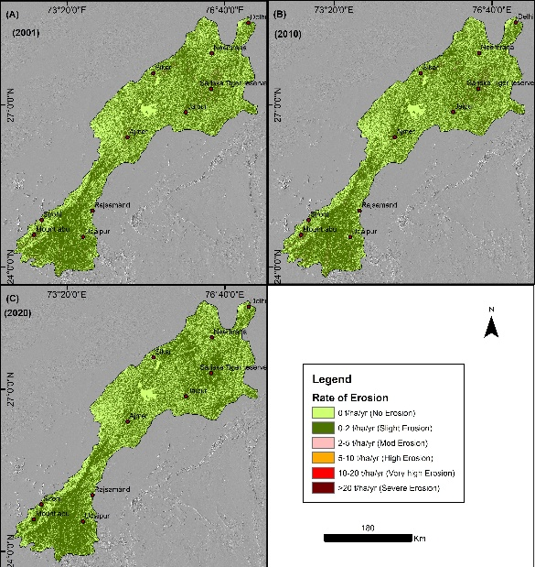

Comment 7: This paper is a highly valuable contribution to the field of geomorphology and sustainable land management. It provides a scalable, high-resolution framework that can be adapted for other vulnerable mountain systems globally. The methodology is technically sound, and the results are significant for future mineral governance and conservation planning.
Answer: We are thankful to the reviewer for his positive comments.
Summary:
The work is scientifically valid as it represents the first time the RUSLE model has been applied at a 30m resolution across the entire AMS scale.

