Point-by-point reply to reviewers’ comments

Reviewer #1
In this review manuscript, Sun et. al. focused on two emerging fields epigenetics and immunotherapy. While the reviewer articles related to the two fields individually are abundant, the work at the interface is limited. This manuscript nicely covered the gap. The manuscript is organized by short reviews of epigenetic modulators and immunotherapy that have clinical potentials and then mainly focus on the status of their combination treatment. The manuscript is well organized, rationally presented and well written. I suggest publishing this work after addressing the following minor concerns and typos:

1. <Comments>
: Through the text, “P53” should be “p53”.

<Answer>
: According to the reviewer’s comment, we checked manuscript seriously and corrected these mistakes and marked in the current manuscript.

2. <Comments>
:Through the text, “P300” should be “p300”.

<Answer>
: According to the reviewer’s comment, we corrected these mistakes and marked in paper.

3. <Comments>
: While there is no inhibitor of HATs in the clinical trail, the newly reported p300 inhibitor showed such potential (Nature, 2017, 550, 7674, 128). Given that it is the only compound and the best candidate against p300, some discussion should be included.

<Answer>
: According to the reviewer’s comment, we have added these contents in section “2.1 Histone acetylation modifiers” and marked in this section.
→
In addition to the above mentioned histone deacetylation inhibitor, recently some inhibitors targeting HATs have also been investigated for cancer therapy and shown prospective efficacy. It has been report that A-485 as a potential selective inhibitor of p300 and CBP showed selectively inhibitory proliferation in lineage-specific tumor types, including several haematological malignancies and androgen receptor-positive prostate cancer [22], suggesting the potential of targeting HAT in cancer treatment.

4. <Comments>
: Through the text, a handful of small-molecule epigenetic modulators were discussed. It will be helpful to include a table of the representative compounds with their chemical structures.

<Answer>
: According to the reviewer’s comment, we have added a simplified table of the representative compounds with their chemical structures to make it easier for the readers to understand these small-molecule epigenetic modulators.
→

Table 2 :The structure of representative histone modification inhibitors.
- The structure of representative HDACis.
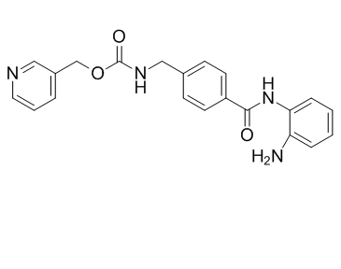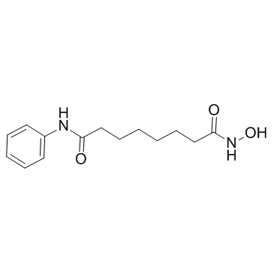
Entinostat (MS-275) Vorinostat (SAHA)

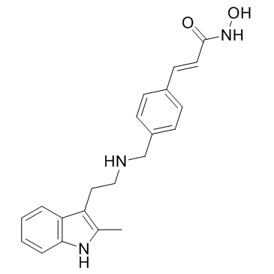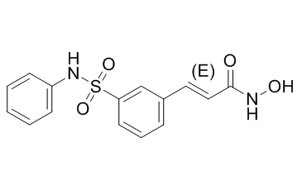
Panobinostat (LBH-589) Belinostat (PXD-101)

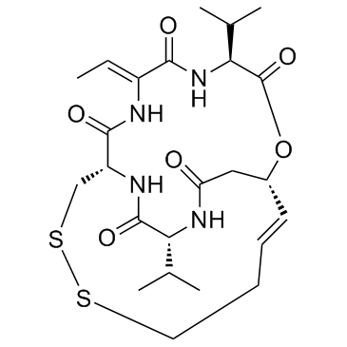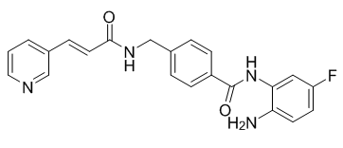

Romidepsin (FK-228) Chidamide (CS-055)

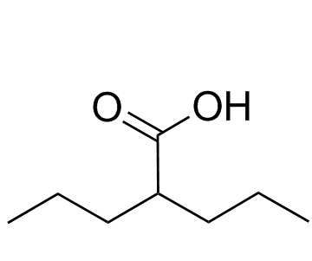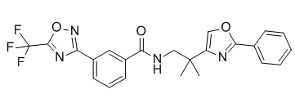

Valproic acid (VPA) TMP-195

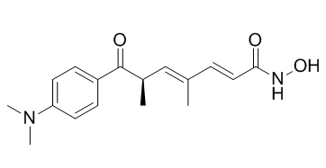
Trichostatin A (TSA)
- The structure of representative HATis.

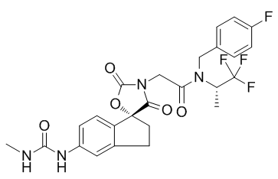

A-485-Target p300/CBP

- The structure of HMTis.
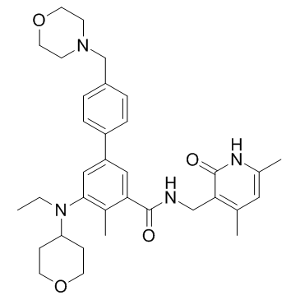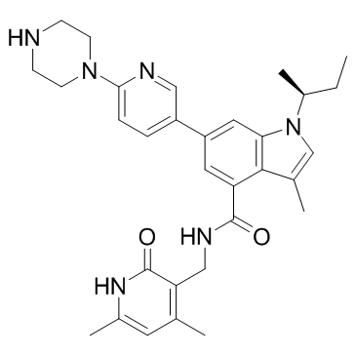

Tazemetostat (EPZ-6438)-Target EZH2 GSK-126-Target EZH2
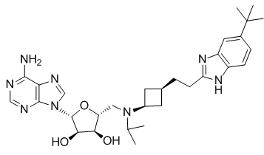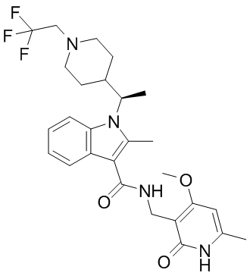

Pinometostat (EPZ-5676)-Target DOT1L CPI-1205-Target EZH2

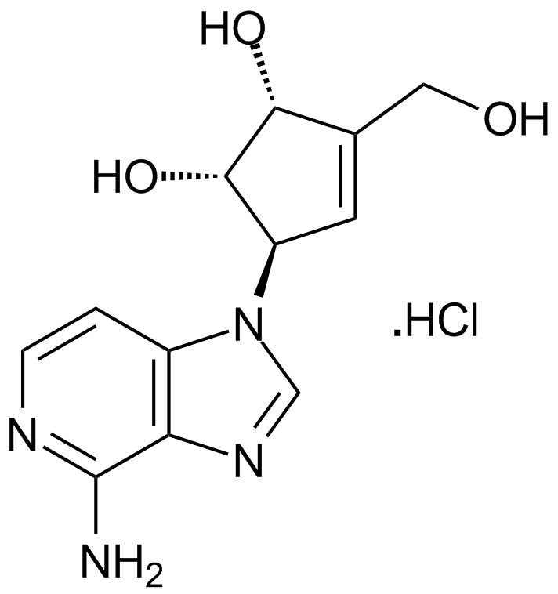

DZNep--Target EZH2

- The structure of representative HDMis.

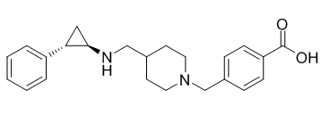

GSK2879552-Target LSD1

