Dear Reviewer,
We sincerely appreciate the time and effort you have dedicated to reviewing our work and strengthening it through your insightful comments. In response, we have addressed each of your observations and indicated the corresponding corrections in the manuscript, referencing the relevant page numbers.
With our regards
Authors.
Responses to Reviewer IV
The study is to highlight some strategies using a combined qualitative exploratory approach for mitigate supply chain disruptions in maritime shipping for a resilient and sustainable global economy. It's meaningful and interesting. There are some minor issues to be addressed as follow:
Comment 1.
The abstract should be rewritten. Now it has not conveyed more contributions and novelty.
Response 1.
The paragraph added in red to more effectively convey the contributions and novelty of the study has been incorporated into the abstract. (lines 11-24)
Abstract: International trade plays a pivotal role in shaping global supply chains, which are increasingly vulnerable to disruptions caused by geopolitical tensions, pandemics, and environmental disasters. These disturbances, particularly in maritime logistics, can trigger cascading effects across global industries. This study aims to identify and prioritize strategic responses to such disruptions by employing a combined qualitative exploratory approach and the Analytic Hierarchy Process (AHP). Expert judgments were obtained from 32 senior professionals across the maritime logistics and port management sectors during a structured evaluation conducted in the second quarter of 2025. AHP was utilized to systematically assess these inputs and determine the relative importance of resilience strategies. The results emphasize the need for adaptive, proactive, and sustainable logistics approaches to ensure long-term stability in maritime trade. By bridging a gap in the literature concerning integrated assessment of disruption responses, the study offers valuable insights for industry stakeholders and policymakers navigating an increasingly volatile global trade environment.

Comment 2.
Fig. 6 can not display all.
Response 2.

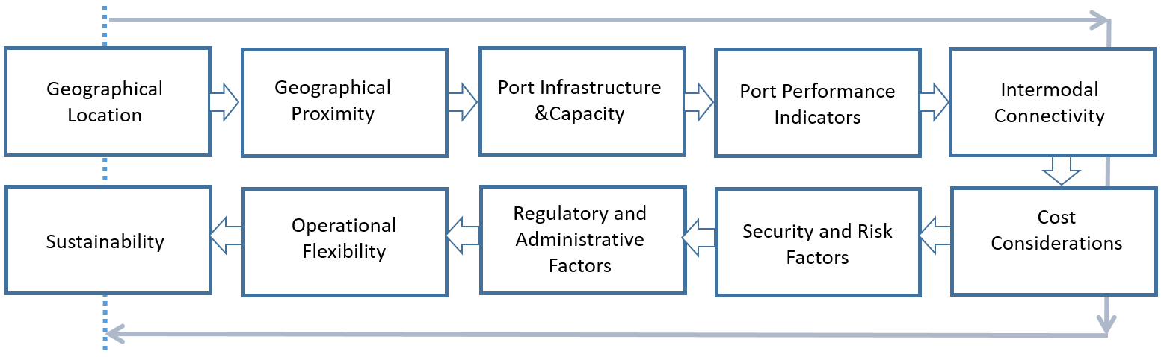
Figure 6. The Methodology for Exploring Alternative Ports.
The previous Figure 6 above has been replaced with the new Figure 6 below. (line 545)

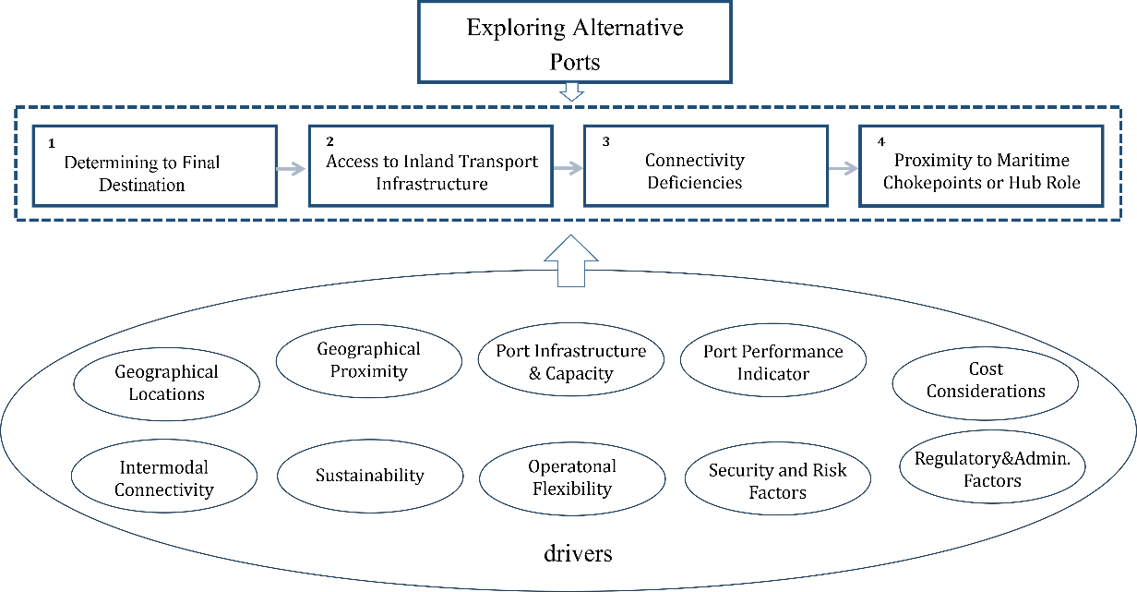

Comment 3.
Part 11 should be placed at the beginning of the article after part 1.
Response 3.
Part 11 has been moved to the beginning of the article, placed immediately after Part 1
Comment 4.
Please list the abbreviations.
Response 4.
The list of abbreviations has been included in the revised text as shown below. (line 28)
Nomenclature
AGVs – Automated Guided Vehicles
AHP – Analytic Hierarchy Process
ECB – European Central Bank
EU – European Union
Federal Reserve – Central Bank of the United States
Forex – Foreign Exchange
GDP – Gross Domestic Product
IMF – International Monetary Fund
JIT – Just In Time
NAFTA – North American Free Trade Agreement
OPEC – Organization of the Petroleum Exporting Countries
PBOC – People's Bank of China
TOS – Terminal Operating Systems
USMCA – United States Mexico Canada Agreement
USSR – Union of Soviet Socialist Republics (Soviet Union)
WB – World Bank
WTO – World Trade Organization

