Reviewer2 comments
Major
Comments 1 : In figure 6, the reader will be confusing. Although the left figure showed mouse lip, the result is mixing mouse and human CL. In the right figure is same. The authors should modify the figure. In addition, DEX is reported to decrease miR-130a-3p. Moreover, the authors need to add phenytoin in the section of atRA (miR-4680-3p ) as well.
Response 1 : Thank you for the detailed comments from the reviewer. In Figure 6, we added some miRNAs to the TCDD and DEX parts as follows, and also modified the title part of the figure. The parts added according to the reviewer's comments were also included in the figure. Thanks to your comments, we were able to add other parts as well.

Comments 2 : The authors seemed to miss [PMID 35774010]. I think the authors should mention this manuscript to review miRNA.
Response 2 : Thank you for your insightful comments. We acknowledge that our study did not include the review miRNA. So we added the content based on your advice. “{Yan, 2022} demonstrated that CP model gene and miRNA expression from E10.5 to E14.5 in the maxillary processes to identify spatiotemporal patterns of gene and miRNA expression. MiR-325-3p and miR-384-5p, that repressed cleft-related genes Adamts3, Runx2, Fgfr2, Acvr1, and Edn2, while their expression increased over time. On the contrary, miR-218-5p and miR-338-5p, repressed cleft-related genes Pbx2, Ermp1, Snai1, Tbx2, and Bmi1, while their expression decreased over time. The findings suggest that these miRNA mimics sig-nificantly inhibited the cell proliferation of the mouse palate mesenchymal cell and O9-1 cranial neural crest cell line by modulating CP-associated genes, confirming their regula-tory role in the pathogenesis {Yan, 2022}.”

Comments 3 : atRA-induced miRNA expression report seemed to be missing. The authors should add entitled “Identification of the Differentially Expressed microRNAs Involved in Cleft Palate Induced by Retinoic Acid (RA) in Mouse Model” around line 1292.
Response 3 : We appreciate your attention to detail, which has helped improve the clarity and accuracy of this manuscript. The corrections are as follows: “{Wei, 2018} has showed that ATRA administration induced changes in miRNA in mice with CP. The CP (CP) in RA-treated mice has been linked to the upregulation of miR-181a-5p, miR-410-3p, miR-3960, miR-1224-5p, miR-3970, let-7e-5p, miR-1907, miR-124–3p and miR-4680–3p {Wei, 2018} [184]. Then, {Wei, 2018} demonstrated that miR-140-3p, miR-351-5p, and miR-503-5p were downregulated in a mouse model of RA-treated (Figure 6).”

Comments 4 : Around 1374, recent investigation revealed that TCDD suppressed cell proliferation and migration through miR-214-3p [PMID 39314083]. The authors should add latest information.
Response 4 : Thank you for your insightful advice. As reviewer’s suggestion, we have included references as follows. “Recently, the upregulation of miRNAs(miR-214-3p, miR-296-5p, and miR-33-5p) in the TCDD-treated group, while miRNAs(miR-92a-3p, miR-126a-3p, and miR-411-5p) were significantly downregulated. Notably, qRT-PCR testing confirmed a significant difference in miR-214-3P expression. These findings support that TCDD inhibits palatal mesenchymal cell proliferation and migration through miR-214-3p, suggesting a its role in TCDD-induced cleft palate in mice {Dong, 2024}.”

Comments 5 : Around 1473, recent investigation revealed that phenytoin suppressed cell proliferation and migration through miR-4680-3p [PMID 38191190]. The authors should add latest information.
Response 5 : We have revised the statement to more accurately reflect our reviews. The revised text reads: “Recently, {Tsukiboshi, 2024} have shown that phenytoin inhibits HEPM cell proliferation in a dose-dependent manner by downregulating cyclin-D1 and cyclin-E. phenytoin treatment upregulated miR-4680-3p while downregulating its target genes, ERBB2 and JADE1. These findings indicate that phenytoin suppresses cell proliferation by modulating miR-4680-3p {Tsukiboshi, 2024}.”

Comments 6 : Table 3. Let-7c-5p, miR-193a-3p. If the authors would like to add “hsa”, the other miRNA should add species. In addition, gene information is missing in the present table. Moreover, reference seemed to be not correct. The authors should check carefully.
Response 6 : Thank you for your insightful advice. We have corrected the part about miRNA of the table (“let-7c-5p, miR-193a-3p”) and reference. Thank you for your comments helped me find additional part to supplement.
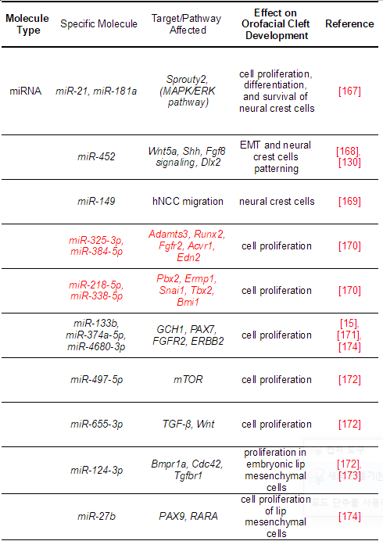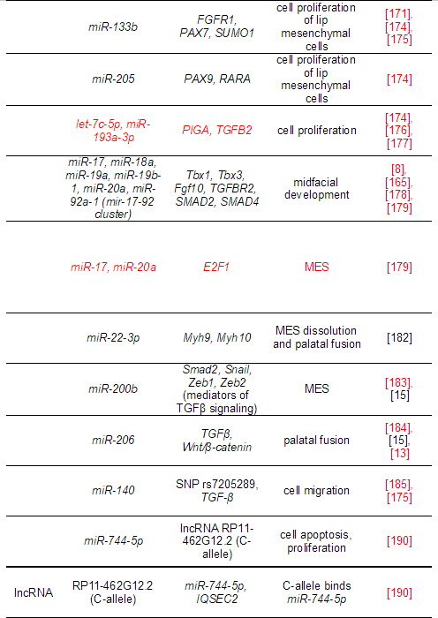
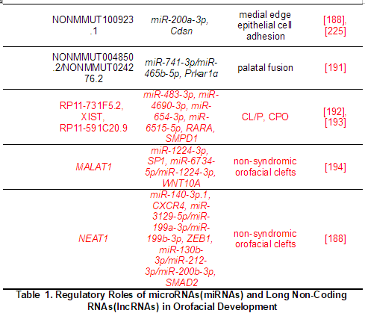

Comments 7 : Line 1034, not only ref 184 but also adding 180 is correct.
Response 7 : Thank you for your accurate advice. We have revised the statement to more accurately reflect our reviews. “In addition, {Suzuki, 2019} and [186] identified miRNAs (miR-133b, miR-140-5p, miR-374a-5p, miR-381a-3p, and miR-4680-3p) associated with CP development in humans through sys-tematic reviews, bioinformatics analyses, and cell proliferation assays in human embry-onic palatal mesenchymal(HEPM) cells[182, 186].”

Comments 8 : Line 1039, I could not understand how seven miRNAs were identified. The authors need to show seven miRNAs correctly. In lilne 1040, “we” seemed to be not correct. The authors should change [PMID 38241808].
Response 8 : We totally understood the reviewer’s comment. We have corrected the sentences as follows. “[185] has showed that Genes predicted in all three databases (FUNRICH, MIRDB, and Targetscan) were considered as potential target genes of the miRNAs (104 target genes of miR-193a-5p, 512 target genes of let-7c-5p). In particular, PIGA and TGFB2 were selected as the most promising targets by further inquiring into three databases (MGI, MalaCards, and DECIPHER). Recently, {Tsukiboshi, 2024} found that Phenobarbital(PB) specifically induced let-7c-5p expression and that the let-7c-5p specific inhibitor alleviated the PB-induced suppression of HEPM cell proliferation, indicating that let-7c-5p plays a crucial role in PB-induced tox-icity. Let-7c-5p is highly expressed in craniofacial tissues of embryonic mice {Tsukiboshi, 2024}.”
Minor
Comments 1 : I feel line 86 “E17” seemed to be E15.5.
Response 1 : Thank you for pointing this out. We agree with your comment. So to clarify, I've revised the text to read “In mice, this process starts at approximately E11.5 and is essentially completed by E15.5.”

Comments 2 : Line 95, ref 138 is correct ? If correct, the authors should change reference numbering.
Response 2 : Thank you for your careful review. We have verified that the reference is correct. Therefore, we have adjusted the reference number throughout the manuscript to ensure consistency and accuracy. We appreciate your attention to detail that has helped improve the clarity of the work.

Comments 3 : CP seemed to change cleft palate throughout the manuscript. The authors should change line 219, 996, 1035, 1135, 1279, 1291, 1402.
Response 3 : Thank you for your valuable comments. We have carefully reviewed the manuscript and revised the first occurrence of the term to the full term and then revised subsequent occurrences to the abbreviated term to ensure clarity and consistency. Additionally, based on your insightful comment, we have also corrected similar terminology in other lines that were not specifically mentioned. All modifications have been marked in red in the revised manuscript for easy identification. We truly appreciate your keen insight and thoughtful suggestions. This has greatly helped improve the clarity and precision of our manuscript.

Comments 4 : In line 1040, what PB means ?
Response 4 : We appreciate your attention to detail, which has helped improve the clarity and accuracy of this manuscript. As reviewer’s suggestion, we have added the sentences as follows. “Recently, {Tsukiboshi, 2024} found that Phenobarbital(PB) specifically induced let-7c-5p expression and that the let-7c-5p specific inhibitor alleviated the PB-induced suppression of HEPM cell proliferation, indicating that let-7c-5p plays a crucial role in PB-induced tox-icity. Let-7c-5p is highly expressed in craniofacial tissues of embryonic mice {Tsukiboshi, 2024}.”

Comments 5 : In line 1280, miR-4680-3p seemed to be not correct. The authors need to change miR-340-5p and cite [PMID 35420127]
Response 5 : Thank you for your insightful advice. As per the reviewer's suggestion, I have reordered the references to fit the content. “Also, the previous study showed that miR-129-5p and miR-340-5p repress cell growth of primary mouse embryonic palatal mesenchymal cells and neural crest-derived O9-1 cells. Specifically, miR-129-5p targets Sox5 and Trp53, while miR-340-5p regulates the expression of Chd7, Fign, and Tgfbr1 to modulate cell growth {Yoshioka, 2022}.”

Comments 6 : The authors mixed E and GD. I recommend to unify E (line 1021, 1060, 1068, 1102).
Response 6 : We appreciate reviewer’s detailed comments. We have corrected the part about embryonic day in text. “In particular, strong expression was found in the maxillary process of miR-124-3p, particularly at E13.5.”, “A decrease in the expression of miR-17-92 from E12-14, with a concomitant increase in the expression of key components of the pathway, such as TGFBR2, SMAD2, and SMAD4, was evident in the palatal shelves.”, “The findings in palatal mesenchymal cells (PMCs) include the expression of E2F1 and E2F3 in palatal tissue on E12-14, significant inhibition of cell proliferation upon E2F1 knockdown, and upregulation of the miR-17-92 cluster with E2F1 overexpression [190].”, “Analysis of the MEE of Tgf-β3-/- mouse fetuses at E13.5, indicated that the expression of miR-206 in the developing palate was significantly diminished compared to that in their wild-type counterparts, suggesting an important role of miR-206 in palatal ontogeny [15] [195].”

Comments 7 : The line 1469 and 1471, the authors are showing miss information. The authors should cite [PMID 335721377].
Response 7 : We totally agree with reviewer’s comment. We changed the part as below. In addition, following the reviewer's advice, we have supplemented any parts that require further explanation. “In addition, {William, 2006} found that phenytoin, an inducer of CL, decreased cell proliferation through miR-196a-5p induction. During E10.5 to E12.5, miR-196a-5p expression significantly declines in the MxPs and NPs, while phenytoin upregulates miR-196a-5p and sup-presses MELM cell proliferation by downregulating Pbx1, Pbx3, and Rpgrip1l {Iwaya, 2023}. Especially, treatment with a specific inhibitor for miR-196a-5p restored cell proliferation through normalization of expression of CL-associated genes in the cells treated with phenytoin {William, 2006}. miR-196a-5p suppresses cell proliferation and promotes osteogenic differentiation in human Wharton’s jelly umbilical cord stem cells (WJCMSC) and sup-presses bone formation in WJCMSC-sheet transplanted rat calvaria through suppression of Serpinb2 {Iwaya, 2023}. These collective findings suggest a pleiotropic role for miR-196a-5p in diverse developmental processes, including those critical for palate formation. Recently, {Tsukiboshi, 2024} have shown that phenytoin inhibits HEPM cell proliferation in a dose-dependent manner by downregulating cyclin-D1 and cyclinE. phenytoin treatment upregulated miR-4680-3p while downregulating its target genes, ERBB2 and JADE1. These findings in-dicate that phenytoin suppresses cell proliferation by modulating miR-4680-3p {Tsukiboshi, 2024}.”

Comments 8 : Abbreviation is so missing. The authors should correct as below.
- CL/P: line 79, 444, 445. 915, 1424, 1494, 1511
- FGF : line 312, 1356
- TGF : line 411, 1354, 1488, 1489
- BMP : line 413, 1489
- IRF6: line 656
- VWS : line230, 233, 657
- WHS: line 281
- miRNA: line 688, 980
- OFC : line 700, 775, 820, 822, 873, 1228, 1423, 1487
- CLP : line 700. 849
- CPO : line 700, 850, 1303, 1477, 1495
- EWAS: line 820, 821
- CLO: line 850
- NCC: line 876, 885, 902, 945, 958, 960, 993, 1008, 1169, 1192, 1219
- atRA: 955, 1260, 1296
- EMT: line 989, 1087, 1159,
- SATB2: line 1207
- RA: line 1306
- AcAL: line 1309
- TCDD: line 1332
- MEE : line 1342
- AhR: line 1353
Response 8: Thank you for your valuable comments. We have carefully reviewed the manuscript and revised the first occurrence of each term to its full term, and then revised subsequent occurrences to the abbreviated term to ensure clarity and consistency. We have also revised similar terms in other lines that were not specifically mentioned based on your insightful comments. All revisions have been highlighted in red in the revised manuscript for easy identification. We sincerely appreciate your keen insight and thoughtful suggestions, which have greatly helped us improve the clarity and accuracy of the manuscript.

