Dear Editors and Reviewers:
Re: plants-3249682
We are very grateful to your and the reviewer’s thoughtful suggestions. Based on the suggestions, we have made careful modification on the manuscript. All changes made to the text are in red in the revised manuscript so that they may be easily identified. Some of your questions were answered below.
Once again, we acknowledge your comments and constructive suggestions very much, which are valuable in improving the quality of our manuscript.
Here are our responses to the reviewer’s comments.
Reviewer 1:
- Words and expressions from the title should be avoided in the keywords.
Response:Thank you for your valuable suggestions. Following your advice, we have revised the keywords to remove repetitive term from the article's title.We have revised the content of the keywords section in lines 28-29 as follows:
Keywords: slope stability; root morphological; root tensile strength; In-situ shear test; soil reinforcement

- Citations between brackets in superscript should be corrected.
Response:We sincerely apologize for our oversight and greatly appreciate your reminder. We have corrected all the superscript brackets in the reference section of the original manuscript.The partial corrections are as follows:
Lines 38-40 have been revised：
In recent years, the contribution of vegetation roots to slope reinforcement, due to the friction and interlocking effects between roots and soil [1], has received increasing attention [2-4].
Lines 41-55 have been revised：
Plant roots have strong tensile strength but weak compressive strength, whereas soil exhibits the opposite characteristics [5]. The soil-root system combines the advantages of both soil and roots, converting the shear force on the soil into tensile force in the roots through the friction between soil particles and root surfaces [6]. This mechanical reinforcement increases the soil's shear strength, thereby mitigating soil erosion and water loss [7,8]. The role of roots in improving slope stability has long been recognized [9]. The technique of using vegetation to stabilize slopes and control soil erosion has been widely accepted in many countries and regions [10].
Currently, methods for quantifying the shear strength of vegetation soil-root systems mainly include experimental methods (laboratory shear tests, in-situ shear tests, root tensile tests, etc.) [11,12] and modeling methods (Wu-Waldron Model, fiber bundle model, root bundle model, etc.) [13-15]. The in-situ shear test is widely regarded as a reliable method because it does not disturb the soil, thereby better reflecting natural conditions [16,17].
...
- Line 56: correct the citation to: Xing et al. (2023a)
Response:Lines 59-61 have been revised：
Xing et al. [6] conducted in-situ shear tests using 25×25×10 cm shear boxes to study the effects of land use types on strain energy, peak shear stress, and peak shear stress displacement.

- Line 59: unnumbered citation that corresponds to reference [33], which needs to be corrected and which will change the numbering of all subsequent citations in the article.
Response:Thank you very much for pointing out the issue with the unnumbered citation corresponding to reference [33]. I have corrected it and changed the reference to [18]. I appreciate your careful review, as this adjustment helps ensure the accuracy of the numbering for all subsequent citations in the article.
Lines 61-63 have been revised：
Comino et al. [18]performed in-situ shear tests in the alpine environment of Italy, showing that the presence of roots increased the shear strength of alpine soils.

- Line 65: correct the citation to: De Baets et al. (2008)
Response: Lines 67-69 have been revised：
De et al. [9] used the Wu model to quantify and rank the soil reinforcement effects of 25 typical Mediterranean plants.
- Line 66: correct the citation to: Su et al. (2021)
Response: Lines 69-71 have been revised：
Su et al. [19] applied the Wu model to investigate root reinforcement in the Loess Plateau after reforestation, estimating its impact on root mechanical properties.

- Line 77: correct the citation to: Reubens et al. (2007)
Response: Lines 80-82 have been revised：
Reubens et.al [31] summarized root characteristics affecting soil erosion and mass movement, including root density, root length density, root number, and root area ratio.

- Improve the layout of the figure, clearly identifying the basin where the experimental site was installed
Response:Thank you for your valuable feedback regarding the layout of the figure. I have improved the figure's design to clearly identify the basin where the experimental site was installed. Your suggestions have significantly enhanced the clarity of the presentation.
Lines 128-131 have been revised：
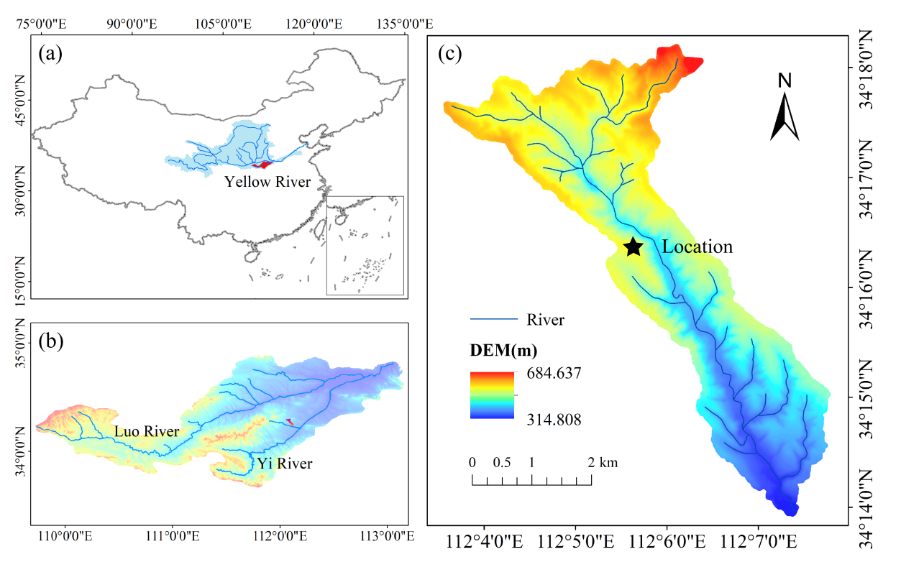
Figure 1. Location of Hugou Basin and the experimental site. (a) The Yellow River Basin in China, (b) The Yiluo River Basin, (c) The Hugou Basin.

- Line 150: correct the citation: (Zhang et al., 2024), which is unnumbered. [10]????
Response: Thank you for your valuable feedback regarding the citation in line 150. I have corrected the citation by inserting the reference as [10] as suggested. I appreciate your attention to detail in helping improve the manuscript.
Lines 164-166 have been revised：
Based on the root diameter (d), roots were divided into four size categories: fine roots (d<2 mm), small roots (2≤d≤5 mm), medium roots (5≤d≤10 mm), and coarse roots (d≥10 mm) [10].

- Improve the expression of the equations, which should follow a uniform standard of expression and layout.
Response:Thank you for your valuable feedback regarding the expression of the equations. I have revised the equations to ensure they follow a uniform standard of expression and layout throughout the manuscript.
Lines 172-175 have been revised：
After recording the root data, plant roots from different soil layers were dried at 65°C for 48 hours to calculate the root mass density (RMD, kg∙m⁻³), root length density (RLD, km∙m⁻³), root surface area density (RSAD, m²∙m⁻³), and root volume density (RVD, m³∙m⁻³) [6,33].
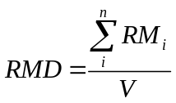 | (3)
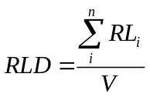 | (4)
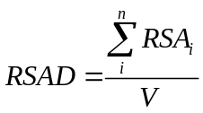 | (5)
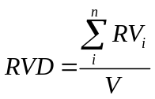 | (6)

- I recommend a more detailed description of the shear test apparatus, for the purpose of reproducing the experiment by interested readers.
Response:I have provided a more detailed description of the experimental process in the revised manuscript to facilitate reproducibility for interested readers. Thank you very much for your suggestion, which will enhance the clarity of the experimental setup.
Lines 177-191 have been revised：
This study utilized a self-designed and custom-fabricated in-situ shear test apparatus. The dimensions of the instrument frame were 150 × 35 × 16 cm, with a shear box size of 20 × 20 × 10 cm and a shear plane area of 0.04 m². The instrument connected the shear box to the guide rail using clamps and sliders. To ensure a stable shear direction, three 60 cm long iron rods were used to secure the instrument at the front and rear into the soil. Pressure sensors (0-3000±0.1 N) and displacement sensors (0-200±0.1 mm) were used for data measurement and recording. The shear rate was set at 0.3 mm/s [18].
Before the shear test began, a rectangular trench was excavated to accommodate the shear apparatus, with a reserved root-containing soil volume of 25 × 25 × 10 cm. The shear apparatus was placed in the trench, aligning the reserved root-containing soil with the shear box, and minor adjustments were made to the surrounding soil outside the shear box. The instrument was fixed in place using iron stakes, and the sensors were zeroed before commencing the test. The specific experimental procedure is shown in Figure 2.

- Lines 232 and 233: Unreferenced citations
Response: I have removed the erroneous citations from the manuscript.
Lines 259-260 have been revised：
All statistical analyses were performed using SPSS 26.0 and Origin Pro 21.0 software.

- Carefully check the callouts of Figures A1, A2, A3, and A4 and Tables A1-13, which do not correspond to the citations in the text.
Response:Thank you very much for your reminder. We have addressed the missing Figures A1 to A4 and Tables A1 to A3 by adding them to Appendix A.
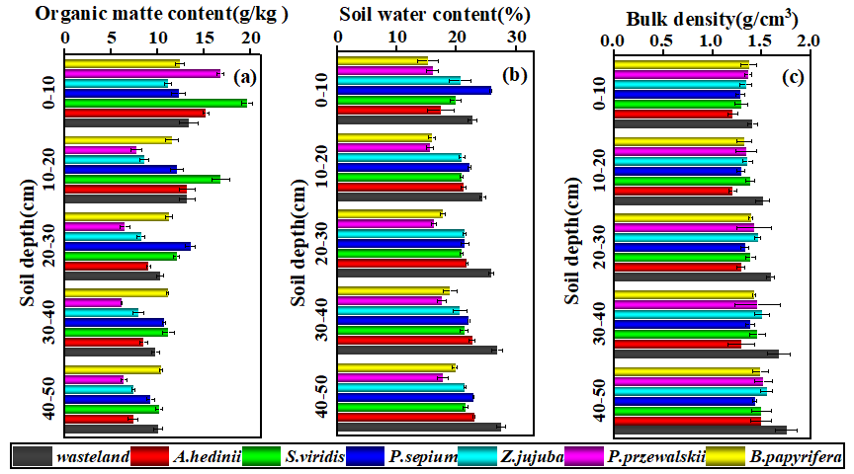
Figure A1. Soil properties at different soil layers (0-10, 10-20, 20-30, 30-40, 40-50 cm) for different plants. (a)-(c) show organic matter content, soil water content, and soil bulk density in each soil layer, respectively.
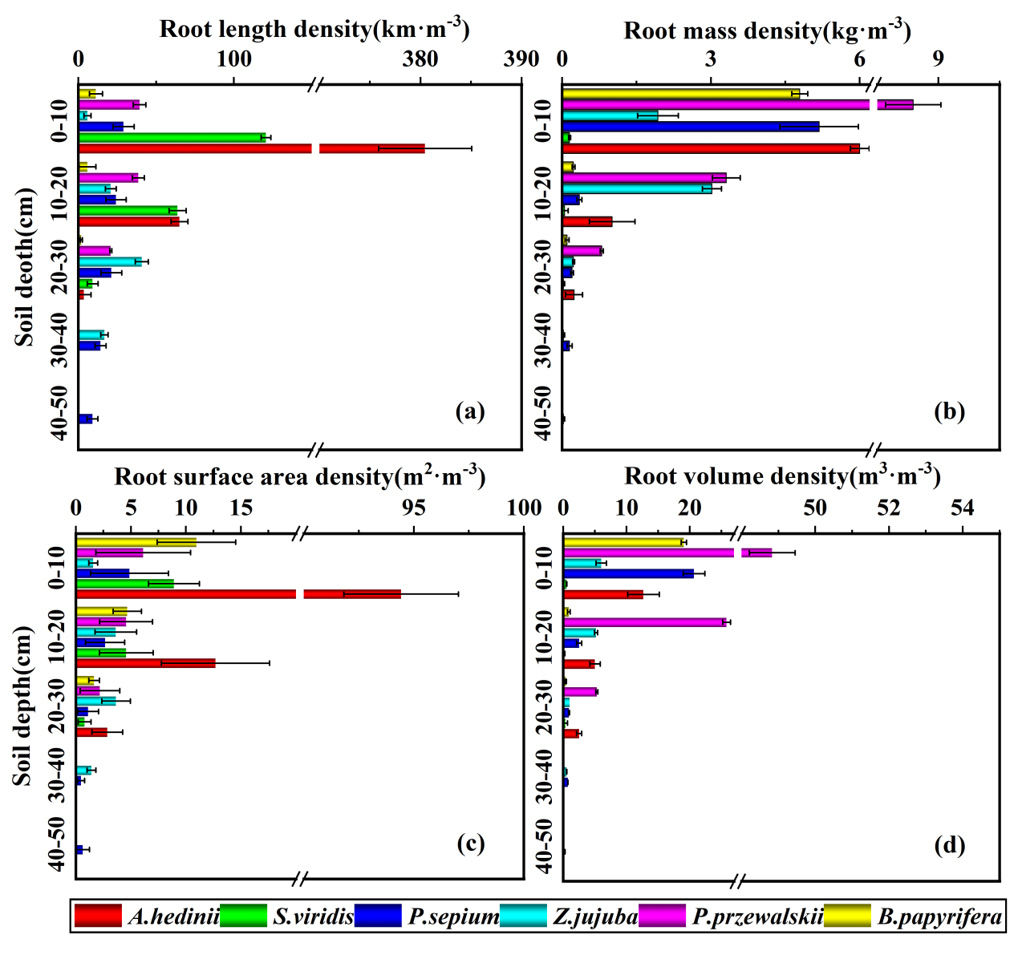
Figure A2. Root distribution characteristics at different soil layers (0-10, 10-20, 20-30, 30-40, 40-50 cm) for different plants. (a)-(d) show the distribution of root length density, root mass density, root surface area density, and root volume density in each soil layer, respectively.
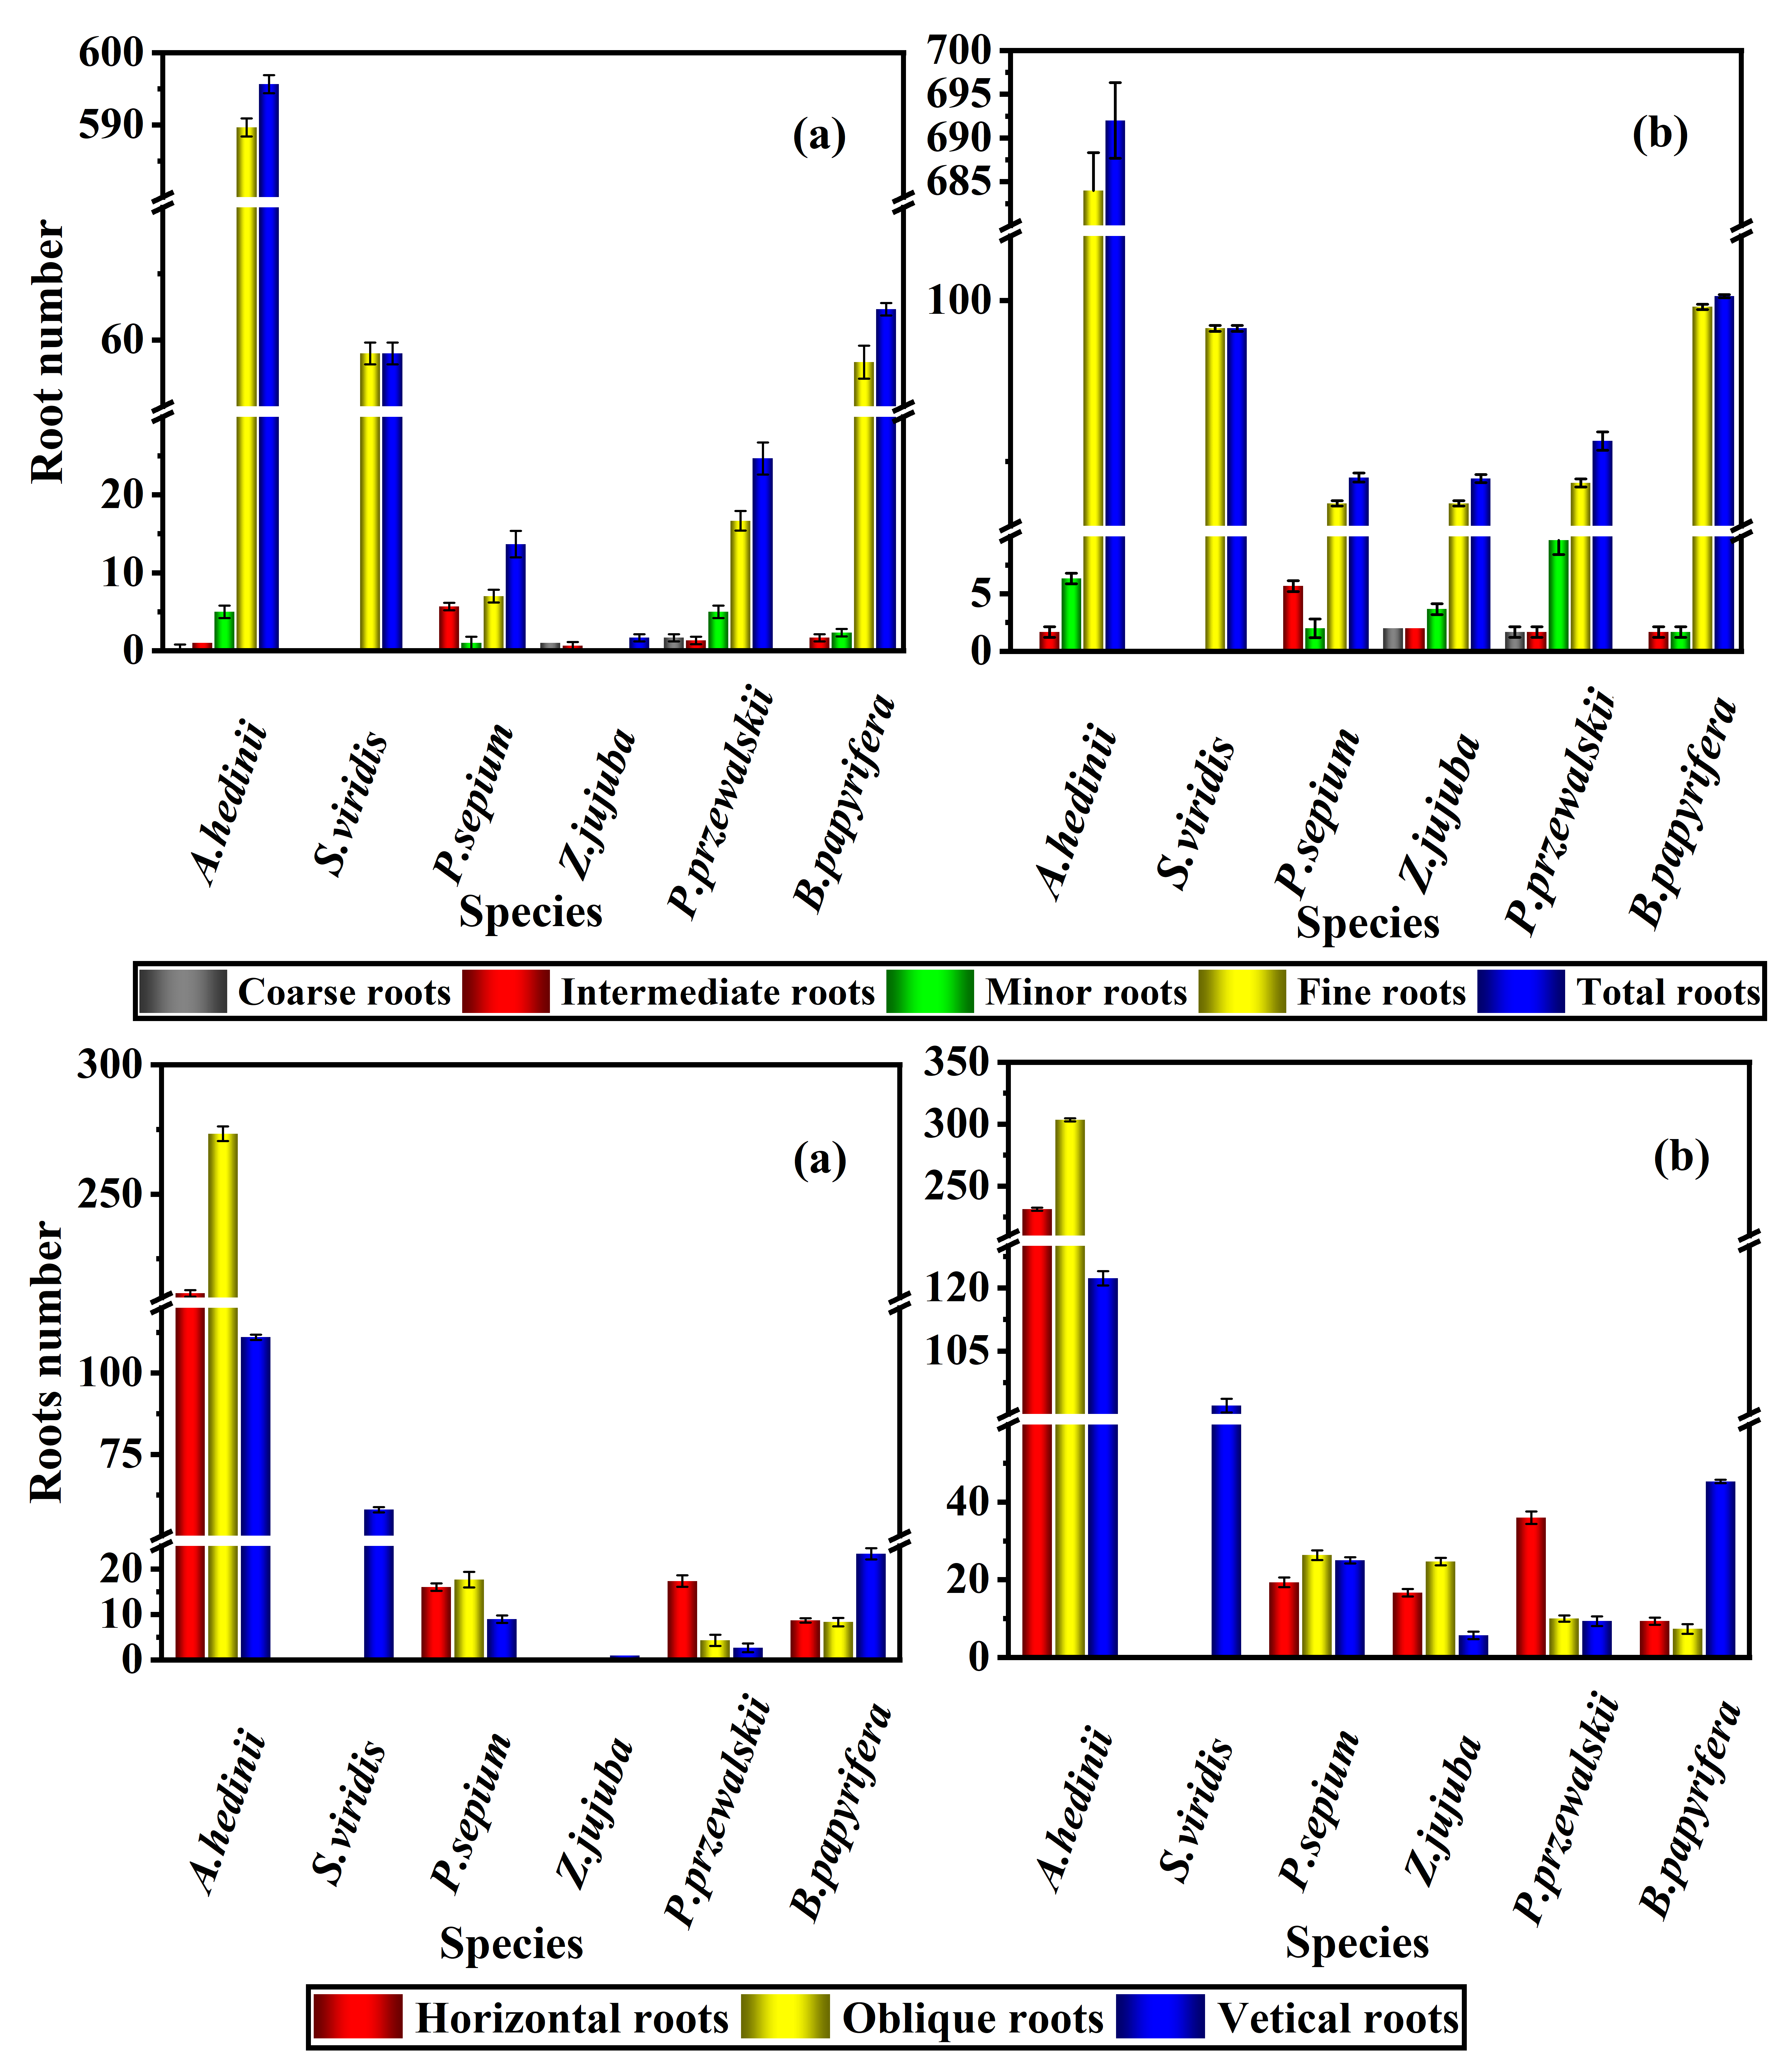
Figure A3. Number of fine, small, medium, and coarse roots for different plants. (a) Number of fine, small, medium, coarse, and total roots for six plants in the 0-10 cm soil layer; (b) Number of fine, small, medium, coarse, and total roots for six plants in the 0-50 cm soil layer. Fine roots (d≤2 mm), small roots (2 mm＜d≤5 mm), medium roots (5 mm＜d≤10 mm), coarse roots (d＞10 mm).
Figure A4. Number of horizontal, oblique, and vertical roots for different plants. (a) Number of horizontal, oblique, and vertical roots for six plants in the 0-10 cm soil layer; (b) Number of horizontal, oblique, and vertical roots for six plants in the 0-15 cm soil layer. Horizontal roots (0°＜θ≤30°), oblique roots (30°＜θ≤60°), vertical roots (60°＜θ≤90°).

Table A1. Average soil properties in the 0-50 cm soil layer for different vegetation types.
Land Use | Plant Species | BD | SWC | COM
Wasteland | / | 1.5861ª | 0.180567^{c} | 11.3667^{b}
Grassland | A. hedinii | 1.2968^{d} | 0.211667^{b} | 9.88^{c}
Grassland | S. viridis | 1.4026^{bc} | 0.208767^{b} | 20ª
Shrubland | P. sepium | 1.3344^{cd} | 0.2286ª | 11.51^{b}
Shrubland | Z. jujuba | 1.4422^{c} | 0.2098^{b} | 9.8833^{c}
Woodland | P. przewalskii | 1.4219^{b} | 0.160067^{d} | 8.5267^{d}
Woodland | B. papyrifera | 1.3236^{d} | 0.185^{c} | 11.3467^{b}
¹ Different lowercase letters indicate significant differences between vegetation types (P < 0.05).

Table A2. Average root distribution characteristics in the 0-50 cm soil layer for different vegetation types.
Land Use | Plant Species | RLD | RMD | RSAD | RVD
Grassland | A. hedinii | 448.895ª | 7.257^{b} | 109.958ª | 20.167^{c}
Shrubland | S. viridis | 193.344^{b} | 0.227e | 57.601^{ab} | 1.060e
Shrubland | P. sepium | 97.469^{c} | 5.913^{c} | 9.717^{b} | 24.983^{b}
Woodland | Z. jujuba | 83.993^{d} | 5.223^{d} | 10.252^{b} | 12.667^{d}
Woodland | P. przewalskii | 98.5167^{c} | 12.487ª | 12.871^{b} | 79.967ª
Land Use | B. papyrifera | 28.920e | 5.113^{d} | 17.273^{b} | 20.333^{c}
Land Use | Plant Species | RLD | RMD | RSAD | RVD
¹ Different lowercase letters indicate significant differences between plant types (P < 0.05).

Table A3. Average root quantity characteristics in the 0-50 cm soil layer for different vegetation types.
Land Use | Site Species | Size classes |  |  |  | Angle classes
Land Use | Site Species | CR | IR | MR | FR | HR | OR | VR
Grassland | A. hedinii | 0^{b} | 1.67^{b} | 6.33^{b} | 684ª | 231.33ª | 303.33ª | 122.33ª
Grassland | S. viridis | 0^{b} | 0^{c} | 0e | 91.33^{c} | 0^{f} | 0e | 92^{b}
Shrubland | P. sepium | 0^{b} | 0.58ª | 2^{d} | 37e | 19.33^{c} | 26.33^{b} | 25^{d}
Shrubland | Z. jujuba | 2ª | 0^{b} | 3.67^{c} | 37e | 16.67^{d} | 24.67^{b} | 5.67^{f}
Woodland | P. przewalskii | 1.67ª | 0.58^{b} | 9.67ª | 43.33^{d} | 36^{b} | 10^{c} | 9.33e
Woodland | B. papyrifera | 0^{b} | 0.58^{b} | 1.67^{d} | 98^{b} | 9.33e | 7.33^{d} | 45.33^{c}
¹ Different lowercase letters indicate significant differences between plant types (P < 0.05).

14. Figure 4: Explain the plant species corresponding to the letters a, b, c, d, e, and f.
Response:Thank you for your valuable feedback regarding Figure 4. I have added detailed annotations to the figure to explain the plant species corresponding to the letters a, b, c, d, e, and f.
Lines 341-344 have been revised：
Figure 4. Power regression curves showing the relationship between tensile strength and root diameter.Source:Author’s own work. Figures (a)-(f) correspond to Artemisia hedinii (A. hedinii), Setaria viridis (S. viridis), Periploca sepium (P. sepium), Ziziphus jujuba (Z. jujuba), Populus przewalskii (P. przewalskii), and Broussonetia papyrifera (B. papyrifera), respectively.

15. Authors should be careful with very low R²s, especially those below 0.6, in Figures 4 and 6, which do not allow for a discussion with the necessary statistical support.
Response:Thank you for your valuable comments and suggestions on our paper.Figure 4 presents the relationship between tensile strength and root diameter, based on measured values from our laboratory experiments. While we acknowledge that the R² value may not be ideal, our analysis suggests that there is a significant correlation between tensile strength and root diameter. Furthermore, we have observed that other researchers conducting similar experiments have reported R² values ranging from 0.1 to 0.7.
For instance, in reference [9], the R² values are as follows: B. ischaemum has an R² of 0.17; C. tristachya has an R² of 0.60; and A. giraldii has an R² of 0.51. In reference [19], Rosmarinus officinalis has an R² of 0.63, Atriplex halimus has an R² of 0.52, and Lygeum spartum has an R² of 0.44.
Regarding Figure 6, in Section 3.5, we initially conducted a correlation analysis of the shear strength indicators, soil properties, and root characteristics. We found that SE is significantly correlated with RMD and SWC, PSS is significantly correlated with RMD and SWC, and DPS shows significant correlations with RMD, SWC, RVD, and FR (p < 0.05). Figure 6 further explores the specific relationships between SE, PSS, DPS, RMD, and SWC using simple linear regression. We acknowledge that the R² values in this context may not be ideal, as noted in the works of other authors as well.
For example, in reference [6], the R² value between SWC and PSS is 0.61, and the R² value between RLD and DPS is 0.54.
We will pay special attention to this issue in our future research.
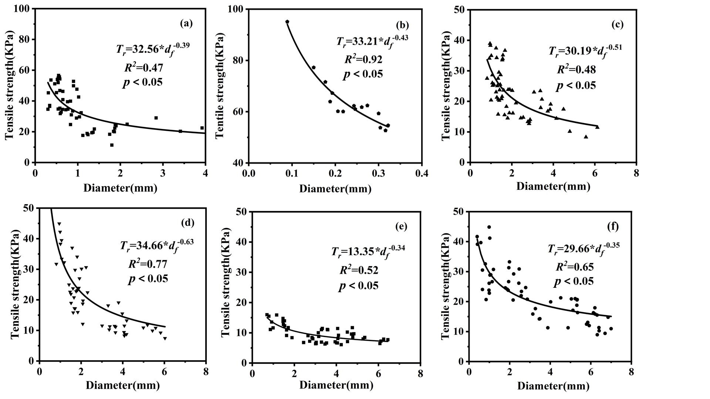
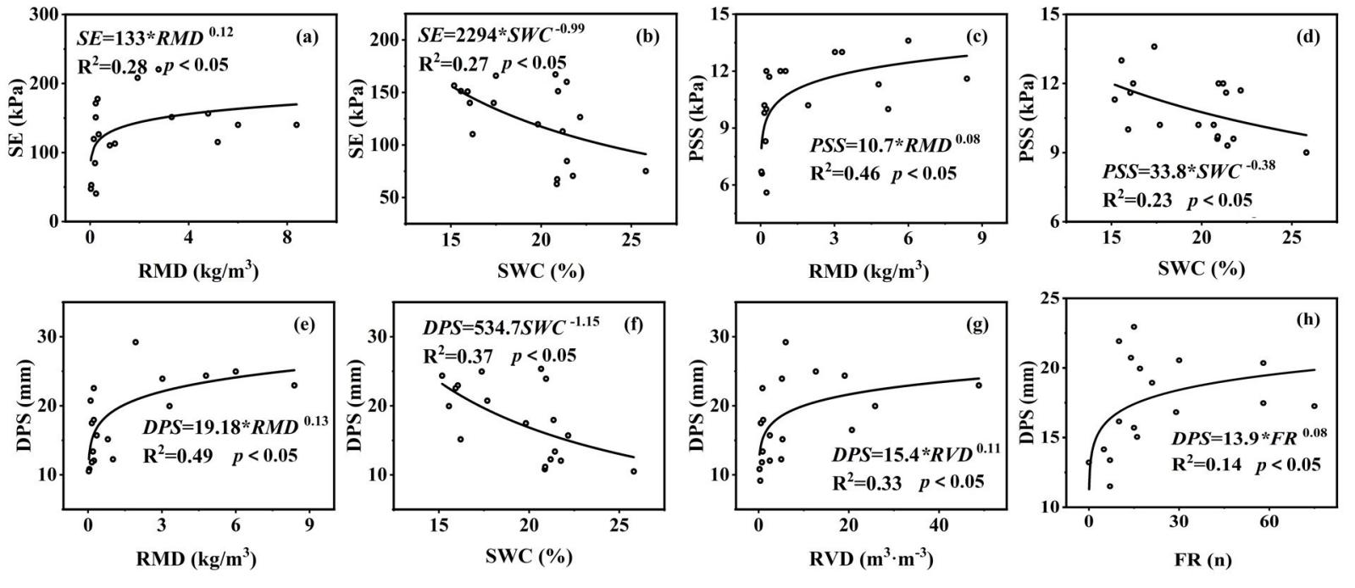
Figure 4. Power regression curves showing the relationship between tensile strength and root diameter.Source:Author’s own work. Figures (a)-(f) correspond to Artemisia hedinii (A. hedinii), Setaria viridis (S. viridis), Periploca sepium (P. sepium), Ziziphus jujuba (Z. jujuba), Populus przewalskii (P. przewalskii), and Broussonetia papyrifera (B. papyrifera), respectively
Figure 6. Relationships between shear strength indicators, soil properties, and root traits. (a)-(b) Relationship between SE and RMD, SWC; (c)-(d) Relationship between PSS and RMD, SWC; (e)-(h) Relationship between DPS and RMD, SWC, RVD, FR
- Review the conclusion that seems to be a continuation of the discussions.
Response:Thank you for your valuable feedback regarding the conclusion of our paper. In response to your suggestion, we have adjusted the conclusion to minimize any overlap with the discussion section. Specifically, we have revised the last paragraph of the Discussion to clearly delineate the two sections. We appreciate your insights, which have helped improve the clarity of our work.
Lines 460-464 have been revised：
Future research should investigate the shear strength of soil-root systems for more plant species, various tree ages, and greater soil depths, as well as their relationships with climate, soil type, and topography. Additionally, this study only considered the mechanical effects of plant roots for plant selection, without addressing deeper landslide mechanisms and economic considerations.
Once again, we sincerely thank you for reviewing our paper and providing your feedback.
Reviewer 2:
- SWC (soil water content) - it is advisable to explain and justify in which units it is given (% volume or % weight).
Response:Thank you very much for your suggestion. We have added the specific unit for soil moisture content in the manuscript, which is highlighted in red font.
Lines 150-152 have been revised：
The bulk density (BD, g∙cm⁻³), soil water content (SWC, % weight), and organic matter content (SOM, g∙kg⁻¹) of soil layers at depths of 0-10, 10-20, 20-30, 30-40, and 40-50 cm were measured for the six vegetation types.
Once again, we sincerely thank you for reviewing our paper and providing your feedback.

Reviewer 3:
- Lines 81-89: Please elaborate more on the selection of the study area. Indicate, if there are any other research studies dealing with it similarly to your work.
Response: Thank you for your valuable suggestion regarding the selection of the study area.We have carefully considered and made revisions, which are marked in red in the manuscript. In this revision, we have provided a detailed explanation of the selection of the study area.
Lines 85-103 have been revised：
The Huguo watershed is located in the hilly region of the Yellow River Basin. Due to its steep terrain, uneven rainfall, and the impact of human activities, soil erosion in the loess hilly area is quite severe, posing a significant threat to the local ecosystem. Therefore, selecting this area as the research object to explore the impact of vegetation on slope protection will provide important theoretical support and practical guidance for improving the ecological environment of the Yellow River Basin.Su et al. [18] explored the root characteristics of herbaceous plants, root-soil shear stress, and their influencing factors in the loess hilly region. They found that over 65% of the roots of herbaceous plants are distributed in the 0-20 cm soil layer, and the plant roots enhance the peak shear stress of the soil.This study focuses on six typical vegetation types in the Huguo watershed of the Yiluo River Basin in the Yellow River region, including forest, shrub, and grassland. It investigates the shear strength of soil-root systems of different vegetation types based on in-situ shear tests and root-soil mechanical analysis models. The study aims to: (1) obtain the shear stress-displacement curves of soil-root systems in the presence of roots through in-situ shear tests for six plant species; (2) quantify the additional root cohesion for six vegetation types using the Wu model; (3) analyze the relationship between shear strength, soil properties, and root traits in in-situ shear tests. The research results can provide a scientific basis for optimizing vegetation for slope protection.

- Figure 1: lt is not clear what step-by-step is represented in thefigure. The components should be called a), b), and c). l don'tunderstand what the bottom figure and the one to the rightrepresent in reference to the upper figure. Also, please change thecolour scale to something more typically used to show DEM.
Response: Thank you for your valuable feedback regarding the layout of the figure. I have improved the figure's design to clearly identify the basin where the experimental site was installed. Your suggestions have significantly enhanced the clarity of the presentation.The bottom figure (a) represents the entire Yellow River Basin in China, while the middle figure (b) focuses on the Yiluo River Basin, and the top figure (c) specifically illustrates the Huguo watershed. These figures demonstrate a progressively narrowing scope of study, aiming to better elucidate the relationship among these three geographical areas.
Lines 129-131 have been revised：
Figure 1. Location of Hugou Basin and the experimental site. (a) The Yellow River Basin in China, (b) The Yiluo River Basin, (c) The Hugou Basin.

- All equations: must be referenced with appropriate literature.
Response: Thank you for your valuable feedback regarding the referencing of equations. We have carefully reviewed and updated the manuscript to ensure that all equations are appropriately referenced with the relevant literature. Your suggestions have greatly improved the quality of our work.
Lines 167-175 have been revised：
Assuming the roots are cylindrical, the root surface area (RSA) and root volume (RV) were calculated based on the measured RD and RL[6,12].
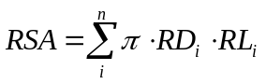 | (1)
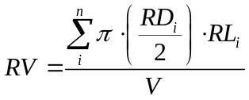 | (2)
where RSA and RV are the root surface area and root volume, respectively, RD_{i} is the diameter (mm) of the i-th root in the sample, RL_{i} is the length (mm) of the i-th root, and V is the soil layer volume.
After recording the root data, plant roots from different soil layers were dried at 65°C for 48 hours to calculate the root mass density (RMD, kg∙m⁻³), root length density (RLD, km∙m⁻³), root surface area density (RSAD, m²∙m⁻³), and root volume density (RVD, m³∙m⁻³) [6,33].
(3)
(4)
(5)
(6)
Lines 234-248 have been revised：
The model states that the shear strength of root-reinforced soil can be calculated using the Mohr-Coulomb equation as follows [13]:
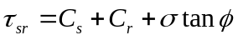 | (7)
where C_{s} is the soil cohesion, C_{r} is the additional cohesion due to the presence of roots, σ is the normal stress on the shear plane of the soil-root system (kPa), and ϕ is the internal friction angle of the soil (°). Assuming the roots are elastic and the Mohr-Coulomb criterion is effective for shear [9], and that the internal friction angle of the soil is unaffected, the additional root cohesion C_{r} can be estimated as [5,13]:
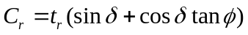 | (8)
where δ is the angle of the roots undergoing shear deformation relative to the shear plane, t_{r} is the product of the average tensile strength of the roots and the root area ratio (RAR), which is the fraction of the soil area occupied by roots. The value of $\left(sinδ+cosδtanϕ\right)$ can be approximated as 1.2 [9,13]. Therefore, the equation can be rewritten as:
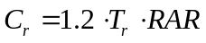 | (9)
Where T_{r} is the average tensile strength of the roots per unit soil area, obtained from single root tensile tests. RAR is the ratio of the total root area (A_{r}) to the soil area (A_{s}) for each soil layer. C_{r} is the additional cohesion due to the presence of roots.

- Figure 2: When providing pictures please indicate the data sources.This comment refers to all figures in the manuscript.
Response:Thank you very much for your valuable feedback. We have carefully considered your suggestions. Figure 2 is a flowchart of the in-situ shear test, and to make the test steps clearer, we have added explanations of the specific steps in the manuscript. The data in Figures 3 and 4 are obtained from experimental results. We hope these changes enhance the clarity of the manuscript.
Lines 177-191 have been revised：
This study utilized a self-designed and custom-fabricated in-situ shear test apparatus. The dimensions of the instrument frame were 150 × 35 × 16 cm, with a shear box size of 20 × 20 × 10 cm and a shear plane area of 0.04 m². The instrument connected the shear box to the guide rail using clamps and sliders. To ensure a stable shear direction, three 60 cm long iron rods were used to secure the instrument at the front and rear into the soil. Pressure sensors (0-3000±0.1 N) and displacement sensors (0-200±0.1 mm) were used for data measurement and recording. The shear rate was set at 0.3 mm/s [18].
Before the shear test began, a rectangular trench was excavated to accommodate the shear apparatus, with a reserved root-containing soil volume of 25 × 25 × 10 cm. The shear apparatus was placed in the trench, aligning the reserved root-containing soil with the shear box, and minor adjustments were made to the surrounding soil outside the shear box. The instrument was fixed in place using iron stakes, and the sensors were zeroed before commencing the test. The specific experimental procedure is shown in Figure 2.
Lines 310-313 have been revised：
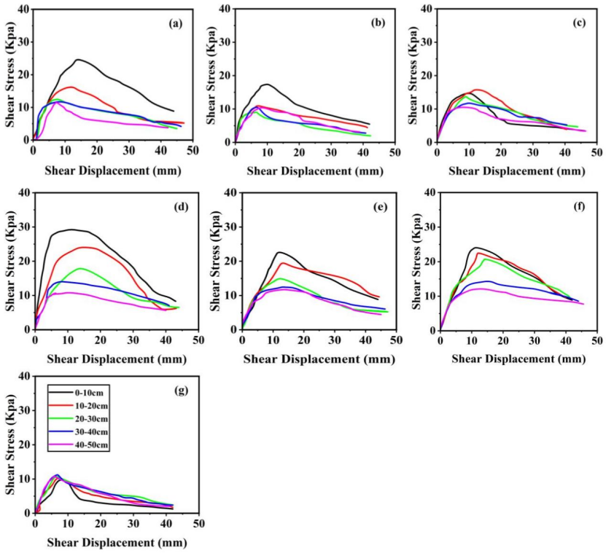
Figure 3. Shear stress-displacement curves of different soil layers under various vegetation types.Source:Author’s own work. Figures (a)-(g) correspond to Artemisia hedinii (A. hedinii), Setaria viridis (S. viridis), Periploca sepium (P. sepium), Ziziphus jujuba (Z. jujuba), Populus przewalskii (P. przewalskii), Broussonetia papyrifera (B. papyrifera), and wasteland, respectively
Lines 341-344 have been revised：
Figure 4. Power regression curves showing the relationship between tensile strength and root diameter.Source:Author’s own work. Figures (a)-(f) correspond to Artemisia hedinii (A. hedinii), Setaria viridis (S. viridis), Periploca sepium (P. sepium), Ziziphus jujuba (Z. jujuba), Populus przewalskii (P. przewalskii), and Broussonetia papyrifera (B. papyrifera), respectively

- Section 2.5 should be expanded, and the selected approach shouldbe discussed in more detail.
Response:Thank you very much for your constructive suggestion. We have expanded Section 2.5 as per your recommendation and provided more detailed discussion on the selected approach. We hope this revision addresses your concern and enhances the clarity and depth of the manuscript.
Lines 250-260 have been revised：
One-way analysis of variance (ANOVA) and Tamhane T2 post hoc test were used to analyze the differences in soil properties (BD, SWC, and SOM), root traits (RLD, RMD, RSAD, RSVD, CRR, MR, FR, HR, OR, and VR), and shear strength parameters (SE, PSS, and DPS) of six plant types in the 0-50 cm soil layers (p < 0.05). Regression analysis was employed to establish the relationship between root tensile strength and diameter, as well as to analyze the specific relationship between shear strength parameters, soil properties, and root traits. Principal component analysis (PCA) was used to group different vegetation types and soil depths, analyzing the correlations between shear strength parameters, soil properties, and root traits to determine the relationships between various variables. All statistical analyses were performed using SPSS 26.0 and Origin Pro 21.0 software.

- Please highlight and bullet a few major conclusions from your study.Also, seeing some comments about possible future steps will be interesting.
Response:Thank you for your valuable feedback. In response to your suggestion, I have revised the conclusion section to highlight the major findings.
Lines 467-481 have been revised：
This study investigated the shear strength of soil-root systems of six vegetation types in the Yellow River Basin of China using both the Wu-Waldron model and in-situ shear tests. It explored the relationship between shear strength, soil properties, and root traits. Significant differences were observed in the root traits among the six woodland shrubland, and grassland plant species. As soil depth increased, RLD, RMD, RSAD, and RVD showed a clear decreasing trend. Additionally, there were significant variations in soil properties; specifically, SOM gradually decreased, while SWC and BD both increased with soil depth.Soil properties and root traits significantly influenced the shear strength of the soil-root systems. In the in-situ shear tests, the three shear strength indices—SE, PSS and DPS—were positively correlated with RMD and negatively correlated with soil water content SWC. The results from both the in-situ shear tests and the Wu-Waldron model were consistent. Considering both methods, Ziziphus jujuba, Populus przewalskii, Broussonetia papyrifera, and Artemisia hedinii demonstrated the best slope protection effects in shallow soil layers. These findings may provide guidance for selecting vegetation for slope protection efforts in the Yellow River Basin.
Once again, we sincerely thank you for reviewing our paper and providing your feedback.
Reviewer 4:
- Figures A1, A2, A3, A4 and tables A1-A3 are mentioned in the paper, but they are not found in the paper, which makes it difficult to evaluate the interpretation of the results.
Response:Thank you very much for your reminder. We have addressed the missing Figures A1 to A4 and Tables A1 to A3 by adding them to Appendix A.
Figure A1. Soil properties at different soil layers (0-10, 10-20, 20-30, 30-40, 40-50 cm) for different plants. (a)-(c) show organic matter content, soil water content, and soil bulk density in each soil layer, respectively.
Figure A2. Root distribution characteristics at different soil layers (0-10, 10-20, 20-30, 30-40, 40-50 cm) for different plants. (a)-(d) show the distribution of root length density, root mass density, root surface area density, and root volume density in each soil layer, respectively.
Figure A3. Number of fine, small, medium, and coarse roots for different plants. (a) Number of fine, small, medium, coarse, and total roots for six plants in the 0-10 cm soil layer; (b) Number of fine, small, medium, coarse, and total roots for six plants in the 0-50 cm soil layer. Fine roots (d≤2 mm), small roots (2 mm＜d≤5 mm), medium roots (5 mm＜d≤10 mm), coarse roots (d＞10 mm).
Figure A4. Number of horizontal, oblique, and vertical roots for different plants. (a) Number of horizontal, oblique, and vertical roots for six plants in the 0-10 cm soil layer; (b) Number of horizontal, oblique, and vertical roots for six plants in the 0-15 cm soil layer. Horizontal roots (0°＜θ≤30°), oblique roots (30°＜θ≤60°), vertical roots (60°＜θ≤90°).

Table A1. Average soil properties in the 0-50 cm soil layer for different vegetation types.
Land Use | Plant Species | BD | SWC | COM
Wasteland | / | 1.5861ª | 0.180567^{c} | 11.3667^{b}
Grassland | A. hedinii | 1.2968^{d} | 0.211667^{b} | 9.88^{c}
Grassland | S. viridis | 1.4026^{bc} | 0.208767^{b} | 20ª
Shrubland | P. sepium | 1.3344^{cd} | 0.2286ª | 11.51^{b}
Shrubland | Z. jujuba | 1.4422^{c} | 0.2098^{b} | 9.8833^{c}
Woodland | P. przewalskii | 1.4219^{b} | 0.160067^{d} | 8.5267^{d}
Woodland | B. papyrifera | 1.3236^{d} | 0.185^{c} | 11.3467^{b}
¹ Different lowercase letters indicate significant differences between vegetation types (P < 0.05).

Table A2. Average root distribution characteristics in the 0-50 cm soil layer for different vegetation types.
Land Use | Plant Species | RLD | RMD | RSAD | RVD
Grassland | A. hedinii | 448.895ª | 7.257^{b} | 109.958ª | 20.167^{c}
Shrubland | S. viridis | 193.344^{b} | 0.227e | 57.601^{ab} | 1.060e
Shrubland | P. sepium | 97.469^{c} | 5.913^{c} | 9.717^{b} | 24.983^{b}
Woodland | Z. jujuba | 83.993^{d} | 5.223^{d} | 10.252^{b} | 12.667^{d}
Woodland | P. przewalskii | 98.5167^{c} | 12.487ª | 12.871^{b} | 79.967ª
Land Use | B. papyrifera | 28.920e | 5.113^{d} | 17.273^{b} | 20.333^{c}
Land Use | Plant Species | RLD | RMD | RSAD | RVD
¹ Different lowercase letters indicate significant differences between plant types (P < 0.05).

Table A3. Average root quantity characteristics in the 0-50 cm soil layer for different vegetation types.
Land Use | Site Species | Size classes |  |  |  | Angle classes
Land Use | Site Species | CR | IR | MR | FR | HR | OR | VR
Grassland | A. hedinii | 0^{b} | 1.67^{b} | 6.33^{b} | 684ª | 231.33ª | 303.33ª | 122.33ª
Grassland | S. viridis | 0^{b} | 0^{c} | 0e | 91.33^{c} | 0^{f} | 0e | 92^{b}
Shrubland | P. sepium | 0^{b} | 0.58ª | 2^{d} | 37e | 19.33^{c} | 26.33^{b} | 25^{d}
Shrubland | Z. jujuba | 2ª | 0^{b} | 3.67^{c} | 37e | 16.67^{d} | 24.67^{b} | 5.67^{f}
Woodland | P. przewalskii | 1.67ª | 0.58^{b} | 9.67ª | 43.33^{d} | 36^{b} | 10^{c} | 9.33e
Woodland | B. papyrifera | 0^{b} | 0.58^{b} | 1.67^{d} | 98^{b} | 9.33e | 7.33^{d} | 45.33^{c}
¹ Different lowercase letters indicate significant differences between plant types (P < 0.05).
Once again, we sincerely thank you for reviewing our paper and providing your feedback.

