Response to Reviewer 3 Comments

We would like to appreciate your time to provide us with your precious feedback on this paper.
Below are the concerns/questions and we tried to address them carefully, and the corresponding revisions/corrections highlighted/in track changes in the re-submitted files.

Comments 1: In the introduction please emphasize the novelty and the idea of this paper as much as possible. Add the hypotheses in form of questions. At the end of the Intro section please add the short description of each of the following manuscript sections.

Response 1: Thank you for your valuable feedback. We have carefully integrated your suggestions into the introduction, Section 1, the last paragraph of the manuscript as follows:
“The novelty of this research lies in its comprehensive comparison of different ML models to predict TBP mixture viscosities, which could significantly streamline industrial processes and reduce exposure to toxic solvents. The second section provides a comprehensive overview of the experimental database, feature visualization, machine learning model setup, and statistical analysis. Section 3 explores our findings, emphasizing the advantages of employing various machine learning techniques and showcasing the impressive effectiveness of each model. Section 4 comprises the discussion, and finally, Section 5 summarizes our findings, underscoring the model's potential in enhancing viscosity refinement and advancing our knowledge of TBP fluid properties.”

Comments 2: In graphs such as figure 1 and others use the same font as in text (TimesNewRoman). All plots in the manuscript were done using the matplotlib. Here is the code for adjusting the font size and set the font style to TimesNewRoman.
import matplotlib.pyplot as plt SMALL_SIZE = 20
MEDIUM_SIZE = 22
BIGGER_SIZE = 24
plt.rc('font', size=SMALL_SIZE) # controls default text sizes plt.rc('axes', titlesize=SMALL_SIZE) # fontsize of the axes title plt.rc('axes', labelsize=MEDIUM_SIZE) # fontsize of the x and y labels plt.rc('xtick', labelsize=SMALL_SIZE) # fontsize of the tick labels plt.rc('ytick', labelsize=SMALL_SIZE) # fontsize of the tick labels plt.rc('legend', fontsize=SMALL_SIZE) # legend fontsize plt.rc('figure', titlesize=BIGGER_SIZE) # fontsize of the figure title
plt.rcParams["font.family"] = "Times New Roman"

Add the grids to all plots in the manuscript this is mandatory.

Response 2: Thanks for this feedback. We modified and updated all figures throughout the paper.

Comments 4: Correlation matrix was done using matplotlib and seaborn library. Please add numbers to the correlation matrix heatmap. Here is the code.
import matploitlib.pyplot as plt
import seaborn as sns
plt.figure(figsize=(12,8))
sns.heatmap(data.corr(), annot=True)
plt.show()
Response 4: The heatmap has been replotted to illustrate the correlations numerically. The updated heatmap is provided here for your review and has also been included in the manuscript on page 5.
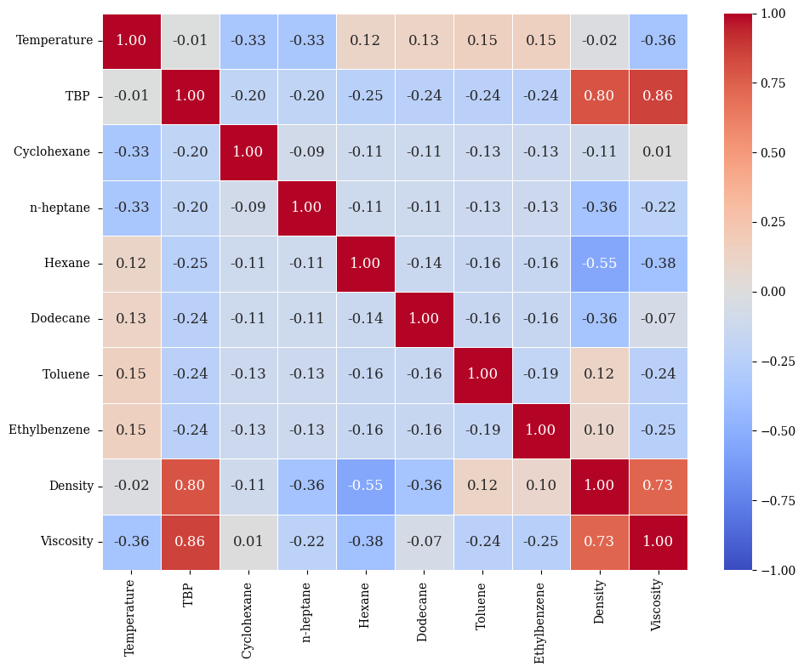

Comments 5: You have used R^2, MAE and RMSE, You should consider using MAPE, RMSE and kling-gupta efficiency. For kling gupta efficiency please check the paper. On the application of symbolic regression in the energy sector: Estimation of combined cycle power plant electrical power output using genetic programming algorithm

Response 5: We appreciate your insightful comments and recommendations on the evaluation metrics. We understand how crucial it is to evaluate machine learning model performance using a variety of measures. We used R², MAE, and RMSE for our study because these metrics are well-known and commonly used in regression analysis and machine learning. In terms of goodness-of-fit (R²), average magnitude of errors (MAE), and overall divergence of predicted values from actual values (RMSE), these metrics offer a comprehensive overview of the models' performance.
R² measures the proportion of variance in the target variable explained by the model, indicating its overall fit. MAE gives the average absolute difference between predicted and actual values, providing a clear and robust assessment of model performance that is less affected by outliers. RMSE highlights larger errors more by penalizing them, making it valuable in contexts where minimizing significant deviations is critical.
While we acknowledge the utility of MAPE and Kling-Gupta Efficiency in specific contexts, we believe that the metrics used in our study adequately capture the performance characteristics of our models. The combination of R², MAE, and RMSE offers a robust evaluation framework that aligns well with our study's objectives and the nature of our data.

In the context of our study, where we focus on absolute values and their deviations, MAE and RMSE offer a more direct and reliable measure of prediction accuracy. Additionally, our study includes the Margin of Deviation (MOD), can be consider instead of MAPE, as defined in Equation 9, which we have investigated to further demonstrate the performance of our model.

Regarding KGE, it is a comprehensive metric that combines correlation, bias, and variability, making it particularly useful for hydrological and environmental modeling. While it offers a comprehensive view, our study focuses on the prediction of viscosity in TBP mixtures, where the primary concern is the magnitude and direction of errors rather than the correlation and variability aspects covered by KGE. Our choice of metrics was guided by their relevance and interpretability in the context of our study.

We added the above justification and added reference 34 (Gupta, 2009) as a future insight to be further investigated to the discussion section, paragraph 4.

Comments 6: The discussion is too short please create a detailed discussion section.
Response 6: Thank you for pointing this out. We agree with this comment. Therefore, we have modified the discussion section to be more comprehensive and cover the most important parts of the paper.

Comments 6: The Conclusion section must be restructured. First paragraph - short description of what was done in the manuscript. The second paragraph - answers the hypotheses defined in the intro section based on the discussion section. Third paragraph are pros and cons of the proposed research methodology. Pros and cons are Advantages and disadvantages. The final paragraph is directions for future work i.e. improvements that are based on the disadvantages of the proposed research methodology.
Response 6: Thank you for bringing that up. We have modified the Conclusion section based on your recommendations.

