Dear Reviewer,
Thank you for taking the time to review our paper and for your valuable comments and suggestions. They were very insightful, and we appreciate the positive feedback. We hope that this revised version is satisfactory for publication in the 'Sustainability' journal.
We are now submitting our edited revised manuscript, considering all the necessary corrections. We believe that the quality of our paper has been improved, and we hope that it now meets the required publication standards in 'Sustainability.'
Thank you in advance, and we look forward to hearing from you.
Best regards,
Prof. Hatem DHAOUADI
--------------------------------------------------

The manuscript describes the use of activated carbon from pear seeds for pesticide removal and investigates physicochemical aspects of the adsorption process. The text is mostly clear and concise and may be of interest to the audience reached by the journal. Hence, I recommend its acceptance after some revisions, as stated below.
Reply:
We appreciate your positive feedback. Thank you for taking the time to review our paper and for your valuable comments and compliments.

1/ It is not clear if the pesticide Deltamethrin is soluble in water. Hence, it should be clarified in which media the adsorption experiments were performed.
Reply:
Pure deltamethrin has low water solubility (0.2 µg L⁻¹ at 25°C) but is soluble in some organic solvents. All experiments were conducted in ultra-pure water using a water-soluble form of the commercial pesticide (DECIS EXPERT, BAYER®), to ensure realistic results. This information has been added to the revised manuscript as per your request. (Please see Page 4 Line 125).

2/ Regarding the acidic groups found on the surface of activated carbon, is there any publication on similar systems that corroborate these results using spectroscopic techniques, like XPS?
Reply:
Regarding the acidic groups found on the surface of activated carbon, our results are corroborated by some publications that used X-Ray Photoelectron Spectroscopy (XPS) on similar systems. As per your request, two new references (67 and 68)) have been added. (Please see Page 9, line 315).
[67] XPS and NMR studies of phosphoric acid activated carbons, A.M. Puziy, O.I. Poddubnaya, R.P. Socha, J. Gurgul, M. Wisniewski, CARBON 46 (2008) 2113 –2123, doi:10.1016/j.carbon.2008.09.010
[68] Oxygen and phosphorus enriched carbons from lignocellulosic material, Alexander M. Puziy, Olga I. Poddubnaya, Amelia Martínez-Alonso, Alberto Castro-Muñiz, Fabian Suárez-García, Juan M.D. Tascón, Carbon 45 (2007) 1941–1950, doi:10.1016/j.carbon.2007.06.014

3/ Pore size distribution seems to lay around 4 nm (Figure 3), although authors state that it is between 2 and 50 nm.
Reply:
You are absolutely right. A mistake was made in choosing the correct figure. Figure 3, in fact, represents the BJH desorption dV/dw Pore volume (dV/dw Pore volume (cm³/g.nm) vs Pore width (nm)). The correct figure we intended to present is the incremental Pore Volume (cm³/g) vs the Pore width (nm), which is the BJH pore size distribution (Figure 4a).
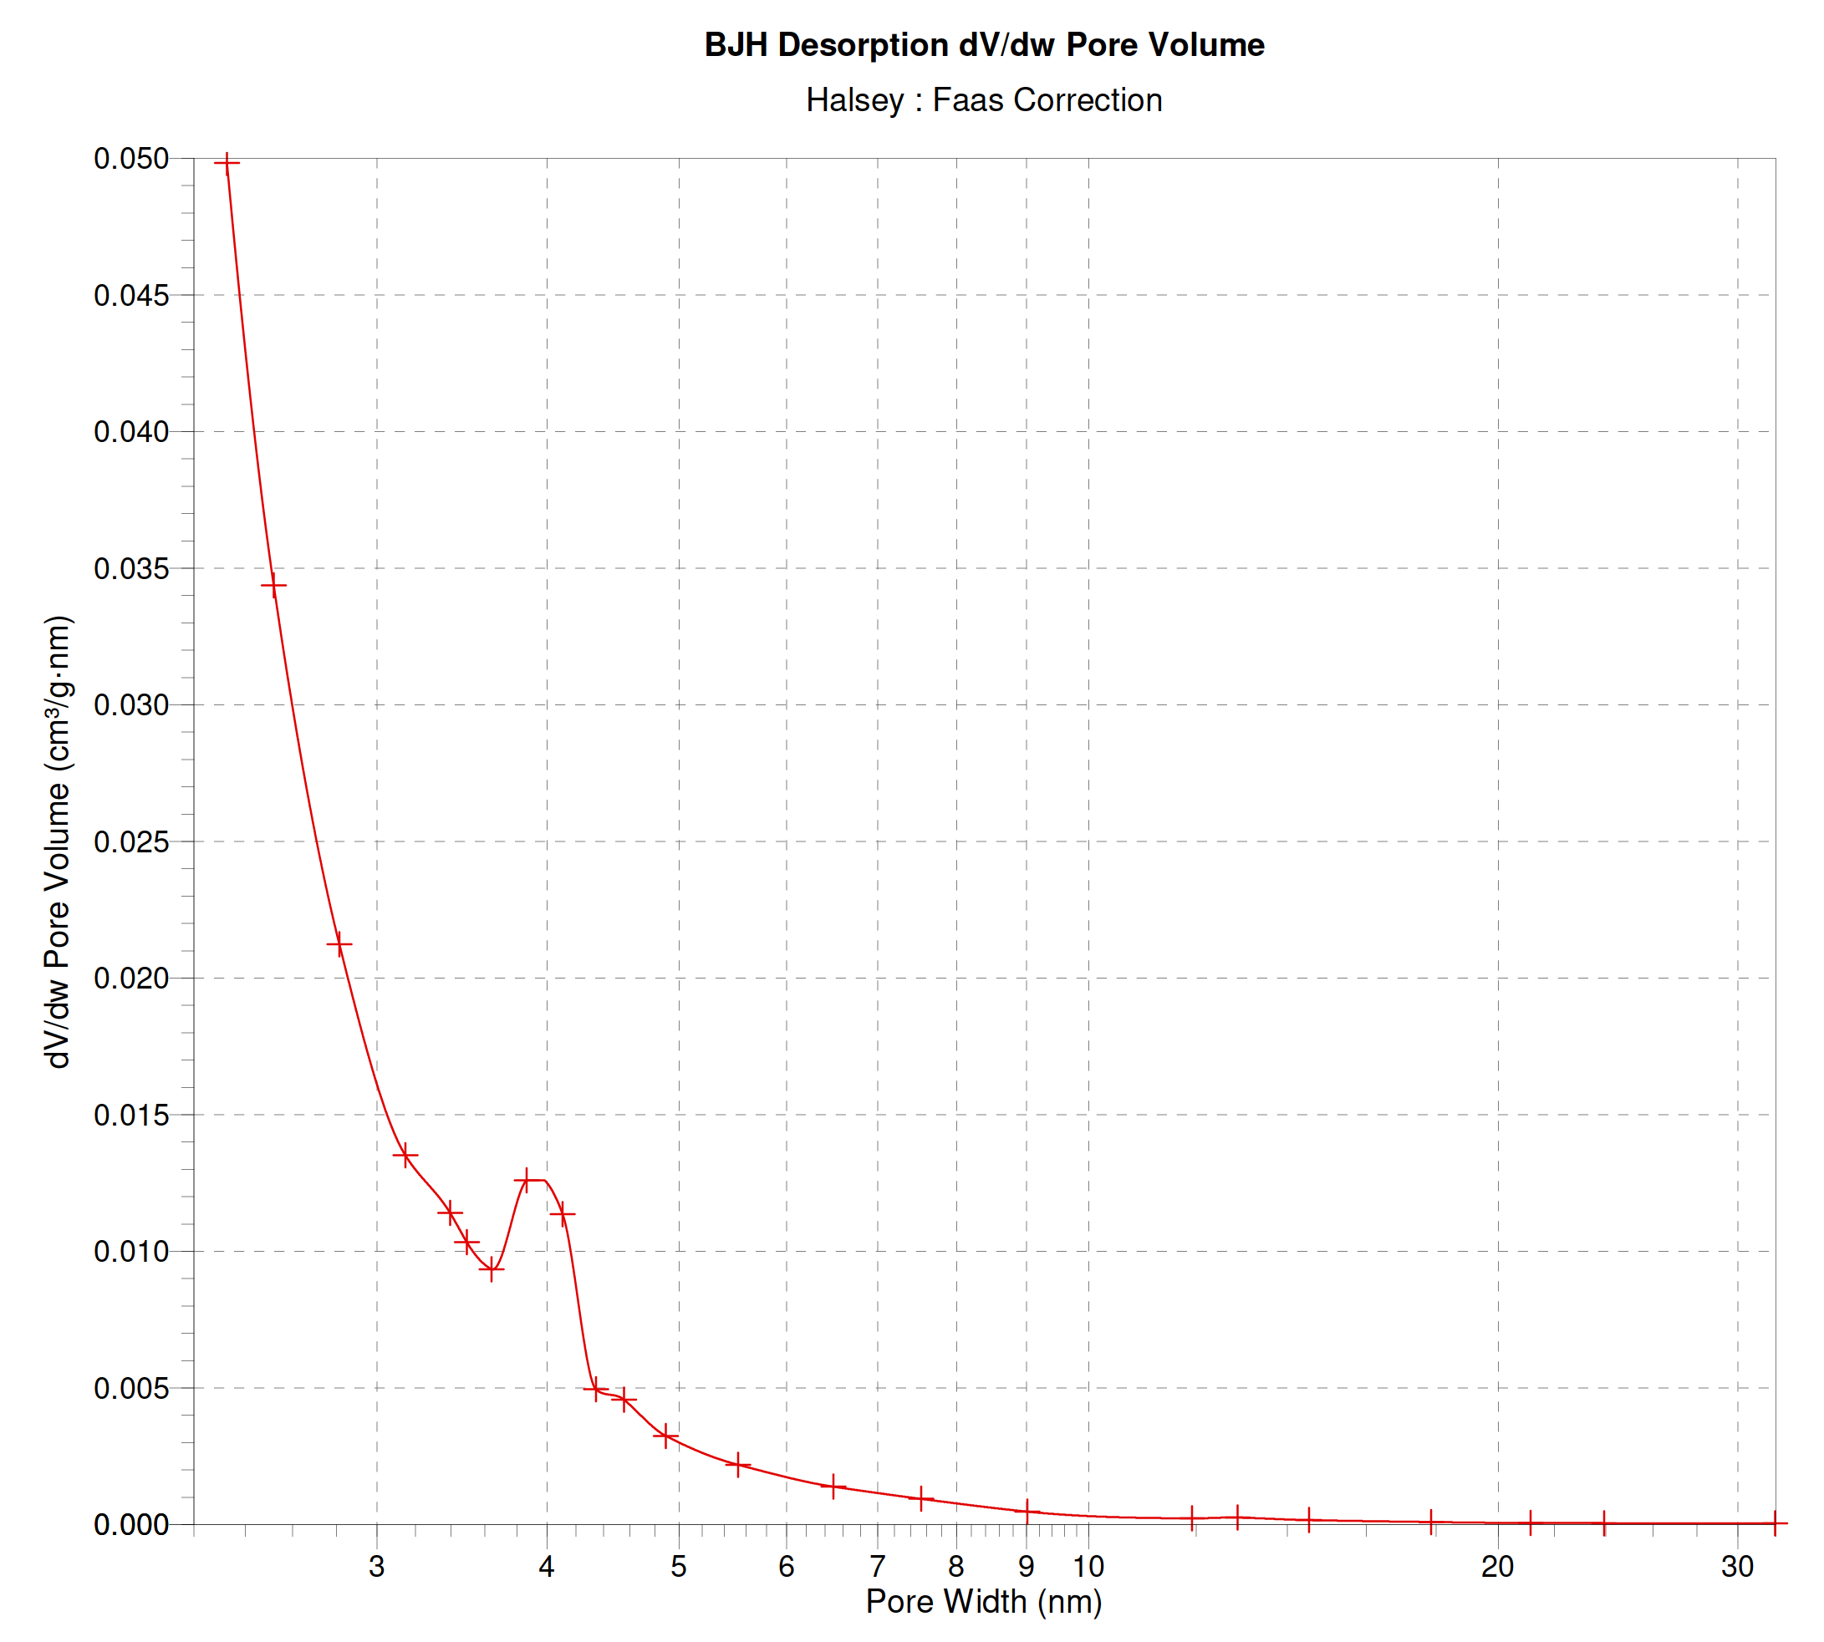 | 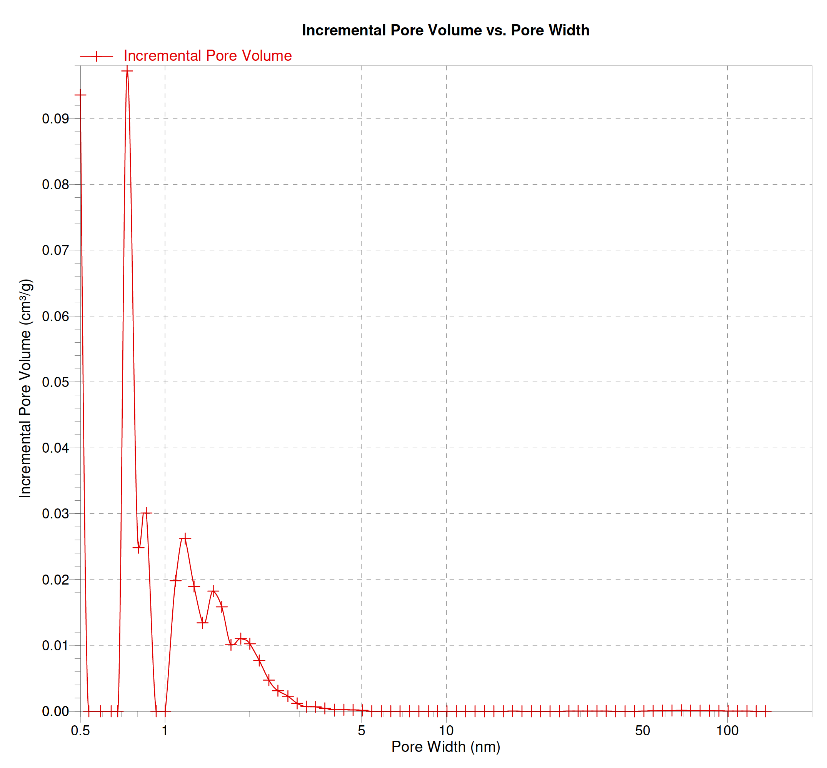
Figure 3 (initially) | Figure 4a (new numbering after a figure addition)
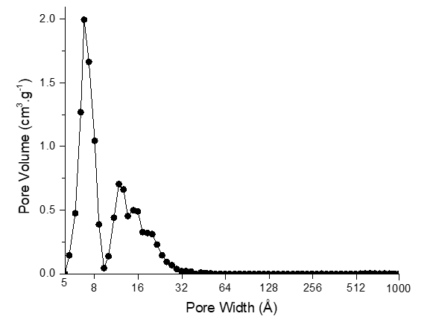 | 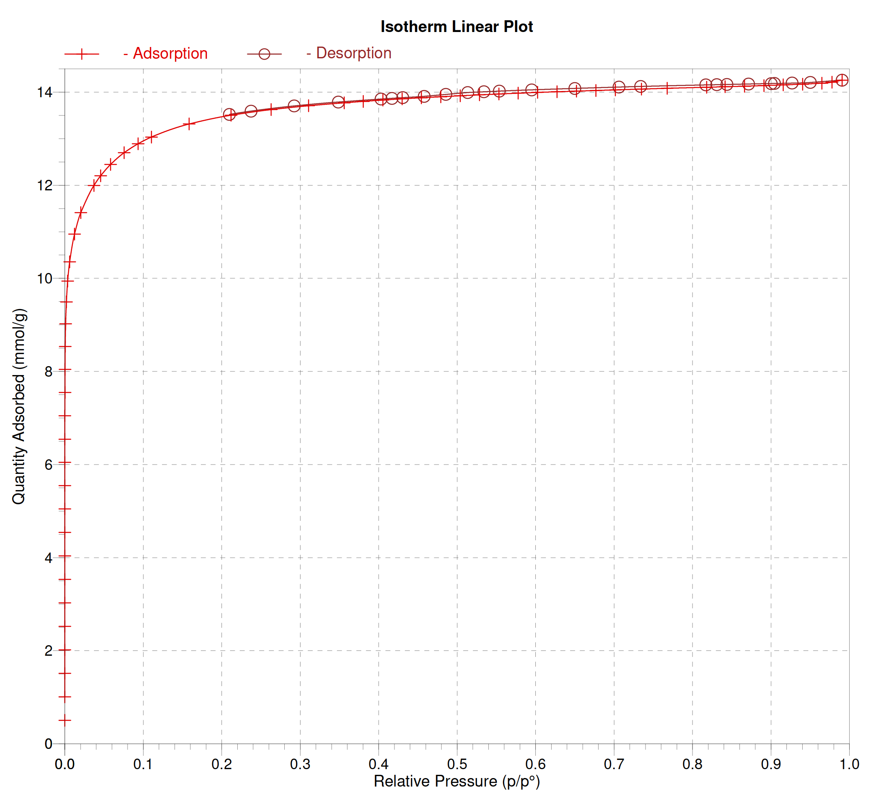
DFT pore size distribution | Figure 4b

The BJH pore size distribution of our elaborated AC indicates a majority of microporosity, with a mean pore width slightly less than 2 nm. This result is also confirmed by the DFT model (left lower part of the above four figures), where the Pore width is presented in Angstrom (Å). The adsorption-desorption isotherm (Figure 4b) is characterized by a rapid adsorption at low relative pressures, followed by a slower adsorption at higher pressures. During desorption, a slow desorption is observed at higher relative pressures, followed by a rapid desorption at low pressures. This behaviour, combined with the absence of hysteresis during the adsorption-desorption process (see figure 4b), is characteristic of microporous material.
The former sentence (page 9 line 340) is replaced by the following one “The Barrett-Joyner-Halenda (BJH) pore size distribution (Figure 4a) clearly indicates a majority of microporosity, with a mean pore width slightly less than 2 nm. This is corroborated by the shape of the adsorption-desorption isotherm and the absence of hysteresis (Figure 4b), which is expected in the case of microporous material.”
The Figure 4b has been added as requested by reviewer 2 and reviewer 4.

4/ Authors are invited to provide more SEM images of the materials. The only one presented in the manuscript has a low resolution and might not be representative for the whole material.
Reply:
According to your request, the resolution of the image have been improved.
(Please see Page 10 Figure 5).
Unfortunately, we only have this SEM image.

5/ What are the lines that adjust the experimental points displayed in Figure 7?
Reply:
In Figure 7 (now Figure 8), the lines that adjust the experimental points displayed are those of the Pseudo First Order (PFO) model. This detail is added to the figure legend.

6/ In Table 6, why were the thermodynamic parameters calculated for one single temperature?
Reply:
Equation (4) on page 7, line 255, states that the standard Gibbs free energy change (∆G°) is temperature-dependent. In the considered temperature range of 30-50°C, we assume that both enthalpy (∆H°) and entropy (∆S°) are constant and temperature-independent. This is the reason why the thermodynamic parameters are calculated for a single temperature. We have added this information to the revised manuscript as per your request (Please see Page 15 line 466).

7/ English editing is recommended in the whole manuscript.
Reply:
All of the manuscript text has been revised, and English language mistakes have been corrected by an English professor. Please find attached to this review an English edition certificate.

