Comments:
The updated version of the manuscript incorporated mostly minor revisions throughout the text, with major alterations made to the conclusion. However, these changes do not effectively fulfill the intended purpose of elucidating recent scientific advancements regarding the role of inflamm-ageing in the decline of periodontal function and the development of periodontitis.
I genuinely appreciate the substantial effort made by the authors to synthesize the existing evidence on this topic. Nevertheless, the paper falls short of delivering substantial clarity or significant insights. I would strongly recommend that the authors consider reworking Figure 1 to provide readers with a graphical representation that aligns with the paper's stated objective of clarification.
Response:
Thank you so much for your constructive suggestion.
- Following your suggestion, we have expanded our conclusion and have made our manuscript clearer. To clarify the mechanisms by ageing affects periodontitis, several challenges need to be addressed. These challenges include distinguishing the direct or external oral environment, the differences of study between mice and humans and the genetic heterogeneity among humans. Based on these results, our revised conclusion as follow: The prevalence and severity of periodontitis increase with age, making it a significant health concern for the growing elderly population. As human lifespan continues extending globally, understanding the impact of ageing on physiological and disease pathological has garnered significant attention in recent years. In this review, we have provided an up-to-date summary of the current knowledge of biological ageing and periodontitis, with a focus on the molecular mechanisms underlying pathological ageing at the periodontal level. Firstly, we have synthesized current knowledge on the pro-inflammatory cytokines, chemokines and cellular signalling pathways that regulate immunosenescence and age-related chronic inflammation. Elucidating these mechanisms enhances our understanding of the relationship between aging and inflammation. Furthermore, we have summarized the key bacteria associated with periodontitis pathogenesis. Identifying these microbes provides critical insights into the etiology of periodontitis. Overall, this review integrates findings across multiple are as immunosenescence, oral microbiome changes, and tissue destruction pathways to provide a comprehensive overview of the linkages between aging and periodontitis. In fact, the interplay between aging and inflammation represents a complex process with no clearly established causality or directionality yet. Several challenges persist in our current understanding of the biological mechanisms through which aging influences periodontitis. However, it is evident that age-related processes can contribute to the initiation of inflammation, be a consequence of existing inflammation, or involve a bidirectional relationship between the two phenomena. Given these understanding, we proposed the pathways linking inflammation and periodontitis, examining how ageing influences the inflammation-periodontitis linkage and immune resistance (Fig. 1). Gaining a more comprehensive the complex interactions between ageing, inflammation and periodontitis are critical for developing effective interventions to prevent and treat these conditions in older adults. Further studies should build upon this synthesis of current knowledge to deepen our mechanistic comprehension of this major age-related oral health concern.
- According to the comment, we have reworked the Figure 1 to provide readers with a graphical representation that aligns with the paper's stated objective of clarification. The revised Figure as follows: 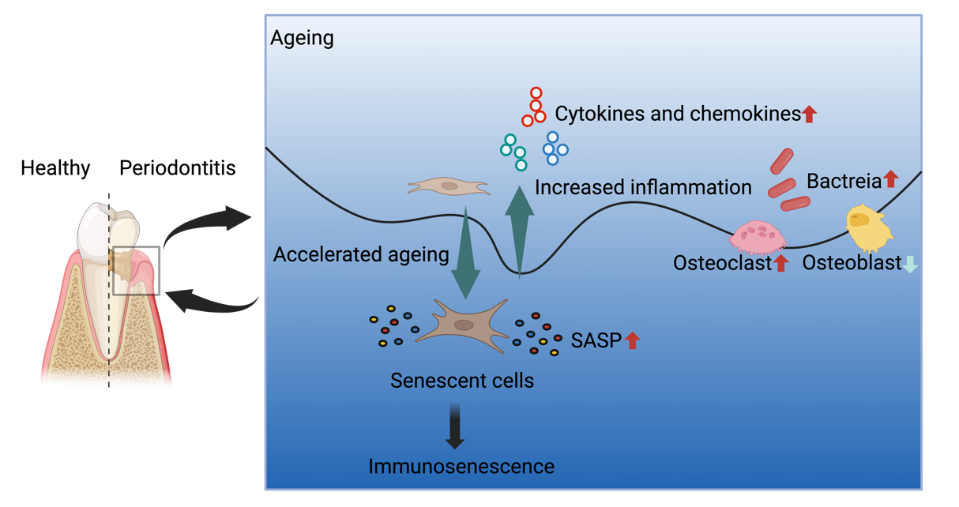
Figure 1. The interplay of factors associated with ageing and inflammation in the development of periodontitis.
Thanks for your suggestions again.

