Point-by-point Response to Reviewers’ Comments
Reviewer #2 Comment:
The present review article discussed the role of TRPC6 in increased synapse formation and enhanced learning and memory in animal models. TRPC6 has been shown to be involved in different synaptic-protective signaling pathways, including antagonism of NMDAR, activation of BDNF, and postsynaptic store-operated calcium entry. Overall article discussed the role of TRPC6 in memory formation in various parts of the brain to understand how TRPC6-specific pharmaceutical agents will affect memory in distinct parts of the CNS.The research paper is well-planned however lacks current research and expert opinion. However, a few suggestions are here to incorporate.
Authors’ response:
We appreciate the time and effort that the reviewer #2 has dedicated to providing valuable feedback on our article. We are grateful to the reviewer for the insightful comments on our paper. Below is our point-by-point response to each comment. Text that has been added to the manuscript is highlighted by yellow color. Text that has been deleted can be seen via “track changes utility”.
Comment 1: In Table 1, the experimental periods and doses should be included, which are very important.
Response 1: We totally agree with this and have incorporated the experimental periods, doses and method of administration into Table 1.
Comment 2: In the abstract, we have observed ……independent fear memory is mentioned however in the main body of the article only 1 case of 5XFAD mice was discussed.
Response 2: Agree. Mention this result is surplus to requirements. We exclude it from abstract and rewrite it. Please, see revised version of abstract (lines: 15 — 16)
Revised manuscript (Line 15 — 16): It has been observed that TRPC6 agonists have a great influence on animal behavior including memory formation and storage.
Comment 3: The major importance of this article is the role of neuronal TRPC6 channels in synapse development, memory formation, and animal behavior however research-based data were vaguely described or completely skipped.
Response 3: Thank you for the comment. We tried our best to describe research-based data comprehensively. We have incorporated some parts of review with additional information for making it more understandable.
We have pointed the NMDAR-dependent neurotoxic cascade (Lines: 116 — 119) and NMDAR’ composition (Line:126 — 128)
We added details to the mechanism of TRPC6’ activation. Please, see the highlighted sentences (lines:95-103).
We have expanded the discussion of TRPC6-mediated mechanism of blocking extrasynaptic and synaptic NMDAR. Briefly, TRPC6 may impede the extrasynaptic NR2B-containing NMDA receptors' calcium influx via calcineurin (see the dashed lines in Figure 1). On the other hand, activation of synaptic NR2A-containing NMDAR may increase TRPC6 mRNA synthesis through a calcineurin-dependent pathway (see the solid lines in Figure 1). Please, see the highlighted parts in the section 3 (Line 113 — 145).
We have added some extra information on BDNF’ levels in the of TRPC6’ blocking condition (Line 199-203).
We also added an explanatory sentence to the detailed TRPC6-mediated neuroprotective mechanism of endocannabinoids (lines 207 — 208) in the section 3.
We have changed the Figure 1 by adding divided pathways for each of the NMDAR types (NR2A- and NR2B-containing). We also distinguished the pathways by the type of lines (dashed lines for extrasynaptic NR2B-containing NMDAR and solid lines for synaptic NR2A-containing NMDAR). Please see the revised figure. Furthermore, we added a brief description of all molecular pathways to the figure legend. Please see the revised legend (lines 224 — 241).
Revised manuscript (Line 116 — 119): Such rapid increases in cytoplasmic calcium concentrations may activate and over-stimulate a variety of proteases, kinases, endonucleases, etc. This downstream neurotoxic cascade may trigger severe damage to neuronal functioning [33].
Revised manuscript (Line 126 — 128): NMDA receptors are composed of two obligatory NR1 subunits and two regulatory NR2A or NR2B subunits. The ratio of NR2A/B NMDA receptor subunits may change during postnatal development.
Revised manuscript (Line 133 — 145): Activation of NR2B-containing NMDARs enhances TRPC6 degradation through calpain [39]. Furthermore, TRPC6 overexpression has been reported to inhibit the NMDA-induced calcium elevation as assayed by calcium imaging [40]. Moreover, the whole-cell patch-clamp recording shows that overexpression or pharmacological activation of TRPC6 selectively suppresses the NMDA-induced current [41]. Conversely, the downregulation of TRPC6 enhances this current [41] and aggravates calcium elevation [40]. The possible mechanism by which TRPC6 may impede the NMDA receptors' activity is their dephosphorylation by calcineurin. Calcineurin may be activated by TRPC6. It has been demonstrated that a calcineurin inhibitor re-versed the TRPC6 inhibition of NMDA current [40]. This suggested that TRPC6 may impede the NMDA receptors' activity via calcineurin. We assume that neuroprotective effect may be achieved by suppressing the toxic calcium elevation through extrasynaptic NR2B-containing NMDAR (see dashed lines in Figure 1).
Revised manuscript (Line 95 — 103): ROC: G protein-coupled receptor-activated phospholipase C (PLC) can modulate TRPC6 channel activity by hydrolysis of phosphatidylinositol bisphosphate (PIP2) to diacylglycerol (DAG) and inositol trisphosphate (IP3) [24]. DAG can directly activate TRPC6. Interestingly, the binding of brain-derived neurotrophic factor (BDNF) to tro-pomysin related kinase B (TrkB) results in the activation of PLC which also leads to the TRPC6 activation [27]. SOC: IP3 may bind to IP3 receptors (IP3R) which leads to the calcium release from the the main intracellular Ca2+ store (the endoplasmic reticulum). IP3-mediated emptying of the endoplasmic reticulum triggers TRPC6 activation via a store-dependent mechanism [28,29] (Figure 1).
Revised manuscript (Line 199 — 203): Interestingly, the other study demonstrated that pharmacological blocking of TRPC6 channels in rat retina leads to a significant increase in proBDNF (the BDNF precursor), while the level of mature BDNF (mBDNF) remains nearly constant [52]. Elevation of proBDNF may be suggested as feed back to the BDNF-initiated protective mechanism in the response of TRPC6 blocking.
Revised manuscript (Line 207 — 208): Both ligands are produced “on-demand” in response to increased calcium concentrations [53].

Revised figure
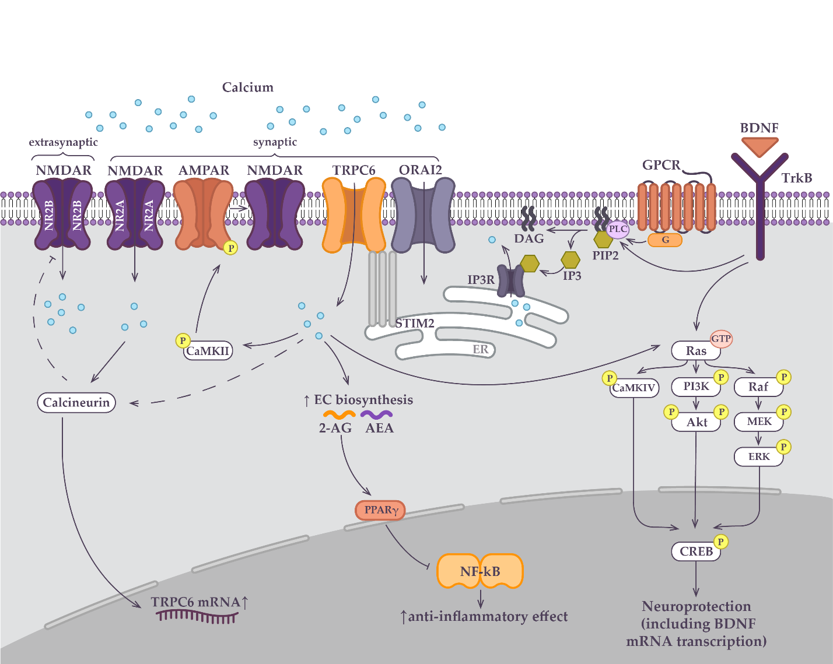
Revised manuscript (Line 225 — 242): Neuroprotective intracellular signaling pathways in the central nervous system involving TRPC6 activation. A detailed description of pathways is given in 3rd section. Presumably, TRPC6 may impede the extrasynaptic NR2B-containing NMDAR-dependent calcium influx via calcineurin-dependent dephosphorylation mechanism (see the dashed lines). On the other hand, activation of synaptic NR2A-containing NMDAR may increase TRPC6 mRNA synthesis through a calcineurin/nuclear factor of activated T-cells -dependent pathway in cortical neurons (see the solid lines). Agonism of synaptic NMDAR has been proposed to underlie the activation of synaptoprotective store-operated calcium entry via TRPC6 in hippocampal silent synapses. TPRC6 is key component of store-operated calcium entry in hippocampal neurons. TRPC6 may be activated directly either by DAG or pharmacological agent such as hyperforin as well as by store-depletion (following IP3R activation). Upon store depletion of ER, the STIM2 detects calcium level reduction and activates Orai2/TRPC6 channels complex. Calcium entry via TRPC6-neuronal SOCE is needed to activate CaMKII, which can phosphorylate AMPAR. This promotes AMPARs trafficking to the post-synaptic membrane, which increases membrane depolarization and enhances NMDAR's contribution to LTP maintenance. In addition, in neuronal tumor cells TRPC6-induced calcium entry is essential for the biosynthesis of endocannabinoids (2-AG, AEA) that have anti-inflammatory properties. Supposedly, neuroprotective effects are achieved by suppressing NF-κB via activation of the PPARγ. The binding of BDNF to TrkB results in the of PLC-dependent activation of TRPC6. Calcium influx through TRPC6 may also activate CREB through three signal cascades: Ras/MEK/ERK, RAS/PI3K/Akt, and CaM/CAMKIV. Neuroprotective effect is achieved via CREB-dependent activation of the BDNF transcription.
Comment 4: Detailed mechanism of action of TRPC6 in animal learning and memory of animals has been discussed.
Response 4: Thank you for the positive evaluation of our efforts.
Comment 5: Without a more detailed explanation of current researchers etc. and an expert opinion of the importance of the results this review is mostly just information.
Response 5: Thank you for this suggestion. We have proposed of a molecular scheme of the neuroprotective functions of TRPC6. Connecting independent studies in a molecular model is a part of our opinion on the role of TRPC6 in neuroprotection. However, we agree that we do not provide our point of view on which of the signaling pathway seems to be the most important in terms of neuroprotection. So we added a few thoughts on it in conclusion. Please, see highlighted sentences (Lines 370 — 377).
In conclusion, we likewise tried to point our opinion on possible therapeutic effect of TRPC6 positive regulation. Please see lines 378 — 387.
Revised manuscript (Line 370 — 377): In the current review, we have described different molecular pathways that we have tried to combine in the unified scheme (Figure 1). However, we still lack a good understanding of how all these different components work together in order to provide a neuroprotection. TRPC6-dependent regulation of BDNF or endocannabinoids has not been precisely studied in AD models or at least in hippocampal neurons, thus their contribution to the positive influence of TRPC6 agonists in AD-affected brains remains controversial. In contrast to this, NMDA antagonism, CaMKIV-CREB or SOCE-CaMKII pathways have stronger arguments in favor of their participation in TRPC6-mediated neuroprotection.
Revised manuscript (Line 378 — 387): However, the overactivation of TRPC6 may result in detrimental side effects. Excessive TRPC6 channel activation was demonstrated to cause glomerular damage due to their function in podocytopenia which all contribute to diabetic kidney disease (DKD) [111,112]. The TRPC6 channel's gain-of-function mutations have been discov-ered as a possible hereditary cause of renal disorders such as focal segmental glomerulosclerosis [113]. In addition, TRPC6-dependent signaling pathways are involved in the development of various types of cancers, as well as in the dysfunction of cells of the immune system [114]. The hyperactivation of TRPC6 channels by hyperforin leads to gastrointestinal disorders [115]. Thus, there is need to pick up the lowest effective dose of TRPC6-specific drug and to optimize drug regime in order to reduce the side effects of TRPC6 positive modulation.
Comment 6: More studies with references could be added to improve the article Ex- https://doi.org/10.3389/fcell.2020.618663, https://doi.org/10.3389/fphys.2020.00238.
Response 6: Thank you for the great reviews. We have mentioned them in our manuscript (Line 40, 66)
Revised manuscript (Line 38 — 40): Although many aspects of the physiology and regulation of TRPC6 are still elusive, dysfunction of the TRPC6 channel may trigger a wide range of CNS related diseases such as epilepsy, autism spectrum disorder (ASD) and Alzheimer’s disease, characterized by cognitive dysfunction [6–9].
Revised manuscript (Line 66): … thus, TRPC6 channels constitute an attractive molecular target neurodegenerative diseases [14].
Comment 7: Check all references for correction (Ex. Ref no 85. Activity. Sci. Reports 2014 41 2014).
Response 7: We thank Reviewer 2 for the careful reading of the manuscript. All references have been checked.
Comment 8: Line 213, in 3rd section instead of 3rd chapter.
Response 8: Thank you. We have fixed it.
Comment 9: Line 151, (AMPAR)), remove 1 extra bracket.
Response 9: Thank you. We have fixed it.

