Response Letter
September 13, 2023

Manuscript ID: remotesensing-2577474
Type of manuscript: Article
Title: EddyDet: A Deep Framework for Oceanic Eddy Detection in Synthetic Aperture Radar Images
Authors: Di Zhang, Martin Gade, Wensheng Wang *, Haoran Zhou
Received: 9 Aug 2023

Review 2:
1. Manuscript will benefit from additional proofreading and editing for clarity; the manuscript is frequently wordy to an unnecessary degree.
Answer: Thanks for your suggestions, we have carefully modified the manuscript to address the issue of wordiness. We hope that the revised version will make the manuscript more readable for you.
2. Authors need to ensure that all acronyms are defined
Answer: Thanks for pointing out this issue. In the revised version of the manuscript, we have addressed this concern.
3. All eddy detection methods and datasets have limitations and error. Authors should temper expectations in the introduction and make claims such as their method being able to detect every single eddy in the ocean perfectly. This is improved in the results and discussion.
Answer: Thank you. In the introduction part, our purpose is to express that we are able to realize “instance segmentation” (a computer vision task), which means we can detect the presence of eddies in an image and then assign a unique label or identifier to each instance. Our intention is not to imply that we can perfectly detect every single eddy.
Our previous statements are quite confusing to readers, so we have changed our description in Page 2 Line 74 “At present, the development of an end-to-end model that can automatically identify and segment individual objects within an image at the pixel level shows great promise” and Page 2 Line 78 “This paper introduces a new oceanic eddy detection network called EddyDet, which aims to identify and segment individual eddies accurately”.
4. This paper varies wildly in its categorization of success. The first half makes it seem as if this eddy detection system is near-perfect, but the discussion seems to only include negative results.
Answer: Thank you. We acknowledge that there may be a discrepancy in the presentation of success between the first half and the discussion section. The intention of the first half was to highlight the positive aspects and strengths of our eddy detection system, showcasing its capabilities and achievements.
However, we understand that it is equally important to provide a comprehensive and balanced view of the system's performance. In the discussion section, we aimed to present a more nuanced analysis by including the challenges, limitations, and negative results encountered during the evaluation of the system. This was done to ensure a realistic assessment of the model's performance and to encourage further research and improvement in this area.
5. Figures 4/5/6: while the colored shapes are useful for indicating where the eddies are, would it not be more useful to show the actual eddy contours as detected by the algorithm? Or are these the contours?
Answer: Thank you for your nice suggestions. We tried to show the eddy contours as detected by our model. However, the presentation results were not satisfactory. Below we show a comparison example, the eddy boundaries are more easily to identify if we use the colored shapes. Therefore, we remain the display way of colored shapes.
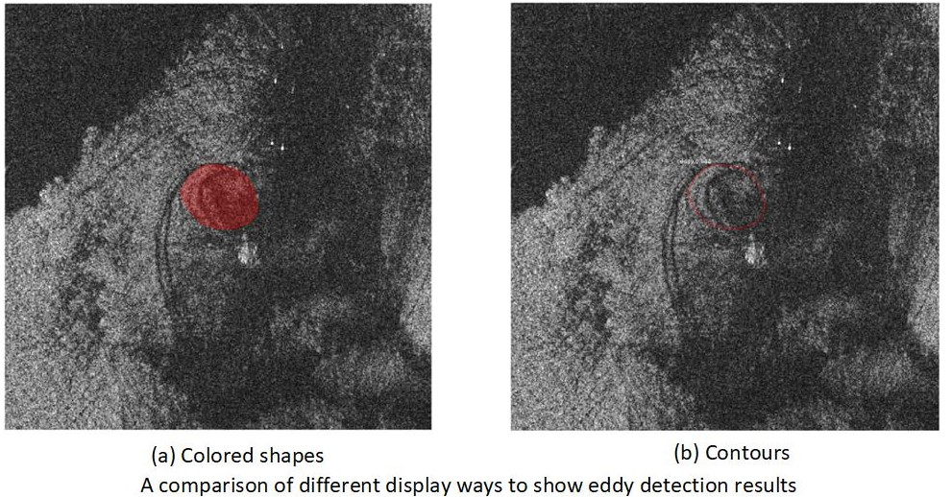
6. Description of eddy detection (around Figure 5) could be clearer.
Answer: Thanks for your suggestions. We modify the caption in Page 8 Figure 5 to make it clearer “The network architecture of EddyDet. It consists of five parts: an FPN Backbone Network, an RCNN Head, a Mask Head, an Edge Head, and a Mask Intersection over Union (IoU) Head. The input SAR image is processed by the FPN Backbone Network to generate Region of Interests (RoIs) and RoI features using RoIAlign. The RoI features are then passed to both the RCNN Head and the Mask Head. The Edge Head takes the predicted mask and its corresponding ground truth as input and compares their similarity after applying edge filters. The RoI features and the predicted mask are concatenated and inputted into the Mask IoU Head to obtain the Mask IoU value for the eddy class. During training, the binary mask and its corresponding ground truth are used as the Mask IoU target. During testing, the Mask IoU value is utilized to calibrate the scores”.
7. Immediately before Section 3.1.3, the authors say that they adopted Gaussian filtering and then immediately say that they abandoned it. Is Gaussian filtering utilized in the final product? If so, what are the details (i.e., half-widths, etc.)? If not, then why was it abandoned? Does this mean that absolutely no planetary wave filtering is included?
Answer: Thank you. In the section immediately before Section 3.1.3, we mentioned the adoption of Gaussian filtering as a potential approach. However, upon further experimentation and analysis, we decided to abandon the use of Gaussian filtering in the final product. Therefore, Gaussian filtering is not utilized in the final version of our eddy detection system. Yes, there is no smoothing methods included in our model.
To provide more clarity, we have revised the corresponding part in Page 9 Line 212 “In the field of image processing, it is common practice to apply smoothing methods like Gaussian smoothing before applying detection filters to reduce noise. However, we have found that utilizing Gaussian smoothing does not yield beneficial results. One possible reason is that it also resulted in the loss of important features and details in the eddy structures. As a result, we have chosen to abandon the utilization of Gaussian smoothing”.
8. What exactly is produced by this eddy tracking system? Eddies are “detected”, but what exactly is the output? Contours? Are eddy trajectories tracked?
Answer: Thank you. Our system generates accurate contours or outlines of the detected eddies. These contours represent the boundaries of the eddies at a given time step. And there are no eddy trajectories tracked.
9. Would there be a way to combine your results with another satellite dataset to better improve identification? What about HF radar? Wind speed is mentioned, but is this incorporated? Or is that future work?
Answer: Thanks for your insightful suggestions. Combining our results with another suitable satellite dataset is an excellent idea to enhance our model. Regarding of the HF radar, its wide coverage, high temporal resolution, non-intrusive nature and surface current mapping, make it a valuable tool for oceanic eddy detection. We will consider to combine it with our SAR data in future work.
We mentioned wind speed, but we only use this information when we produce the eddy labels manually. This information is not incorporated in our model, and yes, it will be our future work to conduct it.

