Response Letter to Reviewers

We thank the reviewers for their careful evaluation and appreciate that the reviewers find the manuscript to be of value to the 2D materials research community. We have modified the review paper in response to the important technical issues and hope that the reviewers agree that is now a stronger paper. In this response letter, we discuss the reviewers’ comments point by point. All changes in the new version of the manuscript are highlighted.

Comment from Reviewer 3. and and the Author’s Response.

Comment 0.
The article "Color Centers in Hexagonal Boron Nitride" presents a review on color centers in hBN, where various aspects of hBN color centers, such as fundamental photon emission principles, categorization based on emitted wavelengths, fabrication methods, etc are considered. hBN color centers associated with defect are also reviewed. Some questions are raising when reading a review. They need to be Responseed before the work will be suggested for publication.

Response 0.
Thank you very much for your discussion and raising questions on our review paper. We totally agree with Reviewer 3’s opinion to polish our explanation about hBN color centers and other materials.

Comment 1.
It will be good to see more information on the history of hBN discovery. When? How? What kind of technics were used? What substrates were used? etc.

Response 1.
Thank you for your suggestion. As the Reviewer 3 requested, we inserted the advance of HTHP (High-Temperature High-Pressure) hexagonal boron nitride synthesis technique invented by Takashi Taniguchi and his colleagues, and the spectroscopic confirmation using CL (Cathodoluminescence) spectroscopy.
The modified paragraphs are followings in page 2~3.

“To create high-quality hBN quantum devices, it is essential to use hBN with excellent material quality. Efforts to grow hBN have been attempted extensively, but challenges re-lated to crystallinity issues and high impurity contents have often led to failures. In 2004, a group of scientists in NIMS (National Institute for Materials Science, Japan) led by T. Taniguchi [8] successfully achieved the large-scale growth of hBN using the HTHP (high-temperature high-pressure) method. The authors used the temperature gradient method under HP (4.0-5.5GPa)/HT (1500-1700°C) conditions using barium boron nitride (Ba3B2N4) as a solvent system to prepare samples of deoxidized hBN. They confirmed the high crystallinity and low defect density with efficient deep UV emission and lasing be-havior at a photon energy of 5.7 eV (215 nm), as shown in Fig. 1(d), and claimed that mul-tilayer hBN has a direct bandgap. The ultraviolet emission spectrum of multilayer hBN was acquired using cathodoluminescence (CL) spectroscopy, irradiating an electron beam on the sample to excite the valence band electrons and observing the light emission during the electron–hole recombination. Despite the efficient and intense emission from multi-layer hBN around 5.7 eV (215 nm), the basic question of the nature of the bandgap proper-ties and bandgap value of hBN was controversial. In 2016, G. Cassabois et al. presented evidence that hBN has an indirect bandgap, along with evidence of a phonon-assisted op-tical transition at 5.955 eV with 130 meV exciton binding energy, through two-photon spectroscopy and temperature-dependent photoluminescence [9]. Nevertheless, hBN has emerged as a key material for the development of robust, next-generation optoelectronics due to its large bandgap (close to 6 eV, and even larger in some cases) and efficient pho-non-assisted optical transition [10] ~ [13].”

Comment 2.
Figure 1 (d), Figures 2 (a), (d), (f), Figure 9 (d) are of a very bad quality. It is not possible for a reader to see the details. is of a very bad quality. It is not possible for a reader to see the details.

Response 2.
I am sorry for any inconvenience. As the Reviewer 3 requested, we arranged the figures for better visibility. In order to enlarge Figure 1 (d), we reduced the size of Figure 1 (a), (b). We revised the Figure 2 (e), (f) and rearranged the Figure 2. We omitted two figures in Figure 9 (d), rearranged, and renamed as Figure 10. with the insertion of Figure 3, the NV center diamond. Here we show how the Figure 1, 2, and 9 has been changed.

Fig 1.

Before Revision | After Revision
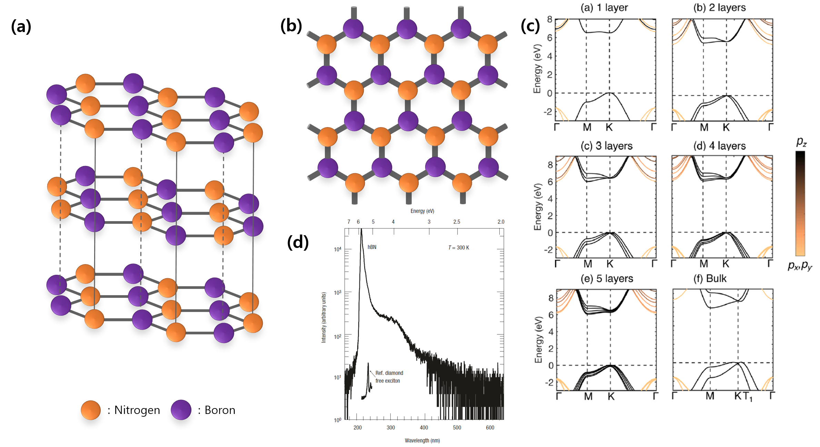 | 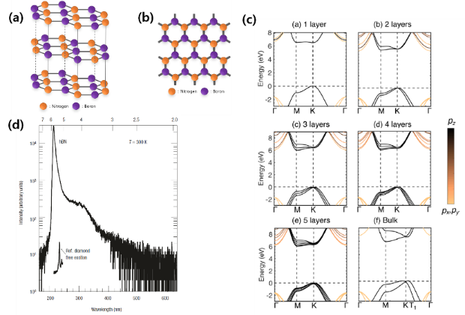

Fig 2.

Before Revision | After Revision
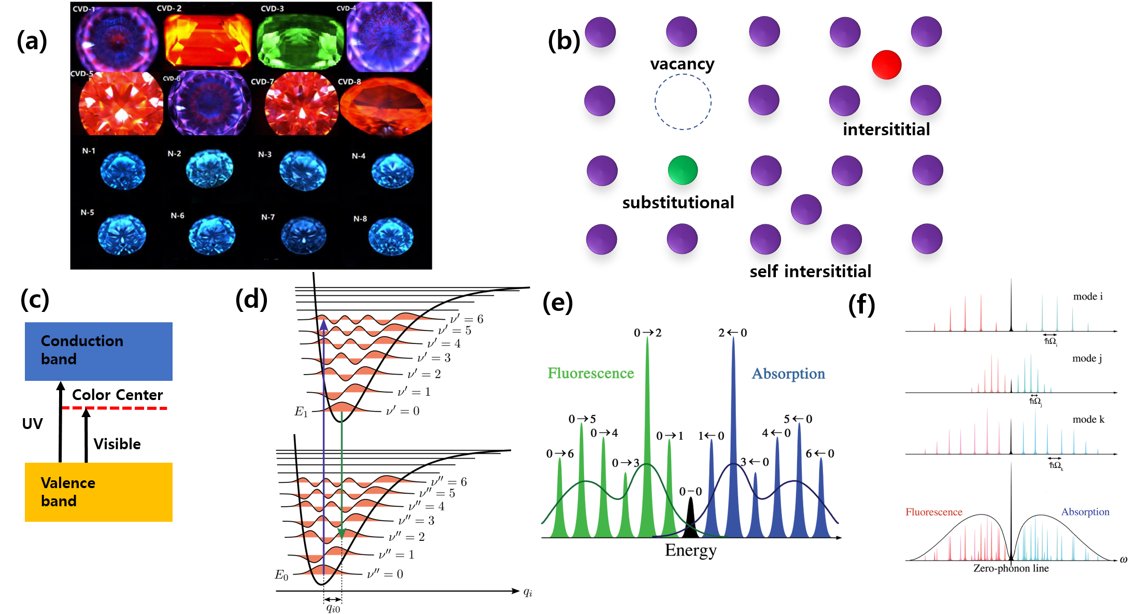 | 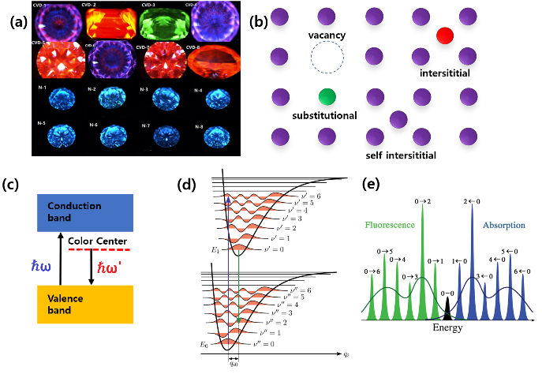

Fig 9.

Before Revision | After Revision
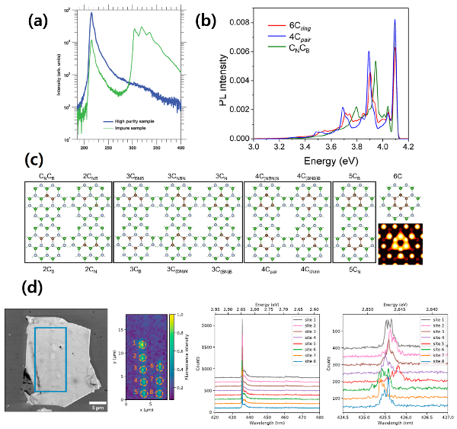 | 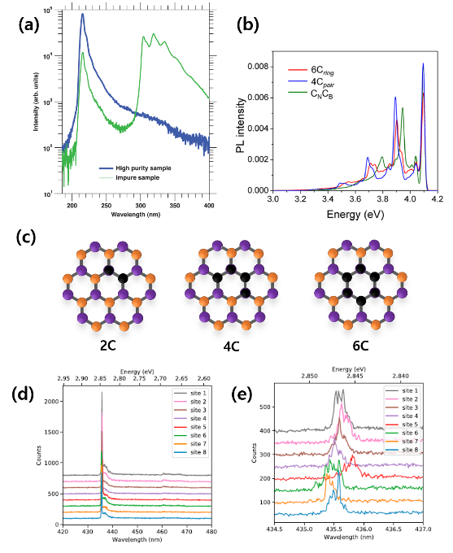

Comment 3.
The title of the article is "Color Centers in Hexagonal Boron Nitride". However, part #2 of the article starts as follows" In this chapter, we will look over the behaviors of defects and impurities in ultra-wide bandgap semiconductors such as diamond and hBN.". Why is diamond considered? Why was it not mentioned in the part #1 of the article?

Response 3.
Thank you for providing these insights. In Chapter 2. “Color centers in ultra-wide bandgap semiconductor”, in order to investigate the hBN color center, we first wanted to explain the theory of color centers in general semiconductor with wide bandgap, not only limited to hBN. We considered diamond color center to be our prerequisite for studying hBN color center, since the researches on NV center Diamond and quantum photon source based on it will help us understanding hBN color centers. In the revised version of the manuscript, we inserted some paragraphs explaining the properties of diamond and comparison with hBN. The inserted paragraphs are followings, in page 5~6.

“In order to provide specific information, we compare nitrogen-vacancy centers in diamond with the color centers in hexagonal boron nitride. The research on quantum de-vices using nitrogen-vacancy (NV) centers in diamond (Fig 3. (a)) [17] dates back to the late 1990s when NV centers were first observed and characterized. The NV center in diamond is a point defect composed of a substitutional nitrogen atom adjacent to a vacant lattice site (vacancy). The detection of electron paramagnetic resonance (EPR) from a single NV center led to the study of quantum devices. Researchers discovered that NV centers possess unique properties, such as long electron spin coherence times even at room temperature, making them promising candidates for quantum information processing and sensing applications. [18] [19]

Throughout the 2000s, significant progress was made in understanding and manipulating the quantum properties of NV center diamond, including quantum control of the electron spin, initialization, and readout techniques. Despite the promising features, NV-center diamond also has limitations. One of the main challenges is related to the coherence times, which can be affected by the surrounding environment and impurities in the crystal lattice. The scalability of NV-center-diamond-based quantum devices has been hindered due to difficulties in fabricating large-scale devices and integrating them with other quantum components. In recent years, researchers have turned their attention to hBN as an alternative platform for quantum devices. hBN's two-dimensional nature and unique crystal structure make it an attractive candidate for quantum technologies, especially for integration with quantum photonic circuits. As a result, efforts have been made to study color centers in hBN as a potential replacement for NV centers in diamond.

The band structure of diamond (Fig 3. (b)) [18] [19] is characterized by a large bandgap be-tween the valence band and the conduction band. The NV center diamond introduces lo-calized energy levels within the bandgap, creating an energy level scheme that involves electronic transitions between these levels. The NV center diamond has a ground state and two low-lying excited states, separated by a zero-phonon line (ZPL). The ZPL wavelength of the NV center in diamond is around 637 nm (nanometers) in the visible region of the electromagnetic spectrum. The ground state corresponds to the electronic configuration of a nitrogen atom in a substitutional site in a diamond lattice with an unpaired electron spin. The two excited states are associated with transitions involving the nitrogen spin and lattice vibrations (phonons).

The NV center diamond's energy level structure exhibits spin-dependent optical transitions, meaning that its optical properties are sensitive to the spin state of the electron. This spin-dependent nature allows for an efficient and high-fidelity readout of the NV center's electron spin state, a crucial property for quantum information processing. In conclusion, the NV center in diamond possesses unique properties related to its electronic bandgap, such as spin-dependent optical transitions and a sharp zero-phonon line emission peak. [20] Comparing NV centers in diamond and color centers in hexagonal boron nitride, hBN has a wider bandgap in the ultraviolet range, typically around 6 eV. The color centers in hBN exhibit broadband photoluminescence in the visible and UV regions. Diamond also has a large bandgap of approximately 5.5 eV, and the NV center diamond exhibits well-defined optical transitions with a zero-phonon line (ZPL) at around 637 nm in the visible spectrum.

The coherence times of the color centers in hBN are generally shorter than those of NV centers diamond. Unlike carbon atoms in diamonds, nitrogen and boron atoms in hBN have nuclear spins, which hinder the spin from being in coherent states. On the contrary, NV centers in diamond are renowned for their long coherence times at room temperature. In Ref [21] M. Ye et al. performed computer simulations to obtain the spin coherence times of four different 2D materials, namely delta-doped diamond layers, thin Si films, MoS¬2, and hBN. Compared to three other materials whose spin coherence times are around few miliseconds, hBN exhibited significantly short spin coherence times which are only about 10~30 microseconds, 2 order of magnitude smaller than the others. The boron-vacancy color center in hBN (which will be discussed again in Section 5-2) is well known for its spin texture, but the spin coherence lifetime is limited compared to that of NV center diamonds. The experimental study [22] tells us that the spin coherence lifetime of an hBN defect measured via Rabi oscillation was 10 microseconds at temperature T = 8K, while an NV-center diamond recorded a much longer spin coherence time of 400 microseconds even at room temperature.

However, improvements in coherence times have been shown by careful engineering of the local environment and isotopically purifying the hBN samples. The study [23] demonstrated the coherent manipulation of VB− spinful color centers in hBN was possible even at room temperature, by applying pulsed spin resonance protocols. Moreover, at cryogenic temperature, spin-lattice relaxation time achieved the record of 18 microseconds, which is three orders of magnitude larger than its usual value. In Ref [24], the authors performed computation on the temporal properties of decoherence, by combining density functional theory (DFT) and cluster correlation expansion (CCE) and demonstrate that the coherence time can be extended by the factor of three, by replacing all the boron atoms in the hBN crystal to ¹⁰B isotopes.

The luminosity factor of the color centers for quantum photonic applications is usually measured by the number of photons emitted from optically saturated single-photon emitters. In a previous study, a nitrogen-vacancy single-photon emitter [25] achieved 4.2 Mcps (million photon counts per second), showing compatibility with other materials such as NV-center diamond and SiC with a brightness of roughly 0.1 ~ 1 Mcps.

Comment 4.
There is one big issue that may confuse the reader. It is not clear if the article is about 2D hBN, hBN crystal of hBN thin films. In different parts of a review there is a different information and no systematic presentation.

Response 4.
I am sorry for giving any confusion to the Reviewer. In this paper we are reviewing many different experimental results, some of them use 2D hBN usually grown by CVD method, other uses mechanically exfoliated hBN flakes from hBN crystal, synthesized by HPHT (High-Temperature High-Pressure) method.

Comment 5.
At the part #1 of the article the role of first-principles calculations in the estimation of the band structure of hBN is mentioned. However, no review on the role of first-principles calculations in study of the defects, for example, vacancy, substitutional, interstitial, and self-interstitial defects in hBN. In my opinion it is important to show significant impact of modelling to the investigation of hBN or make the review totally experiment oriented.

Response 5.
We totally understand what the Reviewer 3 concerned about, and we agree that it would be the best case to show the DFT calculation result of every single kind of the hBN color centers. However, we decided to show up only the DFT calculation result of pristine hBN and make the rest of the review on hBN color centers largely experiment oriented, since the exact origin of hBN color center emissions are still unexplored so the detailed calculation works to forecast the energy levels are still undergoing. The only kind of the hBN color center under detailed computational investigation is carbon based one, where simulated PL emission peaks are available for different carbon atom numbers 2, 4, and 6, as shown in Fig 10 (b).

Comment 6.
Can Authors elaborate how histogram of the ZPL wavelength of color centers in hBN (Fig 4.) has been created? Are only experimental data collected there? Why are 148 data points selected?

Response 6.
The histogram of the ZPL wavelength has been created by only selecting experimentally observed spectroscopy data from the reference [6] ~ [94]. The 148 data points are selected from spectrum graphs that the authors of the papers identified the wavelength. The number of data point per paper might vary.

Comment 7.
The Conclusions seems to be very short. It is suggested to enlarge the discussion with the potential applications of hBN in quantum technologies and advanced UV optoelectronics.

Response 7.
As Reviewer 3 requested, we inserted paragraphs depicting future applications of hBN in quantum technologies and advanced UV optoelectronics at the Chapter 6. Conclusion, as follows.

“Some of hBN’s key applications include, but are not limited to, quantum photonics and UV optoelectronics. In quantum photonics, hBN is being explored as a platform for on-chip integrated quantum photonic devices. It can be used to create sources of single photons from color centers, which are crucial for quantum information processing and quantum key distribution. Compared to other materials such as NV center diamond and silicon carbide (SiC), hBN has a great advantage in that it is an atomically thin 2D material; therefore, its integration into quantum photonic chips and the manipulation of optical properties, such as straining the device, are much easier.

In UV optoelectronics, hBN possesses a wide bandgap, making it an excellent candi-date for UV optoelectronic applications. It can be used to create efficient UV light emitters, detectors, and sensors. hBN-based LEDs can be used in advanced UV lighting applications, such as sterilization, water purification, and UV curing processes in industries. These applications highlight the broad potential of hBN in advancing quantum technologies and UV optoelectronics, enabling the development of more efficient, compact, and robust devices for various scientific and industrial applications.”

