Review
Summarization of Remaining Life Prediction Methods
for Special Power Plants
Weige Liang¹, Chi Li¹, Lei Zhao¹, Xiaojia Yan¹, Shiyan Sun¹
Citation: To be added by editorial staff during production.
Academic Editor: Firstname Lastname
Received: date
Revised: date
Accepted: date
Published: date

Copyright: © 2023 by the authors. Submitted for possible open access publication under the terms and conditions of the Creative Commons Attribution (CC BY) license (https://creativecommons.org/licenses/by/4.0/).
¹ College of Weaponry Engineering, Naval University of Engineering, Wuhan 430033, China;
* Correspondence: 1312021010@nue.edu.cn;
Abstract: With the continuous improvements in integration, totalization and automation, remaining useful life predictions of mechanical equipment have become a key frontier in technology and the core content of equipment prediction and health management. The traditional method based on degradation mechanisms is not fully capable of predicting remaining useful life, especially for special power plants that use industrial transmissions, barrel launchers, etc. The expected service requirements are higher for condition monitoring and remaining service life prediction. Effectively predicting the remaining useful life of such special power plants is a major challenge and technical bottleneck in the industrial field and national defense equipment construction. This paper analyzes and expands on the research status of the remaining life prediction method of special power plants, and analyzes the remaining life prediction method of existing dynamic models, data-driven and data-model fusion drives, and the specific ideas for future research and development in four aspects, such as remaining useful life prediction tests assisted by soft measurements. Additionally, future research directions in the remaining life prediction of special power plants are provided.
Keywords: remaining useful life prediction; special power plants; dynamic model; data-driven; data–model fusion.

1. Introduction
With the continuous improvements in integration, totalization and automation, the remaining useful life (RUL) prediction of mechanical equipment has become a aspect of key cutting-edge technology and a core aspect of equipment regarding prognostics and health management (PHM), providing the technical basis to improve equipment reliability [1,2]. Status monitoring and RUL predictions for mechanical equipment can effectively reduce maintenance costs, eliminate production downtime, and improve productivity. However, the increasingly stringent service environment of mechanical equipment and the increasingly diversified forms of structural failure have caused traditional degradation-mechanism-based methods to be incompetent for RUL prediction [3], especially for special power plants with an industrial transmission device and barrel launcher as the application carrier, where the expected service demand leads to higher requirements for status monitoring and RUL prediction.
For example, transmissions carried out under an extreme reciprocating impact cause internal structure damage (Fig.1) and result in poor transmission or transmission failure. A barrel launcher is subjected to high-temperature, high-pressure and high-frequency impact overloads, which lead to serious wear on the internal structure (Fig. 2), resulting in a decrease in output dynamic energy, and in extreme cases, leading to barrel burst.
The working process of such special power plant cannot be effectively monitored, especially the internal structure wear, damage and other "internal injuries", which are not easy to detect in a timely manner. Additionally, the means of data acquisition are seriously insufficient. Therefore, effectively predicting the RUL of such special power plants is a major challenging technical bottleneck in the industrial field and national defense equipment construction [4,5].
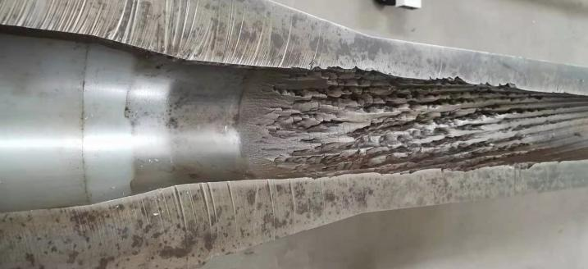
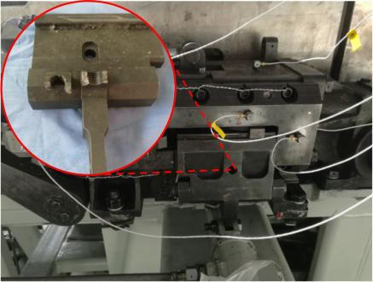
Fig. 1 Internal structural damage to a drive device. Fig. 2 Structural damage of a body barrel launcher.
The degradation of power plant performance is the main factor affecting its RUL. For a long time, research on the degradation mechanism of conventional power mechanisms such as rotating mechanisms has been at a very mature stage, and a complete set of research theories has been formed. However, it is difficult to directly imitate the research experience of conventional power mechanisms for special power plants, mainly due to the following three differences.
(1) Different from rotating motion mechanisms such as gear box and rolling bearing, most parts of special power plants with structural wear or damage are reciprocating motion parts (Fig. 1 and Fig. 2), and the related mature research results [6,7] are not fully applicable in this field. Practical experience shows that, due to the particularities of the working environment and the complexity of the task profile, the “internal injury” of special power plants is not only affected by the material and structure, but also by dynamic parameters such as vibration, impact and pressure in the process of work [8-10]. The degradation mechanism of these influencing factors in the reciprocating motion process is due to the different carriers of action. In the existing research process, the research theory of ordinary power plants cannot be fully followed, and improvements need to be made based on the motion characteristics of reciprocating mechanisms [11]. Therefore, the mapping relationship between a dynamic model constructed by integrating multiple degradation factors and equipment RUL is one of the key challenges in the current research [12].
(2) After constructing the mapping relationship between the dynamic model and the RUL of mechanical equipment, it is necessary to build a prediction model through multi-scale and multi-source data monitoring to realize the real-time prediction of the RUL of special power plants [13]. However, due to the generally poor working conditions of special power plants, traditional measurement methods for the dynamic parameters of power plants are usually not applicable in this environment, making it difficult to directly measure the dynamic parameters. This means that data acquisition methods are lacking [14]. At the same time, the traditional method of installing wired or wireless sensors at key structural points, collecting operational data, and analyzing modes or responses in power plants cannot effectively and objectively reflect the actual dynamic parameters such as the vibration, impact, pressure, etc., of the special power plants’ internal mechanisms due to the complex transmission characteristics of the internal and external mechanisms. At this point, it is necessary to use soft sensing technology to indirectly obtain dynamic data [15]. So-called soft measurement aims to obtain the dynamic parameters that are difficult to measure for special power plants. Through the selection of auxiliary variables, data acquisition and processing, the construction of soft measurement models, and real-time correction, these can be inferred or estimated [16]. Therefore, how to soft-measure the dynamic parameters of special power plants and construct a mapping relationship between dynamic data and RUL is currently one of the key challenges in research [17].
(3) Compared with ordinary power plants, the operating conditions of special power plants have state characteristics such as being time-varying and discontinuous. And its dynamic parameter measurement data have the data characteristics of being non-stationary single-measurement data and imbalanced multiple-measurement data [18]. These specific features result in the inability to accurately characterize the complexity and randomness of the degradation process of conventional power plants based on their mapping relationship with RUL. The mapping relationship between the dynamic data established by conventional power plants and RUL lacks interpretability, generalization, etc. [19]. In view of this, by combining the dynamic data of special plants with their structural characteristics and integrating the dynamic model-driven RUL prediction method with the dynamic data-driven RUL prediction method, breakthroughs can be made in the interpretability and generalization of the model, and the expected results can be obtained [20]. Therefore, how to effectively integrate dynamic models and data to establish RUL prediction methods is currently one of the key challenges in the research [21,22].
In conclusion, the realization of RUL predictions for special power plants faces the following challenges: First, how to construct the dynamic model-driven RUL prediction method to measure the impact of vibration, impact and pressure on mechanism wear and damage. The second problem is that it is difficult to directly measure the internal dynamic parameters of the device. How can a soft sensor be used? How can a dynamic data-driven RUL prediction method be built based on soft-sensor data? Third, how should dynamic models and data effectively be integrated to ensure the interpretability and generalization of the prediction model? In view of the above three challenges, domestic and foreign scholars have carried out research on the RUL prediction of rotary motion mechanisms based on the degradation mechanism [23], deep learning [6,24], fusion method [25], etc. However, they have encountered difficulties in exploring the RUL of reciprocating motion mechanisms. Based on "internal damage" phenomena such as wear and injury in the internal reciprocating motion mechanism of the special power plant, dynamic parameters such as vibration, impact and pressure are the important factors used determine its RUL. Therefore, based on the research results of the dynamic model, dynamic parameter soft-sensor method, data-driven RUL prediction method and other aspects, the RUL prediction method of special power plants can be converged to: the RUL prediction method driven by dynamic model, RUL prediction method driven by dynamic data and RUL prediction method driven by dynamic data–model fusion [26].
Based on the research results of the above three aspects, it is important to consider multiple conditions, multiple factors, and different combination structures of dynamic analog-fusion-driven parametric RUL prediction models, and clarify the mapping relationship between dynamic parameters and the RUL of the reciprocating motion mechanism. Revealing the dynamic degradation mechanism of special power plants provides theoretical and methodological guidance and important research directions for engineering applications, reliability improvements and health management [27].

2. Research status at home and abroad
RUL prediction is the premise of the reliability guarantee of mechanical equipment. It aims to establish relevant analysis methods and criteria, and develop the corresponding life evaluation theory and safety guarantee technology. At present, domestic and foreign scholars’ research on the RUL prediction of mechanical equipment mainly focuses on degradation models and data-driven methods, while research on the data–model fusion method is relatively sparse. For special power plants, dynamic parameters are important factors to determine RUL, so this paper expounds on the research status at home and abroad from three aspects: dynamic model, dynamic data and data-model fusion.

2.1 Research status of dynamic model-driven RUL prediction methods
Model-driven RUL prediction uses differential equations or difference equations to characterize the mapping relationship between mechanical equipment degradation process and many degradation factors [28].
In classical models, physical quantities with practical significance such as stress, strain, fatigue damage and energy are often used to characterize the degradation process of equipment. Experts and scholars at home and abroad have conducted a large number of studies on finite element model modification, rigid–flexible coupling analysis, the vibration characteristics of special beams, and the collision characteristics of multi-body structures [29,30].
Finite element model correction technology refers to the high accuracy and need to provide a guiding confidence degree for practical engineering practice. According to the widespread nonlinear characteristics in the real structure, an important research direction in the future computational finite element model is to constantly revise the structural linear simplification in the computational model [31,32].
Another key problem in dynamic analysis is the analysis of large displacement motion and flexible deformation for the computational model. At present, the analysis methods mainly include flexible modeling based on commercial dynamic analysis software [33,34] and coordinate system method numerical calculation analysis [35,36]. The combination of the two can better realize the dynamic analysis work. However, there is still a significant improvement in model refinement and computational efficiency.
The research on dynamic characteristics in special power plants mainly focuses on an analysis of the collision characteristics of the multi-body structures and vibration characteristics of special beams. Among them, research on the collision characteristics of multi-body structures mainly focuses on material deformation characteristics, contact crash mechanics models, friction and wear morphology, and the optimization characteristics of characteristic structures. Research on material deformation characteristics and contact crash mechanics models is interrelated and influential. The deformation characteristics of materials consider the elasticity, plasticity, and the critical point of the transition between the two stages of deformation [37]. The influencing factors of this characteristic involve many factors, such as the working state of the device, the microstructure of the material, and the processing technology of the material. The action characteristics of a specific material need to be obtained by combining experimental and theoretical analyses [38]. The contact crash mechanics model is a mathematical simulation of the contact crash process that can be achieved by fully understanding the deformation characteristics of materials. By obtaining initial parameters such as elasticity damping mass, the contact crash process is reasonably simulated, and important variables such as force and displacement in the process are obtained [39]. At present, the Lankarani–Nikravesh model or other spring-damping mass models are commonly used to simulate the contact crash process. Through theoretical analysis and simulation experiments, the contact crash process of special power plants can be well-restored with a multi-cycle reciprocating motion [40]. At present, contact crash experiments are mostly simulation experiments, and the obtained test results are mostly indirect verification results. The lack of testing techniques between theoretical analysis results, and actual physical phenomena that occur the research process of special power plants using this analysis method is one of the key research directions at this stage. The study of friction and wear morphology should consider the impact that harsh working conditions within special power plants have on their specificity. At present, using the ablation degradation model, the friction degradation model can quantitatively or partially qualitatively analyze the impact of different matrix materials, coatings, surface structures, and physical strengthening methods on the degradation process of structural performance [41]. The intuitive manifestation of this structural performance degradation is the change in contact crash feature results, and the mapping relationship between contact crash friction wear [42], which is also one of the key research directions at this stage. Research on the optimization characteristics of feature structures is based on the suggestions from the above three aspects, aiming to change the structural morphology and strengthen material properties through physical chemical means from both macro- and micro-perspectives in order to achieve the goal of slowing down the degradation process of special power plants [43,44].
The analysis of the vibration characteristics of special beams focuses on the following aspects: correction of the dynamic differential solution method, extended based on the variational principle [45,46], sensitivity analysis under coupling constraint and time-varying geometric characteristics [47], beam characteristic analysis of feature abstraction [48-50], coupling analysis based on structural correlation characteristics [51-53].
With further PHM research on mechanical equipment, the connotations of basic theories such as fracture mechanics, fatigue damage, corrosion and wear are constantly being enriched [13,14,54], and the classical Paris model [55] and Forman model [56] have been improved. New technologies and methods have been developed for material and strength testing, safety monitoring and control, reliable operation and maintenance [1,2]. A series of standards, such as the environmental test method (MIL-STD-810G), dynamic environmental criteria (NASA-HDBK-7005), condition monitoring and diagnosis (GB/T 23731-2009), and RUL assessment (GB/T 34631-2017), are proposed in the field of engineering application [57-60]. When mechanical equipment has a simple composition and a single degradation factor, the prediction accuracy of model-driven RUL is high [55]. However, with an increase in the structure composition and the complexity of the task profile, the time-varying nature and uncertainty of the degradation process increase, making it difficult to obtain an accurate model and achieve the high-precision model-driven prediction results.
To describe the time-varying and uncertainty qualities of the mechanical equipment degradation process, stochastic degradation models based on the framework of probability theory are introduced to RUL prediction, mainly including the Wiener process [61,62], gamma process [63,64], etc. The main idea of such prediction methods is to define RUL as the first arrival time at which the stochastic process reaches the failure threshold, and to achieve RUL prediction by solving the probability distribution of the first arrival time. The Wiener process is suitable to describe the process of non-monotonic degradation of mechanical equipment caused by a large number of small losses. In order to effectively reflect the non-Markov and multimodal properties of the degradation process, the degradation model based on fractional Brownian motion has become a research hotspot in the current Wiener process lifetime-prediction theory [65,66]. The Gamma process is used to describe the mechanical equipment’s strictly monotonous degradation process, and can better depict the slow degradation caused by continuous small impacts and the damage caused by a large impact, but the increments in the gamma process are gamma distribution, and the mathematical form is complex, making real-time parameter estimation difficult, so it is mainly used to analyze the common life characteristics of similar equipment. Therefore, it is difficult to achieve a high-precision prediction of individual equipment lifespan.
From the existing literature, in addition to the classical model and stochastic process model used to describe the degradation process of mechanical equipment, a regression model (such as a polynomial, exponential model, etc.), based on experience, can be used, which is able to describe the mechanical equipment degradation process evolution rule. In the case of a single piece of equipment and simple conditions, this method can predict RUL accurately. However, with the increasing complexity of mechanical equipment, complex and changeable operating conditions, and coupling interference of degradation factors, it becomes difficult to obtain an accurate degradation model, the cost of obtaining a degradation model becomes too high, and the generalization is not strong. However, the combination of a classical model and stochastic degradation model cannot describe the dynamic performance degradation trend of mechanical equipment, especially for special power plants, whose dynamic performance degradation model (hereinafter referred to as "dynamic model") has not been established.

2.2 Research status of dynamic data-driven RUL prediction methods
With the development and application of sensors, storage, network transmission and other technologies, the monitoring of the operation process of mechanical equipment produces a large amount of data. These can be used to accurately predict RUL by mining the degraded information hidden in the data. At present, such methods have achieved some excellent results, and been used to develop excellent public datasets (such as FEMTO dataset [67], Cincinnati dataset [68], Xi'an Jiao-tong University dataset [69]), and Siemens Predictive maintenance software Equipment Predictive Analytics (EPA), etc. In conclusion, data-driven RUL prediction methods mainly consist of feature extraction, health indicator construction and RUL prediction.
In order to obtain accurate and reliable life prediction results, efficient feature extraction plays an important role. Data features are mainly divided into the time domain, frequency domain and time-frequency domain. The time domain feature extraction method directly calculates the data’s statistical features, such as mean, variance, root mean square, skewness, kurtosis, cliff, entropy, etc. The frequency domain feature extraction method uses Fourier transform to transform the time domain data into the frequency domain, and then uses spectrum analysis to obtain the statistical features in the frequency domain. The time-frequency domain feature extraction method uses Hilbert–Huang transform, wavelet transform, empirical mode decomposition, etc. These can be used to expand the time-domain data to a two-dimensional space, obtain the instantaneous frequency and amplitude at any time, and finally obtain the time-frequency domain features [70-73]. The above feature extraction methods select the data from different perspectives, but key features are extracted and extracting the key features for different types of mechanical equipment are still key problems in the data-driven methods, which have not been successfully solved.
Health indicator construction is the quantitative expression of the health state of mechanical equipment, which can be divided into two categories according to its physical significance, namely physical health indicators and virtual health indicators. Physical health indicators refer to the time domain, frequency domain and time–frequency domain characteristics of mechanical equipment, which have physical significance, but poor monotonicity and a poor trend, and are seriously affected by noise [74]. Virtual health indicators refer to a kind of indicator representing the running state of mechanical equipment obtained from the fusion of multiple physical health indicators or sensor data, which has no physical significance but can reflect the degradation trend and achieve good results in terms of monotonicity, trend and scale similarity [75]. The main research methods include deep learning, principal component analysis, T-distributed random neighbor embedding, locally linear embedding, and restricted Boltzmann machine [28,76].
Based on feature extraction and health indicator construction, representative methods of RUL prediction include convolutional neural networks, deep belief networks, recurrent neural networks, and transfer learning.
Convolutional neural networks have good feature extraction and generalization abilities, and their overall architecture includes an input layer, a convolutional layer (excitation layer, pooling layer, and fully connected layer), and an output layer. The stacked convolutional layers of the network and the pooling layer form a feature-extractor, and the fully connected layer acts as a classifier or predictor, constituting an end-to-end network model. The model's accuracy and robustness depend on the type of network layers, the network depth, the arrangement of various types of layers in the network, the features chosen for each layer, and the training data [77,78].
RUL prediction studies based on convolutional neural networks have the following characteristics [79,80]:
(1) A convolutional neural network can process a large amount of raw data, which makes it suitable for large model computing processes.
(2) Convolutional neural networks can realize automatic feature extraction and recognition without supervision and without human intervention.
(3) Convolutional neural network has a strong processing ability regarding mechanical signals, vibration signals, noise signals, optical signals and other high-dimensional signals, and it has the function of automatic noise reduction during data processing.
(4) Convolutional neural network has a relatively small number of parameters, which makes training more convenient and efficient, and facilitates the construction of a deeper network structure.
(5) The use of a convolutional neural network in data on time series feature extraction ability is insufficient. Special power plants and other equipment with random degradation processes regarding the data information and the characteristics of the equipment are often time-series-related, making it easy to lose of important feature factors.
(6) Convolutional neural network RUL prediction cannot quantitatively provide RUL uncertainty; thus, at this stage of the convolutional neural network, RUL prediction is often used in combination with other intelligent algorithms.
The deep belief network is a joint distribution model between observation data and labels, which consists of multiple layers of restricted Boltzmann machines and one layer of a backpropagation neural network. The network is more expandable, and can be used to perform unsupervised pre-training and supervised backpropagation on the data, and ultimately obtain a good RUL mapping model [81,82].
The RUL prediction studies based on deep belief networks have the following characteristics [83,84]:
(1) A deep belief network can solve the training difficulty problems in the depth model. Through layer-by-layer pre-training and the reverse fine-tuning strategy, the feature representation and extraction of data ranging from shallow to deep can be realized, and the distributed features of the input data can be discovered. Use of this method in the time domain signal does not need to satisfy the requirements of periodicity. The information from data on the deep-level feature extraction plays a greater role.
(2) The short-term prediction performance of the deep belief network is better, while the long-term prediction performance is worse.
(3) The RUL prediction results obtained by deep belief networks cannot reflect the uncertainty of the prediction results, and generally need to be combined with other prediction methods to reflect the uncertainty of the prediction results.
Recurrent neural networks have a short-term memory, can be added to the gating mechanism to control information retention, discarding, and preservation in the memory unit, can learn the dependency relationship with a relatively long timespan, and can solve the phenomenon of gradient disappearance, gradient explosion, etc. Typical recurrent neural networks are long short-term memory (LSTM) and gated recurrent unit (GRU) networks [85].
The study of RUL prediction based on recurrent neural networks has the following characteristics [86,87]:
(1) Recurrent neural networks in RUL prediction are able to fuse the original learning samples with the updated learning model, which can retrain the samples, and has the characteristics of a fast convergence speed and high stability while improving the accuracy.
(2) Recurrent neural networks have certain advantages in dealing with time-series data or before-and-after dependent degradation data, but struggle to analyze and process multidimensional data.
(3) Recurrent neural networks can effectively reduce the uncertainty caused by environmental perturbations through the unique gate structure. However, they can only realize the point estimation of RUL, and it is difficult to assess the confidence of the prediction results. Existing studies focus on the effect of network training than the time-varying stochastic and dynamic characteristics inherent in equipment performance degradation.
Transfer learning is the application of knowledge or patterns learned from the same type of equipment to new equipment or new problems, focusing on how to map the data in the source domain and the target domain from the original feature space to the target feature space, and better utilize the existing labeled data samples in the source domain for RUL prediction [88,89].
RUL prediction research based on transfer learning has the following characteristics [90,91]:
(1) Transfer learning can ignore the requirements of the same feature distribution of model data and application data in traditional degradation models and data-driven models. The full-life performance degradation data of similar equipment can be utilized, and its features can be migrated to the historical data of the target equipment through learning to realize the RUL prediction of the target equipment.
(2) At this stage, transfer learning mainly focuses on research based on the deep transfer model and feature transfer model. The former reduces the complexity of the deep network to a certain extent, but the transfer effect mostly depends on the quality of the trained network. The latter requires prior knowledge of the characteristic differences in data distribution between domains and an exploration of suitable mapping models. There are fewer reasonable explanations for transfer components and transfer tasks, and the theoretical research base is weak.
(3) The effect of transfer learning is related to factors such as the volume of data, the quality of data and the selection of transfer source domains. The applicability of the model under different conditions varies to some extent, and an adaptive adjustment of the transfer parameters is mostly used at present, which leads to a lack of theoretical explanations for the parameters in the model.
(4) If there are large, dynamic changes in the learning source domain and target prediction domain of transfer learning, the iterative updating performance of transfer learning becomes weak, resulting in a low prediction performance. The addition of an intermediate domain can reduce the impact of dynamic changes on the transfer learning model, but the intermediate domain increases the complexity of the model, so balancing these two factors is a research hotspot at present.
In summary, the existing literature can obtain more accurate prediction results through data feature extraction, health indicator construction and RUL prediction modeling, but the hyperparameters and network design are difficult, and the generalization of the model is poor. Additionally, the prediction results ignore the internal degradation mechanism of mechanical equipment, and lack a strict dynamic theoretical basis and interpretability. Furthermore, the method requires a large amount data to train the network, which limits its use in mechanical equipment that cannot obtain a large amount of monitoring data and cannot obtain the expected prediction results. Therefore, the fusion of a dynamic model and data and the study of data generation methods have become a new trend in the research on RUL predictions of mechanical equipment [92,93].

2.3 Research status of data–model-fusion-driven RUL prediction methods
With the continuous development of computer science, new application scenarios of integrating a computational mechanics model and data science are constantly emerging. There are three main means of fusion [94]: The first method directly applies intelligent algorithms to solve linear dynamic models, but still has a certain improvement interval in its ability to determine efficiency and limitations [95]. The second type produces a wide range of sample data through a dynamic model, and uses an intelligent algorithm to extract the abstract mapping relations of the data combined with multi-source data [96-98]. And the third is based on a "data driven" framework of computational mechanics, using random filtering (KF/EKF/UKF/PF) as a bridge and health indicators based on the characteristics of the project to select a suitable degradation model. The fusion filtering method is a random or parameter identification method used to determine the model parameters. Through the model’s extrapolation prediction results and the complementary advantages of implementing data-mode methods, the prediction accuracy can be improved [99].
Kalman filtering (KF) deals with the optimal estimation problem of the linear system state with Gaussian noise for the input and output data. This optimal estimation can be regarded as a filtering process because system noise and interference are included in the observed data. Both extended Kalman filtering (EKF) and unscented Kalman filtering (UKF) can handle nonlinear degradation process with Gaussian noise. Among them, EKF establishes the Jacobi determinant based on the partial derivative of the nonlinear degradation process, and then realizes linearization processing. UKF realizes an approximate calculation of the nonlinear degradation process by untrace transformation. The basic idea of this kind of method is to assume that the mechanical equipment degradation conforms to a certain degradation mechanism model, and the mathematical model and key parameters are fused into a discrete-time-state space model by establishing an extended vector [100]. Then, KF/EKF/UKF is used to realize the state updates and prediction. When studying RUL predictions of the rotation mechanism, the exponential function and its extension model [101], and the fusion curve model [102] are often selected as degradation mechanism models.
Particle filter (PF) is a recursive Bayesian algorithm based on the Monte-Carlo method. It uses sequential importance sampling to provide an approximate solution to the Bayesian optimal solution, and is suitable for describing the nonlinear degradation process with non-Gaussian random noise. There are three main ideas to improve the life prediction accuracy of the PF method: selecting an appropriate degradation model [101], improving PF [103], and integration with other methods [104].
With the development of machine learning, fusion research directly using machine learning and degradation model is also an important direction of data-model fusion. Its basic idea is based on multi-source sensor monitoring data, constructing a virtual health indicator by weighted fusion, using stochastic process-matching with the time-varying evolution trend, optimizing and adjusting the fusion model and parameters using the life prediction deviation to achieve accurate prediction, and quantitatively analyzing the forecast uncertainty [25,105-107]. However, the weighted fusion health indicators rely too much on subjective experience and lack objectivity in the weight determination, which makes them unsuitable for the real-time prediction of mechanical equipment RUL.
According to the existing literature, the prediction accuracy of RULs driven by data–model fusion depends on three aspects: the selection of stochastic degradation model, the determination of fusion method, and the size of the data. For special power plants, whose performance degradation process mainly depends on dynamic parameters, the determination of the stochastic degradation model under a complex task profile is important. For real-time RUL prediction, a breakthrough in the data–model fusion method is also urgently needed. In addition, the acquisition of dynamic data is difficult, and it is necessary to design a reasonable measurement method.

2.4 Existing problems
In conclusion, domestic and foreign scholars have conducted extensive research on mechanical equipment RUL and a series of research results have been achieved, with good results in the field of rotating machinery. However, for the field of special power plants, breakthroughs are still needed regarding the creation of a dynamic stochastic degradation model with interpretability and generalization, and construction of a mapping relationship between dynamic parameters and RUL.
(1) The complexity of the special power plant and the variability of the operating conditions cause the coupling interference of a variety of degradation factors, which is not conducive to describing the degradation trends in its dynamic performance. This makes it difficult to obtain an accurate and generalized degradation model.
(2) The RUL prediction of data-driven mechanical equipment needs to monitor big data, so the data acquisition method is the first problem that needs to be solved. The existing data acquisition method often uses mechanical equipment with wired or wireless sensor external measuring equipment running incentive response parameters. This way of obtaining data leads to a large amount of random noise, and only the internal mechanism dynamics process is passed to the external data. Therefore, it cannot directly and effectively reflect the actual dynamic state of the internal mechanism.
(3) For special power plants, the RUL prediction method driven by the dynamic model mainly builds parametric mathematical model based on the dynamic degradation process but fails to combine the real-time monitoring data. This makes it difficult to reflect the actual state of the current operation; therefore, the prediction deviation is large. The RUL prediction method driven by dynamic data lacks a strict dynamic theoretical basis, lacks interpretability, and has a poor generalization ability. Additionally, it is difficult to design hyperparameters and the network.

3. Future research directions
In view of the RUL’s prediction demand for special power plants, which are widely used in industrial manufacturing and national defense equipment, this paper discusses four aspects of the research on RUL prediction: dynamic model, dynamic data, data–model fusion and test verification. The respective study content, system and hierarchy are shown in Fig. 3. The overall technical route is shown in Fig. 4.
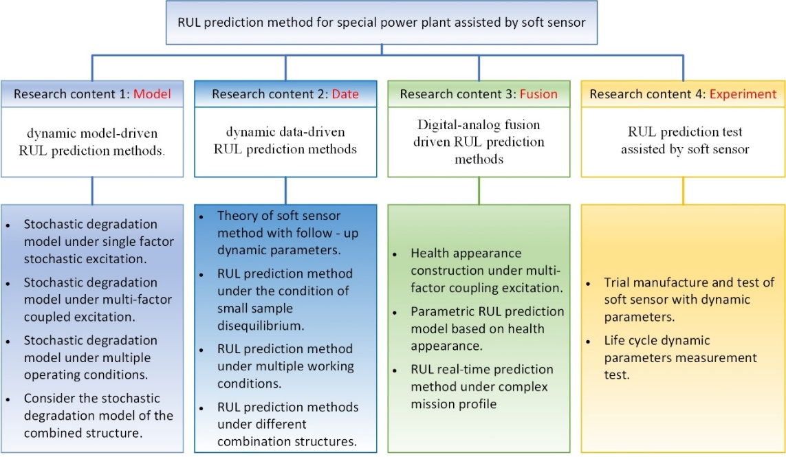
Fig. 3. Research system.
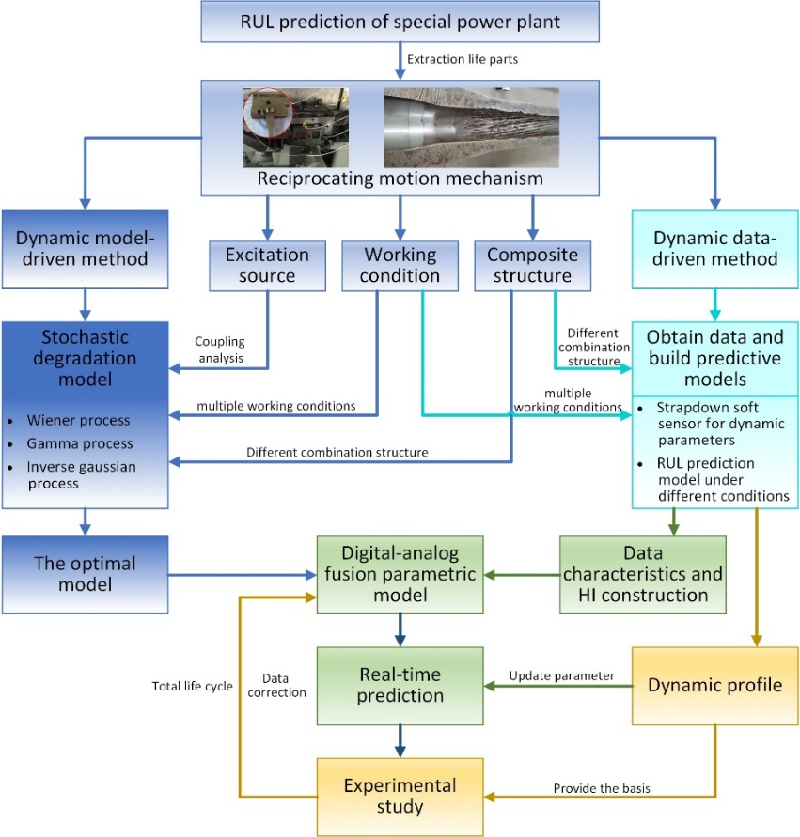
Fig. 4. Overall technical route.

3.1 Dynamic model-driven RUL prediction methods
To construct the dynamic performance degradation model of multi-factor coupling excitation, multi-working conditions are used and a different combined structure. First, the degradation mechanism should be extracted as a reciprocating movement mechanism, combining the dynamic model with the stochastic degradation model, and study vibrations, shock and stress as a single factor under the random vibration. Then, a dynamic stochastic degradation model is constructed under one-factor excitation. Then, the mechanism of multi-factor coupling is analyzed, and the stochastic degradation dynamics model under multi-factor coupling excitation is constructed. Through the extraction of multi-factor features, the dynamic profile and performance degradation law of reciprocating motion mechanisms under multi-working conditions are analyzed, and the construction of a dynamic stochastic degradation model of series, parallel and hybrid structures is explored to clarify the performance degradation mechanism.
The key research content can be summarized into the following four aspects:
(1) A study was carried out on a stochastic degradation model of dynamics under single-factor stochastic excitation;
(2) A study was conducted on a stochastic degradation model of dynamics under multi-factor coupling excitation;
(3) A study was conducted on the random degradation model under multi-working conditions;
(4) A study was conducted on a stochastic degradation model considering a combinatorial structure.
The implementation flowchart of RUL technology prediction using the model-driven dynamic method is shown in Fig. 5.
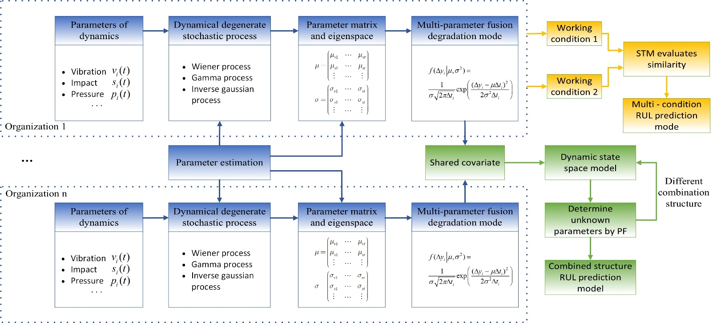
Fig. 5. Implementation flowchart of RUL technology prediction using model-driven dynamic method.

3.1.1 Dynamic stochastic degradation process under single-factor random excitation
By analyzing the actual operation process of the special power plant, it can be found that its internal rotating motion mechanism has a high level of reliability and is maintenance-free throughout the whole life cycle. However, the internal reciprocating motion mechanism often suffers from fatigue damage and corrosion wear, which leads to the degradation of the dynamic performance. In extreme cases, the mechanism may be damaged. Through the analysis of the physical mechanism, the inducement is the coupling effect of multiple dynamic excitation (such as vibration, impact, pressure, etc.), so the classical Paris model and Forman model cannot accurately describe the degradation process of the mechanism's dynamic performance. At the same time, the performance degradation of the reciprocating mechanism is caused by the comprehensive action of dynamic incentives, which should satisfy the infinite separability. However, the stochastic process models that mathematically satisfy the infinite separability are the Wiener process, Gamma process and Inverse Gaussian process, and the degradation process of different types of dynamic excitation is not the same. Therefore, establishing a degradation model of reciprocating motion mechanism using these three kinds of stochastic processes has strong explanatory power in terms of both statistics and dynamics. Starting from single-factor stochastic excitation, such as vibration, impact and pressure, the stochastic degradation process of different types of dynamic excitation is analyzed, and the performance degradation process of the reciprocating mechanism is studied in detail by modeling the stochastic degradation process caused by the single factor and identifying the model parameters. According to dynamic parameters such as vibration, impact and pressure, the stochastic process model is constructed, which can be estimated through the expectation maximization (EM) algorithm so that the probability density distribution function and RUL distribution function of the single-factor stochastic degradation process can be obtained. The performance of different types of dynamic excitation degradation processes conforms to different stochastic processes; for example, vibration excitation degradation conforms to the Wiener process, shock excitation degradation conforms to the Gamma process, and pressure excitation degradation conforms to the Inverse Gaussian process. Therefore, based on the Wiener process, Gamma process and Inverse Gaussian process, dynamic performance degradation probability density functions and RUL distribution functions can be obtained.

3.1.2 Dynamic stochastic degradation process under multi-factor coupling excitation
Based on the degradation model of dynamic performance under single-factor random excitation, according to the infinite separability of the degradation process, the parameters of the stochastic degradation model are extracted, and the parameter matrix is constructed. The matrix contains characteristic information on the degradation of the dynamic performance. The significance of the eigenvalues is positively correlated with the magnitude of the eigenvalues of the matrix. Therefore, by solving the eigenvalues of the parameter matrix, the feature space of dynamic performance degradation is constructed. The parameter optimization of the feature space can be carried out by a Particle Swarm Optimization (PSO) algorithm, and the multi-parameter fusion degradation model can be obtained; that is, the dynamic performance degradation model under multi-factor coupling excitation can be obtained.

3.1.3 RUL prediction model under multiple working conditions
Special power plants tend to constantly adjust the working conditions according to the task profile, and the dynamic parameters of the internal reciprocating motion mechanism will also change under different working conditions (mean, variance, etc.). A dynamic performance degradation model obtained under a single working condition cannot fully describe the performance degradation law under all working conditions. Therefore, the similar trajectory method (STM) can be combined for the prediction of RUL under multiple operating conditions to achieve an RUL prediction for special power plants under multiple operating conditions.
First, according to the dynamic performance degradation model obtained under multi-factor coupling excitation, the dynamic performance degradation trajectory under different conditions can be established. Then, the similarity of the trajectory can be evaluated, Euclidean distance similarity evaluation criteria can be obtained, the performance degradation trajectory can be integrated under different working conditions, and the RUL prediction model can be formed under multiple working conditions.

3.1.4 RUL prediction model for different combined structures
Considering that there is a series, parallel or series–parallel mixed structure in the reciprocating motion mechanism of the special power plant, while the load-sharing mechanism is present in the combined structure, the dynamic excitation factors are the same, and the physical locations of the mechanisms are adjacent, the degradation process of different mechanisms has certain correlations. The dynamic profile of the combined structure at the operation stage will affect the degradation process of each component mechanism, defining the affected dynamic performance degradation parameters as the covariates. Each mechanism in the combined structure is also subject to a shared load or a dynamic profile, and there is a shared covariate. Therefore, shared covariates are used as a "bridge" to connect degradation models of different mechanisms to describe the correlation between the degradation laws of various mechanisms in the combined structure.
Based on the state space model, a combinatorial structure stochastic degradation model is established considering shared covariates. Covariates are introduced to the state space to establish a state-space model of the combined structural dynamics containing the covariates. Secondly, the degradation of the combined structure at a certain time is defined as a state, and the degradation model of its dynamic performance is transformed into the state transition equation in the state space model. The unknown-parameter estimation model in the dynamic state space model can be constructed based on the particle filter (PF) algorithm. The RUL prediction model of the combined structure is obtained by extrapolating the estimated degradation parameters. Based on this process, RUL prediction models with different combined structures can be studied.

3.2 Dynamic data-driven RUL prediction method
To decrease the difficulty of obtaining dynamic data of special power plants, based on the random, non-contact test theory, the incentive transfer models and boundary conditions such as vibration, impact and pressure are studied. Based on the dynamic data obtained from single-working-condition and multi-working-condition tests, the RUL prediction method of special power plants with small-sample and unbalanced data can be researched, the mapping relationship between different types of trial data and RUL can be analyzed, and the change rule of RUL under different types and levels of random incentives can be explored. Then, the method of dynamic data acquisition and pretreatment is researched for different combined structures, such as series, parallel and hybrid structures. The dynamic data characteristics are analyzed and dynamic data-driven RUL prediction models are constructed for different combinatorial structures. RUL prediction methods for complex institutions are explored. The key research content can be summarized into the following four aspects:
(1) Theoretical research is conducted on the soft-measurement method of follow-up dynamic parameters;
(2) Research is conducted on RUL prediction methods using small samples and non-equilibrium data conditions;
(3) Research is conducted on the RUL prediction method driven by dynamic data under multiple working conditions;
(4) Research is conducted on RUL prediction method driven by dynamic data under different combination structures.
The implementation flowchart of RUL technology prediction obtained using the data-driven dynamic method is shown in Fig. 6.
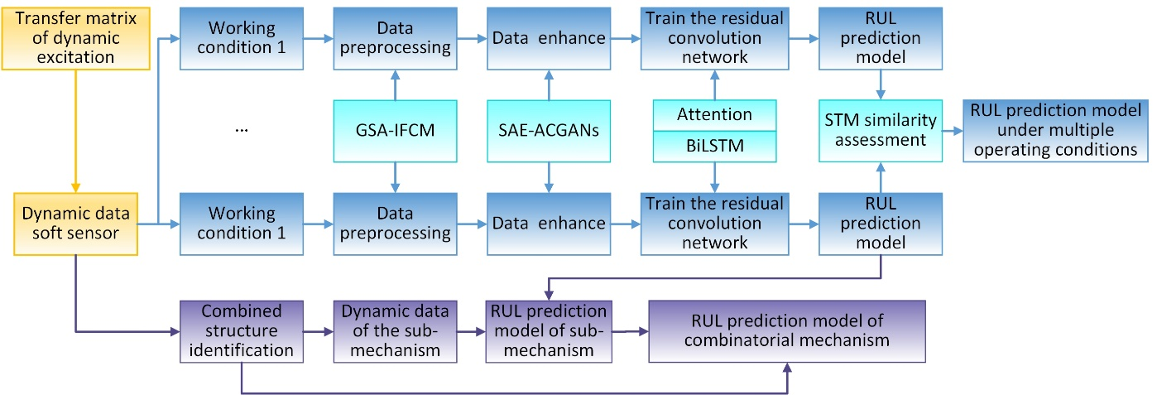
Fig. 6. Implementation flowchart of RUL technology prediction using the data-driven dynamic method.

3.2.1 Theoretical research on the soft-measurement method of follow-up dynamic parameters
The dynamic parameters of the special power plant cannot be directly measured. The traditional measurement method is indirect measurement on the outside of the device, equipped with wired or wireless sensors of internal institutions’ excitation response parameters (Fig.7). The use of such methods to obtain the data leads to a large amount of random noise, and only the internal mechanism dynamics process is transmitted to the external data. Therefore, it cannot directly and effectively reflect the actual operating state of the internal mechanism. Therefore, this paper proposes a soft-measurement method of follow-up dynamic parameters. the basic idea is to integrate the sensor into the special power plant dynamic object, follow the movement of the test mechanism (reciprocating movement mechanism) through the dynamic action object, and directly measure the vibration, impact, pressure and other dynamic parameters, as shown in Fig. 8. Because this method is based on the follow-up sensor group, accompanied by the motion of the dynamic object to measure its dynamic parameters, and further supplemented by the dynamic excitation transfer matrix to deduce the dynamic data of the tested mechanism, it can be called the soft-measurement method of dynamic parameters.
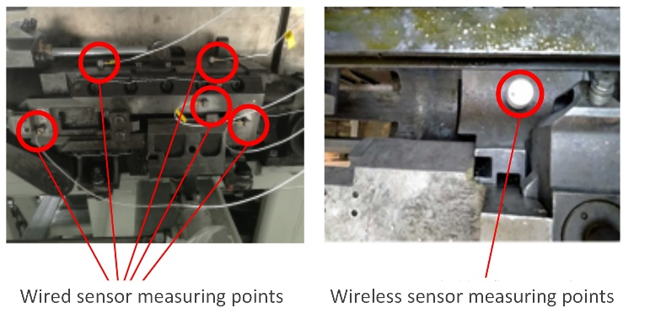
Fig. 7. Schematic diagram of traditional contact measurement method.
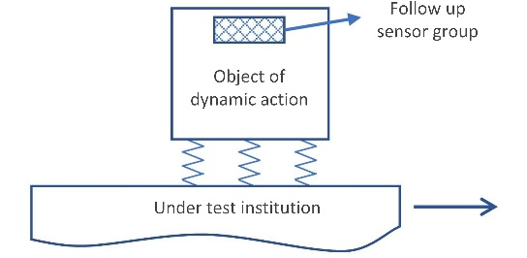
Fig. 8. Schematic diagram of a new type of follow-up measurement method.

3.2.2 RUL prediction method under small-sample and non-equilibrium data conditions
The dynamic data obtained by the soft-sensor method of follow-up dynamic parameters are limited and belong to small samples. At the same time, the sample size of the dynamic data in the short term is much larger than that of the degenerate state, which contains unbalanced data. Therefore, the dynamic data of special power plants are characterized by a small sample and non-equilibrium conditions. The following steps can be taken to model and analyze the RUL of special power plant based on small-sample and non-equilibrium dynamics data:
- Data preprocessing based on the GSA-IFCM method.
The data obtained by measurements of the accompanying sensor group are periodic time series data containing noise interference, which need to be filtered and de-noised according to the operating frequency before extracting the unit cycle sequence. Then, the actual dynamic data in the unit cycle can be reversed through the dynamic excitation transfer matrix. The Improved Fuzzy C-Means (IFCM) algorithm and Genetic Simulated Annealing (GSA) algorithm can be combined to extract the cluster center of the maximum value of the unit time series, and the t-Mean Square Value (t-MSV) method can be used to calculate the energy curve of the time series by setting a time window to determine the start and end points of the unit period time series to adaptively extract the unit period time series. A basic flowchart of data preprocessing based on the GSA-IFCM method is shown in Fig. 9.
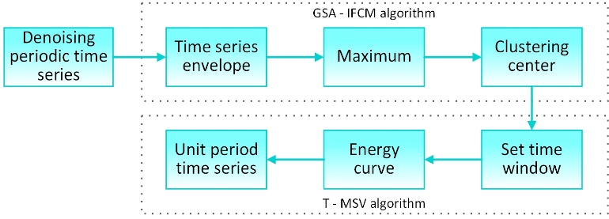
Fig. 9. Basic flowchart of data preprocessing based on the GSA-IFCM method.
(2) Data enhancement based on the SAE-ACGANs method.
On the basis of data preprocessing (1), a sparse auto-encoder (SAE) was combined with ACGANs based on auxiliary classifier generative adversarial networks (ACGANs). Thus, a data-enhancement method based on a time-frequency diagram and SAE-ACGANs is formed, as shown in Fig.10. Firstly, SAE is applied to the in-depth extraction of high-dimensional data features. Then, an SAE structure is added as the extractor of image features in the ACGANs framework, the raw data are encoded as hidden variables, noise is added through the standard normal distribution, and then this is input into the generator to strengthen its ability to represent the hidden variables related to the image category and reduce the generator range needed to learn the real sample feature space, so that the image category features can be effectively maintained in the model training and recognition stage to improve discriminator performance. This data-enhancement method can be used to amplify small-sample and disequilibrium data.
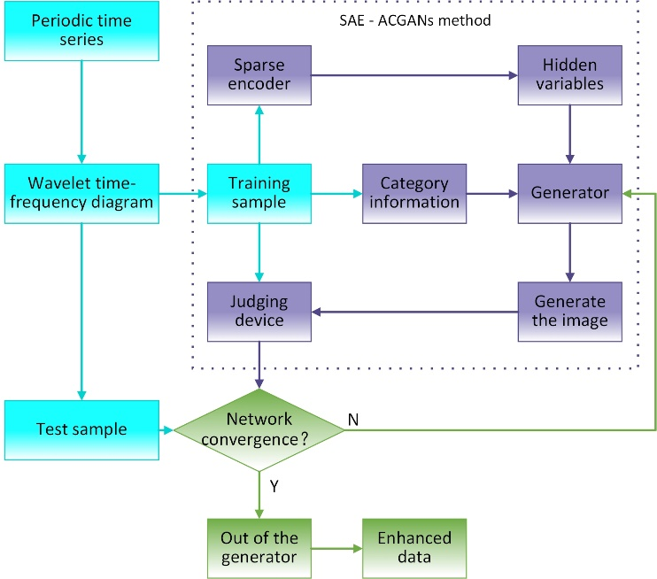
Fig. 10. Basic flowchart of data enhancement based on the SAE-ACGANs method.
(3) Construction of RUL prediction model based on RCNN-ABi-LSTM method.
On the basis of data enhancement, the good feature-extraction ability and generalization ability of convolutional neural networks (CNNs) are adopted to construct a residual convolutional neural networks attentional bidirectional long- and short-term memory (RCNN-Abi-LSTM) network RUL prediction model for special power plants. While extracting depth feature vectors from multi-dimensional sensor signals by CNN, the residual network structure is used to solve the problem of gradient disappearance caused by the deep CNN network. In view of the sequential correlation of sensor data, bidirectional long- and short-term memory (Bi-LSTM) networks can be used to learn the dynamic changes in the features proposed by CNN and capture the long-distance-related features in the time series. In addition, the attention mechanism is introduced to provide different probability weights to the Bi-LSTM implicit states to strengthen the expression of key information regarding RUL prediction.
The basic structure diagram of an RUL prediction model based on the RCNN-ABi-LSTM method is shown in Fig. 11.
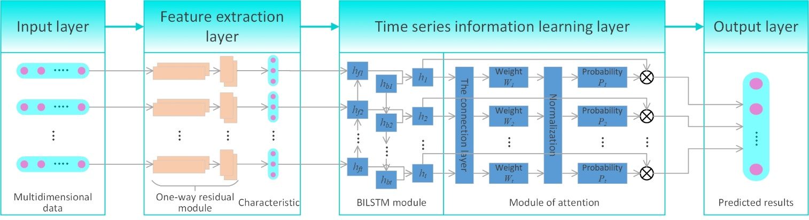
Fig. 11. Basic structure diagram of RUL prediction model based on the RCNN-ABi-LSTM method

3.2.3 RUL prediction method under multi-working conditions
For the multi-working conditions of special power plants, the kurtosis and cliff degree characteristics can be extracted according to the measurement data to effectively identify each working condition, which can be transformed into the RUL prediction problem driven by small-sample and non-equilibrium dynamic data. The dynamic data obtained through the soft-sensor method of dynamic parameters under each working condition can be analyzed according to the above steps. Finally, based on the similar trajectory method (STM), a dynamic data-driven multi-working condition RUL prediction model is constructed.

3.2.4 RUL prediction methods under different combined structure conditions
Combined structures can be simplified and abstracted into series, parallel and mixed structures, as shown in Fig. 12. Based on the dynamic data obtained by the soft-measurement method of dynamic parameters, the temporal domain and frequency domain characteristics can be analyzed, the combined structure can be identified, and the data of each subsystem can be extracted. An RUL prediction model can be constructed for each subsystem. An RUL prediction model is proposed as follows:
Cascaded structure: $RUL=\min\left(RUL_{1},RUL_{2},RUL_{3}\right)$
Parallel structure: $RUL=\max\left(RUL_{1},RUL_{2},RUL_{3}\right)$
Composite construction: $RUL=\min\left(\max\left(RUL_{1},RUL_{2}\right),RUL_{3}\right)$
For cases where the combination structure is relatively complex and there are many subsystems, an analogy can be made according to the above situation on the basis of the RUL prediction model.
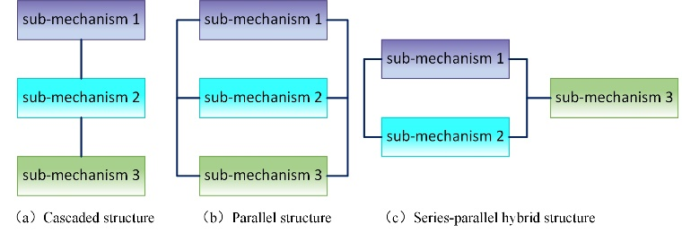
Fig. 12. Schematic diagram of composite structure.

3.3 RUL prediction method driven by data–model fusion
Focusing on the problems of the interpretability and generalization of RUL prediction, typical health indicators were used to characterize the health status of special power plants, and the construction method of health indicators under multi-factor coupling excitation was studied to explore the quantitative expression method of the health status of special power plants. Based on this, to study the RUL prediction method for special power plants, a parametric degradation process model was constructed with dynamic data–model fusion, and the model uncertainty and data uncertainty were quantitatively analyzed. The influence of the uncertainty factors on the prediction accuracy was explored. Research was conducted on the construction method of the data–model fusion RUL prediction model based on complex task profiles, the real-time correction mechanism of dynamic data for prediction models was analyzed, and the real-time prediction method of the RUL of special power plants was explored. The key research content can be summarized into the following three aspects:
(1) Research on the construction method of health indicators under multi-factor coupling excitation;
(2) Research on the parameterized RUL prediction model based on health indicators;
(3) Research on the real-time prediction method of RUL under complex task profiles.
The detailed technical route is shown in Fig.13.
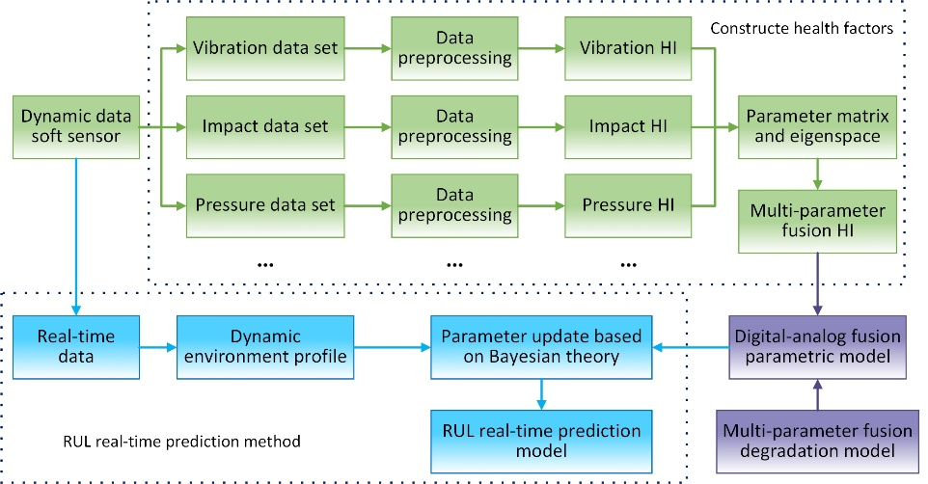
Fig. 13.Technical route of the RUL prediction method driven by data-model fusion.
(1) Study on health indicators under multifactor coupling incentives
The operation data of the special power plant, obtained using the soft-sensor method of dynamic parameters with follow-up, are periodic time series of vibration, impact and pressure with noise interference, which are filtered and de-noised according to the operating frequency to form the vibration data set, impact data set and pressure data set. The health indicator (HI) construction procedure of this institution is as follows:
a) The dynamic excitation transfer matrix constructed through the research content in Section 3.2 is used to infer the actual dynamic data of the device;
b) Considering the degradation process of the dynamic performance of the device as a random process, the parameter variables of stochastic processes are taken as the health indicators of institutions. Vibration HI, impact HI, pressure HI, etc., are extracted based on the vibration data set, impact data set, and pressure data set, respectively; these HIs have practical physical significance and the change process is highly interpretable;
c) The parameter matrix is constructed using each HI constructed in the random process parameter (b), and the eigenspace is constructed by solving the eigenvalues of the parameter matrix;
d) Optimize the feature space with parameters; then, HI can be fused with multiple parameters. This parameter contains the feature information of dynamic performance degradation, and the degree of degradation is positively related to its value size.
(2) Research on the RUL parametric prediction model based on health indicators
Based on the multi-parameter fusion HI obtained by the above process, the parametric prediction model of data–model fusion can be obtained by substituting it into the multi-parameter fusion degradation model that is constructed. In order to preserve generality, the individual differences incorporated into the degradation model are reflected in the model uncertainty of stochastic degradation processes based on the dynamic model. At the same time, the multi-parameter fusion HI based on dynamic data also contains measurement errors, which are manifested as data uncertainty. These two kinds of uncertainty can be treated according to the mutually independent normal distribution; that is, the model uncertainty f(x)~N (μ_{m}, σ_{m}) and the data uncertainty g(x)~N (μ_{d}, σ_{d} ). The sum, difference, and product of the two follow a normal distribution. Finally, the upper and lower boundaries of the confidence interval of the prediction result 100(1-α) % can be obtained.
(3) Research on the real-time prediction method of RUL under a complex task profile
A complex task profile is essentially the condition of special power plants, such as the change in gear transmission speed, barrel launcher firing rate, and the change in conditions, which can lead to dynamic profile changes. Changes in the dynamic data segmentation, thinning, and amount of data are characterized by the small sample size, and disequilibrium. These can also reveal the random parameter drift in the random process. Therefore, the real-time prediction of RUL for special power plants under a complex task profile is required based on the historical measurement data set, which can be implemented using the following technical route:
a) The real-time dynamic measurement data of a complex task profile can be extracted and preprocessed. The actual dynamic data of special power plants can be obtained and the dynamic section can be constructed;
b) Extract the random parameters based on the dynamic profile and the parametric model constructed by (2);
c) Based on Bayesian theory, the random parameters of the data–model fusion parameterized model are updated to obtain a real-time RUL prediction model for special power plants.

3.4 Research on RUL prediction test aided by soft measurement
The correctness of the RUL prediction of the special power plant is directly determined by the correctness of the soft-sensor method and theory of follow-up dynamic parameters, which affects the potential engineering application value of the research content. Therefore, it is necessary to synthesize and verify the correctness of the research content through experimental research. Through the design and testing of follow-up dynamic parameter measurement devices under a variety of working conditions, the dynamic data of the operation process can be extracted, the dynamic profile can be analyzed under a variety of working conditions, and the incentive input of the experimental platform can be preset. Throughout the whole life cycle of the dynamic data measurement test, the RUL-parametrized prediction model and RUL real-time prediction method can be verified. The key research content can be summarized into the following two aspects:
(1) Trial production and test research of soft measuring equipment with follow-up dynamic parameters;
(2) Research measuring the full life-cycle dynamic parameters of the special power plant.
The test principle is detailed as follows:
(1) Trial production and test of soft measuring equipment for the accompanying dynamic parameters
The internal reciprocating motion mechanism of the special power plant is taken as the test object for the trial production and test of a soft sensor with dynamic parameters, and its structure is simplified. The test setting is shown in Fig. 14. The reciprocating motion mechanism is fixed on the vibration test bench, the vibration test bench controller stimulates excitation on the vibration test bench, and the motion controller drives the reciprocating movement mechanism through the motor. The follow-up sensor group is rigidly connected to the moving part of the reciprocating motion mechanism to collect dynamic data such as vibration and impact during the mechanism’s movement. Analysis of the collected data verifies the correctness of the soft-measurement method of random dynamic parameters.
(2) Test of dynamic parameters’ measurement in the whole life-cycle of special power plants
On the basis of the soft-sensor method based on follow-up dynamic parameters, an experiment can be conducted, the dynamic transmission of flat, lift, swing processes of dynamic data can be obtained, the dynamic profile can be extracted and a console preset incentive can be set. The test principle is shown in Fig. 15. The leveling mechanism, lift and swing mechanism had a series structure, two sets of lift and two sets of swing mechanism comprised the parallel structure, and the follow-up sensor set was built in the transmission load (center of gravity). Using the vibration, impact and other dynamic data under actual working conditions, such as single load and multi-load, a dynamic life-cycle data set was constructed to verify the proposed RUL prediction model.
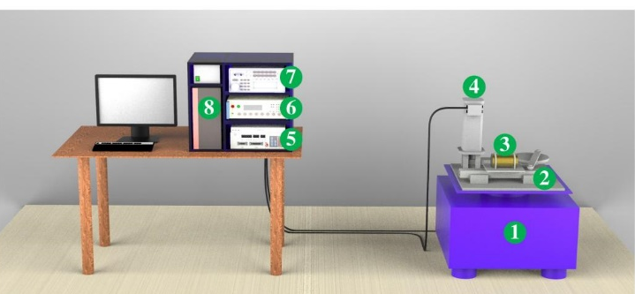
① Vibration test bench, ② reciprocating mechanism, ③ sensor group, ④ electric motor,
⑤ vibration console controller, ⑥ motion controller, ⑦ data record apparatus, ⑧ computer.
Fig. 14. Schematic diagram of the soft-measurement method verification of random follow-up parameters.
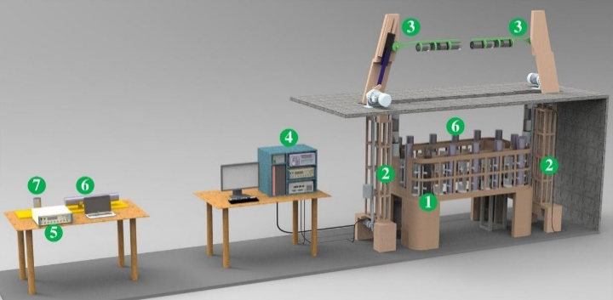
① Leveling mechanism, ② elevating gear, ③ swing mechanism, ④ console,
⑤ debugging desk, ⑥ drive load, ⑦ traveling sensor group.
Fig. 15. Schematic diagram of the full life cycle’s dynamic parameters.

4. Conclusions
This paper mainly summarizes the research status of the RUL prediction method of special power plants, and analyzes the problems at the present stage. In order to further study the RUL prediction method of special power plants, the research contents and ideas regarding four aspects are summarized: the dynamic model-driven method, data-driven method, data–model-fusion-driven method and the RUL prediction test assisted by soft-sensor technology.
The main future research directions can be divided into the following three aspects:
(1) On the basis of existing research on random degradation models, the mechanism and theory of the effects of dynamic degradation factors can be further explored, and a degradation effect model that is more in line with special power plants can be constructed, objectively and effectively furthering RUL prediction research for special power plants.
(2) Focusing on special power plants, a reasonable and effective soft-sensor method can be designed for dynamic environments to directly measure the dynamic data, and then predict the RUL based on the dynamic data.
(3) Furthermore, the dynamic models and data should be effectively fused to develop an RUL prediction method for special power plants with interpretability and generalization abilities.

Author Contributions: Conceptualization, W.L and C.L.; methodology, W.L. and S.S.; formal analysis, W.L and C. L; investigation, W.L and S.S.; resources, W.L and L.Z; writing: original draft preparation, W.L; writing: review and editing, X.Y and S.S; visualization, W.L.X.Y and L.Z; supervision, W.L and S.S; project administration, S.S.; funding acquisition, W.L and S.S. All authors have read and agreed to the published version of the manuscript.
Funding: The author gratefully acknowledges the financial support from the National Natural Science Foundation of China:61640308 and Hubei Provincial Natural Science Foundation: 2019CFB362.
Conflicts of Interest: The author declares no conflicts of interest.

References
- Fei, H.; Hu, C.H.; Si, X.S.; Zhang, J.X.; Pang, Z.N.; Zhang, P. Summary of machine learning-based device RUL prediction methods. Journal of Mechanical Engineering. 2019, 55 (08). https://doi.org/10.3901/JME.2019.08.001.
- Tu, S.D. Advanced design and manufacturing technology frontier: the reliability guarantee of important equipment column preface. Journal of Mechanical Engineering. 2021, 57 (16). https://doi.org/10.3901/JME.2021.16.001.
- Meng, G.; You, M.Y. Review on condition-based equipment RUL prediction and preventive maintenance scheduling. Journal of Vibration and Shock. 2011, 30 (08), 1–11. https://doi.org/10.13465/j.cnki.jvs.2011.08.022.
- Xuan, F.Z.; Zhu, M.L.; Wang, G.B. Retrospect and prospect on century-long research of structural fatigue. Journal of Mechanical Engineering. 2021, 57 (06), 26–51. https://doi.org/10.3901/JME.2021.06.026.
- Feng, Z.P.; Song, X.G.; Xue, D.X.; Xie, Y.; Deng, D.F. Survey of vibration fault diagnosis of rotational machinery. Journal of Vibration and Shock. 2001, No. 04, 38-41+98. https://doi.org/10.13465/j.cnki.jvs.2001.04.010.
- Deng, F.Y.; Bi, Y.; Liu, Y.Q.; Yang, S. Deep-Learning-Based Remaining Useful Life Prediction Based on a Multi-Scale Dilated Convolution Network. Mathematics 2021, 9 (23), 3035. https://doi.org/10.3390/math9233035.
- Ragab, M.; Chen, Z.H.; Wu, M. Attention-Based Sequence to Sequence Model for Machine Remaining Useful Life Prediction. Neurocomputing 2021, 466, 58–68. https://doi.org/10.1016/j.neucom.2021.09.022.
- Han, Z.Y.; Zou, Y.J.; Zhu, W.H.; Pang, S.W. Evolution of the spacecraft mechanical environment predication&test technology. Sci Sin-Phys Mech Astron. 2019, 49 (02), 6–22. https://doi.org/10.1360/SSPMA2018-00171.
- Becker, T. H.; Kumar, P.;. Fracture and Fatigue in Additively Manufactured Metals. Acta Materialia 2021, 219, 117240. https://doi.org/10.1016/j.actamat.2021.117240.
- Lucon, E. An Assessment of Different Approaches for Measuring Crack Sizes in Fatigue and Fracture Mechanics Specimens. Theoretical and Applied Fracture Mechanics 2021, 116, 103119. https://doi.org/10.1016/j.tafmec.2021.103119.
- Cheng, X.L.; Zhao, H.; Jiao, M.; Ye, H.F.; Li, L.C. Dynamic response characteristics of the protection system for a projectile borne recorder under high impact loading. Explosion and Shock Waves.2019, 39 (12), 117–125. https://doi.org/10.11883/bzycj-2018-0418.
- Wei, S.; Han, Q.K.; Chu, F.L. Review on research of uncertain dynamics for gear system. Journal of Mechanical Engineering. 2016, 52 (01), https://doi.org/10.3901/JME.2016.01.001.
- Kusiak, A. Smart Manufacturing Must Embrace Big Data. Nature 2017, 544 (7648), 23–25. https://doi.org/10.1038/544023a.
- Xu, Y.X.; Wang, Y.; Yan, T.H.; He, Y.; Wang, J.; Gu, D.; Du, H.; Li, W. Quality-Related Locally Weighted Soft Sensing for Non-Stationary Processes by a Supervised Bayesian Network with Latent Variables. Front Inform Technol Electron Eng 2021, 22 (9), 1234–1246. https://doi.org/10.1631/FITEE.2000426.
- Ying, Y.L.; Li, J.C.; Pang, J.L.; Yu, T.; Liu, Y. Review of gas turbine gas-path fault diagnosis and prognosis based on thermodynamic model. Proceedings of the CSEE. 2019, 39 (03), 731-743+952. https://doi.org/10.13334/j.0258-8013.pcsee.182102.
- Shui, G.S.; Wang, Y.S.; Qu, J.M. Advances in nondestructive test and evaluation of material degradation using nonlinear ultrasound. Advances in Mechanics.2005, No. 01, 52–68. https://doi.org/10.3321/j.issn:1000-0992.2005.01.006.
- Han, X.Y.; Niu, C.P.; He, H.L.; Wu, J.B.; Chen, Z.W. Review of state monitoring and intelligent evaluation technology of electromagnetic circuit breaker. Electrotechnical Journal. 1–19. https://doi.org/10.19595/j.cnki.1000-6753.tces.220204.
- Zhou, J.M.; Yin, W.H.; You, T.; Li, J.H.; Gao, S.; Du, Y.B. Evaluation of data-driven rolling bearings. Modern Manufacturing Engineering. 2021, No. 05, 146-153+160. https://doi.org/10.16731/j.cnki.1671-3133.2021.05.023.
- Nor, A. K. M.; Pedapati, S. R.; Muhammad, M.; Leiva, V. Overview of Explainable Artificial Intelligence for Prognostic and Health Management of Industrial Assets Based on Preferred Reporting Items for Systematic Reviews and Meta-Analyses. Sensors 2021, 21 (23), 8020. https://doi.org/10.3390/s21238020.
- Zhang, B.; Zhu, J.; Su, H. Toward the third generation of artificial intelligence. Sci Sin-inform. 2020, 50 (09), 1281–1302. https://doi.org/10.1360/SSI-2020-0204.
- Tao, F.; Liu, W.R.; Zhang, M.; et al. Five-dimension digital twin model and its ten applications. Computer Integrated Manufacturing Systems. 2019, 25 (01), 1–18. https://doi.org/10.13196/j.cims.2019.01.001.
- Tao, F.; Liu, E.R.; Liu, L.H.; et al, Digital twin and its potential application exploration. Computer Integrated Manufacturing Systems. 2018, 24 (01), 1–18. https://doi.org/10.13196/j.cims.2018.01.001.
- Villalón-Falcón, A.; Prieto-Moreno, A.; Quiñones-Grueiro, M.; Llanes-Santiago, O. Computational Adaptive Multivariable Degradation Model for Improving the Remaining Useful Life Prediction in Industrial Systems. Comp. Appl. Math. 2022, 41 (1), 48. https://doi.org/10.1007/s40314-021-01752-8.
- Zhou, F.Y.; Jin, L.P.; Dong, J. Review of convolutional neural network. Chinese Journal of Computers.2017, 40 (06), 1229–1251. https://doi.org/10.11897/SP.J.1016.2017.01229.
- Li, N.P.; Cai, X.; Lei, Y.G.; Xu, P.C.; Wang, W.T.; Wang, B. A Model-data-fusion Remaining Useful Life Prediction Method with Multi-sensor Fusion for Machinery. Journal of Mechanical Engineering.2021, 57 (20), 29-37+46. https://doi.org/10.3901/JME.2021.20.029.
- Wang, L.B.; Wang, Q.L.; Zhu, Z.; Zhao, Y. Current status and prospects of research on bridge health monitoring technology. China J. High w. Trans p. 2021, 34 (12), 25–45. https://doi.org/10.19721/j.cnki.1001-7372.2021.12.003.
- Hu, Y.G.; Liu, H.S.; Shi, P.P.; Chen, X.G.; Fang, C.; Li, H.; Ran, J. Overview of fault diagnosis and life prediction for wind turbine yaw system. Proceedings of the CSEE.2022, 42 (13), 4871–4884. https://doi.org/10.13334/j.0258-8013.pcsee.210729.
- Yuan, Y.; Zhang, Y.; Ding, H. Research on key technology of industrial artificial intelligence and its application in predictive maintenance. Acta Automatica Sinica.2020, 46 (10), 2013–2030. https://doi.org/10.16383/j.aas.c200333.
- Wu, B.; Liu, B.J.; Zheng, J.; Wang, T.; Chen, R.; Chen, X.; Zhang, K.; Zou, Z. Strain-Based Health Monitoring and Remaining Life Prediction of Large Caliber Gun Barrel. Measurement 2018, 122, 297–311. https://doi.org/10.1016/j.measurement.2018.02.040.
- Lei, F. The structure dynamics analysis of the inertial reciprocation vibration machine and its application. Henan University of Technology. 2010. https://kns.cnki.net/kcms/detail/detail.aspx?FileName=1016100140.nh&DbName=CDFD2016.
- Zhang, H.; Li, D.S.; Li, H.N. Progress in finite element model modification: from linear to linearity to nonlinear. Mechanics Progress.2019, 49 (00), 542–575. https://doi.org/10.6052/1000-0992-18-004.
- Fei, Q.G.; Li, A.Q.; Zhang, L.M. Study on finite element model updating of nonlinear structures using neural network. Journal of Astronautics.2005, No. 03, 267-269+281. https://doi.org/10.3321/j.issn:1000-1328.2005.03.005.
- Wang, Y.H. Dynamic analysis of mechanical structure with finite wlastic parts. Harbin Institute of Technology.2016. https://kns.cnki.net/kcms/detail/detail.aspx?FileName=HWYJ202206032&DbName=DKFX2022.
- Li, Y.Y.; Wang, C.; Huang, W.H. Dynamics Analysis of Planar Rigid-Flexible Coupling Deployable Solar Array System with Multiple Revolute Clearance Joints. Mech. Syst. Signal Proc. 2019, 117, 188–209. https://doi.org/10.1016/j.ymssp.2018.07.037.
- Fan, J.H.; Zhang, D.G.; Shen, H. Research on elastic line method based on absolute nodal coordinate method. Chinese Journal of Theoretical and Applied Mechanics.2019, 51 (05), 1455–1465. https://doi.org/10.6052/0459-1879-19-076.
- Lu, H.J.; Rui, X.T.; Ding, Y.Y.; Chang, Y.; Chen, Y.H.; Ding, J.G.; Zhang, X.P. A hybrid numerical method for vibration analysis of linear multibody systems with flexible components. Applied Mathematical Modelling. 2022, 101, 748–771. https://doi.org/10.1016/j.apm.2021.09.015.
- Ma, J. Research on Contact-impact events between barrel and bourrelet of medium-large caliber howitzers. Nanjing University of Science&Technology.2019. https://doi.org/10.27241/d.cnki.gnjgu.2019.000039.
- Pawlus, W.; Robbersmyr, K. G.; Karimi, H. R.; Fanghol, A. The Performance Investigation of Viscoelastic Hybrid Models in Vehicle Crash Event Representation. IFAC Proceedings Volumes 2011, 44 (1), 2138–2143. https://doi.org/10.3182/20110828-6-IT-1002.00284.
- Qian, L.F.; Chen, G.S. The Uncertainty Propagation Analysis of the Projectile-Barrel Coupling Problem. Defence Technology 2017, 13 (4), 229–233. https://doi.org/10.1016/j.dt.2017.06.005.
- Ma, J.; Qian, L.F. Modeling and Simulation of Planar Multibody Systems Considering Multiple Revolute Clearance Joints. Nonlinear Dyn 2017, 90 (3), 1907–1940. https://doi.org/10.1007/s11071-017-3771-z.
- Ding, C.J.; Liu, N.; Zhang, X.Y. A Mesh Generation Method for Worn Gun Barrel and Its Application in Projectile-Barrel Interaction Analysis. Finite Elements in Analysis and Design 2017, 124, 22–32. https://doi.org/10.1016/j.finel.2016.10.003.
- Shen, C.; Zhou, K.D.; Lu, Y.; Li, J.S. Modeling and Simulation of Bullet-Barrel Interaction Process for the Damaged Gun Barrel. Defence Technology 2019, 15 (6), 972–986. https://doi.org/10.1016/j.dt.2019.07.009.
- Aravind Kumar, T.; Sidhardha, N. S. G. R. S.; Tom Mathew, A.; S, D.; Kannan, V.; Rao Koka, T. Design of Gas Gun Barrel Support Structure by Finite Element Model Updating Using Optimization Techniques. Materials Today: Proceedings 2020, 22, 3027–3036. https://doi.org/10.1016/j.matpr.2020.03.438.
- Chaturvedi, E. Numerical Investigation of Dynamic Interaction with Projectile and Harmonic Behaviour for T-Finned Machine Gun Barrels. Defence Technology 2020, 16 (2), 460–469. https://doi.org/10.1016/j.dt.2019.07.018.
- Zhou, J.W. Dynamics and vibration control of a horizontal axis wind turbine blade and rotor. Beijing University of Technology.2020. https://doi.org/10.26935/d.cnki.gbjgu.2020.000073.
- J.W. Zhou, S.R. Wen, F.M. Li, Y. Zhu, Coupled bending and torsional vibrations of non-uniform thin-walled beams by the transfer differential transform method and experiments[J], Thin-Walled Structures,2018,127:373-388. https://doi.org/10.1016/j.tws.2018.02.026.
- Ceballes, S.; Abdelkefi, A. Application of Sensitivity Analysis and Uncertainty Quantification Methods on the Dynamic Response of General Nonlocal Beams. Applied Mathematical Modelling 2021, 97, 322–343. https://doi.org/10.1016/j.apm.2021.03.057.
- Hua, H.L. Study on the Dynamics of Eccentrically rotating beam and axially moving cantilever beam. Nanjing University of Science&Technology.2019. https://doi.org/10.27241/d.cnki.gnjgu.2019.000061.
- Sahraei, A.; Pezeshky, P.; Sasibut, S.; Rong, F.; Mohareb, M. Finite Element Formulation for the Dynamic Analysis of Shear Deformable Thin-Walled Beams. Thin-Walled Structures 2022, 173, 108989. https://doi.org/10.1016/j.tws.2022.108989.
- Vo, D.; Borković, A.; Nanakorn, P.; Bui, T. Q. Dynamic Multi-Patch Isogeometric Analysis of Planar Euler–Bernoulli Beams. Computer Methods in Applied Mechanics and Engineering 2020, 372, 113435. https://doi.org/10.1016/j.cma.2020.113435.
- Han, F.; Dan, D.H.; Deng, Z.C. A Dynamic Stiffness-Based Modal Analysis Method for a Double-Beam System with Elastic Supports. Mechanical Systems and Signal Processing 2021, 146, 106978. https://doi.org/10.1016/j.ymssp.2020.106978.
- Wu, J.G.; Lin, Q.H.; Li, B.M. Dynamic response analysis of conducting rails in electromagnetic rail launcher. Journal of Vibration Engineering.2019, 32 (01), 120–127. https://doi.org/10.16385/j.cnki.issn.1004-4523.2019.01.014.
- Shams, S.; Torabi, A. R.; Narab, M. F.; Atashgah, M. A. A. Free Vibration Analysis of a Laminated Beam Using Dynamic Stiffness Matrix Method Considering Delamination. Thin-Walled Structures 2021, 166, 107952. https://doi.org/10.1016/j.tws.2021.107952.
- Jiang, Z.L.; Liu, J.L.; Yuan, C.K.; Chen, H.Y.; Li, X.Y. New progress in the field of extraordinary environmental mechanics-Review of the Chinese Journal of Theoretical and Applied Mechanics symposium on extreme mechanics. Chinese Journal of Theoretical and Applied Mechanics.2021, 53 (02), 589–599. https://doi.org/10.6052/0459-1879-20-442.
- Kuncham, E.; Sen, S.; Kumar, P.; Pathak, H. An Online Model-Based Fatigue Life Prediction Approach Using Extended Kalman Filter. Theoretical and Applied Fracture Mechanics 2022, 117, 103143. https://doi.org/10.1016/j.tafmec.2021.103143.
- Ince, A. Computational Crack Propagation Modeling of Welded Structures under As‐welded and High Frequency Mechanical Impact (HFMI) Treatment Conditions. Fatigue Fracture Eng Mat Struct 2022, 45 (2), 578–592. https://doi.org/10.1111/ffe.13619.
- Anderson, A.; Bair, J.; Bell, D.; Caruso, H.; Williamson, R. Department of Defense Test Method Standard for Environmental Engineering Considerations and Laboratory Tests. Annals of Emergency Medicine 2009, 54 (Supplement), S80.
- Himelblau, H.;Kern, D.; Manning, J.E.; Piersol, A.G.; Rubin, S. Dynamic environmental criteria. NASA-HDBK-7005. USA: NASA.2001.
- GB/T 23713.1-2009, Condition monitoring and diagnostics of machines-Prognostics-Part 1: General guidelines. Beijing: Mechanical Vibration Shock and Condition Monitoring.2009.
- GB/T 34631-2017, Remanufacturing-RUL assessment guidelines of mechanical components. Beijing: Green Manufacturing Technology of Equipment Manufacturing Industry,2017.
- Li, Y.X.; Huang, X.Z.; Ding, P.F.; Zhao, C.Y. Wiener-Based Remaining Useful Life Prediction of Rolling Bearings Using Improved Kalman Filtering and Adaptive Modification. Measurement 2021, 182, 109706. https://doi.org/10.1016/j.measurement.2021.109706.
- Dong, Q.; Zheng, J.F.; Hu, C.H.; Li, B.; Mou, H.X. Remaining useful life prognostic method based on two-stage adaptive winner process. Acta Automatica Sinica.2022, 48 (02), 539–553. https://doi.org/10.16383/j.aas.c210057.
- Belhaj Salem, M.; Fouladirad, M.; Deloux, E. Prognostic and Classification of Dynamic Degradation in a Mechanical System Using Variance Gamma Process. Mathematics 2021, 9 (3), 254. https://doi.org/10.3390/math9030254.
- Al Masry, Z.; Mercier, S.; Verdier, G. Stochastic Comparisons and Ageing Properties of an Extended Gamma Process. J. Appl. Probab. 2021, 58 (1), 140–163. https://doi.org/10.1017/jpr.2020.74.
- Duan, S.W.; Song, W.Q.; Zio, E.; Cattani, C.; Li, M. Product Technical Life Prediction Based on Multi-Modes and Fractional Lévy Stable Motion. Mechanical Systems and Signal Processing 2021, 161, 107974. https://doi.org/10.1016/j.ymssp.2021.107974.
- Zhang, H.W.; Jia, C.; Chen, M.Y. Remaining Useful Life Prediction for Degradation Processes With Dependent and Nonstationary Increments. IEEE Trans. Instrum. Meas. 2021, 70, 1–12. https://doi.org/10.1109/TIM.2021.3085935.
- Nectoux, P.; Gouriveau, R.; Medjaher, K.; Ramasso, E.; Chebel-Morello, B.; Zerhouni, N.; Varnier, C. PRONOSTIA: An experimental platform for bearings accelerated degradation tests. IEEE International Conference on Prognostics and Health Management. IEEE.2012.
- Qiu, H.; Lee, J.; Lin, J.; Yu, G. Wavelet Filter-Based Weak Signature Detection Method and Its Application on Rolling Element Bearing Prognostics. Journal of Sound and Vibration 2006, 289 (4–5), 1066–1090. https://doi.org/10.1016/j.jsv.2005.03.007.
- Wang, B.; Lei, Y.G.; Li, N.P.; Li, N.B. A Hybrid Prognostics Approach for Estimating Remaining Useful Life of Rolling Element Bearings. IEEE Trans. Rel. 2020, 69 (1), 401–412. https://doi.org/10.1109/TR.2018.2882682.
- Lees, A. W.; Sinha, J. K.; Friswell, M. I. Model-Based Identification of Rotating Machines. Mechanical Systems and Signal Processing 2009, 23 (6), 1884–1893. https://doi.org/10.1016/j.ymssp.2008.08.008.
- Zhang, G.; Liang, W.G.; She, B.; Tian, F.Q. Rotating Machinery Remaining Useful Life Prediction Scheme Using Deep-Learning-Based Health Indicator and a New RVM. Shock and Vibration 2021, 2021, 1–14. https://doi.org/10.1155/2021/8815241.
- Glowacz, A.; Tadeusiewicz, R.; Legutko, S.; Caesarendra, W.; Irfan, M.; Liu, H.; Brumercik, F.; Gutten, M.; Sulowicz, M.; Antonino Daviu, J. A.; Sarkodie-Gyan, T.; Fracz, P.; Kumar, A.; Xiang, J. Fault Diagnosis of Angle Grinders and Electric Impact Drills Using Acoustic Signals. Applied Acoustics 2021, 179, 108070. https://doi.org/10.1016/j.apacoust.2021.108070.
- Zhang, T.; Liu, S.L.; Wei, Y.; Zhang, H.L. A Novel Feature Adaptive Extraction Method Based on Deep Learning for Bearing Fault Diagnosis. Measurement 2021, 185, 110030. https://doi.org/10.1016/j.measurement.2021.110030.
- Zhang, G. Research on Intelligent Methods for Health State Assessment and Remaining Useful Life Prediction of Mechanical Equipment. Naval University of Engineering.2021.
- Guo, L.; Lei, Y.G.; Li, N.P.; Yan, T.; Li, N.B. Machinery Health Indicator Construction Based on Convolutional Neural Networks Considering Trend Burr. Neurocomputing 2018, 292, 142–150. https://doi.org/10.1016/j.neucom.2018.02.083.
- Zhu, Y.M.; Wu, J.C.; Wu, J.; Liu, S.Y. Dimensionality Reduce-Based for Remaining Useful Life Prediction of Machining Tools with Multi-sensor Fusion. Reliability Engineering & System Safety 2022, 218, 108179. https://doi.org/10.1016/j.ress.2021.108179.
- Tang, Y.S.; Wang, W.H.; Cui, H.G.; Liu, S.Y.; Chai, K. Application of deep convolution neural network in chaotic vibration identification. Journal of Vibration and Shock.2021, 40 (13), 9–15. https://doi.org/10.13465/j.cnki.jvs.2021.13.002.
- Tian, K.W.; Dong, S.J.; Jiang, B.J.; Pei, X.W.; Tang, B.P.; Hu, X.L.; Zhao, X.X. A bearing fault diagnosis method based on an improved depth residual network. Journal of Vibration and Shock.2021, 40 (20), 247–254. https://doi.org/10.13465/j.cnki.jvs.2021.20.031.
- Luo, J.H; Zhang, X. Convolutional Neural Network Based on Attention Mechanism and Bi-LSTM for Bearing Remaining Life Prediction. Appl Intell 2022, 52 (1), 1076–1091. https://doi.org/10.1007/s10489-021-02503-2.
- Kiranyaz, S.; Avci, O.; Abdeljaber, O.; Ince, T.; Gabbouj, M.; Inman, D. J. 1D Convolutional Neural Networks and Applications: A Survey. Mechanical Systems and Signal Processing 2021, 151, 107398. https://doi.org/10.1016/j.ymssp.2020.107398.
- Zhao, R.; Yan, R.; Chen, Z.; Mao, K.; Wang, P.; Gao, R. X. Deep Learning and Its Applications to Machine Health Monitoring. Mechanical Systems and Signal Processing 2019, 115, 213–237. https://doi.org/10.1016/j.ymssp.2018.05.050.
- Drain, D.; Clement, C. B.; Serrato, G.; Sundaresan, N. DeepDebug: Fixing Python Bugs Using Stack Traces, Backtranslation, and Code Skeletons. 2021. https://www.researchgate.net/publication/351745031_DeepDebug_Fixing_Python_Bugs_Using_Stack_Traces_Backtranslation_and_Code_Skeletons.
- Pei, H.; Si, X.S.; Hu, C.H.; Zheng, J.F.; Li, T.M.; Zhang, J.X.; Pang, Z.N. An Adaptive Prognostics Method for Fusing CDBN and Diffusion Process: Application to Bearing Data. Neurocomputing 2021, 421, 303–315. https://doi.org/10.1016/j.neucom.2020.09.021.
- Zhang, B. Research on Data-Driven Performance Degradation Modelling and Remaining Useful Life Prediction for Mechanical Equipments. University of Science and Technology Beijing.2016. https://kns.cnki.net/kcms/detail/detail.aspx?FileName=HWYJ202206032&DbName=DKFX2022.
- Tang, C.S.; Sun, D.; Tang, W.; Cao, S.Y.; Li, J.Z.; Jing, J.P. A turbine rotor surface stress prediction model based on LSTM recurrent neural network. Proceedings of the CSEE.2021, 41 (02), 451–461. https://doi.org/10.13334/j.0258-8013.pcsee.200626.
- Cheng, Y.W.; Hu, K.; Wu, J.; Zhu, H.P.; Shao, X.Y. Autoencoder Quasi-Recurrent Neural Networks for Remaining Useful Life Prediction of Engineering Systems. IEEE/ASME Transactions on Mechatronics 2022, 27 (2), 1081–1092. https://doi.org/10.1109/TMECH.2021.3079729.
- Liu, J.W.; Song, Z.Y. Overview of recurrent neural networks. Control and Decision. 2022, 37 (11), 2753–2768. https://doi.org/10.13195/j.kzyjc.2021.1241.
- Xu, Y.; Cai, Y.Z.; Song, L. Review research on condition assessment of nuclear power plant equipment based on data-driven. Journal of Shanghai Jiao Tong University.2022, 56 (03), 267–278. https://doi.org/10.16183/j.cnki.jsjtu.2021.502.
- Zhang, M.; Feng, K.; Jiang, Z.N. A mechanical fault early warning methodology based on dynamic self-learning threshold and trend filtering techniques. Journal of Vibration and Shock.2014, 33 (24), 8–14. https://doi.org/10.13465/j.cnki.jvs.2014.24.002.
- Hu, T.; Guo, Y.M.; Gu, L.D.; Zhou, Y.F.; Zhang, Z.S.; Zhou, Z.T. Remaining Useful Life Prediction of Bearings under Different Working Conditions Using a Deep Feature Disentanglement Based Transfer Learning Method. Reliability Engineering & System Safety 2022, 219, 108265. https://doi.org/10.1016/j.ress.2021.108265.
- Shen, F. Transfer Learning-Based Methodologies for Fault Diagnosis and Remaining Useful Life Prediction of Rotary Machine. Southeast University.2020. https://doi.org/10.27014/d.cnki.gdnau.2020.002971.
- Lei, Y.G.; Xu, X.F.; Cai, X.; Li, N.P.; Kong, D.T.; Zhang, Y.M. Research on data quality assurance for health condition monitoring of machinery. Journal of Mechanical Engineering.2021, 57 (04), 1–9. https://doi.org/10.3901/JME.2021.04.001.
- Chen, S.Q.; Peng, Z.K.; Zhou, P. Review of signal decomposition theory and its application in machine fault diagnosis. Journal of Mechanical Engineering.2020, 56 (17), 91–107. https://doi.org/10.3901/JME.2020.17.091.
- Li, X.; Yan, Z.M.; Liu, Z.L. Combination and application of machine learning and computational mechanics. Chin Sci Bull.2019, 64 (07), 635–648. https://doi.org/10.1360/N972019-00005.
- Wang, X.Z.; Zhang, X. Decoupling and partial iterative calculation method of flexibility and sloshing dynamics. Aerospace Control.2021, 39 (06), 9-13+33. https://doi.org/10.16804/j.cnki.issn1006-3242.2021.06.002.
- Wang, Q.H.; Guo, W.G.; Xu, F.; Gao, M.; Wang, Z.H. Synchronous and decoupling calibration of tri-axial impact force transducers based on a Hopkinson bar and an artificial neural network. Explosion and Shock Waves.2022, 42 (10), 87–98. https://doi.org/10.11883/bzycj-2022-0015.
- Li, J.J.; Ren, Z.S.; Wu, Y.M.; Wang, Y.W. Decoupling and dimension reduction calibration method for bogie frame loads of high-speed train and test verification. Journal of Central South University (Science and Technology).2022, 53 (05), 1730–1739. https://doi.org/10.11817/j.issn.1672-7207.2022.05.018.
- Zhang, Y.T.; Li, F.R.; Tian, H.Q.; Hu, J.B.; Wei, C.; Wu, W. Research on decoupling control of integrated dynamics system of unmanned vehicle chassis. Automotive Engineering.2021, 43 (11), 1673-1682+1709. https://doi.org/10.19562/j.chinasae.qcgc.2021.11.013.
- Liu, W.K.; George, K.; Tang, S.Q.; Julien, Y. A computational mechanics special issue on: data‑driven modeling and simulation—theory, methods, and applications. Computational Mechanics.2019. https://doi.org/10.1007/s00466-019-01741-z.
- Dong, Q.R.; Wang, W.G.; Chen, F.; Chen, T.; Zhang, Z.D.; Liu, T.X. Research on single detector decoupling control technology based on adaptive Kalman algorithm. Infrared and Laser Engineering.2022, 51 (06), 345–352. https://kns.cnki.net/kcms/detail/detail.aspx?FileName=HWYJ202206032&DbName=DKFX2022.
- Cui, L.L.; Wang, X.; Wang, H.Q.; Ma, J.F. Research on Remaining Useful Life Prediction of Rolling Element Bearings Based on Time-Varying Kalman Filter. IEEE Trans. Instrum. Meas. 2020, 69 (6), 2858–2867. https://doi.org/10.1109/TIM.2019.2924509.
- Li, N.P.; Lei, Y.G.; Gebraeel, N.; Wang, Z.J.; Cai, X.; Xu, P.C.; Wang, B. Multi-Sensor Data-Driven Remaining Useful Life Prediction of Semi-Observable Systems. IEEE Trans. Ind. Electron. 2021, 68 (11), 11482–11491. https://doi.org/10.1109/TIE.2020.3038069.
- Bender, A. A Multi-Model-Particle Filtering-Based Prognostic Approach to Consider Uncertainties in RUL Predictions. Machines 2021, 9 (10), 210. https://doi.org/10.3390/machines9100210.
- Wen, B.C.; Xiao, M.Q.; Wang, G.H; Yang, Z.; Li, J.F.; Chen, X. A Fusion Prognostic Method for Remaining Useful Life Prediction Based on an Extended Belief Rule Base and Particle Filters. IEEE Access 2021, 9, 73377–73391. https://doi.org/10.1109/ACCESS.2021.3079301.
- Wang, B.; Lei, Y.G.; Yan, T.; Li, N.P.; Guo, L. Recurrent Convolutional Neural Network: A New Framework for Remaining Useful Life Prediction of Machinery. Neurocomputing 2020, 379, 117–129. https://doi.org/10.1016/j.neucom.2019.10.064.
- Li, T.M.; Si, X.S.; Liu, X.; Pei, H. Data-Model interactive remaining useful life prediction technologies for stochastic degrading devices with big data. Acta Automatica Sinica.2022, 48 (09), 2119–2141. https://doi.org/10.16383/j.aas.c201068.
- Li, T.M.; Si, X.S.; Zhang, J.X. Data-model interactive remaining useful life prediction method for multi-sensor monitored linear stochastic degrading devices. Acta Aeronautica et Astronautica Sinica.1–19. https://doi.org/10.7527/S1000-6893.2023.27190.
Disclaimer/Publisher’s Note: The statements, opinions and data contained in all publications are solely those of the individual author(s) and contributor(s) and not of MDPI and/or the editor(s). MDPI and/or the editor(s) disclaim responsibility for any injury to people or property resulting from any ideas, methods, instructions or products referred to in the content.

