Response to Reviewer 1 Comments
Dear Peer Reviewer and Editor,
How are you?
Thank you for your careful review and valuable comments on this article. We have made serious modifications and supplements according to your opinions. All the modifications have been marked in yellow or red in the revised draft.
For the attached amendments, we have revised and supplemented item by item as follows:
English language and style
This article has been edited and polished by MDPI English Editing regarding the English language problem. (Attached with English-Editing-Certificate)
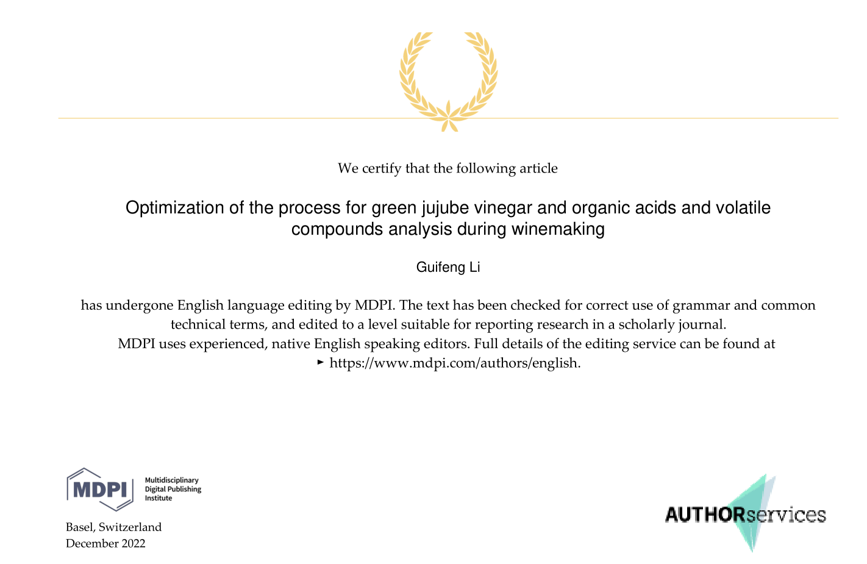
Comments and suggestions for authors
1. The method for the determination of organic acids states that 20 mmol/L potassium dihydrogen phosphate buffer is used as mobile phase A but does not specify the pH of the buffer, it is an important value for the method used.
Response 1: The pH of the buffer has been added. (Line 147)
2. In the model for estimating the acidity content, variables that are not significant have been used; they should be eliminated from the proposed model and only significant variables should be used. To check whether or not it influences the best estimation of the proposed model.
Response 2: These secondary variables have a relatively small impact on the best estimate of the proposed model.
3. Figure 1 represents the surface curve when varying the value of two variables, but the value of the rest of the variables used to obtain this curve must be indicated. The nomenclature of the variables used in the previous table and model must be maintained.
Response 3: The relevant content has been supplemented in the title of Figure 1. The naming convention for variables used in the above table and model was already maintained. (Line 189 -193 and Line 224 -229)
4. For the quantified values of volatile compounds, the significant figures of the different values should be taken into account according to the error of the values.
Response 4: Number of significant digits in table 3 has been modified.
5. In table 3, superscripts (a, b, c) are used for reference which are not detailed in the table footnote.
Response 5: The detailed explanation of superscripts (a, b, c) has been added in the footnote of Table 3.
6. The text of the supplementary material is not in English.
Response 6: We have been corrected the Chinese description of the supplementary materials.

