RESPOND TO REVIEWERS

Nutrients-2473988 “HIGH-FIBER DIET AND CROHN'S DISEASE. SYSTEMATIC REVIEW AND META-ANALYSIS”

We would like to thank you for giving us the opportunity to review again and improve our manuscript.
We have considered all suggestions and incorporated them into the revised manuscript, and as a result, we believe our manuscript is stronger. Responses to his comments are written in bold type. We have highlighted in yellow the changes made to the manuscript.

Reviewer 1:

- Was it possible in some of the selected trials to indentify the type of fiber, soluble vs insoluble?

We could not report the type of fiber consumed because it was not specified in the studies except in one.
As the reviewer suggested, we have added information on the type of fiber in the study that reported it.

- Could you please improve the presentation of the table 3 and the figure 2?

Thank you. As requested, we have improved the presentation of the table 3 and corrected figure 2.

Reviewer 2:

- “indeterminate colitis (IC)” or unclassified IBD (IBD-U)?

Inflammatory bowel diseases (IBDs) are idiopathic pathologies, among which there are 3 subtypes: Crohn's disease (CD), ulcerative colitis (UC) and unclassified IBD (IBD-U)

As you suggested, we have changed the term “indeterminate colitis” to “unclassified IBD”.

- “indeterminate colitis (IC), the latter being the least frequent, accounting for 7-10% of IBD cases worldwide. Specifically, CD is the most common, accounting for 25-30% of IBD cases, with UC accounting for 20%” 20 + 30 + 10 = 60% -> what about the remaining 40%!?

Thank you for the comment, it was a mistake. We have corrected it and updated the reference.

- Use always upper case for western and eastern

As you suggested, we have corrected them.

- Use oxford comma in the whole text

Thank you, we have added the Oxford comma throughout the text. In addition, the English language has been edited again.

- Define the abbreviations the first time they appear (for example, “F. prausnitzii”)

Thank you for the appreciation. We have defined the abbreviations.

- Write the abbreviations of the authors that performed the studies’ evaluation instead of XXX

Thank you. We have made the suggested changes.

- Why did you choose the random effects in the meta-analysis?

Thank you for the comment. Normally, the choice of fixed or random methods to perform the meta-analysis is made based on heterogeneity (if I2>50% random methods). However, as recommended by the Cochrane Handbook, the p-value of heterogeneity must be considered.

In any case, the result of the meta-analysis with fixed methods was the same, as can be seen in the following figure:
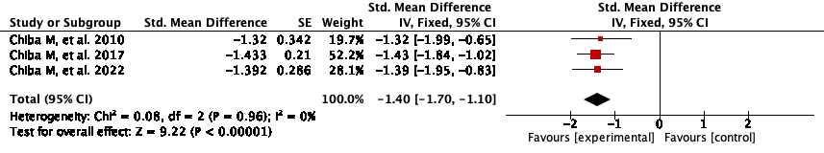

- Graph of Figure 2 in wrong: in fact, the squares intersect the vertical line of the “0” values, despite the confidence intervals don’t intersect the 0 value. In addition, write what is the outcome

Thank you, we have changed the scale of the graph so that the squares do not intersect the vertical line of the "0" values.
In addition, we have added the results in the text.

- Were CD patients excluded from the studies if they were affected by stenosing phenotype?

No, patients with intestinal stenosis were not excluded from the studies. We have corrected the implications for clinical practice to avoid confusion in readers.

