Dear reviewer,
We are very grateful for your comments on the manuscript. This is a response letter about “Improvement of pBRDF model for target surface based on diffraction and transmission effects”. We have revised the original manuscript according to your kind advice and detailed suggestions. The manuscript is resubmitted, and we wish it could be reconsidered for publication in “Remote Sensing”.
Below is the response to the Reviewer’s advice and detailed suggestions. The reviewers’ comments and our replies are listed, respectively. The corrections are red marked and underlined in the revised manuscript for easy check purposes.
If there are other needs, please feel free to inform us.
Thank you very much!

Best regards!
Yours sincerely,

First author: Qiang Fu
Corresponding author: Qiang Fu

- I consider this contribution as the incremental one. The model improvements include the basics of optical physics. So, I do not see enough novelty and originality in this manuscript. The authors should specify the uniqueness of this research and its impact on the optical community.
Response: Thanks for reviewer’s comment. Based on your suggestion, we have added the analysis of the trend of the target DOLP with the probe zenith angle to our previous work. A comparison with other reference models is made to verify the accuracy of the model in this paper. We also explain in more detail the conditions of applicability and research implications of the model in this paper, and describe the uniqueness and usefulness of this study for the field of optics.

According to reviewer’s suggestion, We have made changes in line 127, line 414, line 459 and line 475

2.3 The importance of model improvement
The P-G model and its derivative models are usually applicable to materials with particle size larger than the wavelength, such as metals, plastics and glass. However, for typical coating materials, the particle size is usually between 10-100μm, which is much smaller than the wavelength, and the diffraction effect will occur at this time, so that the propagation path of light will be bent after encountering the object particles in the process of propagation, resulting in random changes in the phase relationship between particles and photons. At this time, it is difficult to describe this part with the P-G model, resulting in reduced model accuracy.
The usual coating materials, such as paint, have low reflectivity and high transmittance. For this kind of material which contains radiation start and high transmittance, the distribution function is a combination of the distribution function of external incident light and a distribution function of positive incident light from inside, and it is difficult for the traditional pBRDF model to accurately simulate this kind of effect.
Coated materials are widely used in various fields, such as spacecraft, military weaponry, medical devices, etc. Therefore, modeling diffraction and transmission effects can improve the fitting and prediction accuracy for such targets.
For most paint targets, such as paints, the surface roughness constants are usually between 0.2 and 0.8, much greater than materials such as metals and glass. Because it is a mixture formed by lipids and pigments, etc., the surface layer of the material is also a mixture of states, which, at the macro level, is rougher. And because of the process of painting, the paint film is not uniform, there are particles in the environment and other factors cannot be avoided. Therefore the surface roughness of the coating material is larger, and its surface undulation is much larger than the wavelength.

As can be seen from Figure 9, the DOLP of the three target materials shows a trend of becoming larger first and then decreasing with an increase in the detection zenith angle; further, the peak occurs near a detection zenith angle of 50°, which is the direction of specular reflection of the incident light. This is because the specular reflection concentrates the reflected light in one direction, and so the intensity of linearly polarised light per unit area is the highest, and the DOLP is also the highest. Therefore, the greater the proportion of specular reflection, the greater the proportion of light received by the detector and the intensity of the polarised light, and the higher the DOLP will be. The transmission effect is a phenomenon that causes the light to rotate relative to the original specular reflection direction because of the presence of a curved or raised surface pattern of the target. Since all three targets are coated materials, their surfaces are relatively uniform, and the proportion of transmission is lower than that of specular reflection. The diffraction effect is because of a random change in the phase relationship between photons and photons, and this random change in phase leads to a decrease in DOLP. Therefore, the DOLP of the target material depends mainly on the proportion of specular reflection that occurs. As the detection zenith angle increases, the proportion of specular reflection gradually increases, and when the detection zenith angle increases to 50°, the detector receives most of the light from the specular reflection in the direction of the specular reflection of the light source; thus, the intensity of the linearly polarised light is the highest and the DOLP is also the highest. Therefore, the DOLP of the three target materials shows a trend of first becoming larger and then decreasing with the increase of the detection zenith angle. The angle located at the specular reflection of the incident light can be selected for polarisation detection of the target, which can improve the detection accuracy and identification capability.

In order to analyze the accuracy of the proposed model more critically, this paper is compared with other improved models. Reference model 1[22] gives an improved model for coating materials, however, the fitting accuracy is significantly lower than the improved model in this paper. Table 2 gives the root mean square error of reference model 2 [23], reference model 3 [20], and reference model 4 [24], and the results of comparison with the model in this paper.

Table 2. The DOLP root mean square error of the model in this paper and the reference model
 | Model of this paper | Reference model 2 | decline rate(%)
DOLP root mean square error of light green lacquer coated aluminium panels | 6.1062% | 11.991% | 49.07%
 | Model of this paper | Reference model 3 | decline rate(%)
DOLP root mean square error of Dark green lacquer coated aluminium panels | 2.4854% | 4.82% | 48.43%
 | Model of this paper | Reference model 4 | decline rate(%)
DOLP root mean square error of Earth yellow lacquer coated aluminium panels | 3.1006% | 4.62% | 32.89%

As can be seen from Table 2, the root-mean-square error of the improved model proposed in this paper decreases by 49.07% compared with reference model 2, 48.43% compared with reference model 3, and 32.89% compared with reference model 4. It can be seen that the model in this paper has high accuracy for coating materials.

The study of polarisation characteristics of target surfaces is of great importance in the fields of polarisation detection and polarisation remote sensing. Using the target polarisation characteristic model, the accuracy of polarisation detection can be improved, and it has high application value in scenarios such as military stealth target detection, atmospheric transportation, and computer vision. Compared with the traditional P-G model, both the intensity and the accuracy of the proposed model of DOLP are improved by a large percentage. In practical applications, the model has higher sensitivity to coated materials or materials with strong light transmission, which can provide better discrimination and identification capabilities and a good basis for material detection. The model also provides rigorous theoretical support for the study of target surface polarisation characteristics and can be applied to the software system of target surface polarisation characteristics measurement devices such as ellipsometers.

- Wang K, Liu H, Zhang X. Study on Polarized Reflection Characteristics of Space Object Thermal Control Coatings. Acta Photonica Sinica, 2020, 49, 1229003.
- Shell I I , James R .Polarimetric Remote Sensing in the Visible to Near Infrared. 2005.
- Yang M, Xu W, Sun Z, et al. Degree of polarization modeling based on modified microfacet pBRDF model for material surface. Optics Communications, 2019, 453, 124390.

- The authors concluded that the relative errors of intensity and degree of linear polarization (DOLP) are reduced by 45-68% and 23-48%, respectively, with their modified new model. It is an ambiguous point and even a bit of data manipulation. One can see from Fig. 10 that the standard and modified models give pretty the same results (except one special case of the DOLP for the earth yellow lacquer), especially in the vicinity of the peaks at the spectra. It seems to me that the relative error in each point does not exceed 10%, but the authors calculate the integral error (sum of the errors in each point) as far as I understand. So, it gives the incorrect picture of the results obtained
Response: Thanks for reviewer’s comment. We invert the optimal combination of parameters of the P-G model and the improved model strictly based on the least squares method. Table 1 gives the inverse values of the five parameters of the improved model and the P-G model for the light green painted aluminum sheet, and Table 2 gives the inverse values of the five parameters of the improved model and the P-G model for the dark green painted aluminum sheet. Table 3 gives the inverse values of the five parameters of the improved model and P-G model for the earth yellow-painted aluminum plate.
Table 1. Inversion parameters of improved model and P-G model for light-green-painted aluminium panels.
Light-green-painted aluminium plate 440 band
 | n | k | ρ_{r} |  | ρ_{s} |  | ρ_{d}
Improved model | 1.204362 | 0.22369 | 0.876714 |  | 0.633368 |  | 0.480844
P-G model | 1.255986 | -0.43036 | 0.101528 |  | 0.01249 |  | 75.73169
Light-green-painted aluminium plate 500 band
 | n | k | ρ_{r} |  | ρ_{s} |  | ρ_{d}
Improved model | 1.293098 | -0.1922 | 0.882285 |  | 0.404471 |  | 0.208865
P-G model | 1.15716 | 0.274863 | 0.066061 |  | 0.017185 |  | 35.21568
Light-green-painted aluminium plate 532 band
 | n | k | ρ_{r} |  | ρ_{s} |  | ρ_{d}
Improved model | 1.305031 | -0.24271 | 0.884144 |  | 0.564302 |  | 0.224101
P-G model | 1.132912 | 0.312985 | 0.061886 |  | 0.023511 |  | 27.97937
Light-green-painted aluminium plate 600 band
 | n | k |  | ρ_{r} |  | ρ_{s} |  |  | ρ_{d}
Improved model | 1.304331 | -0.28605 | 0.886576 |  | 0.419306 |  | 2.162505
P-G model | 1.200987 | -0.29424 | 0.062869 |  | 0.030856 |  | 18.77726
Light-green-painted aluminium plate 675 band
 | N | k |  | ρ_{r} |  | ρ_{s} |  |  | ρ_{d}
Improved model | 1.316789 | 0.322481 |  | 0.891264 |  | 0.442499 |  | -1178.07
P-G model | 1.190736 | -0.31866 |  | 0.060827 |  | 0.024555 |  | 25.3986

Table 2. Inversion parameters of improved model and P-G model for dark-green-painted aluminium panels.
Dark-green-painted aluminium plate 440 band
 | n | k | ρ_{r} | ρ_{s} | ρ_{d}
Improved model | 1.126035 | 0.065906 | 0.753392 | 0.851737 | 0.740351
P-G model | 0.959699 | -0.03458 | 0.099752 | -1.26421 | 2.121518
Dark-green-painted aluminium plate 500 band
 | n | k | ρ_{r} | ρ_{s} | ρ_{d}
Improved model | 1.192801 | -0.00043 | 0.771205 | 0.620802 | 2.956406
P-G model | 1.125987 | -0.14833 | 0.095118 | -1.0338 | 1.618722
Dark-green-painted aluminium plate 532 band
 | N | k | ρ_{r} | ρ_{s} | ρ_{d}
Improved model | 1.242564 | 0.002342 | 0.776439 | 0.578082 | 0.310572
P-G model | 0.997013 | -0.15743 | 0.11997 | 0.0317 | 25.70324
Dark-green-painted aluminium plate 600 band
 | n | k | ρ_{r} | ρ_{s} | ρ_{d}
Improved model | 1.121045 | 0.137057 | 0.788172 | 0.658956 | 0.601819
P-G model | 0.985451 | -0.16748 | 0.1193 | 0.029135 | 28.94432
Dark-green-painted aluminium plate 675 band
 | N | k | ρ_{r} | ρ_{s} | ρ_{d}
Improved model | 1.120698 | -0.13782 | 0.799492 | 0.657386 | 0.595158
P-G model | 0.977783 | -0.17724 | 0.11772 | 0.031431 | 26.66386

Table 3. Inversion parameters of improved model and P-G model for the Earthen-yellow-painted aluminium plate.
Earthen-yellow-painted aluminium plate 440 band
 | n | k | ρ_{r} | ρ_{s} | ρ_{d}
Improved model | 1.427725 | 0.086215 | 0.854565 | 0.784943 | 0.742568
P-G model | 1.168471 | 0.002833 | 0.063223 | -1.88781 | 2.528373
Earthen-yellow-painted aluminium plate 500 band
 | N | k | ρ_{r} | ρ_{s} | ρ_{d}
Improved model | 1.417776 | 0.096084 | 0.861116 | 0.489307 | 0.075971
P-G model | 1.394628 | 0.00252 | 0.08327 | -1.24861 | 1.647718
Earthen-yellow-painted aluminium plate 532 band
 | n | k | ρ_{r} | ρ_{s} | ρ_{d}
Improved model | 1.456787 | -0.01442 | 0.868556 | 0.455987 | 1.068941
P-G model | 1.443334 | -0.00706 | 0.08 | -1.1282 | 1.502205
Earthen-yellow-painted aluminium plate 600 band
 | n | k | ρ_{r} | ρ_{s} | ρ_{d}
Improved model | 1.338608 | -0.04861 | 0.876851 | 0.483799 | 0.866917
P-G model | 1.46876 | -0.00247 | 0.05296 | -1.56724 | 1.881666
Earthen-yellow-painted aluminium plate 675 band
 | n | k | ρ_{r} | ρ_{s} | ρ_{d}
Improved model | 1.569845 | 0.001493 | 0.886552 | 0.49626 | 28.09726
P-G model | 1.554515 | 0.002792 | 0.07295 | -1.20201 | 1.606943

The experimental band selected in this paper is 532 nm, so for the accuracy analysis, we substitute the inversion values of each parameter obtained at 532 nm into the improved model and the P-G model, respectively, and compare them with the measured data to analyze the fitting accuracy.
As requested by the reviewer, we re-substituted the inversion data into the model and re-performed the simulation and accuracy analysis to obtain more rigorously the variation of linear polarization versus detection zenith angle for the three targets under the two models, as shown in Figure:
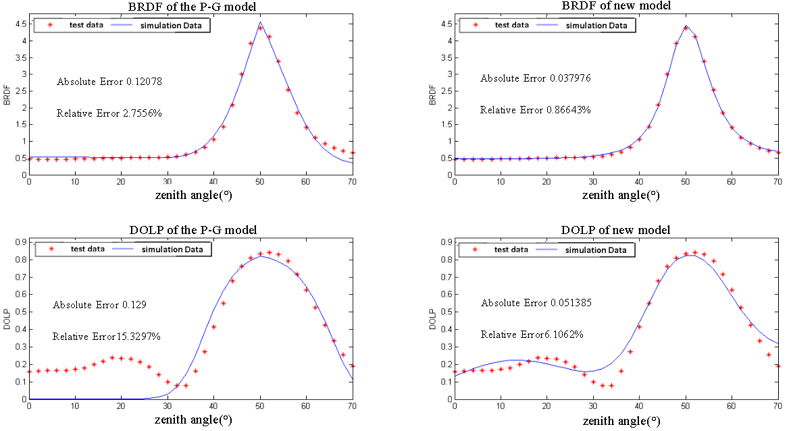
(a) Light-green-lacquer-coated aluminium plate
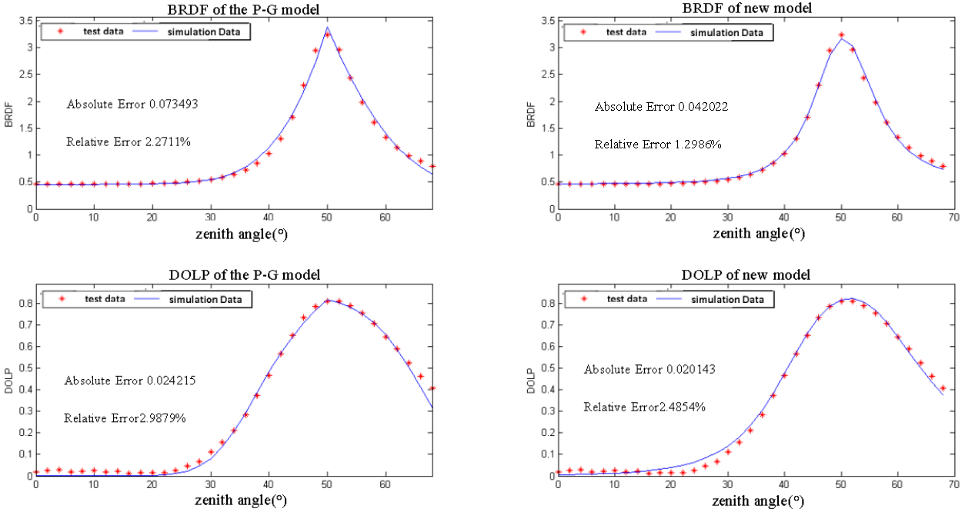
(b) Dark-green-lacquer-coated aluminium plate
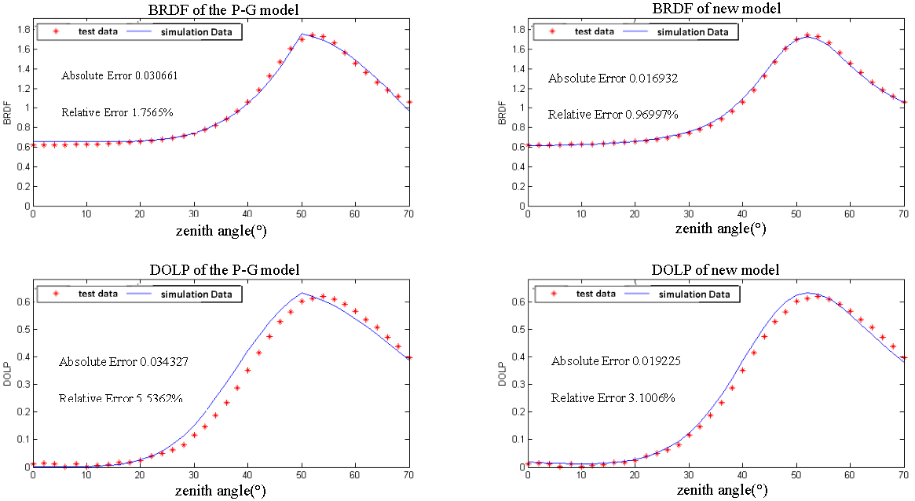
(c) Aluminium plate coated with earthen-yellow paint
Figure. Comparison of intensity and line polarization of target at 550 nm for both models considering different paint.

In the data processing, we took the root-mean-square error between the simulated data of the model and the measured data as the absolute error, and the intensity was the ratio of the root-mean-square error value to the maximum brightness value and the polarization was the ratio of the root-mean-square error value to the maximum line polarization as the relative error.
The decline rate of the relative error was determined by calculating the ratio of the difference between the relative error of the P-G model and the improved model to the relative error of the P-G model and was (2.7556-0.86643)/2.7556=0.6856=68.56% for the intensity model of the light green painted aluminium plate, as an example. We used this value as a measure of the rate of decline of the relative error of the model and to judge the accuracy of the model . Although the relative error of each point is small, the difference between the relative error of the improved model and the relative error of the P-G model accounts for a large proportion of the relative error of the P-G model.
Because our recalculation of all data results in a small change in the values of the parameter combinations obtained from the inversion, the new fit results differ slightly from the initial fit, and the overall data trend does not change. All our data are obtained through experiments or simulations to ensure that there are no data manipulation problems.

According to reviewer’s suggestion, We have made changes in line 446 and Figure 9.

The decline rate of the relative error was determined by calculating the ratio of the difference between the relative error of the P-G model and the improved model to the relative error of the P-G model and was (2.7556-0.86643)/2.7556=0.6856=68.56% for the intensity model of the light green painted aluminium plate, as an example. We used this value as a measure of the rate of decline of the relative error of the model and to judge the accuracy of the model.

(a)
(b)
(c)
Figure 9. Comparative images of Intensity and DOLP for aluminium plates under two models. (a) Intensity and DOLP comparison images of light green lacquer-coated aluminium panels under two models; (b) Intensity and DOLP comparison images of dark green lacquer-coated aluminium panels under two models; (c) Intensity and DOLP comparison images of earth yellow lacquer-coated aluminium panels under two models.

- The manuscript is not well-organized. It is quite difficult for reading, many details are omitted, the figures are of a bad quality. The manuscript contains a lot of misprints (for instance, “nm” instead of “um” in the line 130, “Meuller” instead of “Mueller” in the line 189, etc.)
Response: Thanks for reviewer’s comment. We have fixed the grammatical errors and typos throughout the article.

