Response to Reviewer 1 Comments

Point 1: "The privacy protection method proposes how to use the JFE for secure dissemination in the compressed-encrypted domain.">> please explain how this can be achieved?

Response 1: Thank you for making this comment. Fig.1 shows the proposed scheme. First, the original social image is decomposed by the TSH wavelet transform. The approximation coefficient is selected for permutation with jiugongge block maps. Second, with a probabilistic homomorphic cryptosystem, the compressed contents are encrypted totally. Third, fingerprint information is embedded into the corresponding encrypted coefficients. Finally, the compressed-encrypted-fingerprinted content is distributed on social media platforms.
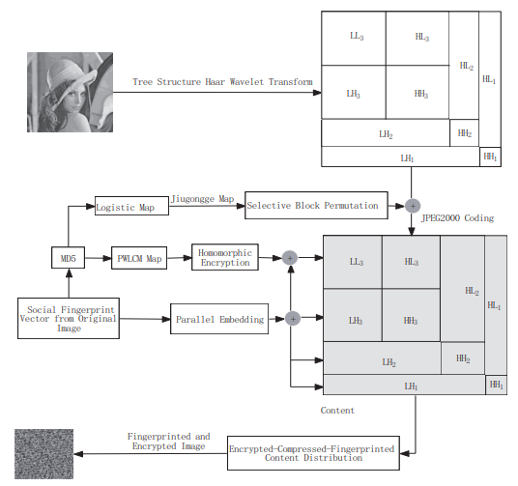
Fig.1 The proposed social image protection scheme.

Point 2: "The proposed scheme can avoid big data problems on social media platforms to the utmost extent with the JFE in the compressed domain." >> please explain how this can be achieved?

Response 2: Thanks for your comment. First, the community fingerprint code segments are not embedded repeatedly for every users in social media platforms. Then, the fingerprinted content will can be sharing with hybrid multicast-unicast scheme, which is more efficient than the traditional unicast distribution mode. With the proposed fingerprinting scheme, the volume of fingerprinted multimedia big data can be decreased sharply in comparison with related unicast schemes, which can avoid big data superimposed effect.

Point 3: There is no threat model to describe the privacy threats and attacker capabilities.

Response 3: Thank you for making this comment. The growth of social image sharing underscores potential security risks for illegal use such as image forgery, malicious copying, piracy exposure, plagiarism, and misappropriation. Preserving privacy in publishing social image becomes an important concern. More importantly, social image has to be of high security and establish privacy in it for dissemination on social media platforms.
Therefore, illegal use of social image is the main threat for users in social media platforms.
For example, once users of social media platforms received and decrypted the social image, it could be copied and re-disseminated arbitrarily. The social image is not protected in this case. Thus, social image redistribution should be deterred by extra protection schemes.
Because the plain social media is easily attacked during personal information insertion, a watermark embedded in the encrypted media is a good solution.
But watermarking cannot trace somebody who redistributed the copy. In the practical application scenario, as a special case, digital fingerprinting can deter the redistribution of content on social media platforms

Point 4: There is no security and privacy analysis to discuss how the proposed scheme achieves the contributions discussed.

Response 4: Thanks for this comment. First, Plain images are encrypted, then the original information of plain images are not visible, the privacy information of original image are protected with the proposed scheme. The experimental results are shown in Fig.2. From Fig.2(d), the fingerprint information which is hidden in decrypted imags will protect them not to be illegal use.
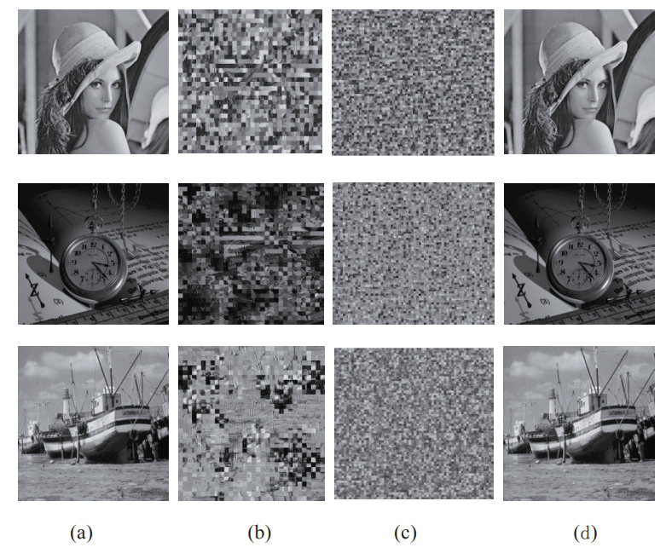
Fig.2 Original images and encrypted images.

Point 5: How is this work different than other works in literature. please explain

Response 5: Thank you for making this comment. Most image encryption schemes encrypt image in the spatial domain. In this paper, images are encrypted in the compressed domain. And the joint fingerprinting and encryption (JFE) scheme will protect social images when then are decrypted. However, usual image encryption cannot protect image when it is decrypted. Most important of all, the proposed JFE scheme in the compressed domain can avoid big data problem.

