Dear reviewer:

The original manuscript is changed according to the comments of the reviewers. There are 5 comments from you, the corresponding response to them are given in Table 1 respectively. The change position in the original manuscript is represented by under lines and bold words in each table, while the changed content is highlighted by red color.
Table 1. Corresponding response to the comments from the reviewer
Comments | Corresponding response of the manuscript
Comment (1):  Please explain why rotating the captured weld image by 180 degrees makes the final model more robust in terms of orientation. | We feel sorry that we did not provide enough information about the reason for introducing rotation operation. The the reason is given.  The reason for introducing rotation operation:  Firstly, in real-world scenarios, the orientation of the weld image might vary due to factors such as the camera position or operator handling. By introducing rotation operation of the images in the training data, the model learns to handle such variations and becomes less dependent on the specific orientation introduced during image capture.  Secondly, each sample is rotated 8 times, 45 degrees each time, generating 8 rotated images from the original one. Rotating the image introduces additional variability to the training data. Since welding defects can occur at various orientations, augmenting the dataset with rotation operation of the images helps the model learn to recognize defects regardless of their orientation. This augmentation technique increases the diversity of training examples and can improve the model's ability to generalize well to unseen orientations.  Finally, when the model encounters test data with different orientations (which it hasn't been trained on explicitly), the exposure to rotated training images helps the model perform better. It has learned to extract relevant features and understand the structure of the defects, irrespective of their orientation. This generalization capability is crucial in real-world applications where the pose or orientation of the object might vary during testing.  Overall, by introducing rotation operation during training, the model can become more robust, invariant to orientation changes, and better able to handle varying orientations encountered in real-world scenarios. This can improve the accuracy and reliability in detecting welding defects.
Comment (2):  Please give the parameter settings for Faster R-CNN+ResNet-50, SSD+ResNet-50 and YOLOv5s. | Thank you very much for this important suggestion. The parameter settings were added in Table 4.  The changed place:  - Line 331:  Table 4. Setting of training parameters.
  Models | Faster RCNN+ResNet-50 | SSD+ResNet-50 | YOLOv5s | Proposed method
  Image size | 640x640 | 640x640 | 640x640 | 640x640
  Learning rate | 0.001 | 0.001 | 0.01 | 0.01
  Optimizer | Adam | Adam | Adam | Adam
  Weight decay | 0.0001 | 0.0001 | 0.0005 | 0.0005
  Batch size | 8 | 16 | 16 | 16
  Number of epochs | 100 | 100 | 100 | 100
Comment (3):  Please complete Figure 12. For example, the titles of the horizontal and vertical axes, etc | Thank you very much for this important suggestion. Figure 12 has been completed.  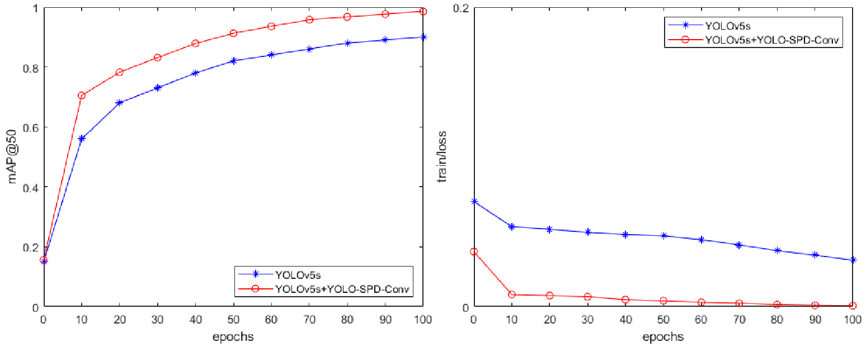  Figure 12. The mAP@50 (left) and train loss (right) during 100 training epochs.
Comment (4):  Please analyze why the speed of the proposed algorithm in this paper is better than other algorithms. | Thank you for your reminding. In the two-stage methods, region proposal generation is performed in the first stage, followed by bounding box refinement in the second stage. This additional stage increases the computational complexity of these models. In contrast, a single-stage object detection approach directly predicts bounding boxes, eliminating the need for a separate region proposal step, which leads to faster inference speeds.  The introduction of YOLO-SPD-Conv module in YOLOv5s can further enhance its speed. The YOLO-SPD-Conv module utilizes dilated convolutions with different dilation rates to effectively capture multi-scale information from the input image. This leads to more efficient feature representation, reducing the computational cost while maintaining accuracy.
Comment (5):  The references can be further expanded to highlight the significance of this study.  Such references have been added.  [1]title: Development of real-time vision-based fabric inspection system  [2]title: Automatic defect detection of metro tunnel surfaces using a vision-based inspection system  [3]title: Computer-vision-based fabric defect detection: A survey  [4]title: A review on recent advances in vision-based defect recognition towards industrial intelligence | Thanks for your suggestions. Some references have been added. The paper mentioned in the Comment is very good.

