Thanks again for the reviewer’s valuable suggestions, that allowed to us give a new sight on the manuscript. We answer her/his questions and highlight in red the changes in the manuscript.

REVIEWER:

Regarding the association between breastfeeding and length of stay, it appears that breastfeeding may be acting as a surrogate for the length of stay in the study. To ensure that the results are not confounded, I suggest that the authors consider controlling for the length of stay in their statistical model. By accounting for the potential influence of length of stay, they can better isolate the effect of breastfeeding on the outcome of interest, reducing the possibility of any spurious associations.
ANSWER
We reconsidered to include the length of stay in the multivariate model. We analyzed the correlation and potential co-lineal relation between the length of stay and other quantitative variables related to BPD: As shown in the table, there’s no co-lineal relation (Pearson coefficient < 0,6), but there exists a high correlation between the length of stay and birthweight, gestational age, 1 min-Apgar, 5 min-Apgar, CRIB score and duration of mechanical ventilation.
 |  | Lenght of stay | Birtweight | 1 minute-Apgar | 5 minutes-Apgar | CRIB score | Duration of invasive mechanical ventilation
Lenght of stay | Pearson Correlation | 1 | -,413** | -,150** | -,151** | ,375** | ,546**
Lenght of stay | Sig. (2-tailed) |  | ,000 | ,000 | ,000 | ,000 | ,000
Lenght of stay | N | 4314 | 4314 | 4261 | 4189 | 3742 | 4019

If the length of stay is included in the model, explanatory variables already documented in other studies, would lose their significance with the BDP. (see tables on the next page)
In addition, taking into account that the length of stay is a variable dependent of the outcome (BDP), due to dependence on the clinical status and evolution of the patient, we assume that it is not appropriate to introduce it in the models analyzed.
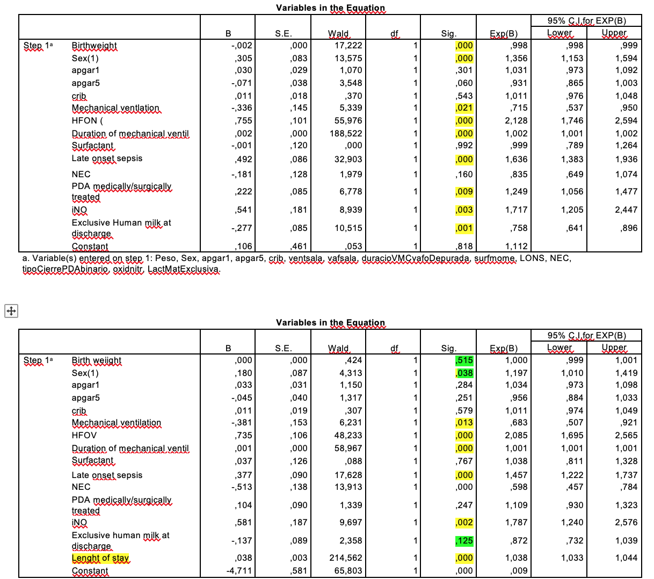

REVIEWER:
The authors mentioned that breastfeeding has the potential to protect against bronchopulmonary dysplasia (BPD). However, I find it puzzling that the incidence of BPD increases as the breastfeeding rate increases during the study period. This observation seems contradictory to the expected protective effect of breastfeeding. It would be helpful if the authors could provide a plausible explanation or discuss any potential confounding factors that might be influencing this finding. By doing so, they can help readers better understand the complex relationship between breastfeeding and BPD in the context of their study.
ANSWER:
The figure showing an increase in the breastfeeding rates during the study period is focused in the use of human milk at discharge (any amount or exclusive breastfeeding) in those infants with BPD, not in the entire population, as an opportunity to improve their short and long term outcome. This is discussed at the end of the discussion section: The protective role of any amount of breastmilk for infants with BPD continues after discharge. It has been associated with fewer emergency department visits, systemic steroid courses, fewer cough or chest congestion episodes, and a trend toward fewer hospitalizations.⁴⁹ ⁴⁷ Hence, if BPD could be prevented to some degree in the neonatal period in this group of extremely preterm infants, it is expected that after their discharge from the neonatal unit, the respiratory health of former extremely preterm infants would be enhanced for years after the neonatal period.
Our intention was to report the increasing use of human milk in the most vulnerable infants as a result of the changes in policies promoting family centered care, introduced in the Spanish NICUs along the period.
We’ve added ‘with BPD’ in the discussion section when talking about the rates of HM in our population:
Since 2011, more than half of the infants below 26 weeks of gestation with BPD in our study population received some HM feeding at NICU discharge

