Comments from Reviewer #2:
Reply: First of all, we sincerely appreciate all of your suggestions/comments. Most importantly, we would like to express our gratitude for offering us many constructive suggestions. According to your comments, we have made corresponding revisions, including language modification for the entire article, sentence reorganization, and related literature supplementation. Point-to-point responses to all the comments and suggestions have been attached, and revisions based on associated suggestions have been conducted to the revised manuscript.
R2C1: v. 28 – the phrase starting with „Areas…” is not clear
Reply: Thanks! We have revised accordingly to avoid possible confusion (Page 1, Lines 27–28).
R2C2: v. 50-52 – the phrase is worth to be rewritten
Reply: Many thanks. We have rewritten the corresponding sentence (Pages 1–2, Lines 44–46).
R2C3: v. 66-67 – as tidal are periodic, wavy changes of different intensity need to be described otherwise
Reply: Many thanks for your comment. The tides along the central Jiangsu coast are dominated by semi-diurnal (Wang et al., 2019), with two high tides and two low tides per day. Affected by the amphidromic wave system and the progressive Poincaré wave system, the tidal dynamics are strong, with a mean tidal range of 2–6 m (Xing et al., 2012). Here, three tidal stations, Sheyang estuary, Jiang port and Yangkou port were selected to show the tidal level changes during the day (Fig. R1). By recording the hourly tide levels, it can be seen that the mean tide range decreases northward and southward, and the greatest mean tide range exists in the section from Jiang Port to Xiaoyangkou Port with a recorded tidal range of 9.28 m (Gong et al., 2012). According to your suggestion, We have supplemented the tide level changes in the attached chart to facilitate the reader's understanding (Fig. S2).
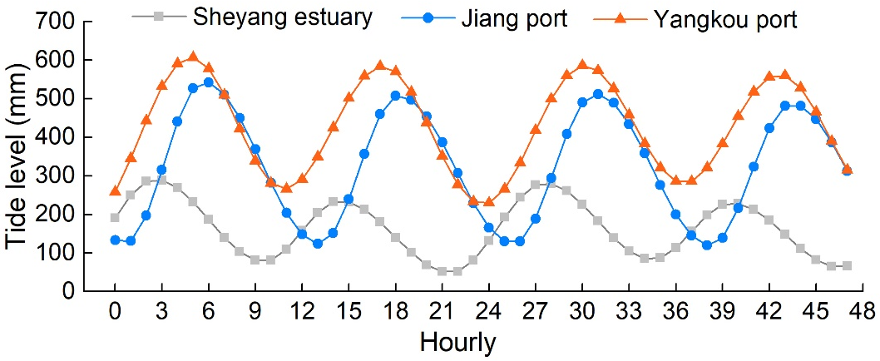
Fig. R1. Hourly tidal level curve of Sheyang estuary, Jiang port, and Yangkou port tidal gauge stations from February 23 to 24, 2018.
R2C4: v. 98 – “annual coastline” seems to be a shortcut, not quite clear
Reply: Thanks! We have corrected this expression accordingly (Page 2, Lines 83–84)
R2C5: v. 130-133 – in the (b) figure caption it is not mentioned about the current tide phase (supposing low tide)
Reply: Many thanks. As you understand, the image in Fig 1b is captured at low tide. We have provided additional description for the caption of Figure 1 (Page 3, Lines 111–112).
R2C6: v.196 – tidal data are not auxiliary, effectively are of primary value
Reply: Many thanks for your comment, and we are sorry for the confusion due to our unclear expression of “Auxiliary data”. We have renamed the title of this section to “Tidal level data”accordingly. Actually, the data used in the study mainly include remote sensing images, DEM and tide level data from tidal stations. Among them, remote sensing images are the primary data. The study screened images with a coverage less than 5%, and retained 87 scenes of images from 1990 to 2020 in the study area; secondly, these data were visual interpreted to exclude the images of medium and high tide levels; finally, for a small number of low tide and high-quality images, the study combined the observation data from tide stations and selected an image of the lowest tide for the extraction of waterline. As you pointed out, the tide level is very important data, which can assist the selection of images and correct the position of the waterline in Section 3.2.
R2C7: v. 201 and the chapter 3.2 is showing the importance of tidal data, as mentioned above (not auxiliary)
Moreover – the term “coastline” here is to be more precisely defined, as it may be differently understood. As I can guess from equations (1) and (2) and fig. 3 it is established at the mean high tide line. It needs also an assumption that the slope is constant, not influencing the range of inundation (as it is different e.g. considering tidal channels or other obstacles). There is no mention of possible sources of uncertainty in the determination of the coastline.
Reply: Many thanks. As you mentioned, the tide level data is not only used to assist in the selection of remote sensing images, but also plays a great role in the correction of the waterline. The equations (1) and (2) in chapter 3.2 require obtaining the tide levels h₁ and h₂ of the two remote sensing images, and then calculate the tidal range between them. In addition, the mean high tide H of the tide stations for many years is also needed to calculate the actual distance L of the waterline moving towards the land, and thus the position of the coastline can be deduced.
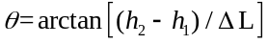 (1)
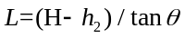 (2)
The central coast of Jiangsu is a typical muddy coastal zone in China, with wide tidal flats and densely developed tidal channels, resulting in a relatively gentle slope of the tidal flats. Affected by the tidal channels and human activities along the coast, the local topography may has changed. Since the sea-land boundary is in a state of constant change, the coastline should be a collection of numerous sea-land boundary lines rather than a fixed line. For the convenience of description and analysis, this paper obtains the mean high tide level of each tide station for many years, along with the tide data at the imaing time of the two satellite images to estimate the local slope, and then corrects the distance of the waterline moving towards the land to obtain the coastline position. In Section 3.2, the influence of factors such as tidal channels and reclamation activities on the slope was not considered, and we have supplemented a description of the uncertainty in the revised manuscript (Page 5, Lines 200–201).
R2C8: v. 357 – e.g. of this expression consider a unified way of expressing changes in the direction of the coastline movement. Erosion rate as a negative value may suggest reverse process.
Reply: Many thanks again for your valuable suggestions and careful corrections of our manuscript. Here, the negative value should be changed to a positive value, and we have revised accordingly (Page 9, Line 336). The change rate of coastline was calculated based on the cumulative change distance of coastline and research period. Since the direction of coastline change is not consistent in different sections, some coasts advance toward the ocean (siltation), others recedes toward the land (erosion), both of which are actual changes in the coastline. Therefore, the absolute value was used for the change distance in formula 5. The central coast of Jiangsu has advanced seaward from 1990 to 2020. For the convenience of calculating the distance of coastline change, we have recorded the change to the ocean side as positive value and the change to the land side as negative value, and the actual distance of coastline changes is the sum of the two absolute values.
R2C9: v. 446 – the chapter 5.2 – limitations and prospects – in the context of earlier considerations on changes in the coastline, issues such as changes caused by the diversification of the supply of sedimentary material to the coastal zone as a result of human activity in river basins flowing into the sea and its distribution by coastal circulation were not discussed (only Fig. 1a refers to the characteristics of the system waves). Similar issues are discussed in the paper by Du et al. 2019, Sediment Dynamics of Chinese Muddy Coasts and Estuaries, https://doi.org/10.1016/B978-0-12-811977-8.00003-0 not referenced here. The characteristics of sea level changes were also completely omitted, also in relation to land movements, described widely in the literature, having an undoubted impact on changes in the coastline over decades.
Reply: Many thanks for your comment. Here, we provide an idea of coastal stability from the perspective of remote sensing images and take a representative area as the study area to realize. The effects of sediment supply and transport, human activities, and sea level changes on coastal changes has not been discussed in this study. Relevant references (Du et al. 2019; Kirwan & Megonigal, 2013) has been supplemented in the revised manuscript (Page 13, Lines 432–434).
R2C10: Not found a reference/discussion with very close paper by Xu et al. 2022 (Marine Policy, 139, https://doi.org/10.1016/j.marpol.2021.104887), using same resource of Landsat images for even longer period.
Reply: Many thanks for the reference you suggested! We are sorry for not timely citing this achievement. We have supplemented the related corresponding references (Xu et al., 2022) in the revised manuscript (Page 11, Line 388).

Thanks again for your comments and constructive suggestions for amending the manuscript's deficiencies and improving its quality.

References
Du, J.B., Shi, B.W., Li, J.S., Wang, Y.P. Muddy coast off Jiangsu, China: Physical, Ecological, and antheopogenic processes. Sediment Dynamics of Chinese Muddy coasts and estuaries. 2019, 24–49.
Kirwan, M.L., Megonigal, J.P. Tidal wetland stability in the face of human impacts and sea-level rise. Nature. 2013, 504, 53–60.
Xu, N., Wang, Y.,Huang, C., Jiang, S., Jia, M., Ma, Y. Monitoring coastal reclamation changes across Jiangsu Province during 1984–2019 using landsat data. Mar Policy. 2022, 136, 104887.

