Dear reviewer,
We appreciate you very much for their positive and constructive comments on our manuscript. We have revised our manuscript carefully and significantly, with consideration of every recommendations. Corresponding changes have been made with the tracking tool in the revised submission, which are listed below in BLUE text point by point. The original comments are copied in italics text.

Thank you very much for your attention and consideration.

Yours sincerely,
Wenbin Ding, on behalf of the authors

Title:
1. Delete “the” from the title as indicated? “Effects of rainfall and plant characteristics on the spatiotemporal variation of the soil moisture in a black locust plantation 3 (Robinia pseudoacacia) on the Chinese Loess Plateau”
Response: Thank you for the suggestion. We have deleted “the” from the title as indicated.
Line 2-4, “Effects of rainfall and plant characteristics on the spatiotemporal variation of soil moisture in a black locust plantation (Robinia pseudoacacia) on the Chinese Loess Plateau”.
Authors and Contact Information:
2. Are lines 11 and 12 needed?
Response: Thank you. We have revised the author line by adjusting the serial number, so that lines 11 and 12 are correctly represented.
Introduction:
3. Line 34: “also” rather than “further”?
Response: Thank you. We have used “also” instead of “further” in this sentence.
Line 54-57, “Spatiotemporal variations of soil moisture affect ecohydrological processes such as infiltration, evaporation, runoff, and plant function and morphology [19], and also affect ecosystem restoration [20], agricultural production, and socioeconomic development [21], particularly in arid and semiarid areas.”
4. Line 34: Is “the” before ecosystem needed? Relevant citation(s)?
Response: Thank you. We have deleted “the” before ecosystem, and the relevant citation was added.
Line 54-57, “Spatiotemporal variations of soil moisture affect ecohydrological processes such as infiltration, evaporation, runoff, and plant function and morphology [19], and also affect ecosystem restoration [20], agricultural production, and socioeconomic development [21], particularly in arid and semiarid areas.”
5. Line 35: for socioeconomic development – relevant citation(s)?
Response: Thank you. The relevant reference has been added in this sentence.
Line 54-57, “Spatiotemporal variations of soil moisture affect ecohydrological processes such as infiltration, evaporation, runoff, and plant function and morphology [19], and also affect ecosystem restoration [20], agricultural production, and socioeconomic development [21], particularly in arid and semiarid areas.”
6. Lines 49/50: First sentence of the third paragraph – relevant citation(s)?
Response: Thank you for the suggestion. We have added relevant citation in this sentence.
Line 71-72, “Factors affecting the spatiotemporal variations of soil moisture are currently among the most debated topics in soil moisture research [28].”
7. Lines 52/53: “the dominant factors generally vary by location and scale” rather than “the dominant factors generally vary among different areas and scales”?
Response: Thank you. We have replaced “the dominant factors generally vary among different areas and scales” with “the dominant factors generally vary by location and scale”.
Line 72-75, “Although the spatiotemporal variability of soil moisture depends on many factors, including vegetation, terrain, soil properties, and meteorological characteristics, the dominant factors generally vary by location and scale.”
8. Lines 49-63: In the third paragraph, different scales are mentioned (e.g., small catchment; watershed; local; slope; individual plants) – some rewording to improve clarity in this paragraph would be helpful. For example, do you mean examining, or modelling, or measuring soil moisture at a given scale, etc..
Response: Thank you for the valuable suggestion. We have revised this paragraph make it simpler.
Line 75-78, “For instance, at the watershed scale, land use type and slope position have a greater im-pact on soil moisture [29]. At the local scale, spatiotemporal variability of soil moisture is primarily determined by precipitation and potential evapotranspiration [30,31], while at the slope scale, topography and soil texture are the primary factors [32].”
9. Lines 61-63: please verify the statement that few studies --- or cite those few studies --- what plant(s) or agricultural crop(s) has/have been the focus of the noted few studies?
Response: Thank you. We have cited those few studies in this sentence.
Line 81-84, “However, few studies have explored the detailed spatiotemporal variations of soil moisture for individual plants [33], which may hinder the development of soil moisture models and understanding of soil moisture variations during plant growth.”
10. Lines 79-84: conflicting information is provided: Black locust plantations are said to improve soil water retention but the next sentence then mentions soil moisture is depleted in the plantations due to transpiration.
Response: Thank you for the suggestion. We have removed the phrase 'retaining soil water' from this sentence, as it is an incorrect description.
Line 46-48, “Black locust plantations improve the ecological environment in the area by reducing soil erosion, regulating soil respiration, and improving microbiology [13-15].”
11. Lines 90-91: I agree that “Our results provide valuable information for forest water resource management and hydrological model modification in arid and semiarid areas.” but providing more specificity, including citations, would strengthen the comment. Connecting the study focus with the issue of scale (in current 2nd and 3rd paragraphs) would also be helpful for the reader.
Response: Thank you. The paragraph has been revised in accordance with the suggestion.
Line 85-94, “Zhifanggou watershed is a typical region on the Loess Plateau that has experienced a process of serious damage and rapid recovery [34]. The soil moisture variability of black locust forest has been studied in this watershed [35]. However, the spatiotemporal variations of soil moisture based on individual plant remain lacking, and the effects of rainfall and vegetation characteristics on soil moisture are still poorly understood in this region. Therefore, in this study, nine black locust plants in the Zhifanggou watershed of the Loess Plateau were used to (1) determine the spatiotemporal variation characteristics at the single plant scale and (2) investigate the effects of individual rainfall and plant characteristics on the soil moisture. Our results provide valuable information for forest water resource management and hydrological model modification in arid and semiarid areas.”
12. I suggest reorganizing and rewording the Introduction (possibly to focus on: understanding soil moisture in Black locust plantations in the Zhifanggou watershed of the Loess Plateau). Possibly begin the introduction with lines 64-86, followed by lines 31-63 + 87-91 including rewording as previously mentioned.
Response: Thank you for the suggestion. As per the suggestion, we have adjusted the paragraph order and added details about soil moisture in the Black Locust plantation situated in the Zhifanggou watershed. Line 31-94.
Materials and Methods
13. Would a figure depicting the study site (the Zhifanggou watershed of the Loess Plateau), its location in the Loess Plateau, including, among others, footprints of the planted Black locust plantations within the Plateau, elevation contours or a DEM for the watershed, County and Province boundary lines, be helpful for the reader?
Response: Thank you. As per our revision, we have incorporated a figure showing the DEM of the watershed into the document.
Line 109-111, “
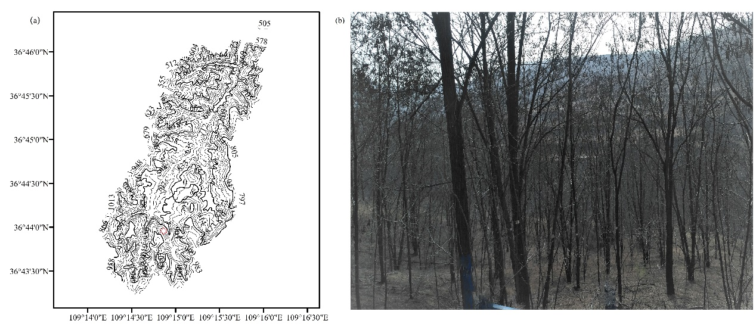
Figure 1. (a) The topographical map of Zhifanggou watershed and (b) the field photograph. Note: The red asterisk represents study site. ”
14. Lines 103-105: Percent breakdown of land use categories for the study site watershed? A separate zoomed in figure showing their locations within the watershed?
Response: Thank you for the suggestion. We have included a reference that provides the percentage breakdown of land use categories in the watershed. However, we were unable to provide a separate figure showing their locations within the watershed due to missing boundary information.
Line 106-108, “Primary land use categories within the watershed are forestland (21%), shrubland (34%), grassland (18%), and cropland (13%), with black locust as the main species in forestland [40].”
15. Lines 107-108: Move the lines further below (~Lines 113-117), that summarize tree selection criteria, to be right after this first sentence?
Response: Thank you. We have moved the lines in the last sentence of this paragraph. Line 126-127.
16. Lines 108-109: I don’t understand this sentence: “The area with typical black locust forest has a size of 20 m × 30 m, is located at an altitude of 1251 m, and has a slope of 30° and northwest exposure.” Please reword for clarity
Response: Thank you. In light of our revision process, we have edited the language of this sentence to make it more precise and easier to understand.
Line 115-117, “The typical black forest site encompasses an area measuring 20 m × 30 m, with a slope of 30° and northwest exposure, situated at an altitude of 1251 m.”
17. Another figure showing the locations of the 9 trees selected for the study?
Response: Thank you. We have included in Figure 2 a diagram showing the locations of the 9 trees selected for the study area.
18. Line 124: citation for the specialized measuring instrument. Reword the sentence to say measured using a … ending with citation(s)
Response: Thank you for the suggestion. We have cited the reference for the specialized measuring instrument.
Line 132-134, “The DBH, which refers to the diameter of the trunk at 1.3 m above the ground, was measured using a specialized measuring instrument ending with Zhai [42].”
19. Lines 129-130: citations for the two noted software used for analysis.
Response: Thank you. We have cited references for the two noted software.
Line 138-142, “An unmanned aerial vehicle was used to take photographs of the canopy above the studied trees, which were then imported into the Gap Light Analyzer 2.0 software [43]. The Sidelook 1.1 software was also used to determine the threshold value [44], and this information was then used to calculate LAI in the Gap Light Analyzer 2.0 software.”
20. Line 135: Is the word strategically needed
Response: Thank you. We have deleted the word “strategically” in this sentence.
Line 145-147, “In black locust experimental stands, soil moisture access tubes were placed at equal distances in four directions (0°, 90°, 180°, and 270°), with the trunks of individual plants serving as the centers.”
21. Line 137: What was the basis for the determination of the distances between each access tube?
Response: Thank you. To determine the distance between access tubes, we relied on canopy width as our guiding factor.
Line 147-149, “According to the canopy width, the distance between the access tubes was 0.8 m and three access tubes were installed in each direction (Figure 2b).”
22. Should references to software and/or measurement devices include a citation (to a user manual for example)
Response: Thank you for the suggestion. We have added the citation for the soil moisture content measurement devices.
Line 150-152, “To measure the soil moisture content (SMC) of the soil profile (volumetric, %), a moisture monitoring tool (TRIME-PICO-BT TDR, Germany) was used to detect data in the 3 m access tubes of TRIME (Figure 2c) [45].”
23. Is the conceptual plot provided in Figure 1 (b) representative of a “typical” root system for a Black locust tree
Response: Thank you. Figure 2 (c) features a conceptual plot that we believe accurately depicts the root system of a typical black locust plant.
Results
24. Line 163: which plant trunk? Average across all nine?
Response: Thank you. This sentence provides a replenished description of the spatial distribution, which is the average across all nine trees.
Line 174-175, “In this study, we analyzed the spatial distribution of trees by utilizing the individual plant trunk as the center and computing the average across all nine trees.”
25. Section 3.1.1 refers to Figure 2, and it is not clear to me what I am looking at. The results in Figure 2 are for which tree among the nine, or are they averaged over all nine trees? What SMC measurement is this from among the 31 that were taken at the 84 observation locations?
Response: Thank you for the suggestion. The findings presented in Figure 2 represent an average across all nine trees. At each of the 84 observation sites, we conducted 31 SMC measurements and have included this additional information in the manuscript.
Line 155-156, “In total, SMC data were collected 31 times at each of the 84 observation sites during the study period.”
Line 174-177, “In this study, we analyzed the spatial distribution of trees by utilizing the individual plant trunk as the center and computing the average across all nine trees. The results are shown in Figure 3. Generally, the SMC (averaged across all nine trees) increases with increasing distance from the tree trunk in the horizontal direction (Fig. 3a).”
26. Line 180: 20 times at each of the 84 observation sites?
Response: Thank you. We measured the SMC 20 times at each of the 84 observation sites, and this information has now been included in the sentence.
Line 192-193, “During the 2019 growing season, the SMC was measured 20 times at each of the 84 observation sites.”
27. The results in Figure 3 are for which tree and which observation site for that tree? Would it be instructive to modify Figure 3(a) to also include a rainfall hyetograph on the top of the figure
Response: Thank you. The results in Figure 4 are for all 84 observation sites. The rainfall characteristics was shown in Figure 7.
Line 192-193, “During the 2019 growing season, the SMC was measured 20 times at each of the 84 observation sites.”
28. Correct to assume no irrigation?
Response: Thank you. The study plot has a natural slope and is not irrigated, making it appropriate for the study.
29. Change Figure 6 x-axis to show date instead? What is the SMC in this plot? Averaged across all 84 observation sites, for all depths? Isn’t rainfall intensity times rainfall duration equal to rainfall amount?
Response: Thank you for the suggestion. We have revised the x-axis to show date in Figure 7. The SMC is that across all 84 observation sites, for all depths. In individual rainfall events, rainfall amounts equal to rainfall intensity times rainfall duration.
Line 234-237, “The data show that there is a similarity between the variations of the SMC (averaged across all 84 observation sites, for all depths) and rainfall amount, indicating that the SMC increases with increasing rainfall.”
Line 239-240, “
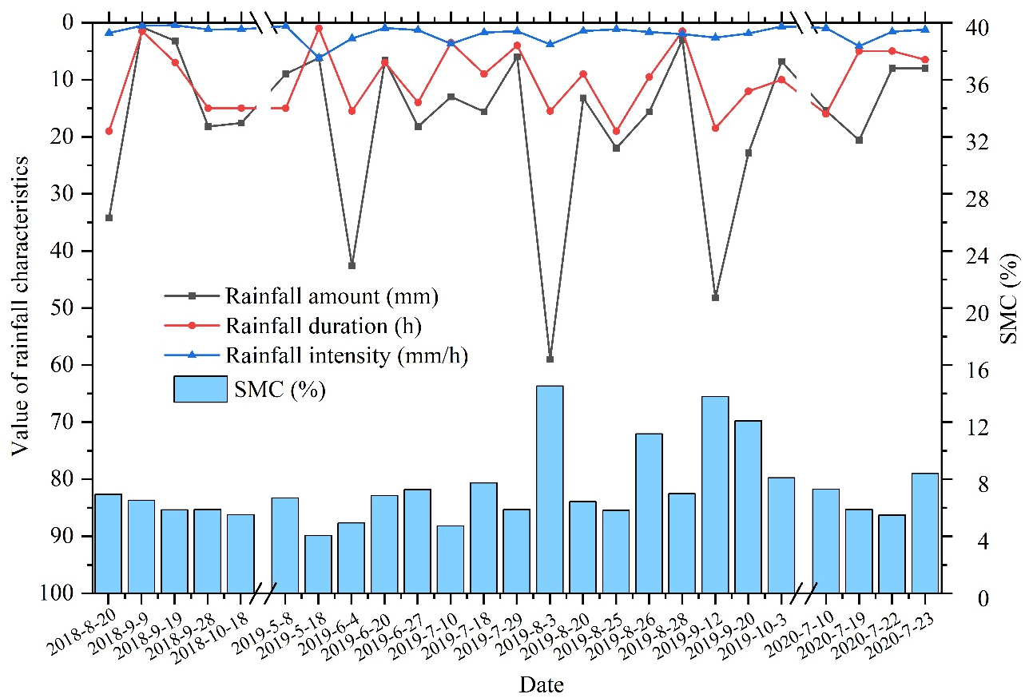
Figure 7. Changes of the rainfall characteristics and SMC during the measurement period.”
Returning to the final sentence of the Intro., it would be interesting to read in the discussion and/or conclusions (and abstract) how the study results would specifically inform changes for water management in a black locust plantation in the Zhifanggou watershed of the Loess Plateau, and support modifications of hydrologic models of a black locust plantation in the Zhifanggou watershed of the Loess Plateau

