Article
Fertigation and Carboxymethyl Cellulose Applications Enhance Water-Use Efficiency, Improving Soil Available Nutrients and Maize Yield in Salt-affected Soil
Yaqi Wang ¹, Ming Gao ¹, Heting Chen ¹, Yiwen Chen ¹, Lei Wang ², and Rui Wang¹*
Citation: To be added by editorial staff during production.
Academic Editor: Firstname Lastname
Received: date
Revised: date
Accepted: date
Published: date

Copyright: © 2023 by the authors. Submitted for possible open access publication under the terms and conditions of the Creative Commons Attribution (CC BY) license (https://creativecommons.org/licenses/by/4.0/).
¹ School of Agriculture, Ningxia University, Yinchuan, Ningxia, China;
² School of Ecology and Environment, Ningxia University, Yinchuan, Ningxia, China;
* Correspondence: amwangrui@126.com;
Abstract: Conventional organic soil amendments and drip irrigation are insufficient in mitigating soil salinization. The development of a more potent soil amendment with higher water retention capability is critical. Carboxymethyl cellulose (CMC) has excellent water retention and adsorption properties and is suitable for soil water retention and amendment, but its effects on water and salt distribution, soil nutrients, and maize yield are not clearly investigated. We set up five treatments with flood irrigation (CK), drip irrigation (W), drip irrigation combined with 100 kg CMC ha⁻¹ (WC1), drip irrigation combined with 200 kg CMC ha⁻¹ (WC2), and drip irrigation combined with 300 kg CMC ha⁻¹ (WC3). The results showed that under the condition of drip irrigation combined with CMC application, the soil moisture content in the 0-40 cm layer increased by 3.73% to 16.46%, while the salt content decreased by 4.08% to 16.61%, resulting in a desalination rate from 10.32% to 12.93%. The salt was gradually washed down and formed a desalination area with the drip emitter as the center, and the salt distribution characteristics shifted from a surface accumulation type to bottom deposition type. The drip irrigation and CMC application also increased the content of available nutrients; reduced surface evaporation, underground water loss, and maize evapotranspiration; and improved water-use efficiency, thus increasing the aboveground biomass and grain yield. In summary, CMC had a significant effect on water retention, desalination, and yield increase. It can serve as a novel soil amendment for salt-affected soil.
Keywords: Drip irrigation; carboxymethyl cellulose; water and salt transport; available nutrients; maize

1. Introduction
Soil salinization is a global environmental issue, resulting in a vast expanse of land becoming infertile due to salt accumulation, which has become an increasingly severe problem worldwide [1]. The total land area with varying degrees of salinization is estimated to be approximately 9.5×10⁸ hm² globally, accounting for about 22% of global agricultural land [2]. This area continues to grow at a rate of 1-2.5×10⁶ hm² per year [3]. Based on projections, it is anticipated that by 2050, around 40%–50% of the world's arable land will be adversely impacted by salinization [4]. In China, there are approximately 3.67×10⁷ hectares of salt-affected soil, mainly distributed in the Northeast, North China, Northwest, and coastal areas [5]. Northern Ningxia, located in the semi-arid region of northwestern China, boasts flat terrain, has good soil quality, and benefits from irrigation from the Yellow River, making it a vital agricultural area and a base for commodity grain production in China. For centuries, people have relied on diverting water from the Yellow River, which has allowed for agricultural prosperity and cultural development in the Yellow River basin of ancient China despite an average annual precipitation of only 200 millimeters. However, due to the evaporation of up to 2000m from the surface of the area and the long-term irrigation by the Yellow River, the groundwater level rises and the salts in the groundwater move up and gather at the surface, resulting in particularly severe secondary soil salinization in the region [6]. Extensive salt-affected soil has been abandoned, further shrinking arable land resources, reducing crop yields, and severely hindering local sustainable agricultural development [7].
Soil salinization is the result of the joint action of water and salt, which is closely related to factors such as irrigation, tillage patterns, climatic conditions, and soil types. The essence of soil improvement measures in salt-affected soil is to regulate soil water and salt transport, accelerate the downward leaching of soil salts, and hinder the upward migration of salts due to transpiration towards the surface [8,9]. Traditional hydraulic engineering improvement measures often use flood irrigation to wash away salt, which not only wastes precious water resources but also increases the risk of environmental pollution [10]. In contrast, water and fertilizer integrated drip irrigation (fertigation) technology achieves a high frequency and precise irrigation, and allows water and fertilizer to evenly seep into the soil. This technique reduces soil solution infiltration and surface runoff while maintaining a high soil moisture content, promoting root growth and development of plants, and increasing water-use efficiency and crop yields [11]. Furthermore, fertigation creates a desalination zone with adequate water and low salt concentration near the dripper, providing a suitable microenvironment for the normal growth of crops in salt-affected soil [12]. Therefore, drip irrigation has become one of the most effective methods for developing low-yield agricultural land affected by salinization and is widely promoted and used nationally and internationally. [8]. Previous research has shown that the comprehensive effects of water and fertilizer interaction in fertigation can increase water-use efficiency by 22%–27% and crop yields by 10%–15% while reducing water consumption by 40%–50% [13]. However, a single-drip irrigation mode is no longer effective in suppressing the increasingly serious soil salinization. In large-scale intensive agricultural production, drip irrigation often needs to be combined with soil amendments for comprehensive management of salt-affected soil, in order to achieve the desired water-saving and salt-suppression effects.
Several studies have indicated that the application of organic soil amendments in salt-affected soil can effectively enhance agricultural productivity [14,15]. Among the most commonly used organic soil amendments for salt-affected soil, humic acid and biochar can both effectively improve soil structure, promote the formation of soil aggregates, increase soil organic carbon content, improve soil organic matter, reduce soil salinity, and stimulate crop growth [16]. However, with global warming and the increasing occurrence of extreme weather events in arid and semi-arid regions, the surface evaporation rate has further increased, and the process of soil salinization has accelerated. Conventional soil amendments are no longer sufficient to address the increasingly severe soil salinization process, and there is an urgent need to develop water-retaining agents with stronger capabilities to cope with this challenge.
Carboxymethyl cellulose (CMC) is a cellulose ether derivative with carboxymethyl groups and its aqueous solution has several beneficial properties, including thickening, film-forming, suspension, adhesion, and water-retention properties [17], making it particularly suitable as a water retention and soil conditioner for salt-affected soils. When applied to soil, CMC can change soil infiltration characteristics and infiltration model parameters by forming a gel-like structure, improve soil water infiltration performance [18], increase soil water holding capacity and salt leaching efficiency, and thus improve plant water utilization [19]. CMC can also act as a binder, which helps to aggregate soil particles, reduces soil compaction, increases soil pore space, improves soil non-capillary porosity, and improves water infiltration into the soil [20]. In addition, the negatively charged carboxymethyl group on the main chain of CMC can interact with the cations of the soil solution through electrostatic attraction, thus inhibiting soil salt stress [21]. However, research on the impact of CMC as a soil amendment on soil water and salt transport, nutrient distribution, and crop growth is currently lacking. Therefore, there is an urgent need to investigate the impact of CMC application on soil and crops, particularly in conjunction with fertigation for improving the soil quality of salt-affected soil. Such research will provide a theoretical basis for the selection and development of soil-improvement agents in comprehensive water-saving and salt control models for salt-affected soil in the future.
To fully understand the integrated effect of CMC on salt-affected soil, it is necessary to have a good understanding of the strong spatial and temporal variation of soil moisture and salinity and crop water use efficiency, and to improve the theory of water and salt transport regulation of CMC combined with fertigation. Therefore, the main focus of this study is on: (1) vertical and horizontal distribution of soil moisture and salinity, (2) availability of soil nitrogen (N), phosphorus (P), and potassium (K), and (3) the plant response to different application rates of CMC combined with fertigation. We anticipate that the impact of the research deliverable could benefit all salt-affected soils in arid and semi-arid regions worldwide. In addition, they will help to choose suitable soil amendments for salt-affected soil, protect water resources, suppress salt deposition, and improve land productivity in salt-affected soil.

2. Materials and Methods

2.1. Study site description
The experimental site was located in Jiaoji Village, Pingluo County, Shizuishan City, Ningxia Hui Autonomous Region (36°15′N, 106°15′E, 1100 m above sea level), with a temperate continental semi-arid climate. An overview of the specific field trial areas is as follows.
Table 1. Overview of the field trial area.
Temperature and rainfall conditions in the field trial area
Annual average temperature | 8.7℃
Effective accumulated temperature | 3100-3300℃
Diurnal temperature range | 10-15℃
Annual average sunshine duration | 2800-3000h
Sunshine rate | 68%
Average annual precipitation | 190-210mm
Average annual evaporation | 1900-2000mm
Frost-free period | 165-170d

Table 2 presents the physical and chemical properties of the initial soil. The soil textures are medium-textured saline alluvial soils with basic sand and loamy sand within 0-70 cm and loamy within 70-100 cm. Prior to the experiment, the average depth of groundwater was 1.38 meters, with a pH of 8.25 and an electrical conductivity (EC) of 15.22 dS m⁻¹.
Table 2. Physical and chemical properties of the initial soil.
Soil layer |  |  |  | Bulk density | Organic matter | pH | EC ¹ | ESP ²
(cm) |  |  |  | (g cm⁻³) | (g kg⁻¹) |  | (dS m⁻¹) | (%)
0–10 |  |  |  | 1.36 | 15.79 | 8.72 | 2.80 | 23.46
10–20 |  |  |  | 1.46 | 14.31 | 8.77 | 2.59 | 22.29
20–30 |  |  |  | 1.46 | 12.51 | 8.68 | 2.32 | 21.16
30–40 |  |  |  | 1.55 | 12.02 | 8.65 | 2.65 | 22.65
40–50 |  |  |  | 1.54 | 10.15 | 8.60 | 2.53 | 21.68
50–60 |  |  |  | 1.53 | 9.36 | 8.38 | 2.41 | 20.91
60–70 |  |  |  | 1.55 | 7.19 | 8.58 | 2.33 | 20.52
70–80 |  |  |  | 1.56 | 5.78 | 8.23 | 2.22 | 19.90
80–90 |  |  |  | 1.55 | 5.21 | 8.54 | 2.22 | 19.91
90–100 |  |  |  | 1.55 | 5.18 | 8.14 | 2.10 | 19.24
¹ EC: electrical conductivity, ² ESP: Exchange sodium percentage.

2.2. Experimental design
The experiment was initiated on April 10th, 2022, and lasted for a period of 130 days, during which the maize variety tested was Da Jing Jiou 26. The wide-narrow row planting pattern (Figure 1B) was employed, with a row width of 60 cm and inter-row spacing of 40 cm, and a plant spacing of 22 cm. Under a drip irrigation system, the main components of the head system were composed of electromagnetic valves, pressure gauges, flow meters, filter screens, and fertilizer tanks, with each treatment field having an independent drip irrigation field control system to control water application rates within each plot. Drip irrigation belts were laid within the narrow rows, with a spacing of 20 cm between each emitter and a flow rate of 1.28 L/h. Five treatments were established: (1) CK (traditional flood irrigation with an irrigation quota of 900 mm); (2) W (fertigation with an irrigation quota of 450 mm); (3) WC1 (fertigation with an irrigation quota of 450 mm and a CMC application rate of 100 kg ha⁻¹); (4) WC2 (fertigation with an irrigation quota of 450 mm and a CMC application rate of 200 kg ha⁻¹); (5) WC3 (fertigation with an irrigation quota of 450 mm and a CMC application rate of 300 kg ha⁻¹). Each treatment was replicated three times, resulting in a total of 15 plots, which were randomly arranged within each block, with a plot area of 20×20 m² and 38 rows of maize per plot, for a total trial area of 6000 m².
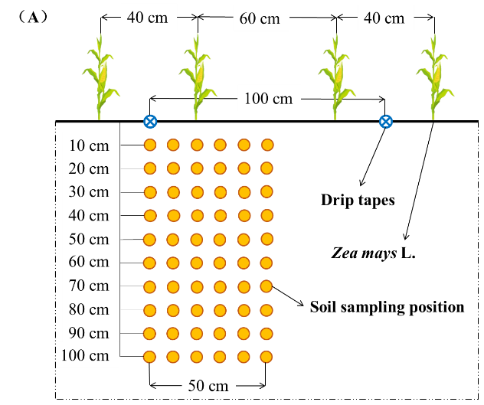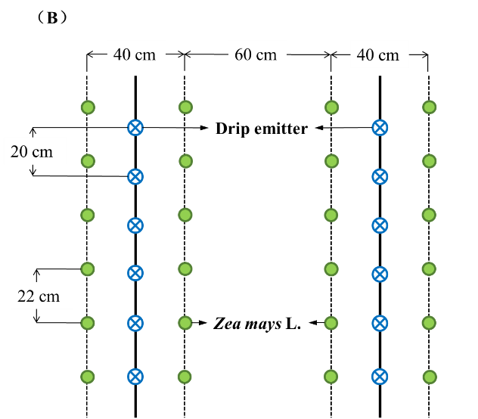
Figure 1. Planting pattern and soil sampling positions in the field experiment. (A), Cross-section view of plot; (B), Top view of the plot details.

2.3. Fertilization management and Irrigation scheduling
The trial fertilization management and irrigation scheduling were consistent with the local conventional irrigation and fertilization schedule. Prior to planting, 1500 kg of matured cow manure was applied per hectare to all plots as a basal fertilizer. The traditional flooding treatment (CK) used urea, ammonium phosphate, and ternary compound fertilizers. The amounts of N, P, and K were 400 kg N ha⁻¹, 200 kg P₂O₅ ha⁻¹, and 225 kg K₂O ha⁻¹, respectively, of which 65% of the N was used as basal fertilizer and 35% as top dressing at a rate of kg ha⁻¹. The fertilizer was immediately incorporated into the soil by rotary tillage to a depth of 20-25 cm after application. During the maize growing season, the remaining urea was applied twice according to the nutrient requirements of maize. We used water-soluble fertilizer (N-P₂O₅-K₂O=24-12-14) for maize as fertilizer for the drip irrigation treatments (W, WC1, WC2, and WC3) according to the traditional local fertilization practices, and applied it by dissolving it in irrigation water during irrigation. Ten rounds of irrigation were carried out during the maize growth period, with seven rounds of fertilization applied by drip irrigation, and the total amount of fertilizer was consistent with that of the flood irrigation treatment. Additionally, WC1, WC2, and WC3 were applied by surface spreading 100 kg CMC ha⁻¹, 200 kg CMC ha⁻¹, and 300 kg CMC ha⁻¹ in the corresponding plots before planting, and then rototilled into 20-25 cm of soil by rotary tillage. Irrigation water was drawn from a canal connected to the Yellow River with EC, pH and SAR of 0.43 dS m⁻¹, 7.98 and 1.87 mmol^{0.5} L^{-0.5}, respectively. The specific field management practices are shown in Table 3.
Table 3. Irrigation and fertilization during growing seasons of maize.
Treatment | Irrigation amount (mm) |  |  |  |  | Fertilization rates |  |  | CMC *
 | Seedling | Jointing | Flowering | Maturation | Total | (kg ha⁻¹) |  |  | (kg ha⁻¹)
CK | 260 | 250 | 190 | 200 | 900 | N | P₂O₅ | K₂O | 0
W | 135 | 135 | 90 | 90 | 450 | 400 | 200 | 225 | 0
WC1 | 135 | 135 | 90 | 90 | 450 | 400 | 200 | 225 | 100
WC2 | 135 | 135 | 90 | 90 | 450 | 400 | 200 | 225 | 200
WC3 | 135 | 135 | 90 | 90 | 450 | 400 | 200 | 225 | 300
*CMC: Carboxymethyl Cellulose.

2.4. Sample collection and analysis

2.4.1. Soil sample collection and analysis
At the end of March, initial soil samples were collected from the test area, and after removing plant and animal residues and stones, the initial soil samples were air dried and then sieved (1 mm), and soil pH was measured by a pH meter (soil: distilled water = 1:5).
Exchangeable sodium percentage (ESP) was calculated as [22]:
ESP=Na+/CEC×100% (1)
where Na⁺ is the concentration of exchangeable sodium (cmol (Na⁺) kg⁻¹) and CEC is the cation exchange capacity (cmol kg⁻¹). The CEC was measured by the EDTA ammonium acetate exchange method [23], and the exchangeable Na⁺ concentration was determined by flame photometry (Mettler Toledo, Shanghai Analytical Instrument Co., Ltd, Shanghai, China).
During the experiment, Soil samples were collected at three time points during the entire maize growing season on April 15th (A), June 15th (B), and August 31st (C). For each sample, a random drip irrigation emitter was selected in each plot and soil samples were collected using a spiral drill with a diameter of 4.0 cm and a height of 15 cm at horizontal distances of 0, 10, 20, 30, 40, and 50 cm from the drip emitter and at vertical distances of 10, 20, 30, 40, 50, 60, 70, 80, 90, and 100 cm (Figure 1.A). A total of 60 soil samples were collected at each sampling point. The soil sampling points for the flood irrigation treatment were distributed similarly to those for the drip irrigation treatment, with 60 soil samples collected randomly in each plot.
After the removal of surface organic impurities and fine roots from fresh samples, soil samples were air-dried, sieved through a 1 mm sieve, and three replicates were mixed into a composite sample. Soil moisture content was determined using the oven-drying method. Saturated soil paste extracts were then made by standard methods [24] with a water-to-soil mass ratio of approximately 3:5, and soil electrical conductivity (EC) was measured using a conductivity meter (DDS-12A, REX).
The total soil salinity content was obtained by EC. The salt desalination rate (SDR, %) was used to characterize the desalination process under different treatments, and was calculated as follows:
SDR=S0-S1S0×100% (21)
where S₀ is the initial soil salinity content (g kg⁻¹) and S₁ is the soil salinity content at the last sampling during the maize-growing season (g kg⁻¹).
The remaining soil samples were analyzed for their contents of alkali hydrolyzed nitrogen (N), available phosphorus (P), available potassium (K), and organic carbon (C). The alkali hydrolyzed N was measured by the NaOH hydrolysis method. Determination of available P by molybdenum blue spectrophotometry using UV–Visible spectrophotometer (UV-9100, Beijing Ruili Analytical Instrument Co., Ltd, Beijing, China). Available P was measured by molybdenum blue spectrophotometry. Available K was determined by a flame photometer (Mettler Toledo, Shanghai Analytical Instrument Co., Ltd, Shanghai, China) [25].

2.4.2. Plant sample collection and analysis
At the maturation stage (maize grain moisture content of approximately 20-22%), three maize plants were randomly selected from each plot to measure their height and stem diameter. After measurement, the whole plants (a total of 45) were immediately transported to the laboratory and dried at 70°C to a constant weight. First, the aboveground parts of the dried single maize plants were weighed, then the grains were separated from the aboveground parts and the weight of the retrieved single maize grains was weighed. Finally, the maize planting density per hectare was calculated based on the row spacing, and the aboveground biomass and grain yield per unit hectare were calculated based on the planting density.
Water-use efficiency (WUE, kg ha⁻¹ mm⁻¹) during the maize growing season was calculated using the following equation [26]:
WUE=Y/ET (34)
where Y is the grain yield (kg ha⁻¹) and ET is maize evapotranspiration during the growth period (mm).
The soil water balance was calculated as follows[26]:
ET=I+P+ΔS+G-R-L-E (45)
where ET refers to the amount of evapotranspiration (mm), I represents the irrigation amount (mm), P is the precipitation collected using a field rain gauge (mm), ΔS is the variation in soil water storage estimated using spatially weighted averaging (mm), G denotes the contribution of groundwater (mm), R signifies surface runoff (mm), L is the amount of groundwater leakage calculated using a soil seepage monitoring device (mm), and E represents the amount of surface water evaporation monitored using a micro-evaporimeter (mm). Since the experimental area is flat and the depth of the groundwater is greater than the average depth of the maize roots, G and R were neglected in this study.

2.4. Statistical analyses
All data were recorded and categorized in Microsoft Office Excel 2016. Graphs were generated using Origin 2018 (Origin Lab Co., Northampton, MA, USA). An analysis of variance (ANOVA) was performed using IBM SPSS Statistics Version 19.0 (IBM Co., Armonk, NY, USA), and Tukey's honestly significant difference (HSD) test was used to compare differences between treatments (P < 0.05). For the comparison of differences between two sampling times, independent samples T-test was used, where *, **, and *** indicate significant differences between two different sampling times (P < 0.05, P < 0.01, P < 0.001).

3. Results

3.1. Soil water transport
Figure 2 shows the migration of soil moisture over time. The distribution of soil moisture varies significantly with irrigation and CMC application, indicating that the infiltration characteristics of soil moisture are significantly altered by irrigation and amendment application. Compared to the control treatment (CK), it can be observed that in drip irrigation treatments (W, WC1, WC2, and WC3), the wetted area of the soil gradually expands in the horizontal and vertical directions around the drip emitter as the maize grows. Conversely, the soil moisture content distribution under the flood irrigation treatment is extremely uneven, with low moisture content (14.75%–15.19%) still present at a depth of 60-70cm during the maize growth period (C). Compared to the drip irrigation treatment without CMC application (W), the application of CMC (WC1, WC2, and WC3) significantly increased the soil moisture content of each soil layer, and with an increase in the CMC application rate, the soil moisture content increased. By the C period, the soil moisture content in the 10-40cm soil layer of the WC1, WC2, and WC3 treatments increased by 3.73%–6.19%, 6.54%–8.92%, and 11.96%–16.46%, respectively, compared to the W treatment, indicating that drip irrigation combined with CMC application has a good effect in maintaining soil moisture in the root zone (0-40cm).

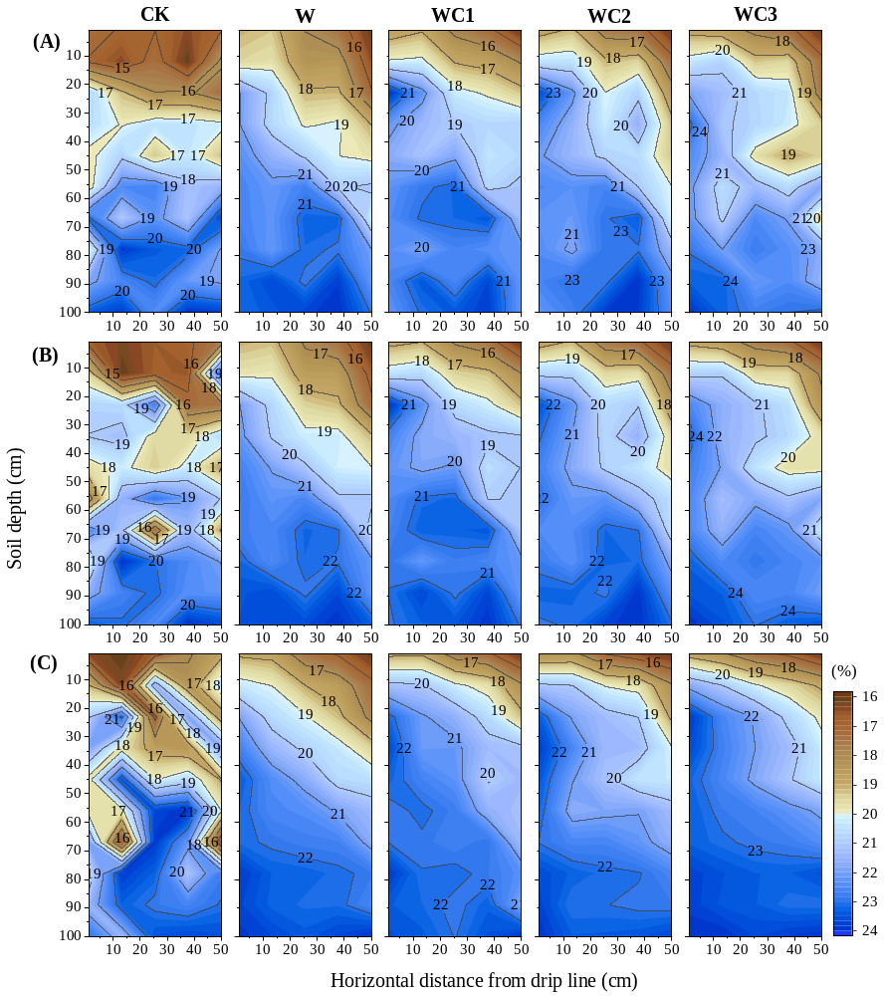
Figure 2. Spatial distribution of soil moisture.
(A) Sampling time 2022/4/15, (B) Sampling time 2022/6/15, (C) Sampling time 2022/8/31.

3.2. Soil salt transport
The changes in soil salinity (EC) with sampling time are shown in Figure 3. Soil water movement controls the migration of soil salinity. Overall, similar to soil water distribution, soil salinity distribution under flood irrigation was uneven. Compared with CK, under drip irrigation (W, WC1, WC2, and WC3), soil salinity gradually leached downwards with the infiltration of soil water and gradually formed a desalination zone centered on the drip emitter with the extension of the maize growth period. By the mid-growth period of maize (B), compared with CK and W treatments, WC1, WC2, and WC3 treatments reduced the soil EC in the 0-20cm soil layer by 1.17%–3.12%, 3.62%–3.99%, and 2.15%–4.72%, respectively. At this stage, soil salinity was mainly concentrated in the 20-50cm soil layer. By the late growth period of maize (C), with continued irrigation, soil salinity further migrated downwards and gradually leached into the deep soil layer. The salinity in the surface soil (0-30cm) further decreased, and the desalination zone continued to expand. Its upper boundary moved from 20-30cm to 40-50cm. In addition, with the increase in the CMC application rate, the desalination effect of surface soil (0-40cm) increased. Compared with the WC1 treatment, the soil EC in the 0-40cm soil layer under the WC3 treatment decreased by 1.99%.
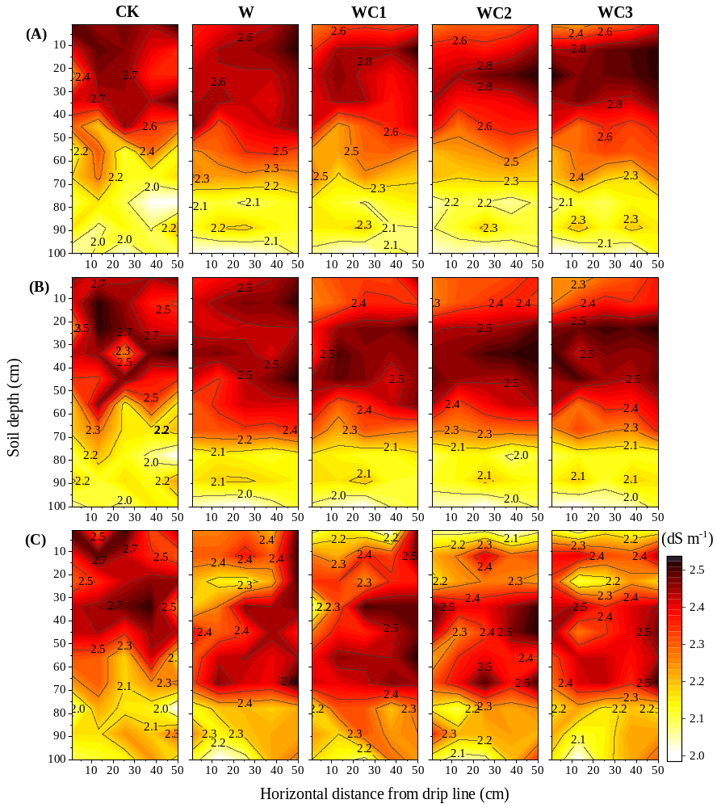
Figure 3. Spatial distribution of soil salinity.
(A) Sampling time 2022/4/15, (B) Sampling time 2022/6/15, (C) Sampling time 2022/8/31.

3.3. Soil desalination
Based on the one-way ANOVA and multiple comparison analysis (Figure 4), it was found that except for the CK treatment, the soil salt content in the 0-40cm soil layer under all treatments was significantly or extremely significantly reduced during the maize growth period compared to the start of the experiment (April 15, 2022). Compared to the start of the experiment, the average soil salt content in the 0-40cm soil layer was reduced by 5.67%–9.88%, 13.97%–17.06%, 11.91%–22.76%, and 13.67%–24.60% for the W, WC1, WC2, and WC3 treatments, respectively, during the maize growth period. In addition, there were significant differences in soil salt content among the treatments during the maize growth period. Compared to the CK treatment, the combination of drip irrigation and CMC application significantly reduced the soil salt content in the surface soil layer, and the soil salt content in the 0-30cm soil layer was reduced by 4.80%–9.62%, 6.98%–15.57%, 9.25%–20.56%, and 6.33%–19.06% for the W, WC1, WC2, and WC3 treatments, respectively. However, there were no significant differences in soil salt content among the drip irrigation treatments (W, WC1, WC2, and WC3) in each soil layer.

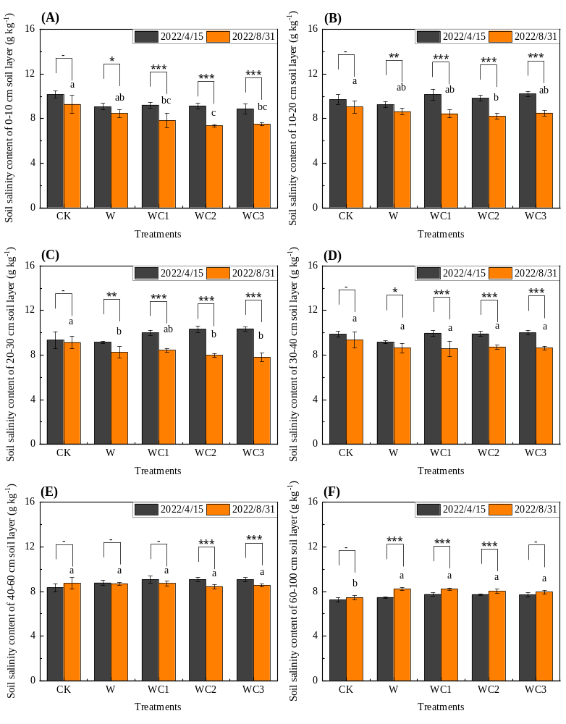
Figure 4. Effectiveness of soil desalination under different treatments.
(A) Salinity in 0-10 cm soil layer, (B) Salinity in 10-20 cm soil layer, (C) Salinity in 20-30 cm soil layer, (D) Salinity in 30-40 cm soil layer, (E) Salinity in 40-60 cm soil layer, (F) Salinity in 60-100 cm soil layer. Different lowercase letters indicate significant differences in soil salt content between different treatments on 2022/8/31; *, **, and *** indicate significant differences in soil salt content between two different sampling times (T-test, P < 0.05, P < 0.01, P < 0.001).

Upon comparing the initial soil salinity content, it was discovered through calculations of soil desalination rates during the late growth period of maize (Table 4) that the desalination effect of the 0-10 cm soil layer under the W, WC1, WC2, and WC3 treatments was significantly higher than that of the CK treatment. Specifically, WC2 and WC3 treatments resulted in a 67.00% and 58.25% higher desalination rate in the 0-10 cm soil layer, respectively, compared to the W treatment. Overall, compared to the uneven desalination effect of the CK treatment, the desalination effect of the surface soil (0-40 cm) was significant for the other treatments, with the desalination rate of most soil layers in the deep soil (40-100 cm) being negative and ranging from -7.92% to 4.60%. This indicates that under high-frequency drip irrigation and CMC application conditions, soil salinity tends to gradually move down to the deep soil layer, accumulating in the process. Finally, the average desalination rate of each soil layer in the WC2 and WC3 treatments reached 4.40%–4.54%, while the other treatments only reached 1.12%–1.90%.
Table 4. Average soil desalination rate of each soil layer under different treatments
Soil layer | CK | W | WC1 | WC2 | WC3
(cm) | (%) | (%) | (%) | (%) | (%)
0-10 | 7.84cAB | 16.00bA | 22.23abA | 26.72aA | 25.32aA
10-20 | 2.55aAB | 7.31aABC | 9.43aB | 11.59aB | 8.83aB
20-30 | -9.11bB | 1.55abBCD | -0.47abAB | 4.90abBCD | 7.06aB
30-40 | 1.80aAB | 9.35aAB | 10.08aB | 8.52aBC | 9.36aB
40-50 | -3.81aAB | 3.43aBCD | 3.99aAB | 4.31aBCD | 4.60aBC
50-60 | 3.84aAB | -2.67aCD | -3.77aB | 2.29aBCD | -0.63aBC
60-70 | 2.55aAB | -7.92aD | -7.17aB | -5.35aD | -5.02aBC
70-80 | 10.00aA | -3.64aCD | -4.62aB | -0.83aCD | 0.44aC
80-90 | 1.51aAB | -4.35aCD | -4.22aB | -3.00aCD | 0.14aBC
90-100 | 1.85aAB | -7.81aD | -7.40aB | -5.15aD | -4.73aC
Average SDR * | 1.90 | 1.12 | 1.81 | 4.40 | 4.54
* SDR: soil desalination rate. Different capital letters in the same column indicate significant differences between different soil layers (P < 0.05); Different lowercase letters in the same line indicate significant differences between different treatments (P < 0.05).

3.4. Soil available nutrients
Alkali hydrolyzed N: Overall, the alkali hydrolyzed N decreased gradually with the increase in soil depth. Among the different treatments, the CK treatment had the lowest alkali hydrolyzed N content, followed by the W treatment, while the WC2 and WC3 treatments had the highest content. The application of CMC significantly increased the content of hydrolyzed inorganic N and easily hydrolyzed organic N in the soil, thereby improving the content of alkali hydrolyzed N in the soil.
Available P: Compared to the control treatment, the soil available P content in the 30-40cm soil layer was significantly increased in the WC1, WC2, and WC3 treatments, but there was no significant difference among the different drip irrigation treatments (W, WC1, WC2, and WC3). As soil depth increased, the available P content gradually decreased, with the overall trend being WC3≥WC2≥WC1≥W>CK. These findings suggest that the application of the amendment can reduce the adsorption and fixation of soil colloids to P, thereby improving the effectiveness of soil P.
Available K: Similar to the patterns of alkali hydrolyzed N and available P, the soil available K gradually decreased with the increase in soil depth. The differences in the soil-available K content among the treatments were significant in the 0-60cm soil layer, with WC3≥WC2≥WC1≥W>CK. The WC1, WC2, and WC3 treatments were, respectively, 12.90%–31.74%, 16.92%–38.92%, and 20.93%–48.69% higher than the CK treatment. However, there was no significant difference among the treatments in the 70-100cm soil layer, with soil available K content ranging from 89.06-135.8 mg kg⁻¹.
Organic C: Overall, the soil organic C content showed a gradual decrease with the increase in soil depth. In the shallow soil layer (0-40cm), the soil organic C content in the WC1, WC2, and WC3 treatments was significantly higher than that in the CK treatment by 27.84%–36.06%, 35.44%–45.13%, and 73.05%–56.23%, respectively, indicating that CMC can significantly increase the soil organic C content in the shallow soil layer. However, as the soil depth increased, the differences among the treatments gradually decreased, and there was no significant difference in soil organic C content among the treatments in the 60-100cm soil layer.

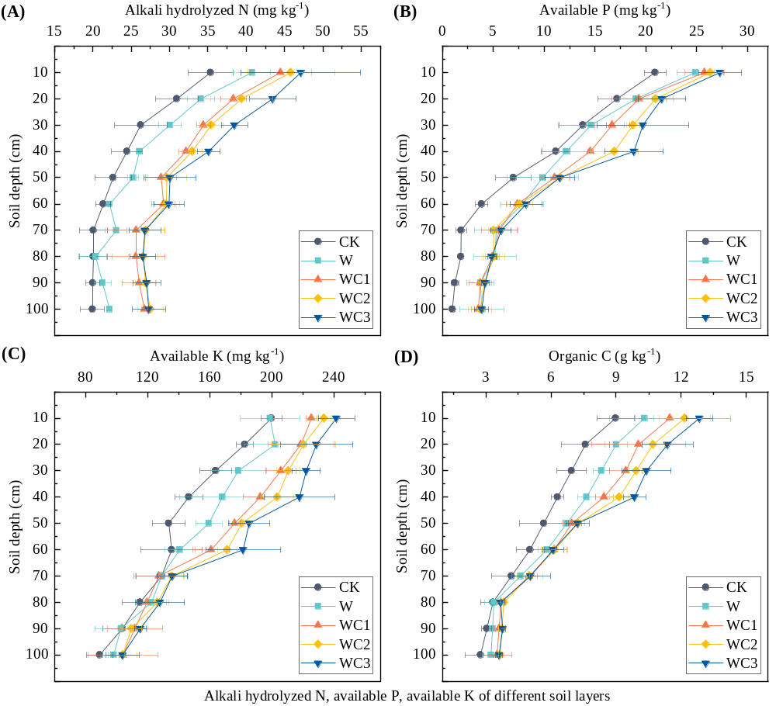
Figure 5. Spatial distribution of soil available nutrients.
(A) Alkali hydrolyzed N content of each soil layer, (B) Available P content of each soil layer, (C) Available K content of each soil layer, (D) Organic C content of each soil layer.

3.5. Crop water consumption
According to Table 5, the soil water storage capacity (ΔS) values ranged from 35.41 to 69.28 mm throughout the growing season, and both the drip irrigation pattern and CMC application significantly increased soil ΔS. Compared with CK treatment, W, WC1, WC2, and WC3 increased soil ΔS by 11.29%–97.59%, 26.54%–91.56%, 41.76%–121.5%, and 52.97%–152.2%, respectively, with WC3 showing the highest increase, followed by WC2 and WC1, and W the lowest. The drip irrigation and CMC application (W, WC1, WC2, and WC3) also significantly reduced groundwater percolation (L), surface evaporation (E), and maize transpiration (ET), which were 19.72%–47.37% (L), 56.70%–71.04% (E), and 16.05%–28.42% (ET) lower than the CK. In the soil treated with CK, L and E accounted for 41.01% of irrigation water (I) and rainfall (P), significantly higher than W, WC1, WC2, and WC3 treatments, which were 31.65%, 24.03%, 23.91%, and 23.70%, respectively. Finally, W, WC1, WC2, and WC3 treatments significantly increased the water-use efficiency (WUE) of maize, but there was no significant difference between them.
Table 5. Maize (Zea mays) evapotranspiration components and water-use efficiency.
Treatment | I ¹ | P ² | ΔS ³ | L ⁴ | E ⁵ | (L+E)/(I+P) | ET ⁶ | WUE ⁷
 | (mm) | (mm) | (mm) | (mm) | (mm) | (%) | (mm) | (kg ha⁻¹ mm⁻¹)
CK | 900.0 | 166.7 | 35.41c | 18.84a | 418.3a | 41.01a | 664.9a | 16.39b
W | 450.0 | 166.7 | 52.98b | 14.25b | 180.7b | 31.65b | 474.7b | 26.03a
WC1 | 450.0 | 166.7 | 56.92ab | 13.35b | 134.7c | 24.03c | 525.6b | 23.76a
WC2 | 450.0 | 166.7 | 62.65ab | 12.45b | 135.0c | 23.91c | 531.9b | 23.68a
WC3 | 450.0 | 166.7 | 69.28a | 11.52b | 134.6c | 23.70c | 539.9b | 23.42a
¹ I: irrigation amount, ² P: precipitation during the maize growing season, ³ ΔS: change in soil water storage in the 0–100 cm soil layer, ⁴ L: underground leakage, ⁵ E: evaporation of surface water, ⁶ ET: maize evapotranspiration during the growth period, and ⁷ WUE: water-use efficiency. Different lowercase letters in the same column indicate significant differences between treatments (P < 0.05).

3.6. Crop growth
According to Table 6, drip irrigation and CMC application did not significantly affect the height and stem diameter of maize. However, there were significant differences in the aboveground biomass and grain yield of maize under different treatments. Compared with the CK treatment, the aboveground biomass and grain yield of maize plants increased by 4.85%-16.16% and 5.44%-16.43%, respectively, under the application of high amounts of CMC (WC2 and WC3). The overall trend was that WC3 = WC2 ≥ WC1 = W ≥ CK, but there was no significant difference in the yield increase effect among the treatments.
Table 6. Maize (Zea mays) growth indicators.
Treatment | Plant height | Stem diameter | Aboveground biomass | Grain yield | Aboveground biomass increase | Grain yield increase
 | (cm) | (mm) | (kg·ha⁻¹) | (kg·ha⁻¹) | (%) | (%)
CK | 297.7 | 20.22 | 47284b | 10868b | - | -
W | 298.4 | 20.38 | 49157ab | 12356ab | 4.00 | 13.98
WC1 | 311.1 | 20.75 | 49324ab | 12474ab | 4.35 | 15.07
WC2 | 302.3 | 20.58 | 49564a | 12592a | 4.85 | 16.16
WC3 | 323.8 | 21.12 | 49839a | 12633a | 5.44 | 16.43
* Different lowercase letters in the same column indicate significant differences between different treatments at P < 0.05. No lowercase letters following the data indicate no significant differences between treatments.

As shown in Table 7, there were no significant differences in the quality of maize grains among the treatments except for crude protein. The application of drip irrigation and high application rates of CMC (WC2 and WC3) significantly increased the crude protein content of maize grains. Compared with the CK treatment, the crude protein content of maize grains in the WC2 and WC3 treatments increased by 2.52%–5.35% and 3.08%–7.60%, respectively.
Table 7. Maize grain quality.
Treatment | Soluble sugar | Crude protein | Crude fat | Starch
 | (%) | (%) | (%) | (%)
CK | 2.71a | 8.41c | 3.24a | 63.96a
W | 2.92a | 8.49bc | 3.32a | 65.08a
WC1 | 2.96a | 8.66abc | 3.35a | 64.62a
WC2 | 2.88a | 8.76ab | 3.23a | 65.30a
WC3 | 2.94a | 8.82a | 3.36a | 65.33a
* Different lowercase letters in the same column indicate significant differences between different treatments at P < 0.05.

4. Discussion

4.1. Soil water and salt transport

In this study, the soil water content varied significantly with time under different irrigation methods and CMC application rates. Compared to traditional high-volume flood irrigation, the soil wetting area under drip irrigation treatments (W, WC1, WC2, and WC3) gradually expanded in both horizontal and vertical directions around the drip emitter with increasing maize growth stage (Figure 2), while the soil water content distribution was extremely uneven under flood irrigation treatments. This suggests that the uniform and stable infiltration of irrigation water under drip irrigation conditions increased the soil moisture content in deeper layers and maintained high soil moisture content in high evaporation climates. In contrast, flood irrigation, which involves the application of a large amount of irrigation water at once, often leads to the accumulation of irrigation water on the soil surface, which is prone to uneven leakage and poor water infiltration, resulting in uneven soil moisture distribution. Furthermore, flood irrigation causes significant evaporative losses of water, increases field evaporation, reduces water use efficiency (Table 5), and wastes precious water resources. Therefore, the large low-frequency irrigation water applied in flood irrigation and the high-frequency uniform irrigation water applied in drip irrigation may be the main reasons for the differences in soil moisture content between the two methods. It is worth noting that the application of CMC (WC1, WC2, and WC3) significantly increased the soil moisture content in the 0-40cm soil layer compared to drip irrigation without CMC application (W), and the soil moisture content increased with increasing CMC application rates. The causes of this phenomenon can be attributed to the following three reasons. Firstly, CMC can increase the water-holding capacity of soil due to its high-water retention ability. The presence of CMC can form a gel-like structure that can hold onto water, reducing the amount of water that is lost through drainage or evaporation. This can help to maintain soil moisture levels and improve water availability for plants [19]. Secondly, CMC can improve soil structure, which can affect the movement of water in the soil matrix [18]. CMC can act as a binder that can help to aggregate soil particles, reduce soil compaction and increase soil pore space. This can improve water infiltration into the soil and reduce the potential for water runoff and erosion. Thirdly, CMC can affect the hydraulic conductivity of the soil. Hydraulic conductivity is a measure of the ease with which water can move through the soil. CMC can reduce the hydraulic conductivity of soil by forming a gel-like structure that can impede the flow of water. This can help to retain water in the soil and improve water availability for plants [19]. Therefore, the formation of CMC gel can block soil pores and reduce the movement of water, which can further improve water retention and reduce the leaching of salts in the soil.
When soil moisture is increased, the movement of water carries away ions from the soil solution, which helps to increase the leaching of many salts from the soil solution, including sodium, magnesium, calcium, and potassium salts [27,28]. Of these, sodium ions are weakly adsorbed and are usually present in exchangeable positions in the soil and are usually carried away more readily than other ions. Therefore, similar to the dynamic changes in soil moisture, with the penetration of water, soil salinity gradually migrates to deeper soil layers, and the salinity characteristics of the soil change from a surface accumulation pattern to a bottom accumulation pattern, significantly reducing the salt content in the surface soil (Figure 3 and Figure 4). Previous studies [29-31] have shown that biochar as a soil amendment can suppress soil greenhouse gas emissions, promote soil C sinks, and remediate contaminated soils, while humic acid application to soil can reduce soil pH and salinity, neutralize free OH⁻ ions, and improve the soil microenvironment. In this study, the effects of CMC on the distribution of soil water and salt are different from those of other soil amendments. As the maize growth period is prolonged, it can be observed that the soil salt content of the CMC-treated plot gradually moves downward with the infiltration of soil water, gradually forming a desalination zone centered on the drip emitter. Moreover, compared with the drip irrigation treatment without CMC, the drip irrigation treatment with CMC significantly reduced the salt content in the surface soil (Figure 3.C). As is well known, under drip irrigation conditions in arid and semi-arid areas, soil salt content is affected by the combined effects of the downward movement of high-frequency drip irrigation water and the upward movement caused by strong surface evaporation [13]. The high-frequency drip flow gradually washes the soil salt downward, and during the interval between each drip irrigation, the upward movement of soil solution caused by surface evaporation dominates. At this time, the powerful water absorption potential of CMC inhibits the surface soil salt accumulation process caused by evaporation [32,33], thus reducing the salt content in the surface soil. From a chemical point of view, CMC is a negatively charged polymer due to the presence of carboxymethyl groups (-COO⁻) on its main chain. When CMC is applied to soil, the negatively charged carboxymethyl group on its main chain can interact with positively charged cations in the soil solution such as sodium (Na⁺), potassium (K⁺), calcium (Ca²⁺), and magnesium (Mg²⁺) through electrostatic attraction, thus reducing their mobility and availability in the soil solution [21]. In this way, on the one hand, the leaching of cations can be reduced and on the other hand, this can reduce the uptake of toxic ions by plants and promote their growth [34]. This may also be the reason why there is little difference in the salt content of the subsurface layers. Overall, under the conditions of CMC application (WC1, WC2, and WC3), the desalination effect of the 0-30cm soil layer is significant (Table 4), but there is no significant difference in soil salt content between the 30-100cm soil layers (Figure 4 and Table 4), indicating that while the salt is fully leached downward, CMC also hinders the upward movement of salt caused by surface evaporation, resulting in a significant decrease in soil salinity in the root zone and the inhibition of soil salinization process [18,35].

4.2. Soil nutrients
Numerous studies have demonstrated that soil amendments can effectively increase soil nutrients and enhance land productivity [36-38]. In this study, CMC was found to significantly increase the content of alkali-hydrolyzed N, available P, available K, and organic C in the 0-40cm soil layer, despite its lack of nutrients such as N and P, which are present in organic soil amendments such as humic acid, amino acids, and decomposed manure (Figure 5). This is partly because CMC helps to maintain soil moisture levels over a longer period of time, thus enhancing the solubility of insoluble nutrients in the soil and improving the biological effectiveness of soil nutrients [39]. By increasing the water holding capacity of the soil, CMC can help reduce nutrient leaching losses from irrigation water due to leaching and form complexes with some ions, thus increasing the supply of nutrients available for plant uptake [40]. On the other hand, CMC, as a polycarboxylate polymer, has a high anion exchange capacity (CEC). The application of CMC increases the CEC of soil, which helps to improve the adsorption and retention capacity of soil for nutrients, thus increasing the effective nutrients in the soil. In addition, CMC, as a carbon source, can promote the growth and reproduction of soil microorganisms. Microorganisms are able to decompose soil organic matter and release nutrients, making them more easily absorbed by crops [41]. At the same time, microorganisms are able to produce some growth factors and enzymes that help to increase the soil nutrient supply potential. It is noteworthy that the application of CMC significantly increased the available P content in the surface soil (Figure 5), which might be due to the formation of complexes between CMC and water-soluble P fertilizer in irrigation water, thus reducing the adsorption and fixation of water-soluble P in irrigation water in the soil [42]. During the process when irrigation water containing CMC drips into the soil with the drip irrigation system, the excellent ion adsorption properties of CMC can form binders with negative ions such as P, and these binders can slowly release phosphate and increase the available P content in the soil, thus improving the effectiveness and availability of P. In addition, CMC can also increase the stability of soil aggregates and reduce the fragmentation of soil aggregates, thus reducing the contact between P and soil particles and reducing P adsorption and immobilization [43]. Therefore, in this study, CMC adsorbed inorganic nutrients (NO₃⁻, PO₄³⁻, and K⁺) from water-soluble fertilizers applied via drip irrigation with integrated water and fertilizer management, thereby increasing the content of alkali-hydrolyzed N, available P, available K, and organic C in the surface soil and improving fertilizer utilization efficiency. Furthermore, the increased soil moisture content also enhanced the solubility of insoluble nutrients in the soil, indirectly activating soil nutrients and increasing their bioavailability. Hence, CMC has great potential as an amendment for soil fertility and salt-affected soil reclamation.

4.3. Crop responses
Soil moisture plays an essential role in plant growth, so improving water-use efficiency in arid areas is an effective way to increase productivity [44]. Surface evaporation and transpiration are important factors affecting soil water loss and salt transport in agricultural fields [45]. Surface evaporation causes soil solution and transpiration to move upward, thereby promoting salt transport to the root zone, exacerbating salt stress, and affecting normal crop growth [46]. In this study, we found that drip irrigation and CMC application can reduce the surface evaporation of field water and increase soil water storage and maize transpiration, thereby improving maize water use efficiency (Table 5). These effects are because flood irrigation causes irrigation water to spread extensively on the surface of agricultural soil, and frequent lateral flow of irrigation water greatly increases surface evaporation. Under drip irrigation treatment, irrigation water was applied to the soil in small amounts and at high frequencies, and there was no surface water accumulation, which maintained soil structure and reduced underground seepage. Secondly, CMC's strong water absorption ability increases the water-holding capacity of the soil, effectively suppressing the phenomenon of water movement caused by surface evaporation, thus locking in soil water [18,19]. However, it is worth noting that there was no significant difference in ET and WUE between drip irrigation with CMC application and without CMC application. This may be because although CMC can enhance the retention of soil moisture in the rhizosphere, it may also increase the difficulty of plant absorption and utilization, and the specific mechanism requires further study.
The variety of maize planted in our study was used for producing silage feed. Plant height and stem thickness are key growth characteristics of maize. Aboveground biomass is an important indicator of maize silage production [47]. Our findings indicate that while there were no significant differences in the height or stem diameter of maize plants among different treatments (Table 6), drip irrigation and the application of CMC helped to significantly increase aboveground biomass and grain yield of maize, as well as elevate the crude protein content of the grain (Table 7). Furthermore, with increasing amounts of CMC applied, grain yield gradually increased. Based on the results of our studies on soil water and salt distribution and nutrient content, we hypothesize that CMC can promote corn growth and increase yield in several ways. First, CMC application significantly increased the available soil nutrient content (Figure 5), which is necessary to promote maize growth. Secondly, the high-water retention of CMC can improve the soil condition, making the water in the soil more stable, increasing the water holding capacity of the soil (Figure 2), reducing the evaporation of water from farmland, which is conducive to the uptake and utilization of water by plant roots, and improving the water utilization efficiency of maize (Table 5). Finally, CMC also has a certain chelating and ion exchange effect on the salts in the soil, and its combination with water and fertilizer-integrated drip irrigation has formed a desalination zone around the soil root system (Figure 3), improving the microenvironment of the maize root system and reducing the negative effects of salts on plants. In addition, the water-fertilizer integrated drip irrigation system made the irrigation frequency, fertilizer application amount and irrigation water amount conform to the nutrient and water requirements of maize growth and development stages [13], providing sufficient nutrients and water for root uptake and promoting the accumulation of crude protein in the seeds, which is one of the important reasons for the increase in maize yield [48]. In summary, we conclude that CMC can be used as a new type of soil amendment for salt-affected soils, in combination with drip irrigation and other soil amendments, to supplement the water-locking ability of organic amendments. Of course, the effect of long-term CMC application on soil health requires continuous follow-up studies.

5. Conclusions
The use of drip irrigation and carboxymethyl cellulose significantly enhances surface soil water content, leading to the gradual infiltration of soil salts into the deep soil and forming a desalination zone centered on the drip irrigation head. This shift in soil salt characteristics from surface aggregation mode to bottom aggregation mode significantly reduces surface evaporation and improves water-utilization efficiency. In addition, the application of carboxymethyl cellulose, owing to its robust adsorption capacity, resulted in a significant increase in the available nutrient content of the surface soil. Ultimately, this led to the creation of an inter-root microenvironment for maize with a high water content, low salt content, and high nutrient content, which significantly improved the maize underground biomass and yield. In summary, carboxymethylcellulose exhibits considerable promise as a novel soil amendment for salt-affected soils in conjunction with drip irrigation and other amendments. Future research should investigate the potential mechanisms underlying desalinization, yield increase, and quality improvement in salt-affected soils using different amendment combinations.

Author Contributions: Conceptualization, Y.W. and R.W.; methodology, Y.W. and R.W.; software, Y.W.; validation, M.G.; formal analysis, H.C.; investigation, Y.C.; resources, Y.C.; data curation, M.G. and H.C.; writing—original draft preparation, Y.W.; writing—review and editing, Y.W.; visualization, L.W.; supervision, L.W.; project administration, R.W.; funding acquisition, R.W. and L.W. All authors have read and agreed to the published version of the manuscript.
Funding: This research was funded by the National Key Research and Development Program of China (grant number 2021YFD1900600).
Institutional Review Board Statement: Not applicable.
Informed Consent Statement: Not applicable.
Data Availability Statement: The datasets used or analyzed during this study are available from the corresponding author upon reasonable request.
Acknowledgments: We would like to thank the other Ningxia University students who participated in the field and data collection and are not included in the author list.
Conflicts of Interest: The authors declare that the research was conducted in the absence of any commercial or financial relationships that could be construed as potential conflicts of interests.

References
1. Pitman, M.G.; Läuchli, A. Global impact of salinity and agricultural ecosystems. In Salinity: environment-plants-molecules; Springer: 2002; pp. 3-20.
2. Zhou, Q.; Zhu, Z.; Shi, M.; Cheng, L. Growth and physicochemical changes of Carpinus betulus L. influenced by salinity treatments. Forests 2018, 9, 354.
3. Mustafa, G.; Akhtar, M.S.; Abdullah, R. Global concern for salinity on various agro-ecosystems. In Salt stress, microbes, and plant interactions: Causes and solution; Springer: 2019; pp. 1-19.
4. Kumar, P.; Sharma, P.K. Soil salinity and food security in India. Frontiers in Sustainable Food Systems 2020, 4, 533781.
5. Luo, S.; Tian, L.; Chang, C.; Wang, S.; Zhang, J.; Zhou, X.; Li, X.; Tran, L.S.P.; Tian, C. Grass and maize vegetation systems restore saline‐sodic soils in the Songnen Plain of northeast China. Land Degradation Development 2018, 29, 1107-1119.
6. Xiong, S.; Xiong, Z.; Wang, P. Soil salinity in the irrigated area of the Yellow River in Ningxia, China. Arid Land Research Management 1996, 10, 95-101.
7. Munns, R.; Gilliham, M. Salinity tolerance of crops - what is the cost? New Phytol 2015, 208, 668-673, doi:10.1111/nph.13519.
8. Stavi, I.; Thevs, N.; Priori, S. Soil salinity and sodicity in drylands: A review of causes, effects, monitoring, and restoration measures. Frontiers in Environmental Science 2021, 330.
9. Guan, Z.; Jia, Z.; Zhao, Z.; You, Q. Dynamics and distribution of soil salinity under long-term mulched drip irrigation in an arid area of northwestern china. Water 2019, 11, 1225.
10. Pimentel, D.; Berger, B.; Filiberto, D.; Newton, M.; Wolfe, B.; Karabinakis, E.; Clark, S.; Poon, E.; Abbett, E.; Nandagopal, S. Water resources: agricultural and environmental issues. BioScience 2004, 54, 909-918.
11. Rajak, D.; Manjunatha, M.; Rajkumar, G.; Hebbara, M.; Minhas, P. Comparative effects of drip and furrow irrigation on the yield and water productivity of cotton (Gossypium hirsutum L.) in a saline and waterlogged vertisol. Agricultural water management 2006, 83, 30-36.
12. Burt, C.M.; Isbell, B. Leaching of accumulated soil salinity under drip irrigation. Transactions of the ASAE 2005, 48, 2115-2121.
13. Wang, Y.; Gao, M.; Chen, H.; Fu, X.; Wang, L.; Wang, R. Soil moisture and salinity dynamics of drip irrigation in saline-alkali soil of Yellow River basin. Frontiers in Environmental Science 2023, 11, 345.
14. Wang, X.; Wang, J.; Wang, J. Seasonality of soil respiration under gypsum and straw amendments in an arid saline-alkali soil. Journal of Environmental Management 2021, 277, 111494.
15. D'Hose, T.; Debode, J.; De Tender, C.; Ruysschaert, G.; Vandecasteele, B. Has compost with biochar applied during the process added value over biochar or compost for increasing soil quality in an arable cropping system? Applied Soil Ecology 2020, 156, 103706.
16. Tang, C.; Yang, J.; Xie, W.; Yao, R.; Wang, X. Effect of Biochar Application on Soil Fertility, Nitrogen Use Efficiency and Balance in Coastal Salt-Affected Soil under Barley–Maize Rotation. Sustainability 2023, 15, 2893.
17. Rahman, M.S.; Hasan, M.S.; Nitai, A.S.; Nam, S.; Karmakar, A.K.; Ahsan, M.S.; Shiddiky, M.J.; Ahmed, M.B. Recent developments of carboxymethyl cellulose. Polymers 2021, 13, 1345.
18. Zhang, J.; Wang, Q.; Shan, Y.; Guo, Y.; Mu, W.; Wei, K.; Sun, Y. Effect of Sodium Carboxymethyl Cellulose on Water and Salt Transport Characteristics of Saline–Alkali Soil in Xinjiang, China. Polymers 2022, 14, 2884.
19. Olad, A.; Zebhi, H.; Salari, D.; Mirmohseni, A.; Tabar, A.R. Slow-release NPK fertilizer encapsulated by carboxymethyl cellulose-based nanocomposite with the function of water retention in soil. Materials Science Engineering: C 2018, 90, 333-340.
20. Qiu, Z.; Zhang, R.; Qiu, H.; Gao, J. Effects of superabsorbents containing montmorillonite and polysaccharide on soil physical properties. Soil Fertil. Sci. China 2013, 3, 11-16.
21. Li, W.; Huang, S.; Xu, D.; Zhao, Y.; Zhang, Y.; Zhang, L. Molecular dynamics simulations of the characteristics of sodium carboxymethyl cellulose with different degrees of substitution in a salt solution. Cellulose 2017, 24, 3619-3633.
22. Zhao, Q.; Tang, J.; Li, Z.; Yang, W.; Duan, Y. The influence of soil physico-chemical properties and enzyme activities on soil quality of saline-alkali agroecosystems in Western Jilin Province, China. Sustainability 2018, 10, 1529.
23. Zhou, M.; Liu, X.; Meng, Q.; Zeng, X.; Zhang, J.; Li, D.; Wang, J.; Du, W.; Ma, X. Additional application of aluminum sulfate with different fertilizers ameliorates saline-sodic soil of Songnen Plain in Northeast China. Journal of Soils Sediments 2019, 19, 3521-3533.
24. Robbins, C.; Wiegand, C. Field and laboratory measurements. 1990.
25. Pansu, M.; Gautheyrou, J. Handbook of Soil Analysis. 2006.
26. Zhang, T.; Zhan, X.; He, J.; Feng, H. Moving salts in an impermeable saline-sodic soil with drip irrigation to permit wolfberry production. Agricultural water management 2019, 213, 636-645.
27. Qi, Z.; Feng, H.; Zhao, Y.; Zhang, T.; Yang, A.; Zhang, Z. Spatial distribution and simulation of soil moisture and salinity under mulched drip irrigation combined with tillage in an arid saline irrigation district, northwest China. Agricultural water management 2018, 201, 219-231.
28. Sun, G.; Zhu, Y.; Gao, Z.; Yang, J.; Qu, Z.; Mao, W. Spatiotemporal Patterns and Key Driving Factors of Soil Salinity in Dry and Wet Years in an Arid Agricultural Area with Shallow Groundwater Table. Agriculture 2022, 12, 1243.
29. Motojima, H.; Yamada, P.; Irie, M.; Ozaki, M.; Shigemori, H.; Isoda, H. Amelioration effect of humic acid extracted from solubilized excess sludge on saline-alkali soil. Journal of material cycles waste management 2012, 14, 169-180.
30. Mosa, A.; Mansour, M.M.; Soliman, E.; El-Ghamry, A.; El Alfy, M.; El Kenawy, A.M. Biochar as a Soil Amendment for Restraining Greenhouse Gases Emission and Improving Soil Carbon Sink: Current Situation and Ways Forward. Sustainability 2023, 15, 1206.
31. Mosa, A.; Taha, A.A.; Elsaeid, M. In-situ and ex-situ remediation of potentially toxic elements by humic acid extracted from different feedstocks: Experimental observations on a contaminated soil subjected to long-term irrigation with sewage effluents. Environmental Technology Innovation 2021, 23, 101599.
32. Kim, B.; Kim, T.-H.; Lee, B. Optimal synthesis of carboxymethylcellulose-based composite superabsorbents. Korean Journal of Chemical Engineering 2021, 38, 215-225.
33. Nie, H.; Liu, M.; Zhan, F.; Guo, M. Factors on the preparation of carboxymethylcellulose hydrogel and its degradation behavior in soil. Carbohydrate Polymers 2004, 58, 185-189.
34. Davidson, D.W.; Verma, M.S.; Gu, F.X. Controlled root targeted delivery of fertilizer using an ionically crosslinked carboxymethyl cellulose hydrogel matrix. SpringerPlus 2013, 2, 1-9.
35. Halidaimu, J.; Ning, S.; Wang, Q.; Zhang, J. Comparative analysis of the effects of PAM and CMC on soil infiltration and evaporation. Soil Water Conserv 2020, 34, 121-127.
36. Singh, B.; Singh, B.P.; Cowie, A.L. Characterisation and evaluation of biochars for their application as a soil amendment. Soil Research 2010, 48, 516-525.
37. Lwin, C.S.; Seo, B.-H.; Kim, H.-U.; Owens, G.; Kim, K.-R. Application of soil amendments to contaminated soils for heavy metal immobilization and improved soil quality—A critical review. Soil science plant nutrition 2018, 64, 156-167.
38. Wu, H.; Lai, C.; Zeng, G.; Liang, J.; Chen, J.; Xu, J.; Dai, J.; Li, X.; Liu, J.; Chen, M. The interactions of composting and biochar and their implications for soil amendment and pollution remediation: a review. Critical reviews in biotechnology 2017, 37, 754-764.
39. Li, H.; Wang, Q.; Tao, W.; Chai, J.; Zhao, G. Effects of different amendments on the yield of surface runoff and loss of nutrients along loess slope soybean farmland. Sci. Soil Water Conserv 2017, 15, 117-125.
40. Senna, A.M.; Botaro, V.R. Biodegradable hydrogel derived from cellulose acetate and EDTA as a reduction substrate of leaching NPK compound fertilizer and water retention in soil. Journal of controlled release 2017, 260, 194-201.
41. Dungait, J.A.; Hopkins, D.W.; Gregory, A.S.; Whitmore, A.P. Soil organic matter turnover is governed by accessibility not recalcitrance. Global Change Biology 2012, 18, 1781-1796.
42. Zhang, H.; Yang, H.; Shao, J.; Chen, Y.; Zhang, S.; Chen, H. Multifunctional carboxymethyl cellulose sodium encapsulated phosphorus-enriched biochar composites: Multistage adsorption of heavy metals and controllable release of soil fertilization. Chemical Engineering Journal 2023, 453, 139809.
43. Wu, J.; Tao, W.; Wang, H.; Wang, Q. Influence of sodium carboxyl methyl cellulose on soil aggregate structureand soil water movement. Transactions of the Chinese Society of Agricultural Engineering 2015, 31, 117-123.
44. Qu, W.; Tan, Y.; Li, Z.; Aarnoudse, E.; Tu, Q. Agricultural Water Use Efficiency—A Case Study of Inland-River Basins in Northwest China. Sustainability 2020, 12, 10192.
45. Nachshon, U. Cropland soil salinization and associated hydrology: Trends, processes and examples. Water 2018, 10, 1030.
46. Li, Y.; Li, M.; Liu, H.; Qin, W. Influence of soil texture on the process of subsurface drainage in saturated-unsaturated zones. International Journal of Agricultural Biological Engineering 2021, 14, 82-89.
47. Rüegg, W.; Richner, W.; Stamp, P.; Feil, B. Accumulation of dry matter and nitrogen by minimum-tillage silage maize planted into winter cover crop residues. European journal of agronomy 1998, 8, 59-69.
48. Wang, D.; Mo, Y.; Li, G.; Wilkerson, C.J.; Hoogenboom, G. Improving maize production and decreasing nitrogen residue in soil using mulched drip fertigation. Agricultural Water Management 2021, 251, 106871.
Disclaimer/Publisher’s Note: The statements, opinions and data contained in all publications are solely those of the individual author(s) and contributor(s) and not of MDPI and/or the editor(s). MDPI and/or the editor(s) disclaim responsibility for any injury to people or property resulting from any ideas, methods, instructions or products referred to in the content.

