Dear reviewer!
The authors of this paper sincerely thank you for studying the article and writing a constructive review! All comments have been taken into account and appropriate improvements/corrections/experiments have been carried out on them. The following is a description of the changes in the work that we made during the revision.
Reviewer's question 1:
1. What is the specific significance of five-membered heterocycles in cancer treatment?
Authors' answer 1:
Changes have been made to the manuscript:
For optimal binding to tubulin and the manifestation of high antimitotic activity, combretastatin molecules must have a cis-configuration. Five-membered heterocycles are considered as a non-isomerizable and metabolically stable bioisosteric replacement of the double bond in combretastatins, fixing the rings A and B in the cis-position. Replacement of combretastatin’s double bond with heterocyclic five-membered rings (1,3-thiazol-2-amine, pyrazole, 1,3-thiazole, 1,2,4-triazoles, tetrazoles, e.g.) does not lead to a decrease in both cytotoxic and antitubulin activities, however, it has a number of advantages: (a) prevention of combretastatin cis-trans; (b) increased specificity due to absence of trans-conformation that is non-specific for other cellular targets; and (c) possible improvement of therapeutic properties due to five-membered heterocycles [11].
Reviewer's question 2:
2. What is the reason for choosing specific cationic chitosan over other options polymers, and what function do fatty acids play in the development of micelles to target cancer cells?
Authors' answer 2:
Polymeric micelles based on chitosan modified with fatty acids are promising in the aspects of enhanced efficiency of anti-cancer and antibacterial drugs. In this article, an approach is proposed using the properties of chitosan as a polycation with pKa=6.4, ionized in such a way that in the microenvironment of tumors (pH 5.5-6.0) the loaded drug is quickly released from the delivery system. In addition, chitosan can provide thermal sensitivity due to hydrophobic chain interactions at 40°C (zone of local inflammation). Fatty acids are necessary for the synthesis of amphiphilic polymers forming polymer micelles, which have low critical concentrations of micelle formation, are biocompatible and relatively selective. The fatty tails of micelles ensure fusion with the cell membrane, and most importantly ensures the solubility of insoluble tubulins - according to UV-visible and fluorescence spectroscopy located inside the hydrophobic micelle' core.
Reviewer's question 3:
3. For a better understanding of the research, it is best to explain the synthesis of Cytostatics 1-4 in a nutshell.
Authors' answer 3:
Changes have been made to the manuscript.
Cytostatics 1, 2, 4 (Table 1, Scheme 1) were obtained according to the techniques described by the authors earlier [12,42].
Scheme 1. Scheme of synthesis of combretastatin derivatives. Reagents and conditions: (1) and (1’) CO(NH₂)₂·H₂O₂, CH₃OH, reflux, 1.5 h; (2) and (2’) SOCl₂, CH₂Cl₂, drops DMF, rt, overnight; (3) and (3’) SOCl₂, C₆H₆, 45–50 °C, 40 min; (4) and (4’) Mg, ZnCl₂, LiCl, THF, rt, 2h; (5) and (5’) CuCN·2LiCl, THF, –20 °C, 1 h, then rt overnight; (6) and (6’) N,N-dimethylformamide dimethyl acetal, without solvent, 60 °C, 3h; (7) MeOH–H⁺, N₂H₄·2HCl, reflux, 1 h; (7’) MeOH–H⁺, NH₂OH·HCl, reflux, 2 h. (1’’) K₂CO₃, MeOH, rt, 48 h; (2’’) Et₂NH, Pd(PPh₃)₄, CuI, 50 °C, 2 h, then rt, overnight; (3’’) DMF, 15000 bar, 100 °C, 7 h; (4’’) H₂, Pd/C, MeOH, CF₃COOH, 20 bar, 55 °C, 50 h.
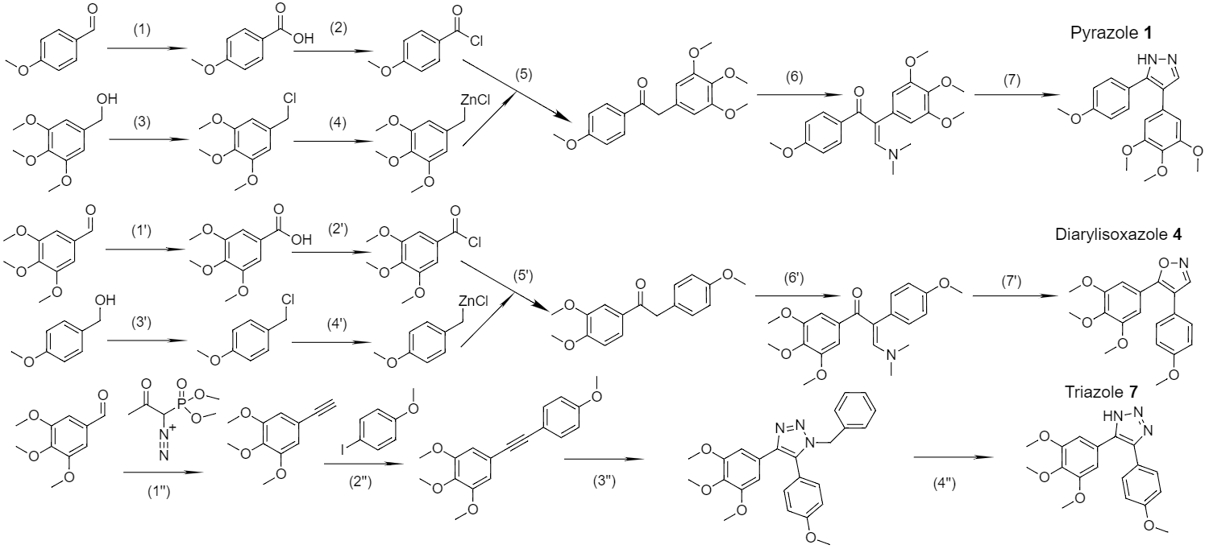

Reviewer's question 4:
4. Along with the FTIR data, provide the NMR spectra to support in the formation of the Chit5-SA, Chit5-OA, Chit5-MUA, and Chit5-LA.
Authors' answer 4:
Relevant information is provided in Supplement
¹H NMR spectra of Chit5 and Chit5 grafted with acid’s are presented in Fig. S4. In the ¹H NMR spectra of Chit5 characteristic peaks (δ, ppm) are observed [24,30,38,43,51]: 4.22 (H1), δ = 3.23 (H2), δ = 3.79, 3.96 (H3, H4, H5, H6, H6’), δ = 2.11 (NH–C(=O)–CH₃). ¹H NMR spectra of the Chit5-MUA-20 and Chit5-LA-20 (Fig. S4c-d) contain both signals of two components (chitosan and acid): 1.41 (S–H of MUA), increased signals at 2.0–2.3, 1.25 were assigned to the methene hydrogen of the N-alkyl groups. Signals 3.64 ppm (C–H near the dithiolane fragment) and 2.3 (β-H with relation to the carboxyl group) indicate the presence of LA in the conjugate. Thus, NMR spectra confirm the structures of compounds described by the FTIR method.

Figure S4. ¹H NMR of (a) Chit5-OA-20 non-loaded and loaded with pyrazole 1 and triazole 2; (b) Chit5, (c) Chit5-MUA-20, (d) Chit5-LA-20. D₂O. T = 25 °C.

(a)

(b)

(c)

(d)

Reviewer's question 5:
5. In section 2.4, authors should provide the concentration range of the micelles formulation for the MTT experiment.
Authors' answer 5:
Changes have been made to the manuscript.
To test acute toxicity, cells were cultivated for 72 h in a V-bottom 96-well plate (TPP, Trasadingen, Switzerland) in the presence of cytostatics (concentration range is 3 nM – 0.3 mM in micelles 1:1 w/w, 3 nM – 1 mM for free cytostatics)
Reviewer's question 6:
6. In section 2.5, authors should provide brief descriptions of the FTIR spectroscopy investigation of pharmacological activities on A549 and HEK293T cells.
Authors' answer 6:
Changes have been made to the manuscript.
ATR-FTIR spectra of cells samples suspension were recorded using a Bruker Tensor 27 spectrometer equipped with a liquid nitrogen-cooled MCT (mercury cadmium telluride) detector as earlier described [45]. A549 or HEK293T cell’s suspensions (2×10⁶ cells/mL) were washed twice with sterile PBS (pH = 7.4) from the culture medium by centrifuging (Eppendorf centrifuge 5415C, 5 min, 1,000×g). The cells are precipitated by centrifugation and separated from the supernatant, washed twice and resuspended in PBS (5×10⁶ cells/mL) to register FTIR spectra. Cell suspensions were incubated with cytostatic-containing samples and FTIR spectra were registered at 37 °C online or after incubation. To quantify absorbed cytostatic the cells were precipitated by centrifugation and separated from the supernatant, washed twice and resuspended in 50 µL PBS to register FTIR spectra. The supernatant was separated to determine the amounts of unabsorbed substances.

Reviewer's question 7:
7. “The excitation and emission wavelength ranges were selected by Olympus U-MNB2 and U-MWG2 fluorescence mirror units for blue and green excitation light respectively”. Section 2.6 requires the wavelength.
Authors' answer 7:
Figure S2. Parameters of the sources used for excitation and registration of fluorescence in optical microscopy of cells. λex(blue) = 470-490 nm, λex(green) = 510-560 nm. The fluorescence of R6G was determined at the excitation of 510-560 nm, and the fluorescence of FITC was determined by the difference of the two channels.

Reviewer's question 8:
8. The cytostatics' water solubility should be tested only after synthesis. As a result, it is recommended that section 2.9 of the method section should rearrange.
Authors' answer 8:
The substances were dissolved in acetonitrile followed by recording UV the spectra at various cytostatics’ concentrations, and plotted calibration dependencies. Next, saturated solutions of substances in water were prepared and the spectra of the aqueous solutions were recorded. Considering the extinction coefficients in water and acetonitrile to be approximately equal, the solubility was determined.
Reviewer's question 9:
9. What is the rationale behind providing just the particle size distribution of NTA Chit5-OA-20 loaded with pyrazole but not other polymer formulations? For a better understanding, authors might display all the formulations' particle size distribution in a tabular format.
Authors' answer 9:

The existence of micelles in solution was confirmed by the NTA method (Videos S1-S4, Fig. 3). Figure 3 shows distribution diagrams of particle sizes formed by modified chitosans. A comparison of non-extruded and extruded samples (Fig. 3a vs Fig. 3b) is presented: after passing through a membrane of 400 nm, inhomogeneous particles become beautiful micelles with orderly distribution. The inclusion of drugs (Fig. 3 cde) is accompanied by additional structuring of micelles, which was demonstrated above by the AFM method.

(a) 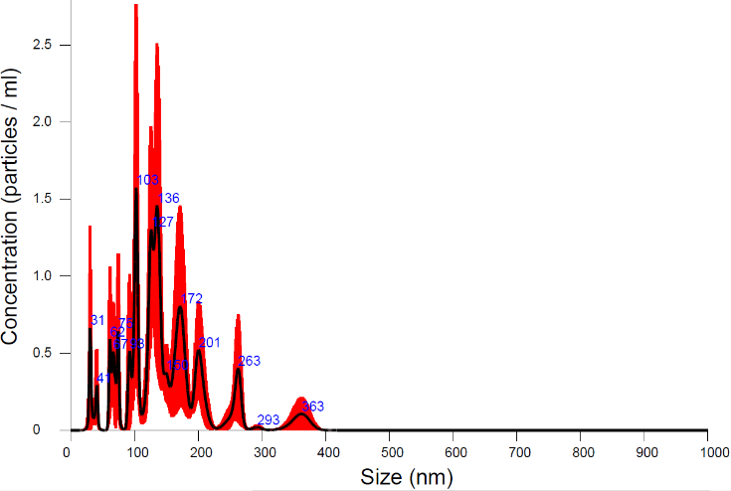

(b) 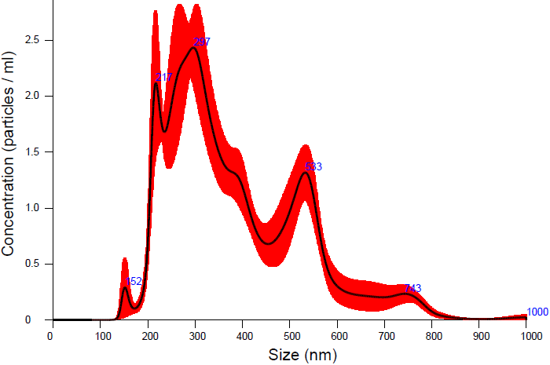

(c) 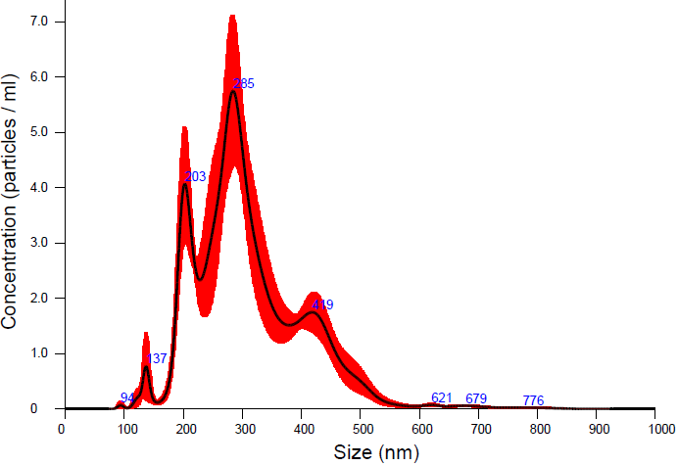

(d) 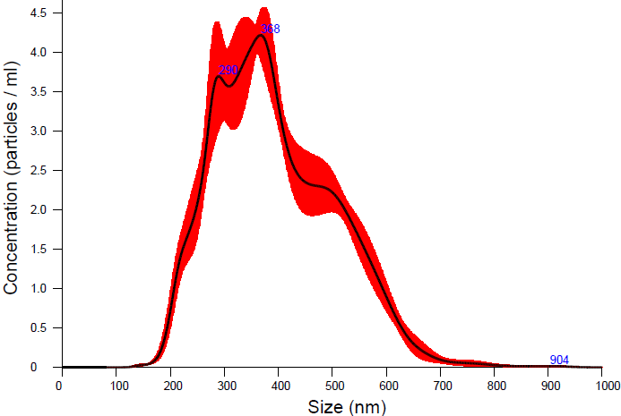

(e) 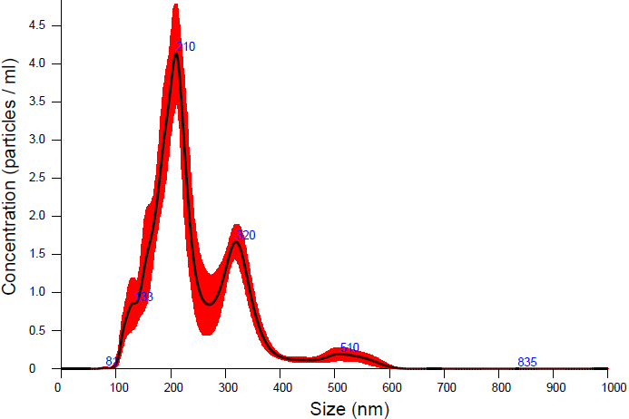

Figure 3. Particle size distribution by NTA of: (a) non-extruded Chit5-OA-20 particles, (b) extruded Chit5-OA-20 micelles, (c) extruded Chit5-MUA-20 micelles, (d) extruded Chit5-MUA-20 micelles loaded with triazole 2, (e) extruded Chit5-MUA-20 micelles loaded with albendazole 3. T = 25 °C. MilliQ H₂O. 10⁹-10¹⁰ particles/mL. Avanti Polar Lipids mini-extruder was used for samples (b)-(e) with 400 nm membrane.

The characteristics of micelles formed by modified chitosan are presented in Table 1.
Table 1. Polymeric micelle’s physico-chemical characteristics.
Micelle designation |  | Chitosan modification degree**, % | Average molecular weight of one structure unit, kDa | Critical micelle concentration, nM | Hydrodynamic diameter by NTA, nm | Hydrodynamic diameter by DLS, nm | Zeta-potential, mV
Chit5-SA-20* |  | 15±2 | 6.2±0.5 | 16±4 | 340±130 | 420±30 | –0.6±0.3
Chit5-OA-20* |  | 19±3 | 6.5±0.6 | 8±2 | 380±140 | 450±70 | +5±1
Chit5-MUA-20* | non-stitched | 17±2 | 6.0±0.3 | 40±7 | 170±60 | 210±20 | +19±1
Chit5-MUA-20* | S–S stitched | 17±2 | 25±4 | 5±1 | 310±100 | 530±80 | +23±2
Chit5-LA-20* |  | 15±3 | 5.9±0.2 | 9±1 | 320±90 | 760±110 | +30.5±0.5
* Chit5-X-20, where 5 is molecular weight of chitosan in kDa, 20 – theoretical degree of chitosan modification, X – acid residue. SA – stearic acid, OA – oleic acid, MUA – 11-mercaptoundecanoic acid, LA – lipoic acid.

** Experimental modification degree was determined by TNBS spectrophotometric titration of NH₂-groups of Chit5 and its conjugates and FTIR peaks ratio.

Reviewer's question 10:
10. What is the significance of referring to the drug-loaded micelles as "pancakes"?
Authors' answer 10:
Drug-loaded micelles renamed as “disc-like”. The difference in morphology and texture according to AFM data for micelles loaded and unloaded with the drug is a very important fact, indicating structural rearrangements when the drug is included in micelle's core. The compaction and structuring of micelles is observed.
Reviewer's question 11:
11. Authors should give supporting evidence for their claim of significant changes in the texture of micellar objects when the drug is loaded. Why do the NTA data and AFM data differ considerably?
Authors' answer 11:
The authors clarified the NTA data after extrusion of micelles empty and loaded with drug. The extrusion technique (400 nm membrane) makes it possible to significantly increase the drug inclusion degree and turn disordered particles into actual micelles. NTA data after extrusion of micelles is consistent with AFM (see question 9). Additionally, the dimensions are determined using DLS (see Table 1 above).

Reviewer's question 12:
12. Micelles are self-assembling nanostructures with the most frequent particle size of <200nm. However, in NTA and AFM data authors indicated that the particle distribution was 31-363nm (NTA) or 200 nm to 1.65 μm . The author should explain their findings and give evidence to support them.
Authors' answer 12:
AFM provides data on micelles that are deposited on the substrate and could spread apart (flattening), so their linear size is higher than according to NTA data. Polymer micelles can be considered as particles from 150 up to 400-500 nm. Since the modified chitosan itself has a large hydrodynamic size, and the micelles formed by it are even larger.

Reviewer's question 13:
13. Why do the authors just look at AFM for Pyrazole 1 loaded micelles and not others? What is the relevance of the non-loaded Chit5-MUA-20 AFM data?
Authors' answer 12:
We added AFM data to the manuscript for a set of other micelles studied in the work. The cytostatics used are structurally similar and have small effect on the structure of loaded micelles. The rest of the loaded micelles have a similar texture. The relevance of the data for loaded and non-loaded Chit5-MUA-20 is to directly compare the influence of the drug loading to the particles formation, structure, morphology and tendency to aggregation of the micelles as particles.

Reviewer's question 14:
14. Why did authors not include Albendazole and Diarylisoxazole in Chit5-OA-20
Authors' answer 14:
The authors included cytostatics in all micelles, but presented optimal combinations of cytostatics-micelles to avoid cluttering. The best results are given by Chit5-MUA-20 and Chit5-LA-20, and partly by Chit5-OA-20. S-S crosslinked micelles (MUA and to a lesser extent LA) are superior in Cyto-tox to non-crosslinked OA and SA because they have glutathione sensitivity to the tumor microenvironment.
Reviewer's question 15:
15. On what grounds do authors choose Chit5-fatty acid for various Cytostatic drugs? Chit5-OA-20 is just for Pyrazole and Triazole, Chit5-MUA-20 is for albendazole, and Chit5-LA-20 is for diarylisoxazole.
Authors' answer 15:
MTT tests were reworked and completed for other micelles’ too.

Reviewer's question 16:
16. Table 2 should be changed as a figure legend.
Authors' answer 16:
The authors consider the presentation of cell images in the form of a table to be more visual. We have changed the name of Figure vs Table according to with the reviewer comments

Reviewer's question 17:
17. To support the claim of pH, temperatures, and glutathione sensitivity of micelles, provide in vitro release data of drug-loaded micelles in different pH and temperature conditions.
Authors' answer 17:
These data are submitted for publication in another manuscript of the authors for the model Dox release (Accepted manuscript).

Figure. Release kinetics curves of free Dox and micellar (Chit5-MUA-20) form of Dox complexes (1 mg/mL, 50% Dox w/w). Dialysis membrane (12-14 kDa cut‐off) into an external solution (1:10 by volumes). PBS (pH = 7.4, 0.01M), sodium acetate buffer (pH = 5.5, 0.01M). Dox is detected by absorption at 488 nm. T = 25, 37 and 42 °C.

Table. Initial rate of Dox release (%/h) at pH = 7.4 or 5.5 and T = 25, 37 or 42 °C. The conditions are similar to those given in Figure.
T, °C \ pH | pH = 5.5 | pH = 7.4
25 °C | 22±3 | 8±1
37 °C | 32±4 | 15±3
42 °C | 49±6 | 23±5

Reviewer's question 18:
18. Although FTIR played an important part in this study, the writers failed to convey its relevance in the introductory section. The involvement of the FTIR in this investigation might be included by the authors to claim a special novelty of their work.
Authors' answer 18:
Changes have been made to the manuscript in Introduction.

New approach based on FTIR, allowing to determine the nature and effectiveness of the drug's effect on individual components of the cell with confirmation of the results by MTT tests was applied to study the effectiveness and mechanism of the action of the micellar cytostatics formulations on tumor cells compared to healthy ones. FTIR spectroscopy allows to monitor the interaction of drugs with the main structural components of the cell (cell membrane, transmembrane and internal proteins, DNA, carbohydrates) and study the molecular mechanism of action of drugs in a simple form and micellar - thereby achieving selectivity against cancer cells [47–54].

Reviewer's question 19:
19. Conclusion should be revised to provide the particular and significant conclusion of the research.
Authors' answer 19:
Changes have been made to the manuscript.

The authors are grateful to the reviewer for valuable comments.

