Screening of candidate housekeeping genes in uterus caruncle by RNA-sequence and qPCR analyses in different stages of goat（Capra hircus）
Zhou Yumei¹, Li Xingchun¹, Zhang Xinyue, Li Minghui¹, Luo Nanjian^{*12}and Zhao Yongju^{*1}
1College of Animal Science and Technology, Southwest University; Chongqing Key Laboratory of Herbivore Science; Chongqing Key Laboratory of Forage & Herbivore; Chongqing Engineering Research Center for Herbivores Resource Protection and Utilization; Chongqing Herbivore Engineering Research Center, Chongqing 400715, China.
2School of Preclinical Medicine, Zunyi Medical University, Zunyi, 563000, China
Citation: Science, C.A.; Technology; University, S.; Center, C.H.E.R.; Chongqing; China. Zhou Yumei¹, Luo Nanjian^{*1}, Li Minghui¹ and Zhao Yongju*1. 2023, 13, x. https://doi.org/10.3390/xxxxx
Academic Editor(s):
Received: date
Revised: date
Accepted: date
Published: date

Copyright: © 2023 by the authors. Submitted for possible open access publication under the terms and conditions of the Creative Commons Attribution (CC BY) license (https://creativecommons.org/licenses/by/4.0/).
zym244075@163.com (Y.Z.); LXC500112@163.com (X.L.); xyxy662303@163.com; minghuili@126.com (M.L.)
* Correspondence: luonanjian28@sina.cn (N.L.), Tel: +86-139-9648-8708; zyongju@163.com (Y.Z.), Tel.: +86-138-8339-9148
Abstract: Uterus is a critical pregnancy organ for mammal. The normal growth and development of ruminant uterus caruncle are crucial to maintain gestation and fetal health in goat. Quantitative real-time polymerase chain reaction (qRT-PCR) is a reliable tool to study gene expression profiling for exploring the intrinsic mechanism underlying the conversion process of uterus caruncle tissue. However, the candidate housekeeping genes (HKGs) are required for normalizing the expression of function genes. In our study, 22 HKGs were selected from analyzing transcriptome data at nonpregnancy and pregnancy process and previous reports about HKGs in goat tissues and we assessed them for expression suitability in 24 samples from uterus tissues at 15 non-pregnant day (Stage 1), early (Stage 2) and medium-later pregnant day (Stage 3). The expression stability of these genes was evaluated by using geNorm, Normfinder, Bestkeeper and Delta Ct algorithms and comprehensively by ReFinder. In addition, the most and least stable HKGs were used to normalize the target genes expression of SPP1, VEGFA and PAG8. It was found that traditional reference genes, such as ACTB and GAPDH were not suitable for target gene normalization. In contrast, PPIB selected from RNA sequencing data and EIF3K selected from previous references showed the least variation and were recommended as the best HKGs during the nonpregnant stage and the whole stages of goat uterus caruncle tissue respectively. It is the first time to explore the HKGs genes in uterus during the non-pregnant day and throughout the total pregnancy. These findings found suitable HKGs in uterus caruncle tissues at various stages of non-pregnancy and pregnancy, which can be useful for gene expression studies to reveal the molecular mechanisms of uterus development in goats.
Keywords: uterus caruncle; the candidate housekeeping genes; RNA-sequence; goat

1. Introduction
The uterus, a place where the embryo is implanted and continues to develop, is necessary for the reproduction of mammals. Uterus caruncle is a special structure located on the endometrium of domestic ruminants. With the process of pregnancy, uterus caruncle participates in placentation and forms to be the maternal part of placenta[1]. Before and after pregnancy, the uterus caruncle develops from endometrial epithelial cells to connective tissue rich in blood vessels. This dynamic process indicates that the structure and cell types of the uterus caruncle undergo significant changes during the pregnancy.
Goat (Capra hircus) is becoming widely accepted around the world due to the increasing demand for low cholesterol content and high nutritive value of goat meat [2]. The successful pregnancy and fetal health in goat are important safeguards for reproductive performance and are dependent on normal uterus function and placenta development. The hircine placenta is the cotyledon placenta, which divide into multiple button-shaped functional units, entrenched into maternal uterus caruncle with the incomplete uterine luminal epithelium, and achieve the synepitheliochorial placenta at gestation [3,4]. Although a lot of physiological process have been reported in uterus from ruminant[5,6], the exact molecular mechanisms remain largely unclear in uterus caruncle development in domestic animals. Gene expression analysis is a useful technique because it provides information on the regulation of uterus development.
Quantitative real-time polymerase chain reaction (qRT-PCR) is widely applied to quickly and accurately characterize the expression of target genes. To obtain the real expression changes of target genes, HKGs must be used to normalize cycle threshold (Ct) value from qRT-PCR. In theory, the HKGs expression should not change in the investigated different tissues or in development stages. To obtain the candidate housekeeping genes, programs (including geNorm[7], Normfinder[8], BestKeeper[9], and Delta-Ct method[10] have been invented to facilitate the statistical analysis of potential endogenous control genes base on the results of qRT-PCR. Furthermore, comprehensive tools have also been developed to compare tested HKGs, for example RefFinder [11] and ComprFinder [12]. Meanwhile, high-throughput RNA sequencing provided a large transcriptional collection of all genes, and the fragments per kilobase of transcript sequence per millions of base pairs sequenced (PFKM) has been used to screen for new or stable reference genes with low coefficient variation [13,14].
To date, several studies have identified the candidate HKGs in uterus of other species but not goats. For instance, the combination of YWHAZ, HPRT1, and HMBS was suggested as the most stable reference group of genes in the ovarian and uterine tissues of laying hens under control and heat stress conditions [15] and YWHAZ was the best reference gene, which could be used as an accurate internal control gene in canine pyometra studies[16]. Moreover, there were also some studies carried on other tissues except uterus of goat. The HMBS and B2M were identified as the the candidate housekeeping genes in hircine spleen, caecum, small intestine, lower lip, large intestine, trachea and upper lip [14]. Several HKGs were also demonstrated in other tissues of goat, such as SDHA in skin[12], EIF3M in adipose tissue[13], and PPIB and HMBS in intramuscular fat [17]. However, the candidate housekeeping genes for using in the study of goat uterus, especially uterus caruncle, are lacking.
In this study, we aimed to screen a set of candidate HKGs in Carpra hircus uterus caruncle. 22 original candidate HKGs were selected by analyzing transcriptome data and referring previous researches. The transcriptional expression levels of these genes were detected in uterus caruncle by qRT-PCR. Four programs and one comprehensive index were applied to assess the stability of HKGs expression during non-pregnant and pregnancy stages. These findings were useful in selecting HKGs to correctly analyse the expression of function genes in the uterus caruncle, which aids in understanding the molecular genetic mechanism of pregnancy in goats.

2. Materials and Methods

2.1. Ethics Statement
All goat experiments were performed in strict accordance with the recommendations for the Southwest University Institutional Animal Care and Use Committee (2019, No. GB14925-2010). All researches involving animals were conducted according to the approved protocols of the Chongqing Key Laboratory of Herbivore Science, Chongqing, China.

2.2. Animals and sample harvesting
The researches involving animals were conducted according to the approved protocols of the Chongqing Key Laboratory of Herbivore Science, Chongqing, China. Animals were from the breeding farm at Southwest University. They were subjected to a standard feeding management regime (DB50/T 510-2013) and housed in free semi-open folds. Sample procedures in this study were supervised and approved by the Institutional Animal Care and Use Committee of Southwest University. With cesarean operation, uterus caruncle samples were collected at eight different non-pregnant and pregnant stages of Dazu Black goats (Figure 1a and 1b).
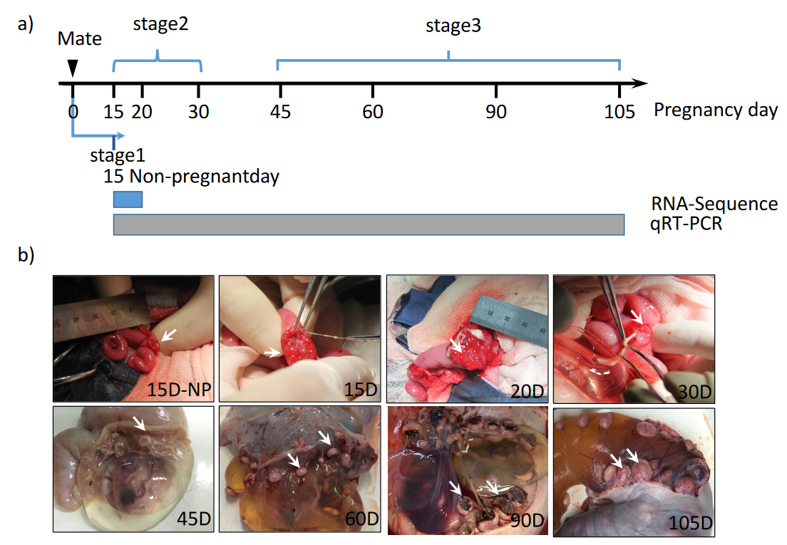
Figure1. a) Sampling time points (15 Non-pregnantday, 15th, 20th, 30th, 45th, 60th, 90th and 105th of pregnancy) and stage division (stage1, stage2 and stage3) of this experiment. Blue rectangle refers to RNA-Seq performed at this stage, grey rectangle presents qRT-PCR performed at these stages. b) Representative images of hircine caruncle tissues when sampling.

2.3. RNA Extraction and cDNA Synthesis
Total RNA is extracted from uterus caruncle tissues using Trizol® reagent according to the manufacturer’s instructions (Invitrogen, USA). RNA concentration was measured by NanoDrop 2000 spectrophotometer (Thermo, USA), and the purity of RNA was determined by the ratio of OD260/280. All the ratio of OD260/280 of our RNA samples value 1.8-2.0. Each sample was reverse transcribed using All-In-One 5X RT MasterMix (Abm, Cat#G592) with 2μg total RNA.

2.4. Selection of candidate reference genes
Transcriptome sequencing data of 9 Dazu Black goat uterus caruncle tissues was performed using the paired-end sequencing technology on an Illumina NovaSeq 6000 platform. After assembly and annotation, the gene expression profiles and read counts of unique transcripts were converted into FPKM values on the platform BMKCloud (www.biocloud.net), according to the formula FPKM = cDNA fragments/[mapped fragments (millions) × transcript length (kb)]. Based on the FPKM value, every gene in each transcriptome, the CV and MFC were calculated using Microsoft Excel. The CV is defined as the ratio of the SDFPKM to the mean of the FPKM of all samples for one gene. The MFC, which is defined as the fold change between the largest and smallest FPKM values within 9 RNA-seq were calculated. A potential HKG should have a relatively high FPKM value[18,19], low CV and MFC values because these are the typical requirements for HKGs, along with a relatively high and low expression variation level. We also got several HKGs from prior studies[20-22] and HKGs of frequently used genes in addition to genes chosen from transcriptome sequencing data with ideal FPKM, CV and MFC values. qRT-PCR was used to amplify all HKGs for later analysis and confirmation.

2.5. Quantitative real-time PCR (qRT-PCR) analysis
Specific primers were designed using the Primer-Blast web tool (https://www.ncbi.nlm.nih.gov/tools/primer-blast/) on the basis of the sequences of unigenes. The information of primers was shown in Table S1. The quantity Real-time PCR was carried out in a CFX96 Real-Time System (BIO-RAD) with SsoAdvanced SYBR Green Supermix (BIO-RAD, #1725262). The qRT-PCR reaction system was performed in a 10μL reaction volume with 5μL of 2× qPCR MasterMix (Abm, Cat#G891), 4.5μL cDNA template and 0.25μL each primer. The thermocycling conditions were performed starting with a 3min enzyme activation step at 95℃, followed by 40 cycles of 15s at 95℃ for denaturation and 1min at 60℃ for annealing/extension. Melting curve analysis was performed at the end of each PCR program to monitor non-specific product formation.

2.6. Analysis of the Expression Stability for Candidate Reference Genes
The qRT-PCR Ct (Cycle Threshold) data has been entered into four traditional algorithms, including geNorm[7], NormFinder[8], BestKeeper[9] and the Delta Ct method[10] to evaluate the stability of HKGs. Moreover, ReFinder[11] was used to get a comprehensive ranking of HKGs.

2.7. Validation of HKGs
For validating the HKGs stability results, the expression profiles of 3 well known goat uterus caruncle genes, viz. VEGFA, PAG8, and SPP1 were investigated by performing qRT-PCR analysis of cDNA samples, in the same way as stated above. The expression levels of target genes were normalized using the 2^{−∆∆CT} method[23]. The primer details of these target caruncle genes have been given in the Supplemental Table S1.

3. Results

3.1. Selection of HKGs Using RNA-Seq Data.
Based on the FPKM value, the coefficient of variation (CV, %) and the maximum fold change (MFC), a total of 383 HKGs we obtained (Figure 2). KEGG (Kyoto Encyclopedia of Genes and Genomes) enrichment analysis indicated that most HKGs were involved in the ribosome and lysosome pathways (Figure S1). Five HKGs including MORF4L1, HNRNPL, PTPRA, ARF1 and PPIB were selected for further validation. We acquired several HKGs from prior studies[21]and HKGs of widely used genes (GAPDH, SDHA, ACTB, YWHAZ and 18S) in addition to genes chosen from transcriptome sequencing data. Table 1 contains all the details of the HKGs we opted from transcriptome data for our research.

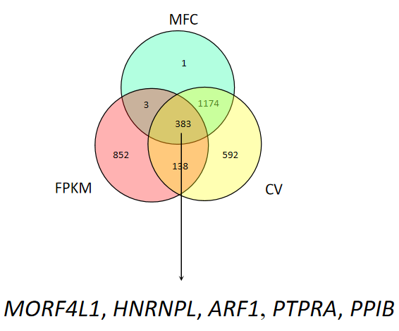
Figure 2. The Venn diagram analysis of overlap genes in FPKM, MFC and CV. The arrow indicated the candidate reference genes screened by the transcriptome data.

3.2. Amplification Specificity and Efficiency of the HKGs and Target Genes.
A total of 25 primer pairs including 22 HKGs and 3 target genes were designed for qRT-PCR experiment. The specificity for each paired primer was validated by the melting curve analysis, which showed a single amplification peak (Figure S2). Each pair of primers had good specificity and amplification efficiency around 100%.

3.3. Expression Profiling of the HKGs.
The expression of 22 HKGs was assayed in sample of caruncle. The distribution of the mean Ct values (the average of 3 technical replicates in the same sample) is displayed in Figure 3a. The mean Ct values range from 19.80 to 32.87. We selected genes with the mean Ct value lower than 28 for our subsequent analysis. In other words, HKGs whose mean Ct value over than 28 including POLR2A, TBP, PTPRA, 18S and UBC were excluded in further analysis. These findings suggest that gene expression varied from approximately 300 folds change compared to the mean gene expression of all 17 genes (Figure 3b).
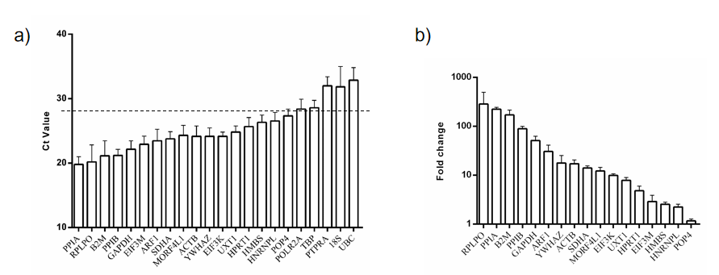
Figure 3. RT-qPCR of Dazu Black goat caruncle samples to analyze 22 candidate genes. a) Ct values are displayed as mean of 3 repeated analyses of control samples. The black line at Ct value= 28 represents the threshold set to include only candidates exhibiting moderate abundance for further analysis. b) Bar chart of relative gene expression of control genes in the caruncle. Means of 3 control samples were normalized to the geometric mean of all gene candidates and the △△Ct method was used to calculate erelative expression (fold change).

3.4. Stability Analysis of HKGs by Four algorithms.

3.4.1. Expression Stability of the HKGs by Delta Ct Analysis.
By Delta Ct method, the gene stability was evaluated by the std-value shown in Table 2. At stage 1, PPIB, a HKG we selected from RNA-seq data, performed the best stability. However, it failed to be the most stable gene in other stages of all uterus caruncle samples while EIF3K to be. Additionally, the other three HKGs selected from RNA-seq data (ie, MORF4L1, HNRNPL and ARF1) did not perform good stability.

3.4.2. Expression Stability of the HKGs by BestKeeper Analysis.
The BestKeeper algorithm determines the best HKGs based on the principle that the expression of good HKGs is highly correlated and constructs a correlative index out of it, which is then compared with the target genes to reach a conclusion whether or not the reference genes are regulated. EIF3K was predicted to be the most stable among stage 2, stage 3 and overall samples by the BestKeeper algorithm with the stability value (standard deviation) of 0.46, 0.36 and 0.46, respectively (Table 3). The cut-off value for this stability measure is 1, below which all the genes are deemed to be stably expressed[9]; this was the case for all the genes investigated in stage 1 of our study. However, 4 and 3 out of the total of 17 HKGs displayed instability in stage 2 and stage 3, respectively, with stability values greater than 1. Furthermore, when every phase was taken into account, 6 HKGs were unstable.

3.4.3. Expression Stability of the HKGs by NormFinder Analysis.
Expression stability values which determined by NormFinder algorithm, are shown in Table 4. In stage 1, PPIB selected from RNA-seq data performed the best stability again, which is the same as the result presented in the Delta Ct method. In stage2 and stage 3, EIF3K was the most stable one while ARF1 and RPLPO were the least stable genes respectively. In all samples, EIF3K, POP4, SDHA and PPIA were the most stable, while ARF1, ACTB, B2M and RPLPO were the least.

3.4.4. Expression Stability of the HKGs by geNorm Analysis.
The geNorm algorithm calculated the M Value to determine the gene stability. The genes with least M value have the most stable expression and stepwise exclusion of genes with highest M-values will result in a combination of two genes with highest stability[7]. The M value of each gene in every stage and all samples were shown in Table 5. In all samples, EIF3K and SDHA with the M-values of 0.940 were predicted to be the most stable genes while B2M and RPLPO were found to be least stable with the M-values of 1.758 and 1.893.

3.5. A Comprehensive Ranking of Four Methods.
ReFinder was used to get an overall ranking of all the selected 17 HKGs among four methods. The result of ReFinder algorithm was shown in Table 6. EIF3K, SDHA, POP4 and PPIA were four most stable genes while ARF1, MORF4L1, HPRT1 and YWHAZ were four least stable genes of all samples.

3.6. Validation the Stability of HKGs with Target Genes.
To validate the HKGs stability results, the most four stable genes (EIF3K, POP4, PPIA and SDHA) and the least four stable genes (ACTB, B2M, RPLPO and ARF1) were used to normalize the same target gene. When using the most four stable genes for normalization, the results showed that PAG8 and VEGFA were expressed in uterus caruncle tissue with the lowest level at stage 1, and increased in stage2, further significantly increased in stage 3 (p<0.01) and reached the highest level (Figure 4a, 4c). SPP1 whose expression reached the highest level in stage 2, expressed the least in stage 1 and the middle in stage 3 (Figure 4e). When it comes to the four least stable genes, there were hardly significant difference between stages (Figure 4b, 4d, and 4f). What’s worse, different expression trend appeared among VEGFA and SPP1 when normalized to ACTB and B2M respectively (Figure 4d, 4f).
A correlation analysis on relative expression data of four most and least stable candidate reference genes normalized to three target genes were performed. As shown in Figure 5, POP4 and PPIA had a high correlation coefficient which R values 0.97. It suggested that they have extremely similar normalization capabilities. However, the R value of ACTB and RPLPO is pretty low i.e., 0.11 and it demonstrates that they have hardly normalization capabilities.
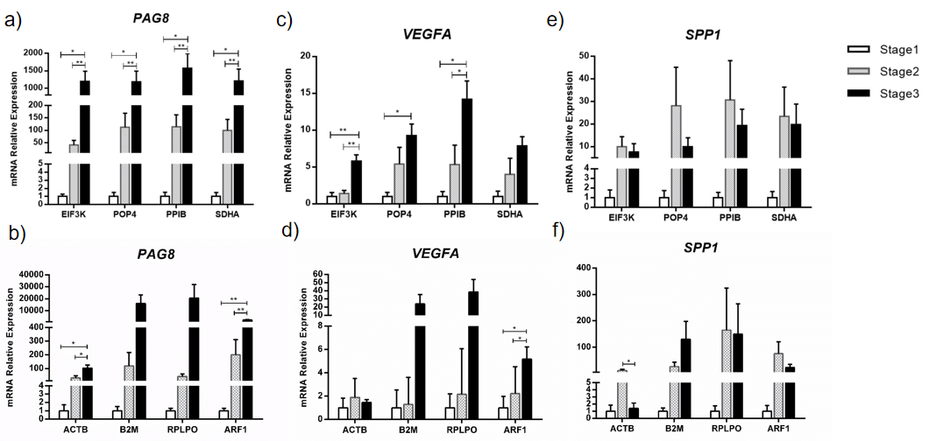

Figure 4. Relative expression of target genes (PAG8, VEGFA and SPP1) normalized to the different reference genes across three stages. a) Relative expression of PAG8 by the most stable genes (EIF3K, POP4, PPIA, and SDHA) .b) Relative expression of PAG8 by the least stable genes (ACTB, B2M, RPLPO, and ARF1). c) Relative expression of VEGFA by the most stable genes (EIF3K, POP4, PPIA, and SDHA). d) Relative expression of VEGFA by the least stable genes (ACTB, B2M, RPLPO, andARF1). e) Relative expression of SPP1 by the most stable genes (EIF3K, POP4, PPIA, and SDHA). f) Relative expression of SPP1 by the least stable genes (ACTB, B2M, RPLPO, and ARF1).

4. Discussion
The uterus is an important organ in the reproductive system of most female mammals and accommodates the embryonic and fetal development of one or more embryos until birth. With the mammal pregnancy, the maternal endometrium maintains a decidua reaction including endometrial thickening, blood vessels increasing, hypersecretion of uterine glands and stromal cell hypertrophy. These changes of morphology and composition from maternal uterus suggest a genetic regulation arises from transcriptional expression. However, the HKGs that normalize the expression of target genes have not been identified during pregnancy, especially in domestic animals. Thus, it is essential to explore the suitable housekeeping genes. In this study, we refer to RNA-seq data to select novel candidate HKGs of goat uterus caruncle tissue, and qRT-PCR data were used for software analysis to obtain the most suitable HKGs. Our results showed that EIF3K, POP4, PPIA and SDHA were the most stable HKGs in the uterus regardless of pregnant or nonpregnant state.
In order to obtain the stable HKGs from RNA-seq and qRT-PCR data, we set three parameters, four methods to rigorously screen HKGs in uterine tissues. Refer to previous studies[18-20], the FPKM value, the coefficient of variation and the maximum fold change were considered to measure the HKGs in the RNA-seq data. Meanwhile, geNorm, NormFinder, Bestkeeper and Delta Ct methods were used to evaluate the stability of HKGs in qRT-PCR data. Specially, a total of 22 HKGs for qRT-PCR analysis. However, only 17 HKGs were used for further study. The reason why we eliminate the 5 HKGs is based on the notion that a Ct of less than 29 is indicative for abundant gene expression[24], which is desirable for qRT-PCR analysis. Considering the accuracy and validity of experiment, we set up a stricter Ct value line, viz. 28.
In our results, PPIB, a HKG we selected from RNA-seq data, showed good stability in stage 1 referring to nonpregnant period. PPIB is a kind of protein coding gene associated with secretory pathway. The reason why PPIB performed better stability than the other 16 HKGs in uterus caruncle may be connected with the tissue structure of endometrium. The uterus caruncle is the pitting structure of endometrium, which contains abundant of epithelial cells. We predict that epithelial cells probably contribute to the secretory process. Previous study[25] has also shown that PPIB performed the best stability in LPS-stimulated and non-stimulated THP-1 and K562, which partly verified the foregoing prediction. Among the studies that HKGs performed on goats, we find a study[17] on Jianyang big-eared goats that showed PPIB was the most stable gene. However, PPIB failed to show the best stability in the following stages. In stage 2 and stage 3, the fertilised ovum lodges in the uterus, establishing and maintaining pregnancy. A series of the aforementioned events might be more connected to genes that pertain to angiogenesis.
When it comes to samples in total stages, including stage 1, stage 2 and stage 3, EIF3K performed the best stability. EIF3K (Eukaryotic translation initiation factor 3) has been suggested as one of the most stably expressed HKGs in bovine endometrium[26]. The uterus caruncle is the pitting structure of endometrium, so our results may partly validate previous research. In addition, it has been suggested that EIF3K is one of the most stably expressed HKGs in bovine endometrium, and is also stably expressed in bovine adipose tissue, mammary gland, muscle and liver, and goat adipose tissue[21,27]. To date, no publications were found on EIF3K as an unstable HKG. This may indicate the potential of EIF3K to serve as a stable HKG in goat uterus tissue.
It is interesting that traditional HKGs like ACTB and GAPDH were not performed well in our research. What’s worse, ACTB was one of the least four stable genes while GAPDH showed the medium stability on the whole. It seems to be a common conclusion that classical reference genes did not have good stability in the studies of HKGs[25,28-31]. This finding reminds us that the need to accurately validate candidate internal control genes in the study before use in gene expression studies using qRT-PCR.
When it comes to methodology in this study, we combine RNA-seq data with referring to references to select HKGs, following use qRT-PCR experiment to validate the selected HKGs, then target genes of uterus caruncle tissue were used for further validation. We used four algorithms that we knew so far viz. geNorm, Delta Ct, NormFinder and BestKeeper, to calculate the stability of HKGs. And ReFinder was applied to evaluate the comprehensive stability of HKGs. In general, we synthesized all the latest methods referring to screen HKGs, which leads us to get a relatively reliable result.
As for the number of HKGs for normalization, we only choose single gene instead of gene combinations. That was determined by geNorm on the basis of the average pairwise variation (V_{n}/V_{n+1}) value. As a routine, 0.15 was proposed as the cut-off value for V value[7], below which the inclusion of an additional control gene was not required. However, all of the V_{n}/_{n+1} values in our study were less than 0.15 (Table S2), indicating increasing number of genes did not significantly change the value of the normalization analyses. Therefore, single top stable HKG might be a good choice for qRT-PCR assay in our study.
Previous studies have shown that SPP1, VEGFA, and PAG8 [32-34] genes were the marker genes for uterus and placenta tissues. In addition, they were differentially expressed in our RNA-seq data (data was not shown) in the uterus caruncle tissues. Therefore, SPP1, VEGFA, and PAG8 genes were selected as target genes for normalization. SPP1 plays an important role in the regulation of maternal-fetus angiogenesis and calcium balance after implantation[35,36]. VEGFA (vascular endothelial growth factor A) has strong pro-angiogenic effect on embryonic vasculogenesis[37]. Early expression of PAG genes including PAG8 in the conceptus may contribute to successful development of early pregnancy and possibly alter mechanisms related with embryo survival such as prostaglandin synthesis[34]. In our study, the extremely upregulated of PAG8 and VEGFA genes during pregnancy were significantly showed by normalized to the most stable HKGs (EIF3K, POP4, PPIA and SDHA). However, hardly any significance and even sever variance appeared when they were normalized to the four least stability HKGs (ACTB, B2M, RPLPO, and ARF1). And the expression of SPP1 performed some variation between referenced to the most stable and unstable HKGs. The suitable HKGs should be carefully chosen, taking into account the precision of qRT-PCR, as unstable reference genes will result in incorrect interpretation of expression data.

5. Conclusions
In our study, four different algorithms and one comprehensive index were used to analyze a panel of HKGs. All four algorithms gave consistent results. PPIB and EIF3K proved to be the most suitable HKGs in non-pregnant stage and both non-pregnant and pregnancy stages respectively. ACTB, B2M, RPLPO and ARF1 were the least four stable HKGs, suggesting they are not suitable for expression data normalization in studies of goat uterus caruncle tissue.
Acknowledgments: This work was supported by grants from the National Natural Science Foundation of China (No. 31772564) and Research and Innovation Project of Chongqing Graduate Students (No: CYB17073).
Author Contributions: Y.Zhao. and N.L. conceived the project, Y.Zhou. designed the experiments and prepared the manuscript. Y.Zhou. , X.L. X.Z. and M.L. performed the experiments and analyzed the data.
Conflicts of Interest: The authors declare that they have no competing interests.

Reference:
1. Pere, M.C. MATERNAL AND FETAL BLOOD-LEVELS OF GLUCOSE, LACTATE, FRUCTOSE, AND INSULIN IN THE CONSCIOUS PIG. Journal of Animal Science 1995, 73, 2994-2999.
2. Talpur, F.N.; Bhanger, M.I.; Sherazi, S.T. Intramuscular fatty acid profile of longissimus dorsi and semitendinosus muscle from Pateri goats fed under traditional feeding system of Sindh, Pakistan. Meat Sci 2008, 80, 819-822, doi:10.1016/j.meatsci.2008.03.028.
3. Reynolds, L.P.; Redmer, D.A. Angiogenesis in the placenta. Biology of Reproduction 2001, 64, 1033-1040, doi:10.1095/biolreprod64.4.1033.
4. Miri, K.; Varmuza, S. Imprinting And Extraembryonic Tissues-Mom Takes Control. International Review Of Cell And Molecular Biology, Vol 276 2009, 276, 215-262, doi:10.1016/S1937-6448(09)76005-8.
5. Zheng, C.Y.; Zou, X.; Zhao, B.C.; Zhang, M.L.; Lin, H.J.; Luo, C.H.; Xu, Z.M.; Shao, L.Y.; Fu, S.X. miRNA-185 regulates retained fetal membranes of cattle by targeting STIM1. Theriogenology 2019, 126, 166-171, doi:10.1016/j.theriogenology.2018.11.030.
6. McNaughton, A.P.; Murray, R.D. Structure and function of the bovine fetomaternal unit in relation to the causes of retained fetal membranes. Veterinary Record 2009, 165, 615-622, doi:10.1136/vr.165.21.615.
7. Vandesompele, J.; De Preter, K.; Pattyn, F.; Poppe, B.; Van Roy, N.; De Paepe, A.; Speleman, F. Accurate normalization of real-time quantitative RT-PCR data by geometric averaging of multiple internal control genes. Genome Biology 2002, 3, doi:10.1186/gb-2002-3-7-research0034.
8. Andersen, C.L.; Jensen, J.L.; Orntoft, T.F. Normalization of real-time quantitative reverse transcription-PCR data: A model-based variance estimation approach to identify genes suited for normalization, applied to bladder and colon cancer data sets. Cancer Research 2004, 64, 5245-5250, doi:10.1158/0008-5472.Can-04-0496.
9. Pfaffl, M.W.; Tichopad, A.; Prgomet, C.; Neuvians, T.P. Determination of stable housekeeping genes, differentially regulated target genes and sample integrity: BestKeeper - Excel-based tool using pair-wise correlations. Biotechnology Letters 2004, 26, 509-515, doi:10.1023/b:bile.0000019559.84305.47.
10. Silver, N.; Best, S.; Jiang, J.; Thein, S.L. Selection of housekeeping genes for gene expression studies in human reticulocytes using real-time PCR. Bmc Mol Biol 2006, 7, doi:Artn 33
10.1186/1471-2199-7-33.
11. Xie, F.L.; Xiao, P.; Chen, D.L.; Xu, L.; Zhang, B.H. miRDeepFinder: a miRNA analysis tool for deep sequencing of plant small RNAs. Plant Mol Biol 2012, 80, 75-84, doi:10.1007/s11103-012-9885-2.
12. Zhang, J.P.; Deng, C.C.; Li, J.L.; Zhao, Y.J. Transcriptome-based selection and validation of optimal house-keeping genes for skin research in goats (Capra hircus). Bmc Genomics 2020, 21, doi:ARTN 493
10.1186/s12864-020-06912-4.
13. Wang, L.J.; Chen, X.Y.; Song, T.Z.; Zhang, X.J.; Zhan, S.Y.; Cao, J.X.; Zhong, T.; Guo, J.Z.; Li, L.; Zhang, H.P.; et al. Using RNA-Seq to Identify Reference Genes of the Transition from Brown to White Adipose Tissue in Goats. Animals-Basel 2020, 10, doi:ARTN 1626
10.3390/ani10091626.
14. Sahu, A.R.; Wani, S.A.; Saxena, S.; Rajak, K.K.; Chaudhary, D.; Sahoo, A.P.; Khanduri, A.; Pandey, A.; Mondal, P.; Malla, W.A.; et al. Selection and validation of suitable reference genes for qPCR gene expression analysis in goats and sheep under Peste des petits ruminants virus (PPRV), lineage IV infection. Sci Rep-Uk 2018, 8, doi:ARTN 15969
10.1038/s41598-018-34236-7.
15. Hassanpour, H.; Aghajani, Z.; Bahadoran, S.; Farhadi, N.; Nazari, H.; Kaewduangta, W. Identification of reliable reference genes for quantitative real-time PCR in ovary and uterus of laying hens under heat stress. Stress-the International Journal on the Biology of Stress 2019, 22, 387-394, doi:10.1080/10253890.2019.1574294.
16. Du, M.; Wang, X.; Yue, Y.W.; Zhou, P.Y.; Yao, W.; Li, X.; Ding, X.B.; Liu, X.F.; Guo, H.; Ma, W.Z. Selection of reference genes in canine uterine tissues. Genetics and Molecular Research 2016, 15, doi:10.4238/gmr.15028138.
17. Zhu, W.Z.; Lin, Y.Q.; Liao, H.H.; Wang, Y. Selection of Reference Genes for Gene Expression Studies Related to Intramuscular Fat Deposition in Capra hircus Skeletal Muscle. Plos One 2015, 10, doi:10.1371/journal.pone.0121280.
18. Brown, A.J.; Gibson, S.; Hatton, D.; James, D.C. Transcriptome-Based Identification of the Optimal Reference CHO Genes for Normalisation of qPCR Data. Biotechnology Journal 2018, 13, doi:10.1002/biot.201700259.
19. Zhang, J.; Deng, C.; Li, J.; Zhao, Y. Transcriptome-based selection and validation of optimal house-keeping genes for skin research in goats (Capra hircus). Bmc Genomics 2020, 21, doi:10.1186/s12864-020-06912-4.
20. Wisnieski, F.; Calcagno, D.Q.; Leal, M.F.; dos Santos, L.C.; Gigek, C.D.; Chen, E.S.; Pontes, T.B.; Assumpcao, P.P.; de Assumpcao, M.B.; Demachki, S.; et al. Reference genes for quantitative RT-PCR data in gastric tissues and cell lines. World Journal of Gastroenterology 2013, 19, 7121-7128, doi:10.3748/wjg.v19.i41.7121.
21. Bonnet, M.; Bernard, L.; Bes, S.; Leroux, C. Selection of reference genes for quantitative real-time PCR normalisation in adipose tissue, muscle, liver and mammary gland from ruminants. Animal 2013, 7, 1344-1353, doi:10.1017/s1751731113000475.
22. Zhao, L.; Yang, H.L.; Li, X.C.; Zhou, Y.M.; Liu, T.L.; Zhao, Y.J. Transcriptome-based selection and validation of optimal reference genes in perirenal adipose developing of goat (Capra hircus). Frontiers in Veterinary Science 2022, 9, doi:10.3389/fvets.2022.1055866.
23. Livak, K.J.; Schmittgen, T.D. Analysis of relative gene expression data using real-time quantitative PCR and the 2(T)(-Delta Delta C) method. Methods 2001, 25, 402-408, doi:10.1006/meth.2001.1262.
24. Mylvaganam, S.; Zhang, L.; Wu, C.P.; Zhang, Z.J.; Samoilova, M.; Eubanks, J.; Carlen, P.L.; Poulter, M.O. Hippocampal seizures alter the expression of the pannexin and connexin transcriptome. Journal of Neurochemistry 2010, 112, 92-102, doi:10.1111/j.1471-4159.2009.06431.x.
25. Cao, X.M.; Luo, X.G.; Liang, J.H.; Zhang, C.; Meng, X.P.; Guo, D.W. Biochemical and Biophysical Research Communications 2012, 427, 366-372, doi:10.1016/j.bbrc.2012.09.066.
26. Wang, G.-H.; Wang, S.-H.; Zhang, W.-Z.; Liang, C.-C.; Cheng, G.; Wang, X.-Y.; Zhang, Y.; Zan, L.-S. Analysis of stability of reference genes for qPCR in bovine preadipocytes during proliferation and differentiation in vitro. Gene 2022, 830, doi:10.1016/j.gene.2022.146502.
27. Saremi, B.; Sauerwein, H.; Daenicke, S.; Mielenz, M. Technical note: Identification of reference genes for gene expression studies in different bovine tissues focusing on different fat depots. Journal of Dairy Science 2012, 95, 3131-3138, doi:10.3168/jds.2011-4803.
28. Solano, M.E.; Thiele, K.; Kowal, M.K.; Arck, P.C. Identification of suitable reference genes in the mouse placenta. Placenta 2016, 39, 7-15, doi:10.1016/j.placenta.2015.12.017.
29. Nazari, F.; Parham, A.; Maleki, A.F. GAPDH, beta-actin and beta 2-microglobulin, as three common reference genes, are not reliable for gene expression studies in equine adipose- and marrow-derived mesenchymal stem cells. Journal of Animal Science and Technology 2015, 57, 18, doi:10.1186/s40781-015-0050-8.
30. Almeida-Oliveira, F.; Leandro, J.G.B.; Ausina, P.; Sola-Penna, M.; Majerowicz, D. Reference genes for quantitative PCR in the adipose tissue of mice with metabolic disease. Biomedicine & Pharmacotherapy 2017, 88, 948-955, doi:10.1016/j.biopha.2017.01.091.
31. Arsenijevic, T.; Gregoire, F.; Delforge, V.; Delporte, C.; Perret, J. Murine 3T3-L1 Adipocyte Cell Differentiation Model: Validated Reference Genes for qPCR Gene Expression Analysis. Plos One 2012, 7, doi:10.1371/journal.pone.0037517.
32. Kramer, A.C.; Erikson, D.W.; McLendon, B.A.; Seo, H.; Hyashi, K.; Spencer, T.E.; Bazer, F.W.; Burghardt, R.C.; Johnson, G.A. SPP1 expression in the mouse uterus and placenta: Implications for implantation. Biology of reproduction 2021, doi:10.1093/biolre/ioab125.
33. Lupicka, M.; Korzekwa, A. Vascular endothelial growth factor A (VEGFA) and its receptors expression in bovine uterus during adenomyosis. Reproduction in Domestic Animals 2016, 51, 111-111.
34. Thompson, I.M.; Cerri, R.L.A.; Kim, I.H.; Ealy, A.D.; Hansen, P.J.; Staples, C.R.; Thatcher, W.W. Effects of lactation and pregnancy on metabolic and hormonal responses and expression of selected conceptus and endometrial genes of Holstein dairy cattle. Journal of Dairy Science 2012, 95, 5645-5656, doi:10.3168/jds.2011-5113.
35. Waterhouse, P.; Parhar, R.S.; Guo, X.J.; Lala, P.K.; Denhardt, D.T. REGULATED TEMPORAL AND SPATIAL EXPRESSION OF THE CALCIUM-BINDING PROTEINS CALCYCLIN AND OPN (OSTEOPONTIN) IN MOUSE-TISSUES DURING PREGNANCY. Molecular Reproduction and Development 1992, 32, 315-323, doi:10.1002/mrd.1080320403.
36. Bayless, K.J.; Erikson, D.W.; Frank, J.W.; Joyce, M.M.; Burghardt, R.C.; Bazer, F.W.; Johnson, G.A. Recruitment and Modulation of Porcine Endothelial Progenitor Cells by Secreted Phosphoprotein 1 (SPP1, Osteopontin). Biology of Reproduction 2010, 71-71.
37. Melincovici, C.S.; Bosca, A.B.; Susman, S.; Marginean, M.; Mihu, C.; Istrate, M.; Moldovan, I.M.; Roman, A.L.; Mihu, C.M. Vascular endothelial growth factor (VEGF) - key factor in normal and pathological angiogenesis. Romanian Journal of Morphology and Embryology 2018, 59, 455-467.

