Response to Reviewer 1 Comments

Point 1: My proposal is that the authors made a graphical abstract/design of experiment to better highlight the concept of the study.

Response 1: A graphical abstract has been created.

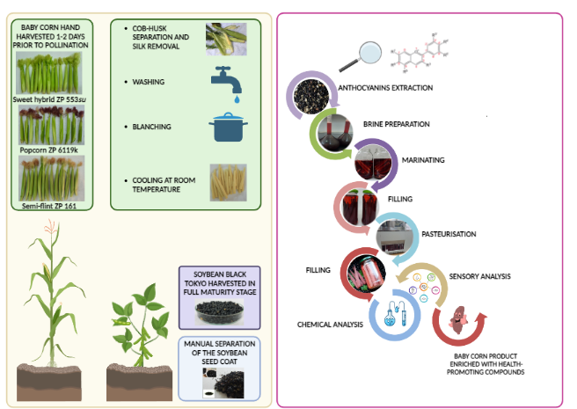

Point 2: The tables must be improved by explaining the statistical significance and what represent the values (mean ± SD, for example). Also, in Table 1 please explain the abbreviation of dietary fibres.

Response 2: Explanation for abbreviation of dietary fibre, statistical significance, mean± SD has been added

Point 3: All values that are given in the manuscript should be specified if they refer to dry or fresh weight/matter. Differences can also occur for this reason.

Response 3: In the header of all Tables (in bracets) now is specified that values are expessed per d.m. Also in Section “Materials and Methods” it was also explained for each method that the results are expressed per d.m.

Point 4: Line 12, 134, 329 - please re-write. Change "having in mind" with other . For example, Considering the great potential of.../Given the great....

Response 4: "having in mind" was replaced with another sinonym in all 3 places

Point 5: The conclusions are too general and could be improved by highlighting the concrete results obtained.

Response 5: Conclusions are improved

Other comments in the Manuscript:
- Explanation of CGE abbreviation has been added
- ABTS method in abstract and section Plant material has been added
- Throughout the manuscript the influence of genotype on chemical composition was shown, but according your suggestion we emphasized this in conclusion too and highlighted which genotype manifested the best functional and sensory properties.
- In description of Figure 1. c) changed to b)
- Spell mistakes were corrected
- Method for total flavonoides was improved

