Review
What is new on Cannabis sativa L.: phytochemistry, new matrices, cultivation techniques, and recent updates on its brain-related effects (2018- 2023)
Laura Siracusa ¹, Giuseppe Ruberto ^{1,}*, Luigia Cristino ²
¹ Istituto di Chimica Biomolecolare, Consiglio Nazionale delle Ricerche, Via Paolo Gaifami, 18 95126 Catania, Italy
² Istituto di Chimica Biomolecolare, Consiglio Nazionale delle Ricerche, Via Campi Flegrei, 34 80078 Pozzuoli (NA), Italy
* Correspondence: giuseppe.ruberto@cnr.it; Tel.: +39 0957338347; Fax: +39 0957338310
Abstract – Cannabis sativa L. is one plant that the humankind has been using for millennia. On the basis of its widespread utilization lies its adaptability to so many different climatic conditions, its rusticity and easy cultivability in innumerable and diversified environments, Because of its variegate phytochemistry, C. sativa has been used in many sectors, although the discovery of the presence in the plant of several psychotropic substances, e.g. Δ⁹-tetrahydrocannabinol, THC) caused a drastic reduction of its cultivation and use together with the official ban from the pharmacopeias. Fortunately, the discovery of Cannabis varieties with a low content of THC as well as the biotechnological development of new clones rich in many phytochemical components endorsed with peculiar and many important bioactivities decreed the reassessment of these species, which study and use today are experiencing new and important developments. In this review we have focused our attention on the phytochemistry, new matrices, suitable agronomic techniques and new biological activities developed in the five last years.
Keywords: Cannabis sativa L.; secondary metabolism; cannabinoids; minor compounds; alternative Cannabis matrices; controlled growth; plant and soil microbiota; neurodevelopmental and neurodegenerative effects.

1. Introduction
The origin of Cannabis sativa as well as its cultivation and uses date back to about 12,000 years ago in the regions of Central and East Asia. Its diffusion around the world has been continuous and inexorable [1], also due to the easy adaptability of this plant to very different climate conditions, and thanks also to its numerous properties and uses as fiber, food and drug [2-6].
C. sativa is an herbaceous and dioecious plant belonging to the order Urticales and the Cannabaceae family [5]. The taxonomic description of the Cannabis genus is almost controversial, de facto ‘sativa’ is considered the sole species of the genus, even though other species have been considered,‘indica’ and ‘ruderalis’ to quote the most important. These different species are today considered merely varieties.
Concerning the content of secondary metabolites, C. sativa has been largely studied and as of today about 750 compounds have been reported in this plant [5,7].
Cannabis has been widely cultivated due to its industrial [8], ornamental [9], nutritional [10], medicinal, and recreational potentials [11]. From regulatory and application perspectives, cannabis plants are categorized based on the level of Δ⁹-tetrahydrocannabinol (THC), one of the most important phytocannabinoids [12]. Plants are generally classified and regulated as industrial hemp if it contains less than 0.3 % THC in the dried flower (this level varies by country) or drug-type with more than this threshold [13].Furthermore, the study of the phytochemical profile of C. sativa has recently demonstrated to be useful not only for determining potential toxicity aspects of C. sativa, considering the large use of this plant for human consumption and as animal feed, but also for traceability purposes. [14-16]. Aim of this review is to provide an update of the studies carried out on C. sativa in these last five years, dealing with different aspects such as phytochemistry, novel cultivation techniques, new biological activities especially connected with the cannabis effects on central nervous system.

2. Secondary metabolites of cannabis

2.1 Cannabinoids
C. sativa contains a peculiar class of phytochemicals known as phytocannabinoids, present almost exclusively in its inflorescences. These substances have been identified also in rhododendron, licorice and liverwort. From a chemical point of view cannabinoids are meroterpenoid compounds with a basic structure of a resorcinyl moiety with different isoprenyl, alkyl, or aralkyl side chains. Tetrahydrocannabinol (THC) and the corresponding acid tetrahydrocannabinolic acid A (THCA-A), cannabidiol (CBD), cannabinol (CBN) and cannabidiolic acid (CBDA) are the main components of this class; altogether, over 200 different cannabinoids have been isolated from the leaves of C. sativa [2,7,17-19]. In Table 1 and Figure 1 a selection of the main cannabinoids found in C. sativa is listed.
Table 1. Selection of cannabinoids isolated from Cannabis sativa L.
Code | Name | Formula | MWª
Δ⁹-THC | δ-9-Tetrahydrocannabinol | C₂₁H₃₀O₂ | 314.55
Δ⁸-THC | δ-8-Tetrahydrocannabinol | C₂₁H₃₀O₂ | 314.52
Δ⁹-THCP | (-)-trans-Tetrahydrocannabiphorol | C₂₃H₃₄O₂ | 342.52
THCV | Tetrahydrocannabivarin | C₁₉H₂₆O₂ | 286.45
Δ⁹-THCA-A | δ-9-Tetraidrocannabinolic acid A | C₂₂H₃₀O₄ | 358.47
ΝΑ^{b} | Anhydrocannabimovone | C₂₁H₂₈O₃ | 328.51
CBN | Cannabinol | C₂₁H₂₆O₂ | 310.43
7-OH-CBD | 7-Hydroxycannabinol | C₂₁H₃₀O₃ | 330.46
CBNA | Cannabinolic acid | C₂₂H₃₀O₄ | 358.47
CBD | Cannabidiol | C₂₁H₃₀O₂ | 314.46
CBDD | Cannabidiol dimethyl ether | C₂₃H₃₄O₂ | 342.52
CBD-C2 | Cannabidiorcol | C₁₇H₂₂O₂ | 258.35
CBD-DER1 | 1,2-Dihydroxycannabidiol | C₂₁H₃₃O₄ | 348.36
CBD-DER2 | 3,4-Dehydro-1,2-dihydroxycannabidin | C₂₁H₃₁O₃ | 330.37
CBD-DER3 | Hexocannabitriol | C₂₁H₃₁0₄ | 348,64
CBC | Cannabichromene | C₂₁H₃₀O₂ | 314.46
CBG | Cannabigerol | C₂₁H₃₂O₂ | 316.48
CNM | Cannabimovone | C₂₁H₃₀O₄ | 346.46
CBND | Cannabinodol | C₂₁H₂₆O₂ | 310.43
CBE | Cannabielsoin | C₂₁H₃₀O₄ | 346.46
CBF | Cannabifuran | C₂₁H₂₆O₂ | 310.24
CBL | Cannabicyclol | C₂₁H₃₀O₂ | 314.46
CBT | Cannabitriol | C₂₁H₃₀O₃ | 330.46
CBR | Cannabiripsol | C₂₁H₃₂O₄ | 348.23
CBCA | Cannabichromenic acid | C₂₂H₃₀O₄ | 358.21
CBGA | Cannabigerolic acid | C₂₂H₃₂O₄ | 360.49
CBDA | Cannabidiolic acid | C₂₂H₃₀O₄ | 358.47
CBDP | Cannabiphorol | C₂₃H₃₄O₂ | 342.52
CBDD | Cannabitwinol | C₄₃H₆₀O₄ | 64033
CBDV | Cannabidivarin (Cannabidivarol) | C₁₉H₂₂O₂ | 282.38
CBTC | Cannabicitran | C₂₁H₃₀O₂ | 314.46
ª Molecular Weight in Dalton (DA)^{; b} NA = not available;
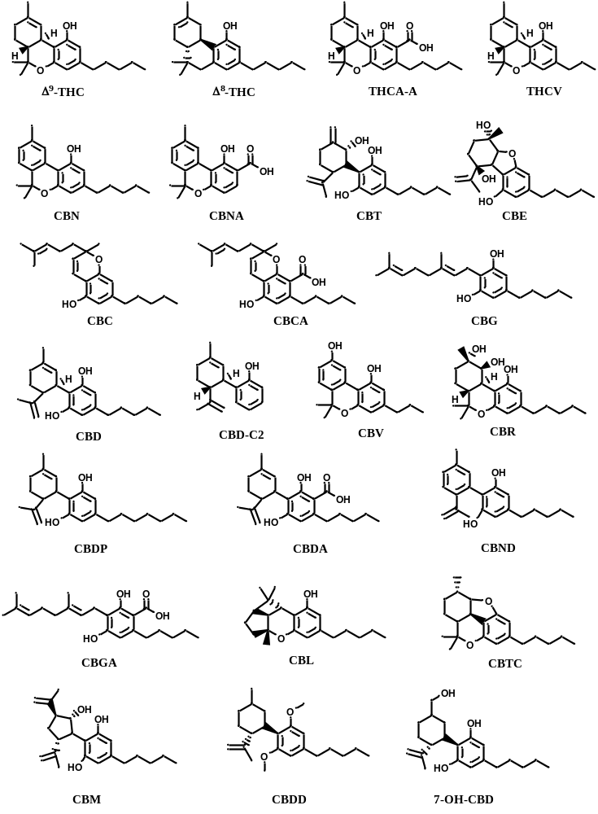
Figure 1. Selection of the main cannabinoids from Cannabis sativa.
These compounds have attracted the interest of the human beings as well as of researchers owing to their broad possibility of exploitation in different sectors and also for their biological activities. In particular, the interest in these molecules has exponentially increased with the discovery in the human body of the endocannabinoid system and of the cannabinoid receptors: CB1 and CB2 [20, 21]. The study of the endocannabinoid system allowed to fully understand the medicinal effectiveness of cannabis in the treatment of different pathologies. However, the discovery of the psychotropic effects associated with Δ⁹-THC decreed the ban of C. sativa from the USA pharmacopoeia and subsequently from many other countries.
On the basis of the THCA/CBDA ratio several chemotypes (Table 2) have been individuated: chemotype I (plants with a THCA/CBDA ratio >1.0), chemotype III (THCA/CBDA >1.0 or fiber plants) and chemotype II (intermediate THCA/CBDA ratio). Finally, plants with a very high content of cannabigerolic acid (CBGA) are classified as chemotype IV, and plants with no cannabinoids belong to chemotype V [22]. It is important to underline that the term “chemotype” refers to plants of the same genus totally identical for botanical and taxonomic features and differing only in the profile of the specialized metabolites that they are able to synthesize and accumulate [2,23].
Table 2. Chemotype of Cannabis sativa L. depending on the ratio THCA/CBDA.
THCA/CBDA | >1 | Chemotype I
THCA/CBDA | <1 | Chemotype III
THCA/CBDA | >1 - <1 | Chemotype II
High CBGA |  | Chemotype IV
No cannabinoids |  | Chemotype V

Today, C. sativa is classified into two main types depending on the amount of Δ⁹-THC: the drug type with Δ⁹-THC > 0.3% is known as cannabis (marijuana), and the fiber type with Δ⁹-THC < 0.3% is commonly referred to as hemp.
THCA is the main cannabinoid in the drug type plant, while CBDA is largely the main cannabinoid in the fiber-type hemp [24]. Both acids undergo a decarboxylation phenomenon during storage and in general with heating, giving rise to the phenols THC and CBD, respectively [24]. While the use and cultivation of cannabis type experienced legal restrictions in many countries owing to the psychotropic effect of Δ⁹-THC, the hemp type is legal and freely cultivated [4,25 ].
Notwithstanding the large number of cannabinoids have been until now isolated and characterized from C. sativa, its phytochemical studies keep arising interest to the point that new cannabinoids are being continuously isolated and characterized (Figure 2).
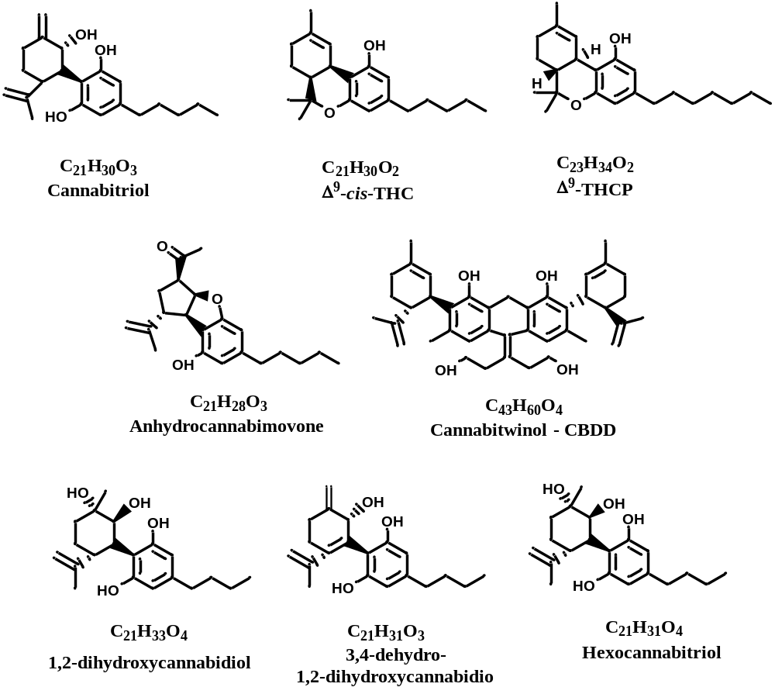
Figure 2. Recently isolated new cannabinoids.
The Δ⁹-Tetrahydrocannabiphorol (Δ⁹-THCP), is a recently discovered cannabinoid, initially known as synthetic derivative, but successively isolated from C. sativa and resulting 30 time more active than Δ⁹-THC, the main psychotropic compound of marijuana [26]. More recently, the racemic couple of the cis-stereoisomers of Δ⁹-THC have been isolated from low THC-containing variety of C. sativa registered in Europe as fiber hemp. Despite the in vivo assay of psychotropic activity revealed that they are mostly inactive in mice, further analyses are compulsory to confirm this aspect [27]. The last new discovered cannabinoid has been called cannabitriol and can be considered a new CBD derivative [19]. Further cannabinoids have recently been characterized such cannabiwinol CBDD, anhydrocannabimovone, isolated for the first time as a natural product, and three new hydroxylated CBD analogues: 1,2-dihydroxycannabidiol, 3,4-dehydro-1,2-dihydroxycannabidiol, and hexocannabitriol, obtained from the crystallization of CBD (Figure 2) [28].
Phytocannabinoids represent the most important and promising specialized/secondary metabolites from C. sativa L. The peculiar characteristics of these compounds, as well as their high and diverse bioactivities allowed the production and approval of several cannabis-derived drugs. Despite over 150 cannabinoids have been already identified, the research of new cannabinoids is particularly lively both synthetic chemistry and biotechnological side. However, some challenging problems are still present as the clarification of the complex biosynthetic route of cannabinoids as well as the optimization of the biotechnological processes [11].

2.2 Terpenoids
Terpenoids represent another important class of secondary metabolites of C. sativa. The previous described cannabinoids can be also defined, from a biosynthetic point of view, meroterpenoids. About 200 terpenoids have been until now detected in C. sativa, mainly in leaves, roots and flowers, as well as in the form of essential oils [4,8,13,15,29-32]. Most of the terpenes isolated from C. sativa come from the hydrodistillation procedures of the inflorescences. A selection of volatile components obtained by hydrodistillation is reported in Table 3.
Table 3. Selected mono and sesquiterpenes togheter with some not terpenoidic compounds and cannabinoids obtained by hydrodistillation of Cannabis sativa inflorescences.
MONOTERPENES
α-Thujene | Sabinene | α-Pinene | Camphene | α-Terpinene | β-Myrcene
β-Pinene | α-Phellandrene | 1,8-Cineole | (Z)-β-Ocimene | (E)-β-Ocimene | p-Cymene
Limonene | Δ3-Carene | α-Terpinene | γ-Terpinene | Fenchone | Terpinolene
Terpinen-4-ol | Linalool | Fenchol | Camphor | Isoborneol | Borneol
Menthol | α-Terpineol | Citronellol | Pulegone | Geranyl acetate | p-Cymenene
Geraniol | Nerol | Geranial | Neral | 2-Heptnone | Heptanal
2-Pinen-10-ol | p-Cymen-8-ol | trans-Pinocarveol | Myrtenol | Linalool acetate | Safranal
SESQUITERPENES
α-Ylangene | α-Copaene | β-Elemene | β-Longipinene | Z-Caryophyllene |  | β-Caryophyllene
α-Longipinene | α-Humulene | β-Guaiene | β-Acoradiene | γ-Himachalene |  | α-Selinene
β-Himacalene | δ-Amorphene | γ-Cadinene | δ-Cadinene | α-Cadinene |  | E-Nerolidol
Germacrene B | Spathunelol | Viridiflorol | Ledol | Humulene epoxide |  | epi-α-Bisabolol
α-Cedrene | Cedrol | β-Eudesmol | α-Bisabolol | Valencene |  | α-Calacorene
β-Patchoulene | γ-Gurjunene | α-Curcumene | β-Selinene | γ-Gurjunene |  | Globulol
Sativene | α-Santalene | Sesquithujene | α−Zingiberene | β−Curcumene |  | Palustrol
Iso-Caryophyllene | α-Bulnesene | Aromadendrene | 6,9-Guaiadiene | Iso-Valencenol |  | γ-Muurolene
Dehydro-aromadendrene | β-cis-Farnesene | Caryophyllene oxide | α-cis-Bergamotene | α-trans-Bergamotene |  | Allo-aromadendrene
Not terpenoidic compounds
2-Heptanone | Heptanal | Hexyl hexanoate | Nonanal | Eugenol |  | Estragol
CANNABINOIDS
Cannabidivarol | Cannabicitran | Cannabidiol | Cannabichromene | Cannabigerol |  | Δ-9-THC

It is interesting to point out that most of these essential oils contain a considerable amount of cannabinoids, which for molecular weight and volatility can be found in the essential oil from C. sativa [4,17,24].

2.3. Polyphenols
Polyphenols represents a class of specialized metabolites almost ubiquitous within the plant kingdom. Although flavones and flavonols (apigenin, luteolin, kaempferol and quercetin) are well represented in C. sativa aerial parts, this species also contains unique flavonoids such as cannaflavins A, B and C, all methylated isoprenoid flavones [25] (Figure 3). Flavonoids constitute about the 10% of the compounds in C. sativa and until today about 26 flavonoids have been recognized [33,34]. Stilbenoids are a further class of phenolic components found in hemp. Nineteen compounds belonging to this class have been isolated until now from C. sativa: canniprene, a unique dihydrostilbene, and three new dihydrostilbenoids are reported in Figure 3. These compounds have all been isolated from C. sativa leaves together with known stilbenoids [4,35].
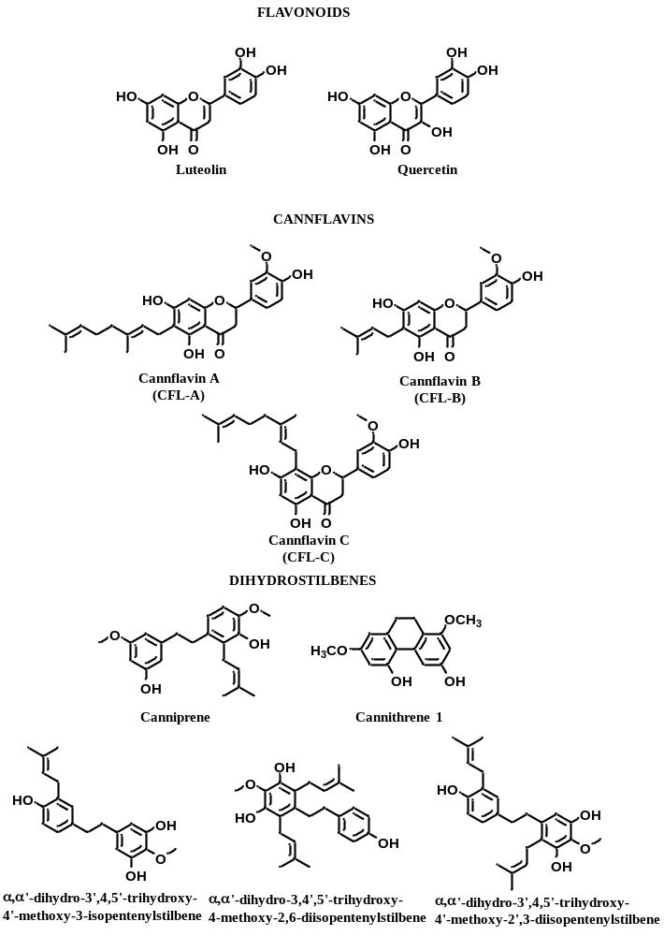
Figure 3. Polyphenols in Cannabis sativa
Among the polyphenolic metabolites found in C. sativa a group of peculiar phenolic amides named phenylproprionamides also known as cannabisins are worth of mention (Figure 4). Until now about 20 cannabisins have been isolated from hempseed. The exact origin of these compounds is not totally clear, most likely they come out from a coupling reaction between hydroxycinnamic acid amids (HCAAs) and rare phenolic amides [36-39]. Biological tests carried out on these particular compounds have revealed their potential as antioxidant and acetylcholinesterase inhibitors, suggesting their suitability in the treatment of Alzheimer disease [40].
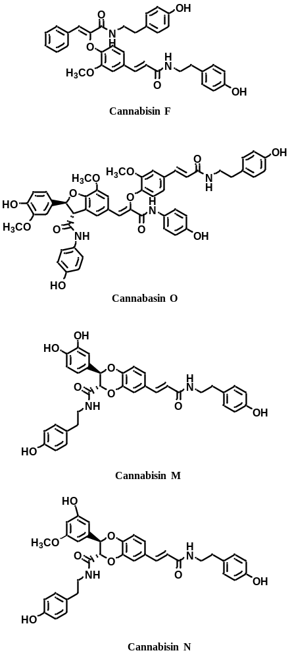
Figure 4. Cannabisins from Cannabis sativa

2.4. Alkaloids
Alkaloids are another important class of secondary metabolites identified in C. sativa and isolated from its leaves, stems, pollen, roots and seeds. Cannabisativine, anydrocannabisativine and the indole alkaloid dihydroxyisoechilunilina (Figure 5) are just a representative example [4,41].

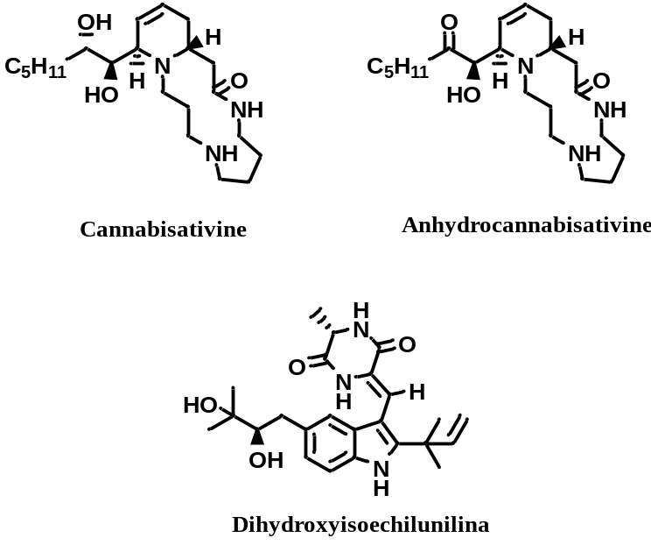
Figure 5. Alkaloids from Cannabis sativa.

3. Alternative Cannabis matrices

3.1. Cannabis roots
As mentioned above C. sativa is a plant with a very ancient tradition from which it is possible to achieve a lot of products useful in many sectors of human daily life, and in the previous chapter we have shown, even if in a not exhaustive way, some of the most interesting phytochemical components. However, to have a more complete picture of this plant it is necessary to take into account other parts of the plant, which have received scarce interest, such as roots, seeds, seed hulls.
In the phytotherapeutic sector the interest for this plant has been devoted to inflorescence and leaves, where the most important bioactive components cannabidiol (CBD) and Δ⁹-tetrahydrocannabinol (THC) are mainly concentrated The roots have been partially neglected, and have not received the same attention as the aerial parts, even if the canapa roots have been used to fight fever, inflammation, infections and arthritis [42,43]. Phytochemical analyses of roots did not show the presence of cannabinoids if not in traces, whilst the most important components of this matrix resulted in a series of triterpenoids subdivided between triterpenes and phytosterols, some of which are reported in Figure 6 [1]. The presence of triterpenoidic compounds in the root of C. sativa has been recently confirmed by Ferrini et al.[44] who suggests to apply the aeroponic cultivation since this procedure would facilitate all the agronomic processes by being easy, standardizable and favoring the growth of the root system of the plant if compared with the conventional soil-cultivated ones.
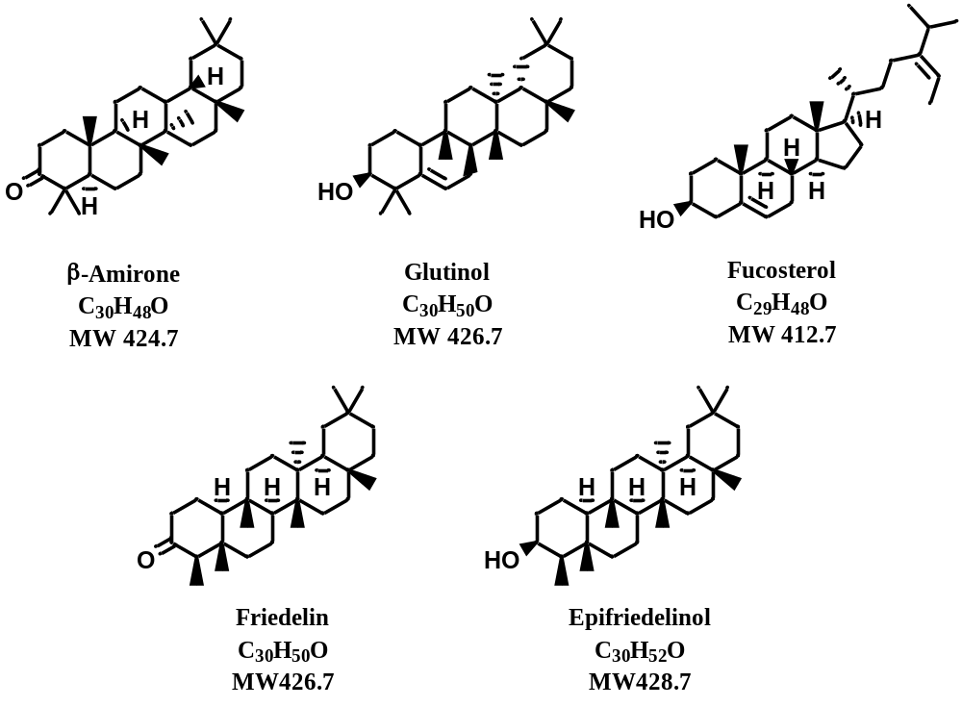
Figure 6. Triterpenoids from Cannabis sativa.
A further and recent phytochemical study on the canapa roots has been carried out by Oh et al. [45], who have worked out a sample of hemp cultivated in Korea. Briefly, the roots after water washing and air drying and analyzed by HPLC-DAD, which allowed establishing the presence and the amount of p-coumaric acid and ethyl-p-coumarate as the main constituents of the root extracts (Figure 7). By this finding the authors suggested to consider an industrial exploitation of the hemp roots of C. sativa as the main source of p-coumaric acid derivatives in consideration of the broad biological activities.

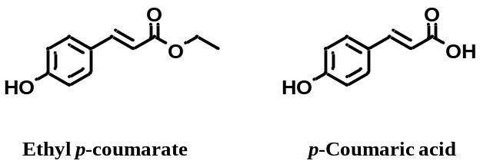
Figure 7. p-Coumaric acid and its ethyl ester in the roots of Cannabis sativa.
A very recent study aimed to determine the antibacterial activities of the extracts from inflorescences and roots of C. sativa has been carried out by an Argentinian research group [46]. The content of total phenolic compounds, total flavonoids and total saponins has been determined by applying previous methodologies [47-50].
The antibacterial activities was measured by the MIC methodology against Paenibacillus larvae, Staphilococcus aureus and Esherichia coli, the activities recorded even if not very significant were associated with the high content of triterpenoids and saponins.
Many research groups consider the cannabinoids absent or at trace levels in the root of C. sativa. However, this consideration has been recently denied [50]. Furthermore, more recently a Brazilian research group reported the presence of a new cannabinoid called Δ⁹-tetrahydrocannabutol (known also as tetrahydrocannabinol-C4 – THC-C4), that is structurally is very similar to the main cannabinoid Δ⁹-THC, being the sole difference a butyl side chain instead of a pentyl side chain. Further, four nitrogenous compounds have been characterized and all are reported in Figure 8 [51].
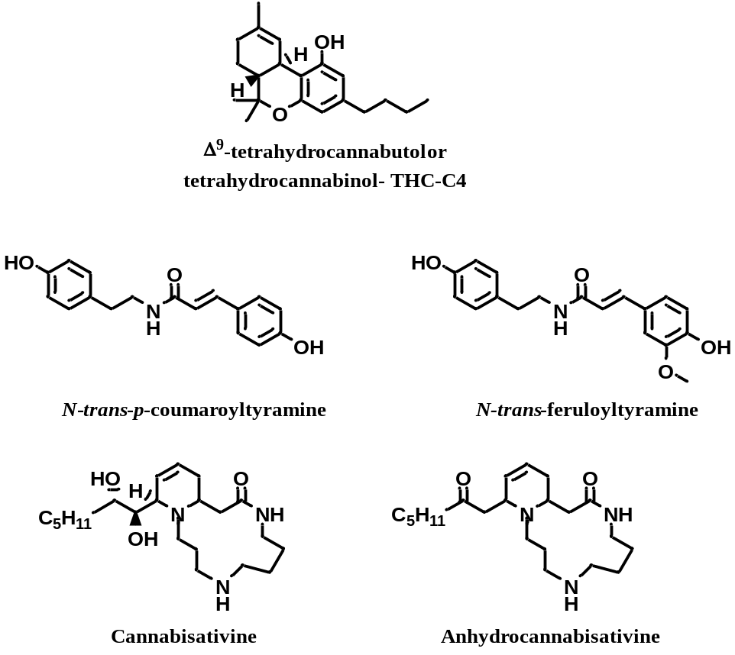
Figure 8. Δ⁹-tetrahydrocannabutol and four nitrogenous compounds isolated from roots of C. sativa.

3.2. Cannabis seeds and seedhulls
Three different types of oil can be obtained from C. sativa:
a) vegetable oil, obtained by extraction of seeds and constituted mainly by triglycerides, suitable for human consumption owing to a good balance of ω-6 and ω-3 of essential fatty acids (EFAs);
b) essential oil from inflorescences and flowers, obtained by hydrodistillation and steam distillation;
c) the so called ‘hashish oil’ , normally obtained by solvent extraction of plants [1].

With the aim to exploit each fraction coming from the work out of hemp Cannabis sativa also seed hulls from C. sativa have been investigated for the content of polar. Using chloroform as extracting solvent and HPLC/MS as analytical tool nine diacylglycerols (DAGs), six lysophatidylcholine (LPCs), five lysophosphatidylethanolamines (LPEs), eight phosphatidylethanolamine (Pes), and thirteen phosphatidylethanolamines (PCs) have been recovered from this matrixs [52]. This new compositional data add another input to the use of this ancient plant.
Fibers represent a considerable portion (>77%) of C. sativa L. and therefore the main component usable for further industrial processes. Recently, an Australian group has shown a large increase in fiber solubility by applying the so called “extrusion technology”; the authors observed also an enhancement of the binding capacity of water and oil, delayed starch gelatinization and inhibition of the retro-degradation. The supplementation of this material to the animal feed showed positive effect on animal microbiota [53].
A research team from different countries carried out a study on eight varieties of whole hemp seeds, and on eight commercial samples of dehulled hemp seeds, with the aim to determine their chemical composition and biological properties [54]. The compounds analyzed were soluble sugar and phenolic compounds, the antioxidant, cytotoxic, and antimicrobial activities were the tested biological properties. Whole seeds and dehulled seeds showed similar soluble sugars profile containing fructose, glucose, sucrose and raffinose and sugars were the main components in both samples. Concerning the phenolic compounds the two studied matrices showed also in this case similar profiles, being the ferulic acid-hexoside and syringic acid the main components. The biological activities were interesting and the authors concluded that hemp seed have an optimal potential as functional food.
Considering that edible seeds are today largely present in human and animal diets an Indian group has recently focused its attention on the nutritional and pro-health properties of the five most popular edible seeds: Chia (Salvia hispanica L.), Hemp (Cannabis sativa L.), Pumpkin (Cucurbita), Sunflower (Helianthus annus) and Safflower (Carthamus tinctoria) [55,56]. Concerning hemp the authors report that 100 g of seeds contain 553 kcal of energy and possesses digestible proteins, polyunsaturated fatty acids (PUFA), lipids and carbohydrate. The omega-6 compounds in the total content of fatty acids ranges from 64 to 72 %. Oil from C. sativa seeds shows traces of cannabidiol, β-sitosterol, and terpenes together with the tocopherol molecular group including α−, γ−, β−, and δ−tocopherol. The presence of the three main nutrients, namely healthy fat, protein, and fiber provide to the seeds a big opportunity of success, which is also supported by a significant diffusion of vegan/vegetarian diets among the people. Always under the nutritional point of view of C. sativa seed oil it is important to underline that the seeds are particularly rich in omega-3 and stearidonic acids [57]

3.3. Cannabis leaves as functional foods
Roots stems and leaves from C.sativa have been recently investigated for their content in tryptophan (TRP) and its metabolic products: kyurenine (KYN) and kynurenic acid (KYNA), which have biological properties. Since these compounds are present in higher quantity in the leaves of C. sativa, this matrix is proposed as alternative source for these substances in the field of functional foods [58].
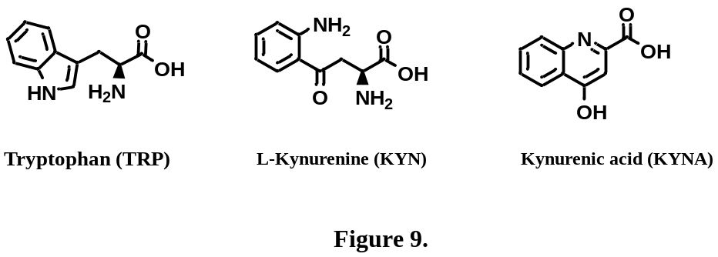
Figure 9. Tryptophan, kynurenine and kynurenic acid from leaves, stem and roots of Cannabis sativa.

4. Cultivation techniques especially effective on Cannabis sativa – recent updates.

4.1. The state of the art
As previously stated, secondary metabolites in C. sativa (mainly cannabinoids, terpenoids, and polyphenols) are produced in all aerial parts of the plants, particularly in the leaves and female inflorescences; their production, such as that of all species belonging to the vegetable kingdom, is related to genetic, environmental and agronomic factors (plant chemotype, growth conditions and phenological stage of harvested) [59]. This high variability of growth conditions inevitably leads to a broad variability in the content of the plant’s secondary metabolites, which represents the main problem for the use of cannabis for medical purposes. To overcome this intrinsic problem, several strategies have been developed, such as asexual propagation of selected varieties and high technological indoor cultivation [60-62]. Asexual reproduction of Cannabis requires only a single plant, then allowing the multiplication of a single genotype for commercial production of individuals meet the desirable pharmaceutical traits [63]. Since indoor cultivation in controlled conditions of high technological greenhouses carries significantly high manufacturing costs, the attention is directed towards biomass production and the content of bioactive substances in order to compensate for the expenses [64]. Another approach, being somehow opposed to the latest, is to improve and control the secondary metabolism of plant in open field through the use of selected new generation fertilizers or by controlling plant and soil microbiota. These strategies will be discussed in detail in this paragraph. It is worth mentioning that, in order to produce medically relevant Cannabis varieties having elevated concentrations of specific molecules, the agronomic techniques can be replaced (or associated) with molecular approaches such as the sequencing of the Cannabis genome, and the manipulation of the Cannabis plant itself for the altered production of specific compounds [65].

4.2. Soil less growing technologies applied to cannabis: hydroponic, aquaponic, and aeroponic cultivation – recent updates
Because of the aforementioned issues associated with the high intrinsic variability in C. sativa secondary metabolism, the majority of medical research involving the cultivation of this species occurs in controlled environments (hi-tech greenhouses and indoor facilities) making use of soilless cultivation systems such as hydroponics, aquaponics and aeroponics. Hydroponics are well-known systems in which plant roots are partially and/or totally immersed in a nutrient solution; irrigation methods in hydroponics include: drip irrigation (a nutrient solution is fed into an inert growing medium merely used as physical support for the root system), deep water culture (the plant root system is completely submerged in the nutrient solution and the plants are supported by a membrane system that blocks the immersion of the aerial parts), nutrient film technique (only a bottom portion of the root system is immersed in a flowing nutrient solution whilst the upper roots are exposed to the air), and flood and drain, in which plant roots are immersed in a nutrient solution for a period of time, subsequently drained and collected into a reservoir to aerate the root bed [66]. One soilless cultivation system having recently raised scientific and commercial interest due to its circular approach and reduced environmental impact is aquaponics [67]. Aquaponics uses fish effluent and naturally occurring bacteria to fertilize plants in a circular ecosystem that produces fish and plant materials at the same time; with this approach, the utilization of fertilizers and pesticides is highly reduced, gaining an overall ecofriendly system. The comparable yields found in aquaponic cultivation when compared to conventional systems can be attributed to a plethora of diverse plant growth-promoting microorganisms that can improve nutrient-use efficiency.
The third soilless approach useful for C. sativa indoor cultivation is aeroponics, in which the plant is entirely exposed to the air and the nutrient mixtures are nebulized to plant root systems in the form of droplets, tipically of 10–100 µm diameter. The most commonly used aerosol generation technology is aeroponics is high pressure atomization, where high pressure liquids are forced through a small orifice, breaking the liquid stream into droplets [68].

4.3. LED lighting techniques
In the so-called “ecological pyramid”, plants are classified as the sole producer organisms, lying just in the pyramid basement. In fact, the members of the vegetable kingdom are able to synthetize glucose, the molecule at the center of all metabolic charts, starting from carbon dioxide and water and using solar light as catalysts. Is therefore self-evident that a tight relationship exists between plants and light: plant morphology, metabolism, growth and development are strongly influenced by circadian cycles and can be artificially manipulated by the quality and duration of light [69-71]. In the indoor cultivation scenario, the use of artificial lights, particularly that of light-emitting diode (LED) technology for plant cultivation can result in significant reductions in energy consumption and in the achievement of desirable yields and phytochemical traits. In fact, it has been demonstrated that different light wavelengths have effects on different physiological features of the plant such as pigmentation, secondary metabolites production, chloroplast development, photosynthetic activity, and plant biomass accumulation just to cite a few [72,73]. In C. sativa, due to the already mentioned complexity of its secondary metabolism, light quality and quantity have a significant effect on the biologically active components; as example, UV-B radiation (280–315 nm) did not impact cannabinoid content in cannabis plants with the exception of Δ⁹-THC whilst UV-A radiation (315–380 nm) from full-spectrum LED arrays induced an increase of several compounds including CBD, CBG, Δ⁹-THC and tetrahydrocannabivarin (THCV) [74]. Recently, Moher et al demonstrated that not only the choice of light radiation but also light intensity can induce modifications in C. sativa plants morphology and growing process [75]. The authors did not mention the effects of the parameters they applied on secondary metabolic profiles of cannabis plants, which can surely be a further step in knowledge in this field.

4.4. Cannabis symbiotic microorganisms: a yet unexplored scenario
In the last decade the study of the microbial communities associated with higher living organisms, the so called “beneficial microbes”, has gained an exponential interest due to its significant effects on human health. The composition and content of microbial species hosted in several human body districts, particularly those residing in the gut, have been intensively studied by a plethora of multidisciplinary approaches. In spite of the innumerable works in literature dealing with human microbiota, those focused on the microbiota of agricultural plants are relatively few. This is indeed due to the high number of plant species involved and to the fact that plant microbial communities are heavily affected by a number of factors, such as developmental stages, root exudation, soil type, and environmental conditions. Although not the focus of this work, the approaches involving the manipulation of C. sativa microbiota are definitely worth to mention. For an extensive review of this specific topic, see the recent paper of Taghinasab & Jabaji [76].
C. sativa, owing a rich and variegate secondary metabolic pool, constitutes a perfect model to explore plant–microbiome interactions and to assess how these endophytes can modulate its production of secondary metabolites. In fact, among the list of abiotic and biotic elicitors for the growth, mass yield and metabolic performance of this plant, endophytes started to have a prominent role. Pagnani et al. reported that a mixture of four bacterial species applied to the roots of cannabis seedlings in vitro efficiently colonized the entire root system of the plant, favoring plant growth and development in greenhouses as well as plant secondary metabolites accumulation. Particularly two of the main cannabinoids from cannabis, CBD and THC, were significantly improved by endophytic treatment [77]. Nowadays, even though basic information on cannabis endophytes diversity and composition is published, the majority of the works deal with the isolation and identification of microbes rather than their modulating effects on its secondary metabolic pool. Therefore, a systematic study on this topic is desiderable.

5. Brain-related effect of Cannabis use: risks and beneficial impact in users and patients
The legalization of cannabis in many countries, as well as the decrease in perceived risks by the users, have contributed to the increase in recreationally consumption. However, despite the widespread use and misuse of cannabis, little is still known about its putative harmful cognitive and neurobiological effects, possibly associated with psychoactive risks of a “drug of abuse” [78-80]. To disentangle divergent results about risk factors for users from therapeutic benefits for patients, this section summarizes studies searched in MEDLINE, and published in English between 2018 and March 2023. To the current stage of our knowledge is emerging that no formal study has shown cognitive impairment in medical cannabis patients. Meta-analysis of the data from non-medical Cannabis users among teenagers and young adults reveal non-statistical salience after 72 hours abstinence and no evident permanent sequelae [81]. From the biological point of view, ∆⁹-tetrahydrocannabinol (THC) is the major euphoric component of the C. sativa [82,83] followed by minor euphoric cannabinoids such as cannabinol (CBN), and cannabinodiol, while cannabidiol, cannabigerol (CBG), cannabichromene (CBC), cannabidivarin (CBDV) and ∆⁹-tetrahydrocannabivarin (THCV) are non-euphoric compounds. Today, over a hundred of cannabinoids have been isolated from C. sativa. The term ‘cannabinoids’ refers to the oxygen-containing C21 aromatic hydrocarbon compounds naturally occurring in the cannabis plant, however the term “phytocannabinoids” is also used to distinguish them from the synthetic compounds that mimic chemical structure and function than the botanical one [84]. Despite the larg part of the dichotomy between risk and beneficial side of cannabis is attributable to variability in the cannabinoids composition within the plant itself, only THC administration (and to a lesser degree cannabinol) in mice produces similar effects to those of marijuana in humans such as catalepsy, analgesia, hypolocomotion and hypothermia [85]. Consequently, THC is considered as the major psychotropic component of recreational cannabis preparations. On the contrary, there is no evidence that THC mediates the medicinal effects of cannabis whereas CBD is recognized as the most relevant cannabinoid with therapeutic potential in several disorders.
The empirical use of the cannabis plant has been practiced in many cultures for millennia to alleviate pain, migraine and inflammatory state. The medical and therapeutic application of cannabis began to be well understood from the 1960s, when the structure and functional expression of the first G protein coupled receptor of cannabinoids, named CB1, were characterized in the brain tissue [86-89], followed by the GPCR cannabinoid receptor 2 (CB2) which was later identified by homology cloning in the cells of the immune system [90]. These discoveries led, in turn to identification of endogenous CB1 and CB2 ligands that are the lipids 2-arachidonoylglycerol (2-AG) and anandamide (the ethanolamide of arachidonic acid) and named “endocannabinoids” [91,92]. The enzymes involved in their biosynthesis were later identified as N-acylphosphatidylethanolamine (NAPE)-specific phospholipase D-like hydrolase (NAPE-PLD) catalysing the synthesis of anandamide, and other N-acylethanolamines, and Diacylglycerol lipase α (DAGLα) and DAGLβ which catalyse the biosynthesis of 2-AG and other monoacylglycerols. The enzymes involved in the endocannabinoid inactivation were identified as fatty acid amide hydrolase (FAAH), catalysing the hydrolysis of anandamide (and other N-acylethanolamines and fatty acid primary amides) and monoacylglycerol lipase (MAGL) which catalyses the hydrolysis of 2-AG (and that of other monoacylglycerols) [93]. Altogether, the complex of cannabinoid endogenous signals, receptors and metabolic enzymes is known as the “endocannabinoid system”. This system is complicated by the overlap with other pathways and alternative metabolic processes merging in an expanded endocannabinoid system named “endocannabinoidome”. Starting from the common cannabinoid signal pathway through CB1 and CB2 which are expressed in brain regions involved in the neural processing of reward, habit formation, and cognition, the physiological effects of cannabinoids in the nervous system are exerted through various receptors, such adrenergic receptors, peroxisome proliferator-activated receptor-gamma, 5-HT_{1A} and the recently discovered GPCRs (GPR₅₅, GPR₃ and GPR₅) [94]. The medical use of CBD has demonstrated safety, efficacy and consistency sufficient for regulatory approval in spasticity in multiple sclerosis (MS), and in Dravet and Lennox-Gastaut Syndromes (LGS) whereas for other pathologies the therapy approach is in Phase II–III or under observational studies (see Table 4).

Table 4. Neurological disfunctions for which cannabis-based treatments have been employed (revised, and
supplemented from Cristino et al. [86].
Code | Name | Formula
Epilepsy  (Lennox-Gastaut  and Dravet syndromes) | Cannabidiol (Epidiolex®) | Phase III,  Regulatory approval
Chronic pain | THC, nabiximols | Phase II RCTs
Schizophrenia, | CBD | Phase II
Sleep disturbance | THC, nabilone, nabiximols | Phase II–III
Tourette syndrome | THC, cannabis | Phase II,  observational studies
Parkinson disease symptoms | THC, CBD, cannabis | Observational studies
Post-traumatic stress disorder | Cannabis | Observational studies
Dementia with agitation | THC, cannabis | Observational studies
Social anxiety | CBD | Phase II,  observational studies

Further promising therapeutic approaches come from recent discoveries regarding the efficacy of cannabis-based preparations against intractable epilepsy, brain tumors, Parkinson disease (PD), Alzheimer disease (AD) and traumatic brain injury (TBI)/chronic traumatic encephalopathy (CTE). Indeed, extensive observations of seizures in Dravet and Lennox-Gastaut Syndrome (LGS) patients indicate a good therapeutic successes with lower doses of CBD then in Epidiolex® when utilized in cannabis-based preparations with small concomitant amounts of THC, THCA and linalool, a terpenoid component of cannabis [71,95,96]. In this regard, selective cannabis breeding via Mendelian techniques raises new therapeutical possibility of producing chemovars with multiple anticonvulsant components that may offer synergistic benefits [97]. Phytocannabinoids offer cytotoxic benefit with effect on brain tumors that have been considered concerning synergistic benefits of combinations of THC, CBD and standard chemotherapy with temozolomide on glioma [98]. More recently, cannabis preparation with an equal THC and CBD content combining THCA, and even CBDA along with cytotoxic terpenoids such as limonene, has been considered potentially useful in cancer treatment [73]. Concerning AD patients, an extract of a Type II chemovar of cannabis (THC/CBD) with a sufficient pinene fraction would seem to be an excellent candidate for clinical trials providing multiple benefits on target symptoms like agitation (THC, CBD, linalool), anxiety (CBD, THC - low dose -, linalool), psychosis (CBD), insomnia/restlessness (THC, linalool), anorexia (THC), aggression (THC, CBD, linalool), depression (THC, limonene, CBD), pain (THC, CBD), memory (α-pinene, THC), neuroprotection (CBD, THC). Finally, chemovar of Cannabis combining THC and CBD, have been extremely helpful in treatment of dementia pugilistica, or “punch-drunk syndrome, Traumatic Brain Injury (TBI) and Chronic Traumatic Encephalopathy (CTE) by alleviating symptoms such as headache, nausea, insomnia, dizziness, agitation, substance abuse, and psychotic symptoms [99-100].
In recent times, special attention has been reserved to the use of cannabis by pregnant women, young mothers and teens. Since in the prenatal/perinatal and adolescent periods the endogenous cannabinoid system plays important role in the neurodevelopmental processes, the consequence of cannabis abuse could be mainly attributable to epigenetic reprogramming that could maintain the long-term impact into adulthood and across generations [101]. These negative outcomes can be amplified by individual genetic predispositions ultimately precipitating or worsening in mental [102]. Neuroimaging studies have shown that high CBD doses induces significant alterations in brain activity and connectivity patterns during resting state and performance of cognitive tasks in both healthy volunteers and patients with a psychiatric disorder [103]. Despite larger studies are essential to reconcile divergent results in to assessing potential moderators of cannabis effects on the developing brain, preliminary neuroimaging evidence provide functional and structural alterations in frontoparietal, frontolimbic, frontostriatal, and cerebellar regions among adolescent cannabis users [104]. In recent times, almost 200 million people use cannabis yearly worldwide for recreational or therapeutic purposes. However, the potential neuropsychiatric effects still need to be better understand, expecially concerning possible induction of psychosis by cannabis consumption. In this regards meta-analysis of data reviewed by Hindley et al. [105], has examined the effect of THC, alone and in combination with cannabidiol (CBD) compared with placebo, on psychiatric symptoms in healthy people. They found that a single THC administration induces psychotic, negative, and other psychiatric symptoms while no evidence supported that CBD induces symptoms or counteracts the effects of THC. Furthermore, cross-sectional studies of adolescents and young adults report an association between cannabis use and cognitive dysfunction that may reflect residual effects from acute use or withdrawal of cannabis [72].

6. Conclusions

In the time period considered by this review (2018-2023) a considerable interest in C. sativa has grown exponentially, as documented by the more than 3,000 articles published on this species just in 2021.
The topics covered in this work – phytochemistry, cultivation techniques and brain-related effects of cannabis - are only apparently unrelated to each other, since a leading thread exists and it is the highly variegated secondary metabolism of this plant which gives rise to a not so usual chemodiversity.
In particular, the phytochemical studies carried out on cannabis allowed establising the toxicity aspects normally connected to an abuse of this plant (see TCH), and at the same time how for example CBD is recognized as the most relevant cannabinoid with therapeutic potential in several disorders.
The interest towards the phytochemical composition of cannabis is not only due to the possibility to use many of its phytochemicals in the medical sectors, but also to the industrial interest towards the same products. Many industrial applications of cannabis could not exist without the development of suitable and high performance cultivation techniques. However, notwistanding the large number of studies carried out in the phytochemical sectors, an exhaustive and complete characterization of cannabis extracts has not yet been reached, therefore new extraction procedures, as well as novel and more sophisticated characterization methodologies still have to be applied.
In any case, cannabis phytochemistry, as well as agronomical and biotechnological techniques applied to its cultivation have benefited from this growing interest and from the trend observed in these years appears that the discovery of new specialized metabolites seems inevitable. In particular, as pointed out in this review, in the medical sector many new discoveries on the role of the metabolism of cannabis and how it interacts with human central nervous system appear close to their discovery.

Aknowledgements. The authors sincerely thank Dr. Vincenzo Di Marzo (ICB-CNR, Italy and Université Laval, Québec City, Canada) for critically reviewing the manuscript.

References
- Martinez, A.S., Lanaridi, O.; Stagel, K.; Halbwirth, H.; Schnűrch, M.; Bica Schröder, K. Extraction techniques for bioactive compounds of cannabis. Nat. Prod. Rep. 2023, 40, 676-717,, doi: 10.1039/d2np00059h.
- Hanuš, L.O.; Meyer, S.M.; Muñoz, E.; Taglialatela- Scafati, O.; Appendino, G. A unified critical inventory. Nat. Prod. Rep. 2016, 33, 1357-1392.
- ElSohly, M.A.; Radwan, M.M.; Gul, W.; Chandra, S.; Galal, A. Phytochemistry of Cannabis sativa L. In Kinghorn, A.D.; Falk, H.; Gibbons, S.; Kobayashi, J. (eds), Phytocannabinoids, Progr. Chem. Org. Nat. Prod. 2017, 103, 1-36.
- Pisanti, S.; Bifulco, M. Medical Cannabis: a plurimillennial history of an evergreen. J. Cell. Physiol. 2019, 234, 8342-8351.
- Kanabus, J.; Bryla, M.; Roszko, M.; Modrzewska, M.; Pierzgalski, A. Cannabinoids – Characteristics and potential for use in food production. Molecules 2021, 26, 6723.
- Mattoteia, D. Novel chemistry of biological relevance. Università degli Studi Piemonte Orientale “Amedeo Avogadro”, Department of Pharmaceutical Sciences, Ph.D. in Chemistry & Biology, XXXIII cycle 2017-2020. Dissertation Ph.D. thesis, 2021.
- Gonҫalves, E.C.D.; Baldasso, G.M.; Bicca, M.A.; Paes, R.S.; Capasso, R.; Dutra, R.C. Terpenoids, cannabimetic ligands, beyond the Cannabis plant. Molecules 2020, 25, 1567.
- Karke, T.; Singh, M.R. The application of hemp (Cannabis sativa L.) for a green economy: a review. Turkish J. Bot. 2019, 43, 710-723.
- Hesami, M.; Pepe, M.; Baiton, A.; Salami, S.A.; Jones, A.M.P. New insight into ornamental applications of cannabis: perspective and challenges. Plants 2022, 11, 2383.
- Krüger, M.; van Eeden, T.; Beswa, D. Cannabis sativa cannabinoids as functional ingredients in snack foods – Historical and developmental aspects. Plants 2022, 11, 3330.
- Hesami, M.; Pepe, M.; Baiton, A.; Salami, S.A.; Jones, A.M.P. Current status and future prospects in cannabinoid production trough in vitro culture and synthetic biology. Biotech. Adv. 2023, 62, 108074.
- Kovalchuk, I.; Pellino, M.; Rigault, P.; van Velzen, R.; Ebersbach, J.; Ashnest, J.R.; Mau, M.; Schranz, M.E.; Alcorn, J.; Laprairie, R.B.; McKay, J.K.; Burbridge, C.; Schneider, D.; Vergara, D.; Kane, N.C.; Sharbel T.F. The genomics of Cannabis and its close relatives. Annual Rev. Plants Biol. 2020, 71, 713-739.
- Hesami, M.; Pepe, M.; Alizadeh, M.; Rakei, A.; Baiton, A.; Jones, A.M.P. Recent advances in cannabis biotechnology. Ind. Crops Prod. 2020, 158, 113026.
- Nava, V.; Albergamo, A.; Bartolomeo, G.; Rando, R.; Litrenta, F.; Lo Vecchio, G.; Giorgianni, M.C.; Cicero, N. Monitoring Cannabinoids and the Safety of the Trace Element Profile of Light Cannabis sativa L. from Different Varieties and Geographical Origin. Toxics 2022, 10, 758. https://doi.org/10.3390/toxics10120758
- Amendola, G.; Bocca, B.; Picardo, V.; Pelosi, P.; Battistini, B.; Ruggieri, F.; Barbini, D.A.; De Vita, D.; Madia, V.N.; Messore, A.; et al. Toxicological aspects of cannabinoid, pesticide and metal levels detected in light Cannabis inflorescences grown in Italy. Food Chem. Toxicol. 2021, 156, 112447
- Bengyella, L.; Kuddus, M.; Mukherjee, P.; Fonmboh, D.J.; Kaminski, J.E. Global impact of trace non-essential heavy metal contaminants in industrial cannabis bioeconomy. Toxin Rev. 2021, 41, 1215–1225
- Liu, Y.; Liu, H.-Y.; Li, S.-H.; Ma, W.; Wu, D.-T.; Li, H.-B.; Xiao, A.-P.; Liu, L.-L.; Zhu, F.; Gan, R.-Y. Cannabis sativa bioactive compounds and their extraction, separation, purifications, and identification technologies: an updated review. Trends Anal. Chem. 2022, 149, 116554.
- Stefkov, G.; Karanfilova, I.C.; Gjorgievska, V.S.; Trajkovska, A.; Geskovski, N.; Karapandzova, M.; Kulevanova, S. Analytical techniques for phytocannabinoid profiling of cannabis and cannabis-based products – A comprehensive review. Molecules 2022, 27, 975.
- De Vita, S.; Finamore, C.; Chini, M.G.; Saviano, G.; De Felice, V.; De Martino, S.; Lauro, G.; Casapullo, A.; Fantasma, F.; Trombetta, F.; Bifulco, G.; Iorizzi, M. Phytochemical analysis of the methanolic extract and essential oil from leaves of industrial hemp Futura 75 cultivar: isolation of a new cannabinoid derivative and biological profile using computational approaches. Plants 2022, 11, 1671.
- Lelario, F.; Pascale, R.; Bianco, G.; Scrano, L.; Bufo, S.A. Hemp chemotype definition by cannabinoids characterization using LC-ESI(+)-LTQ-FTICR MS and infrared multiphoton dissociation. Separation 2021, 8, 245.
- Sommano, S.R.; Chittasupho, C.; Ruksiriwanich, W.; Jantrawut, P. The Cannabis terpenes. Molecules 2020, 25, 5792.
- Calvi, M.; Bontempo, L.; Pizzini S.; Cucinotta, L.; Camin, F.; Stenni, B. Isotopic characterization of Italian industrial hemp (Cannabis sativa L.) intended for food use: a first exploratory study. Separations 2022, 9, 136.
- Mandrioli, M.; Tura, M.; Scotti, S.; Gallina Toschi, T. Fast detection of 10 cannabinoids by RP-HPLC-UV method in Cannabis sativa L. Molecules 2019, 24, 2113.
- Hanuš, L.O.; Hod, Y. Terpene/terpenoids in cannabis are they important? Medical cannabis and cannabinoids, 2020, 3(1), 25-60.
- Andre, C.M.; Hausman, J.-F.; Guerriero, G. Cannabis sativa: the plant of the thousand and one molecules. Front. Plant Sci. 2016, 7, 19.
- Wiles, D.; Shanbhag, B.K.; O’Brien, M.; Doblin, M.S.; Bacic, A.; Beddoe, T. Heterologous production of Cannabis sativa-derived specialized metabolites of medicinal significance – insight into engineering strategies. Phytochemistry 2022, 203, 113380.
- Citti, C., Linciano, P.; Russo, F.; Luongo, L.; Iannotta, M.; Maione, S.; Laganà, A., Capriotti, A.L.; Forni, F.; Vandelli, M.A.; Gigli, G.; Cannazza, G. A novel phytocannabinoid isolated from Cannabis sativa L. with an in vivo cannabimimetic activity higher than Δ⁹-tetrahydrocannabinol: Δ⁹-Tetrahydrocannabiphorol. Scientific Reports 2019, 9, 20335
- Schafrot, M.A.; Mazzoccanti, G., Reynoso-Moreno, I.; Erni, R.; Pollastro, F.; Caprioglio, D.; Botta, B.; Allegrone, G.; Grassi, G.; Chicca, A.; Gasparrini, F.; Gertsch, J.; Carreira, E.M.; Appendino, G. Δ⁹-cis-Tetrahydrocannabinol: natural occurrence, chirality, and pharmacology. J. Nat. Prod. 2021, 84, 2502-2510.
- Chianese, G.; Lopatriello, A.; Schiano-Moriello, A.; Caprioglio, D.; Mattoteia, D.; Benetti, E.; Ciceri, D.; Arnoldi, L.; De Combarieu, E.; Vitale, R. M.; Amodeo, P.; Appendino, G.; De Petrocellis, L.; Taglialatela-Scafati, O. Cannabitwinol, a dimeric phytocannabinoid from hemp, Cannabis sativa L., is a selective thermo-TRP modulator.J. Nat. Prod. 2020, 83, 2727−2736.
- De Vita, S.; Finamore, C.; Chini, M.G.; Saviano, G.; De Felice, V.; De Marino, S.; Lauro, G.; Casapullo, A.; Fantasma, F.; Trombetta, F. Phytochemicals analysis of the methanolic extract and essential oil from leaves of industrial hemp Futura 75 cultivar: isolation of a new cannabinoid derivative and biological profile using computational approaches. Plants 2022, 11(13), 1671.
- Vuerich, M.; Ferfuia, C.; Zuliani, F.; Piani, B.; Sepulcri, A.; Baldini, M. Yield and quality of essential oils in hemp varieties in different environments. Agronomy 2019, 9, 356.
- Bakro, F.; Jedryczka, M.; Wielgusz, K., Sgorbini, B.; Inchingolo, R.; Cardenia, V. Simultaneous determination of terpenes and cannabidiol in hemp (Cannabis sativa L.) by fast chromatography with flame ionization detection. J. Sep. Sci. 2020, 43, 2817-2826.
- Fiorini, D.; Scortichini, S.; Bonacucina, G.; Greco, N.G.; Mazzara, E.; Petrelli, R.; Torresi, J.; Maggi, F.; Cespi, M. Cannabidiol-enriched hemp essential oil obtained by an optimized microwave-assisted extraction using a central composite design. Ind. Crops Prod. 2020, 154, 112688.
- Nagy, D.U.; Cianfaglione, K.; Maggi, F.; Sut, S.; Dall’Acqua, S. Chemical characterization of leaves, male and female flowers from spontaneous cannabis (Cannabis sativa L.) growing in Hungary. Chem Biodiversity 2019, 16, e1800562
- Bautista, J.L.; Yu, S.; Tian, L. Flavonoids in Cannabis sativa: biosynthesis, bioactivities, and biotechnology. ACS Omega 2021, 6, 5119-5123.
- Guo, T.; Liu, Q.; Hou, P.; Li, F.; Guo, S.; Song, W.; Zhang, H.; Liu, X.; Zhang, S.; Zhang, J.; Ho, C.-T.; Bai, N. Stilbenoids and cannabinoids from the leaves of Cannabis sativa f. sativa with potential reverse cholesterol transport activity. Food Funct. 2018, 9, 6608-6617.
- Leonard, W.; Xiong, Y.; Zhang, P,; Ying, D.; Fang, Z. Enhanced lignanamide absorption and antioxidative effect of extrude hempseed (Cannabis sativa L.) in caco-2 intestinal cell culture. J. Agric. Food Chem. 2021, 69, 11259-11271.
- Wang, S.; Luo, Q.; Fan, P. Cannabisin F from hemp (Cannabis sativa) seed suppresses lipolysaccharide-induced inflammatory responses in BV2 microglia as SIRT1 modulator. Int. J. Mol. Sci. 2019, 20, 507.
- Sakakibara, I.; Katsuhara, T.; Ikeya, Y.; Hayashi, K.; Mitsuhashi, H. Cannabisin A, an arylnaphthalene lignanamide from fruits of Cannabis sativa. Phytochemistry 1991, 30(9), 3013-3016.
- Yana, X.; Tang, J., dos Santos Possos, C.; Nurisso, A.; Simões-Pires, C.A.; Ji, M., Lou, H.; Fan, P. Characterization of lignanamides from hemp (Cannabis sativa L.) seed and their antioxidant and acetylcholinesterase inhibitory activities. J. Agric. Food Chem., 2015, 63 10611-10619.
- Yan, X.; Zhou, Y.; Tang, J.; Ji, M.; Lou, H.; Fan, P. Diketopiperazine indole alkaloids from hemp seed. Phytochem. Let. 2016, 18, 77-82.
- Kornpointner, C.; Martinez, A.S.; Marinovic, S.; Haselmair-Gosh, C.; Jamnik, P.; Schröder, K,; Löfke, C.; Halbwirth, H. Chemical composition and antioxidant potential of Cannabis sativa L. roots. Ind. Crops Prod. 2021, 165, 113422.
- Ryz, N.R.; Remillard, D.J.; Russo, E.B. Cannabis roots: a traditional therapy with future potential for treating inflammation and pain. Cannabis Cannabinoid Res. 2017 2(1), 210-216. https://doi.org/10.1089/can.2017.0028
- Ferrini, F.; Fraternale, D.; Donati Zeppa, S.; Verardo, G., Gorassini, A.; Carrabs, V.; Albertini, M.C.; Sestili, P. Yield, characterization, and possible exploitation of Cannabis sativa L. roots grown under aeroponics cultivation. Molecules 2021, 26, 4889.
- Oh, C.M.; Choi, J.Y.; Bae, I.A.; Kim, H.T.; Hong, S.S.; Noah, J.K.; Boo, Y.C. Identification of p-.coumaric acid and ethyl p-coumarate as the main phenolic components of hemp (Cannabis sativa L.) roots. Molecules 2022, 27, 2781.
- Fuentes, G.; Iglesias, A.; Orallo, D.; Fangio, F.; Ramos, F.; Mitton, G.; Fuselli, S.; Matias, S.; Ramirez, C. Antibacterial activity of cannabis (Cannabis sativa L.) female inflorescence and root extracts against Paenibacillus larvae, causal agent of American foulbrood. Biocatal. Agric. Biotechn. 2023, 47, 102575.
- Singleton, V.L.; Rossi, J.A. Colorimetry of total phenolics with phosphomolybdic phosphotungstic acid reagents. Am. J. Enol. Vitic. 1965, 16(3), 144–158.
- Woisky, R.G.; Salatino, A. Analysis of propolis: some parameters and procedures for chemical quality control. Analysis of propolis: some parameters and procedures for chemical quality control. J. Apicult. Res. 1998, 2 (37).
- Lamuela-Raventós, R.M. Folin–Ciocalteu method for the measurement of total phenolic content and antioxidant capacity. In: Measurement of Antioxidant Activity & Capacity: Recent Trends and Applications. I ed., 2018, John Wiley & Sons Ltd.
- Le, A.V.; Parks, S.E.; Nguyen, M.H.; Roach, P.D. Improving the vanillin-sulphuric acid method for quantifying total saponins. Technologies 2018, 6, 84.
- Gul, W.; Gul, S.W.; Chandra, S.; Lata, H.; Ibrahim, E.A.; ElSohly, M.A. Detection and quantification of cannabinoids in extracts of Cannabis sativa roots using LC-MS/MS. Planta Med. 2018, 84(4), 267-271.
- Menezes, P.M.N.; Pereira, E.C.V.; Lima, K.S.B.; da Silva, B.A.O.; Brito, M.C.; de Lima Araújo, T.C.; Neto, J.A.; de Araujo Ribeiro, L.A.; Silva, F.S.; Rolim, L.A. Chemical analysis by LC-MS of Cannabis sativa root samples from Northeast Brazil and evaluation of antitussive and expectorant activities. Planta Med. 2022, 88(13), 1223-1232.
- Banskota, A.H.; Jones,A.; Hui, J.P.M.; Stefanova, R.; Burton, I.W. Analysis of polar lipids in hemp (Cannabis sativa L,) by-products by ultra-high performance liquid chromatography and high resolution mass spectrometry. Molecules 2022, 27, 5856.
- Leonard, W.; Zhang, P; Ying, D.; Nie, S.; Liu, S.; Fang, Z. Post-extrusion physical properties, techno-functionality and microbiota potential of hempseed (Cannabis sativa L.). Food Hydrocol. 2022, 131, 1077836.
- Alons-Esteban, J.I.; Pinela, J.; Ćiric, A.; Calhelha, F.F.; Soković, M.; Ferreira, I.C.F.R.; Barros, L.; Torija-Isasa, E.; de Cortes Sánchez-Mata, M. Chemical composition and biological activities of whole and dehulled hemp (Cannabis sativa L.) seeds. Food Chem. 2022, 374, 131754.
- Ben Necib, R.; Manca, C.; Lacroix, S.; Martin, C.; Flamand, N.; Di Marzo, V.; Silvestri, C. Hemp seed significantly modulates the endocannabinoidome and produces beneficial metabolic effects with improved intestinal barrier function and decreased inflammation in mice under high-fat, high-sucrose diet as compared with linseed. Front. Immunol, 2022,13, doi.10.3389/fimmu.2022.882455.
- Devi, V.; Khanam, S. Study of ω-6 linoleic and ω-3 α-linoleic acids of hemp (Cannabis sativa) seed oil extrcated by supercritical CO₂ extraction: CCD optimization. J. Environ Chem. Engin. 2019, 7(1), 102818.
- Kakkar, S.; Tandon, R.; Tandon, N. The rising status of edible seeds in lifestyle related disease: A review. Food Chem. 2023, 402, 134220.
- Berstein, N.; Gorelick, J.; Koch, S. Interplay between chemistry and morphology in medical cannabis (Cannabis sativa L.). Ind. Crops Prod. 2019, 129, 185-194.
- Wiredu Addo, P.; Desaulniers Brousseau, V.; Morello, V.; MacPherson, S.; Paris M.; Lefsrud, M. Cannabis chemistry, post-harvest processing methods and secondary metabolites profiling. A review. Ind. Crops Prod. 2021, 170, 113743.
- Danzigr, N.; Bernstein, N. Plant architecture manipulation increases cannabinoid standardization in ‘drug-type’ medical cannabis. Ind. Crops prod. 2021, 167, 113528.
- Capalna, D.; Stemeroff, J.; Dixon, M.; Zheng, Y. Vegetative propagation of cannabis by stem cuttings: effects of leaf numebr, cutting porsition, rooting hormone, and leaf tip removal. Can. J. Plant Sci. 2018, 98, 5.
- Russo, F.; Tolomeo, F.; Vandelli, M.A.; Biagini, G.; Paris, R.; Fulvio, F.; Laganà, A.; Capriotti, A.L.; Carbone, L.; Gigli, G.; Citti, C. Kyurenine and kynurenic acid: two human neuromodulators found in Cannabis sativa L. J. Pharm. Biomed. Anal. 2022, 211, 114636.
- Siracusa, L.; Ruberto, G. Plant polyphenol profiles as a tool for traceability and valuable support to biodiversity. Chapter II (15-33) In Polyphenols in Plants: Isolation, Purification and Extract Preparation. 1st Edition (2014). Elsevier Books, ISBN 9780123979346.
- García-Tejero, I.F; Durán Zuazo, V.H.; Sánchez-Carnenero, C.; Hernández, A.; Ferreiro-Vera, C.; Casano, S. Seeking suitable agronomical practices for industrial hemp (Cannabis sativa L.) cultivation for biomedical applications. Ind. Crops Prod. 2019, 139, 111524
- Oultram, J.M.J.; Pegler, J.L.;Bowser, T.A.; Ney, L.J.; Eamens, A.L.; Grof, C.P.L. Cannabis sativa: Interdisciplinary strategies and avenues for medical and commercial progression outside of CBD and THC. Biomedicines 2021, 9, 234. https://doi.org/10.3390/biomedicines9030234
- Wimmerova, L.; Keken, Z.; Solcova, O.; Bartos, L.; Spacilova, M. A comparative LCA of aeroponic, hydroponic, and soil cultivations of bioactive substance producing plants. Sustainability 2022, 14, 2421. https://doi.org/10.3390/su14042421
- Yep, B.; Gale, N.V.; Zheng, Y. Comparing hydroponic and aquaponic rootzones on the growth of two drug type Cannabis sativa L. cultivars during the flowering stage. Ind. Crops Prod. 2020, 157, 112881.
- Landi, M.; Zivcak, M.; Sutar, O.; Brestic, M.; Allakhverdiev, S.I. Plasticity of photosynthetic processes and the accumulation of secondary metabolites in plants in response to monochromatic light environmnts. A review. BBA Bioenergetics 2020, 1861, 148131.
- Gil, K.E.; Park, C.-M.; Thermal adaptation and plasticity of the plant circadian clock. New Phytologist 2019, 221, 1215-1229.
- Amaducci, S.; Zatta, A.; Pelatti, F.; Venturi, G.; Influence of agronomic factors on yield and quality of hemp (Cannabis sativa L.) fibre and implocation for an innovative production system. Field Crops Res. 2008, 107, 161-169.
- Eldridge, B.M.; Manzoni, L.R.; Graham, C.A.; Rodgers, B.; Farmer, J.R.; Dodd, A.N. Getting to the roots of aeroponic indoor farming. New Phytologist 2020, 228, 1183–1192.
- Islam, M.J.; Ryu, B.R.; Azad, M.O.K.; Rahman, M.H.; Rana, M.S.; Kang, C.-W.; Lim, J.-D.; Lim, Y.-S. Comparative growth, photosynthetic pigments, and osmolytes analysis of hemp (Cannabis sativa L.) seedlings under an aeroponics system with different LED light sources. Horticulturae 2021, 7, 239. https://doi.org/10.3390/horticulturae7080239
- Namdar, D.; Charuvi, D.; Ajjampura, V.; Mazuz, M.; Ion, A.; Kamara, I.; Koltai, H. LED lighting affects the composition and biological activity of Cannabis sativa secondary metabolites. Ind. Crops Prod. 2019, 132, 177–185.
- Moher, M.; Llewellyn, D.; Jones, M.; Zheng, Y. Light intensity can be used to modify the growth and morphological characteristics of cannabis during the vegetative stage of indoor production. Ind. Crops Prod. 2022, 183, 114909.
- Taghinasab, M.; Jabaji, S. Cannabis microbiome and the role of endophytes in modulating the production of secondary metabolites: an overview. Microorganisms 2020, 8, 355; doi:10.3390/microorganisms8030355.
- Pagnani, G.; Pellegrini, M.; Galieni, A.; D’Egidio, S.; Matteucci, F.; Ricci, A.; Stagnari, F.; Sergi, M.; Lo Sterzo, C.; Pisante, M.; et al. Plant growth-promoting rhizobacteria (PGPR) in Cannabis sativa ‘Finola’ cultivation: An alternative fertilization strategy to improve plant growth and quality characteristics. Ind. Crop. Prod. 2018, 123, 75–83.
- Urits, I.; Charipova K.; Gress , K.; Li, L.; Berger, A.A.; Cornett, E.M.; Kassem, H.;, Ngo A.L.; Kaye, A.D.; Viswanath, O. Adverse Effects of Recreational and Medical Cannabis. Psychopharmacol Bull. 2021, 51, 94.
- De Faria, L.; Mezey, L.; Winkler, A. Cannabis Legalization and College Mental Health. Curr Psychiatry Rep. 2021, 23, 17.
- St Pierre, M.; Daniels, S.; Sanchez, T.A.; Holtzman, S.; Russo, E.B.; Walsh, Z.J. The Naturalistic Cannabis Administration Protocol (NCAP): A Proof-of-Concept Study. Psychoactive Drugs. 2022, 21, 1. doi: 10.1080/02791072.2022.2125466.
- Scott, J. C. et al. Association of Cannabis With Cognitive Functioning in Adolescents and Young Adults: A Systematic Review and Meta-analysis. JAMA Psychiatry . 2018, 75, 585.
- Jin, D.; Dai, K.; Xie, Z.; Chen, J. Secondary metabolites profiled in cannabis inflorescences, leaves, stem barks, and roots for medicinal purposes. Sci. Rep. 2020, 10, 1–14.
- Odieka et al., The Medicinal Natural Products of Cannabis sativa Linn.: A Review Molecules . 2022, 27, 1689
- Morales, P.; Hurst, D.; Reggio, P. Molecular Targets of the Phytocannabinoids - A Complex Picture. Prog Chem Org Nat Prod. 2017. 103, 103–131.
- Cristino, L.; Bisogno, T.; Di Marzo, V. Cannabinoids and the expanded endocannabinoid system in neurological disorders. Nat. Rev. Neurol. 2020, 16, 9–29.
- Mechoulam, R.; Gaoni, Y. A total synthesis of DL-Δ1- tetrahydrocannabinol, the active constituent of hashish. J. Am. Chem. Soc. 1965, 87, 3273–3275.
- Matsuda, L. A.; Lolait, S. J.; Brownstein, M. J.; Young, A. C.; Bonner, T. I. Structure of a cannabinoid receptor and functional expression of the cloned cDNA. Nature. 1990, 346, 561–564.
- Devane, W. A., Dysarz, F. A., Johnson, M. R., Melvin, L. S.; Howlett, A. C. Determination and characterization of a cannabinoid receptor in rat brain. Mol. Pharmacol. 1988, 34, 605–613.
- Matsuda, L. A. et al. Structure of a cannabinoid receptor and functional expression of the cloned cDNA. Nature. 1990, 346, 561–564.
- 74. Munro, S.; Thomas, K. L. & Abu-Shaar, M. Molecular characterization of a peripheral receptor for cannabinoids. Nature 1993, 365, 61–65.
- Devane, W. A. et al. Isolation and structure of a brain constituent that binds to the cannabinoid receptor. Science. 1992, 258, 1946–1949.
- Sugiura, T. et al. 2-Arachidonoylglycerol: a possible endogenous cannabinoid receptor ligand in brain. Biochem. Biophys. Res. Commun. 1995, 215, 89–97.
- Di Marzo, V.; Fontana, A. Anandamide, an endogenous cannabinomimetic eicosanoid: ‘killing two birds with one stone’. Prostaglandins Leukot. Essent. Fatty Acids. 1995, 53, 1–11.
- Mechoulam, R. et al. Identification of an endogenous 2-monoglyceride, present in canine gut, that binds to cannabinoid receptors. Biochem. Pharmacol. 1995, 50, 83–90.
- Devinsky, O. et al. Randomized, dose-ranging safety trial of cannabidiol in Dravet syndrome. Neurology . 2018, 90, e1204–e1211.
- Thiele, E. A. et al. Cannabidiol in patients with seizures associated with Lennox-Gastaut syndrome (GWPCARE4): a randomised, double-blind, placebo-controlled phase 3 trial. The Lancet. 2018, 391, 1085–1096.
- Pamplona, F. A.; da Silva, L. R.; Coan, A. C. Corrigendum: Potential Clinical Benefits of CBD-Rich Cannabis Extracts Over Purified CBD in Treatment-Resistant Epilepsy: Observational Data Meta-analysis. Front. Neurol. 2019, 9, 1050.
- Lewis, M.; Russo, E.; Smith, K. Pharmacological Foundations of Cannabis Chemovars. Planta Med. 2018, 84, 225–233.
- Dumitru, C. A., Sandalcioglu, I. E.; Karsak, M. Cannabinoids in Glioblastoma Therapy: New Applications for Old Drugs. Front. Mol. Neurosci. 2018, 11, 159.
- Omalu, B. et al. Postmortem Autopsy-Confirmation of Antemortem [F-18]FDDNP-PET Scans in a Football Player With Chronic Traumatic Encephalopathy. Neurosurgery. 2018, 82, 237–246.
- Hergert D.C .; Robertson-Benta , C.; Sicard, V.; Schwotzer , D.; Hutchison, K.; Covey, D.J.; Quinn . D.K.; Sadek , J.R.; McDonald , J.; Mayer, A.R. Use of Medical Cannabis to Treat Traumatic Brain Injury. J Neurotrauma. 2021. 38, 1904-1917. doi: 10.1089/neu.2020.7148.
- Bara, A., Ferland, J.-M. N., Rompala, G., Szutorisz, H. & Hurd, Y. L. Cannabis and synaptic reprogramming of the developing brain. Nat. Rev. Neurosci. 2021, 22, 423–438.
- De Faria, L., Mezey, L. ;Winkler, A. Cannabis Legalization and College Mental Health. Curr. Psychiatry Rep. 2021, 23, 17.
- Batalla, A., Bos, J., Postma, A.; Bossong, M. G. The Impact of Cannabidiol on Human Brain Function: A Systematic Review. Front. Pharmacol. 2021, 11, 618184.
- Hindley, G. et al. Psychiatric symptoms caused by cannabis constituents: a systematic review and meta-analysis. Lancet Psychiatry. 2020, 7, 344–353.

