# Reviewer 2
Dear researchers, Once again, congratulate you on your work, it has clearly undergone substantial changes. However, I have some doubts about the new changes made:
Abstract:
Why was the word "subjective" changed to "current"?
Response：Thank you very much for your suggestions. In fact, current SES is current subjective SES. In our current research, to express simpler and clearer, we used current SES to represent current subjective SES, and used future SES to represent future subjective SES. We have added this note in the introduction:
Previous studies mostly focused on the current subjective SES and objective SES, few studies shed light on future subjective SES. In the current research, to express simpler, current subjective SES was abbreviated as current SES, and future subjective SES was abbreviated as future SES which referred to the socioeconomic status people expect to be in the future.

Introduction:
Point 1: I couldn't find the papers for line 28, is citation 2 a book chapter?
Response：Thank you very much for your suggestions. The citation 2 is an article from a Chinese journal named China Higher Medical Education, which mentioned that college students' sense of meaning in life was at a moderate to low level (大学生生命意义感处于中等偏低水平) in the abstract. Please see the details in the following picture.
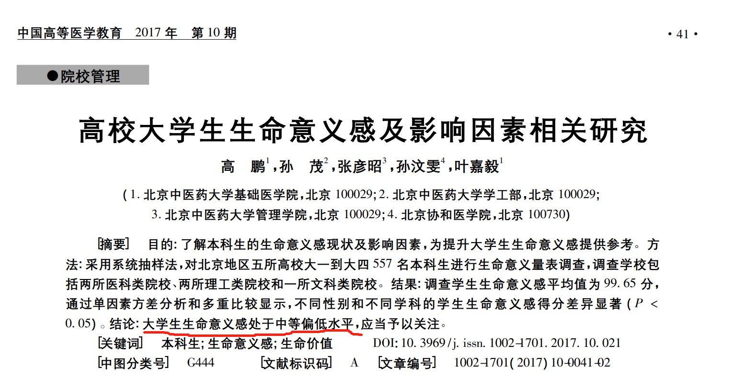
Point 2: The papers in line 30 are extensive, they speak of various fields, is this part of your research?
Response: Thank you very much for your suggestions. The papers in line 30 are really extensive, including the relationship between sense of meaning in life and mental health, sense of meaning in life and college sports, sense of meaning in life and psychological resilience, sense of meaning in life and purpose of life, sense of meaning and internet altruism. Even though these topics are not of interest to our research, all these researches showed that almost 50% of undergraduates’ life goals are not clear and their sense of meaning in life is low, which suggested that it is necessary and important to study how to improve undergraduates’ sense of meaning in life.
Point 3: Ref. 11 is it a book?, because this ref. defines the concept that is being used.
Response: Thank you very much for your suggestions. Ref. 11 is a book chapter written by Michael F. Steger in the book “The Oxford handbook of positive psychology (2nd ed)”.
Point 4: Lines 45 and 46, they talk about SES Objective and Subjective, but the summary mentions "current", why was this change made?
Response: Thank you very much for your suggestions. Socioeconomic status (SES) includes subjective SES and objective SES. Previous studies mostly focused on the current subjective SES and objective SES, few studies shed light on future subjective SES. In our current research, to express simpler, we used current SES to represent current subjective SES, and used future SES to represent future subjective SES. To make it clearer, we have added this note in the introduction:
Previous studies mostly focused on the current subjective SES and objective SES, few studies shed light on future subjective SES. In the current research, to express simpler, current subjective SES was abbreviated as current SES, and future subjective SES was abbreviated as future SES which referred to the socioeconomic status people expect to be in the future.
Methodology:
Information is detailed in a better way
Response: Thank you very much.
Results:
Point 1: Review the tables and figures please. There are some that do not contain information at the bottom of them (or at the top), and table 4 has words in black.
Response：Thank you very much for your suggestion. We have reviewed all the tables and figures. Please see the followings:
Table 1. The descriptive analysis of undergraduates' sense of life meaning and SES (M±SD).
 | Gender |  |  |  |  |  | Rural/Urban
 | male | female | t/Z | p | Rural | Urban t/Z |  |  |  | p
1 | 5.12±0.93 | 4.92±0.80 | 2.01 * | 0.04 | 5.00±0.88 | 5.12±0.87 |  | -1.07 |  | 0.29
2 | 4.76±1.24 | 4.39±1.21 | 2.68 ** | 0.01 | 4.59±1.22 | 4.63±1.29 |  | -0.24 |  | 0.81
3 | 5.48±1.05 | 5.46±1.00 | 0.43 | 0.66 | 5.42±1.04 | 5.61±0.99 |  | -1.61 |  | 0.11
4 | 3.30±1.69 | 3.42±1.70 | -0.58 | 0.56 | 3.15±1.61 | 3.84±1.79 |  | -3.48 ** |  | 0.001
5 | 7.89±2.04 | 7.67±1.60 | 2.09 * | 0.04 | 7.77±1.94 | 7.85±1.66 |  | -0.17 |  | 0.87
6 | 1.73±1.05 | 1.84±1.02 | -1.43 | 0.15 | 1.45±0.82 | 2.61±1.05 |  | -9.65** |  | 0.001
7 | 1.50±0.90 | 1.71±0.95 | -2.42 * | 0.02 | 1.28±0.65 | 2.36±1.07 |  | -9.77 ** |  | 0.001
8 | 2.14±1.19 | 2.04±1.03 | 0.64 | 0.52 | 1.86±1.02 | 2.72±1.28 |  | -5.84 ** |  | 0.001
9 | 1.79±0.82 | 1.87±0.83 | -1.12 | 0.26 | 1.53±0.59 | 2.56±0.87 |  | -9.91 ** |  | 0.001
Note: * p < 0.05, ** p < 0.01. 1= total meaning in life, 2 = meaning experience, 3 = meaning seeking, 4 = current SES, 5 = future SES, 6 = father's education, 7 = mother's education, 8 = monthly household income, 9 = objective SES. For variables 3-9, Mann-Whitney U test, instead of t test, was conducted due to the non-normal distribution.
Table 2. Correlation analysis between SES and sense of meaning in life
 | 1 | 2 | 3 | 4 | 5 | 6
1 Total meaning in life | 1
2 Meaning experience | 0.82 *** | 1
3 Meaning seeking | 0.72 *** | 0.19 *** | 1
4 Objective SES | 0.01 | - 0.01 | 0.02 | 1
5 Current SES | 0.09 | 0.12 * | 0.02 | 0.21 *** | 1
6 Future SES | 0.22 *** | 0.21 *** | 0.12 * | 0.04 | 0.24 *** | 1
Note: * p < 0.05, ** p < 0.0, *** p < 0.001.
Table 3. Regression analysis of undergraduates' sense of meaning in life on SES
 | Meaning experience (β) |  | Meaning seeking (β) |  | Total score of meaning in life (β)
gender | 0.13 * | 0.12 * | 0.02 | 0.01 | 0.10 | 0.09
age | 0.15 ** | 0.14 ** | - 0.06 | - 0.07 | 0.07 | 0.06
objective SES | - 0.03 | - 0.02 | 0.02 | 0.02 | -0.01 | - 0.09
current SES | 0.13 * | 0.09 | 0.01 | -0.02 | 0.10 | 0.92
future SES |  | 0.17 ** |  | 0.13 * |  | 0.20 ***
F | 5.22 *** | 6.32 *** | 0.32 | 1.23 | 2.25 | 4.36 **
R ² | 0.0 6 | 0.09 | 0.004 | 0.02 | 0.0 3 | 0.0 7
ΔR ² | 0.03 ** |  | 0.02 * |  | 0.04 **
Note: * p < 0.05, ** p < 0.01, *** p < 0.001. Gender is a dummy variable, 1=male, 0=female.
Table 4. Analysis of the mediating effect of basic psychological needs satisfaction between future SES and undergraduates' sense of meaning in life
independent variable | Step 1: sense of meaning in life | Step 2: basic psychological needs satisfaction | Step 3: sense of meaning in life
gender | 0.09 | - 0.09 | 0.13 *
age | 0.06 | 0.08 | 0.03
objective SES | - 0.09 | 0.07 | - 0.04
current SES | 0.92 | 0.01 | 0.05
future SES | 0.20 *** | 0.21 *** | 0.11 *
basic psychological needs |  |  | 0.43 ***
F | 4.36 ** | 4.61 *** | 16.53 ***
R ² | 0.07 | 0.06 | 0.23
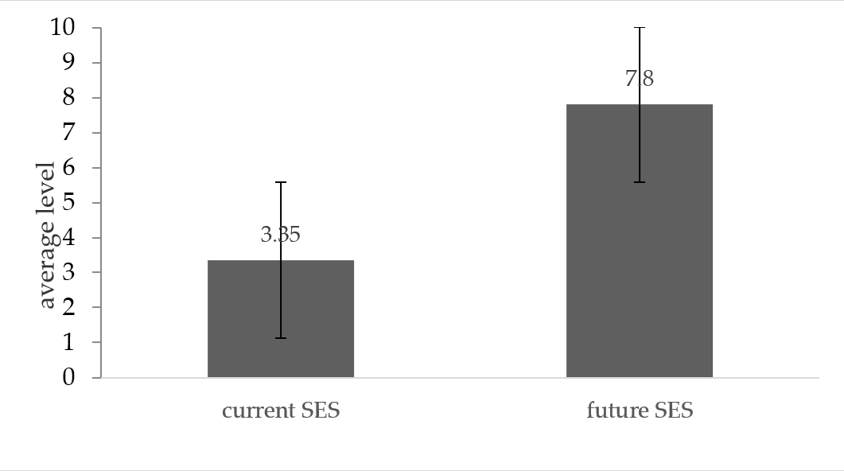
Figure 1. Average level of undergraduates’ current SES and future SES.
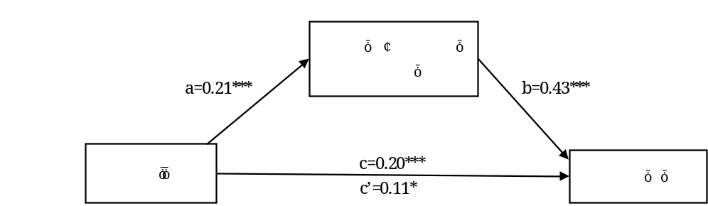
Figure 2. The mediating effect of basic psychological needs in the relationship between future SES and meaning in life.

Point 2: I have doubts, what is the difference between "subjective" and "current"
Response：I am sorry to make you confuse about the difference between "subjective" and "current". In fact, current SES is subjective SES. For simpler expression, we used “current SES” to represent current subjective SES.
Discussion:
I only have doubts with the references that have been used.
Response：Thank you very much for your suggestions. We thought your doubts might be because we cited several Chinese literatures in the discussion and you couldn't search. We have provided both the Chinse abstract and English abstract of the Chinese literatures used in the discussion, please see the following pictures:

6. Wang, F.; Qian, Y.; Ye, J.H. Relationships Between the Sense of Life Meaning, the Purpose of Life and Subjective Well—being in Medical Students. China Journal of Health Psychology 2018, (08),1253-1257.
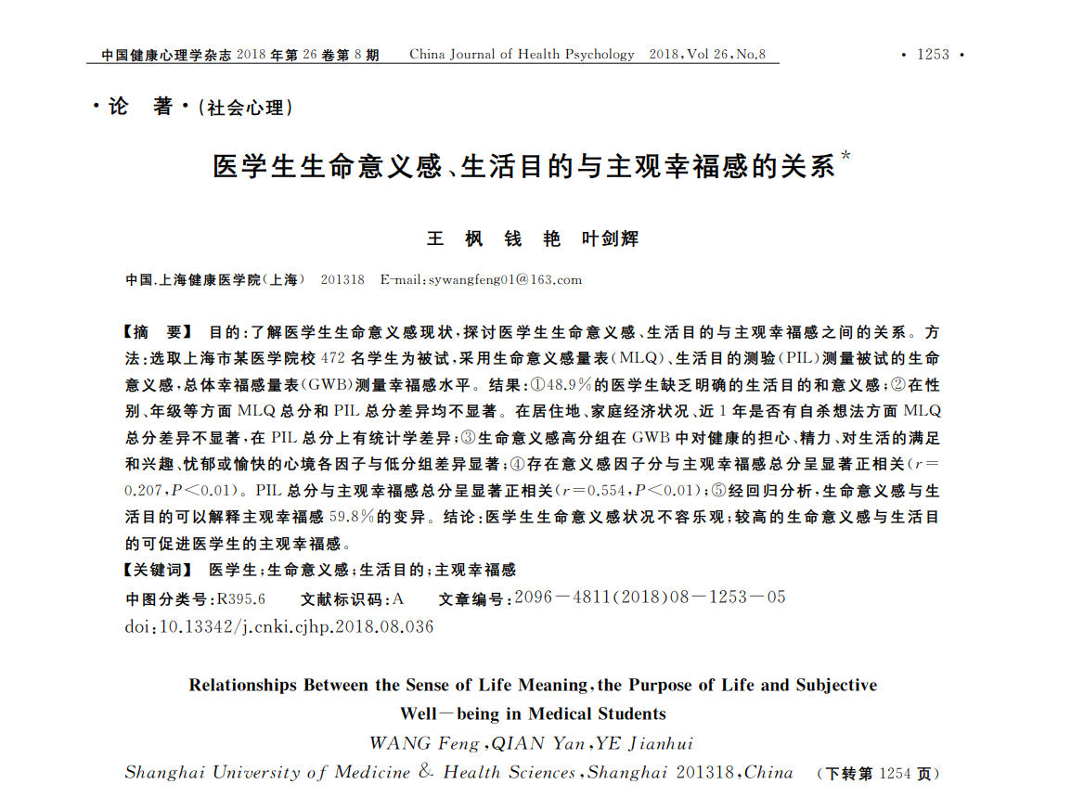
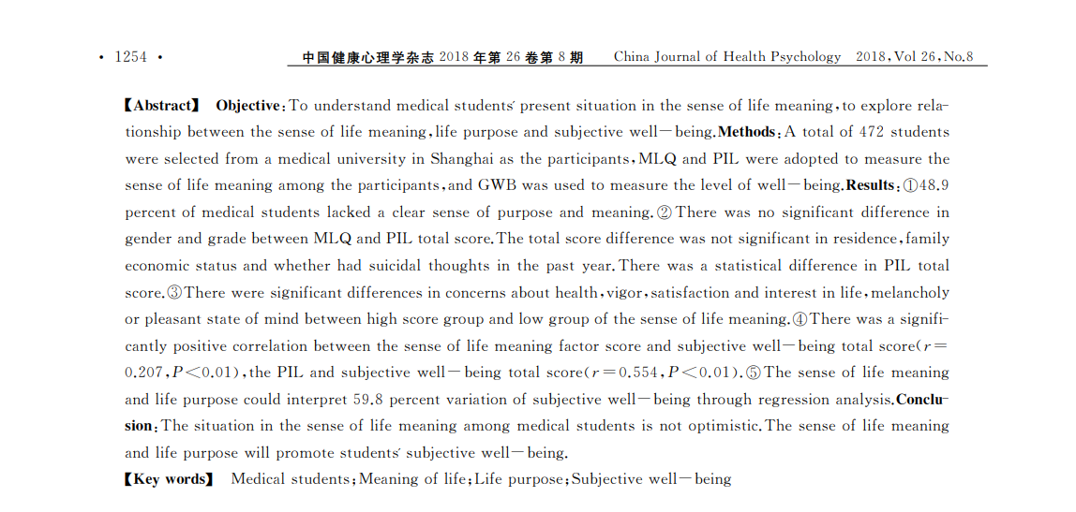

21. Shang, S.J.; Bai, B.Y.; Zhong, N. Family Social Class and Meaning in Life：Mediating of Basic Psychological Need Satisfaction. Chinese Journal of Clinical Psychology 2016, 24(06):1108-1111.
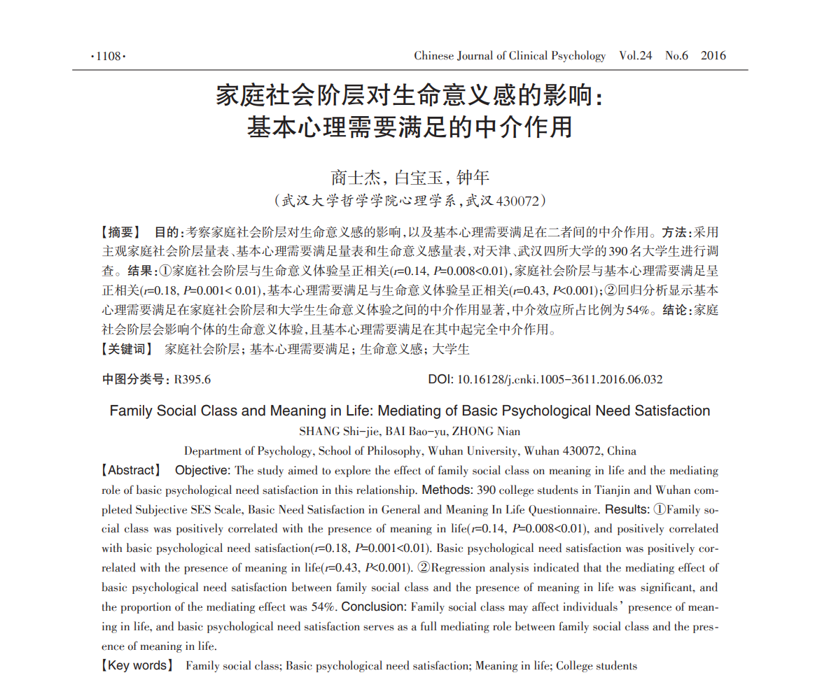
- Tang, L.; Zhang, S.; Shan, G.Y.; Tang, Y. The Relationship between Life Meaning and Problem Students' Problem Behavior: the Moderating Role of Family Socioeconomic Status. Journal of Educational Development 2021, (09),33-39.
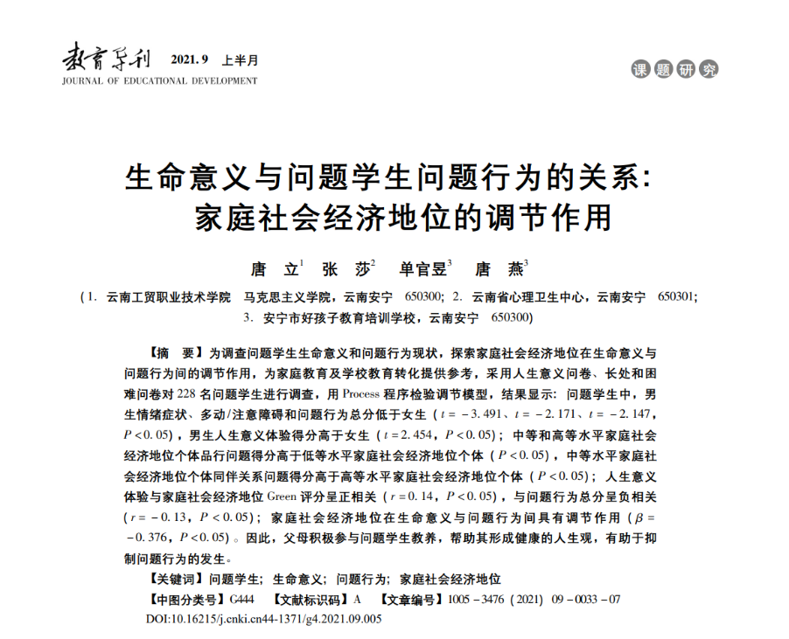
- Zhao, Y.F.; Huang, J.H.; Chen, B. The Influence of Subjective Social Class on Subjective Well-being: The Role of Sense of Security and Social Support. Journal of Southwest University (Social Science Edition) 2019, 45(3).
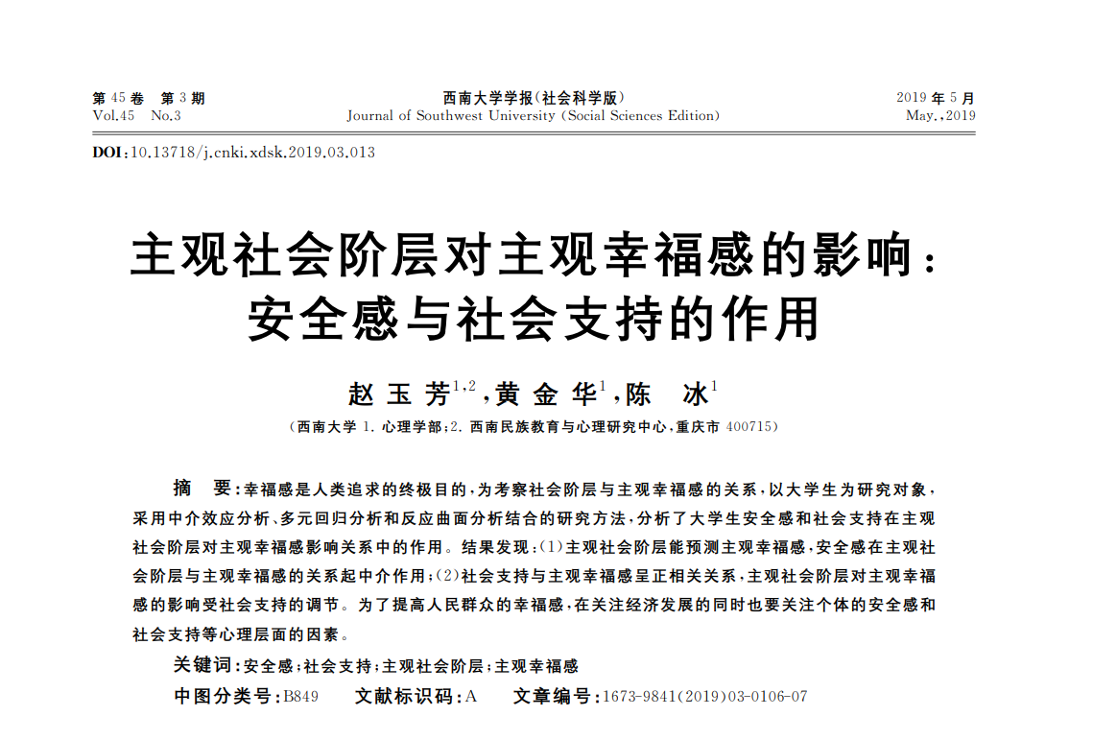
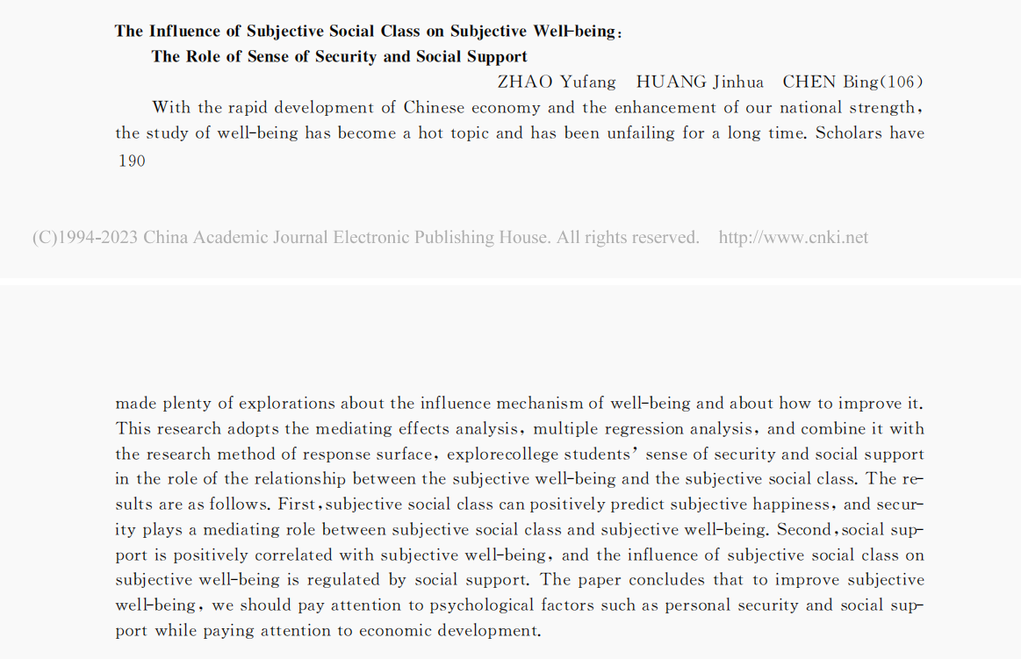

- Yang, Q.; Bi, C.Z.; Li, L.; Huang, X.T. Self-uncertainty: Concepts, structures, and theories. Advances in Psychological Science 2017, 25(06): 1012-1024.
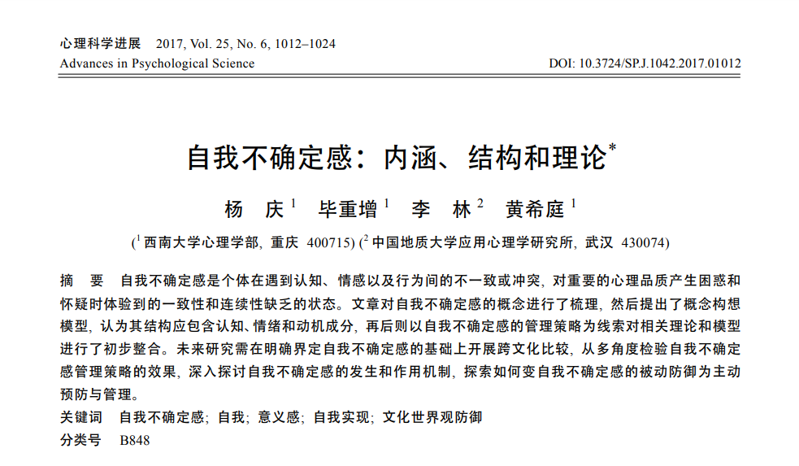
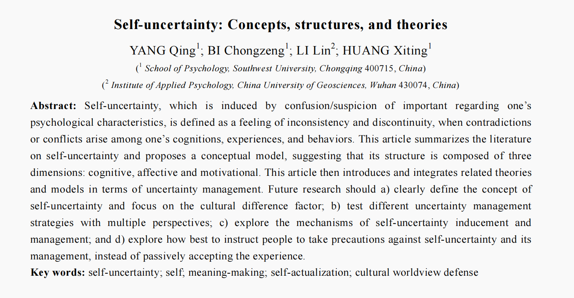

Conclusion:
It has improved, it has presented itself in an improved way.
Response：Thank you very much.
References
I had small problems, I couldn't access some references, perhaps because the journal is very, very specific, such as papers 1 and 2, among others.
Response：Thank you very much for your suggestions. The papers 1 and 2 are from
Chinese journals. We have provided the abstract of citation 1 and citation 2. Please see the following pictures:
Citation 1:
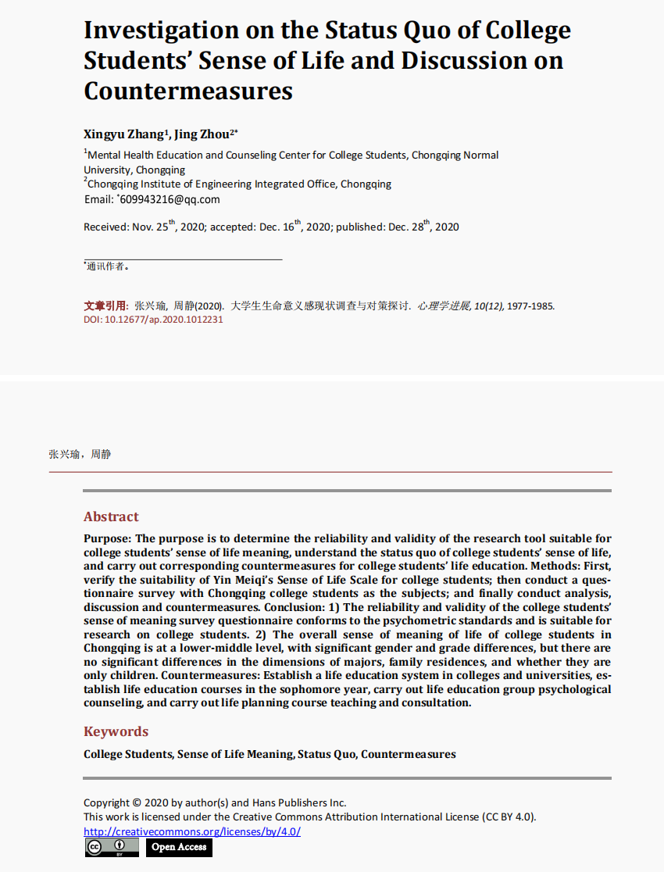
Citation 2:
