Article
Intestinal microbiota differences in Litopenaeus vannamei shrimp between greenhouse and aquaponic rearing
Yabin Dou^{1†}, Mengying Wen^{1†}, Hui Shen^{1,2,3,4*}, Sheng Zhang⁴, Ge Jiang², Yi Qiao², Jie Cheng², Xiaohui Cao², Xihe Wan², Xiaoman Sun³
Citation: To be added by editorial staff during production.
Academic Editor: Firstname Lastname
Received: date
Revised: date
Accepted: date
Published: date

Copyright: © 2023 by the authors. Submitted for possible open access publication under the terms and conditions of the Creative Commons Attribution (CC BY) license (https://creativecommons.org/licenses/by/4.0/).
1 Shanghai Ocean University, Shanghai 201306, China
2 Nanjing Normal University, Nanjing 210023, China
3 Jiangsu Marine Fisheries Research Institute, Nantong 226007, China
4 Jiangsu Ocean University, Lianyungang 222005, China
* Corresponding authors.Email:darkhui@163.com
† These authors contributed equally to this paper

Simple Summary: The sustainability of shrimp aquaculture can be achieved through the development of heterotrophic and autotrophic bacteria aquaculture systems, such as greenhouse and aquaponic rearing modes. This study aimed to compare the microbiota of shrimp samples from greenhouse- and aquaponic-rearing ponds, as well as water samples from both. The Alpha and Beta diversity analysis revealed that there was basically no significant difference between the two modes in terms of shrimp intestinal microbiota and water microbiota (P>0.05). However, the common bacteria between water samples from the greenhouse and aquaponic differed significantly when analyzed at the level of phylum and genus. Pathways such as biosynthesis of secondary metabolites, microbial metabolism, and carbon metabolism were significantly up-regulated in greenhouse mode compared to aquaponic mode (P<0.05). The greenhouse mode, a typical heterotrophic bacteria system, was found to be composed of Amaricoccus, Micrococcales, Flavobacteriaceae and other bacteria, thus indicating the biological sludge process. On the other hand, the aquaponic mode, an autotrophic bacteria system, was characterized by Acinetobacter, Demequina, Rheinheimera and other bacteria, signifying the autotrophic biological process.
Abstract: The sustainability of shrimp aquaculture can be achieved through the development of greenhouse and aquaponic rearing modes, which are classified as heterotrophic and autotrophic bacteria aquaculture systems. However, To date, there has been limited investigation into the discrepancies between the intestinal and water microbiota of these two rearing methods. In this study, we collected shrimp samples from greenhouse-rearing (WG) and aquaponic-rearing (YG) ponds, and water samples (WE, YE), and investigated the intestinal and water microbiota between the two rearing modes. The results showed that the Alpha and Beta diversity analysis revealeded that there were basically no significantly difference between shrimp intestine WG and YG (P>0.05), between rearing water WE and YE (P>0.05). At the level of phylum and genus, the common bacteria between WE and WG differ significantly from those of YE and YG. Analysis of the top six phyla showed that Proteobacteria and Patescibacteria were significantly more abundant in the WG group than in the YG group (P<0.05). Conversely, Actinobacteriota, Firmicutes, and Verrucomicrobiota were significantly more abundant in the YG group than in the WG group (P<0.05). Venn analysis between WE and WG showed that Amaricoccus, Micrococcales, Flavobacteriaceae, Paracoccus were the dominant genera bacteria, while the Acinetobacter, Demequina, Rheinheimera were the dominant genera bacteria between YE and YG. Pathways such as biosynthesis of secondary metabolites, microbial metabolism in different environments, and carbon metabolism were observed to be significantly up-regulated in WG than YG (P<0.05). In addition, pathways such as sulfate, chloroplast, phototrophy, and nitrogen metabolism were significantly different between WE and YE samples. These findings suggest that the greenhouse mode, a typical heterotrophic bacteria model, contains a bacterial flora consisting of Amaricoccus, Micrococcales, Flavobacteriaceae and other bacteria, which is indicative of the biological sludge process. Conversely, the aquaponic mode, an autotrophic bacteria model, is characterized by Acinetobacter, Demequina, Rheinheimera and other bacteria, signifying the autotrophic biological process. This research provides an extensive understanding of heterotrophic and autotrophic bacterial aquaculture systems.
Keywords: greenhouse rearing mode; aquaponic rearing mode; microbiota

1. Introduction
The Litopenaeus vannamei species was first introduced to China in 1988 and has since experienced a surge in popularity.As the need for nutritious food rises, farmed shrimp have become the fastest-growing food product worldwide [1]. In 2016, China produced an estimated 1,672,246 tons of shrimp, as reported by the FAO. The expansion of shrimp aquaculture has had a detrimental effect on the environment due to wastewater. To mitigate this, circular farming modes should be implemented to reduce nutrient content in aquatic environments and ensure sustainable aquaculture development. In Jiangsu, the current shrimp breeding mode is mainly greenhouse ponds, which involve the periodic addition of probiotics and carbon into the ponds [2]. The greenhouse mode is characterized by lower water consumption and greater yield as compared to outdoor earth-pond mode. Unlike the Greenhouse-enclosed raceways mode [3], Jiangsu’s greenhouse mode combines with the earth pond and plastic warming shed, thus enabling the pond sediment to interact with the aquaculture system.
An aquaponic system is characterized by a symbiotic relationship between aquatic livestock, plants and biofloc. Bacteria are reponsible for transforming the nitrogen-rich effluent into forms that can be absorbed by plants, thereby improving nutrient removal efficiency and producing vegetables [4]. In recent years, the aquaponic system between fish and vegetables has been the focus of research, particularly in terms of freshwater fish and vegetables [5]. However, aquaponic system relationship between mariculture animals and plants has been rarely reported. Despite a few reports of the symbiosis between Litopenaeus vannamei and gracilaria as well as sea anemone has been published in relation to seawater conditions [6,7], there is still no report of aquaponic system between Litopenaeus vannamei and vegetables under brackish conditions (salinity 5~15). In this study, an aquaponic rearing mode between Litopenaeus vannamei and lycium barbarum has been explored under conditions of salinity10, which has yielded successful breeding results.
To sum up, greenhouse and aquaponic rearing modes are mainly based on heterotrophic and autotrophic bacterial systems, respectively.
Previous studies have examined the dynamic characteristics of biofloc[8-10] and circulation modes [11-12] in shrimp aquaculture. It is commonly acknowledged that the microbiome of the host and its environment are pivotal in the host's health and the stability of the environment [13]. However, there is a lack of understanding regarding the microbiota and the dissimilarity in microbiota between the two modes throughout the rearing period. Consequently, this study aims to explore the differences in the intestinal and water microbiota between the greenhouse and aquaponic rearing modes of the same batch of larvae. The results of this study could provide a better understanding of heterotrophic and autotrophic bacterial aquaculture systems.

2. Materials and Methods
2.1 Sample collection
Samples of shrimp and water were collected from a commercial marine shrimp hatchery on 25 September 2021, with the shrimp being bred together from larvae to juveniles.(Figure 1). In the greenhouse mode, the density is fixed at 400 tails per square meter, whereas it is set at 1000 tails per square meter in the aquaponic mode. After 30 days of breeding, the juveniles were transferred into greenhouse and aquaponic ponds. Shrimp individuals and six water samples were collected from the greenhouse (body length 12.7 ± 0.4 cm, n=12) and aquaponic ponds (body length 11.9 ± 0.4 cm, n=12) when juvenile shrimp were bred for 60 days. The shrimp intestines were divided into two groups, the group collected from greenhouse ponds (WG) and aquaponic ponds (YG). Considering the inter-individual variations, three intestines from each group were combined to form a single microbial sample, while three hepatopancreases from the sample group were pooled for pathogen testing. The shrimp's surface was sterilized with 70% alcohol, and the intestines were carefully dissected in the field and kept at -80°C until further use. A total of 12 samples were conducted for 454 Pyrosequencing and data processing, which were shrimp intestine (WG, YG) and water samples
(WE, YE).
2.2 DNA Extraction
The shrimp intestines, water filters and bacterial colonies samples were homogenized and blended with 1 mL of TE buffer (1 M Tris-HCl, 0.5 M EDTA, pH 8.0) and 0.3 g of sterilized quartz sand. This mixture was then processed on a FastPrep-24 Homogenization System (MP Biomedicals) for three cycles of 45 seconds each at a speed of 6.0 m/s. Afterward, total DNA of intestine, water filters and bacterial colonies were extracted using PowerFecal DNA Isolation Kit and PowerWater DNA Isolation Kit (Mobio) in accordance with the manufacturer's instructions.
2.3 Various Pathogens test
To determine the presence or absence of different shrimp pathogens, including white spot syndrome virus (WSSV), Enterocytozoon hepatopenaei (EHP), acute hepatopancreatic necrosis disease Vibrios (VP_{AHPND}), and infectious hypodermal and hematopoietic necrosis virus (IHHNV), purified DNA templates of all samples were tested using the primers as described[14] . Subsequently, the PCR products were then subjected to electrophoresis on 1.5% agarose gels.
2.4 PCR Amplification
Amplification of the V3-V4 regions of the bacterial 16S rRNA gene was conducted from 50 ng of DNA extracts for each sample using the primer set 341F and 806R. Three replicates of 16S amplification were performed for DNA sample. The triplicate PCR products were combined, using an AxyPrep DNA Gel Extraction Kit (Axygen, Hangzhou, China), and a Quant-iT PicoGreen double-stranded DNA assay (Invitrogen, Carlsbad, CA, United States). The amplicons from reaction mixture were purified, pooled at an equimolar ratio and subjected to emulsion PCR to set up amplicon libraries. Subsequently, sequencing was done using a Roche Genome Sequencer FLX Titanium platform. The generated DNA sequences were analyzed with QIIME toolkit, version 1.9.1 [15].
2.5 454 Pyrosequencing and data processing
Analysis of Illumina sequencing data was conducted using the Fast Length Adjustment of Short reads program (FLASH, vl.2.11) to obtain the tags for merging pairs of reads [16]. These were clustered into operational taxonomic units (OTUs) with a cutoff value of 97% using UPARSE software v7.0.1090 [17]. The OTUs were compared with the Gold database, and any putative chimeras were removed using UCHIME v4.2.40 [18]. Alpha-diversity indices, such as the Chao1 index and Simpson index, were calculated to evaluate community richness and diversity. Venn diagrams were generated using the R package to show unique and shared OTUs. Beta-diversity analysis was conducted using unweighted UniFrac distance metric to identify the relationships between different samples based on bacterial community [19], which was visualized by principal coordinate analysis (PCoA) and the unweighted pair group method with arithmetic mean (UPGMA) clustering [15]. To predict the functions of the intestinal microbiota, the Kyoto Encyclopedia of Genes and Genomes (KEGG) database and PICRUSt software were used [20], and FaPROTAX was employed to predict the functions of water microbiota (YE and WE). PCoA analysis was performed with the help of WGCNA, stat, and ggplot2 packages in R software (Version 2.15.3). To interpret the distance matrix, Unweighted Pair-group Method with Arithmetic (UPGMA) Means Clustering, a form of hierarchical clustering, was applied with average linkage, using QIIME software (Version 1.7.0). The Wilcoxon rank sum test was conducted to assess the differences between the microbiome data, and those with a P value of less than 0.05 were deemed statistically significant.

2.6 Statistical analysis
All statistical analyses in this study were conducted using R package software. One-way analysis of variance (ANOVA) was applied to analyze Chao, ACE, Shannon, relative abundance of phyla, and relative abundance of genus data is conducted using with a confidence level of 95%.

3. Results
3.1 Shrimp physiological state and pathogen analysis
After thirty days, the same batches of larvae were divided into two groups. After a sixty-day culture period, both groups of shrimp were found to be in a good state of health. However, the aquaponic-reared group was evaluated as “good”, with approximately one kilogram of dead shrimp in the aquaponic pond every day. In contrast, the greenhouse-reared shrimp had no death and was evaluated as “very good”. The production of the greenhouse-reared shrimp was 2.5 kg/m², while the production of the aquaponic-reared shrimp produced 4 kg/m². Furthermore, the body sizes of the greenhouse-reared shrimp were significantly larger than those of the aquaponic-reared shrimp (P<0.05). Additionally, no pathogens, such as EHP, VP_{AHPND}, IHHNV, and WSSV, were detected.
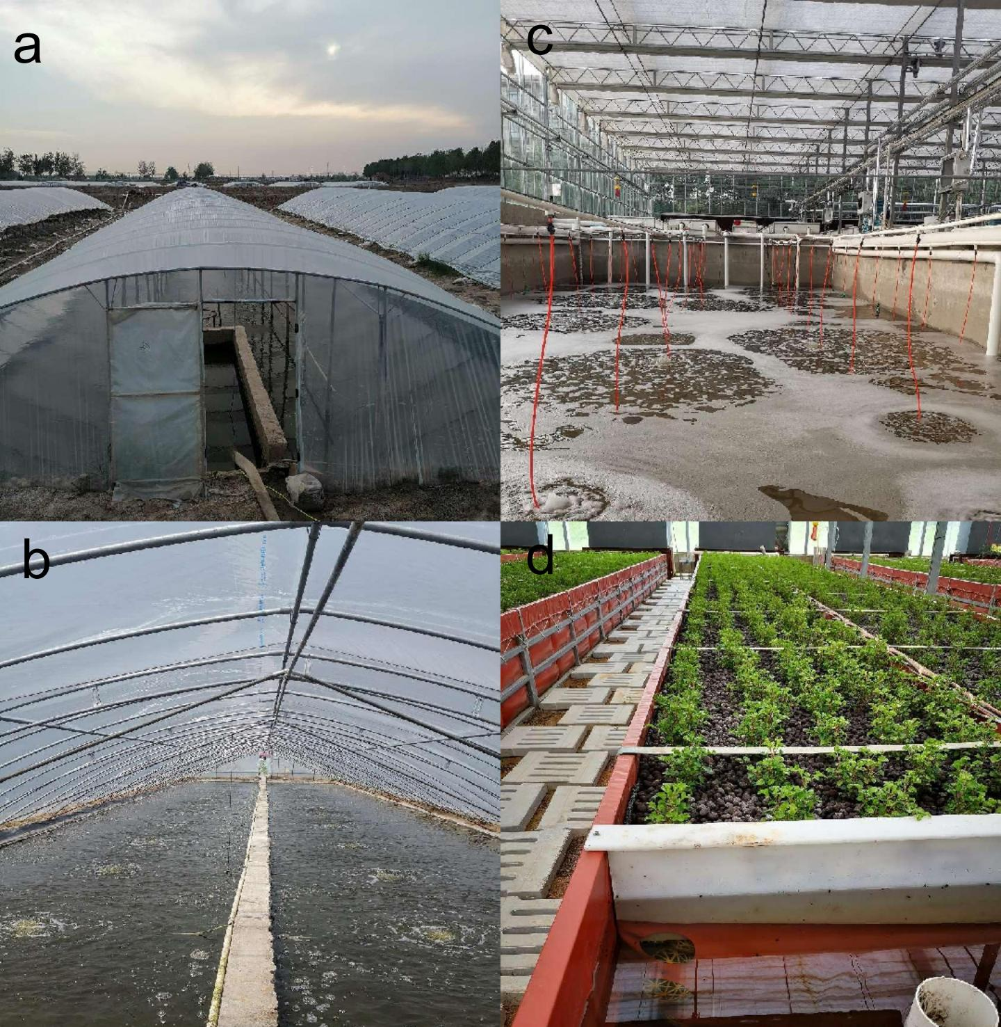
Figure 1. The greenhouse rearing mode and aquaponic rearing mode. (a). The external structure of greenhouse ponds; (b). The Internal structure of greenhouse ponds with about 0.8 m depth water; (c) The rearing pond of aquaponic rearing mode; (d)The recyclable bio-based packages combined with plants of aquaponic rearing mode.

3.2 OTUs and diversity of the intestinal microbiota
The average number of clean reads obtained from the shrimp intestines per sample was 32156±6591. The Chao1, ACE, Shannon indices showed that the shrimp and water collected from the greenhouse pond were significantly higher than those collected from the aquaponic pond (P<0.05) (Figure 2).
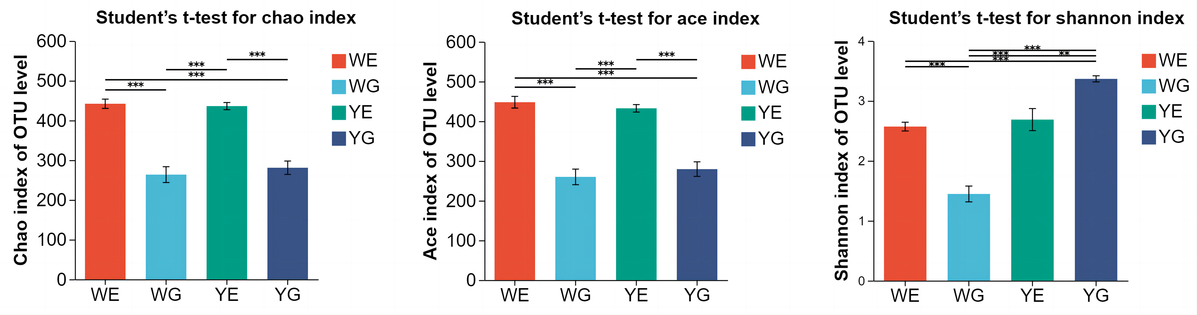
Figure 2. The richness and diversities of bacterial species in four groups. * represents significant differences 0.01<P≤0.05, **represents significant differences0.001<P≤0.01 and ***represents significant differences P≤0.001.

The Venn diagram revealed that Proteobacteria, Actinobacteriota and Bacteroidota were among the thirteen bacterial phyla shared by all four groups, WE, WG, YE and YG (Figure S1). Moreover, 74 bacteria at the genus level were common among them, including Amaricoccus, Micrococcales, and Paracoccus (Figure S1). The common phyla of bacteria between WE and WG were similar to those between YE and YG, with Proteobacteria, Actinobacteriota being the most prominent. However, the following phyla of bacteria were markedly different (Figure 3. A-D). The following common phyla in WE&WG is Bacteriodota (11.32%), Patescibacteria (5.68%), Chloroflexi (1.96%) and others (2.03%). Meanwhile, the following common phyla in YE&YG is Firmicutes (4.57%), Bacteriodota (3.47%), Verrucomicrobiota (1.38%), others (1.62%). Additionally, the common genera of bacteria between WE and WG were distinct from those between YE and YG (Figure 3. E-H). The most common genera in WE&WG were Amaricoccus (49.76%), Micrococcales (13.74%), Flavobacteriaceae (9.93%), Paracoccus (6.72%); while Acinetobacter (27.45%), Demequina (12.58%), Rheinheimera (10.92%), Paracoccus (6.87%), Enterobacteriaceae (6.17%), Rhodobacteraceae (4.93%) were most common genera in YE&YG.
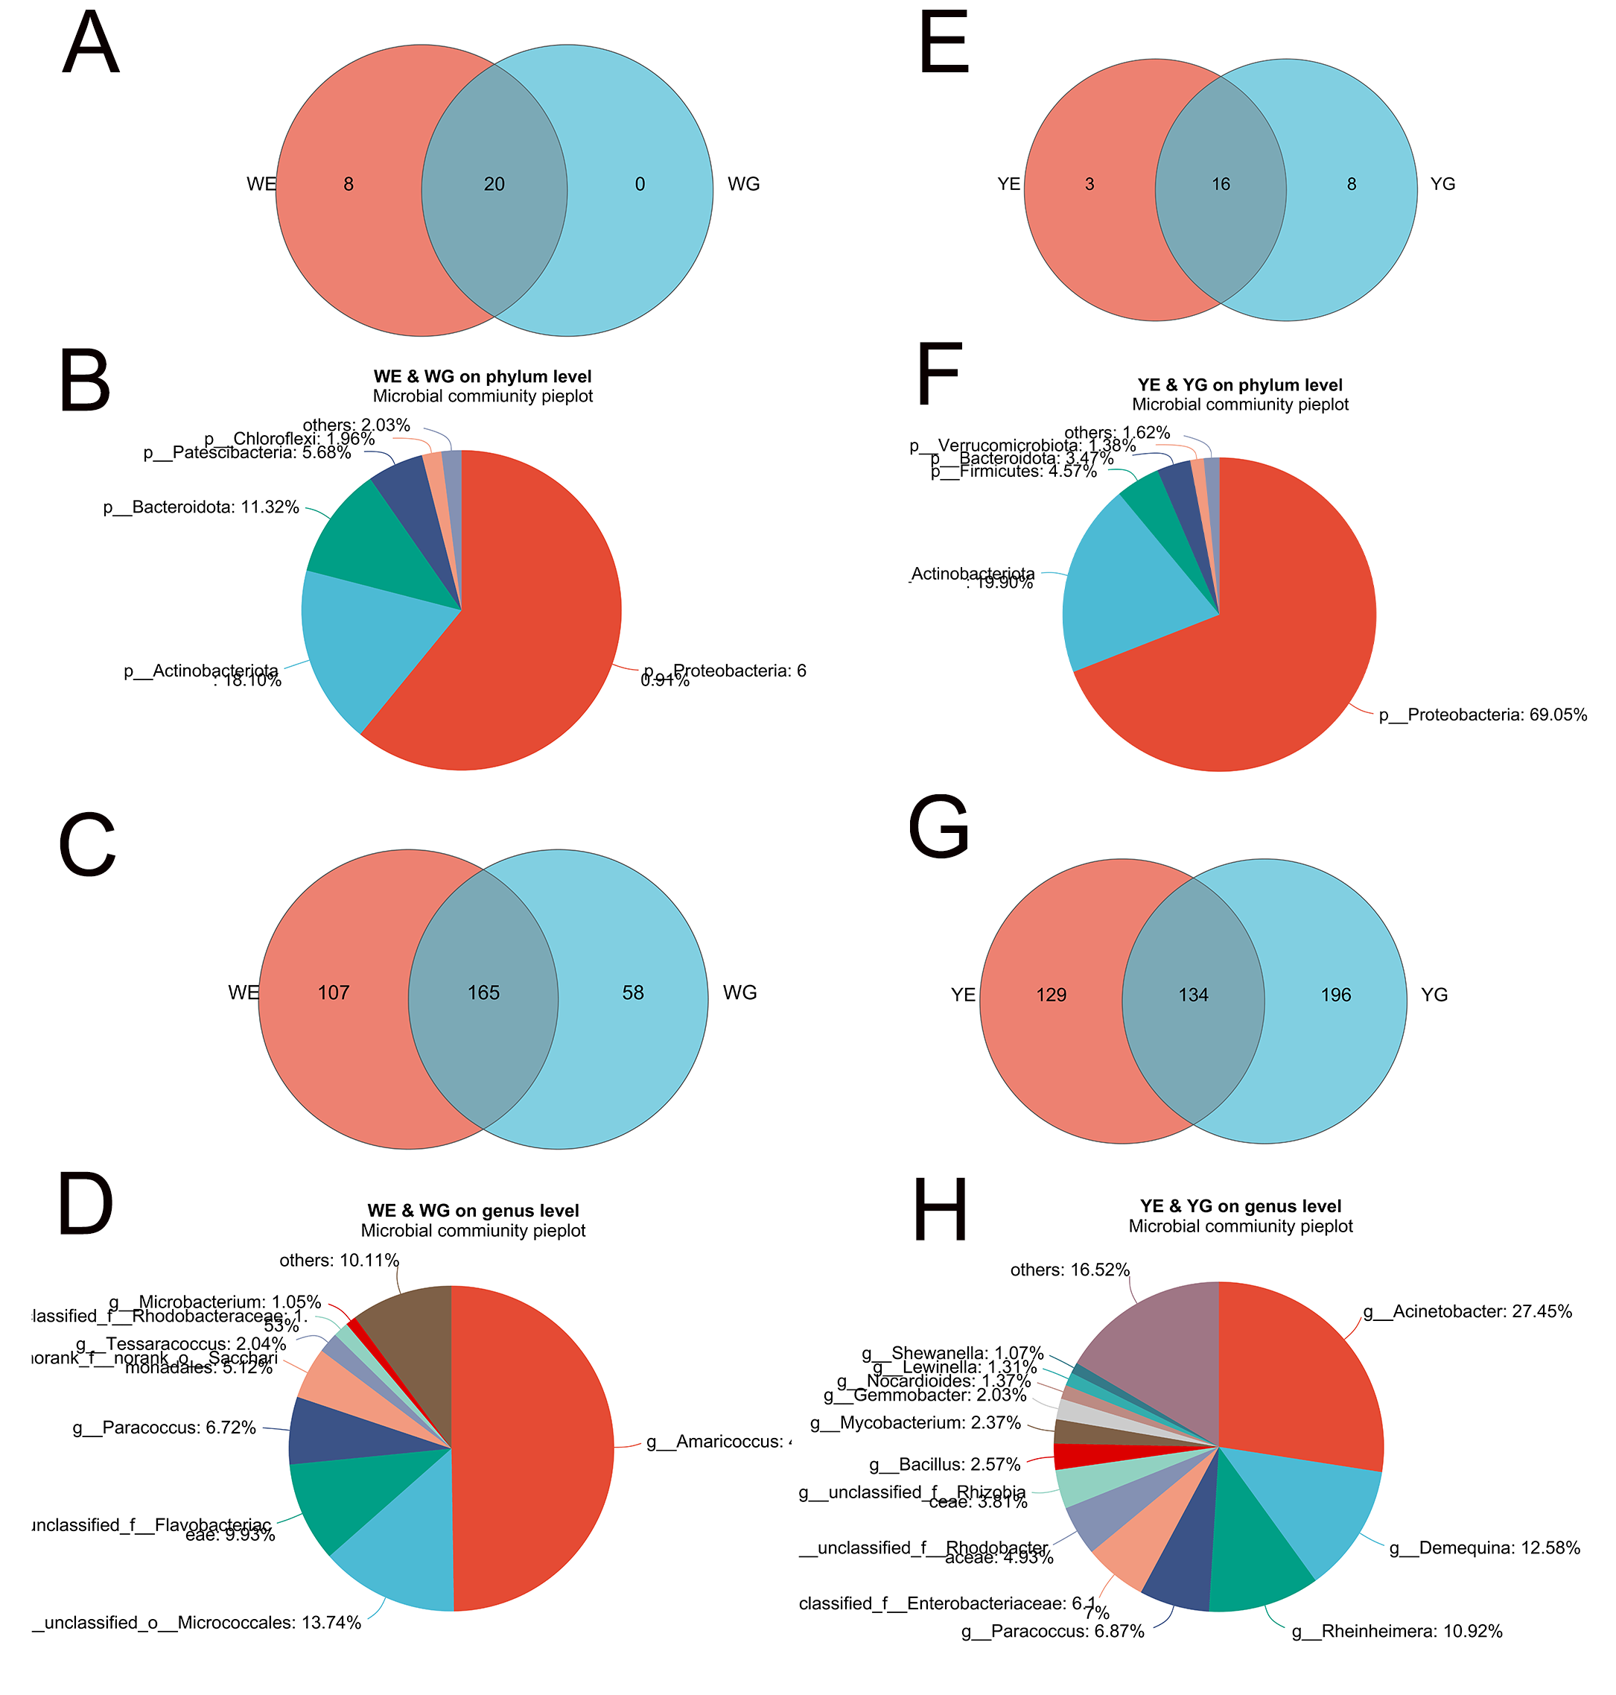
Figure 3. Venn diagrams among WE, WG, YE, YG, and the pieplots of the common bacteria. (A) Venn diagram between WE and WG at the phylum level; (B) The pieplot of common phyla between WE and WG ; (C) Venn diagram between WE and WG at the genus level; (D) The pieplot of common genera between WE and WG ;(E) Venn diagram between YE and YG at the phylum level; (F) The pieplot of common phyla between YE and YG ; (G) Venn diagram between YE and YG at the genus level; (H) The pieplot of common genera between YE and YG.

PCoA showed that the shrimp intestines and water samples collected from the greenhouse ponds were similar, yet distinct from the the aquaponic ponds. Additionally, the intestine groups in the aquaponic ponds were dissimilar to the aquaponic water (Figure 4). Nevertheless, there were no significant differences between WG, WE, YE, and YG (P>0.05).

Figure 4. The principal co-ordinates analysis (PCoA) of bacterial community

3.3 Community composition of the microbiota among samples
Analysis of the dominant phyla and genera revealed that the relative abundances varied among the WG, YG, WE and YE groups.The four shared phyla among these groups were Proteobacteria, Actinobacteria, Bacteroidetes, and Firmicutes. Proteobacteria and Patescibacteria were more abundant in the WG group compared to the YG group, while Actinobacteriota, Firmicutes, and Verrucomicrobiota were more abundant in the YG group than the WG group (Figure 5a). Additionally, the relative abundances of Amaricoccus, Micrococcales, Saccharinonadales, Rhodobacteraceae and Demequina at genus level were significantly greater in the WG group than the YG group (Figure 5b). Differences were observed between the WE and YE groups, with the abundances of all the top six phyla except Bacteroidota being higher in the WE group than the YE group (Figure 5c). The abundances of the top nine genera were also higher in the WE group than the YE group (Figure 5d). Fifteen genera were found to be significantly different among the four groups (Figure 6a). Photobacterium was mainly present in the YE and YG groups and was highly abundant in the YG group (Figure 6g), although it did not show any statistically significant differences in abundance among the four groups.
Figure 5. Significant difference analysis of the top six most abundant phyla (a) and top eight most abundant genera (b) between WG and YG groups. Significant difference analysis of the top six most abundant phyla (c) and top nine most abundant genera (d) between WE and YE groups..

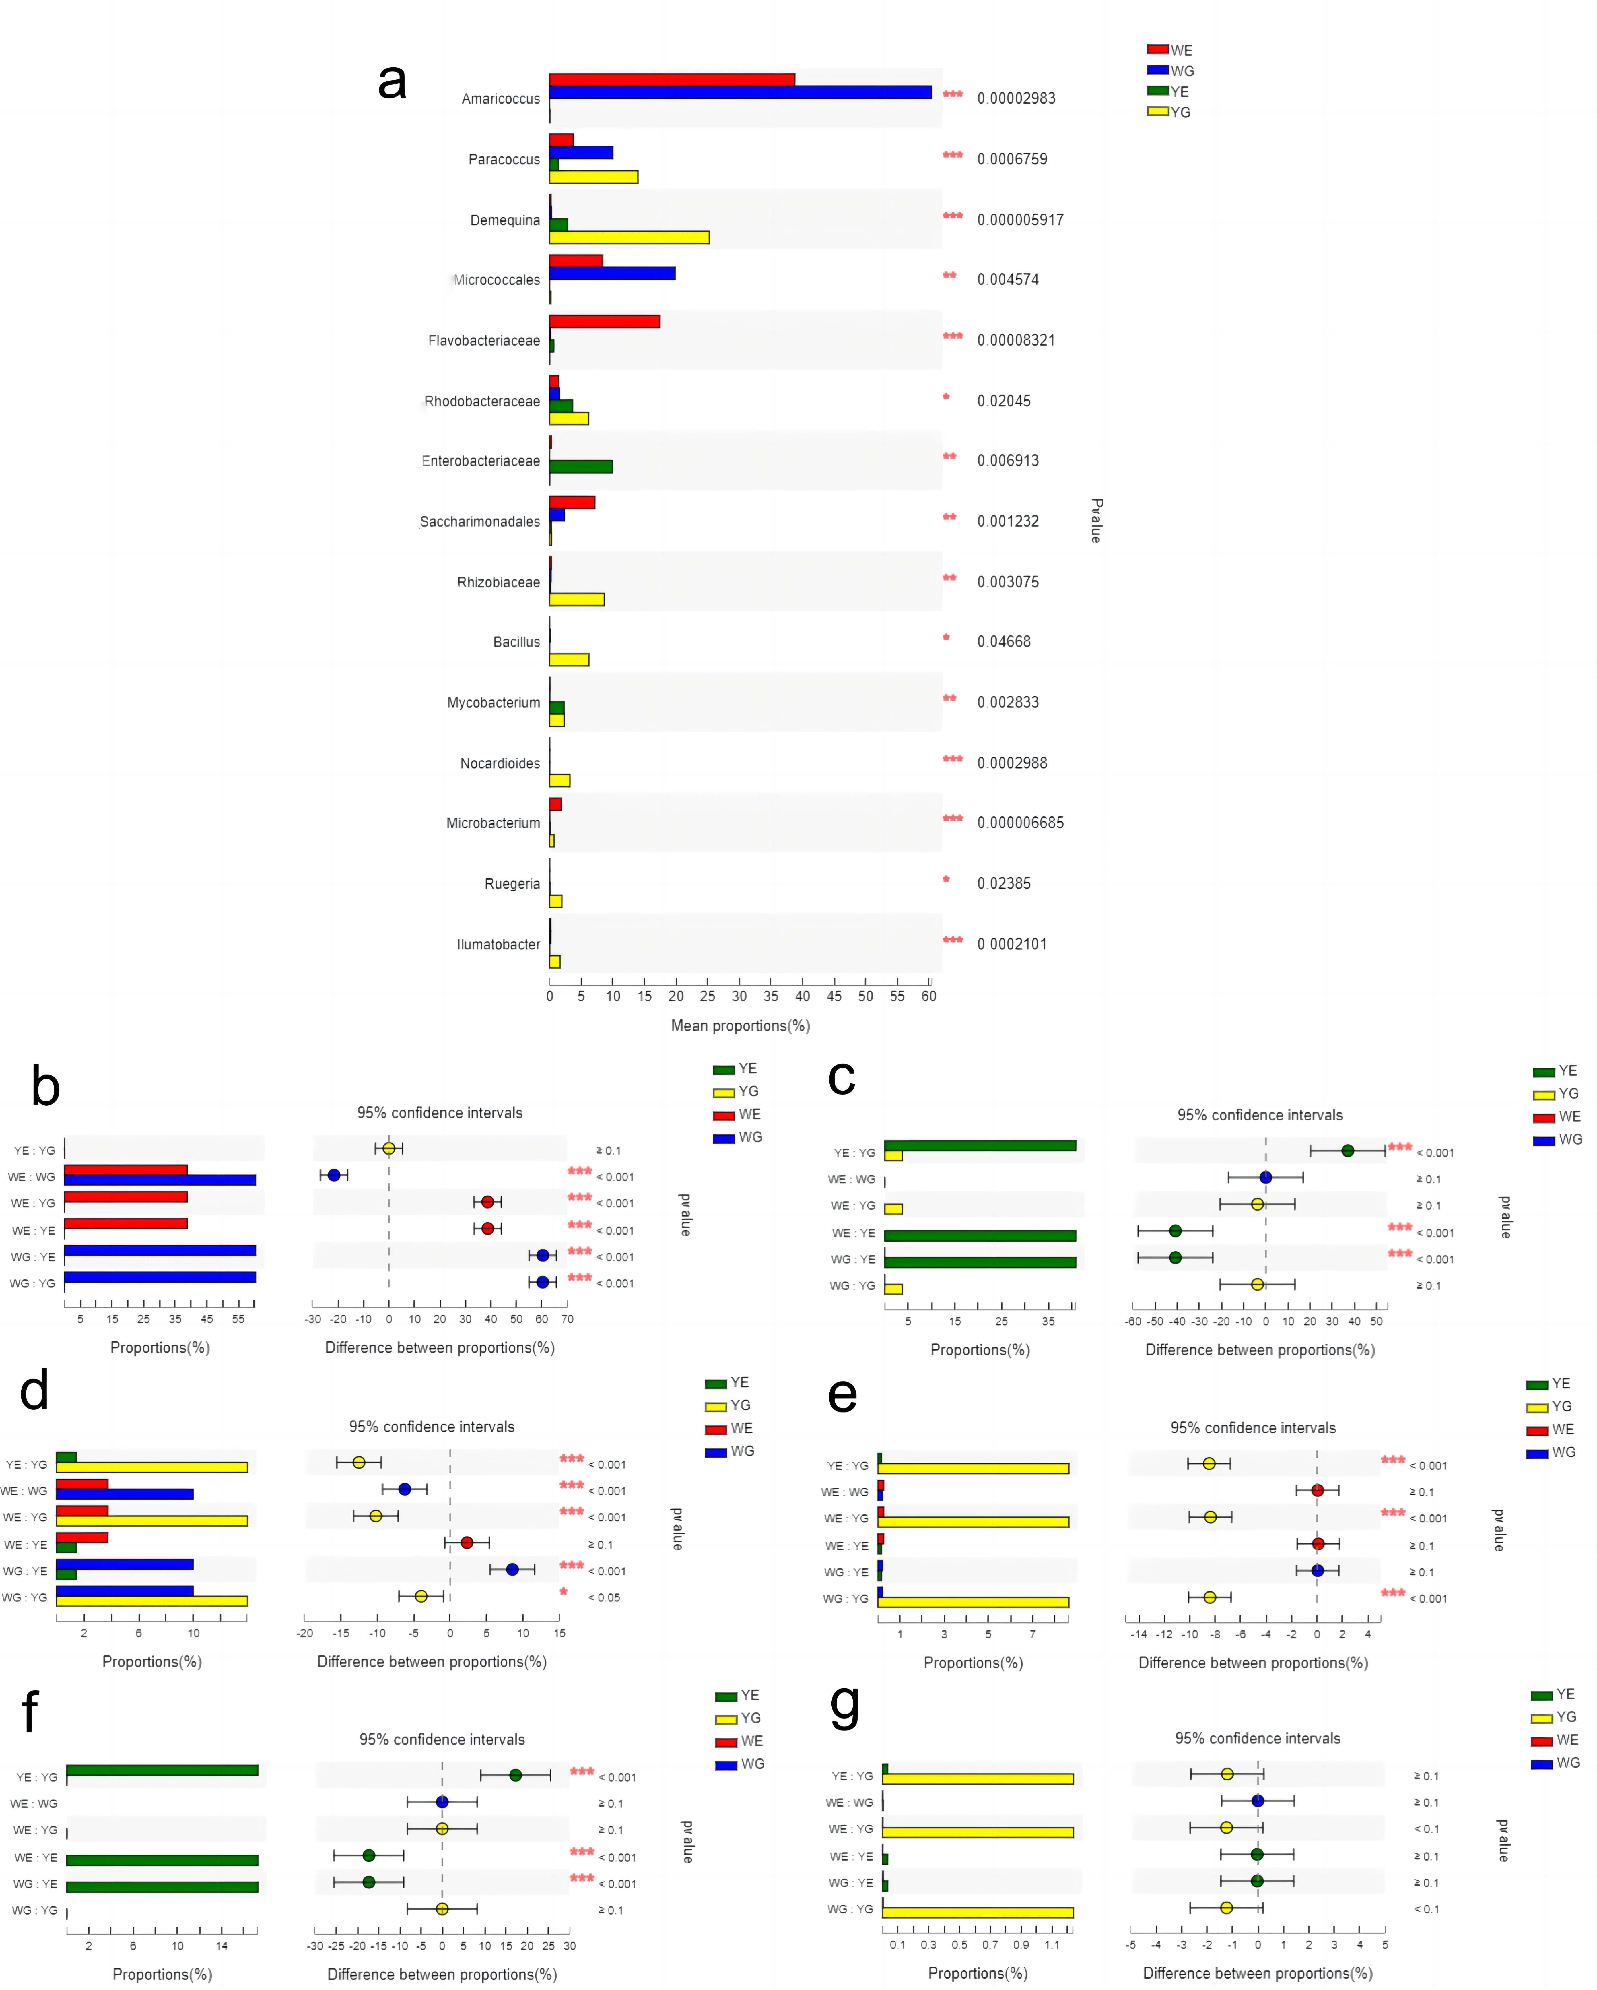

Figure 6. A comparison of bacterial abundances at the genus level between WG, WE, YG and YE is presented. (a). One-way ANOVA bar plot on genus level for Amaricoccus (b), Acinetobacter (c), Paracoccus (d), Rhizobium (e), Rheinheimera (f), Photobacterium (g). * represents significant differences 0.01<P≤0.05, **represents significant differences0.001<P≤0.01 and ***represents significant differences P≤0.001.

3.4 Functional prediction
The intestinal microbiota of WG and YG were annotated at KEGG level 3 to identify their respective KEGG functions. Of the top 50 pathways, the majority were categorized as metabolic pathways, with 38 pathways exhibiting significant differences between WG and YG. Compared with the YG group, a number of pathways were significantly upregulated in the WG group, including biosynthesis of secondary metabolites, microbial metabolism in diverse environments, carbon metabolism, among many others. Conversely, several pathways, such as amino sugar and nucleotide sugar metabolism; alanine, aspartate and glutamate metabolism; and sulfur metabolism, were up-regulated in the YG group (Figure 7).
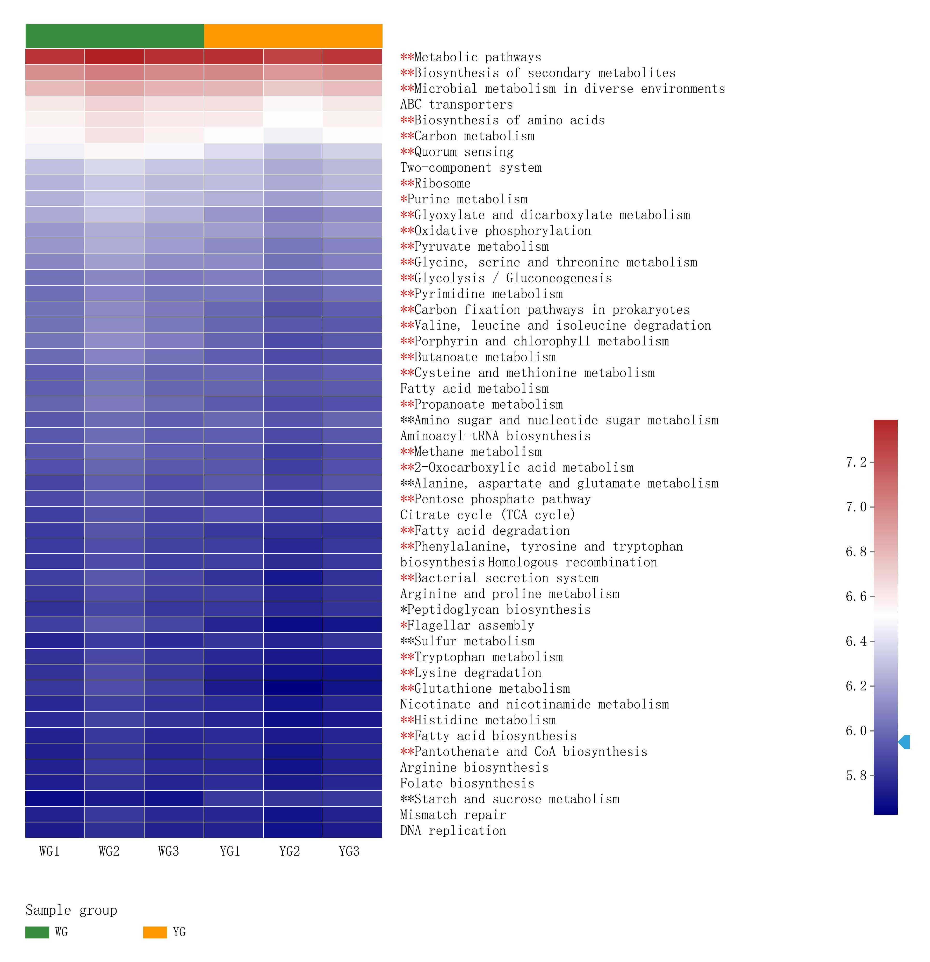
Figure 7. A Heatmap and hierarchical clustering of the significantly different KEGG functions (level 3) between WG and YG is provided. Red asterisks shows the Significantly up-regulated pathways (WG vs YG), black sterisks shows the Significantly down-regulated pathways (WG vs YG).**represents significant differences0.001<P≤0.01 and ***represents significant differences P≤0.001.

The FaPROTAX annotation revealed that the water microbiota (WE vs. YE) had distinct functions. Pathways such as sulfate, chloroplasts, phototrophy, and nitrogen metabolism were significantly different between the WE and YE groups (Fig. 8). Of the top 32 pathways, 19 were found to be significantly different between WE and YE. The WE group had a higher abundance of pathways related to sulfur oxidation, methylotrophy and phototrophic metabolism, whereas the YE group had a higher abundance of pathways related to phtotrophy, fermentation, chemoheterotrophy.
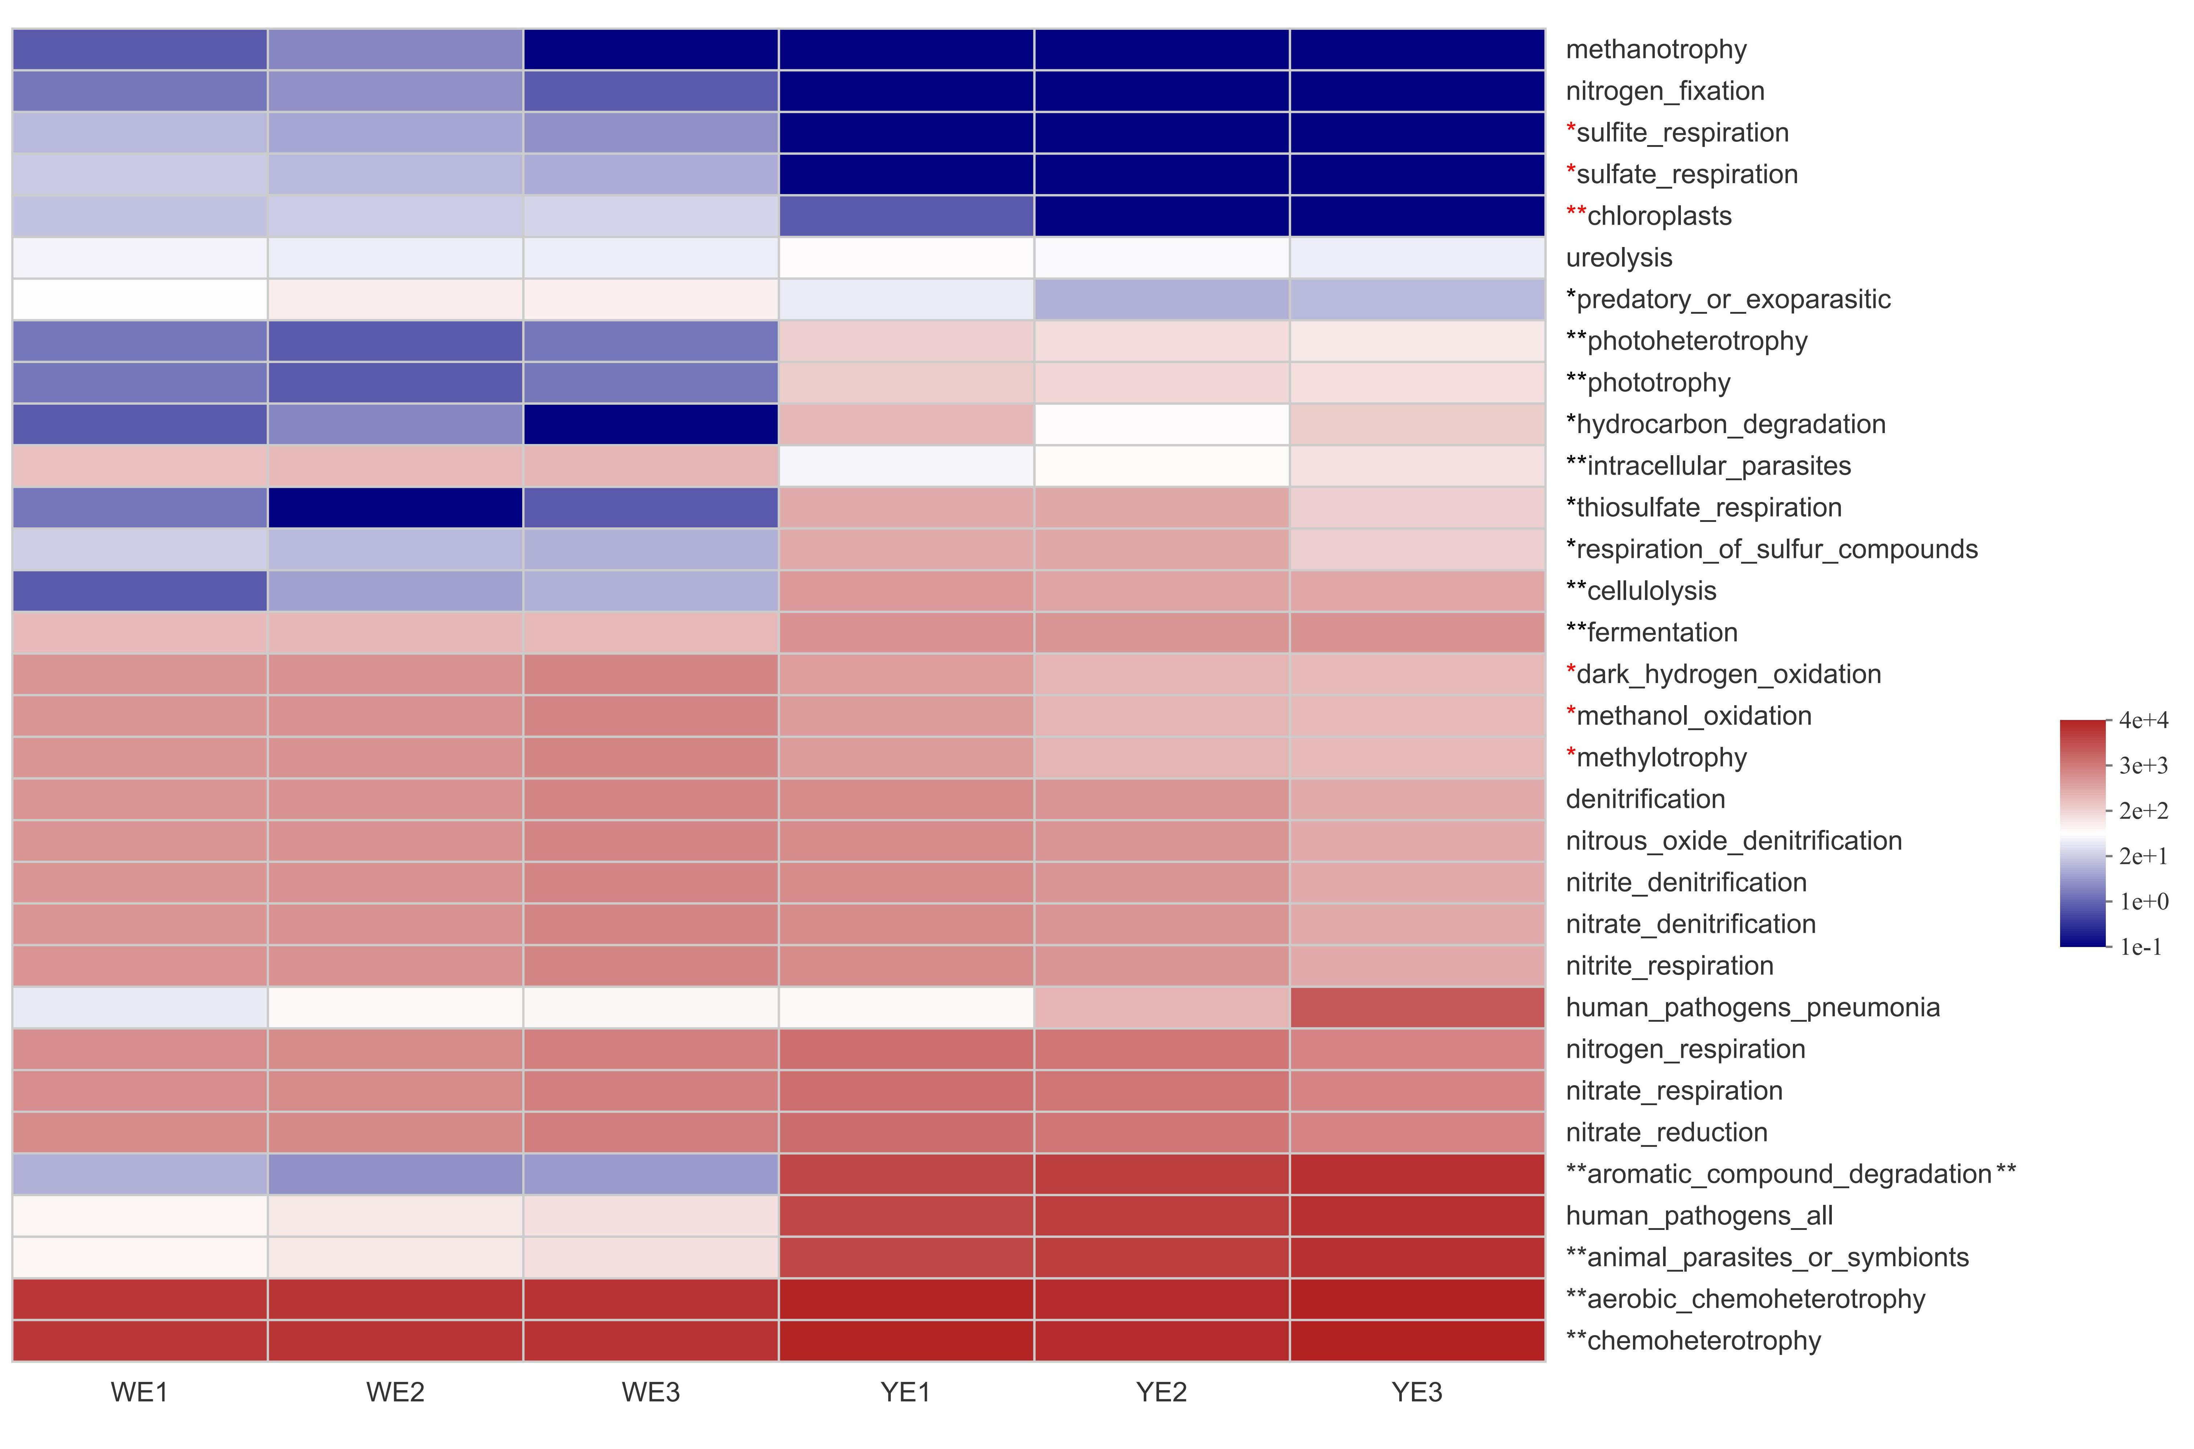
Figure 8. A visualization of the significantly different FaPROTAX functions between WE and YE is provided in the form of a heatmap and hierarchical clustering.Red asterisks shows the significantly up-regulated pathways (WE vs YE), black sterisks shows the significantly down-regulated pathways (WE vs YE).* represents significant differences 0.01<P≤0.05, **represents significant differences 0.001<P≤0.01

4. Discussion
There has been a lack of understanding of the difference between greenhouse earth ponds and aquaponic ponds rearing L. vannamei, and we hypothesized that there were large differences between them. Analysis of Alpha diversity showed that the microbial diversity of water samples (WE, YE) was significantly higher than that of intestinal samples (WG, YG). This suggests that tthe microflora in shrimp intestines is largely derived from the nearby aquatic environment, or that the two contribute to the formation of microflora[14], and shrimp intestinal microbiota can act as a barrier against the surrounding environmental microbiota [21]. Despite the different breeding modes of the two systems, the Chao, Shannon and ACE indices between the water and intestinal samples did not differ significantly, indicating that there was no considerable contrast in Alpha diversity between the greenhouse and aquaponic shrimp and water.(Figure 2). Furthermore, the growth process of prawn in a fixed water body lacks essential minerals and trace elements, whereas the greenhouse model has a reduced deficiency in this regard due to its contact with the soil.
At the phylum level, a Venn analysis between WE and WG reveal that the common bacteria are Proteobacteria, Actinobacteriota, Bacteroidota, Patescibacteria and Chloroflexi in descending order. Which are different from the common bacteria between YE and YG, those are Proteobacteria, Actinobacteriota, Firmicutes, Bacteroidota, Verrucomicrobiota. Previous studies have demonstrated that Proteobacteria, Firmicutes, Actinobacteria, Cyanobacteria, Tenericutes, Planctomycetes, Bacteroidetes, Chloroflexi and Verrucomicrobia are the dominant phyla in L. vannamei and the surrounding environment [22-23]. In this study, Proteobacteria, Actinobacteriota are the most prevalent bacteria in both culture modes. Notably, the abundance of Actinobacteriota is particularly remarkable.
Investigations have revealed the presence of Patescibacteria in various environments, such as ground water sediments, activated sludge and lakes [24], and have demonstrated its involvement in the denitrification of nitrite [25]. In this study, Patescibacteria was found to be the common bacteria between WE and WG, with high abundance. This suggested that the water in the greenhouse pond has been transformed into biofloc, such as sludge, with abundant bacterial diversity since a certain amount of glucose has been added to the greenhouse pond every day. Furthermore, Patescibacteria could have a parasitic relationship with Bacteroidota in partial-nitration/anammox reactors[26]. This study's findings are in agreement with previous research, suggesting that Patescibacteria may have an ecological function in furnishing lactate to other bacteria that inhabit the same environment [27].
Analysis of the Verrucomicrobiota phyla revealed that the genus Luteolibacter was the dominant species in the YE and YG groups, which is often found in recirculating aquaculture systems (RASs), wetlands and activated sludge [28-29]. Additionally, the abundance of the Firmicutes phyla was significantly higher in YE and YG groups than in the WE and WG groups, which was reported to be dominant in the RAS connected with a solid-phase denitrification reactor for nitrate and nitrite removal [30]. This suggested that Verrucomicrobiota and Firmicutes were the representative phyla of the YG and YE groups, indicating that they were the specific phyla of RAS.
At the genus level, Venn analysis between WE and WG revealed that Amaricoccus, Micrococcales, Flavobacteriaceae, Paracoccus were the dominant genera bacteria, while Acinetobacter, Demequina, Rheinheimera were the dominant genera bacteria between YE and YG. This indicated that the core flora between greenhouse mode and aquaponic mode was significantly different. The genera of Amaricoccus (Figure 5b), Paracoccus (Figure 5d), and Tessaracoccus, among other genera, were the common genera bacteria between WE and WG, significantly higher than those between YE and YG. The genera Amaricoccus and Paracoccus are typical aerobic denitrifying bacteria that have the ability to decompose a broad range of organic compounds and transform nitrate to N₂ [31]. This suggested that the water containing sediment in the greenhouse pond had been transformed into activated sludge with the use of glucose and adequate aeration. In addition, OTU361 and the genus Demequina were both classified as Actinobacteria, with OTU361 being significantly more abundant in the WG group, and Demequina being significantly more abundant in the YG group. This class of bacteria has been associated with antagonistic activity against pathogenic Vibrio [32], suggesting that the two organisms have distinct characteristics between the two aquaculture modes. Acinetobacter, a significant contributor to hydroponics, has been observed to increase plant biomass and eliminate nutrients [33]. It is commonly found in the rhizosphere of plants and is known to have a higher abundance when the levels of dissolved nutrients in the water are high [34]. In this study, Acinetobacter was found to be the most abundant genus among the common genera shared between YE and YG, accounting for 27.45%, while Rhizobia was the second most abundant, making up 3.81% (Figure 3H). This result is in agreement with previous studies on the microbiota of hydroponic systems. However, It has suggested that the genus Acinetobacter may be responsible for red leg disease in L. vannamei in shrimp [35]. We believe Acinetobacter, as a key bacterium in the aquaponic system, has a twofold effect, considering the fact that a kilogram of prawns per day in the aquaponic mode.

The YG group was observed to have a higher abundance of Acinetobacter (Figure 5c) and Photobacterium (Figure 5g) than the WG group. These genera are known to be opportunistic pathogens. Photobacterium species are commonly found in marine environments and have been linked to the pathogenesis of aquatic organisms, such as shrimp and fish [36-37]. Additionally, the presence of Rhizobium, a symbiotic bacterium typically found in plant roots [38], in the YG group suggests that the shrimp intestinal microbiota interacted with bacteria from plant roots.
Previous studies have indicated a strong relationship between the microbiota of shrimp intestines and their surrounding water, suggesting that microorganisms from ambient water can interact with the microbiota of aquatic animals [39-40]. In this study, 20 common phyla were identified between WE and WG, and no unique phyla in WG compared to WE(Figure 3A). In contrast, there 8 unique phyla were observed in YG compared to YE (Figure 3B), suggesting that the interaction between shrimp intestines and water in greenhouse mode was stronger than in aquaponic mode. It is likely that the presence of micro flocs in the water body of the greenhouse mode is what causes the strong shaping effect on the shrimp intestines as they feed on these micro-flocs. The intestinal microbiota of healthy shrimp may be more dependable than that of the surrounding water, as it creates a microenvironment that encourages the growth of certain microorganisms[21]. In the aquaponic mode, the water is filtered through a microfilter, resulting in a lack of micro floc and thus, a minimal interaction between the shrimp intestine and the microbial flora of the water body. This suggests that, to mediate the interaction between shrimp intestines and water microbiota, micro- flocs can be used as an example.
PCoA results revealed that the correlation between the WE and WG groups was greater than between the YE and YG groups (Figure 4), suggesting that the shrimp grown in the greenhouse pond were in better health than those grown in the aquaponic pond. Notably, the YG group was distinct from the WG and WE groups, even though they were initially together for the initial 30 days, indicating that there were considerable differences between the greenhouse and aquaponic modes. It is evident that the intestinal flora of shrimp is largely influenced by the aquatic environment flora. Additionally, the Venn diagram indicates that the number of bacteria varieties in shrimp intestines and water bodies in the greenhouse mode is lower than that in the aquaponic mode at the level of phyla and genus (Figure 3). We hypothesize that the addition of carbon sources in the greenhouse mode will lead to an increase in the abundance of bacteria with high C/N, thus reducing the species of bacteria with low C/N.
The microbiome of greenhouse rearing and aquaponic rearing modes showed a close correlation with the taxa. Among the top 50 abundant pathways, mainly metabolic pathways, such as carbon metabolism, biosynthesis of secondary metabolites, purine metabolism, glyoxylate and discarboxylate metabolism, pyruvate metabolism, pyrimidine metabolism, tryptophan metabolism, glutathione metabolism, and histidine metabolism, were found to be more abundant in WG group than in YG group, indicating that a higher proportion of heterotrophic biomass and better digestion and absorption of nutrients [25]. However, some pathways, such as alanine, aspartate and glutamate metabolism, were significantly lower in the WG group than in the YG group. These pathways were up-regulated by environmental stress, such as exposure to microcystin-LR [41] and long-term low salinity [42]. Although the WG and YG groups were in the same salinity of 10 and were not exposed to microcystin-LR, the responses of intestinal function were very different between them. This suggests that the ecosystem of the greenhouse system was more favorable than that of the aquaponic system and that shrimp reared in aquaponic ponds were under some unknown stress. Interestingly, the YG group exhibited a significantly greater sulfur metabolism than the WG group, likely due to the addition of ammonium sulfate to the YG group to form biofilms of autotrophic denitrifying bacteria.
The difference between the predicted functionalities of the microbiome in the WG and YE groups were more significant than those between WG and YG groups. According to the annotation of FaPROTAX, the YE group had significantly higher levels of photoheterotrophy, phototrophy, hydrocarbon degradation, thiosulfate respiration and cellulolysis than the WE group, suggesting that these results were consistent with a aquaponic system that combined plants and biological floating biomass[43]. Previous studies have found that methylotrophy is largely driven by the orders Rhodobacterales and Rhodospirillales [44]. The WE group, which possessed higher light intensity than the YE group, displayed a significantly higher relative abundance of Rhodobacterales due to the higher levels of methylotrophy present. This process followed the same principles as chloroplasts being more abundant than microalgae. It is noteworthy that, despite the considerable distinctions between greenhouse and aquaponic systems, the nitrogen cycles, such as denitrification, nitrous oxide denitrification, nitrite denitrification, nitrate denitrification, nitrite respiration, and nitrate respiration, did not show significant variations. This suggests that the autotrophic and heterotrophic denitrification systems in the YE and WE groups were capable of effectively removing water nitrogen.

5. Conclusions
To obtain the difference of microbiota rearing between greenhouse and aquaponic modes, we compared the microbiota of shrimp samples from greenhouse-rearing (WG) and aquaponic-rearing (YG) ponds, and water samples (WE, YE). Our results revealed that there were basically no significant difference of Alpha and Beta diversity between the two modes in terms of shrimp intestinal microbiota and water microbiota. However, the common bacteria between WE and WG differ significantly from those of YE and YG when analyzed at the level of phylum and genus. Pathways including biosynthesis of secondary metabolites, microbial metabolism, and carbon metabolism were observed to be significantly more activated in WG than YG (P<0.05). Results suggest the greenhouse model has a bacterial flora composed of Amaricoccus, Micrococcales, Flavobacteriaceae, and other bacteria, indicating that it is a product of the biological sludge process. On the other hand, the aquaponic model, an autotrophic bacteria model, is characterized by Acinetobacter, Demequina, Rheinheimera and other bacteria, signifying the autotrophic biological process.

Supplementary Materials: The following supporting information can be downloaded at: www.mdpi.com/xxx/s1, Figure S1: Venn diagrams among WE, WG, YE, YG, and the pieplots of the common bacteria ; Table S1: Table S1. The primers for detection of pathogens; Video S1: title.
Author Contributions: Conceptualization, H.S., and X.W.; methodology, Y.D., M.W., S.Z.,.; investigation, J.C., G. J.; data curation, Y. Q., H. C. ; writing—original draft preparation, Y.D., M. W,; writing—review and editing, H.S., X. S.; supervision, H.S.; project administration, H.S.; funding acquisition, H.S.. All authors have read and agreed to the published version of the manuscript.
Funding: This research was funded by Agriculture Projects Of Provincial, China, grant number 2022-SJ-037-2 and Yancheng Fishery High Quality Development Research Project, grant number YCSCYJ2021005.

Institutional Review Board Statement: Not applicable.

Informed Consent Statement: Not applicable.
Data Availability Statement: Data are provided in the article.
Acknowledgments: The authors thank the anonymous reviewers for their valuable comments and suggestions.
Conflicts of Interest: The authors declare no conflict of interest.

References
- Sampantamit, T.; Ho, L.; Lachat, C.; Sutummawong, N.; Sorgeloos, P.; Goethals, P. Aquaculture production and its environmental sustainability in Thailand: Challenges and potential solutions. Sustainability. 2020.12(5), 2010.
- Shen, H.; Jiang, G.; Wan, X. H.; Fan, X.; Qiao, Y. Multiple pathogens prevalent in shrimp Penaeus vannamei cultured from greenhouse ponds in Jiangsu province of China. J. Aquac. Res. Dev. 2017. 27, 675-683.
- Samocha, T. M.; Lawrence, A. L.; Collins, C. A.; Castille, F. L.; Bray, W. A.; Davies, C. J.; Lee, P. G.; Wood, G. F. Production of the Pacific white shrimp, Litopenaeus vannamei, in high-density greenhouse-enclosed raceways using low salinity groundwater. J. Appl. Aquac. 2004. 15(3-4), 1-19.
- Love, D. C.; Fry, J. P.; Li, X.; Hill, E. S.; Genello, L.; Semmens, K.; Thompson, R. E. Commercial aquaponics production and profitability: Findings from an international survey. Aquaculture. 2015. 435, 67-74.
- Wongkiew, S.; Hu, Z.; Chandran, K.; Lee, J. W.; Khanal, S. K. Nitrogen transformations in aquaponic systems: A review. Aquac. Eng. 2017. 76, 9-19.
- Castilho-Barros, L.; Almeida, F. H.; Henriques, M. B.; Seiffert, W. Q. Economic evaluation of the commercial production between Brazilian samphire and whiteleg shrimp in an aquaponics system. Aquacult. Int. 2018. 26, 1187-1206.
- Pinheiro, I.; Carneiro, R. F. S.; do Nascimento Vieira, F.; Gonzaga, L. V.; Fett, R.; de Oliveira Costa, A. C.; Magallon-Barajas, F. J.; Seiffert, W. Q. Aquaponic production of Sarcocornia ambigua and Pacific white shrimp in biofloc system at different salinities. Aquaculture. 2020. 519, 734918.
- Pacheco-Vega, J. M.; Cadena-Roa, M. A.; Leyva-Flores, J. A.; Zavala-Leal, O. I.; Pérez-Bravo, E.; Ruiz-Velazco, J. M. Effect of isolated bacteria and microalgae on the biofloc characteristics in the Pacific white shrimp culture. Aquac. Rep. 2018. 11, 24-30.
- Holanda, M.; Besold, C.; Sempere, F. L.; Abreu, P. C.; Poersch, L. Treatment of effluents from marine shrimp culture with biofloc technology: Production of Arthrospira (Spirulina) platensis (cyanobacteria) and nutrient removal. J. World Aquac. Soc. 2021. 53(3), 669-680.
- Xu, W. J.; Morris, T. C.; Samocha, T. M. Effects of C/N ratio on biofloc development, water quality, and performance of Litopenaeus vannamei juveniles in a biofloc-based, high-density, zero-exchange, outdoor tank system. Aquaculture. 2016. 453, 169-175.
- Brune, D. E.; Kirk, K.; Eversole, A. G. Autotrophic intensification of pond aquaculture; shrimp production in a partitioned aquaculture system. Animals. 2004. 201-210.
- Itano, T.; Inagaki, T.; Nakamura, C.; Hashimoto, R.; Negoro, N.; Hyodo, J.; Honda, S. Water circulation induced by mechanical aerators in a rectangular vessel for shrimp aquaculture. Aquac. Eng. 2019. 85, 106-113.
- Rajeev, R.; Adithya, K. K.; Kiran, G. S.; Selvin, J. Healthy microbiome: a key to successful and sustainable shrimp aquaculture. Rev. Aquac. 2021. 13(1), 238-258.
- Shen, H.; Dou, Y.; Li, H.; Qiao, Y.; Jiang, G.; Wan, X. H.; Cheng, J.; Fan, X. P.; Li, H.; Wang, L. B.; Shi, W. J.; Qin, Y. L.; Shen, J. Changes in the intestinal microbiota of Pacific white shrimp (Litopenaeus vannamei) with different severities of Enterocytozoon hepatopenaei infection. J. Invertebr. Pathol. 2022. 191, 107763.
- Caporaso, J. G.; Kuczynski, J.; Stombaugh, J.; Bittinger, K.; Bushman, F. D.; Costello, E. K. QIIME allows analysis of high-throughput community sequencing data. Nat. Methods. 2010. 7, 335-336.
- Magoč T.; Salzberg S. L. FLASH: fast length adjustment of short reads to improve genome assemblies. Bioinformatics. 2011. 27(21), 2957-2963.
- Edgar, R.C. UPARSE: highly accurate OTU sequences from microbial amplicon reads. Nat. Methods. 2013. 10, 996-998.
- Edgar, R. C.; Haas, B. J.; Clemente, J. C.; Quince, C.; Knight, R. UCHIME improves sensitivity and speed of chimera detection. Bioinformatics. 2011. 27, 2194-2200.
- Avendaño-Herrera, R.; Toranzo, A. E.; Magariños, B. Tenacibaculosis infection in marine fish caused by Tenacibaculum maritimum: a review. Dis. Aquat. Org. 2006. 71, 255-266.
- Wilkinson, T. J.; Huws, S. A.; Edwards, J. E.; Kingston-Smith, A. H.; Siu-Ting, K.; Hughes, M.; Rubino, F.; Friedersdorff, M.; Creevey, C. J. CowPI: a rumen microbiome version of the PICRUSt functional inference software. Front. Microbiol. 2018. 9, 1095.
- Xiong, J.; Wang, K.; Wu, J.; Qiuqian, L.; Yang, K.; Qian, Y.; Zhang, D. Changes in intestinal bacterial communities are closely associated with shrimp disease severity. Appl. Microbiol. Biotechnol. 2015. 99(16), 6911-6919.
- Hou, D.; Huang, Z.; Zeng, S.; Liu, J.; Weng, S.; He, J. Comparative analysis of the bacterial community compositions of the shrimp intestine, surrounding water and sediment. J. Appl. Microbiol. 2018. 125, 792–799.
- Shen, H.; Fan, X. P.; Qiao, Y.; Jiang, G.; Wan, X. H.; Cheng, J.; Li H. L.; Dou, Y.; Li, H.; Wang, L. B.; Shi, W. J.; Qin, Y. L.; Shen, J. The links among Enterocytozoon hepatopenaei infection, growth retardation and intestinal microbiota in different sized shrimp Penaeus vannamei. Aquac. Rep. 2021. 21, 100888.
- Kindaichi, T.; Yamaoka, S.; Uehara, R.; Ozaki, N.; Ohashi, A.; Albertsen, M.; Nielsen, P. H.; Nielsen, J. L. Phylogenetic diversity and ecophysiology of Candidate phylum Saccharibacteria in activated sludge. FEMS Microbiol. Ecol. 2016. 92, fiw078.
- Li, E.; Xu, C.; Wang, X.; Wang, S.; Zhao, Q.; Zhang, M.; Chen, L. Gut microbiota and its modulation for healthy farming of Pacific white shrimp Litopenaeus vannamei. Rev. Fish. Sci. Aquac. 2018. 26(3), 381-399.
- Speth, D. R.; Guerrero-Cruz, S.; Dutilh, B. E.; Jetten, M. S. Genome-based microbial ecology of anammox granules in a full-scale wastewater treatment system. Nat. Commun. 2016. 7(1), 1-10.
- Tian, R.; Ning, D.; He, Z.; Zhang, P.; Spencer, S. J.; Gao, S.; Zhou, J. Small and mighty: adaptation of superphylum Patescibacteria to groundwater environment drives their genome simplicity. Microbiome. 2020. 8(1), 1-15.
- Danilova, O. V.; Ivanova, A. A.; Terent’eva, I. E.; Glagolev, M. V.; Sabrekov, A. F. Microbial community composition of floodplains shallow-water seeps in the bolshaya rechka floodplain, Western Siberia. Microbiology. 2021. 90(5), 632-642.
- Mohamed Ramli, N.; Giatsis, C.; Md Yusoff, F.; Verreth, J.; Verdegem, M. Resistance and resilience of small-scale recirculating aquaculture systems (RAS) with or without algae to pH perturbation. PloS one. 2018. 13(4), e0195862.
- Qiu, T.; Liu, L.; Gao, M.; Zhang, L.; Tursun, H.; Wang, X. Effects of solid-phase denitrification on the nitrate removal and bacterial community structure in recirculating aquaculture system. Biodegradation. 2016. 27(2), 165-178.
- Kor-Bicakci, G.; Pala-Ozkok, I.; Ural, A.; Jonas, D.; Orhon, D.; Ubay-Cokgor, E. Is the chronic impact of sulfamethoxazole different for slow growing culture? The effect of culture history. Bioresour. Technol. 2016. 206, 65–76.
- Ninawe, A. S.; Selvin, J. Probiotics in shrimp aquaculture: avenues and challenges. Crit. Rev. Microbiol. 2009. 35(1), 43-66.
- Ishizawa, H.; Ogata, Y.; Hachiya, Y.; Tokura, K. I.; Kuroda, M.; Inoue, D.; .Toyama, T.; Tanaka, Y.; Mori, K.; Morikawa, M.; Ike, M. Enhanced biomass production and nutrient removal capacity of duckweed via two-step cultivation process with a plant growth-promoting bacterium, Acinetobacter calcoaceticus P23. Chemosphere. 2020. 238, 124682.
- Marwa, N.; Singh, N.; Srivastava, S.; Saxena, G.; Pandey, V.; Singh, N. Characterizing the hypertolerance potential of two indigenous bacterial strains (Bacillus flexus and Acinetobacter junii) and their efficacy in arsenic bioremediation. J. Appl. Microbiol. 2019. 126(4), 1117-1127.
- Huang, X.; Gu, Y.; Zhou, H.; Xu, L.; Cao, H.; Gai, C. Acinetobacter venetianus, a potential pathogen of red leg disease in freshwater-cultured whiteleg shrimp Penaeus vannamei. Aquac. Rep. 2020. 18, 100543.
- Cornejo-Granados, F.; Lopez-Zavala, A. A.; Gallardo-Becerra, L.; Mendoza-Vargas, A.; Sánchez, F.; Vichido, R.; Ochoa-Leyva, A. Microbiome of Pacific Whiteleg shrimp reveals differential bacterial community composition between Wild, Aquacultured and AHPND/EMS outbreak conditions. Sci. Rep. 2017. 7(1), 1-15.
- Liu, F.; Liu, G.; Li, F. Characterization of two pathogenic Photobacterium strains isolated from Exopalaemon carinicauda causing mortality of shrimp. Aquaculture. 2016. 464, 129-135.
- Sessitsch, A.; Howieson, J. G.; Perret, X.; Antoun, H.; Martinez-Romero, E. Advances in Rhizobium research. Crit. Rev. Plant Sci. 2002. 21(4), 323-378.
- Rungrassamee, W.; Klanchui, A.; Maibunkaew, S.; Karoonuthaisiri, N. Bacterial dynamics in intestines of the black tiger shrimp and the Pacific white shrimp during Vibrio harveyi exposure. J. Invertebr. Pathol. 2016. 133, 12-19.
- Xiong, J.; Zhu, J.; Dai, W.; Dong, C.; Qiu, Q.; Li, C. Integrating gut microbiota immaturity and disease-discriminatory taxa to diagnose the initiation and severity of shrimp disease. Environ. Microbiol. 2017. 19(4), 1490-1501.
- Duan, Y.; Lu, Z.; Zeng, S.; Dan, X.; Mo, Z.; Zhang, J.; Li, Y. Integration of intestinal microbiota and transcriptomic and metabolomic responses reveals the toxic responses of Litopenaeus vannamei to microcystin-LR. Ecotoxicol. Environ. Saf. 2021. 228, 113030.
- Xu, C.; Li, E.; Liu, Y.; Wang, X.; Qin, J. G.; Chen, L. Comparative proteome analysis of the hepatopancreas from the Pacific white shrimp Litopenaeus vannamei under long-term low salinity stress. J. proteomics. 2017. 162, 1-10.
- Puyol, D.; Barry, E. M.; Hülsen, T.; Batstone, D. J. A mechanistic model for anaerobic phototrophs in domestic wastewater applications: Photo-anaerobic model (PAnM). Water Res. 2017. 116, 241-253.
- Galachyants, A. D.; Krasnopeev, A. Y.; Podlesnaya, G. V.; Potapov, S. A.; Sukhanova, E. V.; Tikhonova, I. V.; Belykh, O. I. Diversity of aerobic anoxygenic phototrophs and rhodopsin-containing bacteria in the surface microlayer, water column and epilithic biofilms of Lake Baikal. Microorganisms. 2021. 9(4), 842.
Disclaimer/Publisher’s Note: The statements, opinions and data contained in all publications are solely those of the individual author(s) and contributor(s) and not of MDPI and/or the editor(s). MDPI and/or the editor(s) disclaim responsibility for any injury to people or property resulting from any ideas, methods, instructions or products referred to in the content.

