Response to Reviewer 2 Comments

Point 1: Please clarify if the approach is suitable for new and existing buildings. Introduce also the potential energy saving of the approach.

Response 1: Thank you for your comment. We agree with you that we need to clarify the application range of the MODI method. The MODI method can be used for both work phases, i.e. new and existing buildings. For a new building, the MODI method can be used in the early planning stage to develop a mode-based control algorithm and test if it works well. For an existing building, we can also use this method to develop a new control strategy instead of the previous one which may be suboptimal.
The revised text reads as follows:

Section 3.5, Ln 480: “Based on the use case and the discussion, we can demonstrate that the MODI method can be used not only for the planning process of a new building project but also for an existing building. If the operation of an existing building is suboptimal, a suitable control strategy can be developed by using this method. The operation data of the existing building can further support the improvement of the control strategy.”

Point 2: Would be interesting for the readers to have a more clear representation of the case study showing also were the MODI model act..

Response 2: Thanks for pointing this out. In the case study, we primarily showed the structure of the MODI model in Fig. 8– Fig 10., which illustrated the decision-making of the Petri nets. Fig. 13– Fig. 14 further represented how the MODI model works through the simulation results. We added a new diagram to show how the system model and the MODI model work as follows:

Section 3 Ln 334: “In each time step of the simulation, the system model provides state variables relevant to the control strategy, while the control model decides the used operating mode and then transfers this decision to the components and actuators in the system.
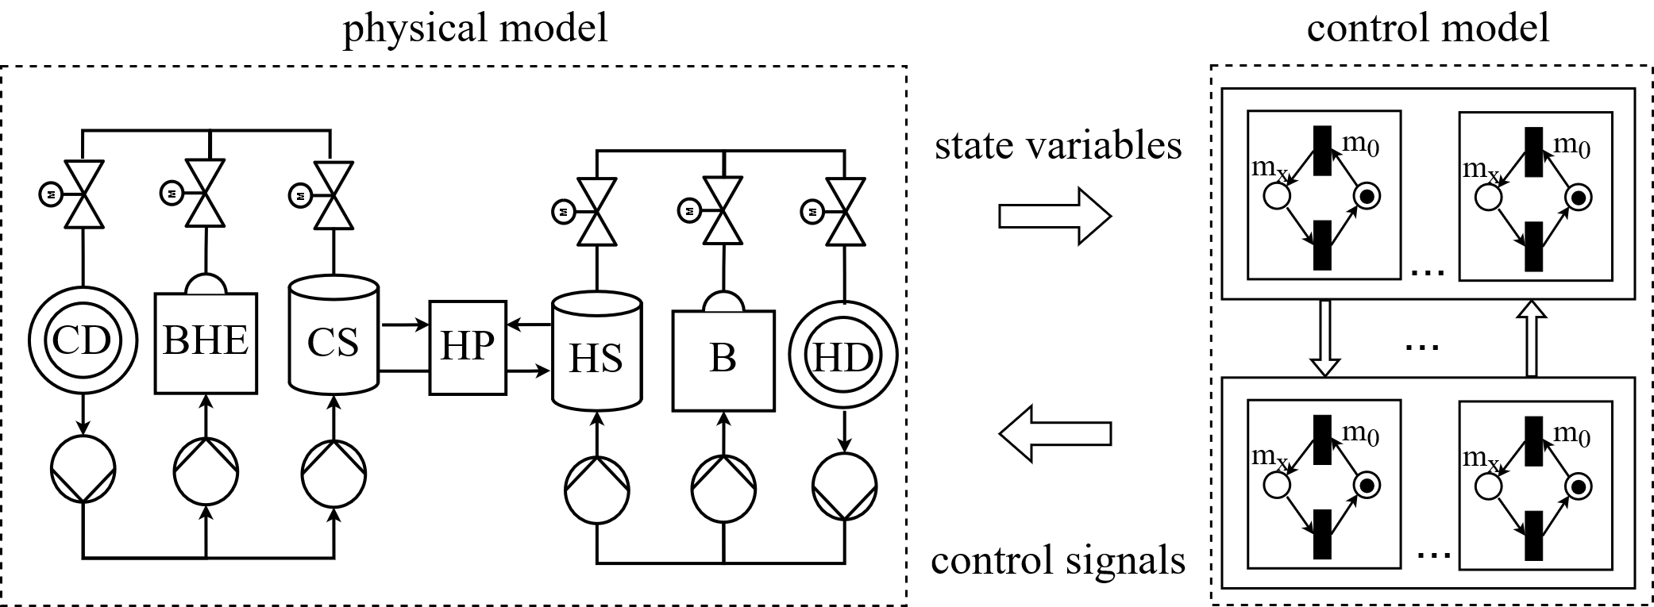
Figure 11: Modeling the energy system and the controller in the modeling language Modelica.CD: cold demand; BHE: borehole-heat-exchanger field; CS: cold storage; HP: heat pump; HS: heat storage; B: boiler; HD: heat demand; V: valve; P: pump.
”

Point 3: Please clarify also if and how the authors intend to increase the market uptake of the system.

Response 3: Thanks for your comments. In Section 3.5’s discussion, we’ve shown the possibility of automatically applying the MODI method and discussed the potential of this method to contribute to the digitized planning and implementation of building automation. These mentioned methods can be implemented in a toolchain to automatically apply the MODI method and hence reduce the cost of time and human resources. It might be an effective way to increase market uptake. To further highlight these two points, we added some text as follows:

Section 3.5, Ln 484: “The above-mentioned contributions of the MODI method to digitize the planning and implementation of building control functions are summarized in Fig. 16. According to these mentioned works, it is possible to automatically perform the MODI method in both the planning and implementation process of MODI control algorithms. Implementation of these works in a toolchain can facilitate the application of the MODI method and significantly contribute to the digitization of the planning and implementation of building automation.
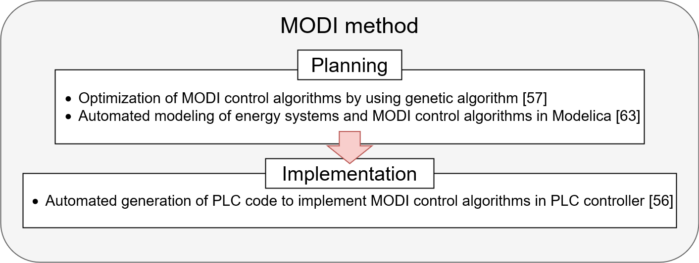Figure 16: The further investigations of the MODI method to enable a digitized planning and implementation process of building automation.”

