#2 Comments to Author
The author proposed the manuscript entitled “Indium oxide powder synthesis in a low-current
discharge plasma at atmospheric pressure”. The manuscript is well written and can be suitable
for acceptance, but there are some problems in this work preventing it from further consideration.
The following are some points that might be useful to refine the context.
Category: “Major revision”

Thanks for the valuable comments. The answers are given here. Corrections in the text of the manuscript are highlighted in red.
Comment:
1. There is a lack of correlation in the introduction section, I strongly recommend the author
rewrite the introduction starting with the In2O3 material property or background, what other
competitive wide bandgap materials have been studied so far, the need for In2O3 or its
advantages of it over other semiconducting materials, previously used synthesis technique for
In2O3, economic or another specific advantage of the present plasma technique, and so on.

2. What is the main novelty of this work, and what are the material's basic physical or
electrical properties? I would suggest the author accredit the related In2O3 article in the
introduction section.
According to the first and second points, the section "Introduction" is supplemented with information in accordance with these comments, including additional references to works related to this study.

3. It would be more attractive for the readers if the author modified the eye-catching
schematic Figure 1.
The figure has been modified.
4. Please check the Gas flow rate description is it really “1 l/min.”? usually gas flow rate is
described in SCCM standards.
Text has been corrected.
5. Is it possible for the author to measure or estimate the surface tension of the molten metal?
In accordance with this comment, the surface tension of molten indium was estimated. A related sentence and a link to the corresponding work, which describes the experimental technique for measuring this parameter, has been added to the text of the manuscript.
The surface tension is 518 mN/m, which corresponds to a surface energy of 5.18 10⁻⁵ J/cm². It is easy to estimate the energy density dissipated near the working surface of the cathode in one pulse of the discharge current. For example, when the discharge operates in an argon flow with a current of 670 mA, at a voltage of 180 V, and a pulse duration of 10 μs, with an active cathode surface area equal to the area of a hemisphere with a radius of 4 mm - 0.25 cm², it is approximately 480 10⁻⁵ J/cm² . Thus, it can be concluded that sufficient energy is imparted to the surface of the meniscus formed by molten indium to overcome the surface tension.
6. What is the range of applied current for the JEM 2100 transmission electron microscope,
and what are the other specific experimental operating condition for all instruments used?
The applied current in TEM does depend on the exposition mode. In particular, for collecting of the bright-field images in TEM the current was the largest ~104.5 μA. To get the high-resolution TEM images, we employed the smaller condenser aperture and the current dropped up to 103.7 μA. Finally, in the nano-beam diffraction mode, the applied current was the smallest ~103.1 μA.

7. The XRD reference data card (pdf card #03-065-3170) is the JCPDS reference or any other,
please mentioned it clearly.
The reference XRD pattern used for indexing of experimental data was taken from the commercially available ICDD (International Centre for Diffraction Data) Database, as mentioned in ref. 29. We described the pdf card number (#03-065-3170) as well as a symmetry group and a lattice constant in the manuscript. There are only two modification of In2O3: cubic and hexagonal. The former was found in our study.

8. How are the morphology, crystallinity, and particle size growth affected for the different
conditioned samples (Figure 5-7), is there any correlation between these properties and the
synthesis condition?
The text of the manuscript contains several sentences describing the effect of synthesis conditions on the morphology and structure of particles.
“Structural studies of the dispersed individual nanosized powder particles performed by transmission electron microscopy and powder aggregation in the form of a coating using X-ray diffractometry show that the data obtained by these inde-pendent methods are in good agreement. It was found that the structure of powder particles corresponds to a single phase of indium oxide (III) with body-centered cubic (bcc) lattice with a lattice parameter a = 1.013 nm. Energy dispersive analysis shows that, within the framework of this work, these particles are represented by non-stoichiometric indium oxide In₂O₃ with a nanocrystalline structure (<d> = 13–16 nm), regardless of the working gas (Ar or He).”

9. The author must estimate the particle size from the XRD data using the Debye Scherrer
formula, and compare the obtained data with the estimated particle size from TEM analysis.
Indeed, the size of the coherent scattering regions may be estimated by XRD using a peak broadening and Debye-Scherrer formula. Taking into account the splitting of Ka-dublet of the single peaks belonging to In₂O₃, the mean particle size calculated by XRD is ~10 nm that is slightly lower than that estimated in TEM (~15 nm). The possible reason of this discrepancy is a presence of defects (dislocations and stacking faults) inside the particles (Fig. 6c), so the perfect (mosaic) crystal packing is violated.

10. Did the author estimate the (= 0.1013 nm) value, it is identical for all three samples, please
provide the formula used for the estimation of a value.
The formula used for the estimation of the lattice parameters is given in Materials and Methods. We made an annoying misprint, because the value of the lattice parameter for In₂O₃ phase was a = 1.013 nm rather than 0.1013 nm. The accurate estimation of the lattice constant was done for symmetric (Bragg-Brentano) scheme of X-ray analysis. Since the larger measurement error of the lattice parameter in asymmetric scheme of X-ray analysis due to elastic stresses, etc., we did not perform such calculations in the paper. For all studied samples, the lattice parameter of In₂O₃ was practically the same and all SAED patterns are well indexing using the value of a = 1.013 nm.

11. What is the effect of current variation on cathodic thermal erosion, did the author check it?
Yes, such an effect exists.
The nature of the operation of a glow discharge at atmospheric pressure in the mode of generating flows of indium atoms for the synthesis of indium oxide nanopowder is such that the dependence of the temperature erosion of the cathode insert on the discharge current has a threshold character. Under the conditions of the present study, the transition to this regime was observed at the flat part of the discharge current pulse at a level of 350 mA. This was accompanied by the appearance in the spectrum of the optical radiation of the discharge plasma of lines of excited indium atoms of low intensity compared to the intensity of the lines of argon or helium. An increase in the discharge current led to an increase in the intensity of the lines of metal atoms, which is equivalent to an increase in their concentration in the total particle flux. This process is described in more detail using the example of obtaining fluxes of magnesium atoms in a discharge at atmospheric pressure in the work J. Appl. Phys. 127, 213303 (2020); https://doi.org/10.1063/5.0006239.

12. Figure format, font size, thickness, and used symbol should be consistent throughout the
manuscript, it must be in accordance with journal guidelines.
Agree. Done.
13. The author should provide the abbreviation at the of the manuscript before the reference
section.
Agree. Done. The explanation of the main abbreviations is given in the abstract and in the introduction.
14. English correction is highly needed to improve the manuscript's grammatical errors and
typo mistakes.
The English correction was performed by Dr. Ian G. Brown (Lawrence Berkeley National Laboratory). He is specialist in the field of gas and vacuum arc discharges physics, material physics. He is originally Australian and is a native speaker.
Article
Indium oxide powder synthesis in a low-current discharge plasma at atmospheric pressure
Konstantin Savkin ^{1,}*, Dmitry Sorokin ^{1,2}, Dmitry Beloplotov ¹, Marina Ostapenko ³,
Viktor Semin ^{2,3}, and Efim Oks ^{1,4}
Citation: To be added by editorial staff during production.
Academic Editor: Firstname Lastname
Received: date
Accepted: date
Published: date
Publisher’s Note: MDPI stays neutral with regard to jurisdictional claims in published maps and institutional affiliations.

Copyright: © 2022 by the authors. Submitted for possible open access publication under the terms and conditions of the Creative Commons Attribution (CC BY) license (https://creativecommons.org/licenses/by/4.0/).
¹ Institute of High Current Electronics SB RAS, 2/3, Akademicheskii Ave., 634055 Tomsk, Russia;
savkinkp@mail2000.ru (K.S.), rff.qep.bdim@gmail.com (D.B.)
² National Research Tomsk State University, 30, Lenin Ave., 634050 Tomsk, Russia;
sdmA-70@loi.hcei.tsc.ru (D.S.),
³ Institute of Strength Physics and Materials Science SB RAS, 2/4, Akademicheskii Ave., 634055 Tomsk, Russia;
viktor.semin.tsk@gmail.com (V.S.), artifakt@ispms.tsc.ru (M.O.)
⁴ Tomsk State University of Control Systems and Radioelectronics, 40, Lenin Ave., 634050 Tomsk, Russia; oks@fet.tusur.ru (E.O.)
* Correspondence: savkinkp@mail2000.ru; Tel.: +73822491776 (K.S.)
Abstract: We describe The results of a study of the processes involved in the production of indium oxide In₂O₃ powder, which is widely used to create transparent and electrically conducting ceramics are described. The powder was produced in a flow of rare gas (argon or helium) at atmospheric pressure under conditions for the formation of metal-containing plasma in a non-arc discharge mode. The discharge operated in pulsed mode with a pulse repetition rate 70 kHz and pulse duration 12 μs. The discharge current was 670 mA and mean power were 700 mA and 130 W discharge voltages were 180 V and 250 V when the working gases were argon and helium, respectively. These parameters ensure a mode in which the indium cap of a molybdenum cathode suffer thermal erosion. The morphology, elemental and phase composition of the erosion products were studied using transmission electron microscopy (TEM), energy-dispersive X-ray spectroscopy (EDS), and X-ray diffraction (XRD) analysis. We show It was shown that the structure of the synthesized powder particles corresponds to a phase of indium oxide (III) with a body-centered cubic (bcc) lattice with lattice parameter a = 0.1013 1.013 nm. The powder particles, regardless of working gas (Ar or He), consist of non-stoichiometric indium oxide In₂O₃ with nanocrystalline structure. The average particle diameter is <d> = 13–16 nm.
Keywords: Indium oxide; nano-powder; ceramic parts; atmospheric pressure discharge; plasma source; cathode; thermal erosion, TEM; EDS; XRD.

1. Introduction
Indium oxide (III) In₂O₃ is known as a material with some unique electrical, optical, and chemical properties. It is a wide-bandgap n-type semiconductor with a conductivity which changes with temperature [1, 2]. Researchers began to show a high interest in this material after the first works on its synthesis in the middle of the last century [1, 2]. At first, its thermoelectric (conductivity vs. temperature) [1, 2] and optical (transmittance vs. wavelength) properties [2, 3.] were studied. It was shown that indium oxide can be used as the basis of thin electrically conductive coatings with high transparency in the visible spectral region and a high reflection coefficient in the infrared one [4.]. In addition, in pioneering papers on this topic, an equally interesting and useful property of indium oxide was discovered, namely, the dependence of its electrical conductivity on the oxygen concentration in the surrounding atmosphere [1].
The change in its electrical properties due to chemisorption establishes its effectiveness in sensors for the detection of poisonous gases [35]. In addition, In₂O₃ can be used as a catalyst in carbon dioxide conversion reactions [46].
Powder composites based on indium oxide doped with a metal species (In_{2-x}M_{x}O₃) or tin oxide ([In₂O₃]_{0.9}-[SnO₂]_{0.1}) (ITO) are used for the formation of ceramic products for heating elements in thermoelectric generators [57], and of sputter targets for planar magnetron sputtering systems [68]. The latter are also used in technologies for creating thin-film transparent electrically conducting coatings for touch screens [79], solar panels [810], and low-emission coatings that are transparent in the visible spectral range and opaque in the infrared [9, 1011, 12]. Doping of indium oxide with atoms of ferromagnetic materials makes it possible to obtain transparent coatings with magnetic properties [13].
In parallel with research on the synthesis and application of indium oxide, a direction was developed related to the study of other wide-gap semiconductor materials, on the basis of which it is possible to form transparent electrically conductive coatings. Such materials are, for example, cadmium oxide [14], tin oxide [15] and zinc oxide [16]. Recently discovered graphene can also be added to this list [17].
Against the background of the depletion of world reserves of metallic indium [18], the trends in the development of new materials, for example, based on zinc oxide, are becoming more noticeable [19].
At present, the problem of the synthesis of indium oxide has passed the stage of laboratory research and its production, including in the form of a powder material, has securely occupied its niche in the world market. Nevertheless, scientific interest in the physical features of the synthesis of this material remains at a high level.
Some conventional chemical methods have been applied for the synthesis of indium oxide powders: sol-gel methods [11, 12 20, 21], including combustion of the reaction mixture [13 22]; thermal decomposition [14 23]; micro emulsion [15 24]; spray pyrolysis [16 25]; mechanochemical techniques [17 26]; nonaqueous synthesis [18 27]; and hydrothermal synthesis [19 28], including the use of ion-exchange membranes [20 29].
Indium oxide powders can be synthesized by ablation of a ceramic target by pulsed laser irradiation [21 30] and by laser photolysis [22 31]. We note particularly the use of electric discharge technologies for the production of nanosized particles. The use of a spark discharge approach is effective for this purpose as well [23–32-25-34].
Note that the above chemical methods for indium oxide nanopowder synthesis are directly related to the use of salts, alkoxides, acids and solvents. Thus, if technologies for disposing of the decomposition products of these substances are not applied, harm to both the environment and human health may ensue. In consideration of electrophysical and optical methods, it should be recognized that laser technology for the synthesis of nanopowders is less productive than an electrospark approach. However, as a result of the formation of cathode spots, which are an essential part of a spark discharge, the ejection of microdroplets occurs. These droplets have a significant scatter in size and can reach 1 µm in diameter [26 35].
These circumstances have encouraged researchers to seek new approaches for the synthesis of nanosized indium oxide powders using toxic material-free methods.
This study does not aim to prove a clear advantage of using indium oxide as the main raw material for the production of transparent electrically conductive ceramic coatings. The main idea of the paper is that the variety of methods for the synthesis of powders of oxide materials has not yet been exhausted. Along with the results of recent studies, for example, on the synthesis of indium oxide by combined evaporation of metallic indium simultaneously with its oxide [36], we propose a synthesis method based on a no less original electric discharge technology.
In the work described here, we have explored the synthesis of nanosized indium oxide powder via the generation of indium atom flows in an atmospheric-pressure, low-current, discharge plasma have been explored. The plasma was formed in a discharge gap with indium cathode, through which argon or helium at atmospheric pressure was pumped. A feature of this approach is the thermal erosion of the cathode; the use of powders, wires, or liquid precursors is not required. Since The discharge operates in a current range below the threshold for cathode spot formation glow mode. A characteristic feature of this mode is a sufficiently high voltage, more than 100 times higher than that of the cathode arc with an indium cathode [27 37]. This circumstance in this case eliminates the problem of erosion of the cathode material in the form of microdroplets the microdroplet problem is automatically eliminated. The presence of atomic indium particles was established by optical diagnostic methods, namely by the presence of the corresponding atomic and ionic lines in survey spectra of the plasma emission. The structural parameters (shape, size, phase composition) of particles synthesized in this way were explored using transmission electron microscopy (TEM) and X-ray diffraction analysis (XRD).

2. Experimental setup and measurement techniques
An illustration of the system we which have was used for the formation of metal-containing plasma in an atmospheric-pressure discharge is shown in Figure 1. The discharge gap of the plasma source is formed by an aluminum (Al) anode and molybdenum (Mo) cathode. Most of the cathode has a cylindrical shape, which morphs into a truncated cone (the working surface) at the end facing the anode. The cathode diameter is 6.5 mm, and the angle at the apex of the truncated cone is 60°. This design feature follows from temperature conditions in the discharge under which stable operation occurs while maintaining the discharge gap geometry and cathode mechanical strength. The anode is in the form of a disk with a central aperture. The back of the anode serves as part of a 10-ml glass container designed vial mounted to collect the erosion products from the cathode; this container can be replaced by another, as necessary. The discharge gap is located inside a quartz tube with outer diameter 20 mm and wall thickness 1.2 mm, allowing not only visual observation of the discharge but also recording of plasma emission spectra over a wide spectral range. The cathode is connected to the negative terminal of a power supply through a ceramic/metal current feedthrough. In the main body, made of Al alloy, this current feedthrough is fastened by a threaded connector. In operation of the plasma source, the current feedthrough retains its mechanical strength and insulating properties at temperatures up to 1000 K. A hole with a centering nut is located at the bottom of the main body, providing connection to a cable to the negative terminal of the power supply. The main body is at anode potential and is connected to the positive terminal of the power supply.
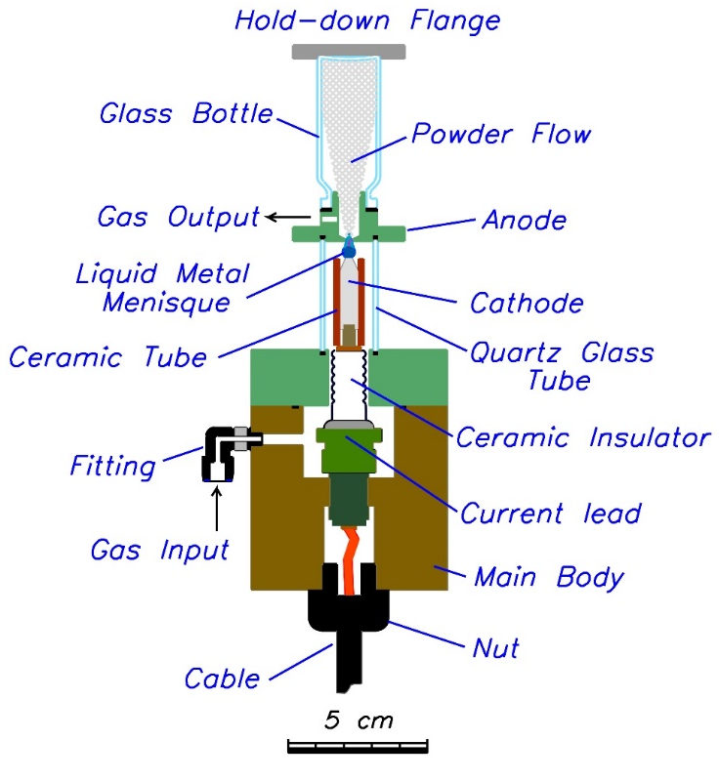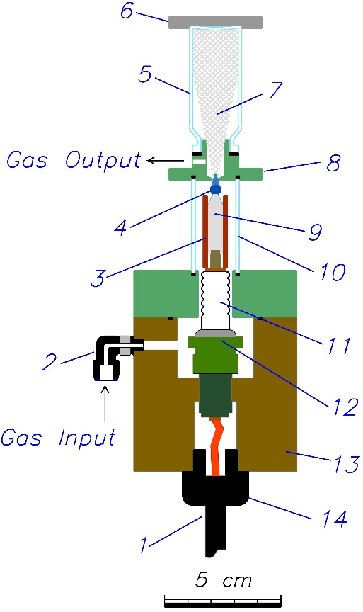
Figure 1. Schematic of the metal-containing plasma generator: 1 –Cable, 2 –Fitting, 3 –Ceramic Tube, 4 –Liquid Metal (Indium) Meniscus, 5 –Glass Vial, 6 –Hold-down Flange, 7 –Powder Flow, 8 –Anode, 9 –Cathode, 10 -Quartz Glass Tube, 11 –Ceramic Insulator, 12 Current Lead, 13 –Main Body, 14 –Nut.
Gas (argon or helium) is admitted to the discharge gap through an inlet in the main body, and is removed from the discharge chamber through an outlet in the side of the anode. Gas flow rate during experiments is approximately 1 l/min 750 sccm, taking into account the fact that the working gas was heated to a temperature of about 100 degrees Celsius (approximately 373 K). All joints are sealed with heat-resistant graphite packing gaskets.
The power supply operates in a repetitively pulsed mode, generating negative polarity pulses which feed the gap. The positive terminal of the power supply is grounded. The temporal behavior of the discharge pulse in argon is shown in Figure 2. During the pulse plateau (Δt = 2–10 μs), the discharge voltage U_{d} and discharge current I_{d} are 180 V and 670 mA, respectively. In helium the discharge voltage is U_{d} = 250 V at the same I_{d}. Thus, the pulse power P_{He} ≈ 167 W in helium is greater than that in argon, P_{Ar} ≈ 120 W. The pulse repetition rate is 67 kHz, for a duty cycle of 0.78.
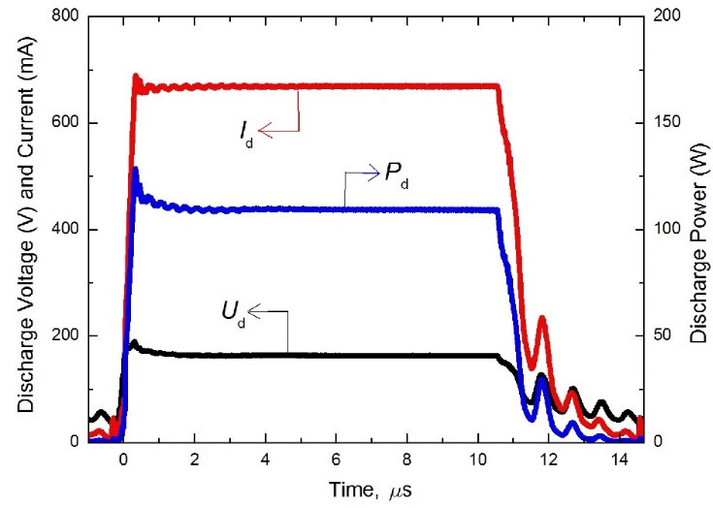
Figure 2. Measured waveforms of the discharge voltage and current, and the calculated discharge pulse power. Cathode tip – indium; working gas – argon.
The source of In atoms is an indium cap covering the working surface of the molybdenum cathode. To form this cap, a ceramic tube was put on the cathode, and a piece of metallic indium (3×3×3 mm) placed on the top of the truncated cone (the cathode top). The indium melts in 5–6 minutes of discharge in argon. The molten indium wets the cathode surface and forms a ball-shaped cap; this shape is generated by the surface tension of the molten metal. According to the empirical expression presented in [38. White, D.W.G. The surface tensions of indium and cadmium. Metall Mater Trans B 3, 1933–1936 (1972). https://doi.org/10.1007/BF02642581], the surface tension of liquid indium at a characteristic value of the cathode-crucible temperature of 600±30 degrees Celsius, measured by the contact method using a thermocouple, is approximately 518 mN/m (518 dynes/cm). The surface tension is 518 mN/m, which corresponds to a surface energy of 5.18 10⁻⁵ J/cm². It is easy to estimate the energy density dissipated near the working surface of the cathode in one pulse of the discharge current. For example, when the discharge operates in an argon flow with a current of 670 mA, at a voltage of 180 V, and a pulse duration of 10 μs, with an active cathode surface area equal to the area of a hemisphere with a radius of 4 mm - 0.25 cm², it is approximately 480 10⁻⁵ J/cm² . Thus, it can be concluded that sufficient energy is imparted to the surface of the meniscus formed by molten indium to overcome the surface tension.
The ceramic tube placed on the cathode, in turn, prevents runoff of liquid indium. After some operation time, the power is turned off and the system allowed to cool, after which the tube is removed. In the experiments, the absence of this ceramic tube had no effect on discharge stability and the generation of a stream of In atoms.
The presence of In in the discharge was established by spectral analysis of the optical radiation emitted by the plasma. The optical measurement scheme was arranged as follows. A converging lens of focal length 75 mm was used to project an image of the discharge onto a screen through a 1 mm aperture. A lens connected to a fiber optic cable was positioned opposite the aperture on the reverse side of the screen, and close to it. The light guide, in turn, was mounted to the input of an HR4000CG-UV-NIR (OceanOptics Inc.) spectrometer operating over the wavelength range Δλ = 200–1100 nm. The instrumental function of the spectrometer is Δλ_{instr} ~ 0.1 nm. In this way, the plasma optical radiation spectrum incident upon the aperture in the screen was recorded. For all elements of the optical measuring system, there are dependencies of the transmittance and sensitivity on the wavelength, provided either by the device or measured in-house using well-known methods and calibrated radiation sources. Identification of atomic In in the plasma was performed using the NIST database (National Institute of Standards and Technology, USA) [28 39].
The structural parameters (shape, size, phase composition) of particles synthesized in the atmospheric-pressure plasma in rare (Ar or He) gas flow were explored using a JEM 2100 transmission electron microscope (Jeol, Japan) operating at an accelerating voltage of 200 kV. The elemental composition of the particles was determined using an “INCA Energy” energy-dispersive spectrometer (Oxford Instruments, UK) mounted on a transmission electron microscope. The procedure was carried out by accumulating maps of the distribution of elements, as well as spectra from individual particles (point analysis). After cooling and condensation of the erosion products of indium, powder layers were obtained. These layers were subsequently dispersed by sonication in a solution of ethyl alcohol and then deposited on carbon-coated copper grids. X-ray diffraction studies of all samples were carried out using a Shimadzu XRD-7000 (Japan) diffractometer in Cu-K_{α} radiation. The lattice parameter a_{B2} of the В2 cubic phase was determined by a precision method with the construction of extrapolation dependencies a_{B2}^{hkl} a_{cubic} on the {2-1[(cos2θ/sinθ) + (cos2θ/θ)]} function. The lattice parameter measurement accuracy was Δa = ±0.00005 nm. Samples for X-ray diffraction studies were made on sheet copper. During the coating process, the samples were placed with the polished side directly towards the aperture in the anode. In this case, the glass vial at the top of the setup (see Figure 1) was removed. When analyzing the diffraction patterns, data on the structure of possible crystalline phases corresponding to the In-O system, taken from the database of powder X-ray diffraction patterns PDF-2, were used [29 40].

3. Results
A photographic image of the metal-containing plasma source in operation is shown in Figure 3a. Figure 3b shows an image of the discharge gap, in argon, captured on an enlarged scale and with reduced brightness.
Figure 3b shows clearly a meniscus of liquid indium (2) surrounded by cathode glow, the discharge column (3), and a “fringe” (4) formed by thermal erosion products of indium condensed near the anode aperture. The flow of working gas (Ar or He) through the anode hole transports the main part of the flow of indium particles from the discharge zone into the glass vial volume, where they settle on the wall inner surface.
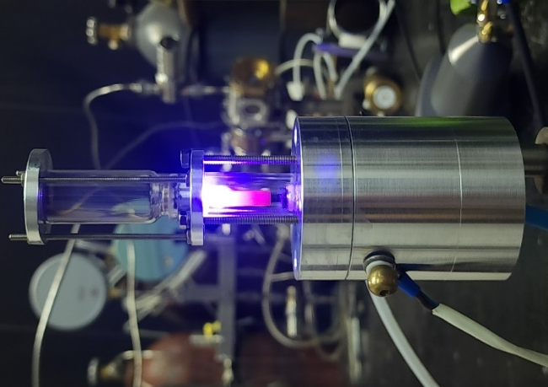 | 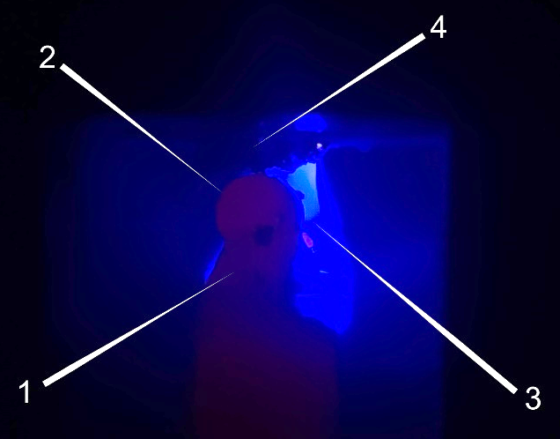
(a) | (b)
Figure 3. (a) Photograph of the plasma source during operation. (b) Photograph of the cathode region of a discharge in argon: 1 – conical surface of the cathode; 2 – meniscus formed by molten indium; 3 – discharge plasma glow; 4 – thermal erosion products of indium condensed near the anode hole (“fringe”).
The presence of In particles was identified by the emission spectra of the plasma (Figure 4). Thus, along with Ar or He atomic lines, lines of atomic indium with λ_{In1} = 410.17 nm and λ_{In2} = 451.1 nm were observed in the survey spectra. Note that the emission spectra contain the line of excited atomic molybdenum Mo I (λ_{Mo} = 587.39 nm), indicating the erosion of the top part of the cathode.
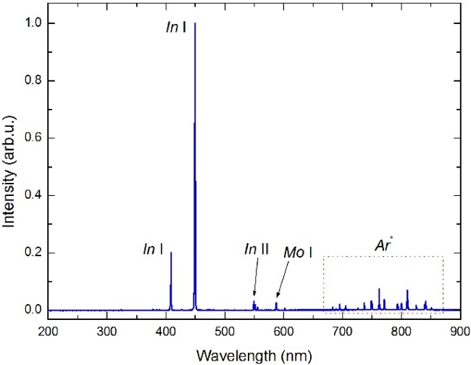 | 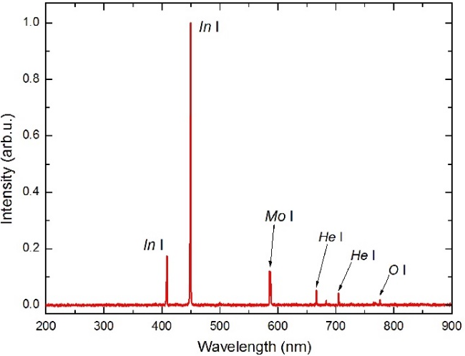
(a) | (b)
Figure 4. Optical emission spectra of the atmospheric-pressure discharge plasma (a) in Ar, and (b) in He flow.
The results of electron microscope studies of the structure of the erosion products of the material of the ball-shaped cathode tip formed by molten In are shown in Figures 5–7. TEM images of the particles condensed in the vicinity of the In cathode cap at the end of a ceramic tube placed on the Mo cathode are shown in Figure 5. Thus the bright-field image (Figure 5a) demonstrates the presence of particles with square cross-section. Nanodispersed particles of spherical or round shape were observed less often. Interpretation of the ring microdiffraction results (Fig. 5b) shows the presence of a single phase of indium oxide with cubic lattice, which is described by the Pearson symbol cI80 and the symmetry group Ia¯3. The distribution and thickness of the quasi-ring reflections indicate the nanocrystalline structure of the particles of synthesized powder. The high-resolution image (Fig. 5c) contains moiré patterns resulting from the superposition of misoriented In₂O₃ lattices. In this case, the interplanar distances in this phase, measured by the diameter of the rings on microdiffraction and high resolution patterns, differ from reference distances (pdf card #03-065-3170) [29 40]. This may indicate a defective structure of indium oxide crystals and their nonstoichiometric composition. The first assumption is supported by the deformation contrast observed on large particles and arising on single dislocations. A typical nanodiffraction pattern from an individual particle is shown in the inset to Figure 5c and represents the reciprocal lattice of the In₂O₃ phase of the same crystal structure described above. The average particle size measured from a series of dark-field images (Figure 5d) is 15±8 nm. The corresponding particle size distribution histogram is shown in the inset to Figure 5a.
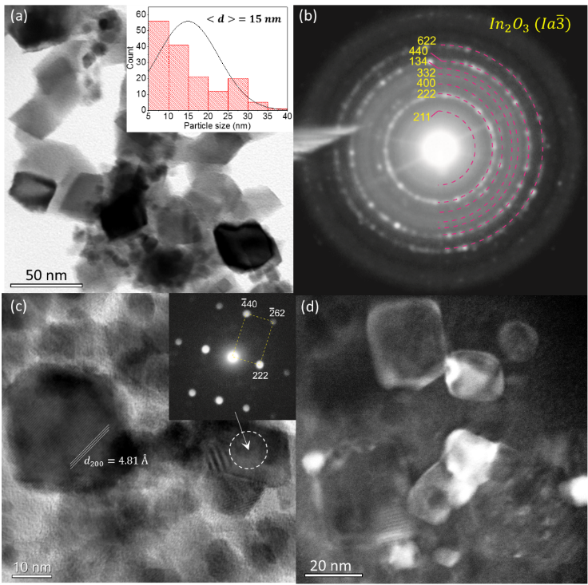
Figure 5. TEM images of In₂O₃ nanoparticles synthesized in an argon atmosphere and condensed in the immediate vicinity of the In cathode tip: (a, c) bright-field images, (b) microdiffraction pattern, (d) dark-field image. Insets in figures: particle size distribution histogram (Figure 5a), and nanodiffraction from a selected area (Figure 5c).
Analysis of TEM images of particles synthesized in argon plasma and condensed on the inner surfaces of the walls of the discharge chamber quartz tube and the glass vial located behind the anode indicates a greater variety of morphological types of crystallites, which have both straight faces and equiaxed shapes. The particles are grouped into conglomerates up to 100 nm in dimensions and belong to the bcc phase of In₂O₃. This is confirmed by the interpretation of the corresponding micro- (Figure 6b) and nano-diffraction patterns (inset to Figure 6c). Planar stacking faults are contained in the particle structure (Fig. 6c). The nature of these defects can be associated with the formation of dislocations during crystal growth. The average particle size (≈16±7 nm) in this case remains practically unchanged. The dark-field image (Figure 6d) shows an inhomogeneous diffraction contrast that intensifies near the boundaries of conjugated particles.
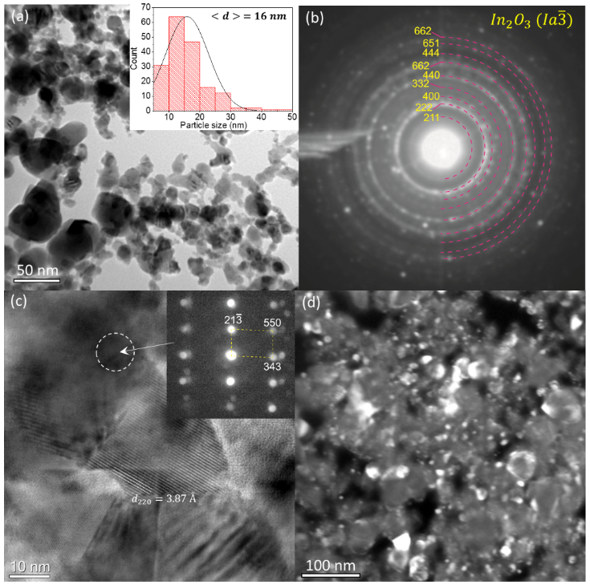
Figure 6. TEM images of In₂O₃ nanoparticles synthesized in an argon atmosphere and condensed on the inner surface of the wall of the discharge chamber quartz tube: (a, c) bright-field images, (b) microdiffraction pattern, (d) dark-field image. Insets in figures: particle size distribution histogram (Figure 6a) and nanodiffraction from a selected area (Figure 6c).
Indium erosion products condensed in a helium medium in the form of a powder collected on the glass vial walls contained In₂O₃ particles, predominantly of irregular shape. The boundaries of some crystallites are blurred and do not contain flat faces being typical for recrystallized grains (Figure 7a). Microdiffraction (Figure 7b) from the largest clusters of particles has a quasi-ring character and consists of a smaller number of point reflections. This, in turn, is associated with the formation of relatively large particles up to 50 nm in size. The identification of ring reflections demonstrates the same set of interplanar distances of the In₂O₃ phase as in the previous cases (Fig. 5b and Fig. 6b). The average particle size of the powder is reduced to 13±6 nm. In high-resolution images (Figure 7c,d), the contrast from dislocations and the interference contrast from moiré fringes are observed.
X-ray diffraction analysis of coatings based on indium erosion products during the discharge in an argon flow deposited on copper substrates (2×2 cm²), shows (see Figure 8) that the diffraction pattern contains only reflections from two phases Cu (Fm-3m (225), 00-001-1241) and In₂O₃ (Ia-3 (206), 03-065-3170). These phases have a cubic structure [29 40]. To separate the contributions to the diffraction patterns from the coating and the copper substrate, asymmetric survey schemes were carried out at grazing angles α₁ = 12° (Figure 8b) and α₂ = 5° (Figure 8c). These studies show that with decrease in the grazing angle α, which is equivalent to decrease in the thickness of the analyzed layer, the intensity of reflections of the In₂O₃ phase on the diffractograms increases (Figure 8c). Accordingly, the layer containing the phase of indium oxide (III) was on the surface. The lattice parameter of the Cu-based cubic phase was a = 0.3618 nm, and for the In₂O₃ phase a = 0.1013 1.013 nm.
The results of energy dispersive analysis of powder particles, performed by means of transmission electron microscopy equipped with an appropriate spectrometer (Table 1), indicate deviation of the chemical composition from stoichiometric. The proportion of indium in relation to oxygen is 1:4. In this case, an impurity of Mo (in trace concentration) was detected in the particles.
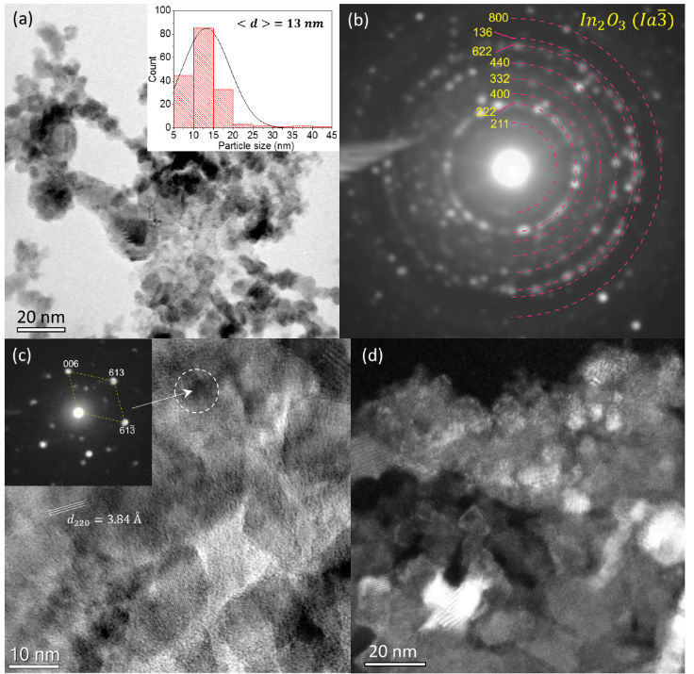
Figure 7. TEM images of In₂O₃ nanoparticles synthesized in an argon helium atmosphere and condensed on the inner surface of the wall of the glass vial located behind the anode: (a, c) bright-field images, (b) microdiffraction pattern, (d) dark-field image. Insets in figures: particle size distribution histogram (Figure 7a) and nanodiffraction from a selected area (Figure 7c).
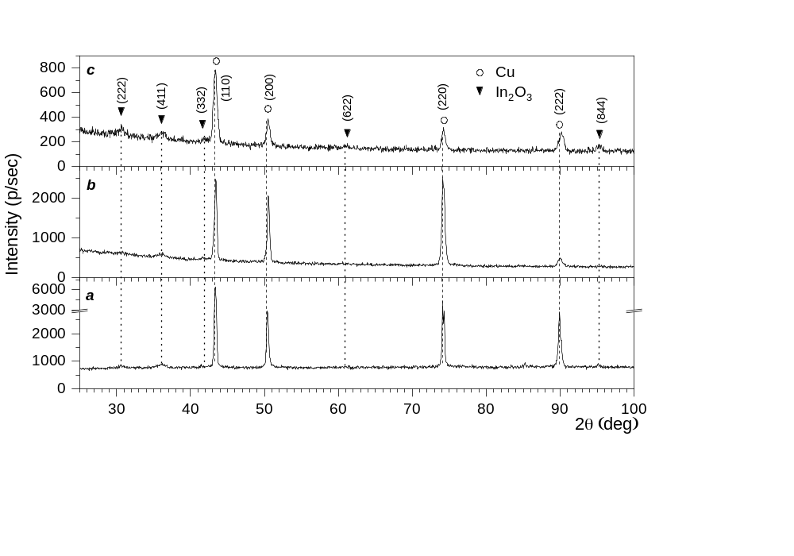
Figure 8. X-ray diffraction patterns of Cu samples coated with In₂O₃, obtained by (a) symmetric, and (b) asymmetric survey schemes, with grazing angles α = 12° and (c) α = 5°.

Table 1. TEM/EDS analysis of In₂O₃ powder particles elemental composition.
Sample | In, at.% | O, at.% | Mo, at.%
@ discharge current I_{d} = 670 mA and discharge voltage U_{d} = 180 V
In₂O₃ @ Ar  near the cathode | 20.4 | 79.3 | 0.3
In₂O₃ @ Ar  quartz tube walls | 23.4 | 76.0 | 0.6
@ discharge current I_{d} = 670 mA and discharge voltage U_{d} = 250 V
In₂O₃ @ He  glass vial walls | 17.6 | 81.9 | 0.5

4. Discussion
The appearance of the visually observable jet flowing through the anode hole from the region of atmospheric-pressure plasma is a consequence of the fact that, because of processes at the cathode, flows of metal atoms are generated due to thermal erosion of the molten material of the cathode cap. A possible mechanism for this phenomenon could be based on the transport of metal atoms by the working gas (Ar or He) flow from the thinnest vapor layer above the surface of the liquid metal meniscus formed at the top of the cathode. Direct evaporation in this case is difficult, since the temperature of the cathode, under these conditions, is significantly lower than the boiling point of indium. Thermal diffusion across the meniscus surface is the reason why atoms enter the discharge gap, where they are then ionized and excited in collisions with plasma electrons.
Analysis of the emission spectra shows that strong In atomic lines are observed in addition to lines of atoms of the working gas – argon or helium. Note that in the wavelength range under consideration, atomic transitions of metal atoms account for the radiation energy, which makes up a significant share of the spectral energy distribution over the entire range. It follows from the observed spectra that the molybdenum cathode also contributes to the plasma emission. This is confirmed by the fact that when visualizing the near-cathode region (see Figure 3b), it is clearly seen that the cathode glow covers not only the indium meniscus, but also the molybdenum body of the cathode that is not wetted with indium. Since the temperature of the cathode is much lower than the melting temperature of Mo, the proposed mechanism of Mo atomic diffusion into the vapor layer and subsequent transport upon interaction with the working gas flow, most likely cannot be implemented. In this regard, it should be assumed that electrical erosion can occur in the cathode spots of a sub-microsecond spark discharge that occurs at the initiation of individual discharge pulses. In any case, this phenomenon deserves special attention and requires a more detailed study.
Structural studies of the dispersed individual nanosized powder particles per-formed by transmission electron microscopy and powder aggregation in the form of a coating using X-ray diffractometry show that the data obtained by these independent methods are in good agreement. It was found that the structure of powder particles corresponds to a single phase of indium oxide (III) with body-centered cubic (bcc) lattice with a lattice parameter a = 0.1013 1.013 nm. Energy dispersive analysis shows that, within the framework of this work, these particles are represented by non-stoichiometric indium oxide In₂O₃ with a nanocrystalline structure (<d> = 13–16 nm), regardless of the working gas (Ar or He).
Note that among the investigated erosion products of the indium cathode tip, particles of metallic indium were completely absent. When coatings are deposited on copper substrates placed in ambient air, this is an obvious consequence. The metal-containing plasma jet is mixed with ambient air at the source outlet, where the transported indium particles are oxidized. However, the use of a container for collecting the erosion products, in the form of a glass vial placed immediately after the anode hole and hermetically fixed to the anode through sealing gasket, assumes that both the generation of metal particles during discharge operation and their collection is carried out in an airless environment. The design of the plasma source allows continuous pumping of the working rare gas, both during dispersion of In in the discharge plasma and after it is turned off, up to the cooling of the structural elements of the source. However, in this case also, only In₂O₃ particles are seen in the composition of the erosion products. This experimental fact can be associated with the oxidation of metallic indium particles as a result of interaction with oxygen already in the discharge plasma, since the working gases are not 100% pure and contain small quantities of nitrogen, oxygen, and water vapor admixtures; the volume fraction of oxygen in these mixtures is about 2 x 10⁻⁴%. One should also not exclude the possibility of the formation of indium oxide as a result of interaction with oxygen of metal particles located on the walls of the glass vial, as well as on the anode and other elements of the plasma source discharge system after its operation is completed, as a result of prolonged exposure to the ambient atmosphere. The production of metallic indium nanoparticles was not the aim of this study. Nevertheless, plasma-chemical processes involving dispersed metal particles with a gaseous medium are of considerable interest and call for a more detailed study.

5. Conclusions
We have explored The processes of indium oxide (III) powder synthesis by indium dispersion due to cathode thermal erosion in a low-current (up to 1 A 670 mA) atmospheric-pressure discharge in an argon or helium flow have been explored. A newly-developed kind of plasma source was used to provide a stable flow of thermal erosion products from the ball-shaped meniscus formed by the melting of the indium cathode tip in continuous discharge operation. As applied to the generation of metal-containing plasma flows at atmospheric pressure, this approach differs from more conventional approaches in that the cathode is a source of metal atoms that enter the plasma by diffusion through the liquid-metal meniscus surface. In addition, this approach does not require a supply of raw materials in the form of metal powder, wire, or injection of solutions of metal chemical compounds into the discharge zone, since all processes occur through the interaction of non-equilibrium low-temperature plasma with electrodes of specific design. Studies of the powder formed by TEM, XRD and EDS show that the synthesized indium oxide In₂O₃ has the following characteristics. The structure of the powder particles corresponds to a single phase of indium oxide (III) with body-centered cubic (bcc) lattice with lattice parameter a = 0.1013 1.013 nm. Powder particles, regardless of the working gas (Ar or He), consist of non-stoichiometric In₂O₃ with nanocrystalline structure (<d> = 13–16 nm). Our novel plasma source is a self-consistent system that generates flows of indium oxide (III) powder which can be used to create indium-containing ceramics.

Author Contributions: Conceptualization, K.S. and D.S.; methodology, K.S., D.S and D.B..; validation, K.S., D.S. and E.O.; formal analysis, D.B., D.S. and V.S.; investigation, D.B., D.S., V.S., M.O. and K.S.; resources, D.S., V.S., M.O. and E.O.; data curation, K.S.; writing—original draft preparation, D.B., D.S., V.S. and K.S.; writing—review and editing, D.B., D.S., V.S. and K.S.; visualization, V.S. and E.O.; supervision, K.S., D.S. and E.O.
All authors have read and agreed to the published version of the manuscript.
Funding: The study was supported by the Russian Science Foundation under grant 22-19-00265, https://rscf.ru/en/project/22-19-00265/.
Acknowledgments: The authors greatly appreciate Dr. Ian Brown (Lawrence Berkeley National Laboratory) for helpful discussion as well as for English correction.
Institutional Review Board Statement: Not applicable.
Informed Consent Statement: Not applicable.
Data Availability Statement: Not applicable.
Conflicts of Interest: The authors declare no conflict of interest.

References

- Rupprecht G. Untersuchungen der elektrischen und lichtelektrischen leitfähigkeit dünner indiumoxydschichten. Z. Physik. 1954, 139, 504–517. DOI: 10.1007/BF01374559
- Weiher R. L. Electrical properties of single crystals of indium oxide. J. Appl. Phys. 1962, 33, 2834-2839. DOI: 10.1063/1.1702560
- Weihr R.L. and Ley R.P. Optical properties of indium oxide. J. Appl. Phys. 1966, 37, 299-302. DOI: 10.1063/1.1707830
- Müller H.K. Phys. Electrical and optical properties of sputtered In₂O₃ films. II. Optical properties in the near infrared. Status Solidi B. 1968, 27(2), 733-740. DOI: 10.1002/pssb.19680270230
- Korotcenkov G., Choa B.K., Boris I., Han S.H., Lychkovsky Yu., Karkotsky G. Indium oxide ceramics doped by selenium for one-electrode gas sensors. Sensors and Actuators B. 2012, 174, 586–593. DOI: 10.1016/j.snb.2012.07.090
- Dang S., Qin B., Yang Y., Wang H., Cai J., Han Y., Li S., Gao P., Sun Y. Rationally designed indium oxide catalysts for CO₂ hydrogenation to methanol with high activity and selectivity. Sci. Adv. 2020, 6, eaaz2060 (1–11 pp.). DOI: 10.1126/sciadv.aaz2060
- Guilmeau E., Bérardan D., Simon Ch., Maignan A., Raveau B., Ovono Ovono D., and Delorme F. Tuning the transport and thermoelectric properties of In₂O₃ bulk ceramics through doping at In-site. J. Appl. Phys. 2009, 106, 053715 (1–8 pp.). DOI: 10.1063/1.3197064
- Saadeddin I., Hilal H.S., Decourt R., Campet G., Pecquenard B. Indium oxide co-doped with tin and zinc: A simple route to highly conducting high density targets for TCO thin-film fabrication. Solid State Sciences. 2012, 14, 914–919. DOI: 10.1016/j.solidstatesciences.2012.04.021
- Wu C.-C. Highly flexible touch screen panel fabricated with silver-inserted transparent ITO triple-layer structures. RSC Adv. 2018, 8, 11862–11870. DOI: 10.1039/c7ra13550e
- Chen D., Jiang Y., Sun Z., Huang Y, Yu J., Chen T. ITO/Ag/ITO and ITO/Cu/ITO transparent rear contacts for semi-transparent perovskite solar cells. Thin Solid Films. 2022, 752, 139252. DOI: 10.1016/j.tsf.2022.139252
- Sun K., Zhou W., Tang X., Luo F. Application of indium tin oxide (ITO) thin film as a low emissivity film on Ni-based alloy at high temperature. Infrared Physics & Technology. 2016, 78, 156–161. DOI: 10.1016/j.infrared.2016.07.021
- Ghosh S.S., Biswas P.K., Neogi S. Thermal performance of solar cooker with special cover glass of low-e antimony doped indium oxide (IAO) coating. Appl. Therm. Eng. 2017, 113, 103–111. DOI: 10.1016/j.applthermaleng.2016.10.185
- Berardan D. and Guilmeau E. Magnetic properties of bulk Fe-doped in-dium oxide. J. Phys.: Condens. Matter. 2007, 19, 236224 (1-9 pp). DOI:10.1088/0953-8984/19/23/236224
- Heidari A., Brown C. Study of composition and morphology of cadmium oxide (CdO) nanoparticles for eliminating cancer cells. J. Nanomed. Res. 2015, 2(5), 141-154. DOI: 10.15406/jnmr.2015.02.00042
- Dheyab M.A., Aziz A.A., Jameel M.S., Oladzadabbasabadi N. Recent advances in synthesis, modification, and potential application of tin ox-ide nanoparticles. Surf. Interfaces, 2022, 28, 101677 (1-16 pp.). DOI: 10.1016/j.surfin.2021.101677
- Mandal A.K., Katuwal S., Tettey F., Gupta A., Bhattarai S., Jaisi S., Bhandari D.P., Shah A.K., Bhattarai N., Parajuli N. Current research on zinc oxide nanoparticles: synthesis, characterization, and biomedical applications. Nanomaterials 2022, 12, 3066 (1-31 pp.). DOI: 10.3390/nano12173066
- Fan X., Zhao Z., Liang X., Huai X., Wang C., Liu J., Duan C. Graphene reinforced anticorrosion transparent conductive composite film based on ultra-thin Ag nano-film. Materials 2022, 15, 4802 (1-14 pp.). DOI: 10.3390/ma15144802
- Werner T.T., Mudd G.M., Jowitt S.M. The world’s by-product and critical metal resources part III: A global assessment of indium. Ore Geol. Rev., 2017, 86, 939-956. DOI: 10.1016/j.oregeorev.2017.01.015
- Salimian A., Hasnath A., Anguilano L., Onwukwe U., Aminishahsavarani A., Sachez C., Upadhyaya H. Highly conductive zinc oxide based transparent conductive oxide films prepared using RF plasma sputtering under reducing atmosphere. Coatings 2020, 10, 472 (1-17 pp.). DOI:10.3390/coatings10050472
- Li X., Xu X., Yin X., Li C., Zhang J. A sol–gel method to synthesize indium tin oxide nanoparticles. Particuology. 2011, 9, 471–474. DOI: 10.1016/j.partic.2011.03.013
- Maensiri S., Laokul P., Klinkaewnarong J., Phokha S., Promarak V., Seraphin S. Indium oxide (In₂O₃) nanoparticles using Aloe vera plant extract: Synthesis and optical properties. Optoelectronics and Advanced Materials – Rapid Communications. 2008, 2, 161–165.
- Ayeshamariama A., Kashif M., Bououdinac M., Hashimb U., Jayachandrane M., Ali M.E. Morphological, structural, and gas-sensing characterization of tin-doped indium oxide nanoparticles. Ceramics International. 2014, 40, 1321–1328. DOI: 10.1016/j.ceramint.2013.07.012
- Rey J.F.Q., Plivelic T.S., Rocha R.A., Tadokoro S.K., Torriani I., and Muccillo E.N.S. Synthesis of In2O3nanoparticles by thermal decomposition of a citrate gel precursor. Journal of Nanoparticle Research. 2005, 7, 203–208. DOI: 10.1007/s11051-004-7899-7
- Jiang Z., Liu T., Zhai X., and Liu J. Optimization preparation of indium tin oxide nanoparticles via microemulsion method using orthogonal experiment. Crystals. 2021, 11, 1387 (1–13 pp.). DOI: 10.3390/cryst11111387
- Prathap P., Gowri Devi G., Subbaiah Y.P.V., Ramakrishna Reddy K.T., Ganesan V. Growth and characterization of indium oxide films. Current Applied Physics. 2008, 8, 120–127. DOI: 10.1016/j.cap.2007.06.001
- Yang H., Tang A., Zhang X., Yang W., Qiu G. In₂O₃ nanoparticles synthesized by mechanochemical processing. Scripta Materialia. 2004. 50, 413–415. DOI: 10.1016/j.scriptamat.2003.11.011
- Niederberger M., Garnweitner G., Buha J., Polleux J., Ba J., Pinna N. Nonaqueous synthesis of metal oxide nanoparticles: Review and indium oxide as case study for the dependence of particle morphology on precursors and solvents. J. Sol-Gel Sci Techn. 2006, 40, 259–266. DOI: 10.1007/s10971-006-6668-8
- Xu J., Wang X., Shen J. Hydrothermal synthesis of In₂O₃ for detecting H₂S in air. Sensors and Actuators B. 2006, 115, 642–646. DOI: 10.1016/j.snb.2005.10.038
- Xu H.-R., Zhou H., Zhu G., Chen J., Liao C. Synthesis of tin-doped indium oxide nanoparticles by an ion-exchange and hydrothermal process. Materials Letters. 2006, 60, 983–985. DOI: 10.1016/j.matlet.2005.10.062
- Acacia N., Barrec F., Barlett E., Spadaro D., Currò G., Neri F. Laser ablation synthesis of indium oxide nanoparticles in water Applied Surface Science. 2010, 256, 6918–6922. DOI: 10.1016/j.apsusc.2010.05.003
- Tsuchiya T., Watanabe A., Niino H., Yabe A., Yamaguchi I., Manabe T., Kumagai T., Mizuta S. Low temperature growth of metal oxide thin films by metallorganic laser photolysis. Applied Surface Science. 2002, 186, 173–178. DOI: 10.1016/S0169-4332(01)00616-X
- Zhang L., Wu J., Chen F., Li X., Schoenung J.M., Shen Q. Spark plasma sintering of antimony-doped tin oxide (ATO) nanoceramics with high density and enhanced electrical conductivity. Journal of Asian Ceramic Societies. 2013, 1, 114–119. DOI: 10.1016/j.jascer.2013.03.010
- Wang X., Suwardi A., Zheng Y., Zhou H., Chien S.W., Xu J. Enhanced thermoelectric performance of nanocrystalline indium tin oxide pellets by modulating the density and nanoporosity via spark plasma sintering. ACS Appl. Nano Mater., 2020, 3, 10156–10165. DOI: 10.1021/acsanm.0c02113
- Rudzik T.J. and Gerhardt R.A. Effect of spark plasma sintering current and voltage on the microstructure and electrical properties of borosilicate glass–indium tin oxide composites. Adv. Eng. Mater. 2020, 22, 1901431. DOI: 10.1002/adem.201901431
- Siemroth P., Laux M., Pursch H., Sachtleben J., Balden M., Rohde V., Neu R. Diameters and velocities of droplets emitted from the cu cathode of a vacuum arc. IEEE Trans. Plasma Sci. 2019, 47, 3470–3477. DOI: 10.1109/TPS.2019.2912518
- Smirnov A.S., Gribchenkova N.A., Alikhanyan A.S. Thermodynamics of hetero-gene-ous equilibria in the In–In₂O₃ system by Knudsen effusion mass spectrometry. Rapid Commun. Mass Spectrom. 2022, 36, e9248. DOI: 10.1002/rcm.9248
- Kesaev I.G. Cathode Processes in Electric Arcs; Nauka: Moscow, Russia, 1968. (in Russian)
- White D.W.G. The surface tensions of indium and cadmium. Metall. Mater. Trans. B, 1972, 3, 1933–1936. DOI: 10.1007/BF02642581
- NIST Atomic Spectra Database (ver. 5.10). Available online: https://www.nist.gov/pml/atomic-spectra-database (accessed on 11/24/2022).
- Release 2014 of the Powder Diffraction File. The International Centre for Diffraction Data, 2017 [https://www.icdd.com/]

