Response to Reviewer 2 Comments

Point 1: Figure 1 must be readable.

Response 1: Figure 1 has been modified as follows:
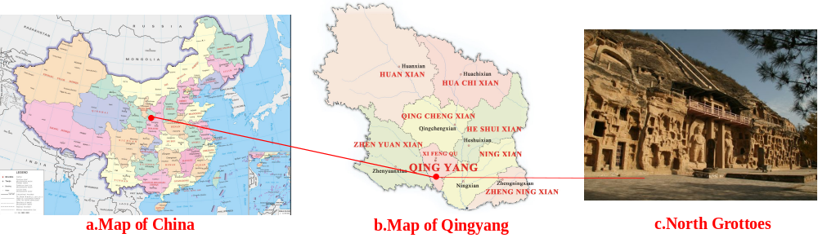

Point 2: Reference style must be as per journal format.

Response 2: Reference style in the manuscript has been modified.

Point 3: Concise the abstract according to the journal format.

Response 3: The abstract has been modified as follows:
The influence of rock weathering caused by freeze-thaw on stone cultural relics cannot be ignored. For immovable stone cultural relics, different parts under different environmental conditions will be under different freeze-thaw action, suffer different degrees of damage. In this paper, three typical freeze-thaw cycle tests of sandstone are designed, namely, immersion test, capillary action test and periodic saturation test. The macroscopic and microscopic morphologies of rock samples under different freeze-thaw cycles were analyzed. Weathering indicators such as porosity, water content, wave velocity and surface hardness were tested, as well as uniaxial compressive strength. The variation law of weathering index and uniaxial compressive strength under different freezing-thawing cycles was obtained, and the quantitative relationship between each index parameter was further analyzed. The results show that under different freezing-thawing conditions, the apparent morphology of rock samples is different, and the trend of weathering indexes is similar, but the change rate is different. The water content of rock has great influence on the test results of wave velocity, but has little influence on the surface hardness. The function relationship between weathering index and compressive strength under different freezing-thawing modes is similar, but the fitting parameters are different. Finally, the strength and wave velocity damage factors were used to quantitatively evaluate the rock weathering degree. The results show that the immersion freeze-thaw damage is the highest, the periodic saturated freeze-thaw damage is the second, and the capillary freeze-thaw damage is the least. It is consistent with the field observation results. The conclusion of this paper can provide reference for the detection of stone cultural relics and provide scientific basis for the anti-weathering protection of stone cultural relics.

