Response to Reviewers
First of all, thank you for allowing me to improve the quality of the study, the authors sincerely appreciate the editors and the reviewers for their work to review the manuscript again. Based on the valuable comments, the authors revised some of the text as well as the figures, though the essence of the manuscript keeps unchanged. Now the authors are sure that the revised manuscript is much better than the original, and they would appreciate it very much if the editors and reviewers could point out further comments toward the publication.
The authors respond to all the comments one-by-one in the following. They also prepared the detailed revision note as a separate file.

Reviewer 2:
1. The abstract must contain the methodology. Also, in existing position, the abstract is comparatively lengthy (read the instructions for the authors). The revised abstract must include the problem statement/research gap, methodology, and results along with concise background.
Thank you for your advice.The article abstract has been rewritten as follows:
Freeze-thaw is one of the most important factors of stone cultural relics weathering in northern China. Due to the large size of the immovable caves, there are significant differences in the environments in which different parts of the caves are located, and they are damaged to different degrees from the same freeze-thaw action. In this paper, three kinds of typical freeze-thaw cycle tests of sandstone were designed, namely, immersion test, capillary action test, and periodic saturation test. The macroscopic and microscopic morphologies of rock samples under different freeze-thaw cycles were analyzed,, and weathering indexes such as porosity, water content, wave velocity, and surface hardness were tested. Uniaxial compressive strength was taken as a reference index of mechanical properties. The variation rules of weathering indexes and mechanical properties under different freeze-thaw cycles were obtained, and the quantitative relationship among the indexes was further analyzed. The results show that under different freeze-thaw conditions, the morphologic characteristics of rock samples are significantly different, and the variation trend of each weathering index is similar, but the change rate is different. The water content of rock has a great influence on the wave velocity test results, but a slight influence on the surface hardness. The functional relationship between nondestructive testing indexes and mechanical strength was similar under different freeze-thaw methods, but the fitting parameters were different. Finally, the strength and wave velocity damage factors were used to quantitatively evaluate the weathering degree of rock under different freeze-thaw modes, in which the immersion freeze-thaw damage degree was the highest, the periodic saturation freeze-thaw damage degree was the second, and the damaging effect of capillary freeze-thaw was the least. The conclusion of this paper can provide a reference for the detection of stone cultural relics and the scientific basis for the protection of stone cultural relics against weathering.

2. Details map of the samples location.
The authors add a map of rock sampling locations to the article as follows:
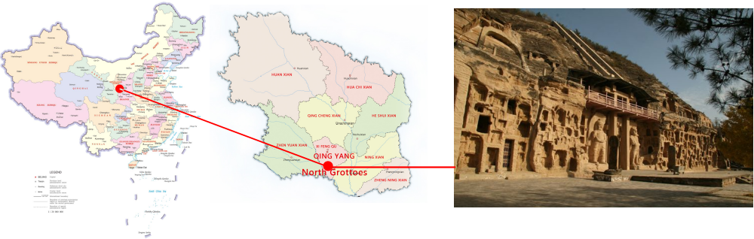
Fig. 1 Rock sampling site - Qingyang, Gansu, China

3. Temperature record of the area, from where the samples are collected. Is this taken as the
maximum and minimum temperature in the experiments.
4. The background is discussed comprehensively, but how about the freezing and thawing
duration. On what basis the authors selected the temperature and their duration (Figure 3).Discuss comprehensively.
The authors explain questions 3 and 4 as follows:
According to meteorological data of the North Grottoes in Qingyang, Gansu, the climatic temperature in the region in recent 10 years is 30°C at the highest and -20°C at the lowest. The surface temperature of the caves in summer afternoon is around 40°C and in the winter the surface temperature is close to -25°C, with a moderate increase on the basis of the historical true temperature. The annual trend of seasonal relative temperature in the Qingyang shows that the time period of below and above 0°C is about 6 months. The present study investigates the failure characteristics and variation rules of rock mass under extreme temperature conditions.

5. Show the experimental setup.
The freeze-thaw test is carried out in the humid heat chamber with rapid temperature change. The temperature control range is from -40°C to +120°C, and the allowable error is ±1°C. The heating and cooling rates are up to 10℃/min, which meets the requirements of the test, the test chamber is shown in Figure 4.

Fig. 4 Rapid temperature to humidity test chamber

6. Avoid the slash (/) between the symbol and unit. Some other minor linguistic mistakes are
present in the manuscript (For example line 19, 189).
Thank you for your correction. Some minor linguistic mistakes have been amended in the article.

7. Discuss the results. For example, Figure 6 need discussion.
Thank you for your advice. The authors have reanalysed the results as follows:
In terms of the change law of micromorphology,the phenological deterioration rate of rock samples under different freeze-thaw modes is different, but the change law of rock samples under the three freeze-thaw conditions is similar.The sample with periodic saturated freeze-thaw cycles is taken as an example, and its micromorphology is shown in Figure 9. At the beginning of the test (FIG. 9a), the particles were closely arranged, the pores and cracks were small, and the cement was filled between the particles. After 10 cycles (FIG. 9b), the sample was in a state of "rapid metamorphic". Compared with the initial compact arrangement, microcracks between grains gradually developed, and some cements were affected by hydrolysis and developed more internal cracks. Small particles such as calcite can be seen attached; During the 10 cycles (FIG. 9c), on the one hand, the mass loss of cement leads to the formation of pores and the connection of fractures; on the other hand, feldspar and dolomite particles are broken under the influence of hydrolysis, and new fractures are generated on the surface. Finally, at the time of failure (FIG. 9d ~f), the cracks have been completely connected, and the particles are scattered and cut by them. Some particles also develop internally, and some particles also develop cracks within and become fragments. In general, with the increase of the number of cycles, the cracks of sandstone particles continue to expand, and the pores in rock samples gradually increase and the pore size becomes larger. In addition, the pores continue to expand and extend, and gradually form the connected cracks, typical variations in rock micromorphology are shown in the red circle area.
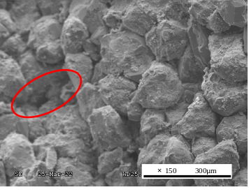 | 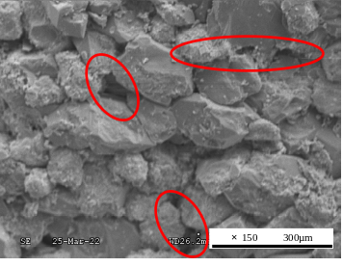 | 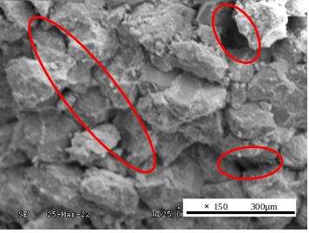
- 5 cycles | - 10 cycles | - 20 cycles
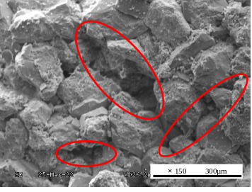 | 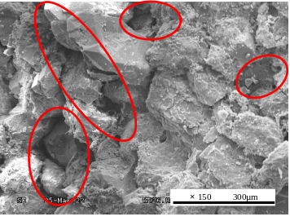 | 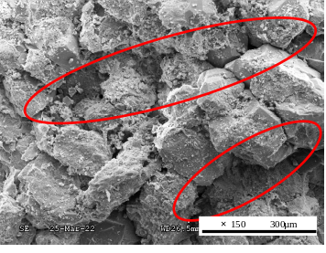
- 40 cycles | - 60 cycles | - 80 cycles
Fig. 9 Microscopic morphology changes of rock samples with capillary freeze-thaw cycles

8. The authors have plotted the results, but how about the trend in literature between different parameters. Discuss your results with existing literature. The following paper can enhance the literature; Development of Predictive Models for Determination of the Extent of Damage in Granite Caused by Thermal Treatment and Cooling Conditions Using Artificial Intelligence.
Thank you for your advice. The authors have quoted the article as follows:
Khan N et al. developed three models for predicting the degree of flint thermal response damage based on density, wave velocity and porosity. The results showed that the prediction model similar to the neural network was more accurate than MLR and ANFIS, and the damage factor based on porosity was more effective than that based on elastic modulus.

9. How about the results relation with filed (real time deterioration)? Discuss.
Figure 8 shows the current state of weathering on the façade of the North Grottoes in Qingyang, Gansu, China. It can be seen that, under the influence of freeze-thaw action and cave building environment, the bottom and interior of the cave are seriously damaged by seepage erosion, and the cave deteriorates obviously. There are many longitudinal and transverse pore cracks in the surface layer. In the severely weathered area, part of the surface layer has spalled off. The upper part of the cave, the middle part and the Buddha in the cave are affected by capillity, the particle loss is serious, and the surface has white crystal precipitation. The appearance of the cavity is similar to the test results, with obvious discoloration and longitudinal and transverse cracks.
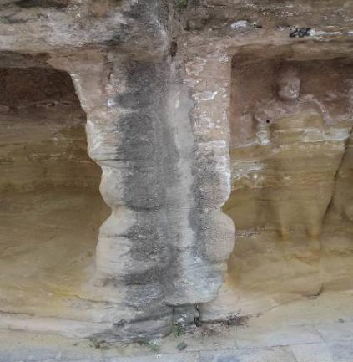 | 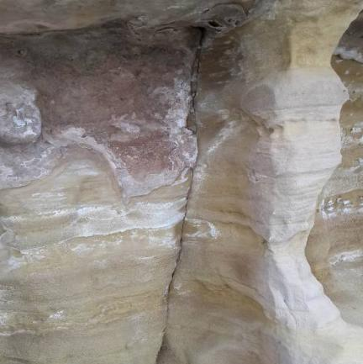 | 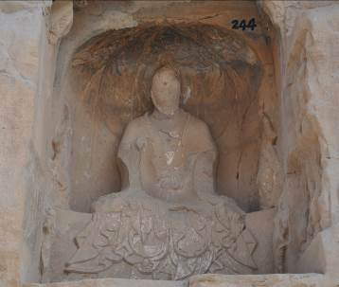
a. Significant fissures at the base and upper areas of the cave | b. White crystals precipitating from the upper and middle surfaces of the cave body | c. Blurring of the Buddha's face
Fig. 8 Weathering characteristics of North Grottoes in Qingyang, China under freeze-thaw action

10. Conclusion must be concise and must be based on the study results. Avoid discussion in the conclusion.
Thank you for your advice. The conclusion has been modified.

