Response to Reviewer 2 Comments

We thank the editors and reviewers for the valuable comments and suggestions. We have revised the paper substantially; and carefully made corrections according to the reviewers' comments and suggestions. Revised portions of manuscript are highlighted by red color. Our detailed point-by-point responses to the reviewers' comments are given below.

Point 1: To be more clear for the abstract, three decision fusion methods including "Majority Voting Fusion (MVF), Average Probability Fusion (APF), and Optimal Selection Fusion (OSF)" can be introduced.

Response 1: We appreciate your careful comments. We have added descriptions of the three decision fusion strategies in the Abstract section. Please read the revised manuscript.

Point 2：Some of citations are not cited with references. Please supplement the references in "SegNet in Line227, PSPNet in Line237, DeeplabV3+ in Line 248, RAUNet in Line 258, MVF in Line 314, APF in Line 326, OSF in Line338...".

Response 2: Thank you for your comments and suggestions. We have cited the relevant literatures in the Methods section. The specific literature is shown as follows.
- Badrinarayanan, V.; Kendall, A.; Cipolla, R. SegNet: A Deep Convolutional Encoder-Decoder Architecture for Image Segmentation. IEEE Transactions on Pattern Analysis and Machine Intelligence 2017, 39, 2481–2495, doi:10.1109/tpami.2016.2644615.
- Zhao, H.; Shi, J.; Qi, X.; Wang, X.; Jia, J. Pyramid Scene Parsing Network. 2017 IEEE Conference on Computer Vision and Pattern Recognition (CVPR) 2017, doi:10.1109/cvpr.2017.660.
- Chen, L.-C.; Zhu, Y.; Papandreou, G.; Schroff, F.; Adam, H. Encoder-Decoder with Atrous Separable Convolution for Semantic Image Segmentation. Computer Vision – ECCV 2018 2018, 833–851, doi:10.1007/978-3-030-01234-2_49.
- Ni, Z.-L.; Bian, G.-B.; Zhou, X.-H.; Hou, Z.-G.; Xie, X.-L.; Wang, C.; Zhou, Y.-J.; Li, R.-Q.; Li, Z. RAUNet: Residual Attention U-Net for Semantic Segmentation of Cataract Surgical Instruments. Neural Information Processing 2019, 139–149, doi:10.1007/978-3-030-36711-4_13.
- Takruri, M.; Rashad, M.W.; Attia, H. Multi-Classifier Decision Fusion for Enhancing Melanoma Recognition Accuracy. 2016 5th International Conference on Electronic Devices, Systems and Applications (ICEDSA) 2016, doi:10.1109/icedsa.2016.7818536.

Point3: In Line 185 "the three different image datasets" should be clearly stated in the text.

Response 3: We appreciate your careful comments and suggestions. We have revised the sentence of “the three different image datasets ……” as following :
Finally, we combined DOM, DSM and TFs to obtain three image feature datasets (RGB, RGBS, and RGBST), and the detailed feature composition information is shown in Table 1.

Point4: Why the quadrat size is set as 1m × 1m when resample the DOM and DSM to 0.1m spatial resolution? Some explaination should be added.

Response 4: Thank you for your comments and suggestions. The original spatial resolution of the UAV aerial images obtained in this paper is 0.05m-0.06m. In order to reduce the computational cost, we resampled the UAV image to 0.1m, which is still enough high spatial resolution for identifying each vegetation types.
In the field investigation, we built 1×1m sample plot in the area with the high spatial homogeneity of vegetation distribution, and record the geographical coordinates of the center point of each sample quadrat. These high quality of sample plots can help to create sematic labels for training CNN models.

Point5: Have you considered about that the results could be reliable for other areas? I suggest to test for a different area.

Response 5: We appreciate your careful comments and suggestions. We additional selected a mangrove wetland to verify the applicability of the three decision fusion methods (Majority Voting Fusion (MVF), Average Probability Fusion (APF), and Optimal Selection Fusion, (OSF) proposed this paper. The mangrove wetland is located in Beibu Gulf, Guangxi, south China (Fig. 1), which was covered with Avicennia marina (AM), Kandelia candel (KC), and Aegiceras corniculatum (AC), and the edges of the area were also covered with Spartina alterniflora (SA). In addition, other land cover types in the area are Death mangrove (DM), Terrestrial vegetation (TV), Artifact (AF), Mudflat (MF), and Water Body (WB).
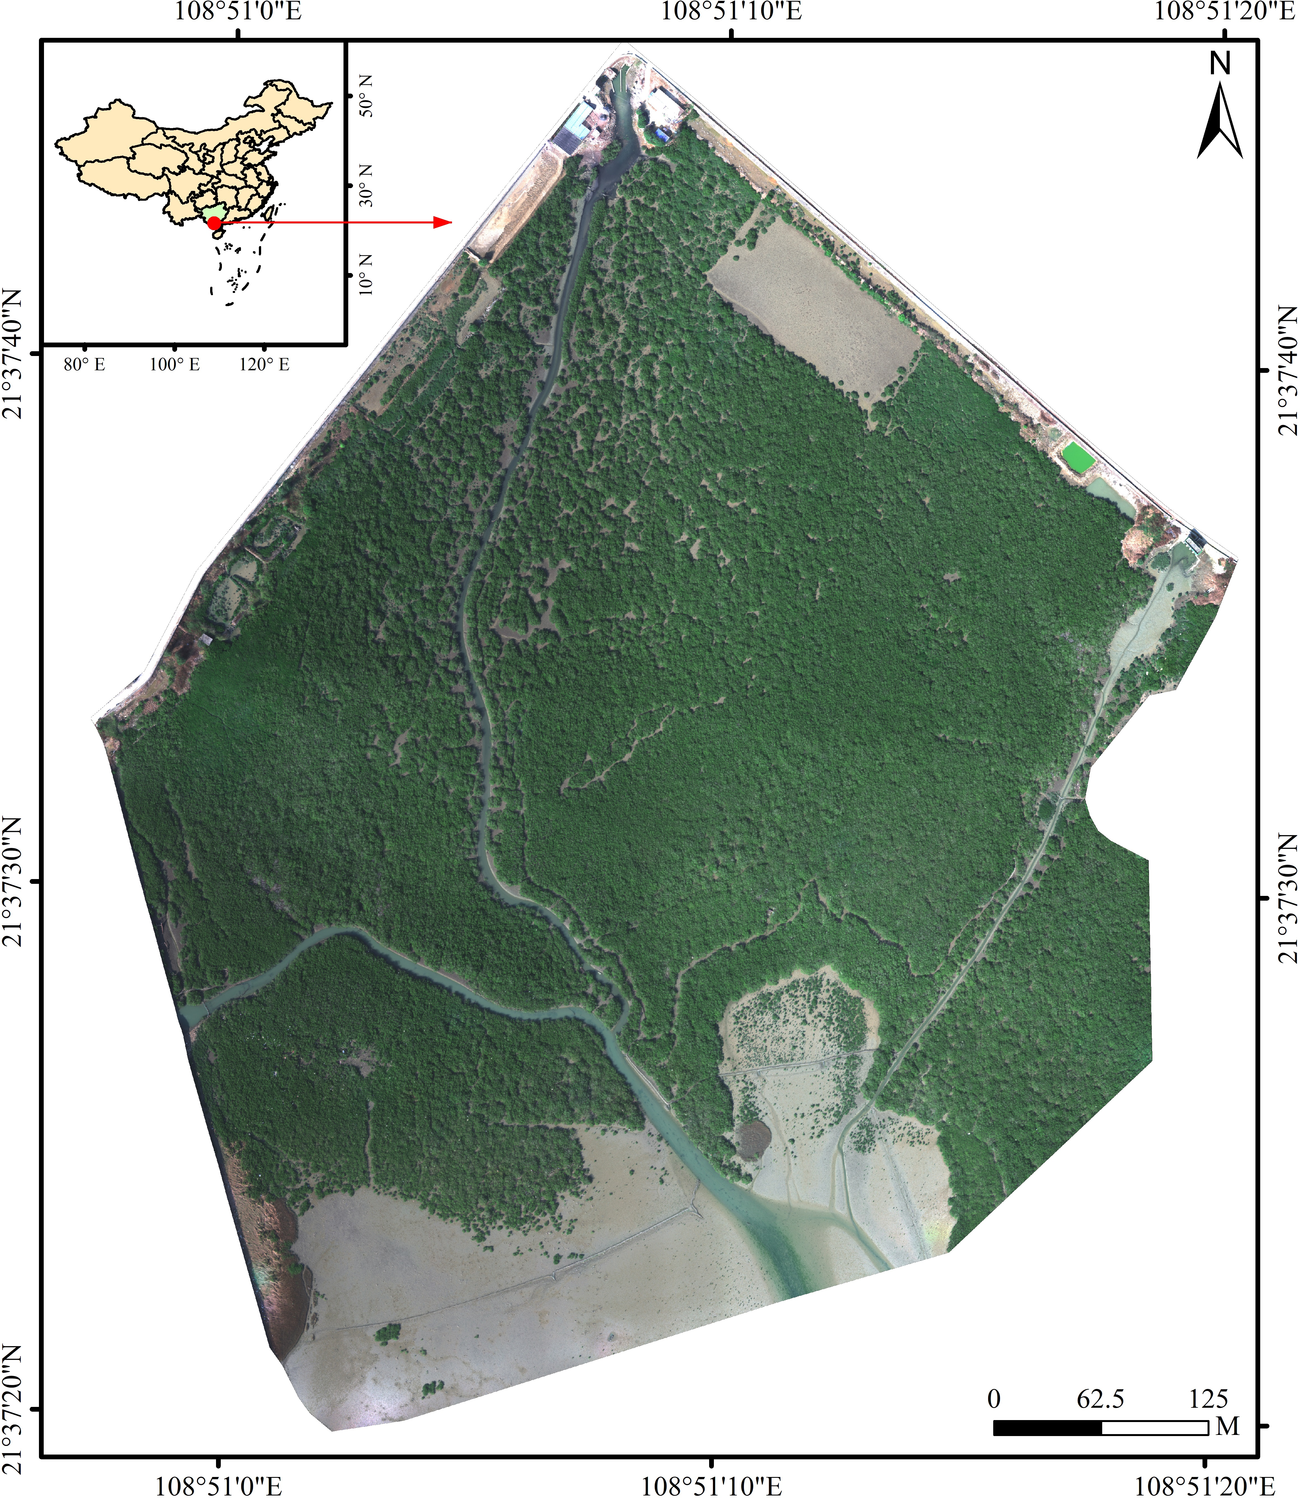
Fig. 1. Mangrove wetland of Beibu Gulf
We used DeepLabV3+ and HRNet algorithms with UAV multispectral imagery and digital surface models (DSM) to classify mangrove wetland community. We also used three decision fusion methods to fuse the multi-class classification models (MCC) of DeepLabV3+ and HRNet algorithms. We select overall classification accuracy (OA) and Kappa as the metrics for accuracy assessment. The specific classification accuracy showed in the Table 1.
Table 1. Classification accuracy of mangrove communities using DeepLabV3+ and HRNet algorithms
 | MVF | APF | OSF | DeepLabV3+ | HRNet
OA | 0.9052 | 0.9293 | 0.9138 | 0.9276 | 0.9276
Kappa | 0.8880 | 0.9168 | 0.8988 | 0.9146 | 0.9148
As seen in Table 1, Average Probability Fusion (APF) achieved the highest OA and Kappa of 92.93% and 91.68%, respectively, which provided better classification results than single DeepLabV3+ and HRNet. The other decision fusion methods (MVF and OSF) achieved similar classification accuracy with the single DeepLabV3+ and HRNet. These results demonstrated that decision fusions could improve the identification ability for mangrove vegetation compared to single CNN models.

