First of all, thank you very much for taking the time to review my article in your busy schedule. Thank you for your suggestions. All your suggestions are very important to me, and those comments are valuable and very helpful.
We have read through comments carefully and have made corrections. And then, here are my answers to each comment. Revisions in the text are highlighted with red text and yellow to indicate changes.
We would like to thank you for allowing us to resubmit a revised copy of the manuscript and we highly appreciate your time and consideration.

Question 1(1)：English needs to be improved significantly. Here are just some examples of the parts that need to be corrected, revised or clarified：
line 97: "judge" the level of communication or evaluation the level of communication?
Answer：We are grateful for these suggestions. To be more clearly and in accordance with the reviewer concerns, the term evaluation should be used. We have modified it. We are very sorry for the mistakes in this manuscript and inconvenience they caused in your reading. The manuscript has been thoroughly revised and rewritten, so we hope it can meet the journal’s standard.
As shown in the figure：
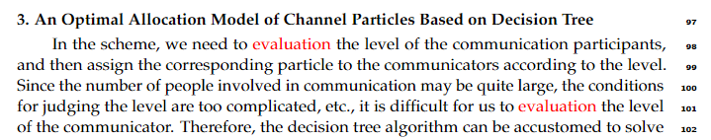

Question 1(2)： line 103: "decide" -> "to decide"
Answer：We are grateful for the suggestion. We have modified it. As shown in the figure below:

Question 1(3)：line 113: "number of honesty"? Do you mean "value of accuracy"?
Answer: Thank you for your question. What I want to express is actually the number of honest communications, which we have revised in the paper.

Question 1(4)：line 121: "...the decision tree will generate the decision tree..."
Answer: We are grateful for these suggestions. To be more clearly and in accordance with the reviewer concerns, we have revised the content of the paper. As follows:
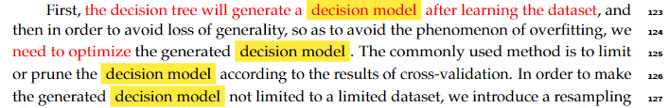

Question 1(5)：line 123: "need optimizing" -> "need to optimize..."
Answer: We have modified this expression throughout the text according to the comment. As shown in the picture：

Question 1(6)：line 147: "we need only the decision tree is restricted..." incorrect grammar.
Answer: We deeply appreciate the reviewer’s suggestion. According to the reviewer’s comment, we have modified it. As shown in the figure below:
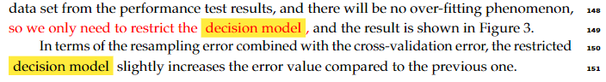

Question 1(7)："Matlab" needs to be capitalized consistently.
Answer: Thank you for your careful review. We are very sorry for the mistakes in this manuscript. We have revised it. As follows:
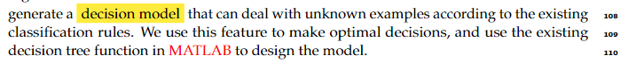

Question 2：From conclusion"Compared with the previous hierarchical quantum information splitting scheme, our advantage is to design the scheme according to the decision, which makes the scheme more effective in practical applications, and can transmit more particle information with fewer particles." The author could have cited which they were comparing to.
Answer: Thank you for the suggestion. We have marked the cited articles in the article. As shown in the figure：
