Response to reviewers

Dear Reviewers
Thank you very much for your helpful comments.
We have listed your comments below chronologically along the structure of the paper, and documented in the right column how the comments were addressed in the revision. We sincerely thank them for your helpful comments. They have helped to make the paper more stringent and clear.
Sincerely,
The authors

Nr. | Challenges and Suggestions |  | Adressing of the comments
 | Reviewer #1
 | 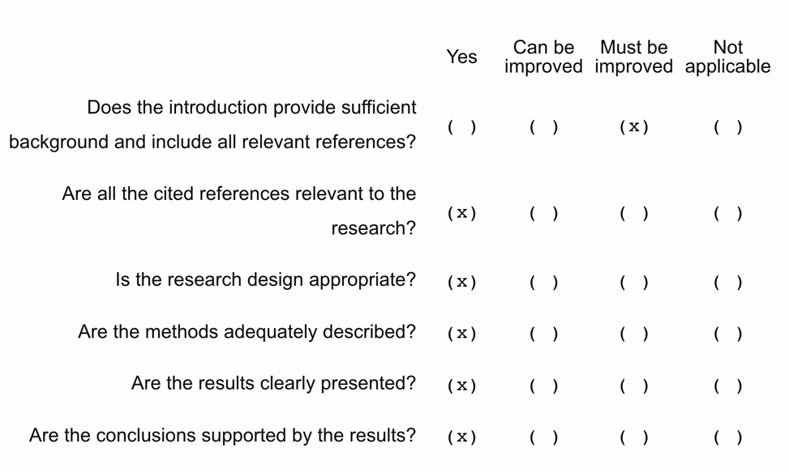 |  | Thank you for addressing the shortcomings in our introduction. We have revised and rewritten our introduction.
1a | In Switzerland, there is no description of how school health or health education is included in the training of school principals. If possible, it should also be mentioned how health education is included in the curriculum for the training of all teachers, or whether it is included in the training of specific subject teacher. | R#1 | Thank you very much for addressing this point.  We have included some information about the integration of health promotion in the curricula of teacher and school leader training in Switzerland in the introduction.
1b | Then, the process of becoming a principal in Switzerland should be described and discussed, as well as whether health education is included in the examination and education process. These systems vary from country to country and are not uniform. | R#1 | We have further elaborated on these suggestions with the inclusion of relevant literature.
2 | In conclusion, since the authors mention the need for principals' leadership in the dissemination of HPS even in the ordinary time, authors should be mentioned more than leadership in emergency response is needed. | R#1 | We have included a note to this effect under the “Practical Implications” section.
 | Reviewer #2
 | 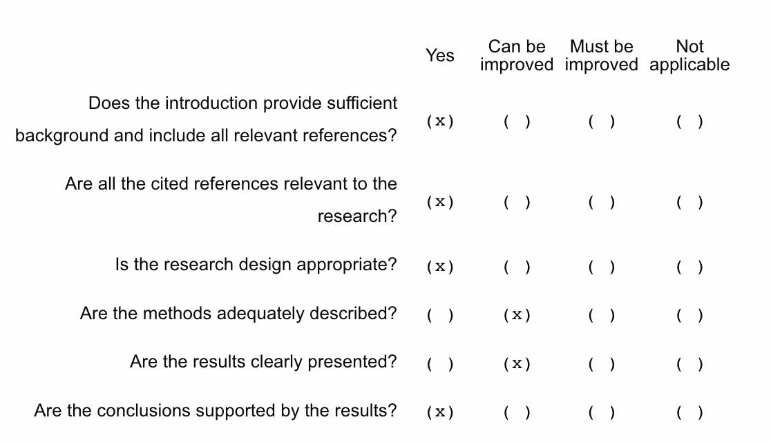 |  | Thank you for the suggestions. We have rewritten the two sections according to the suggestions below.
1 | Summary:  The authors make a brief introduction to the topic, but do not specify its purpose and the instruments they used. | R#2 | Thank you for the important note.  We have revised the summary and added missing parts.
2a | Methods:  In the Study Design and Study Population section, the authors present the characteristics of the sample, however, these data are already results, so they should be presented only in the results section. The same is true for Cronbach's alpha values. | R#2 | When writing the article, we were guided by existing publications of the journal. Various examples (Benzing et al., 2022; Dadaczynski et al., 2020; Dadaczynski & Hering, 2021; Müller et al., 2022; Usán et al., 2022) suggest a similar structure, where Characteristics of the Sample and Cronbach’s alpha values are integrated into the “Methods” section. We have adopted this structure in our article.  If you insist, we can of course include the relevant sections under “Results”.
2b | Methods:  The authors refer that alpha values ​​are acceptable, although there is evidence that emphasizes that only 0.7 is an acceptable value, so I suggest that they refer to authors who confirm what they say. | R#2 | We have adapted the wording as suggested or have found other authors confirming our statement.
3 | Results:  In this section, the authors present the results and, to a certain extent, are already discussing the results. I think you should in the next discussion section. This section should be objective and present the results of the present study, as it will be better for the reader. | R#2 | We have rewritten the section and included the relevant parts in the discussion.
 | Reviewer #3
 | 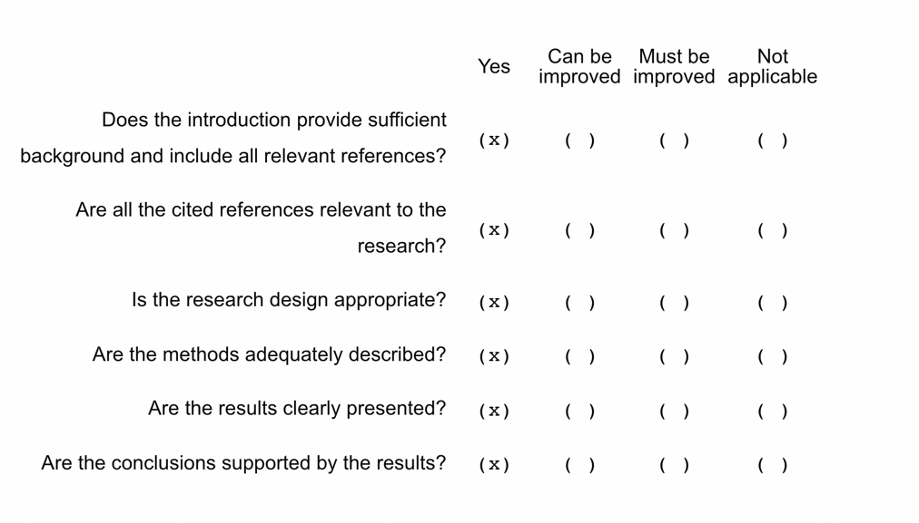 |  | Thank you very much for the excellent review.
1 | How is school health promotion implemented in Switzerland? Is there some sort of national/regional programme/ network/ financial incentives for schools? Maybe you could give just a little context | R#3 | Thank you for asking for more in-depth information about the implementation of school health promotion in Switzerland. We added some more information in the section “Introduction”.
2 | Are the characteristics of the study participants similar to the characteristics of school leaders in Switzerland? I would find a comparison for the characteristics gender and type of school interesting. | R#3 | We did some research to compare the sample with official figures from the Swiss Federal Statistical Office and included the information in the “Methods” section. However, since this is a convenience sample, it cannot be assumed that it is representative.
3 | Have you asked the school leaders how long they have/their school has been adopting a health promoting school approach? Is there a possibility that the school leaders’ health literacy is not a supporting factor but rather a result from school health promotion? | R#3 | Thank you for these inspiring questions that led us to discuss in more depth the possible role of school leaders’ health literacy in the implementation of HPS. We have included these … in the discussion.
4 | in line 410 the word “hast” should be “has” | R#3 | We have corrected the spelling error

Comments in detail

