Article
Thermal Comfort Prediction Accuracy With Machine Learning Between Regression Analysis and Naive Bayes Classifier
Hidayatus Sibyan^{1,}*, Jozef Svajlenka² , Hermawan^{1,}, Nasyiin Faqih¹, Annisa Nabila Arrizqi³
Citation: Lastname, F.; Lastname, F.; Lastname, F. Title. Sustainability 2022, 14, x. https://doi.org/10.3390/xxxxx
Academic Editor: Firstname Lastname
Received: date
Accepted: date
Published: date
Publisher’s Note: MDPI stays neutral with regard to jurisdictional claims in published maps and institutional affiliations.

Copyright: © 2022 by the authors. Submitted for possible open access publication under the terms and conditions of the Creative Commons Attribution (CC BY) license (https://creativecommons.org/licenses/by/4.0/).
¹ Qur’anic Science University (Universitas Sains Al-Qur’an), Indonesia; hsibyan@unsiq.ac.id (H.S.); hermawanarsit@gmail.com (H.H); nasyiin@unsiq.ac.id (N.F.)
² Department of Construction Technology and Management, Faculty of Civil Engineering, Laboratory of Construction Technology and Management, Technical University of Košice, 042 00 Košice, Slovakia; ingsvajl@gmail.com
³ Universitas Islam Indonesia, Indonesia; nabilaibil1104@gmail.com
* Correspondence: hsibyan@unsiq.ac.id; Tel.: +6285291041812
Abstract: Various data analysis methods can make thermal comfort prediction models. One method that is often used is multiple linear regression statistical analysis. Regression analysis needs to be checked for accuracy with other analytical methods. This study compares the making of a thermal comfort prediction model with regression analysis and Naive Bayes analysis. The research method uses quantitative methods for the data collection on thermal comfort. The thermal comfort variable consisting of 8 independent variables and 1 dependent variable, was measured at Wonosobo High School, Indonesia. The analysis to make the prediction model is carried out by two different analyses: multiple linear regression analysis and Naïve Bayes analysis. The results show that Naïve Bayes is more accurate than Multiple Linear Regression Analysis.
Keywords: Machine Learning; Thermal Comfort; Regression; Naïve Bayes; Prediction

1. Introduction
The problem of energy and thermal comfort has become a global issue. Many studies have tried to solve energy problems by predicting thermal comfort with variations in the type and shape of the building. Thermal comfort predictions can reduce energy wastage in buildings [1]. Thermal comfort cannot be separated from the scale of thermal sensation, model, climate, and personal variables. Several studies have used a variety of thermal sensation scales. The model is the result of an analysis of the thermal comfort variable, which is used to predict human thermal comfort [2]. Climatic variables associated with the thermal sensation of residents in naturally ventilated nursing homes can influence the mathematical model found. Regions with different climates will also produce different responses, so research areas must pay attention to hot or cold areas [3]. User's thermal perception is one of the main variables in thermal comfort research. Field tests can be used in thermal comfort research. The use of a questionnaire based on the thermal perception standard from ASHRAE 55. The analysis uses regression analysis, producing a mathematical model or equation of thermal comfort [4]. Airflow is one of the factors of thermal comfort. Human perception of airflow is also essential to know in achieving thermal comfort. Using the laboratory as an experimental room in research can get results that can be accounted for. The use of regression analysis can be applied to airflow research using an experimental room [5]
The thermal comfort research model aims to predict building occupants' thermal comfort. The prediction model generated from the research is used as a standard for making building designs. The current prediction model uses an adaptive thermal comfort approach. Research verifying the adaptive thermal comfort model has been conducted in four Brazilian cities. The study used the Preferred Reporting Items for Systematic Review and Meta-Analysis (PRISMA) method and found that the variation of the verified adaptive thermal comfort model was more than 90% for the four cities in Brazil [6]. Predictive modelling of personal thermal comfort has become a trending topic in improving human comfort in the room. Thermal comfort is closely related to the design and performance of building systems, especially in sustainable and intelligent buildings [7]. Thermal comfort modelling is manifold. The basis of modelling that is currently developing is the use of stochastic algorithms and variables [8].
The model's accuracy in predicting the thermal comfort of occupants is an important aspect that must continuously be developed. Accurate models can predict the right results to be convincing [9]. Linear regression is also used in outdoor thermal comfort studies. Thermal perception and other variables such as air temperature, wind, and sun exposure were analyzed using linear regression. The results showed a predictive model of thermal comfort. In addition, equations about air temperature were also found based on wind and sun exposure [10]. In outdoor thermal comfort research, sun exposure is a factor that is more considered than in indoor thermal comfort research. The temperature of solar radiation in the room is not too significant compared to the temperature of solar radiation outside. The mathematical model of thermal comfort in the interior still includes the average solar radiation temperature according to the thermal comfort factor that has been formulated [11].
Methods in thermal comfort research: simulation with software, modelling in the lab, and field testing. Field tests are most widely used in thermal comfort research. The measurement of the thermal comfort variable is also sometimes coincided with the measurement of the acoustic and visual comfort variables. The study's results will show the relationship between the variables of thermal, acoustic, and visual comfort [12]. The experimental method is also one of the methods in thermal comfort research. Some studies make experimental space a tool to test a model. The developing technology makes the experimental space more varied [13]. Simulation methods are often used as validation of a model found in research. Simulation using software is widely used in model validation. One of the software used for simulation is ENVI-NET.
Simulations are often combined with field measurements to obtain more valid results, with both methods carried out in a study [14]. Measurements in the field coupled with simulations can use Building Information Modeling (BIM). Computational Fluid Dynamic (CFD) analysis is often one of the analytical methods in BIM [15]. Several studies have combined the two methods, but research on the comparison of the two methods has not been widely carried out.
The development of the database field has led to the emergence of increasingly sophisticated data analysis tools. Machine learning algorithms are a new approach to analyzing thermal or visual comfort data. The use of machine learning algorithms as analytical tools is widely used for research on human comfort in buildings [16]. The use of machine learning algorithm data analysis methods continues to be developed and used in various types of buildings. Numerical computing is one of the strengths of machine learning algorithms [17]. The algorithm can also be used in urban heat island research. Research can produce effective strategies to reduce the Urban Heat Island effect by avoiding overcrowding in infrastructure development, increasing plantations and water bodies, roof gardens, and using white roof colour in construction. Research findings will enable urban planners, policymakers, and local governments to achieve environmentally friendly outcomes [18]. Machine Learning (ML) based building models have gained popularity in building Predictive Control (MPC) models for building energy management applications. However, ML-based building models are usually nonlinear to capture building dynamics, which causes a high computational load for MPC, prohibiting their application for real-time building control [19]. Analysis of the hot water usage model for the thermal comfort of occupants can also be done with machine learning. The created model provides control performance for occupant adaptation [20].
Developing convenience models using machine learning is inevitable with database development and automated calculations. Determination of the analytical method is essential to determine an accurate thermal comfort model. The purpose of this study was to compare the method of multiple linear regression analysis and Naïve Bayes in making an accurate thermal comfort model.
Measurement of thermal comfort can be done with objective and subjective measurements. Objective measurements use a thermal measuring instrument that measures air temperature, average solar radiation temperature, wind speed and tire humidity. Subjective measurements include filling out a thermal sensation questionnaire from ASHRAE by means of the respondent sitting for 15 minutes on the research object [21]. Gender is an important factor in thermal comfort. The selection of respondents needs to consider gender as a respondent. Different sexes will produce different thermal sensations [22]. Thermal comfort measurement has PMV (Predicted Mean Vote) and PPD (predicted per cent dissatisfied) indicators. These two aspects are the keywords in the analysis of thermal comfort [23].
Thermal comfort prediction with machine learning is still being developed today. Prediction can be used for the development of science in building design. Not many studies predict thermal comfort using machine learning [24]. Machine learning methods have various forms, both by using mathematical calculations and by Computational Fluid Dynamics (CFD). The use of various machine learning methods makes research results vary [25].
Thermal comfort prediction using a neural network has also been carried out. The thermoelectric air duct (TE-AD) cooling system is used to predict air temperature, PMV and PPD. The prediction model found it proved to be accurate in predicting thermal comfort [26]. The development of artificial neural networks as machine learning is still being carried out to find the right predictions [27]. The use of machine learning in predicting indoor air quality is also still being developed [28]. Thermal comfort prediction can also combine methods with thermal comfort variables [29].
Regression analysis is widely used in thermal comfort research to find a predictive model of thermal comfort. Currently, there are many models of thermal comfort that use regression analysis. Many comparisons of machine learning methods to find predictive models of thermal comfort have been carried out. One of the machine learning methods is using Naïve Bayes. A comparison of naïve Bayes with other methods has also been carried out [30]. Naïve Bayes can be an alternative to machine learning that does not require complicated calculations. Research that compares the Regression method with Naïve Bayes to form a predictive model of thermal comfort needs to be done so that it is known that the method is not complicated but produces a better predictive model.

2. Materials and Methods
This research compares two data analysis methods, regression analysis and Naïve Bayes. The data used results from the measurement of thermal comfort in the field. Respondents were students at two private high schools in Kejajar District, Wonosobo Regency. The variables used are gender, age, height, weight, temperature, globe temperature, humidity, velocity, and Thermal Sensation Vote (TSV). The survey was conducted on two measurement days: morning, afternoon, and evening. Temperature and humidity are measured using a measuring tool with the extect brand. Measure the globe temperature using a black copper ball with a diameter of 15 cm.
Respondents were asked to wait for 15 minutes when the initial measurements were taken. Respondents are high school students, so respondents have gone through adaptation to the room. The determination of research subjects involved male and female respondents. In thermal comfort research, it is possible that there are differences in the results of thermal sensation between men and women, although there are studies that say there are not many differences between men and women [31]. Research subjects were not selected using sampling. Respondents were taken by all students who became the object of the research. The number of high school students is 252 students and all of them are used as research subjects.
Data analysis used regression analysis with SPSS and Naïve Bayes software. The results of data analysis will be compared for accuracy so that more accurate analytical tools will be found. Regression analysis is done by making a mathematical equation model as follows:
Y = α + β1gender + β2age + β3height + β4weight + β5temperature + β6globe_temperature + β7relative_humidity + β8velocity (1)

Data analysis using Naïve Bayes requires a reasonably long process starting with determining the training data that will be the test data. The calculation is done by calculating the class probability, the class probability P(Y), the probability of each P(X) criterion, and the final probability. Naïve Bayes analysis will produce output from Y or TSV predictions. The resulting output can predict the TSV generated by building occupants with the value of the independent variable set (Figure 1).
Start
training data
test data
Calculate Class Probability
Calculate Class P(Y) Probability
Calculate the Probability of Each Criteria P(X)
Calculate Final Probability
P(X|Y) = P(X|Y).P(Y)
Prediction Result Output Y(TSV)
End
Figure 1. Naïve Bayes Flowchart

3. Results
The data obtained amounted to 252 data sets. The total data from 8 independent variables and 1 dependent variable is 2268. Respondents consisted of 44% men and 56% women. Respondents' age ranged from 14-19 years, with an average of 16.3 years. The respondent's height is between 140-177 cm, with an average of 156 cm. The respondent's body weight is between 30 and 82 kg, averaging 47.9 kg. The temperature in the class is between 22-25.5°C with an average of 23.75°C. Globe Temperature in the class was between 23-26.5°C with an average of 24.6°C. Humidity is between 60-80%, with an average of 68.63%. Velocity is not too much movement, so it shows more zeros. The most significant velocity is 1 m/s. The Thermal Sensation Votes obtained ranged from -3 (very cold) to +3 (very hot), with an average of -0.89 (near cool). Data measurement is done by bringing the measuring instrument closer to the respondent by placing the measuring instrument on the class table (Figure 2).
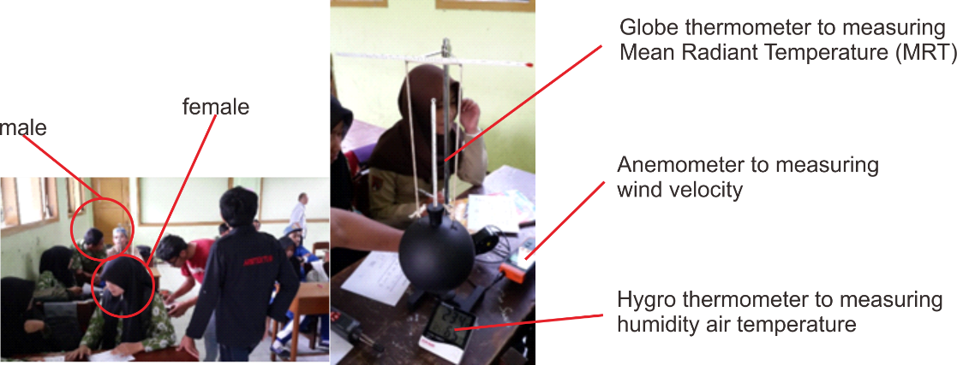
Figure 2. Data measuring

Data analysis using multiple linear regression has several data test requirements, namely validity and reliability. In addition, the classical assumption test also needs to be carried out to obtain data that can be used for multiple linear regression analysis. Analysis using SPSS software resulted in several valid test data. The normality test is part of the regression analysis and has obtained a model that meets the assumption of normality (Figure 3)
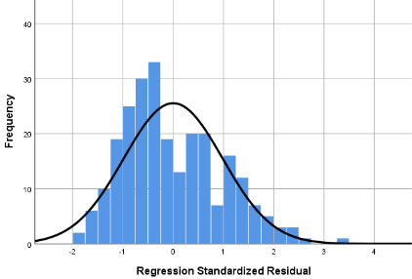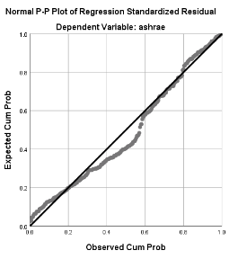
Figure 3. Classic assumption test
Multiple linear regression data analysis using SPSS will produce a value of unstandardized Coefficients that can be used as the coefficient of the prediction model. Some of the resulting values look insignificant. This value indicates that the influence of the independent variable on the dependent is less potent (Table 1). This value can still be used in predicting thermal comfort because several models from other studies also found the same results
Table 1. Regression Value
Coefficients
Model |  | Unstandardized Coefficients |  | Standardized Coefficients | t | Sig. | Correlations |  |  |  | Collinearity Statistics
 |  | B | Std. Error | Beta | t | Sig. | Zero-order | Partial | Part | Tolerance |  | VIF
1 | (Constant) | -8.796 | 3.231 |  | -2.723 | .007
1 | gender | -.308 | .182 | -.138 | -1.696 | .091 | -.179 | -.108 | -.097 | .493 |  | 2.030
1 | age | -.093 | .074 | -.078 | -1.266 | .207 | -.226 | -.081 | -.072 | .854 |  | 1.171
1 | height | -.015 | .013 | -.106 | -1.235 | .218 | .083 | -.079 | -.070 | .437 |  | 2.289
1 | weight | .005 | .012 | .030 | .439 | .661 | .055 | .028 | .025 | .705 |  | 1.419
1 | temperature | .265 | .124 | .238 | 2.139 | .033 | .359 | .136 | .122 | .263 |  | 3.808
1 | globe_temperature | .183 | .119 | .182 | 1.534 | .126 | .334 | .098 | .087 | .231 |  | 4.332
1 | humidity | .018 | .011 | .102 | 1.588 | .114 | .014 | .101 | .090 | .784 |  | 1.275
1 | velocity | 1.420 | .433 | .198 | 3.282 | .001 | .144 | .206 | .187 | .891 |  | 1.123
a. Dependent Variable: TSV

Based on the value of the constants and regression coefficients obtained from the regression analysis, it is known that the multiple linear regression equation is as follows:
Y = (-8,796) + (-0,308)gender + (-0,093)age + (-0,015)height + 0,005weight + (0,265)temperature + (0,183)globe_temperature + (0,018)relative_humidity + (1,420)velocity.
Calculation of comfortable air temperature when Y = 0 (comfortable thermal sensation condition) and obtained a comfortable air temperature of 33.19ºC. The comfortable air temperature produced is higher than the average comfortable air temperature in the tropics, which is 27ºC. This is possible because the closed clothes worn by respondents are hijab for women and trousers for men.
Based on the equation model that has been generated, a prediction of thermal comfort will be made for the sample data as follows:
Table 2. Sample of testing data for prediction
Gender | Age | Height | Weight | Temperature | Globe_temperature | Relative_humidity | Velocity | TSV
1 | 18 | 160 | 46 | 22 | 24 | 62 | 0 | ?

Y = α + β1gender + β2age + β3height + β4weight + β5temperature + β6globe_temperature + β7relative_humidity + β8velocity
Y = (-8,796) + (-0,308)1 + (-0,093)18 + (-0,015)160 + (0,005)46 + (0,265)22 + (0,183)24 + (0,018)62 + (1,420)0
Y = -1,61 ≡ -2

Naïve Bayes analysis begins with determining the training data in as many as 252 data sets according to the data from the measurement results. The variables used in predicting thermal comfort (TSV) are the same as regression analysis, namely gender, age, height, weight, temperature, globe temperature, relative humidity, and velocity. The training data is used as test data which is used as the basis for calculating.
Based on the training data used, there are 7 TSV classes, namely class -3 with 3 data, class -2 with 87 data, class -1 with 81 data, class 0 with 50 data, class 1 with 24 data, class 2 with 6 data, and class 3 as much as 1 data. It can be seen that the TSV class classification data in the Weka software is shown in Figure 4.

Figure 4. TSV class
The probability value for each criterion generated from the weka program is shown in Figure 5.
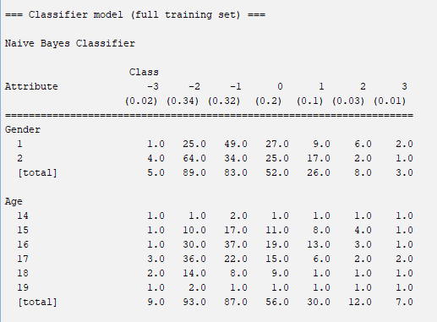  (a) | (b)
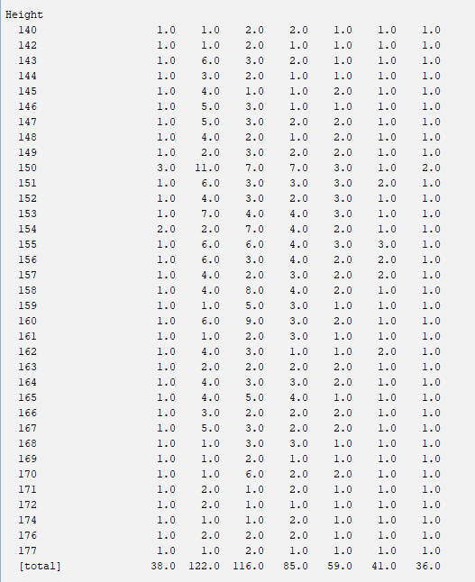  (c) | 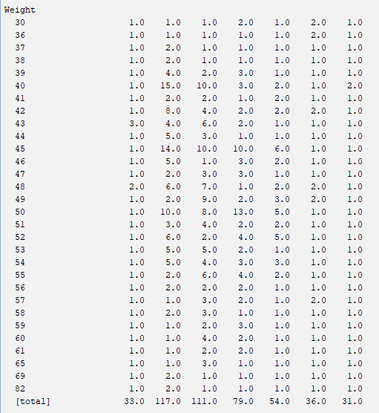  (d)
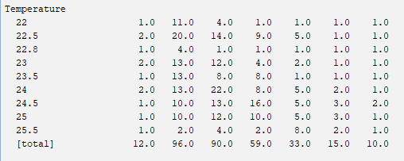  (e) | 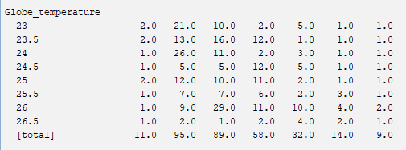  (f)
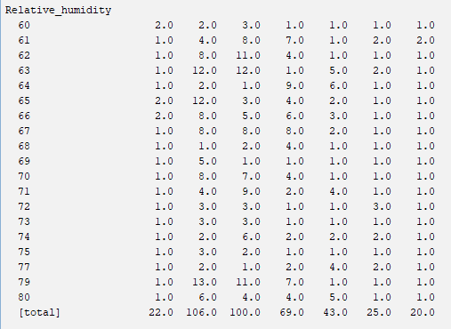  (g) | 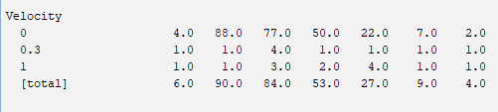  (h)
Figure 5. The probability value of each criterion in the weka software. (a) probability value for TSV class and gender criterion probability value; (b) the probability value of the age criterion; (c) the probability value of the height criteria; (d) the probability value of the weighted criteria; (e) the probability value of the temperature criterion; (f) the probability value of the world_temperature criterion; (g) the probability value of the relative_humanity criteria; (h) speed probability value.
In this test data, a thermal comfort (TSV) prediction will be made if the data used are gender: 1, age: 18, height: 160, weight: 46, temperature: 22, globe temperature 24, relative humidity: 62, and velocity: 0.
Table 3. Sample of testing data for prediction
Gender | Age | Height | Weight | Temperature | Globe_temperature | Relative_humidity | Velocity | TSV
1 | 18 | 160 | 46 | 22 | 24 | 62 | 0 | ?

Based on the test data above, a prediction calculation will be made for the data above.
Table 4. Prediction result
Variable | Probability
Variable | -3 | -2 | -1 | 0 | 1 | 2 | 3
 | 3 | 87 | 81 | 50 | 24 | 6 | 1
Gender | 0,00 | 0,2759 | 0,59 | 0,52 | 0,33 | 0,83 | 1,00
Age | 0,33 | 0,1494 | 0,09 | 0,16 | 0,00 | 0,00 | 0,00
Height | 0,00 | 0,0575 | 0,10 | 0,04 | 0,04 | 0,00 | 0,00
Weight | 0,00 | 0,0460 | 0,00 | 0,04 | 0,04 | 0,00 | 0,00
Temperature | 0,00 | 0,1149 | 0,04 | 0,00 | 0,00 | 0,00 | 0,00
Globe_temperature | 0,00 | 0,2874 | 0,12 | 0,02 | 0,08 | 0,00 | 0,00
Relative_humidity | 0,00 | 0,0805 | 0,12 | 0,06 | 0,00 | 0,00 | 0,00
Velocity | 1,00 | 1,0000 | 0,94 | 0,98 | 0,88 | 1,00 | 1,00
Sum | 0 | 0,000026 | 0 | 0 | 0 | 0 | 0
Prediction Result | -2

Based on the Naïve Bayes algorithm calculations, the highest value is 0.000026 for class -2. So the prediction of the test data is class -2
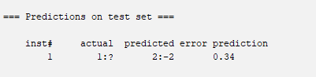
Figure 6. Prediction results on weka software
The accuracy of the prediction results is calculated based on the confusion matrix. From a total of 252 available data, 0 data in class a are predicted to be correct as class a (-3), and 3 data are predicted to be incorrect as class one. 72 data in class b are predicted to be correct as class b (-2), and 15 data are predicted to be incorrect as class b. 49 data in class c were correctly predicted as class c (-1), and 32 data were predicted incorrectly as class c. 29 data in class d were correctly predicted as class d (0), and 21 data were predicted incorrectly as class d. 16 data in class e were correctly predicted as class e (1), and 8 data were predicted incorrectly as class e. 3 data in class f are predicted to be correct as class f (2), and 3 data are predicted to be incorrect as class f. 0 data in class g were correctly predicted as class g (3), and 1 data was predicted incorrectly as class g.
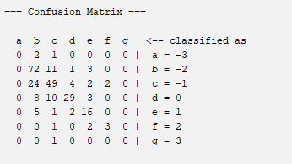
Figure 7. Confusion matrix
The results showed that the correctly predicted data (correctly classified instances) were 169 data or 67.06%, while the incorrectly predicted results (incorrectly classified instances) were 83 data or 32.94%.
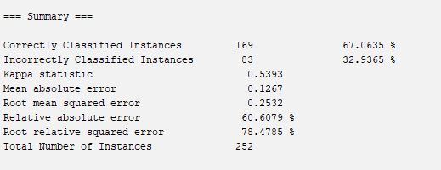
Figure 8. Naïve bayes prediction accuracy
The comparison between regression analysis and Naïve Bayes seen from the number of TSV shows that the regression analysis found the highest TSV predictions in the cool range (-1), with as many as 147 data. In the Naïve Bayes prediction, the highest TSV was found in the cold range (-2), as much as 104. The highest TSV difference showed a difference in results between the regression analysis and Naïve Bayes (Figure 9).

Figure 9. The difference in prediction result
Higher data variation was found in the results of naive bayes analysis, which could predict all TSV categories. While the data generated using linear regression looks clustered at a value of 0 to -2. If the prediction results using linear regression and the Naïve Bayes method are compared with the actual data in the field, then the Naïve Bayes method has a better level of accuracy because the results obtained from Naive Bayes can approach the actual data in the field.
The value generated from naive Bayes looks close to the actual data generated by field testing. The value using regression analysis shows the greater the value, the higher the value.

Figure 10. Prediction result comparison between actual TSV, linear regression and naïve bayes
The level of accuracy in both methods by comparing the prediction results with the initial data is that linear regression analysis has data accuracy of as much as 84 of 252 data sets. Naïve Bayes analysis has the correct prediction of 181 data from 252 data sets. The accuracy of linear regression analysis is 33%, while the Naïve Bayes analysis is 67%. Prediction results show that the accuracy of Naïve Bayes is higher than the multiple linear regression analysis (Table 5).

Table 5. Comparison of data analysis accuracy
Method | Correct Prediction | Count of Data | Accuracy
Linear Regression | 84 | 252 | 33%
Naïve Bayes | 169 | 252 | 67%

4. Discussion
Thermal comfort data obtained based on age are still relevant to be used as a basis for formulating a thermal comfort model. Age is essential in thermal comfort, and other studies have analyzed elderly respondents. Thermal comfort models built with different age data will produce different findings. Research in Tibet in winter and summer with elderly respondents found differences in the research results on the acceptance of thermal comfort [32]. Individual thermal comfort response is inseparable from the microclimate of each region. Solar radiation influences the individual's thermal comfort response with an influence on the average solar radiation temperature. The air content also influences the thermal comfort response of each individual in an area [33]. Modelling with thermal comfort data more often uses regression analysis. The use of machine learning has now grown so that the methods applied are more varied [34].
The use of regression analysis is still carried out in modelling thermal comfort in outdoor spaces. Research with regression analysis is still accurate in evaluating outdoor thermal comfort by including physiological parameters. The model found it can provide a design basis for creating comfortable thermal open spaces in urban parks [35]. A comparison of methods in modelling thermal comfort using Thermal Sensation Vote (TSV) has been carried out and still needs to be done to find the most accurate method. TSV is one of the appropriate variables in predicting the thermal comfort of 95.8%. The bayesian optimization technique is considered an accurate method for making prediction models. Algorithms in Bayesian optimization techniques can predict individual thermal comfort [36]. The results of other studies show that Linear Discriminant Analysis (LDA) is better than Linear Regression (L.A.). Several algorithms used show different performances in different cases. These findings can contribute to studying subjective and objective feelings of indoor thermal comfort in public buildings, thereby guiding architectural design, intelligent control of ventilation systems, and realizing human-building interaction interfaces [37].
Naïve Bayes is better than regression analysis. The results showed that Naïve Bayes has a calculation accuracy of 67%. Another study compared naïve Bayes with Artificial Neural Network (ANN), Fuzzy Logic (FL) and PMV-based algorithms. Other results show that the naïve Bayes calculation provides a prediction accuracy of 73% [38]. The difference between the research conducted with other studies is 1%. Another study comparing several machine learning methods in finding predictions of city thermal comfort found that Naïve Bayes resulted in a data accuracy of 40.43% [39]. The results of other studies are quite different from the research that has been done. Thermal comfort data in urban areas may differ from indoor data. Research on energy consumption savings that compares naïve Bayes and regression also find results that are not different from the research on thermal comfort that has been carried out. The results of the study of energy consumption savings with regression resulted in data accuracy of 41.43% and naïve Bayes accuracy of 73% [40]. The results of other research regressions with research that has been done have a difference of 41.43 minus 33%, which is 8.43%. The difference in naïve bayes accuracy is 1%.
PMV (Predicted Mean Vote) and PPD (Predicted Percentage of Dissatisfied) values were obtained using software from the CBE Thermal Comfort Tool from https://comfort.cbe.berkeley.edu/. Thermal variable data in the form of air temperature, average solar radiation temperature (globe temperature), wind speed, humidity, metabolism and respondent activity are entered into the software, and PMV and PPD values are obtained. A total of 252 respondents calculated their PMV and PPD. The distribution of PMV values is more in the value of -0.5 to -1, which indicates that the respondent is almost cold (score: -1). Another value, respondents seem to get a PMV value of 0.5 which indicates that some respondents feel close to warm (score: 1). The overall PMV results show that the respondents are still not too cold or too hot.

Figure 11. PMV score
The PPD value produced by the highest respondent reached 19%. The minimum value is 5%, and the average PPD produced is 9%. The value of respondents who reached 19% is not too much. The PPD value generated using the https://comfort.cbe.berkeley.edu/ software shows that respondents are predicted to still be able to accept the existing thermal conditions. The PPD value is still below 25%, which means that respondents are still relatively comfortable with the existing thermal conditions.

Figure 12. PPD score

5. Conclusions
The use of multiple linear regression analysis as a model for predicting thermal comfort. Prediction of thermal comfort using a regression model in a study at Wonosobo High School showed results with a more excellent range of coolness. Naïve Bayes analysis is one of the analytical alternatives classified as machine learning. The use of machine learning in thermal comfort is important because the analysis is expected to have accuracy in predictions. Using Naïve Bayes analysis in thermal comfort research at Wonosobo Senior High School, Indonesia, shows differences from the research results using multiple linear regression analysis. The difference in prediction results shows that the Naïve Bayes analysis has a cooler TSV result than the multiple linear regression analysis. The level of accuracy in predicting using Naïve Bayes is higher than the multiple linear regression analysis. The comparison of predictions from the two analytical methods is not too different, so it is still possible to use both methods in predicting the thermal comfort of building occupants.

References
[1] P. Gong, Y. Cai, Z. Zhou, C. Zhang, B. Chen, and S. Sharples, “Investigating spatial impact on indoor personal thermal comfort,” Journal of Building Engineering, vol. 45, no. November 2021, p. 103536, 2022, doi: 10.1016/j.jobe.2021.103536.
[2] Y. Dzyuban et al., “Landscape and Urban Planning Outdoor thermal comfort research in transient conditions : A narrative literature review,” Landscape and Urban Planning, vol. 226, no. November 2021, p. 104496, 2022, doi: 10.1016/j.landurbplan.2022.104496.
[3] M. T. Baquero Larriva, A. S. Mendes, and N. Forcada, “The effect of climatic conditions on occupants’ thermal comfort in naturally ventilated nursing homes,” Building and Environment, vol. 214, no. February, p. 108930, 2022, doi: 10.1016/j.buildenv.2022.108930.
[4] X. Zang et al., “The influence of different functional areas on customers’ thermal comfort – A Field study in shopping complexes of North China,” Energy and Built Environment, no. November 2021, 2022, doi: 10.1016/j.enbenv.2022.01.004.
[5] X. Jia, J. Wang, Y. Zhu, W. Ji, and B. Cao, “Climate chamber study on thermal comfort of walking passengers with elevated ambient air velocity,” Building and Environment, vol. 218, no. April, p. 109100, 2022, doi: 10.1016/j.buildenv.2022.109100.
[6] I. L. Niza and E. E. Broday, “Thermal comfort conditions in Brazil : A discriminant analysis through the ASHRAE Global Thermal Comfort Database II,” Building and Environment, vol. 221, no. April, p. 109310, 2022, doi: 10.1016/j.buildenv.2022.109310.
[7] Y. Feng, S. Liu, J. Wang, J. Yang, Y. L. Jao, and N. Wang, “Data-driven personal thermal comfort prediction: A literature review,” Renewable and Sustainable Energy Reviews, vol. 161, no. September 2021, p. 112357, 2022, doi: 10.1016/j.rser.2022.112357.
[8] A. Heidari, F. Maréchal, and D. Khovalyg, “Reinforcement Learning for proactive operation of residential energy systems by learning stochastic occupant behavior and fluctuating solar energy: Balancing comfort, hygiene and energy use,” Applied Energy, vol. 318, no. February, p. 119206, 2022, doi: 10.1016/j.apenergy.2022.119206.
[9] M. Jia, J. H. Choi, H. Liu, and G. Susman, “Development of facial-skin temperature driven thermal comfort and sensation modeling for a futuristic application,” Building and Environment, vol. 207, no. PB, p. 108479, 2022, doi: 10.1016/j.buildenv.2021.108479.
[10] K. Liu, Z. Lian, X. Dai, and D. Lai, “Comparing the effects of sun and wind on outdoor thermal comfort: A case study based on longitudinal subject tests in cold climate region,” Science of the Total Environment, vol. 825, p. 154009, 2022, doi: 10.1016/j.scitotenv.2022.154009.
[11] Y. Ji, J. Song, and P. Shen, “A review of studies and modelling of solar radiation on human thermal comfort in outdoor environment,” Building and Environment, vol. 214, no. February, p. 108891, 2022, doi: 10.1016/j.buildenv.2022.108891.
[12] Y. Geng, B. Hong, M. Du, T. Yuan, and Y. Wang, “Combined effects of visual-acoustic-thermal comfort in campus open spaces: A pilot study in China’s cold region,” Building and Environment, vol. 209, no. November 2021, p. 108658, 2022, doi: 10.1016/j.buildenv.2021.108658.
[13] K. Dharmasastha, D. G. L. Samuel, S. M. S. Nagendra, and M. P. Maiya, “Thermal comfort of a radiant cooling system in glass fiber reinforced gypsum roof - an experimental study,” Applied Thermal Engineering, p. 118842, 2022, doi: 10.1016/j.applthermaleng.2022.118842.
[14] X. Ma, T. M. Leung, C. K. Chau, and E. H. K. Yung, “Analyzing the influence of urban morphological features on pedestrian thermal comfort,” Urban Climate, vol. 44, no. May, p. 101192, 2022, doi: 10.1016/j.uclim.2022.101192.
[15] J. C. P. Cheng, H. H. L. Kwok, A. T. Y. Li, J. C. K. Tong, and A. K. H. Lau, “BIM-supported sensor placement optimization based on genetic algorithm for multi-zone thermal comfort and IAQ monitoring,” Building and Environment, vol. 216, no. February, p. 108997, 2022, doi: 10.1016/j.buildenv.2022.108997.
[16] Z. Luo, C. Sun, Q. Dong, and X. Qi, “Key control variables affecting interior visual comfort for automated louver control in open-plan office – a study using machine learning,” Building and Environment, vol. 207, no. PB, p. 108565, 2022, doi: 10.1016/j.buildenv.2021.108565.
[17] R. Zhang, D. Liu, and L. Shi, “Thermal-comfort optimization design method for semi-outdoor stadium using machine learning,” Building and Environment, vol. 215, no. September 2021, p. 108890, 2022, doi: 10.1016/j.buildenv.2022.108890.
[18] A. Al Kafy et al., “Predicting the impacts of land use/land cover changes on seasonal urban thermal characteristics using machine learning algorithms,” Building and Environment, vol. 217, no. February, p. 109066, 2022, doi: 10.1016/j.buildenv.2022.109066.
[19] S. Yang and M. P. Wan, “Machine-learning-based model predictive control with instantaneous linearization – A case study on an air-conditioning and mechanical ventilation system,” Applied Energy, vol. 306, no. PB, p. 118041, 2022, doi: 10.1016/j.apenergy.2021.118041.
[20] A. Heidari, F. Maréchal, and D. Khovalyg, “An occupant-centric control framework for balancing comfort, energy use and hygiene in hot water systems: A model-free reinforcement learning approach,” Applied Energy, vol. 312, no. February, 2022, doi: 10.1016/j.apenergy.2022.118833.
[21] K. Irshad, K. Habib, M. W. Kareem, F. Basrawi, and B. B. Saha, “Evaluation of thermal comfort in a test room equipped with a photovoltaic assisted thermo-electric air duct cooling system,” Int J Hydrogen Energy, vol. 42, no. 43, pp. 26956–26972, Oct. 2017, doi: 10.1016/J.IJHYDENE.2017.05.247.
[22] K. Irshad, S. Algarni, B. Jamil, M. T. Ahmad, and M. A. Khan, “Effect of gender difference on sleeping comfort and building energy utilization: Field study on test chamber with thermoelectric air-cooling system,” Build Environ, vol. 152, pp. 214–227, Apr. 2019, doi: 10.1016/J.BUILDENV.2019.01.058.
[23] Z. Yang, C. Du, H. Xiao, B. Li, W. Shi, and B. Wang, “A novel integrated index for simultaneous evaluation of the thermal comfort and energy efficiency of air-conditioning systems,” Journal of Building Engineering, vol. 57, p. 104885, Oct. 2022, doi: 10.1016/J.JOBE.2022.104885.
[24] W. Zhang, Y. Wu, and J. K. Calautit, “A review on occupancy prediction through machine learning for enhancing energy efficiency, air quality and thermal comfort in the built environment,” Renewable and Sustainable Energy Reviews, vol. 167, p. 112704, Oct. 2022, doi: 10.1016/J.RSER.2022.112704.
[25] R. Zhang, D. Liu, and L. Shi, “Thermal-comfort optimization design method for semi-outdoor stadium using machine learning,” Build Environ, vol. 215, p. 108890, May 2022, doi: 10.1016/J.BUILDENV.2022.108890.
[26] K. Irshad, A. I. Khan, S. A. Irfan, M. M. Alam, A. Almalawi, and M. H. Zahir, “Utilizing Artificial Neural Network for Prediction of Occupants Thermal Comfort: A Case Study of a Test Room Fitted With a Thermoelectric Air-Conditioning System,” IEEE Access, vol. 8, pp. 99709–99728, 2020, doi: 10.1109/ACCESS.2020.2985036.
[27] M. Elnour et al., “Neural network-based model predictive control system for optimizing building automation and management systems of sports facilities,” Appl Energy, vol. 318, p. 119153, Jul. 2022, doi: 10.1016/J.APENERGY.2022.119153.
[28] M. Esrafilian-Najafabadi and F. Haghighat, “Impact of predictor variables on the performance of future occupancy prediction: Feature selection using genetic algorithms and machine learning,” Build Environ, vol. 219, p. 109152, Jul. 2022, doi: 10.1016/J.BUILDENV.2022.109152.
[29] R. Rana, B. Kusy, R. Jurdak, J. Wall, and W. Hu, “Feasibility analysis of using humidex as an indoor thermal comfort predictor,” Energy Build, vol. 64, pp. 17–25, Sep. 2013, doi: 10.1016/J.ENBUILD.2013.04.019.
[30] P. I. Benito, M. A. Sebastián, and C. González-Gaya, “Study and Application of Industrial Thermal Comfort Parameters by Using Bayesian Inference Techniques,” Applied Sciences, vol. 11, no. 24, 2021, doi: 10.3390/app112411979.
[31] A. Asif, M. Zeeshan, S. R. Khan, and N. F. Sohail, “Investigating the gender differences in indoor thermal comfort perception for summer and winter seasons and comparison of comfort temperature prediction methods,” J Therm Biol, vol. 110, p. 103357, Dec. 2022, doi: 10.1016/J.JTHERBIO.2022.103357.
[32] F. Yao, H. Fang, J. Han, and Y. Zhang, “Study on the outdoor thermal comfort evaluation of the elderly in the Tibetan plateau,” Sustainable Cities and Society, vol. 77, no. May 2021, p. 103582, 2022, doi: 10.1016/j.scs.2021.103582.
[33] D. Wei, L. Yang, Z. Bao, Y. Lu, and H. Yang, “Variations in outdoor thermal comfort in an urban park in the hot-summer and cold-winter region of China,” Sustainable Cities and Society, vol. 77, no. September 2021, 2022, doi: 10.1016/j.scs.2021.103535.
[34] H. Qin and X. Wang, “A multi-discipline predictive intelligent control method for maintaining the thermal comfort on indoor environment,” Applied Soft Computing, vol. 116, p. 108299, 2022, doi: 10.1016/j.asoc.2021.108299.
[35] R. Zhu, X. Zhang, L. Yang, Y. Liu, Y. Cong, and W. Gao, “Correlation analysis of thermal comfort and physiological responses under different microclimates of urban park,” Case Studies in Thermal Engineering, vol. 34, no. April, p. 102044, 2022, doi: 10.1016/j.csite.2022.102044.
[36] B. Yang et al., “Comparison of models for predicting winter individual thermal comfort based on machine learning algorithms,” Building and Environment, vol. 215, no. March, p. 108970, 2022, doi: 10.1016/j.buildenv.2022.108970.
[37] G. Song, Z. Ai, G. Zhang, Y. Peng, W. Wang, and Y. Yan, “Using machine learning algorithms to multidimensional analysis of subjective thermal comfort in a library,” Building and Environment, vol. 212, no. December 2021, p. 108790, 2022, doi: 10.1016/j.buildenv.2022.108790.
[38] J. J. Aguilera, J. Toftum, and O. Berk Kazanci, “Predicting personal thermal preferences based on data-driven methods,” E3S Web of Conferences, vol. 111, p. 05015, Aug. 2019, doi: 10.1051/e3sconf/201911105015.
[39] N. Gao, W. Shao, M. S. Rahaman, J. Zhai, K. David, and F. D. Salim, “Transfer learning for thermal comfort prediction in multiple cities,” Build Environ, vol. 195, p. 107725, May 2021, doi: 10.1016/J.BUILDENV.2021.107725.
[40] C.-M. Lin, S.-F. Lin, H.-Y. Liu, and K.-Y. Tseng, “Applying the naïve Bayes classifier to HVAC energy prediction using hourly data,” Microsystem Technologies, vol. 28, no. 1, pp. 121–135, 2022, doi: 10.1007/s00542-019-04479-z.

