Editor and Reviewers
Thank you for your valuable suggestions and comments. We have addressed all issues raised by reviewers.
REVIEWER 1
Comment:
The research article entitled “Molecularly Targeted Photothermal Ablation of Epidermal Growth Factor Receptor-Expressing Cancer Cells with a Polypyrrole-Iron Oxide-Afatinib Nanocomposite” investigated the photothermal ablation capability of Polypyrrole-Iron Oxide-Afatinib Nanocomposite in the invasive treatment of cancer. The article has many grammatical and sentence errors, and the language organization needs to be improved. For these reasons, I conclude that the paper should undergo minor revision.
Reply to the Reviewer:
Thank you for your recommendation, suggestions, and comments. We have addressed all issues raised by the reviewer following his/her suggestions.
Comment:
- Abstract needs to be improved by providing more quantitative data
Reply to the Reviewer:
Thank you for your suggestions and comment. We have addressed the comment following the suggestion by including more quantitative data.
Revision Made:
We have added: “The Fourier transform infrared spectra showed 3295 cm⁻¹ peaks, substantial O-H stretching was seen, with significant C=C stretching at 1637 cm⁻¹, and a modest appearance of C-O-H bending at 1444 cm⁻¹ confirmed the chemical conjugation of afatinib but not iron oxide to the NC.
This was followed by early induction of cellular apoptosis for 54 ± 0.081% of A549 cells. The number of viable cells was less than a quarter of a percent. Viability levels of A549 cells that had been treated with NIR or PIA were only 50 ± 0.216 % and 80 ± 0.216%, respectively. Only 10 ± 0.816% of NIH3T3 cells had undergone necrosis, meaning that 90 ± 0.124% were alive. Viability levels were 65 ± 0.081% and 81±0.2%, respectively, when only NIR and PIA were used. PIA binding was effective against A549 cells but not against NIH3T3 cells. The outcome revealed that higher levels of NC+NIR exposure caused cancer cells to produce more ROS.”

- The introduction is good but very general in nature. More elaborately.
Reply to the reviewer:
We appreciate the suggestion from the reviewer. We have added some details to the introduction of the manuscript.
Revision Made
In the second paragraph of the introduction, we included “Although targeted medicines have made a greater impact thus far, immunotherapy has the potential to make a greater, longer-lasting contribution since it offers the chance of a long-term cure for some patients with metastatic disease. Targeted therapies, however, have had a greater impact thus far because, for the subset of lung cancer patients with driver mutations (often nonsmokers), persistent response and survival extension therapy are targeted to EGFR, ALK, RAF, ROS, RET, andHER2. After a single tumor-targeting therapy, the incidence of tumor recurrence or metastasis is still very high. PTT and immunotherapy in combination can greatly reduce tumor metastasis. When combined with checkpoint blockage, the tumor-associated antigens produced in situ following photothermal tumor ablation may exhibit vaccine-like properties that result in potent anti-tumor immune responses, enabling successful cancer immunotherapy.[10-12]
10. Li, X.; Naylor, M.F.; Le, H.; Nordquist, R.E.; Teague, T.K.; Howard, C.A.; Murray, C.; Chen, W.R. Clinical effects of in situ photoimmunotherapy on late-stage melanoma patients: a preliminary study. Cancer biology & therapy 2010, 10, 1081-1087.
11. Chen, Q.; Xu, L.; Liang, C.; Wang, C.; Peng, R.; Liu, Z. Photothermal therapy with immune-adjuvant nanoparticles together with checkpoint blockade for effective cancer immunotherapy. Nature communications 2016, 7, 1-13.
12. https://www.targetedonc.com/view/immunotherapy-versus-targeted-therapywhich-has-greater-impact-in-nsclc.

- Authors may provide greater details of other cancer therapies with their merits and demerits. How immunotherapy is photothermal therapy better than others
Reply to the reviewer:
We thank the suggestion from the reviewer. We provided details of other cancer therapies with their merits and demerits and how photothermal therapy better than others
Revision made:
In the second paragraph of the introduction, we included “Although targeted medicines have made a greater impact thus far, immunotherapy has the potential to make a greater, longer-lasting contribution since it offers the chance of a long-term cure for some patients with metastatic disease. Targeted therapies, however, have had a greater impact thus far because, for the subset of lung cancer patients with driver mutations (often nonsmokers), persistent response and survival extension therapy are targeted to EGFR, ALK, RAF, ROS, RET, andHER2. After a single tumor-targeting therapy, the incidence of tumor recurrence or metastasis is still very high. PTT and immunotherapy in combination can greatly reduce tumor metastasis. When combined with checkpoint blockage, the tumor-associated antigens produced in situ following photothermal tumor ablation may exhibit vaccine-like properties that result in potent anti-tumor immune responses, enabling successful cancer immunotherapy.[10-12]
10. Li, X.; Naylor, M.F.; Le, H.; Nordquist, R.E.; Teague, T.K.; Howard, C.A.; Murray, C.; Chen, W.R. Clinical effects of in situ photoimmunotherapy on late-stage melanoma patients: a preliminary study. Cancer biology & therapy 2010, 10, 1081-1087.
11. Chen, Q.; Xu, L.; Liang, C.; Wang, C.; Peng, R.; Liu, Z. Photothermal therapy with immune-adjuvant nanoparticles together with checkpoint blockade for effective cancer immunotherapy. Nature communications 2016, 7, 1-13.
12. https://www.targetedonc.com/view/immunotherapy-versus-targeted-therapywhich-has-greater-impact-in-nsclc.

- Please provide a higher resolution of Figures 5 and 7
Reply to the reviewer:
We thank the suggestion from the reviewer. We have provided a higher resolution of Figures 5 and 7
Revision made:
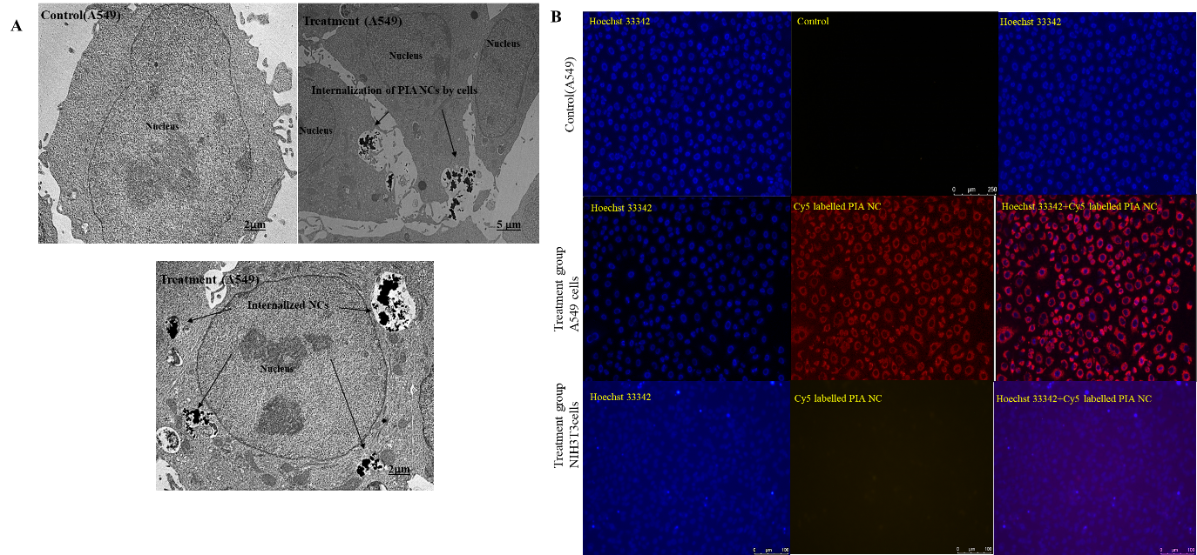
Figure 5. The TEM image of control cells, NC being internalized by A549 cells and internalized NC by the A549 cells. (B) The FM images of control cells, Cy-5 labeled PIA NC by A549 cells, Cy-5 labeled PIA NC by NIH3T3 cells. (n=3) Images showed a significant Cy5 fluorescent signal in the group of A549 cells treated with Cy5-PIA NCs. In the group of NIH3T3 cells treated with Cy5-PIA NCs, a notably lower signal was found.
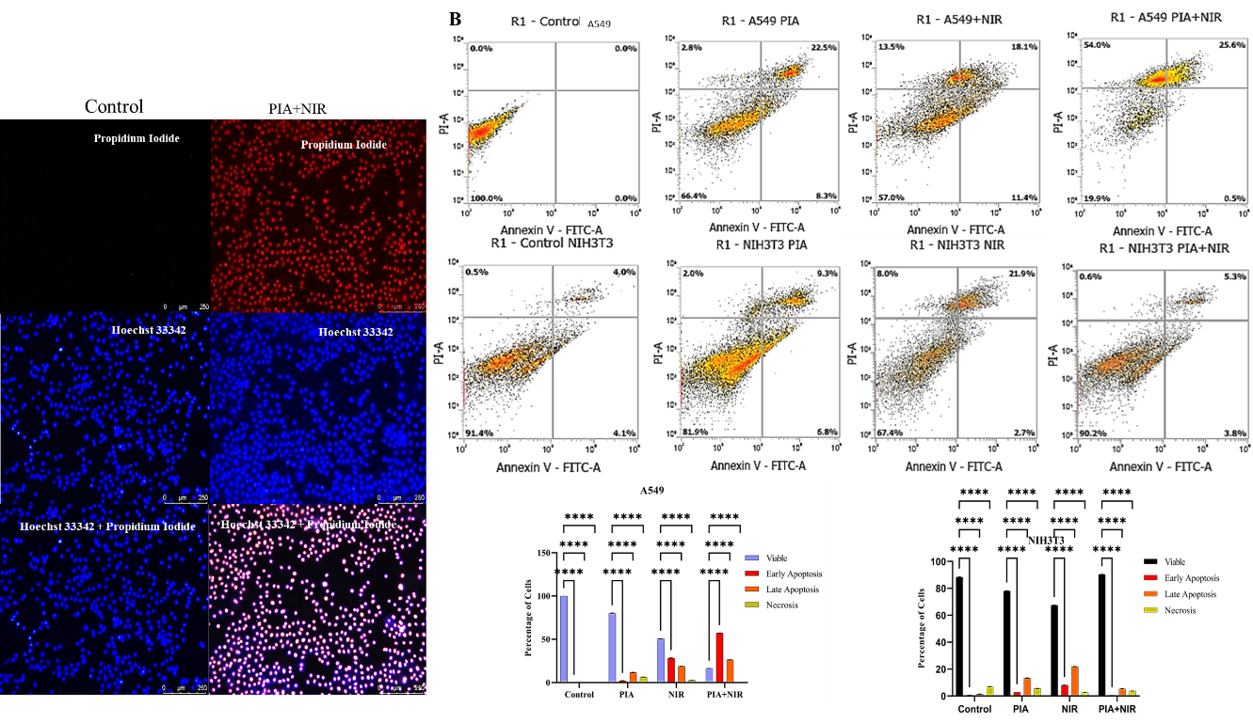
Figure 7. (A) The FM analysis of the apoptosis in A549 cells in control and under PIA+NIR treatment. (B)Flow cytometry data of A549 cells and NIH3T3 cells under different treatment conditions and graphical representation of the PCD under different treatments. 54% of A549 cells and 26% of NIH3T3 cells had reached the necrotic and apoptotic phases. The number of viable cells was less than a quarter of a percent. Viability levels of cells that had been treated with NIR or PIA were only 50% and 80%, respectively. Only 10% of NIH3T3 cells had undergone necrosis, meaning that 90% were alive. Viability levels were 65% and 81%, respectively, when only NIR and PIA were used. PIA binding was effective against A549 cells but not against NIH3T3 cells. (n=3, p <0.0001).
- Typographical errors can be avoided. The language and grammar used throughout the manuscript need to be improved. Specific attention needs to be given to this which will improve the standard of the manuscript.
Reply to the reviewer:
We thank the insightful comment from the reviewer. We have addressed this issue. We have submitted the manuscript for the English editing service provided by MDPI and the revised manuscript is uploaded. The image of the English editing certificate is provided below.
