Prof. Jongwook Park
Department of Chemical Engineering

October 24, 2022

< This submission is for the Special Issue Solution-Processed Metal Oxide Nanostructures for Carrier Transport>

Dear Editor,
I am Jongwook Park, professor at Kyung Hee University in Korea. Now I am submitting the manuscript of a paper entitled “Organic–inorganic hybrid device with a novel deep-blue emitter of donor–acceptor type and ZnO nanoparticles for solution-processed OLEDs” by Seokwoo Kang¹, Raveendra Jillella¹, Sunwoo Park¹, Sangshin Park¹, Joo Hwan Kim¹, Dakyeung Oh², Joonghan Kim² and Jongwook Park^{1,*} to Nanomaterials journal.

We revised the submitted manuscript according to the referees’ comments.

It would be grateful if the revised manuscript could be reviewed and considered for publication in Nanomaterials journal.

I am looking forward to hearing your response.

Very sincerely yours,

Prof. Jongwook Park
Professor/Department of Chemical Engineering
Director/Nano-Materials Project
Chief/Regional Innovation Center
Director/Priority Research Institute Program
Director/BK21 Printing Program

Kyung Hee Univeristy
Yongin, Kyunggi, 17104, Korea
Office:+82-(0)31-201-3675
Fax:+82-(0)31-204-8114
jongpark@khu.ac.kr

Manuscript number: nanomaterials-1948726
< Reviewer 1>
The present work by Kang et al. discussed the synthesis, characterization and device application of two blue organic emitters with an organoboron based acceptor unit and two different carbazole based donor units. They also studied the EL performance in both normal and inverted device structures. My main concern with this work is that it lacks a main focus and the novelty is unclear. Some of the descriptions seem strange for the field of OLEDs. To improve, the authors might focus on one specific topic, such as how the D-A structure affects the properties of the organoboron emitter. The contents on ZnO based inverted OLEDs need further investigations, such as improve the device performance, study the device physics, and so on, and might be better submitted separately as a new work. The manuscript in the current form is not acceptable for publication in Nanomaterials.
=> Thank you for the insightful comment and we partially agree with you. However, several papers have been reported with the inverted OLED device including ZnO layer. Moreover, the issues on the solution process and the inverted device using ZnO material have been recently raised in the display industry field, and we would like to report the related research work in this special issue of Nanomaterials. As you pointed out, further studies on the relationship between donor-acceptor structure and organoboron emitter as well as the ZnO effect in device physics are underway at our group. We will separately report other papers regarding these issues in the future. We already finalized enough data contents for the manuscript this time. So, please understand this situation. Instead of that, we added the related information in the introduction part according to the reviewer’s comment as below.
Page 2, line # 66-70
For example, Xu et al. reported the inverted OLED device optimization using the electron injecting layer of ZnO:CsCO₃. Performance was controlled by the work function and high electron carrier mobility. Jeon et al. also reported the device characteristics using ZnO:PEI hybrid electron injection layers based on two key factors of the molecular configuration and charge carrier property [49-50].

< Reviewer 2>
In this manuscript, bipolar deep-blue-light-emitting materials were designed, synthesized, and characterized, targeting large-area production solution-processed OLEDs with enhanced performance.
The synthesis and characterization of organic blue emitters (e.g., photophysical properties, surface morphology, thermal properties) important for the fabrication of OLED devices are detailed. The photophysical properties of road-shaped ZnO nanoparticle-based films and the electroluminescence properties of fabricated OLED are convincing and supported by experimental evidence. Future improvement steps concerning efficiency are also pointed out.
Q 1. Overall the interpretation of the results is accessible, and the obtained results logically support the conclusion. However, the device lifetime, efficiency, and narrow-band should be further discussed regarding suitability for applications.
The manuscript can be published in Nanomaterials after minor revision along the above lines.
Q 1.1 <Device lifetime>
=> Thank you for the important comment. According to the reviewer’s comment, we added the related sentences and data in main text and supporting part.
Page 10, line #408-413
In addition, to evaluate the stability of the fabricated OLED devices, device lifetime was measured at 1000 cd/m². The operational lifetime (LT₅₀) means the device lifetime that final light intensity reaches 50% of initial intensity. The LT₅₀ values of TDBA-BCZ and TDBA-PCZ were 15.4 and 21.5 hr as shown in Figure. S9. In solution-processed OLED device applications, the device lifetime is relatively excellent compared to previously reported papers [47-48].

Page 14, line #623-628
47. Kreiza, G.; Berenis, D.; Banevičius, D.; Juršėnas, S.; Javorskis, T.; Orentas, E.; Kazlauskas, K. High efficiency and extremely low roll-off solution- and vacuum-processed OLEDs based on isophthalonitrile blue TADF emitter. Chemical Engineering Journal 2021, 412, doi:10.1016/j.cej.2021.128574.
48. He, Y.; Qiao, Z.; Cai, X.; Li, M.; Li, W.; Xie, W.; Qiu, W.; Wang, L.; Su, S.J. Pyridine-Based Bipolar Hosts for Solution-Processed Bluish-Green Thermally Activated Delayed Fluorescence Devices: A Subtle Regulation of Chemical Stability and Carrier Transportation. ACS Appl Mater Interfaces 2020, 12, 49905-49914, doi:10.1021/acsami.0c14123.

Supporting information, Page 7
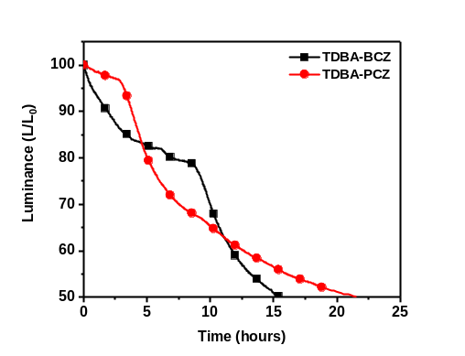
Figure. S9 Operational stability of TDBA-BCZ and TDBA-PCZ

Q 1.2 <Device efficiency>
=> Thank you for the comment. We already EQE result and meaning in page 10, line #383-386. However, according to the reviewer’s comment, we added the related sentence as below.
Page 10, line #395-397
Also, TDBA-PCZ device showed very high efficiency, EQE of 10.14% in CIE y of 0.155, real blue color. It means that this device can be used for the mobile display.

Q 1.3 <Narrow-band>
=> Thank you for the comment. According to the reviewer’s comment, we added the related sentence in page 10 line #390-392.

Page 10, line #390-392
It is explained by the simplified electron transition which comes from the decreased molecular packing as well as the twisted chemical structure.
Q2. Also, minor corrections are needed (e.g., on page 2, line 88, the reference number should be added, in the “Experimental” section, the heading number (“synthesis 2.1”) should be deleted the subsections should be corrected accordingly.
=> Thank you for the comment. According to the referee’s comment, we corrected those.
Page 2, line #91-92
Before)
The synthesis methods of TDBA, 1, 2, 3, and 4, which are used in the present work as intermediate compounds (Figure. S1), have been reported elsewhere [ref].”
After)
The synthesis methods of TDBA, 1, 2, 3, and 4, which are used in the present work as intermediate compounds (Figure. S1), have been reported elsewhere [24, 38].

Page 2, line #94-95
Before)
2.1.1 Synthesis of 2-(9H-carbazol-9-yl)-5-(2,12-di-tert-butyl-5,9-dioxa-13b-boranaphtho[3,2,1-de]anthracen-7-yl)-5H-benzo[b]carbazole (TDBA-BCZ)
After)
2.1 Synthesis of 2-(9H-carbazol-9-yl)-5-(2,12-di-tert-butyl-5,9-dioxa-13b-boranaphtho[3,2,1-de]anthracen-7-yl)-5H-benzo[b]carbazole (TDBA-BCZ)

Page 3, line # 113
Before)
2.1.2 Synthesis of 4-bromo-9-phenyl-9H-carbazole (5)
After)
2.2 Synthesis of 4-bromo-9-phenyl-9H-carbazole (5)

Page 3, line # 124
Before)
2.1.3 Synthesis of 9-phenyl-4-(4,4,5,5-tetramethyl-1,3,2-dioxaborolan-2-yl)-9H-carbazole (6)
After)
2.3 Synthesis of 9-phenyl-4-(4,4,5,5-tetramethyl-1,3,2-dioxaborolan-2-yl)-9H-carbazole (6)

Page 3, line # 136
Before)
2.1.4 Synthesis of 4-(2-nitrophenyl)-9-phenyl-9H-carbazole (7)
After)
2.4 Synthesis of 4-(2-nitrophenyl)-9-phenyl-9H-carbazole (7)

Page 3, line # 146
Before)
2.1.5 Synthesis of 5-phenyl-5,8-dihydroindolo[2,3-c]carbazole (8)
After)
2.5 Synthesis of 5-phenyl-5,8-dihydroindolo[2,3-c]carbazole (8)

Page 4, line # 156-157
Before)
2.1.6 Synthesis of 5-(2,12-di-tert-butyl-5,9-dioxa-13b-boranaphtho[3,2,1-de]anthracen-7-yl)-8-phenyl-5,8-dihydroindolo[2,3-c]carbazole (TDBA-PCZ)
After)
2.6 Synthesis of 5-(2,12-di-tert-butyl-5,9-dioxa-13b-boranaphtho[3,2,1-de]anthracen-7-yl)-8-phenyl-5,8-dihydroindolo[2,3-c]carbazole (TDBA-PCZ)

< Reviewer 3>
Authors have presented their work on blue OLED which is very important to generate a full-color display. OLED performance depends on device design, interfacial energy band alignment, emitter design, external quantum efficiency, power efficiency, and operational stability. Utilizing ZnO nanoparticles could be beneficial in OLED technology. The author's work is impressive but requires a few additional clarifications. I suggest publication after some minor corrections and addition

1. How the molecular packing affects the PL shift in the film state compared to the solution state?
=> Thank you for the important comment. According to the reviewer’s comment, we amended the related sentence.

Page 6, line #233-239
Before)
Thus, the emissions of TDBA-BCZ and TDBA-PCZ in the solution state were red shifted by 23 and 19 nm, respectively, compared with those of TDBA-BCZ and TDBA-PCZ in the solution state; this shift is attributed to the packing of the molecules in the film state.
After)
Thus, the emissions of TDBA-BCZ and TDBA-PCZ in the film state were red shifted by 23 and 19 nm, respectively, compared with those of TDBA-BCZ and TDBA-PCZ in the solution state; this shift is attributed to the packing of the molecules in the film state. In the diluted solution state, there is enough molecular distance, and it does not make the additional molecular interaction in the excited state. According to the decreased molecular distance in film state, the increased molecular interaction from molecular packing causes the energy loss and the red-shifted photoluminescence emission.

2. Authors should provide reference to the aggregation induce effect (AIE) mentioned in line 250.
=> Thank you for the important comment. Actually, we had already inserted the related reference #39 in line 263, but we added four references in line 250 according to the referee’s comment.

Page 6, line #256-257
Before)
Interestingly, both emitters exhibited higher PLQY values in the neat film state than in the solution state, suggesting an aggregation-induced emission (AIE) effect.
After)
Interestingly, both emitters exhibited higher PLQY values in the neat film state than in the solution state, suggesting an aggregation-induced emission (AIE) effect [39-42].

Page 14, line #601-611
39. Jung, H.; Shin, H.; Kim, S.; Kim, J.; An, B.-K.; Lee, J.-H.; Ihee, H.; Park, J. High electroluminescence efficiency and long device lifetime of a fluorescent green-light emitter using aggregation-induced emission. Journal of Industrial and Engineering Chemistry 2020, 87, 213-221, doi:10.1016/j.jiec.2020.04.003.
40. Guo, X.; Yuan, P.; Fan, J.; Qiao, X.; Yang, D.; Dai, Y.; Sun, Q.; Qin, A.; Tang, B.Z.; Ma, D. Unraveling the Important Role of High-Lying Triplet-Lowest Excited Singlet Transitions in Achieving Highly Efficient Deep-Blue AIE-Based OLEDs. Adv Mater 2021, 33, e2006953, doi:10.1002/adma.202006953.
41. Lin, C.; Han, P.; Qu, F.; Xiao, S.; Li, Y.; Xie, D.; Qiao, X.; Yang, D.; Dai, Y.; Sun, Q.; et al. Suppressing singlet-triplet annihilation processes to achieve highly efficient deep-blue AIE-based OLEDs. Mater Horiz 2022, 9, 2376-2383, doi:10.1039/d2mh00627h.
42. Liu, D.; Wei, J.Y.; Tian, W.W.; Jiang, W.; Sun, Y.M.; Zhao, Z.; Tang, B.Z. Endowing TADF luminophors with AIE properties through adjusting flexible dendrons for highly efficient solution-processed nondoped OLEDs. Chem Sci 2020, 11, 7194-7203, doi:10.1039/d0sc02194f.

3. The power efficiency plot should be included in the main manuscript.
=> Thank you for the important comment. According to the reviewer’s comment, we added the related data as below.

Page 9, line #371-376
Before)
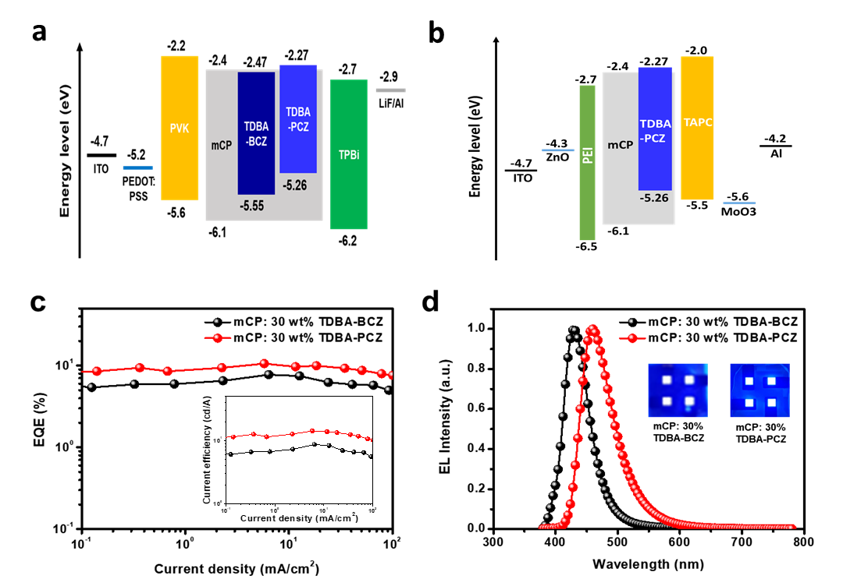
Figure. 6 (a) Energy-level diagrams of a conventional forward device, (b) energy-level diagrams of an inverted device, (c) external quantum efficiency (EQE) vs current density curves (inset: current efficiency vs current density curves), and (d) EL spectra (inset: photographs of devices operating at 7 V).

After)
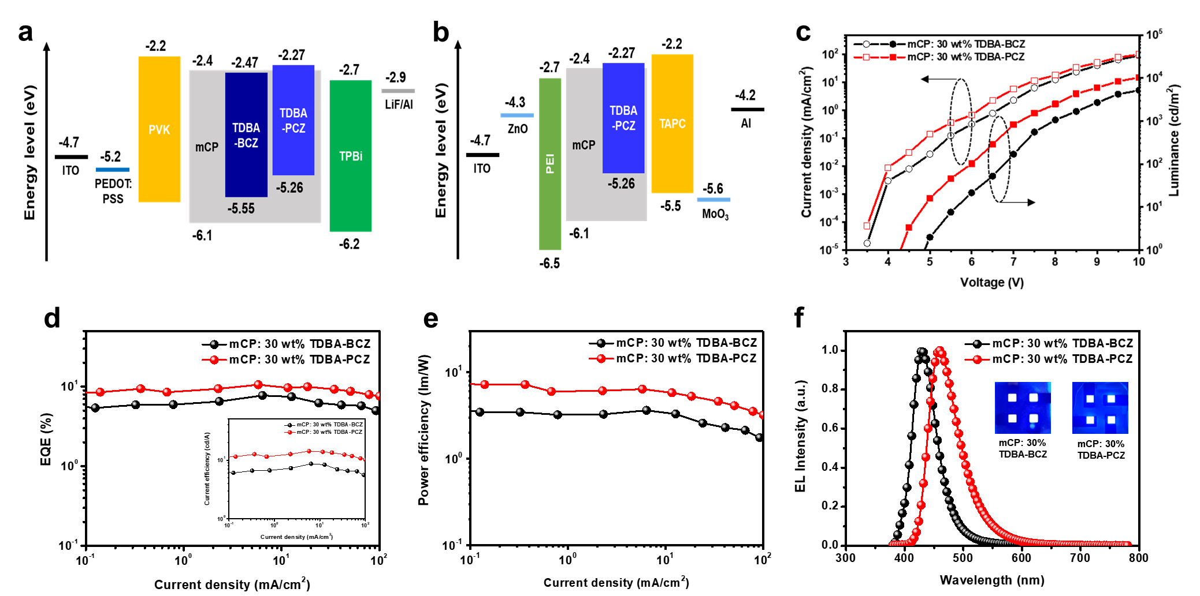
Figure. 6 (a) Energy-level diagrams of a conventional forward device, (b) energy-level diagrams of an inverted device, (c) Current density–voltage–luminance (J–V–L) curves of solution-process-doped OLED devices, (d) external quantum efficiency (EQE) vs current density curves (inset: current efficiency vs current density curves), (e) power efficiency vs current density curves and (f) EL spectra (inset: photographs of devices operating at 7 V).

4. How was the operational stability of the devices under constant current?
Thank you for the comment. According to the reviewer’s comment, we added the related sentence and data in main text and supporting part as below.

Page 10, line #408-414
In addition, to evaluate the stability of the fabricated OLED devices, device lifetime was measured at 1000 cd/m². The operational lifetime (LT₅₀) means the device lifetime that final light intensity reaches 50% of initial intensity. The LT₅₀ values of TDBA-BCZ and TDBA-PCZ were 15.4 and 21.5 hr as shown in Figure. S9. In solution-processed OLED device applications, the device lifetime is relatively excellent compared to previously reported papers [47-48].

Page 14, line #624-629
47. Kreiza, G.; Berenis, D.; Banevičius, D.; Juršėnas, S.; Javorskis, T.; Orentas, E.; Kazlauskas, K. High efficiency and extremely low roll-off solution- and vacuum-processed OLEDs based on isophthalonitrile blue TADF emitter. Chemical Engineering Journal 2021, 412, doi:10.1016/j.cej.2021.128574.
48. He, Y.; Qiao, Z.; Cai, X.; Li, M.; Li, W.; Xie, W.; Qiu, W.; Wang, L.; Su, S.J. Pyridine-Based Bipolar Hosts for Solution-Processed Bluish-Green Thermally Activated Delayed Fluorescence Devices: A Subtle Regulation of Chemical Stability and Carrier Transportation. ACS Appl Mater Interfaces 2020, 12, 49905-49914, doi:10.1021/acsami.0c14123.

Supporting information, Page 7
Figure. S9 Operational stability of TDBA-BCZ and TDBA-PCZ

5. Do the PL properties of these emitters expected to be changed under different photon flux/power densities?
=> Thank you for the comment. Unfortunately, our PL instrument does not have that function regarding different photon flux/power densities because our equipment is the general photoluminescence instrument. We are sorry about that. Instead of the related experiment limitation, we have changed the current density in OLED device and have measured EL spectrum according to the increased voltage and the current density. This data would be related to your suggestion. We added the result as below. Please understand the inevitable situation.

Page 10, line #397-400
In order to evaluate the luminescence property of the OLED emitters according to the excitation energy density, the EL spectra were measured according to the voltage variation. As shown in Figure. S7, the EL spectrum of the solution processed OLED device is not changed as the voltage is increased.

Supporting information, Page 6
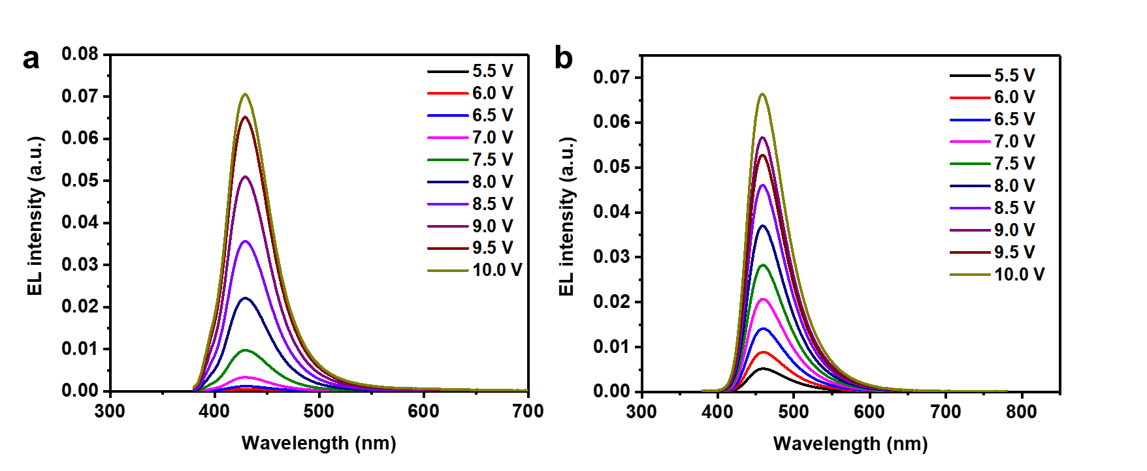
Figure. S7 EL spectra of (a) mCP:30 wt% TDBA-BCZ, (b) mCP:30 wt% TDBA-PCZ at different applied voltages.

6. The lower leakage current from the L-I-V curve (Figure. S7) is not quite clear. Authors are suggested to remove the data processing on the plotting or increase the number of data steps that indicate the lower leakage current. Also, please insert the LIV Curve in the main manuscript.
=> Thank you very much for the important comment. According to the reviewer’s comment, we corrected the related data of Figure. S7 and added it into Figure. 6.

Page 9, line #371-376
Before)
Figure. 6 (a) Energy-level diagrams of a conventional forward device, (b) energy-level diagrams of an inverted device, (c) external quantum efficiency (EQE) vs current density curves (inset: current efficiency vs current density curves), and (d) EL spectra (inset: photographs of devices operating at 7 V).

After)
Figure. 6 (a) Energy-level diagrams of a conventional forward device, (b) energy-level diagrams of an inverted device, (c) Current density–voltage–luminance (J–V–L) curves of solution-process-doped OLED devices, (d) external quantum efficiency (EQE) vs current density curves (inset: current efficiency vs current density curves), (e) power efficiency vs current density curves and (f) EL spectra (inset: photographs of devices operating at 7 V).
7. Particle size distribution of ZnO with mean and standard deviation should be included for the readers.
=> Thank you for the important comment. According to the reviewer’s comment, we added the related data in supporting part.
Page 11, line #423-424
ZnO nanoparticles have an average diameter of 23.5 nm and polydispersity index of 0.15 as shown in Figure. S10.

Supporting information, Page 1 line #32-33
Particle size distribution of the ZnO nanoparticles were obtained using a ELS-2000ZS (Otsuka).

Supporting information, Page 2, line #12-15
Before)
In inverted devices, ZnO (Avantama N-10) as an electron injection layer (EIL) was deposited by spin coating at a speed of 3500 rpm for 60 s and baking at 150 °C for 30 min, whereas 0.25 wt% PEI (Sigma-Aldrich) in H₂O as the ETL and IL was spin-coated at a speed of 5000 rpm for 60 s followed by an annealing for 10 min at 130 °C.”
After)
In inverted devices, ZnO (Avantama N-10, nano particle size of 23.5 nm, polydispersity index of 0.15) as an electron injection layer (EIL) was deposited by spin coating at a speed of 3500 rpm for 60 s and baking at 150 °C for 30 min, whereas 0.25 wt% PEI (Sigma-Aldrich) in H₂O as the ETL and IL was spin-coated at a speed of 5000 rpm for 60 s followed by an annealing for 10 min at 130 °C.

Supporting information, Page 8
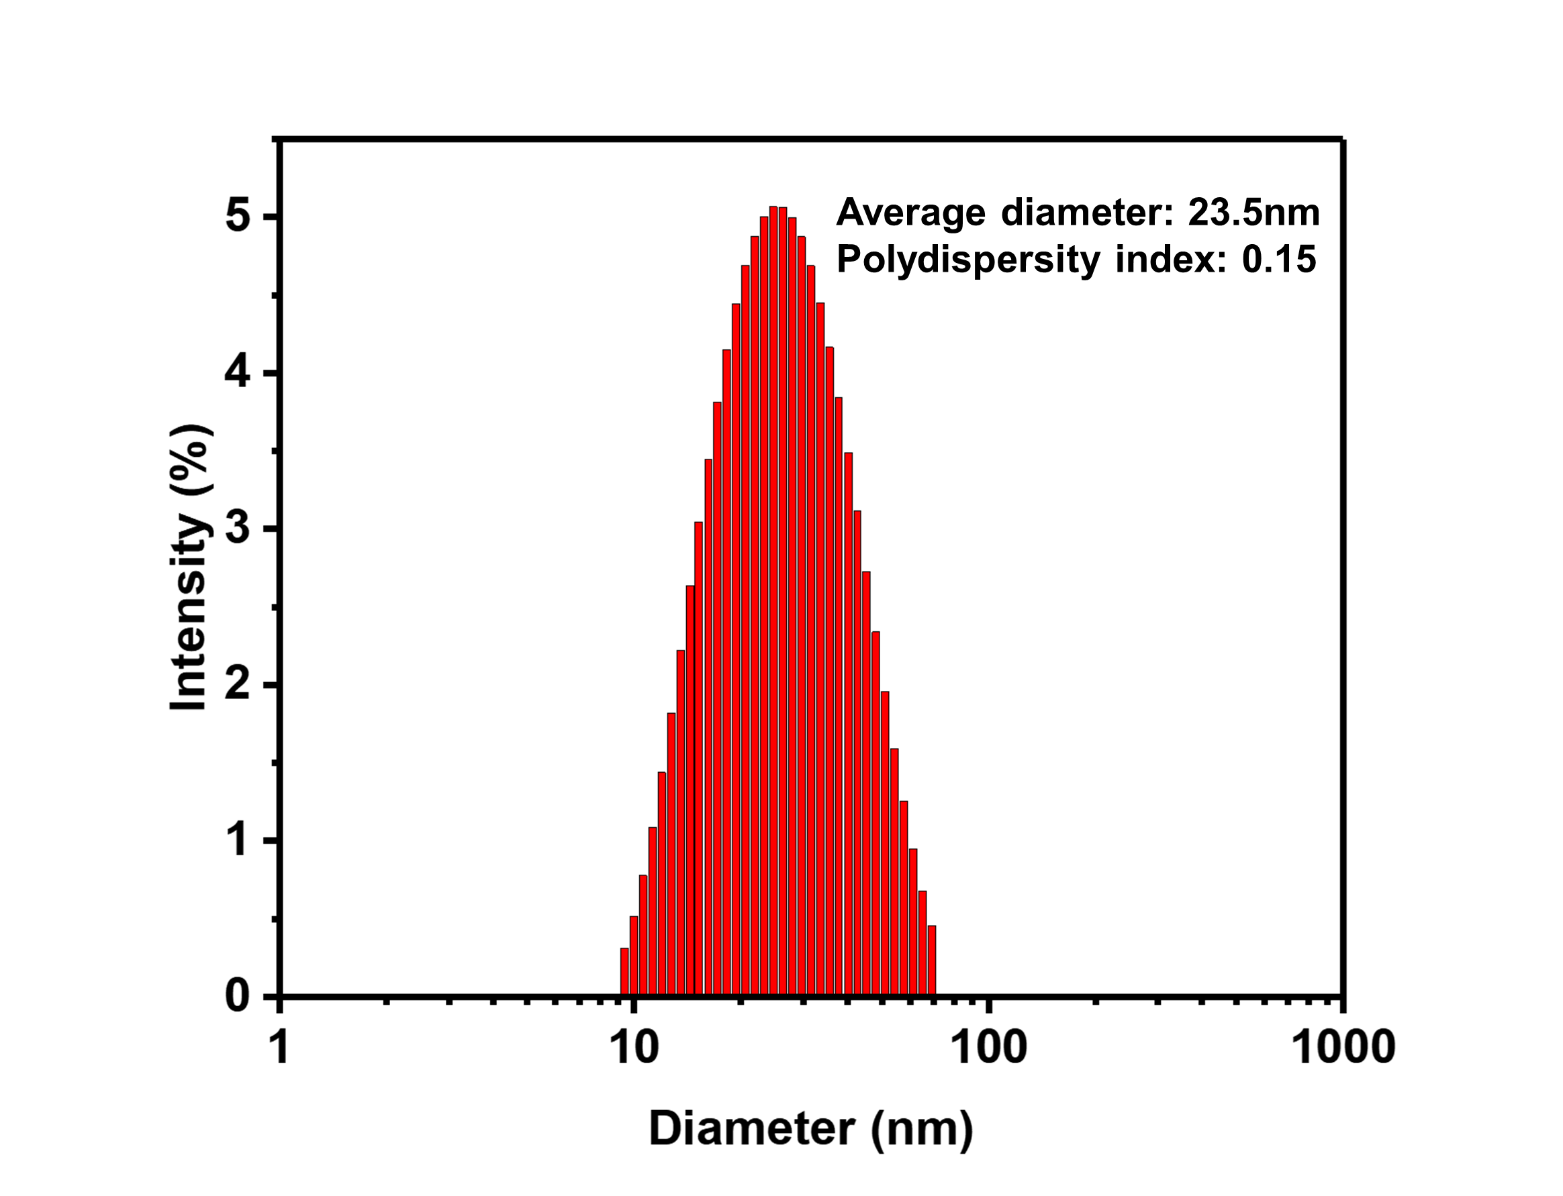
Figure. S10 Particle size distribution curve of ZnO nanoparticles
8. A cross-sectional SEM image is advised to be included in the manuscript for both devices so that readers can see each thin film thickness and thin film stacking configuration.
=> Thank you for the insightful comment. According to the reviewer’s comment, we have tried to get cross-sectional SEM images of two devices during the revised manuscript preparation period many times as much as we can. As a result, we could not unfortunately get the clear cross-sectional view as shown in below. It is because it requires the special equipment for the clear cutting method not to collapse down the multi-organic layers upon cutting, but we don’t have that equipment. Thus, it is not recommended to input the cross-sectional SEM image in manuscript but if you think it is still needed, we will insert the related text and figure as below. Please let us know your opinion. We will follow it. If there is no any other comment, we will skip it.

Supporting information, Page 13
We measured the cross-sectional SEM images of the multilayers in the conventional forward (a) and the inverted (b) OLED devices as shown in Figure. S17. Multilayers of (a) and (b) are PEDOT:PSS (40 nm)/PVK (20 nm)/mCP: 30% dopant (TDBA-PCZ) (20 nm)/TPBi (40 nm)/LiF (1 nm) and ZnO (30 nm)/PEI (5 nm)/mCP:30 wt% TDBA-PCZ (20 nm)/TAPC (20 nm)/MoO₃ (10 nm) for Figure. S17 (a) and (b), respectively. Looking at Figure. S17 (a), PEDOT:PSS with hydrophilic property shows the separated layer interface with 40.3 nm thickness and all other layers do not show the clear interfaces in picture because of the similar hydrophobic property. In the case of Figure. S17 (b), it does not show clear interface results between all layers, either. It can be explained by the fact that all layers do not have quite different hydrophobic properties.

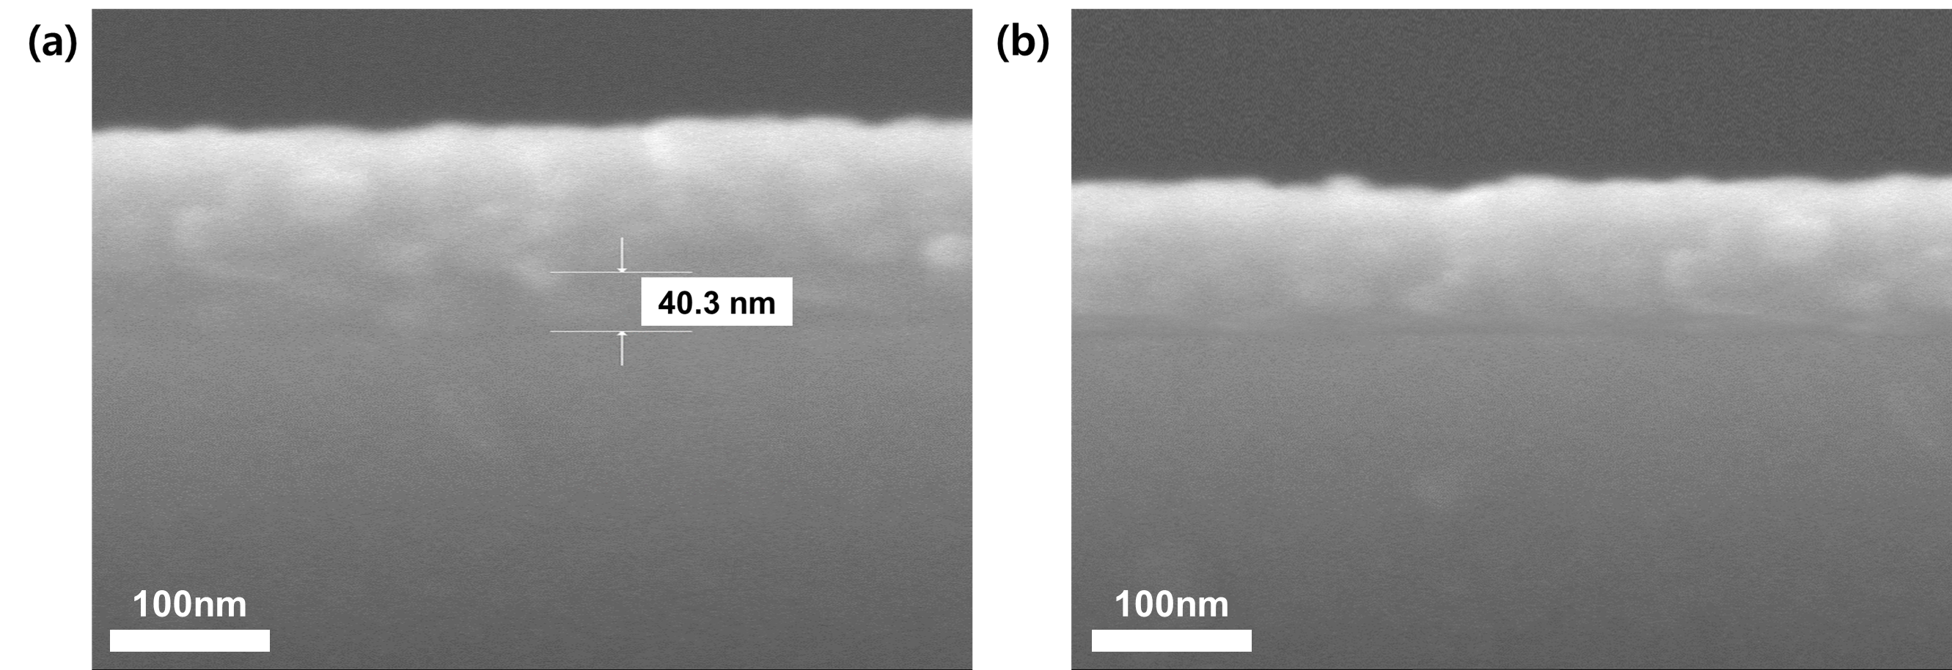
Figure. S17 Cross-sectional SEM image of (a) conventional forward device and (b) inverted device.

