Dear Editors and Reviewers:
Thank you for your letter and for the reviewers’ comments concerning our manuscript entitled “Research on the control of mining instability and disaster in crisscross roadway”. Those comments are all valuable and very helpful for revising and improving our paper, as well as the important guiding significance to our researches. We have studied comments carefully and have made correction which we hope meet with approval. Revised portion are marked in red in the paper. The main corrections in the paper and the responds to the reviewer’s comments are as flowing:
1.Response to comment: The citation format of references needs to be improved following the journal requirement. It is suggested that some latest related research literature can be added appropriately.
Response: Thank you for your suggestion. According to your suggestion, we have made corresponding changes to the format of the references according to the citation style of MDPI. See the reference section of the article for details, and several English articles have been added to the introduction, result and discussion, and marked red in the corresponding position in the article.
2.Response to comment: It is suggested to standardize the size and text in the figures and tables of the paper.
Response: Thank you for your suggestion. We have processed and modified some of the pictures in the article, as detailed in the article.
3.Response to comment: Figure 15 is not clear, please adjust it.
Response: Thank you for your suggestion. We have processed and modified some of the pictures in the article, as detailed in the article.
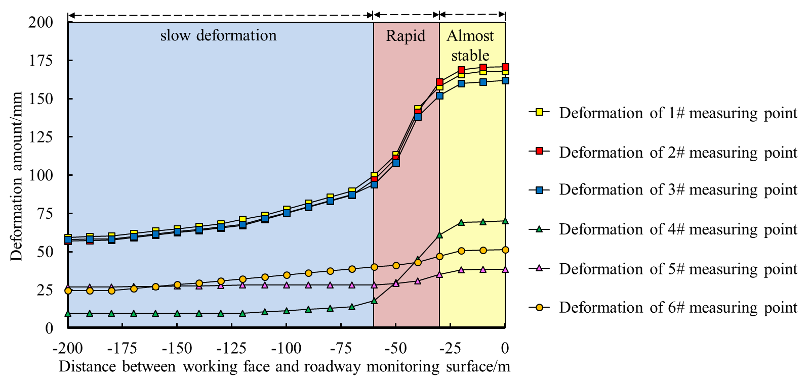
4.Response to comment: The borehole scanning results need to be explained properly.
Response: Thank you for your suggestion. We have made a supplementary description and analysis of the borehole scan results as follows:
031604 before the return aircourse is driven, the drilling hole peeping method is adopted on the spot, and three boreholes with a depth of 15m and a diameter of 32mm are arranged in front of the working face of the side 031601 transport roadway. The roof strata structure and the failure form of mining surrounding rock are analyzed, representative screenshots are selected to express, and combined with geological data, the comprehensive column is obtained as shown in figure 2. There is solid coal in the range of 0-5.3m from the roadway roof, and the cracks crisscross and crisscross in the range of 0-2m from the roof, which is seriously broken. The coal body is cut into a large number of pieces, and the fragments are of different sizes, accumulated on both sides of the top coal drilling wall, and local voids and holes collapse occur, as shown in figures (a) and (b). The distance from the roadway roof is about 5-6.9 m, which is composed of solid coal, sand shale and carbon shale interbedding. In this range, the coal (rock) body is relatively complete, with one or more horizontal, vertical and inclined fissures, with large scale and wide extension. The fissures contain a small amount of small fragments with a width of about 0-15mm, as shown in figures (c) and (d). Within 7-15m from the roof of the roadway is fine sandstone, the rock mass is complete, only a small number of small cracks exist locally, and the hole wall is relatively flat, as shown in figure (e), there are a small amount of coal lines in the 14.0m-14.3m position, there is a phenomenon of separation, the integrity is good, and the development of cracks is rare, as shown in figure (f).
5.Response to comment: Please explain the innovation point of this article compared with previous studies.
Response: Thank you for your suggestion. After discussion, we made the following answer: at present, there are many theoretical and technical research achievements on surrounding rock control of crisscross roadway and advanced mining roadway. however, most of the studies on surrounding rock stability control of spatial crisscross roadway caused by strong mining are only based on experience and lack of reliable scientific basis. The research on the failure characteristics and mechanical mechanism of roadway surrounding rock under such conditions is relatively scarce, and the existing research results can not meet the needs of surrounding rock stability control. Therefore, this paper will study this subject. We attach great importance to your suggestion, and have added this part to the introduction, which clearly illustrates the innovation of this paper compared with previous studies.
6.Response to comment: The English writing of this paper needs to be improved.
Response: We attach great importance to your suggestions, and we will devote ourselves to improving the professional writing ability of English literature, reading and learning English literature extensively.
Here, thank you again for your affirmation of our paper and your valuable comments. On behalf of all the authors, I would like to express my sincere thanks to you. I wish you every success in your work and a happy life.

