Response to Reviewer 3 Comments
A report for: land-1872279. Study on the scale effect of spatial variation of soil salinity based on Geostatistics A case study of Yingdaya River irrigation area

The authors analyze and test the physical and chemical properties of soil using Geostatistics and GIS technology to analyze the scale effect of soil salt and build a nested model of three scales. This type of studies focused to explore the spatial distribution law of soil salt are always interesting. The subject falls within the general scope of the journal. Some paragraphs could be improved as suggested below.

In Title: I propose: Study on the scale effect of spatial variation of soil salinity based on Geostatistics: A case study of Yingdaya River irrigation área.
Thank you very much for the expert's opinion. I also think there are some problems with the title, so I modified it as follows:
Study on the scale effect of spatial variation of soil salinity based on Geostatistics: A case study of Yingdaya River irrigation area

-Line 20. …L, M, and S.. The first time an acronym like these is used, it should be indicated what it is. (L = low?..).
Thanks for the experts' suggestions, I ignored the division of scales in the original version, so I revised the abstract in the original version, as shown below:
Abstract: Soil salinization seriously restricts the development of the agricultural economies in arid and semi-arid areas. Mastering the spatial variability characteristics of multi-scale soil salt in irri-gated areas is of great significance for the improvement and utilization of saline soil and agricultural production. The middle and lower reaches of the Yingdaya River were selected as the study area, and the irrigation area was divided into three scales: the L scale (irrigation area), the M scale (township level) and the S scale (village level). A total of 131 data sets were obtained through field investigations and sampling, and the spatial variability characteristics and scale effects of the soil salt in multi-scale irrigated areas were analyzed using classical statistics, geostatistics and nested model methods.

-Line 36. The problem of scale has always been a core topic in ecology and landscape science. Please add soil science.
Thanks for the expert opinion. I have rewritten the preface and hope the experts are satisfied with it. The details are as follows:
Soil salinization restricts the agricultural development of arid and semi-arid are-as[1], seriously affecting the stability of their ecosystems and the sustainable development of their agricultural economies. Therefore, accurately mastering the spatial distribution characteristics of soil salt is of great significance in preventing and control-ling the occurrence and development of soil salinization as well as the scientific management of soil salinity [2][3].
At present, experts and scholars both at home and abroad have carried out a lot of research on the variation characteristics of soil salt. From the perspective of the re-search areas, most of the research has been concentrated in coastal and plain areas, and research on arid and semi-arid alluvial-proluvial fan areas has been relatively small-scale. For example, Emadi et al. used geostatistics to study the distribution law of the soil pH and salt in the coastal areas of northern Iran [4], Said Eljebri studied the spatial distribution characteristics of the soil salt in the Doukkala irrigation plain of Morocco [5], and Abderraouf Benslama analyzed the spatial variations in the soil salinity of the palm forest in the Algeria Plain [6]. From the perspective of the research scale, most studies on spatial variations in soil salt have been concentrated on a single scale, and a few studies have specifically discussed the spatial variations of soil salt at different scales to verify the scale effect [7] [8][9][10]. For example, Cui sampled soil salt from the three scales of fields, plots and ridges to explore the multi-scale variation law of soil salt in the summer in the Yellow River Delta [11], and Ren et al. studied the soil salt variation in the agricultural area of the Hetao Plain from the field scale, canal scale and regional scale [12]. Qiao et al. studied the spatial variability of soil salt con-tent in cotton fields by multi-scale nested sampling (4km, 500 m and 100 m) [13]. The research on soil salinities at different scales mentioned above focused primarily on analyzing the differences of the parameters and the mechanisms of spatial structure formation, but how to use and deal with multi-scale parameters based on the scale effect has still yet to be thoroughly explored. Therefore, it is necessary to study the variation characteristics of the soil salinity at the different scales of continuous spaces, and to explore and construct a nested method for multi-scale spatial structures, accurately grasping the spatial distributions of soil salinity, and allowing the spatial management and control of saline soil to reach a higher level.
This study takes the Yingdaya irrigation area as its research area, studies the spatial variations in soil salt using the three scales of L (the irrigation area), M (the town-ship level) and S (the village level), proposes a multi-scale nested model for the re-search process, and discusses the interrelationships and action intensities of various influencing factors and the soil salinization at the different scales, so as to effectively elucidate the spatial distribution characteristics and formation causes of the presence of soil salt in the irrigation area, providing a scientific basis for the formulation and implementation of a salinization control plan.

-Line 39. In traditional soil research, the concept of the scale was not clear. Who says that?, reference.
Thank you very much for your opinions. When I read the literature, I found that the research on spatial variation of soil attributes is mainly aimed at single scale, and some of them mentioned multi-scale, but most of them are about the differences of different scale parameters. However, how to carry out scale transformation, multi-scale nesting is still relatively small, so I wrote this sentence in this article. It may be because the literature I read is too old. For this reason, I revised the introduction in the revised edition and highlighted it in yellow. I hope the experts are satisfied.
-Line 73… have not been adequately studied…Adequately or suficient/ enough?.
Thank you for the expert's opinions. Maybe the expression is not accurate enough, so I revised it in the revised version, as shown below:
The research on soil salinities at different scales mentioned above focused primarily on an-alyzing the differences of the parameters and the mechanisms of spatial structure formation, but how to use and deal with multi-scale parameters based on the scale effect has still yet to be thoroughly explored. Therefore, it is necessary to study the variation characteristics of the soil salinity at the different scales of continuous spaces, and to explore and construct a nested method for multi-scale spatial structures, accurately grasping the spatial distributions of soil salinity, and allowing the spatial management and control of saline soil to reach a higher level.

-Line 77. … Yingdaya River irrigation area in Kuqa County.. And line 87 Tianshan Mountain and the middle part of the north foot of the Tarim Basin. I suggest adding more details such as central? or southern? China?... Not everyone knows the whole territory.
Thank you very much for your expert opinions. You are right. Not everyone knows this place. Therefore, I added the specific location of the research area in the revised edition to make it easier for readers to find the location of the research area, as shown below:
The Yingdaya River irrigation area is located at the south foot of the Tianshan Mountains and the middle part of the northern foot of the Tarim Basin (Location: Southeast of Kuqa County, Aksu Prefecture, Xinjiang, China). It is part of the alluvial plain of the Kuqa River and is mainly an agricultural area, featuring an oasis, desert, and other landscapes, and is at an altitude of 950-1030 m[14]. The administrative region is subordinate to Kuqa County, which includes Arahag Town, Qiman Town, the Akwusitang Township, and the Hanikatamu Township, with geographical coordinates of 82° 40′～ 83° 16′ E and 41° 14′～ 41° 37′ N。

-Line 85. 2. Materials and Methods. Put in bold
Thanks for the experts' opinions, I corrected them in the revised version

-Line 86 2.1. Overview of the study área. Please, provide details on the type of soil and its characteristics.
I added soil type information in "2.1. Overview of the study area", as shown in:
The study area is located in the alluvial proluvial fan, so the spatial distribution of soil types is closely related to the landform. From the northeast to the southeast of the study area, the soil particles show a sorting effect from coarse to fine. Therefore, the soil in the northeast of the study area is dominated by sand and medium coarse sand, and the degree of salinization is poor; The terrain in the southeast is relatively flat, the soil particles are small, and the soil deposits are composed of light loam such as sand, sandy soil and loam, with a heavy degree of salinization.
At the same time, the spatial distribution of silt content in the study area was added in the discussion, as shown in Figure 1:
Later, I will upload the soil type detection data to the system in the form of an attachment.
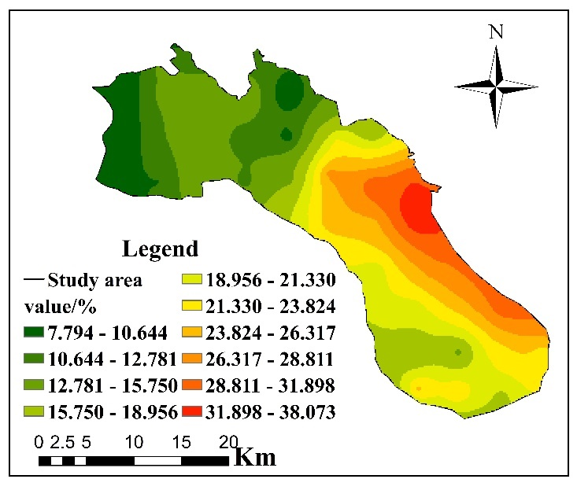
Figure 1.Silt content distribution in the study area

-Please improve the quality of figure 1
Thanks for the experts' reminder, pictures a to f only represent the number of the location map of the research area, where a to c are the location map of the research area, and e to f are the soil sampling and salinization landscape map, which have nothing to do with the scale division (L, m, s). It may be due to the low resolution of the picture, which has been modified in the revision. The location map of the study area is shown in Figure 2, and the salinization landscape is shown in Figure 3
Figure 2. Location map of research area
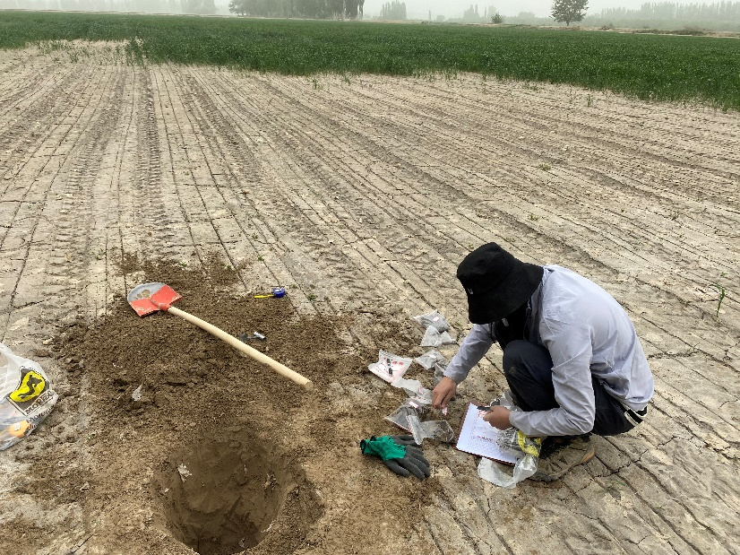 | 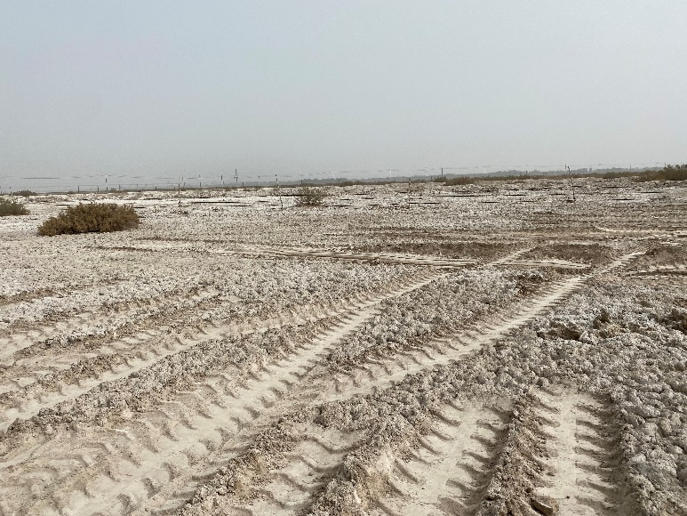
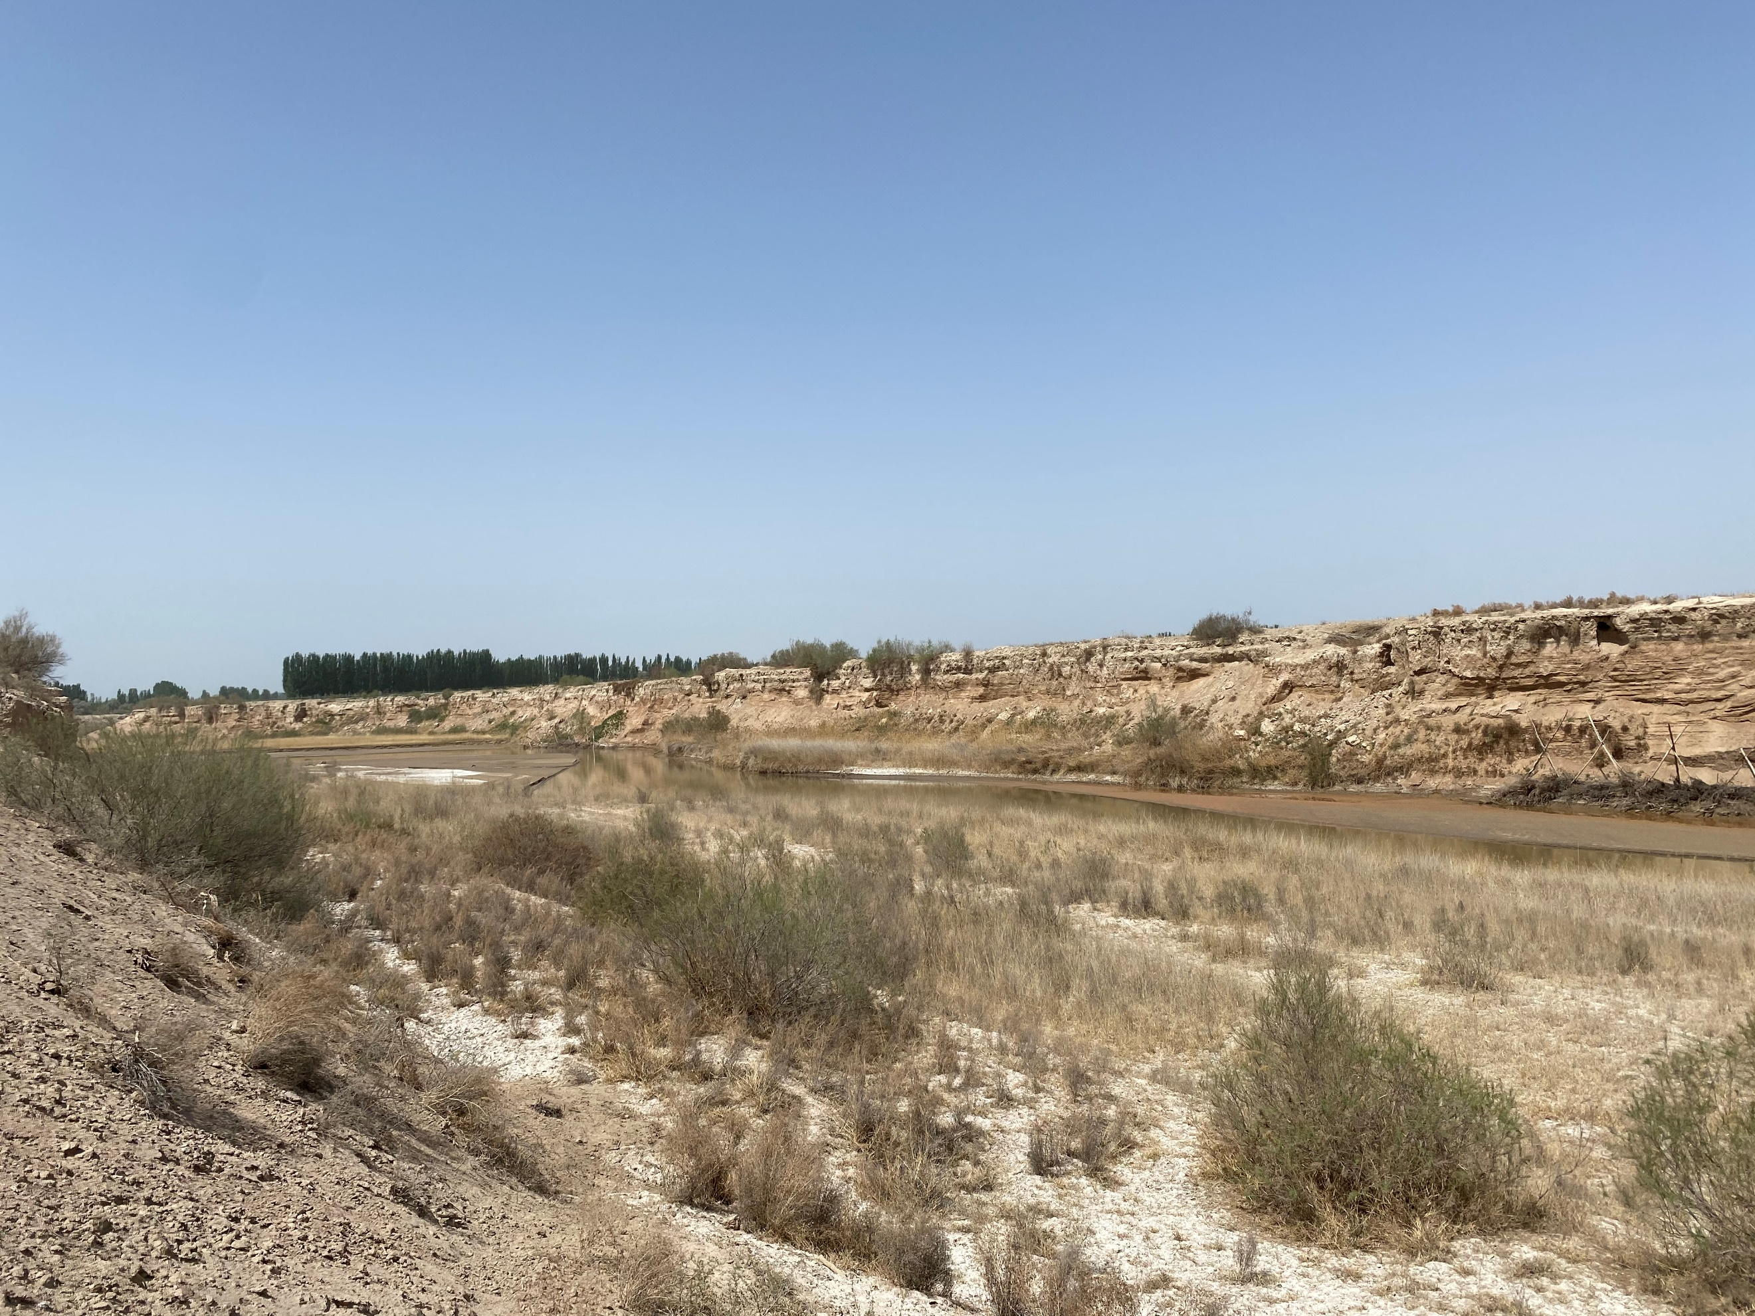 | 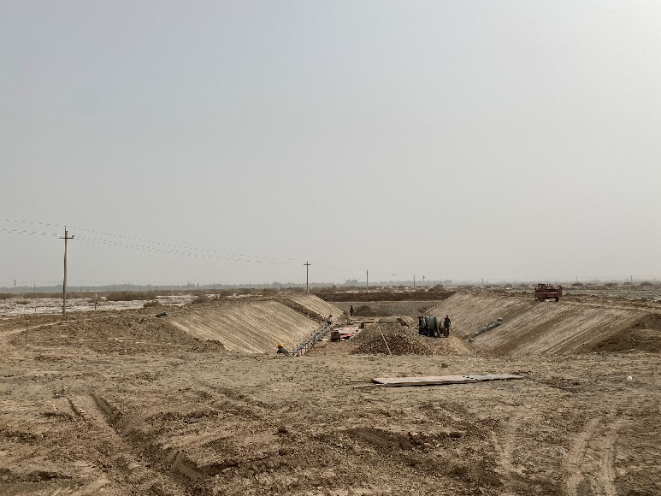
Figure 3.Salinization landscape in irrigated area: Salinization of cultivated land (a); Oasis edge salinization（b）;River salinization (c); Reclamation of saline alkali land (d)

-Line 105. April 2019 used the GIS fishing net tool… I am not an expert in the English language, but I think it is poorly expressed.
Thanks for the experts' opinion. It may be that the expression was inaccurate during the translation, so I rewrote 2.2. Collection of soil sample in the revised version. As shown below:
Soil collection was carried out from April 20, 2021 to May 5, 2021, and a total of 131 sampling points were arranged in the study area via grid nested encryption using GIS. The L-scale sampling distance was 4.4 km, and there were 44 sampling points. The M scale featured encrypted sampling with a sampling interval of 2 km and 51 sampling points. Finally, the S-scale was locally encrypted again in the same way, with a sampling interval of 550 m and 36 sampling points. The above sampling levels together constituted an interconnected nested system, as shown in Figure 3. In order to re-duce soil differences, five sampling points were arranged with the sampling point as the center and a radius of 10 m forming a plum blossom distribution, and the sampling depths were 0-30 cm. The corresponding layers of soil from five sampling points were mixed and about 0.5 kg of soil samples were taken by the quartering method. After sampling, the samples were numbered and sealed, and the sealed soil samples were brought back to the room for finishing, at which point the soluble salt of the soil was measured according to the design requirements.

-Line 115. the sampling interval was 550 m,. Why select these meters?.
Thanks to the expert's advice. After careful consideration, I think that the division of sampling scale is not clear enough. Therefore, in “2.2. Collection of soil sample”, the basis for scale division is described in detail, as follows:
The spatial scale mainly includes the sampling amplitude and sampling granularity [17]. In this study, the sampling amplitude and grain size were changed simultaneously to represent the changes in the spatial scale, so as to facilitate the study of the spatial variability of the soil salinity at the different scales. According to the administrative division principle [18], the sampling amplitudes are divided into three classifications, namely the L scale (the irrigation area), the M scale (the township level) and the S scale (the village level). The whole irrigation area is taken as the L scale, Qiman Town as the M scale, and Dabozi Village in Qiman Town as the S scale. Based on the preliminary investigation and literature review for the sample area, it is generally believed that the formation process of the spatial variation of the soil salinity is significantly affected by factors such as the topography, groundwater environment, rivers, soil parent materials and cultivation management[15][19][20]. Among them, the in-fluences of the topography and groundwater environment are generally within a larger scale of 4 km or more, which shows obvious differences. Generally, the influence of the river, soil texture and land use type can only highlight differences at scales of 2 km or above. Differences caused by farmers' personal characteristics, such as farming management and micro-topographical changes, usually occur at scales of less than 600 m [21][22]. At the same time, in order to choose the appropriate step length for the calculation and analysis of the variogram, it is necessary to sample according to the regular grid. Therefore, based on the basic principles of geostatistics on sampling point setting and the actual situation of the study area, the sampling intervals for this study were determined to be 4.4 km, 2 km and 550 m.

- 2.3. Sample data processing or Analytical methdos and Sample data processing. Also it is strange that authors do not measure the pH, given its easy measurement, and can help interpret.
Thanks to the expert's advice, I did measure the pH of the soil in my experiment, but it was not described in the article.
Different saline soils have different pH values, among which chloride and sulfate are neutral salts, and the pH is basically maintained at about 7. Soda saline soil contains a large amount of HCO₃⁻ and CO₃²⁻, so the soil is alkaline, generally greater than 8.5. In arid and semi-arid areas, soda saline soil belongs to primary salinization, and the soil has not been reclaimed and irrigated. However, the study area belongs to the agricultural area, and the salinization in the irrigation area gradually transits from primary salinization to secondary salinization. Among them, the types of saline soil are mainly chloride and sulfate, and a few of the primary saline soil are soda saline soil. Therefore, I did not mention the measurement of soil pH.
The soil pH is shown in the following table:
Table 1.Soil pH data in some study areas
number | X | Y | pH | number | X | Y | pH
P1 | 642832.8 | 4603957 | 7.7 | T1 | 650491.4 | 4608763 | 7.8
P2 | 642733.4 | 4599526 | 7.7 | T2 | 659269.8 | 4592881 | 7.6
P3 | 647144.6 | 4594990 | 7.8 | T3 | 665901.7 | 4588928 | 7.6
P4 | 647181.1 | 4599513 | 7.7 | T4 | 670640.2 | 4583923 | 7.7
P5 | 647269.1 | 4603994 | 7.8 | T5 | 672302.5 | 4600148 | 7.8
P6 | 651706.5 | 4604184 | 8.5 | T6 | 658386.9 | 4607056 | 7.7
P7 | 651620.2 | 4599513 | 7.8 | T7 | 652337.8 | 4606004 | 7.6
P8 | 652219.6 | 4594717 | 7.7 | T8 | 653755.3 | 4604468 | 8.0
P9 | 647209.5 | 4607012 | 7.7 | T9 | 657063 | 4602072 | 7.8
P10 | 656196.2 | 4594994 | 7.7 | T10 | 663863.3 | 4601704 | 8.0
P11 | 656092.7 | 4599532 | 7.6 | T11 | 663364.9 | 4598053 | 8.2
P12 | 656364.7 | 4604083 | 8.8 | T12 | 649784.4 | 4606977 | 7.7
P13 | 660924.7 | 4604303 | 8.5 | T13 | 659290.5 | 4597499 | 7.6
P14 | 660817.3 | 4599688 | 8.5 | T14 | 651706.5 | 4604184 | 7.7
P15 | 661082.7 | 4595111 | 8.6 | T15 | 656092.7 | 4599532 | 7.8
P16 | 660864.2 | 4591818 | 7.8 | T16 | 656364.7 | 4604083 | 7.7
P17 | 665785.4 | 4603420 | 7.6 | T17 | 660924.7 | 4604303 | 7.7
P18 | 665859.1 | 4599520 | 7.8 | T18 | 665785.4 | 4603420 | 7.6
P19 | 665029.9 | 4595956 | 8.1 | T19 | 665859.1 | 4599520 | 7.7
P20 | 665000.5 | 4590843 | 8.6 | T20 | 661082.7 | 4595111 | 8.5
P21 | 669660.8 | 4600215 | 7.7 | T21 | 660864.2 | 4591818 | 8.0
P22 | 669651.9 | 4594736 | 8.8 | T22 | 665000.5 | 4590843 | 8.6
P23 | 669796.1 | 4590574 | 7.7 | T23 | 670126.8 | 4585723 | 7.7
P24 | 670126.8 | 4585723 | 8.7 | T24 | 669660.8 | 4600215 | 7.7
P25 | 670779.3 | 4577188 | 8.7 | T25 | 670239.3 | 4600378 | 7.7
P26 | 674463.3 | 4573215 | 7.7 | T26 | 661871.7 | 4600778 | 8.3
P27 | 674221.7 | 4576803 | 7.6 | T27 | 664118.7 | 4589224 | 7.6
P28 | 674161.3 | 4581591 | 8.2 | T28 | 650491.4 | 4608763 | 7.8
P29 | 674969.5 | 4586297 | 7.6 | T29 | 659269.8 | 4592881 | 7.6
P30 | 674666.8 | 4591627 | 7.8 | T30 | 665901.7 | 4588928 | 7.6
P31 | 673965.4 | 4595680 | 7.6 | T31 | 670640.2 | 4583923 | 7.7
P32 | 677419.3 | 4586186 | 7.8 | T32 | 672302.5 | 4600148 | 7.8
P33 | 678776 | 4577041 | 8.1 | T33 | 658386.9 | 4607056 | 7.7
P34 | 678724.8 | 4572759 | 7.9 | T34 | 652337.8 | 4606004 | 7.6
P35 | 683306.4 | 4581502 | 7.6 | T35 | 653755.3 | 4604468 | 8.0
P36 | 683236 | 4577009 | 7.7 | T36 | 657063 | 4602072 | 7.8
P37 | 683270.6 | 4572495 | 7.6 | T37 | 663863.3 | 4601704 | 8.0
P38 | 687738.6 | 4577032 | 8.3 | T38 | 663364.9 | 4598053 | 8.2
P39 | 673300.2 | 4582084 | 8.1 | T39 | 649784.4 | 4606977 | 7.7
P40 | 645064.5 | 4604123 | 8.8 | T40 | 659290.5 | 4597499 | 7.6

-Line 143. 2.4. Data analysis and Methods. I am not sure that it is necessary to detail the procedure. I suggest summarizing.
Thanks for the experts' opinions, I also think the methods and steps described in the article are too detailed, so I have reduced 2.4. Data analysis and methods in the revised version. The details are as follows:
(1) Variogram and Theoretical model
As a basic function to study the spatial variation of soil attributes, some important parameters such as range (a), nugget(C₀), sill(C₀+C), and fractal dimension can reflect the variation degree and autocorrelation range of soil characteristics on a certain scale. The calculation formula is shown in Eq. (1).
$γ\left(h\right)$=$\frac{1}{2N(h)}\sum_{i=1}^{N(h)}{[Z\left(x_{i}\right)-Z(x_{i}+h)}$]² | (1)
where$γ\left(h\right)$ is the experimental variogram; N(h) is the number of sample pairs; h is the vector between the two sample points; Z(x_{i}) and Z(x_{i}+h) are the observed values of Z(x_{i}) at spatial positions x_{i} and x_{i}+h, respectively.
The spatial variation causing soil salinity includes two parts: one is the nugget (C₀) that represents the variation caused by random factors, including sampling error and human factors such as land use mode, cultivation, and irrigation within the minimum sampling interval. The other is the partial sill (C), which represents the variation caused by structural factors, mainly including natural factors such as topography, groundwater environment and soil parent material [13][19]. nugget coefficient [C₀/ (C₀ + C)] indicates the proportion of variation caused by random factors in the total variation of the system, and the ratios < 25%, 25 ~ 75%, and > 75% respectively indicate that the correlation of spatial variables is strong, moderate and weak. The higher the ratio, the more soil salt variation is caused by random factors. On the contrary, salt variation is caused to a greater extent due to structural factors [24][25].
(2) Anisotropic nesting structure
For most geometric anisotropy, the directional variation diagram approximates an ellipse. At this time, let a₁ be the major axis of the ellipse, which coincides with the horizontal direction, a₂ be the minor axis, which coincides with the vertical direction (Figure 4), and k= a₁/ a₂, then the linear transformation matrix is: A=$\left[\begin{matrix}1 & 0 \\ 0 & k\end{matrix}\right]$, the transformed $h^{'}$is shown by Eq. (2).
$h^{'}=\left[\begin{aligned}h_{w}^{'} \\ h_{v}^{'}\end{aligned}\right]$=$\left[\begin{matrix}1 & 0 \\ 0 & k\end{matrix}\right]$=$\left[\begin{aligned}h_{w} \\ h_{v}\end{aligned}\right]=\left[\begin{aligned}h_{w} \\ {kh}_{v}\end{aligned}\right]$
At this time, the pattern of the shape of the ellipse becomes a circle with the major axis as the radius (Figure 4), and the anisotropy becomes isotropy. The variation in the vertical direction is $γ\left(h^{'}\right)$, the horizontal variation is γ (h), and the final anisotropic nesting result is expressed in Eq. (3).
$$γ^{*}\left(h\right)=γ\left(h^{'}\right)+γ(h)$$
In practical research, there is no specific variation direction (Figure 5), which is generally studied by first rotating the coordinate axes by an angle φ so that they are parallel to the major axis of the ellipse, and then converted into Isotropy through a linear transformation in Eq. (2).
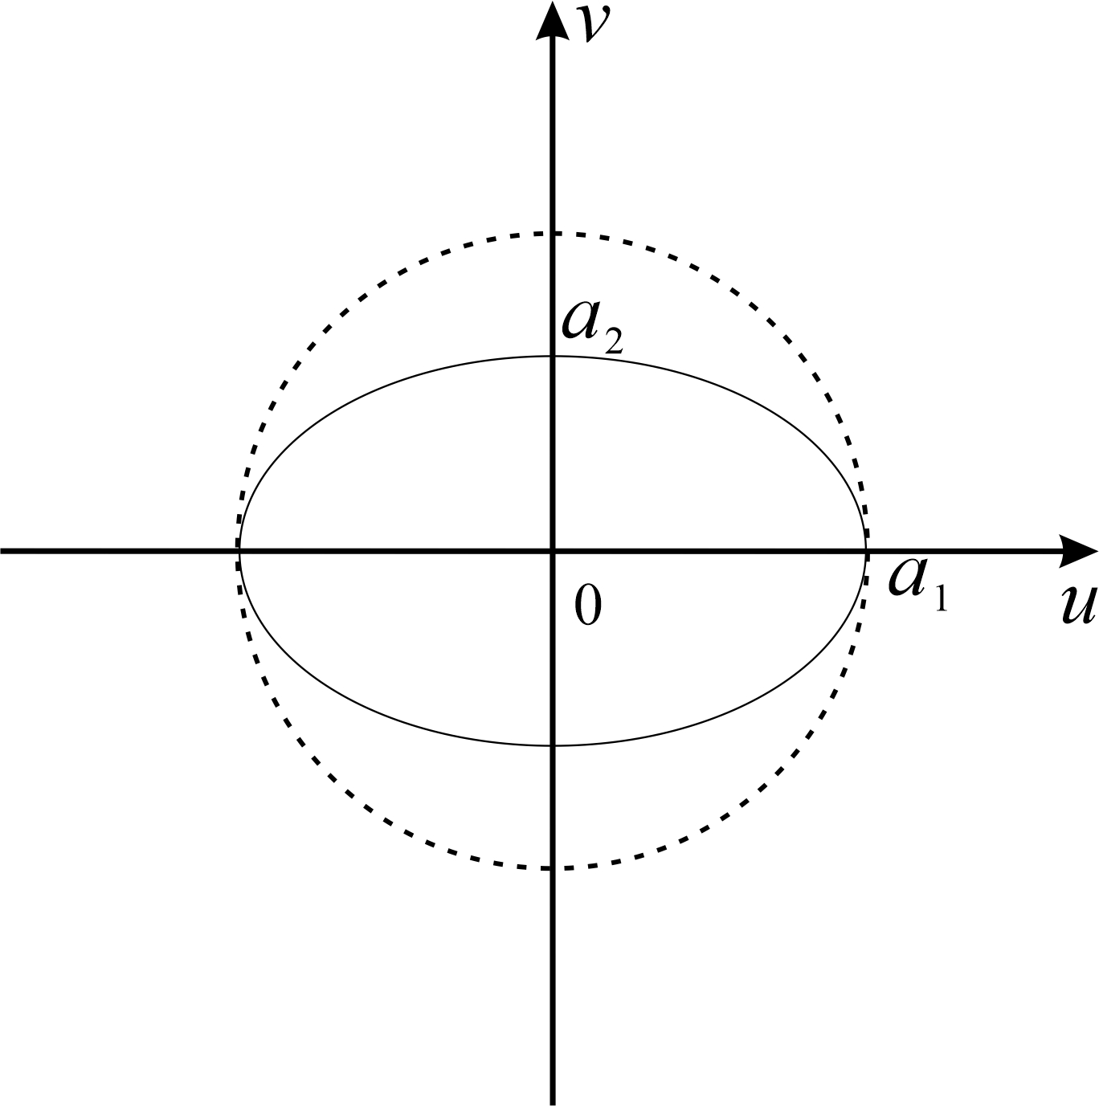  Figure 4. Ellipse stretching transformation | 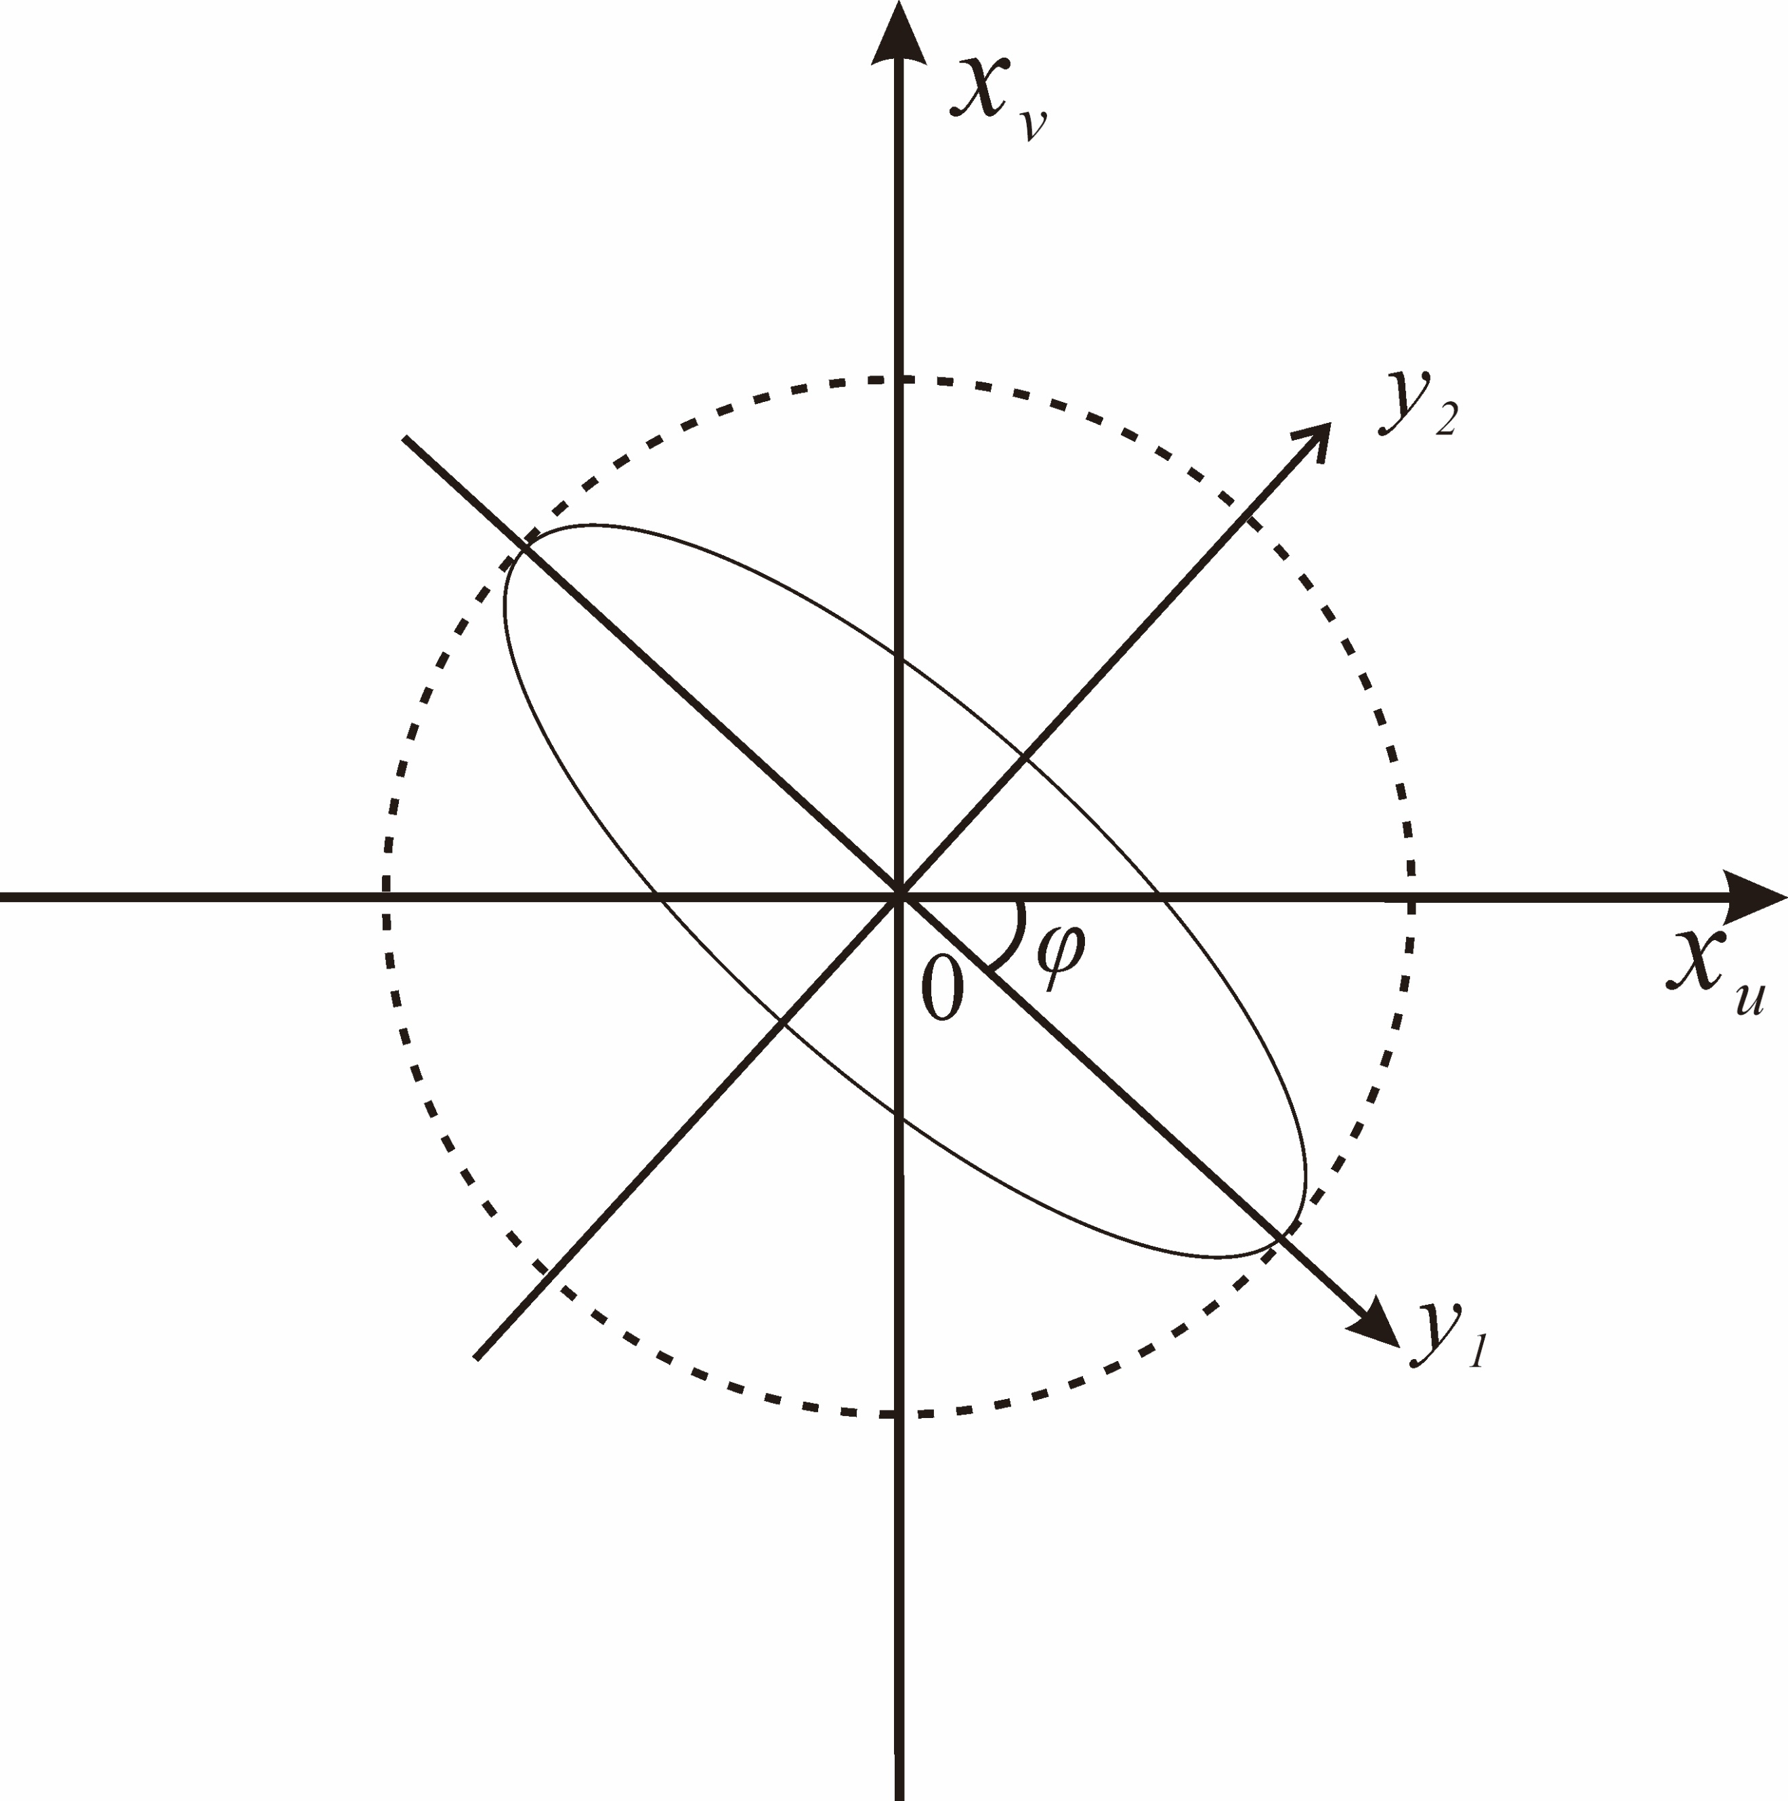  Figure 5 .Coordinate axis rotation transformation
(3) Multiscale nested structure.
Since the variation characteristics of regionalized variables on different scales are different, they cannot be represented by a simple theoretical model, but need to be described by two or more theoretical models whose structure is the superposition of multiple structures on each other, which can be expressed by the sum of multiple semi variograms reflecting the changes of different scales, as shown in Eq. (5).
$γ(h)$= ${ γ}_{0}(h)$+ ${ γ}_{1}(h)$+⋅⋅⋅⋅⋅⋅+$γ_{n}(h)$=$\sum_{i=0}^{n}{γ_{i}}(h)$
where${ γ}_{0}(h)$ is the variation on the micro-scale, which is usually expressed as the spatial structure and randomness that cannot be expressed on the minimum sampling scale, that is the nugget of the nested structure; $γ_{i}(h)$ can be the same or different theoretical models, representing the spatial structure with good integration and independence on different spatial scales.
(4) Model optimality test method
I-value test method and cross-validation method are used to test the optimality of the theoretical semi-variogram model, which is the calculation method as follows:
I =$\overline{{\hat{[Z}\left(x_{i}\right)-Z(x_{i})]}^{2} }$×$\left[P\left|1-\frac{1}{\overline{[{\frac{\hat{Z}\left(x_{i}\right)-Z(x_{i})}{\hat{}(x_{i})}]}^{2}}}\right|+(1-P)\right]$
P=$\left\{\begin{aligned}0.1, 0≤ \overline{{\hat{[Z}\left(x_{i}\right)-Z(x_{i})]}^{2} }≤100 \\ 0.2, 100≤\overline{{\hat{[Z}\left(x_{i}\right)-Z(x_{i})]}^{2} } \end{aligned}\right.$
where $\hat{}\left(x_{i}\right)$ is the standard error of Kriging prediction, $\hat{Z}\left(x_{i}\right)$ is the predicted value of the i^{th} sample at position x, $Z\left(x_{i}\right)$is the measured value of the i^{th} sample at position x, and P is an empirical parameter. The smaller the value of I, the better the representativeness of the theoretical model to the spatial variation structure of the soil.

- Line 201. 3. Results and analysis. Following criteria to use, is not reasonable “and analysis”. Please this section must be “Results”. On the other hand, I think some paragraphs fit better in the discussion section.
Thanks for the experts' opinions, I revised it in the revised version and changed it to 3. Results. At the same time, the discussion part is added in the article and highlighted in yellow, hoping that the experts will be satisfied.

-Line 411. The autor. Plase add s
Thank you for your suggestions. After careful consideration, I felt that the discussion part was not well written. Therefore, in the revised edition, I conducted quantitative analysis on the influencing factors of salinization at different scales through gray correlation degree to explore the differences of influencing factors. I hope the experts are satisfied.
I hope you find my review useful.
Thank you for reviewing the manuscript. Your opinion is very important to improve the quality of your paper

All the above modifications are highlighted in yellow font in the revised edition.

Here, I would like to thank the experts for their efforts

