Article
Structural features of a post-clear-cutting ecotone between 90-year-old bilberry spruce forest and 35-year-old herbs-forbs deciduous stand
Nadezhda V. Genikova*, Alexander M. Kryshen, Roman P. Obabko, Anna Yu. Karpechko and Aleksey N. Pekkoev
Citation: Genikova, N.V.; Kryshen, A.M.; Obabko, R.P.; Yu, A.; Pekkoev, A.N. Structural features of a post-clear-cutting ecotone between 90-year-old bilberry spruce forest and 35-year-old herbs-forbs deciduous stand. Forests 2022, 13, x. https://doi.org/10.3390/xxxxx
Academic Editor(s):
Received: date
Accepted: date
Published: date
Publisher’s Note: MDPI stays neutral with regard to jurisdictional claims in published maps and institutional affiliations.

Copyright: © 2022 by the authors. Submitted for possible open access publication under the terms and conditions of the Creative Commons Attribution (CC BY) license (https://creativecommons.org/licenses/by/4.0/).
¹ Laboratory for Boreal Forest Dynamics and Productivity, Forest Research Institute, KarRC RAS, 185910, Petrozavodsk, Russia
* Correspondence: genikova@krc.karelia.ru
Abstract: In a natural regeneration process, a community dominated by birch and aspen forms in the site 35 years after a bilberry-type spruce stand is logged down. The newly-formed ecotone complex consists of four zones, each characterized by certain features of the ground vegetation and epiphytic vegetation structure. The transitional zones and the mature bilberry-type spruce forest feature a clear dominance of boreal dwarf shrubs (bilberry and cowberry). Another feature of the transitional zone is a greater role of hygrophytic mosses of genera Polytrichum and Sphagnum. Meanwhile, true mosses Pleurozium schreberi and Hylocomium splendens dominate under spruce forest canopy, and the moss cover in the young deciduous stand is virtually non-existent. The structure of epiphytic vegetation depends on the habitat conditions – the surface of tree trunks in the transitional zone is better lit and drier than inside the tree stand, which results in a higher abundance of epiphytic lichens of the genus Cladonia. The deciduous:coniferous fine root biomass ratio is dependent on the tree stand structure and is unrelated to ecotone zones. Overall, the studies have demonstrated that transitional zones have certain characteristic ecological and community features, which persist for a long time after tree stand removal.
Keywords: ecotone complex; bilberry-type spruce forest; deciduous stand; clear-cut; edge effect; ground vegetation; epiphytes; tree fine root biomass

1. Introduction
Russia contains a half of all the world’s boreal forests and their significance for maintaining the climate, supplying people with timber products, and performing other ecosystem services is significant [1–5]. The cutting practice regulations [6] adopted in Russia limit rather strictly the size of sites to be clear-cut and the cutting cycle (the period after which the site immediately adjoining a previously clear-cut site can be clear-cut). Allowable clear-cut site area in mature and over-mature stands in exploitable forests of European Russia cannot exceed 50 hectares irrespective of the tree species composition, and the corresponding cutting cycle is 5–6 years for coniferous stands and 2–4 years for soft-wooded deciduous stands. These restrictions are meant to secure that natural regeneration can proceed on the one hand, and that fragments of the forest environment and, hence, the biological diversity are preserved on the other [7]. As a result, there form large areas transitional from forest to clear-cut sites of different ages (Figure 1). The interest in the ecotone complexes forming after clear-cutting (forest – transitional zone – clear-cut site) is explained not only by their wide occurrence, but also by the transformation of the environment, the processes of vegetation regeneration in the transitional zone [8–10]. The characteristics of transitional states over space and time in relation to phytosociology and sylviculture have been drawing researchers’ attention since the early 20th century [11,13]. Trees immediately neighboring clear-cut sites generate the conditions for mother tree species regeneration, reducing reforestation costs [14–18]. The spatial extent to which the forest edge influences the microclimate and plant community parameters both into the intact forest site and into the clear-cut site has been estimated differently by different authors depending on the climatic belt, type of forest, and period since clear-cutting [19–21]. A suggested assumption is that the forest edge effect extends to a distance equaling tree height [22]. In boreal forests, the transitional zone width varies from 5 to 20 m depending on the period since cutting [23–27]. In Russian forestry practice, a regulation for alternate strip cutting is that the cut strip width must not exceed 1.5 heights of trees [6], implying that the extent of the forest edge effect is thought to be less than one tree height. Our previous studies [28] suggest that the forest edge effect does not extend beyond a half of tree height.
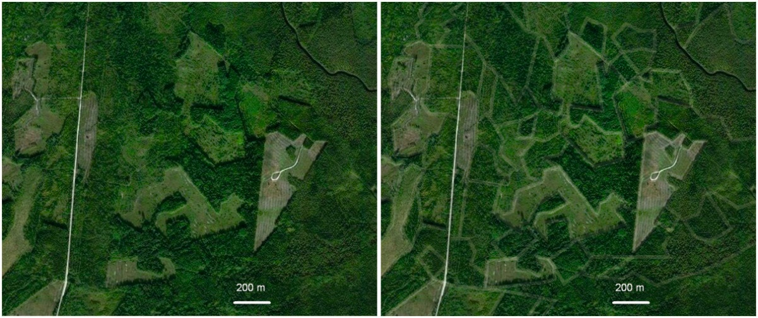
Figure 1. Forest vegetation fragmentation – a mosaic of varying-age clear-cut sites in the study area. Image borrowed from www.bing.com. The original image is on the left; the image on the right has the boundaries between communities in different stages of post-logging regeneration “highlighted”.
As a rule, the objects in edge effect studies are plant communities in early regeneration stages, within one decade since tree stand removal [20,23,28]. Changes taking place in the contact zone between two communities decades after the disturbance are considered less often [29–32]. Meanwhile, these studies can elucidate important issues such as the effect of the forest edge on woody species regeneration. It is not only the amount of regenerating woody saplings and their survival in the early stage of clear-cut regeneration that matters but also the tree layer formed in the ecotone complex (EC). The EC is a transition between two adjacent plant communities. Our focus here is the structure of the herb-dwarf-shrub, moss-lichen, and epiphytic vegetation.
Our preliminary studies have demonstrated that all EC zones have certain characteristic features of the ground vegetation structure, which persist for a long time [27,28]. What are the causes of the differences? Some papers [33,34] talk about the connection between ground vegetation and the biomass of tree fine roots and the distribution of the latter across the soil profile. The question was therefore raised regarding the role of fine roots, which provide trees with water and nutrients [35,36], in the making of the communities in different ecotone zones? Knowledge about fine root growth and development processes is poor [37] and studies on the distribution of roots in ecotone complexes are all but missing.
Another little studied matter is the formation of epiphytic vegetation in boreal forests. Epiphytes are commonly researched as an indicator of environmental quality and community age [38–39]. The perspectives discussed less often are the composition and structure of epiphytic vegetation in communities forming in logged sites [40]. The response of epiphytic vegetation to logging can be indirectly judged from its structure in the forest communities adjoining mire sites, logged sites, and farmland [42–47]. At the same time, there is hardly any information available on the structure of epiphytic vegetation several decades after cutting, when the forest no longer borders open space but neighbors a community with fundamentally different tree layer composition and structure [48].
Relying on our own previous data [27,28] and facts from the literature as the background, we undertook to answer two main questions in this study:
1. Do the distinct transitional zones on the clear-cut side as well as on the forest side persist 35 years after clear-cutting of a bilberry-type spruce forest?
2. If the distinct transitional zones between the mature coniferous forest and the deciduous stand do persist, then what are the characteristic features of their plant community structure?

2. Materials and Methods

2.1. Study area
The studies were carried out in 2019-2020 in Pryazhinsky District, Republic of Karelia (61.85° N 33.92° E) (Figure 2). The area belongs to the boreal biome. According to the geobotanic zonation adopted in Russia [48], the study area belongs to the middle taiga subzone. Absolute elevations in the study area vary within 80-150 m a.s.l., mean annual air temperature (over the past 10 years) is +2.5°С, mean annual precipitation is 600-650 mm. The coldest month is January (–10.7°С). The warmest month is July (+16.3°С). The snow-covered period lasts from early November through April, the duration of the growing season is about 140 days – from mid-May through September (Pryazha weather archives (www.rp5.ru)). The most common types of forests in the study area are bilberry spruce and pine stands on sandy loam and sandy soils respectively. There are also areas of Sphagnum spruce and pine stands. Pristine spruce- and pine-dominated coniferous forests used to prevail until the late 20th century. As of now, areas of secondary mixed forest dominated by birch and aspen have become widespread instead of the coniferous stands.

2.2. Objects
Surveys were carried out in 2018 and 2020 in two sampling sites. Each site consisted of two sampling plots representing adjacent forest communities: (А) 90-year-old bilberry-type spruce forests and (B) 35-year-old deciduous stands occupying the sites where bilberry-type spruce forest had been clear-cut (Figure 2).
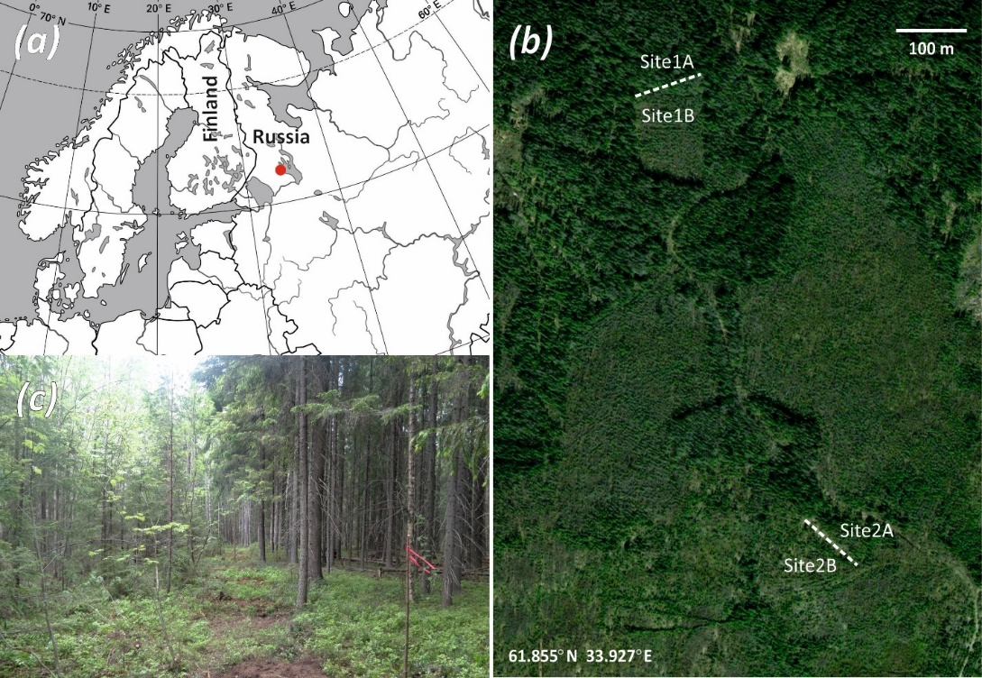
Figure 2. Location of sampling plots (a – geographic location of the study area; b – locations of sampling sites and plots; c – photo from sampling site 2 (deciduous stand on the left, mature bilberry-type spruce forest on the right).
Apart from spruce, the tree stand in mature spruce (Picea abies (L.) H.Karst.) forests (1А and 2А) comprised birch (Betula pubescens Ehrh.) and aspen (Populus tremula L.) (Table 1). The ground vegetation was dominated by bilberry (Vaccinium myrtillus L.), cowberry (V. vitis-idaea L.), and true mosses (Table 2). Their deciduous counterparts were an aspen stand (1B) and a birch stand (2B), both of the forbs type, 35 years old, emerging after forest clear-cutting in 1983. The ground vegetation dominants were species of forbs, true mosses, and haircap mosses (Table 2).
The 90-year-old bilberry-type spruce forest, 35-year-old deciduous stand formed after clear-cutting, and the transitional zone between them constitute an ecotone complex (Figure 3). We conventionally subdivide the ecotone complex into 4 zones: bilberry-type spruce forest (or coniferous forest, CF), transitional zone on the forest side (or coniferous forest edge, CFE), transitional zone on the deciduous stand side (or deciduous forest edge, DFE), deciduous forest (DF).
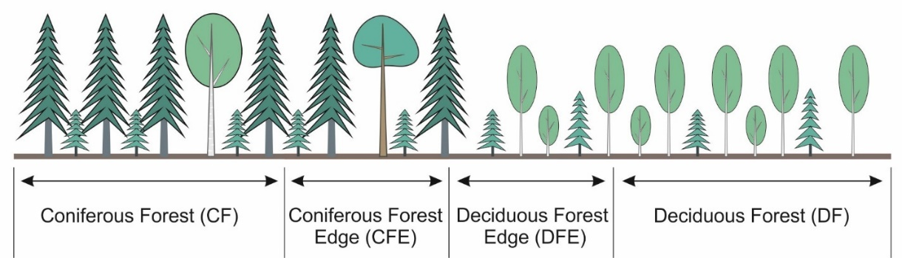
Figure 3. Chart of the ecotone between bilberry-type spruce forest and the deciduous stand formed after clear-cutting.
Surveys in bilberry-type spruce forests (1А and 2А) included mapping and complete enumeration of trees in 0.1 ha areas (30x30 m², 25x40 m²) with measurement of their height and diameter at 1.3 m height. Trunk volumes (V) were determined by the formula suggested by N.I. Kazimirov [49] applied to the conditions of Karelia:
V = (H+2)/2,2 * (0,02+0,073*D+0,0695*D²),
where H is the average tree height in the diameter class, m;
D is the diameter class, cm.
Total timber volume in the sample plot (m³) was found by multiplying trunk volumes by the number of trees in the respective classes and then summing up the products. The resultant total volume was converted to per hectare value. The composition of the stand was estimated in percentages showing the volume contributions of each tree species to the total volume.
The procedure for deciduous stands was different because of high stand density. To map the tree stand characteristics of the deciduous communities, we established 2 transects 2 m wide and 25 m long. Trees large enough to be inventoried (DBH ≥4 cm) were registered along the transects. Trees with smaller diameters were regarded as tree regeneration and analyzed separately. The inventory characteristics of the tree stands are given in Table 1.
Table 1. Inventory characteristics of tree stands in the sampling plots.
Site | Plot | Age, years | Composition by volume, % | Density,  10³trees /ha | Average |  | Volume, m³/ha | Basal area, m²/ha
 |  |  |  |  | diameter, cm | height, m | Volume, m³/ha | Basal area, m²/ha
Site 1 | 1A | 90 | 62 Spruce  15 Birch  15 Aspen  8 Pine | 1.00  0.20  0.09  0.02 | 16.7  18.4  30.4  40.2 | 17.2  20.0  23.7  23.8 | 251  62  61  30 | 26.0  6.2  7.2  2.8
Site 1 | 1B | 35 | 57 Aspen  28 Birch  15 Spruce | 1.56  1.20  3.20 | 10.3  5.7  2.0 | 14.9  8.4  2.7 | 92  46  24 | 12.7  6.2  5.3
Site 2 | 2A | 90 | 77 Spruce  12 Birch  6 Aspen  5 Pine | 1.43  0.25  0.04  0.02 | 16.6  16.0  25.4  34.0 | 16.8  19.0  24.0  24.5 | 285  46  22  20 | 31.1  5.0  2.0  1.8
Site 2 | 2B | 35 | 73 Birch  19 Spruce  8 Aspen | 2.80  1.07  0.47 | 10.4  9.6  9.4 | 14.7  9.8  10.0 | 187  48  21 | 23.8  7.7  3.2

2.3. Methods
The structure of the forest communities was studied in transects (3 ones at each sampling site) running from spruce forest into deciduous forest. The transects were 50 m long (25 meters on each side of the interface of the forest communities). The transects were split into 50х50 cm² sampling subplots in which the percentage covers of species in the moss-lichen and the herb-dwarf-shrub layers were estimated. There were 100 subplots in each transect. In addition, the average shoot height of dwarf-shrubs (bilberry and cowberry) was measured in each subplot.
We have demonstrated previously [26,50] that in terms of the ground vegetation and tree regeneration characteristics the transitional zones are approximately 8 m wide in each direction both in a clear-cut site younger than 10 years and in the settings investigated here (Figure 4). Thus, the transect along which forest community characteristics were studied was conventionally split into EC zones of varying extent: CF – 17 meters, CFE – 8 meters, DFE – 8 meters, DF – 17 meters. The interface between plots (spruce stand and deciduous stand) was 30 to 40 meters wide.
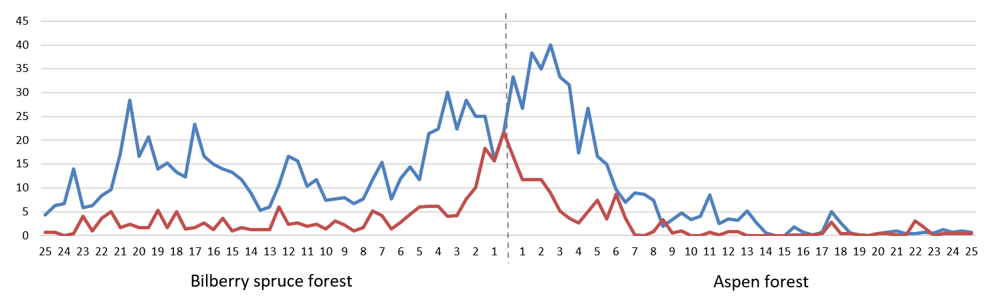
Figure 4. Alteration of the percentage covers of bilberry and cowberry in the transect running from bilberry-type spruce forest (on the left) into grass-forbs-type aspen forest (on the right) (Site 1), the ordinate indicates the percentage cover of plant species ( bilberry, cowberry); the abscissa represents the distance from the interface of the communities towards the spruce forest and towards the aspen forest (in meters); dashed line is the interface of the communities (quoted from: [26]).
The species composition of vascular plants was determined for each EC zone. The vascular species dominance structure in different EC zones was estimated by Pielou’s evenness index, which takes values from 0 to 1, where 1 means that all species are represented in equal numbers. Pielou’s index is a variant of the Shannon index [51]: H/logN, where H is Shennon index and N is species number. The measure of similarity of the vascular plant species composition between EC zones was the Jaccard index [52] Kj = c/(a+b-c), where a is the number of species in the first plot, b is the number of species in the second plot, c is the number of species shared by the first and the second plots. Jaccard index takes values from 0 (no shared species) to 1 (total similarity of the species compositions). The similarity of the ground vegetation structure between EC zones was examined by cluster analysis (Euclidian distance, Ward’s method).
Trunk-base epiphytic vegetation was described by recording the linear dimensions of clumps of each species in the vertical projection for the four cardinal directions [53]. The parameters recorded for each species were the height at which the species started growing (bottom of the clump) and the height corresponding to the top of the clump. Only solid covers were taken into account, while solo plants potentially occurring at greater heights were disregarded. Species names are according to [54] with some modifications [55,56]. Since epiphytic vegetation in 35-year-old communities was not yet fully formed and comparison to the mature community was irrelevant, we studied it only in 90-year-old spruce forests on spruce and aspen trees growing at different distances from the border with the deciduous stand. The selection of the trees from which epiphytes were sampled differed between the sites because of differences in the tree stand composition. The sample set in site 1 was 8 aspen trunks, on which the span of Hylocomium splendens (Hedw.) Bruch et al. clumps was measured. In site 2, we examined 40 spruce trees, measuring clump sizes of Cladonia spp., crustose lichens, and bryophytes. Data from site 2 were grouped into subsets equal intervals of distance from the forest communities’ interface with 5 meter step (0 to 5 meters, 5 to 10 meters, etc.). The arithmetic mean and standard error of the mean were determined for each subset. In addition, the relationship between changes in the abundance of epiphytic species with distance from the interface of the two forest communities into the spruce forest was investigated by correlation analysis (non-parametric Spearman’s rank correlation coefficient).
To determine fine root biomass, 10х10х20 cm soil monoliths were sampled along the transect running from spruce forest into deciduous forest in 5–7 replications for each EC zone (a total of 20–28 samples for each sampling plot). The monolith depth was made 20 cm considering that this soil layer contains 80-90 % of fine roots, according to different sources [36,57]. The monoliths were packed in plastic bags. After delivering the monolith to the laboratory, tree roots (coniferous and deciduous separately, distinguished by morphological traits: color and texture) up to 2 mm in diameter were picked out, oven dried at 105°С, and weighted using OHAUS PX224 analytical balance.
The data was checked for normality. Due to data inconsistency with the normal distribution data sub-sets were compared by the analysis of variance (one-way ANOVA, non-parametric Kruskal-Wallis test).

3. Results

3.1. Ground vegetation
Overall, the species diversity in the surveyed sites was quite low. The ground layer contained a total of 23 vascular plant species. Deciduous communities (DF), however, generally harbored a greater number of plant species than the mature spruce forest and the transitional zones (Table 2). The average number of species per transect subplots was also reliably higher in deciduous communities compared to other EC zones (p-value < 0.05).
Table 2. Composition and average percentage covers of plants in ecotone complex zones.
Species | Average percentage cover, %
Species | Site 1 |  |  |  | Site 2
Species | CF | CFE | DFE | DF | CF | CFE | DFE | DF
Vascular plants:
Angelica sylvestris | – | – | – | – | – | – | – | 0.01
Athyrium felix-femina | – | – | – | 0.70 | – | – | – | –
Calamagrostis arundinacea | 0.20 | 1.09 | 1.02 | 2.22 | 0.44 | 0.43 | 0.91 | 2.78
Convallaria majalis | – | – | – | – | – | – | – | 0.49
Deschampsia flexuosa | 0.20 | 0.18 | 0.65 | 0.46 | 0.15 | 0.18 | 0.65 | 0.49
Dryopteris carthusiana | 0.05 | 0.03 | 0.01 | 5.24 | – | – | – | –
Geranium sylvaticum | – | – | – | – | – | – | – | 0.01
Goodyera repens | – | – | – | – | 0.01 | – | – | –
Gymnocarpium dryopteris | – | – | – | 0.94 | – | – | – | –
Linnaea borealis | 0.48 | 0.32 | 0.56 | – | – | – | – | –
Luzula pilosa | 0.04 | 0.02 | 0.38 | 0.22 | 0.04 | 0.05 | 0.27 | 0.09
Lycopodium annotinum | 0.27 | 0.10 | – | – | – | – | – | –
Maianthemum bifolium | 0.52 | 0.25 | 0.46 | 1.27 | 4.71 | 0.75 | 0.17 | 0.45
Melampyrum sp. | 0.15 | 0.17 | 0.27 | 0.39 | 0.09 | 0.29 | 0.26 | 0.61
Orthilia secunda | 0.26 | 0.04 | 0.16 | 0.05 | – | – | – | –
Oxalis acetosella | 2.16 | 0.01 | – | 0.36 | – | – | – | –
Potentilla erecta | – | – | – | 0.02 | – | – | – | –
Rubus saxatilis | – | – | – | 0.59 | 0.09 | – | – | 2.35
Solidago virgaurea | 0.05 | – | 0.52 | 1.71 | 0.05 | – | 0.07 | 0.66
Trientalis europaea | 0.21 | 0.10 | 0.44 | 0.47 | 0.07 | – | – | 0.20
Vaccinium myrtillus | 12.30 | 18.27 | 22.23 | 1.78 | 8.72 | 20.52 | 16.20 | 0.74
Vaccinium vitis-idaea | 2.22 | 7.47 | 6.33 | 0.46 | 1.49 | 8.53 | 4.93 | 0.16
Veronica chamaedrys | – | – | – | 0.02 | – | – | – | –
Total number of vascular plant species: | 14 | 13 | 12 | 17 | 11 | 7 | 8 | 13
Mean number of vascular plant species per 50x50cm² subplot | 7.7 | 6.4 | 8.4 | 10.9 | 4.7 | 4.4 | 5.8 | 8.0
Pielou’s evenness index | 0.50 | 0.38 | 0.46 | 0.80 | 0.49 | 0.44 | 0.46 | 0.77
Mosses:
Pleurozium schreberi | 3.00 | 1.29 | 2.01 | 0.33 | 7.64 | 9.77 | 6.57 | 2.20
Hylocomium splendens | 4.98 | 4.85 | 5.00 | 0.82 | 13.06 | 7.89 | 2.88 | 0.20
D.scoparium | 3.45 | 1.28 | 3.51 | 1.42 | 1.22 | 7.51 | 2.23 | 0.89
D.polysetum | 0.22 | 0.09 | 0.79 | 0.03 | 0.38 | 5.31 | 8.85 | 0.10
Polytr.commune | 0.06 | 0.45 | 10.94 | 3.13 | 0.01 | 0.00 | 0.53 | 0.24
Sphagnum girgensohnii | 0.18 | 0.44 | 2.92 | 0.25 | 0.00 | 0.00 | 0.00 | 0.00
Rhytidiadelphus triquetrus | 0.02 | 0.13 | 0.00 | 0.00 | 1.58 | 0.00 | 0.00 | 0.00
Aulacomium palustre | 0.01 | 0.02 | 0.33 | 0.02 | 0.00 | 0.00 | 0.00 | 0.00
Rhodobrium roseum | 0.02 | 0.01 | 0.02 | 0.06 | 0.03 | 0.00 | 0.00 | 0.12
Plagiomnium | 0.00 | 0.00 | 0.00 | 0.00 | 0.00 | 0.00 | 0.00 | 0.01
Total number of moss species: | 9 | 9 | 8 | 8 | 7 | 4 | 5 | 7
Mean number of moss species per subplot | 3.7 | 3.9 | 4.9 | 2.7 | 3.3 | 3.4 | 3.7 | 2.1
Total number of higher plant species in the ground layer: | 23 | 22 | 20 | 25 | 18 | 11 | 13 | 20
Note: CF – coniferous forest, CFE – coniferous forest edge, DFE – deciduous forest edge, DF – deciduous forest.
Comparison of the species checklists of vascular plants growing in different EC zones using Jaccard index revealed no patterns (Table 3) except for the deciduous communities showing the lowest coefficients of similarity with other EC zones. A very different picture appears when the species compositions are compared with regard to the percentage covers (Figure 5). In this case, the eight zones of the two sites formed four clusters based on the abundance of vascular plants (Figure 5) paired by EC zone types, not sites, although the young deciduous stands differed from each other in the tree stand and ground vegetation composition.
Table 3. Similarity of vascular plant species compositions between ecotone complex zones in the two plots (Jaccard index).
 | 1CF | 1CFE | 1DFE | 1DF | 2CF | 2CFE | 2DFE | 2DF
1CF | 1 | 0.93 | 0.86 | 0.63 | 0.56 | 0.50 | 0.57 | 0.50
1CFE |  | 1 | 0.79 | 0.58 | 0.50 | 0.54 | 0.50 | 0.44
1DFE |  |  | 1 | 0.61 | 0.64 | 0.58 | 0.67 | 0.56
1DF |  |  |  | 1 | 0.56 | 0.41 | 0.47 | 0.50
2CF |  |  |  |  | 1 | 0.64 | 0.73 | 0.71
2CFE |  |  |  |  |  | 1 | 0.88 | 0.54
2DFE |  |  |  |  |  |  | 1 | 0.62
2DF |  |  |  |  |  |  |  | 1
Note: CF – coniferous forest, CFE – coniferous forest edge, DFE – deciduous forest edge, DF – deciduous forest.
The spruce forest and the transitional zones showed relatively low Pielou’s index values (Table 2) because of the dominance of bilberry and cowberry in the ground layer, and the values were the lowest in the transitional zone. Deciduous forest featured high values of this index (0.78 on average) due to the higher species diversity and absence of obvious dominants.
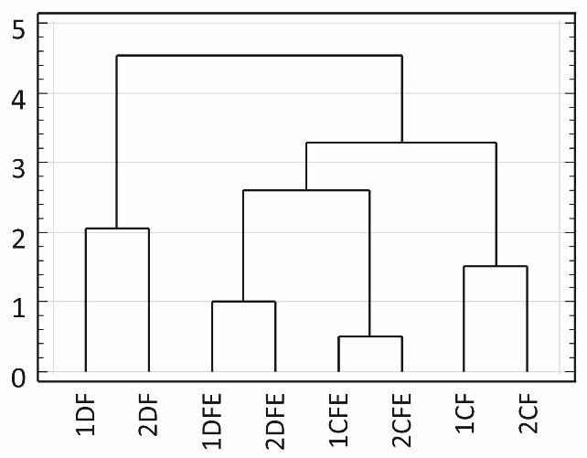
Figure 5. Clustering of ecotone complex zones by the composition and percentage cover of vascular plant species in the ground layer. Ecotone zones are along the abscissa and distance is along the ordinate. Note: CF – coniferous forest, CFE – coniferous forest edge, DFE – deciduous forest edge, DF – deciduous forest.
All vascular plant species in all EC zones can be conventionally split into three groups: boreal dwarf shrubs, grasses, and forbs. The prevalent group in the spruce forest and the transitional zone was dwarf shrubs while the contribution of forbs and grasses was minor. The abundance of dwarf shrubs in the transitional zone was much higher than in the forest. Deciduous forest had the lowest total percentage cover because of a thick tree layer, and the role of boreal dwarf shrubs in this zone was minimal while grasses and forbs prevailed (Figure 6).
Site 1 | Site 2
Figure 6. Relative contributions of species groups ( dwarf shrubs, forbs, grasses) to the herb-dwarf-shrub layer in different ecotone complex zones. Note: CF – coniferous forest, CFE – coniferous forest edge, DFE – deciduous forest edge, DF – deciduous forest.
Bilberry and cowberry in transitional zones were noted both for greater percentage covers and for 1.5–2.5 times greater shoot heights compared to plants growing under spruce forest canopy and in the deciduous community (Table 4).
Table 4. Mean percentage cover and shoot height values for bilberry and cowberry in the ecotone complex.
 | Site 1 |  |  |  | Site 2
 | EC zone |  |  |  | EC zone
 | CF | CFE | DFE | DF | CF | CFE | DFE | DF
Height of bilberry shoots
M±m | 13.3±0.3ª | 19.1±1.2^{b} | 23.7±1.2^{c} | 11.6±0.6ª | 9.5±0.3ª | 13.4±1.0^{b} | 13.3±1.2^{b} | 6.0±0.3^{c}
relative to the value in CF | 1.0 | 1.4 | 1.8 | 0.9 | 1.0 | 1.4 | 1.4 | 0.6
Height of cowberry shoots
M±m | 11.1±0.5ª | 14.8±1.2^{b} | 14.6±1.0^{b} | 8.2±0.6^{c} | 10.1±0.5ª | 13.7±0.9^{b} | 9.3±0.8ª | 6.2±0.6^{c}
relative to the value in CF | 1.0 | 1.3 | 1.3 | 0.7 | 1.0 | 1.4 | 0.9 | 0.6
Note: letter indexes refer to significant differences (Kruskal-Wallis test, p < 0.05) in dwarf shrub shoot height among EC zones in each plot. Zones: CF – coniferous forest, CFE – coniferous forest edge, DFE – deciduous forest edge, DF – deciduous forest.
The moss layer also varied among EC zones. The percentage cover of typical boreal species Pleurozium schreberi (Brid.) Mitt. and Hylocomium splendens declined from CF towards DF. Mosses associated with moist habitats (Polytrichum commune Hedw., Sphagnum girgensohnii Russow) were the most abundant in the DFE zone (Figure 7).
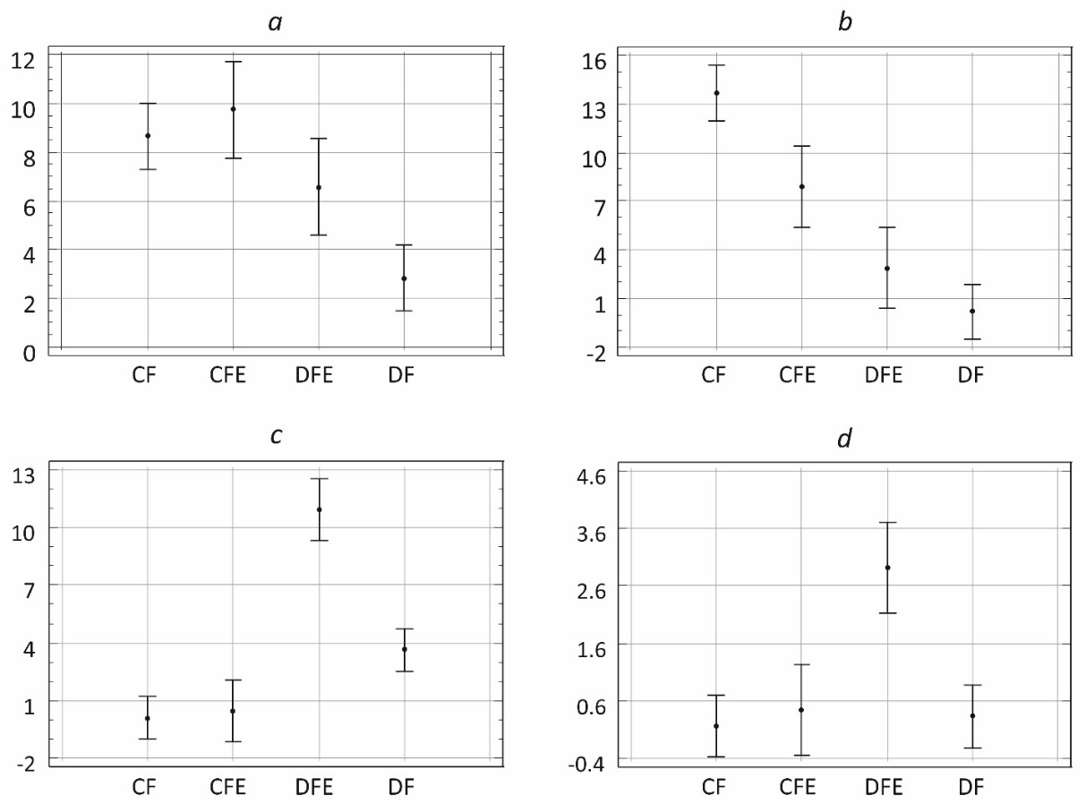
Figure 7. Average percentage covers of moss layer dominants in the ecotone complex. a – Pleurozium schreberi (Site 2), b – Hylocomium splendens (Site 2), c – Polytrichum commune (Site 1), d – Sphagnum girgensohnii (Site 1). Ecotone zones are along the abscissa and percentage cover is along the ordinate. Note: CF – coniferous forest, CFE – coniferous forest edge, DFE – deciduous forest edge, DF – deciduous forest.

3.2. Epiphytic vegetation
Surveys of the plots detected a total of 20 species of epiphytic bryophytes. Of these, 9 species occurred on spruce (Brachythecium salebrosum (F. Weber & D. Mohr) Bruch et al., Dicranum fuscescens Turner, Dicranum scoparium Hedw, Plagiomnium cuspidatum, Plagiothecium rossicum (Hedw.) T.J. Kop, Pleurozium schreberi, Ptilidium pulcherrimum (Weber) Vain., Sciuro-hypnum reflexum (Starke) Ignatov et Huttunen, Sciuro-hypnum starkei (Brid.) Ignatov et Huttunen); 17 species grew on aspen (Brachythecium salebrosum, Campylidium sommerfeltii (Myrin) Ochyra, Chiloscyphus profundus (Nees) J.J. Engel et R.M. Schust., Dicranum scoparium Hedw., Hylocomium splendens, Hypnum cupressiforme Hedw., Lewinskya elegans (Schwägr. ex Hook. & Grev.) F. Lara, Garilleti & Goffinet, Nyholmiella obtusifolia (Brid.) Holmen & E. Warncke, Plagiomnium cuspidatum (Hedw.) T.J. Kop, Ptilidium pulcherrimum (Weber) Vain., Pylaisia polyantha (Hedw.) Bruch et al, Radula complanata (L.) Dumort., Rhodobryum roseum (Hedw.) Limpr., Sanionia uncinata (Hedw.) Loeske, Sciuro-hypnum reflexum (Starke) Ignatov et Huttunen, Sciuro-hypnum starkei (Brid.) Ignatov et Huttunen, Seproleskea subtilis (Hedw.) Loeske).
Some species of terricolous mosses can also grow on living tree trunks. One of them, Hylocomium splendens, dominated both in the ground layer and at the base of aspen trunks. In site 1, the occurrence and vertical span of Hylocomium splendens clumps on aspen trunks was found to correlate positively with the phorophyte’s distance from the interface between the two forest communities (r=0.76, p-value=0.045). Right at the spruce forest and deciduous stand interface, H. splendens was either totally absent from aspen trunks or the vertical span of its clumps was minimal (1–2 cm). The span of moss clumps on aspen trunks increased farther away from the interface, reaching a maximum of 60 cm at 30 m distance.
The vertical span of all epiphytic organisms on trunks in site 2 remained almost invariable from the spruce forest outer edge into the forest (p-value > 0.5), being some 15 cm (Figure 8).
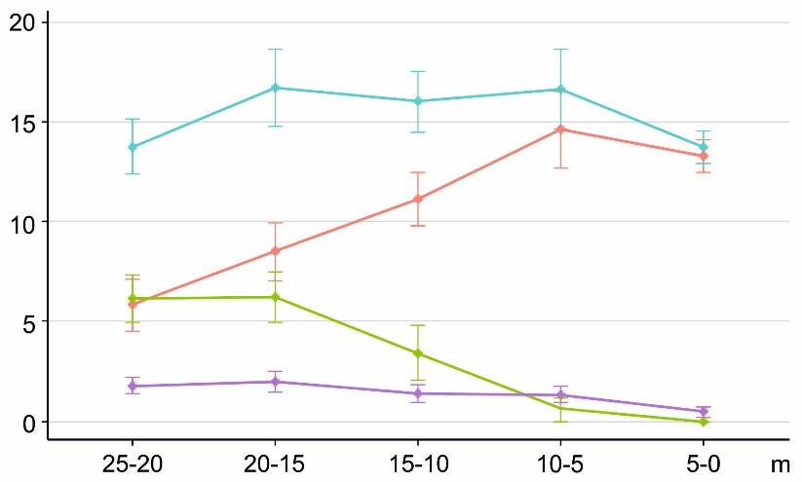
Figure 8. Changes in the abundance of epiphytic species ( bryophytes, crustose lichens, epiphytic Cladonia spp., all epiphytes) with distance to spruce forest edge (means and standard errors). The abscissa indicates the distance from the interface between communities into the spruce forest; the ordinate represents the linear dimensions of epiphyte clumps.
As we moved away from the interface of the communities, the vertical span of epiphytic Cladonia spp. declined from 13.5 cm at the forest outer edge to 6.5 cm in the forest interior (p-value < 0.001). Linear dimensions of crustose lichen clumps, on the contrary, increased towards the forest interior, reaching a maximum (6.2 cm along the trunk) 15–20 meters away from the forest outer edge (p-value < 0.001). The clump length of all bryophytes also increased into the forest, with a maximum 15–20 meters away from the forest outer edge (p-value < 0.003).

3.3. Fine root biomass
In site 1, the total biomass of fine roots of tree species (spruce+deciduous) varied significantly between zones (Table 5). Spruce root biomass declined steadily (p < 0.01) in the bilberry-type spruce forest – transitional zone – deciduous stand sequence. The saturation of the top layer of soil with deciduous roots showed no significant variation between EC zones (except for the DFE zone, where their biomass was notably lower).
Table 5. Biomass of tree roots (diameter ≤2 mm) in the top 20 cm of soil.
 | Site 1 |  |  |  |  | Site 2
 | Ecotone complex zone |  |  |  |  | Ecotone complex zone
 | CF | CFE | DFE | DF | CF |  | CFE | DFE | DF
Spruce roots, tons/ha | 2.10±0.2ª | 1.75±0.4ª | 1.02±0.16^{b} | 0.61±0.1^{b} | 3.08±0.9ª |  | 2.39±0.6ª | 1.66±0.13^{ab} | 0.50±0.08^{b}
Deciduous roots, tons/ha | 1.25±0.3^{ab} | 1.78±0.2ª | 0.70±0.2^{b} | 1.56±0.2ª | 0.88±0.07ª |  | 0.74±0.21ª | 1.55±0.4ª | 3.05±0.3^{b}
Roots of all species, tons/ha | 3.35±0.4ª | 3.53±0.5ª | 1.72±0.1^{b} | 2.17±0.1^{b} | 3.96±0.9ª |  | 3.14±0.5ª | 3.11±0.4ª | 3.56±0.3ª
Note: letter indexes refer to reliable (p < 0.05) differences in the amount of fine roots between ecotone complex zones (one-way ANOVA, non-parametric Kruskal-Wallis test). Zones: CF – coniferous forest, CFE – coniferous forest edge, DFE – deciduous forest edge, DF – deciduous forest.
In site 2, there was significant variation of the total (spruce+deciduous) biomass of fine roots among zones (Table 5). The amount of spruce roots was greater in the spruce forest, declining towards the young deciduous stand (р < 0.05). The biomass of deciduous fine roots, on the contrary, increased in this direction (р < 0.01).
Importantly, differences between the CF and CFE zones in deciduous-root and spruce-root biomass were insignificant in both sites.

4. Discussion
A mature stand adjoining middle-aged bilberry-type spruce forest was clear-cut 35 years ago. The ecotone complex forming as a result consisted of four zones: bilberry-type spruce forest, transitional zone on the forest side, transitional zone on the clear-cut side, and clear-cut site. After 35 years of natural community dynamics, these zones persisted although the spruce forest reached maturity and the clear-cut was occupied by naturally forming deciduous communities dominated by birch and aspen.

4.1. Ground vegetation
Differences between EC zones in our study appeared in the number of vascular plant species, the structure of the herb-dwarf-shrub and moss-lichen layers, and in the abundance of epiphytic species.
The number of herb-dwarf-shrub-layer species was the greatest in the DF zone. Elevation of the species diversity in logging-transformed boreal forest communities has been reported in many studies [29,58–60]. In fact, overstorey removal and emergence of many vegetation-free microhabitats triggers a sharp rise in the species diversity, but a year or two later there establishes a system with 2–3 dominant species – in bilberry-type spruce forests these are usually boreal grasses and fireweed. As the tree layer regenerates, the abundance of clear-cut dominants declines but they do not “leave” altogether. In the relatively rich conditions of young deciduous stands there forms a mosaic community with many species. The mosaic is determined by the tree layer structure and the microtopography. The ground layer in the community we studied was abundant (in addition to grasses) in forest ferns and species typical of young deciduous stands: Melampyrum pratense, Oxalis acetosella, Rubus saxatilis, and Solidago virgaurea. This structure explains the high value of Pielou’s index. The dominant in both transitional zones (CFE, DFE) was bilberry, and in CF cowberry co-dominated together with bilberry. The presence of clear dominants in combination with a smaller total number of species results in a lower value of Pielou’s index. Similar patterns in the ground vegetation structure have been observed in studies of boreal forest dynamics [58,61,62]. The greatest divergence of DF from all other zones of the ecotone complex is corroborated by Jaccard similarity index values.
The analysis of similarity between EC zones regarding the percentage covers of vascular plants proved they clustered together based on belongingness to a certain type of zone rather than certain plot. As mentioned above, the herb-dwarf shrub layer responds to changes in the tree layer, so similarity between the matching EC zones in different plots is not surprising.
There is another result of practical significance that has to be emphasized. Transitional zones of the EC show a rise in the percentage cover and average height of forest dwarf shrubs. This means that the transitional zone both on the clear-cut side and on the forest side proved to be more favorable for the growth of both bilberry and cowberry compared to mature forest and, especially, compared to deciduous stand, where the abundance of both dwarf shrubs was rather low. The reasons are somewhat better illumination of the transitional zone compared to spruce forest on the one hand [63,64] and lower abundance of grasses and forbs than in deciduous forest on the other [59,65].
Our results provide further evidence that terricolous mosses can act as indicator species [66]. The abundance of forest mosses (Pleurozium schreberi, Hylocomium splendens) was found to decline steadily from coniferous forest to deciduous stand. The latter had the lowest percentage covers of true mosses, likely as a result of plentiful leaf fall [61]. At the same time, the abundance of forest mosses associated with moist habitats – Polytrichum commune, Sphagnum girgensohnii, was the highest in the DFE zone. Its elevated moisture can be explained by the tree layer effect. The transitional zone between DF and CF is shaded but lacks thick deciduous regeneration which could actively absorb moisture from the soil [67].

4.2. Epiphytic vegetation
The fact that the structure of epiphytic vegetation depends on distance from the forest edge is explained by the changing ecological conditions. E.g., a study of light conditions in an ecotone between a spruce forest site and a 10-year-old deciduous stand [68] showed that illumination was the lowest in the spruce forest (CF) (2.5 kLx on average) and increased (up to 10-fold) depending on aspect in transitional zones (CFE or DFE). The forest edge is better lit and better “ventilated” than the forest, due to which tree trunks are in a drier condition [40]. Farther away from the forest edge, the vertical span of relatively xerophytic epiphytes Cladonia spp. declined [47], whereas the total linear dimensions of hygrophytic bryophytes [68] and crustose lichens increased.

4.3. Fine root biomass
Fine root biomass is a highly variable parameter influenced by multiple factors: soil properties, tree species composition of the stand, its age, ecological and weather conditions, and so on [35,69]. The similar values of both spruce- and deciduous fine root biomasses in the CF and CFE zones in both plots are probably due to the relatively homogeneous ecological conditions. The prevalence of spruce roots in the total tree root biomass in the coniferous forest is explained by the dominance of the species in the tree stand, as illustrated by stemwood standing stock and basal area values. The lowest biomass of spruce roots was found in DF.
Deciduous species are pioneers that actively colonize territories vacated after clear-cutting. As the root system of deciduous trees grows and develops, they turn into strong competitors of spruce for nutrients [70,71]. In such stands, spruce occupies a subordinated position. This is especially explicit in the DF zone of site 1, where the diameter and height of spruce trees are much lower than those of the dominant deciduous species. Thus, the high biomass of deciduous fine roots in the DF zone of both plots is a consequence of the dominance of deciduous species above the ground.
The total biomass of tree roots in site 2 in general did not vary among zones. The situation in site 1 was different: the total biomass of tree roots in zones DF and DFE was significantly lower than in CF and CFE. Differences in fine root biomass corresponded to differences in the basal areas of the respective stands (Tab. 1), which, as a number of studies have demonstrated [72–74], is related to root biomass.
Our study has demonstrated that the biomass of tree fine roots in ecotone zones is largely dependent on the composition and inventory characteristics of the tree stands. Thus, there is no obvious correlation between topsoil root saturation and alteration of ground vegetation characteristics.

5. Conclusions
Thirty five years after clear-cutting of a bilberry-type spruce stand, a community dominated by birch and aspen formed in the site through natural regeneration. Our studies show that a transitional zone composed of 8-meter-wide strips on the clear-cut side and the forest side each persisted between the original spruce forest community and the secondary deciduous stand. Thus, the newly-formed ecotone complex consists of 4 zones (bilberry-type spruce forest, transitional zone on the coniferous forest side, transitional zone on the deciduous stand side, and deciduous forest), each with its characteristic features of the ground vegetation and epiphytic vegetation structure.
The transitional zones are more favorable for the growth of boreal dwarf shrubs – bilberry and cowberry: their percentage cover and shoot height in these zones are roughly twice greater than in the mature spruce forest or the deciduous stand. The transitional zone on the deciduous forest side features a relatively high abundance of hygrophytic mosses Polytrichum commune, Sphagnum girgensohnii. Boreal true mosses, on the other hand, sharply decline in abundance from the bilberry-type spruce forest towards the deciduous stand.
The structure of epiphytic vegetation was studied only in the bilberry-type spruce forest since its formation in the deciduous stand was not yet completed. The most abundant group of epiphytic vegetation in the spruce forest edge zone was Cladonia spp., while dominance in the forest interior belonged to true mosses. The most plausible explanation for this pattern is higher illuminance and drier surface of tree trunks at the forest edge.
The studies have not corroborated the hypothesis about the effect of tree root systems on the structure of the ground vegetation. The total biomass of fine roots did not depend on the ecotone zone. Differences in the spruce:deciduous roots ratio are explained by the structure and characteristics of the tree layer. This aspect, however, requires further study.
Overall, the study of the vegetation structure in two ECs of the same age but differing in the tree species composition of the deciduous stand showed that matching zones of different plots correlated more closely with each other than with other zones in the same plot. This pattern may indicate that the zones of transition from mature forest to transformed communities have some special properties. These properties are not of purely scientific interest but have practical implications as potentially optimal conditions for regeneration of the mother tree species and growth of commercially significant species [27,60].
Author Contributions: Conceptualization, N.V.G. and A.M.K.; methodology, N.V.G.; formal analysis, N.V.G. and R.P.O.; investigation, N.V.G., R.P.O. and A.Yu.K., A.N.P.; writing—original draft preparation, N.V.G., A.N.P., A.Yu.K. and R.P.O.; writing—review and editing, A.M.K. and A.N.P. All authors have read and agreed to the published version of the manuscript.
Funding: This research was funded by the federal budget under state research assignment to KarRC RAS (Forest Research Institute), Kone Foundation (RETROFOR 202 005 775) and Russian Foundation for Basic Research (20-34-90031\20).
Data Availability Statement: Not applicable.
Conflicts of Interest: The authors declare no conflict of interest.

References
- Lapenis, A.; Shvidenko, A.; Shepaschenko, D.; Nilsson, S.; Aiyyer, A. Acclimation of russian forests to recent changes in climate. Glob. Chang. Biol. 2005, 11, 2090–2102. doi:10.1111/j.1365-2486.2005.001069.x
- Schepaschenko, D.; Moltchanova, E.; Fedorov, S.; Karminov, V.; Ontikov, P.; Santoro, M.; See, L.; Kositsyn, V.; Shvidenko, A.; Romanovskaya, A.; Korotkov, V.; Lesiv, M.; Bartalev, S.; Fritz, S.; Shchepashchenko, M.; Kraxner, F. Russian forest sequesters substantially more carbon than previously reported. Sci. Rep. 2021, 11. https://doi.org/10.1038/s41598-021-92152-9
- Lukina N.V. Global challenges and forest ecosystems. Vestn. rossijskoj akad. nauk. 2020, 90, 528-532. DOI: 10.31857/S0869587320060080 (In Russian)
- Filipchuk A.; Malysheva N.; Zolina T.; Yugov A. The boreal forest of Russia: opportunities for the effects of climate change mitigatiоn. For. inf. 2020, 1, 92–113. DOI 10.24419/LHI.2304-3083.2020.1.10 (In Russian).
- Harris, N.L.; Gibbs, D.A.; Baccini, A.; Birdsey, R.A.; de Bruin, S.; Farina, M.; Fatoyinbo, L.; Hansen, M.C.; Herold, M.; Houghton R.A.; Potapov, P.V.; Suarez, D.R.; Roman-Siesta, R.M.; Saatchi, S.S.; Slay, Ch.M.; Turubanova, S.A.; Tyukavina, A. Global maps of twenty-first century forest carbon fluxes. Nat. Clim. Change. 2021, 11 234-240. doi:https://doi.org/10.1038/s41558-020-00976-6.
- Regulations for harvesting wood. In the order of the ministry of natural resources of the Russian Federation; No. 993; 2020; p. 53. (In Russian)
- Pfeifer, M.; Lefebvre, V.; Peres, C.A.; Banks-Leite, C.; Wearn, O.R.; Marsh, C.J.; Butchart, S.H.M.; Arroyo-Rodríguez, V.; Barlow, J.; Cerezo, A.; et al. Creation of forest edges has a global impact on forest vertebrates. Nature 2017, 551, 187–191. doi:10.1038/nature24457
- Baker, S.C.; Spies, T.A.; Wardlaw, T.J.; Balmer, J.; Franklin, J.F.; Jordan, G.J. The harvested side of edges: effect of retained forests on the re-establishment of biodiversity in adjacent harvested areas. For. Ecol. Manag. 2013, 302, 107–121. doi:10.1016/j.foreco.2013.03.024
- Rudolphi, J.; Gustafsson, L. Forests regenerating after clear-cutting function as habitat for bryophyte and lichen species of conservation concern. PLoS One 2011. 6, e18639. doi: 10.1371/journal.pone.0018639
- Baker, T.P.; Baker, S.C.; Dalton, P.J.; Fountain-Jones, N.M.; Jordan, G.J. Temporal persistence of edge effects on bryophytes within harvested forests. For. Ecol. Manag. 2016, 375, 223–229. doi:10.1016/j.foreco.2016.05.044
- Odum, E. P.; Barrett, G. W. Fundamentals of ecology, 3rd ed.; Philadelphia: Saunders, USA 1971; p. 574.
- Kark, S. Effects of ecotones on biodiversity. 2013. In: Encyclopedia of Biodiversity. P. 142–148. https://doi.org/10.1016/B978-0-12-384719-5.00234-3
- Kreyling, J.; Schmiedinger, A.; Macdonald, E.; Beiekuhnlein, C. Potentials of natural tree regeneration after clearcutting in subalpine forests. West. J. Appl. For. 2008, 23, 46–52.
- Solov'eva V.V.; Rozenberg G.S. A contemporary concept of ecotones or theory of ecotones. Biol. Bull. Rev. 2006, 126, 531–549. (In Russian).
- Tsvetkov V.F. Potential of reforestation in felled areas of the Russian European North. Russ. For. J. 2010, 3, 3–14. (In Russian).
- Belyaeva N.V., Gryaz'kin A.V. Structure transformation of the spruce young generation after selective cutting. Les. Zhurnal 2012, 6, 44–51. (In Russian).
- Franklin, C.; Harper, K.; Clarke, M. Trends in studies of edge influence on vegetation at human-created and natural forest edges across time and space. Can.J.For.Res. 2021. 51, 274–282. https://doi.org/10.1139/cjfr-2020-0308
- Martínez Pastur, G.J.; Vanha-Majamaa, I.; Franklin, J.F. Ecological perspectives on variable retention forestry. Ecol. Process. 2020, 9, 12, s13717-020-0215–3. doi:10.1186/s13717-020-0215-3
- Chen, J.; Franklin, J.F.; Spies, T.A. Growing-season microclimatic gradients from clearcut edges into old-growth douglas-fir forests. Ecol. Appl. 1995, 5, 74–86. doi:10.2307/1942053
- Jung, S.H.; Lim, C.H.; Kim, A.R.; Woo, D.M.; Kwon, H.J.; Cho, Y.C.; Lee, C.S. Edge effects confirmed at the clear-cut area of Korean red pine forest in Uljin, Eastern Korea. J. ecol. environ. 2017, 41, 36. doi:10.1186/s41610-017-0051-2
- Schmidt M.; Jochheim H.; Kersebaum K.; Lischeid G.; Nendel C. Gradients of microclimate, carbon and nitrogen in transition zones of fragmented landscapes – a review. Agric. For. Meteorol. 2017. 232, 659–671. http://dx.doi.org/10.1016/j.agrformet.2016.10.022
- Beese, W.J.; Deal, J.; Dunsworth, B.G.; Mitchell, S.J.; Philpott, T.J. Two decades of variable retention in British Columbia: a review of its implementation and effectiveness for biodiversity conservation. Ecol. Process. 2019, 8, 33. doi:10.1186/s13717-019-0181-9
- Nelson C.; Halpern C. Edge-related responses of understory plants to aggregated retention harvest in the Pacific NorthWest. Ecol. Appl. 2005, 15, 196–209. https://doi.org/10.1890/03-6002
- Harper, K.A.; Macdonald, S.E.; Mayerhofer, M.S.; Biswas, S.R.; Esseen, P.; Hylander, K.; Stewart, K.J.; Mallik, A.U.; Drapeau, P.; Jonsson, B.; et al. Edge influence on vegetation at natural and anthropogenic edges of boreal forests in Canada and Fennoscandia. J. Ecol. 2015, 103, 550–562. doi:10.1111/1365-2745.12398
- Harper, K.A.; Drapeau, P.; Lesieur, D.; Bergeron, Y. Negligible structural development and edge influence on the understorey at 16-17-yr-old clear-cut edges in black spruce forest. Appl. Veg. Sci. 2016, 19, 462–473. doi:10.1111/avsc.12226
- Genikova N.V.; Kharitonov V.A.; Pekkoev A.N.; Karpechko A.Yu.; Kikeeva A.V.; Kryshen A.M.; Obabko R.P. Structure of bilberry spruce–grass-forbs aspen forest ecotone communities in the Republic of Karelia. Rastit. Resur. 2020, 56 151–164. (In Russian) DOI: 10.31857/S0033994620020053 (In Russian).
- Genikova, N.V.; Mamontov, V.N.; Kryshen, A.M.; Kharitonov, V.A.; Moshnikov, S.A.; Toropova, E.V. Natural regeneration of the tree stand in the bilberry spruce forest—clear-cutting ecotone complex in the first post-logging decade. Forests 2021, 12, 1542. doi:10.3390/f12111542
- Cienciala, E.; Mellander, P.-E.; Kučera, J.; Oplutilová, M.; Ottosson-Löfvenius, M.; Bishop, K. The Effect of a north-facing forest edge on tree water use in a boreal Scots pine stand. Can. J. For. Res. 2002, 32, 693–702. doi:10.1139/x02-013
- Selmants, P.C.; Knight, D.H. Understory plant species composition 30–50 years after clearcutting in Southeastern Wyoming coniferous forests. For. Ecol. Manag. 2003, 185, 275–289. doi:10.1016/S0378-1127(03)00224-X
- Dupuch, A.; Fortin, D. The extent of edge effects increases during post-harvesting forest succession. Bio. Conserv. 2013, 162, 9–16. doi:10.1016/j.biocon.2013.03.023
- Baker, T.P.; Jordan, G.J.; Steel, E.A.; Fountain-Jones, N.M.; Wardlaw, T.J.; Baker, S.C. Microclimate through space and time: microclimatic variation at the edge of regeneration forests over daily, yearly and decadal time scales. For. Ecol. Manag. 2014, 334, 174–184. doi:10.1016/j.foreco.2014.09.008
- Sun, T.; Dong, L.; Mao, Z.; Li, Y. fine root dynamics of trees and understorey vegetation in a chronosequence of Betula platyphylla stands. For. Ecol. Manag. 2015, 346, 1–9. doi:10.1016/j.foreco.2015.02.035
- Shanin,V.N.; Rocheva, L.K.; Shashkov, M.P.; Ivanova, N.V.; Moskalenko, S.V.; Burnasheva, E.R. Spatial distribution features of the root biomass of some tree species (Picea abies, Pinus sylvestris, Betula sp.). Biol. bull. 2015, 42, 3, 260–268. doi:10.1134/S1062359015030115
- Pacé, M.; Fenton, N.J.; Paré, D.; Bergeron, Y. Ground layer composition affects tree fine root biomass and soil nutrient availability in jack pine and black spruce forests under extreme drainage conditions. Can. J. For. Res. 2016, 47, 433-444. doi:10.1139/cjfr-2016-0352
- Yuan, Z.Y.; Chen, H.Y.H. Fine root biomass, production, turnover rates, and nutrient contents in boreal forest ecosystems in relation to species, climate, fertility, and stand age: literature review and meta-analyses. CRC Crit Rev Plant Sci. 2010, 29, 204–221. doi:10.1080/07352689.2010.483579
- Vanninen, P.; Makela, A. Fine root biomass of scots pine stands differing in age and soil fertility in Southern Finland. Tree Physiol. 1999, 19, 823–830. doi:10.1093/treephys/19.12.823
- Kuuluvainen, T. Forest management and biodiversity conservation based on natural ecosystem dynamics in Northern Europe: the complexity challenge. AMBIO: J. Hum. Environ. 2009, 38, 309–315. doi:10.1579/08-A-490.1
- Brumelis, G.; Jonsson, B.; Kouki, J.; Kuuluvainen, T.; Shorohova, E. Forest naturalness in Northern Europe: perspectives on processes, structures and species diversity. Silva Fenn. 2011, 45. doi:10.14214/sf.446
- Hylander, K. Aspect modifies the magnitude of edge effects on bryophyte growth in boreal forests. J. Appl. Ecol. 2005, 42, 518-525. https://doi.org/10.1111/j.1365-2664.2005.01033.x
- Klein, J.; Low, M.; Thor, G.; Sjögren, J.; Lindberg, E.; Eggers, S. Tree species identity and composition shape the epiphytic lichen community of structurally simple boreal forests over vast areas. PLoS ONE 2021, 16, e0257564. doi:10.1371/journal.pone.0257564
- Kivistö, L.; Kuusinen, M. Edge effects on the epiphytic lichen flora of Picea abies in middle boreal Finland. The Lichenologist 2000, 32, 387–398. doi:10.1006/lich.2000.0282
- Gignac, L.D.; Dale, M.R.T. Effects of fragment size and habitat heterogeneity on cryptogam diversity in the low-boreal forest of Western Canada. The Bryologist 2005, 108, 50–66. doi:10.1639/0007-2745(2005)108[50:EOFSAH]2.0.CO;2
- Esseen, P. Edge influence on the old‐growth forest indicator lichen Alectoria Sarmentosa in natural ecotones. J. Veg. Sci. 2006, 17, 185–194. doi:10.1111/j.1654-1103.2006.tb02437.x
- Johansson, P. Consequences of disturbance on epiphytic lichens in boreal and near boreal forests. Biodivers. Conserv. 2008, 141, 1933–1944. doi:10.1016/j.biocon.2008.05.013
- Boudreault, C.; Bergeron, Y.; Drapeau, P.; Mascarúa López, L. Edge effects on epiphytic lichens in remnant stands of managed landscapes in the eastern boreal forest of Canada. For. Ecol. Manag. 2008, 255, 1461–1471. doi:10.1016/j.foreco.2007.11.002
- Hofmeister, J.; Hošek, J.; Brabec, M.; Tenčík, A. Human-sensitive bryophytes retreat into the depth of forest fragments in Central European landscape. Eur. J. Forest Res. 2016, 135, 539–549. doi:10.1007/s10342-016-0953-z
- Lesica, P.; McCune, B.; Cooper, S.V.; Hong, W.S. Differences in lichen and bryophyte communities between old-growth and managed second-growth forests in the Swan Valley, Montana. Can. J. Bot. 1991, 69, 1745–1755. doi:10.1139/b91-222
- Aleksandrova, V.D., geobotanical zoning of the non-chernozem region of the european part of the Russian Soviet Federative Socialist Republic; Aleksandrova, V.D., Yurkovskaya, T.K., Eds.; Nauka: Leningrad, Russia, 1989; p. 64. (In Russian)
- Kazimirov N.I.; Kabanov V.V. Forest inventory tables. Petrozavodsk: Karelian Branch of the USSR Academy of Sciences, 1976. 32 p. (In Russian).
- Genikova, N.V.; Mamontov, V.N.; Kryshen, A.M. Abundance of forest dwarf shrubs and microclimatic conditions in the bilberry spruce forest–clear-cut ecotone. Rastit. Resur. 2021, 2, 99–114. DOI: 10.31857/S0033994621020059 (In Russian).
- MacArthur R.H. Fluctuations of animal populations, and measure of community stability. Ecol. 1955, 36, 353—356.
- Jaccard P. The Distribution of the Flora in the Alpine Zone. New Phytologist. 1912, 11, 37–50. doi:10.1111/j.1469-8137.1912.tb05611.x
- Degtyareva, S. I. Quantitative accounting of epiphytic groups. Reproduction, monitoring and protection of natural, natural-anthropogenic and anthropogenic landscapes, Voronezh State Forestry academy, Russia, June 14–15, 2012; M. V. Drapalyuk, O. V. Tregubov; Editorial Board: A. V. Tsaralunga, N. N. Kharchenko, S. M. Matveev, V. I. Mikhin, S. Yu. Krakhotina; Voronezh, Russia, 2012.
- Ignatov M.S.; Afonina O.M.; Ignatova E.A. Check-list of mosses of East Europe and North Asia. Arctoa 2006, 15, 1-130.
- Ignatov M.S.; Milyutina I.A. A revision of the genus Sciuro-hypnum (Brachytheciaceae, Bryophyta) in Russia. Arctoa 2007, 16, 63-86.
- Ignatova, E.A.; Fedorova, A.V.; Kuznetsova, O.I.; Ignatov, M.S. Taxonomy of the Plagiothecium laetum Complex (Plagiotheciaceae, Bryophyta) in Russia. Arctoa 2019, 28, 28–45. doi:10.15298/arctoa.28.05.
- Bolte, A.; Villanueva, I. (2006) Interspecific competition impacts on the morphology and distribution of fine roots in European beech (Fagus sylvatica L.) and Norway spruce (Picea abies (L.) Karst.). Eur J For Res. 2006, 125, 15–26. https://doi.org/10.1007/s10342-005-0075-5
- Tonteri T. Species richness of boreal understorey forest vegetation in relation to site type and successional factors. Ann. Zoo. Fennici. 1994, 31, 53-60.
- Graae, B.J.; Heskjær, V.S. A Comparison of understorey vegetation between untouched and managed deciduous forest in Denmark. For. Ecol. Manag. 1997, 96, 111–123. doi:10.1016/S0378-1127(97)00046-7
- Genikova, N.V.; Gnatiuk, E.P.; Kryshen, A.M. Coenoflora of bilberry spruce forests in Eastern Fennoscandia. Bot. Zhurnal 2019, 104, 699–716. (In Russian) DOI: 10.1134/S0006813619050041 (In Russian).
- Marozas, V.; Grigaitis, V.; Brazaitis, G. Edge effect on ground vegetation in clear-cut edges of pine-dominated forests. Scand. J. For. Res. 2005, 20, 43–48. doi:10.1080/14004080510040986
- Kryshen, A.M. Plant communities of clearings of Karelia; Nauka: Moscow, Russia, 2006; p. 262. (In Russian).
- Burova N.V.; Tarakanov A.M.; Drozdov I.I.; Kononov O.D.; Gelfand E.D. Edge effect on the condition of separate components of wood biogeocenoses. Bull. Mosc. State Univ. For. Lesn. Vestnik. 2012, 4, 19–22 (In Russian).
- Sobolev A. N.; Feklistov P. A. Microclimate variability in forest stands of the Solovetsky Archipelago. Arct. Environ. Res. 2017, 17, 245-254. DOI: 10.17238/issn2541-8416.2017.17.3.245 (In Russian).
- Mölder, A.; Bernhardt-Römermann, M.; Schmidt, W. Herb-layer diversity in deciduous forests: raised by tree richness or beaten by beech? For. Ecol. Manag. 2008, 256, 272–281. doi:10.1016/j.foreco.2008.04.012
- Frego, K.A. Bryophytes as potential indicators of forest integrity. For. Ecol. Manag. 2007, 242, 65–75. doi:10.1016/j.foreco.2007.01.030
- Kramer, P.D.; Kozlovsky, T.T. Physiology of woody plants; Lesnaya promyshlennost: Moscow, Russia, 1983; p. 464. (In Russian).
- Caners, R.T.; Macdonald, S.E.; Belland, R.J. Responses of boreal epiphytic bryophytes to different levels of partial canopy harvest. Botany 2010, 88, 315–328, doi:10.1139/B09-089
- Vogt, K.A.; Vogt, D.J.; Palmiotto, P.A.; Boon, P.; O’Hara, J.; Asbjornsen, H. Review of root dynamics in forest ecosystems grouped by climate, climatic forest type and species. Plant Soil 1995, 187, 159–219. doi:10.1007/BF00017088
- Kalliokoski, T.; Nygren, P.; Sievänen, R. Coarse root architecture of three boreal tree species growing in mixed stands. Silva Fenn. 2008, 42. doi:10.14214/sf.252
- Kalliokoski, T.; Pennanen, T.; Nygren, P.; Sievänen, R.; Helmisaari, H.-S. Belowground interspecific competition in mixed boreal forests: fine root and ectomycorrhiza characteristics along stand developmental stage and soil fertility gradients. Plant Soil 2010, 330, 73–89. doi:10.1007/s11104-009-0177-9
- Finér, L.; Ohashi, M.; Noguchi, K.; Hirano, Y. Factors causing variation in fine root biomass in forest ecosystems. For. Ecol. Manag. 2011, 261, 265–277. doi:10.1016/j.foreco.2010.10.016
- Lehtonen, A.; Palviainen, M.; Ojanen, P.; Kalliokoski, T.; Nöjd, P.; Kukkola, M.; Penttilä, T.; Mäkipää, R.; Leppälammi-Kujansuu, J.; Helmisaari, H.-S. Modelling fine root biomass of boreal tree stands using site and stand variables. For. Ecol. Manag. 2016, 359, 361–369. doi:10.1016/j.foreco.2015.06.023
- Xu, Y.; Zhang, Y.; Yang, J.; Lu, Z. Influence of tree functional diversity and stand environment on fine root biomass and necromass in four types of evergreen broad-leaved forests. Glob. Ecol. Conserv.2020, 21, e00832. doi:10.1016/j.gecco.2019.e00832

