Paper S/N: electronics-1858741

Title
AI-based Trust Level Scheme for Excluding Malicious Nodes
Authors
Bashar Igried , Ayoub Alsarhan, Igried Alkhawaldeh, Ahmad AL-qerem , Amjad Aldweesh

Dear Editor,
We would like to thank the reviewers for their diligent and thorough reading of this paper, as well as their intelligent comments and helpful suggestions, which helped to improve its quality. We are pleased to notify you that we have updated the manuscript in response to the reviewers' recommendations. We believe that the updated manuscript is in much better shape after incorporating the feedback. We appreciate the reviewer's forthright comments: we recognized that some crucial paragraphs of the original article lacked clarity, with ambiguities that led to reader misunderstandings. This update, we believe, improves the manuscript's readability. The reviewer's comments are addressed in detail below.

We hope that these revisions improve the paper such that the reviewers now deem it worthy of publication in your esteemed journal. For the reviewers' convenience, we have followed their comments by our response in Times New Roman font. The uploaded a copy of the original manuscript marked with all the changes made during the revision process. The new text is highlighted.

Thank you

Reviewer 2

Comment: The authors have addressed most of the concerns recommended and have improved the paper. However, the following changes and recommendations (which are not properly addressed in your revision) need to be incorporated for further improvements.

Reply: Thank you so much for your comments that help us to improve our work significantly. We attentively studied your comments and did our best to answer them one by one, particularly in terms of improving the presentation. We hope that this revision has enhanced the work to Electronics standards.

--------------------------------------------------------------------------------------------------------

Comment: A proper name of the proposed model/scheme is still missing. It is strongly recommended that for clarity and identification a proper name with a clear context should be used for the model. The name the scheme will help the readers to understand the context and goal of the scheme/model. The authors should also have a separate section with the proposed name of the scheme which discusses its different components, operations, and functions etc.
Reply: We have changed the name of the proposed model into ” A Novel Fuzzy Logic-Based Scheme for Malicious Node Eviction in a Vehicular Ad Hoc Network”. Clearly, the name contains the following:
- the purpose of the scheme (i.e. malicious nodes eviction).
- The methodology for trust evaluation (i.e. fuzzy logic).
- The main objective of the proposed scheme (i.e. malicious node eviction).
- The targeted system ( VANET).

--------------------------------------------------------------------------------------------------------

Comment: A figure/diagram of the proposed framework or model should be included to help understanding the whole picture and concept. For instance, you can pictorially illustrate that how your model works step-wise or phase-wise etc.

Reply: We thank the reviewer in supporting our intention. Totally agree, we added the figure below to Section 4. The figure depicted how data for a new node is collected and fed into a fuzzy logic model to determine the node's final trust level.

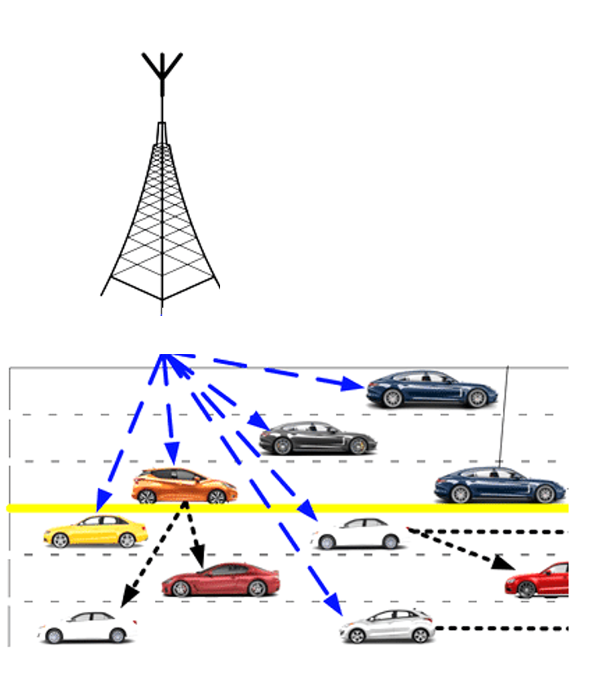
Calculate final
trust level using
Fuzzy Logic Model
Emulation attack attempt
Collaboration degree
What is your opinion of i^{th} node?
RSU assessment

-------------------------------------------------------------------------------------------------------

Comment: The quantitative measures of improvements for the performance evaluation of comparison should be included in the abstract and conclusion sections to show the readers how much improvement has been achieved in terms of percentage (%).

Reply: As requested, quantitative measures of improvement for comparison performance evaluation were included in the abstract and conclusion sections. Please refer to the submitted revised version.

-----------------------------------------------------------------------------------------------------------------

Comment: The table of parameters newly added by the authors has many flaws, first, the MAC protocol used by VANET is not IEEE 802.11b, also see the units of each parameter and add some additional parameters such as beacon message size, radio propagation model, the total area for simulation, total simulation time, communication protocol, vehicles speed, etc. Similarly double check each parameter for avoiding further complications.

Reply: We thank the reviewer in supporting our intention. As requested, more parameters have been added. Please refer to the submitted revised version.

-------------------------------------------------------------------------------------------------------

Comment: Revise the keywords. It should be relevant and must reflect the work undertaken.

Reply: We appreciate the guidance. Some keywords were removed, while others were added. Please refer to the submitted revised version.

-------------------------------------------------------------------------------------------------------

