Response to Reviewer 3 Comments

This paper designed a multi-scale object detection network with multi-feature selection module based on attention mechanism. The novelty of proposed approach is low and there are some serious issues with experimental analysis.

Q1: In Introduction and Related work, this paper treats angle prediction as a classification problem and uses the circular smooth label (CSL). On one hand, more relevant works that apply classification for object angle prediction should be introduced. On the other hand, please illustrate the difference between the proposed method and the existing CSL method.
Response to Q1: Thanks for your constructive suggestions. For the related work on applying classification to object angle prediction, as far as we know, the main work currently only includes CSL proposed by ECCV2020 (Lin, T.Y.; Goyal, P.; Girshick, R.; He, K.; Dollar, P. Arbitrary-Oriented Object Detection with Circular Smooth Label. Yang, Xue and 420 Yan, Junchi 2020, 12353, 677–694) and DCL proposed by CVPR2021 (Yang X, Hou L, Zhou Y, et al. Dense label encoding for boundary discontinuity free rotation detection[C]//Proceedings of the IEEE/CVF conference on computer vision and pattern recognition. 2021: 15819-15829.), other similar methods have not appeared. As suggested by the reviewer, we have also supplemented the description of the DCL method in Section 3.3 of the revised manuscript as follows:
Common methods include circular smooth label (CSL) method and Densely Coded Label (DCL) method. Among them, the DCL method is an improvement of the CSL method, which solves the heavy prediction layer and the unfriendly detection of square objects. This paper directly uses the CSL method as the angle classification method.
Furthermore, the method proposed in this paper is the directly cited CSL method.

Q2: There are many problems with the organization of this paper. First, the visualization results of multi-scale feature maps in Figure 6 should be shown in Results. Second, Figure 7 can be shown in the Results to verify the effectiveness of the proposed angle classification method compared with a five-parameter method. Third, in Section 3.3, the paper should focus on the proposed angle classification method. Some irrelevant descriptions should be deleted. Fourth, Figure 8 lacks comparative results, and can be shown in Section 4.2.
Response to Q2: Thanks for your constructive suggestions. As suggested by reviewer, Figures 6 and 7 have been adjusted in the Results section. Section 3.3 also adds some explanations for the angle classification method. For the comparison results in Figure 8, we also added the comparison results between our method and the RetinaNet method. Reviewers can view our revised manuscript, and some of the results are shown below:
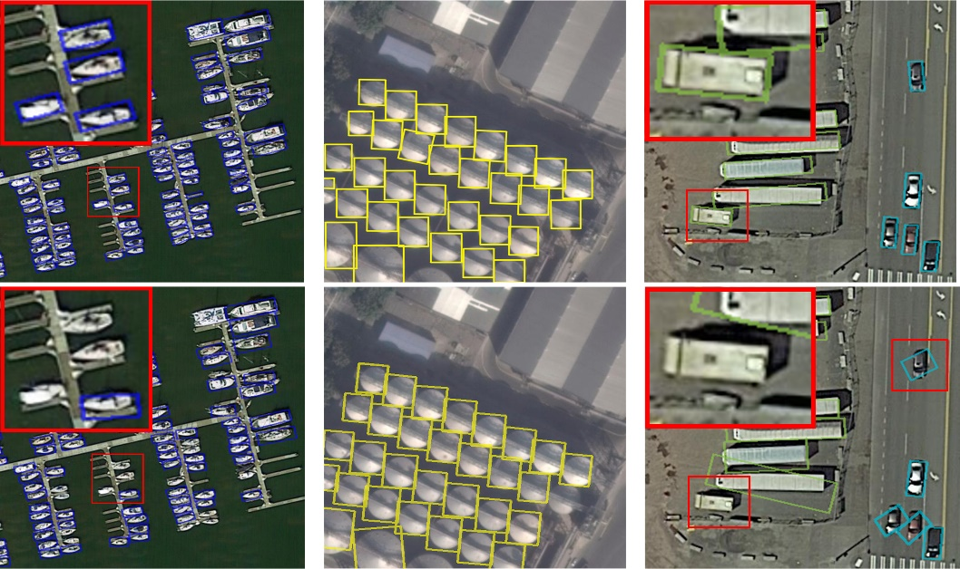
Figure 9 DOTA data set detection results (the first line is the proposed algorithm, the second line is the RetinaNet algorithm)

Q3: In the experiments, this paper selects 6 types of remote sensing objects in the DOTA dataset. The motivation for selecting 6 objects is not clear.
Response to Q3: Thanks for your suggestions. In this paper, six remote sensing objects are selected in the DOTA dataset: plane (PL), ship (SH), bridge (BG), small vehicle (SV), large vehicle (LV), and storage tank (ST). The motivation for selection is that the aspect ratios of the 6 objects are representative. That is, among the targets in the remote sensing images, the aspect ratio of objects such as plane (PL) and storage tank (ST) is about 1:1, ship (SH), bridge (BG), small vehicle (SV), large vehicle (LV) and other targets are less than 8:1 in length and width. Selecting targets with different aspect ratios helps to demonstrate the accuracy of angle classification. In the revised manuscript, section 4.1.1 is supplemented as follows:
This is because among the targets in the remote sensing images, the aspect ratio of objects such as plane (PL) and storage tank (ST) is about 1:1, ship (SH), bridge (BG), small vehicle (SV), large vehicle (LV) and other targets are less than 8:1 in length and width.

Q4: In Sections 4.2, 4.3, and 4.4, different comparison methods are chosen to verify the advancement of the proposed approach. Considering the experimental results on DOTA, CSL(2020), RRPN(2018), RetinaNet(2020), and Xiao(2020) are selected as comparative algorithms. More existing methods for oriented object detection in remote sensing images should be added. Besides, the results of CSL in Table 5 are lower than the published results. Considering the fewer object categories in the experiments, the APs of 6 typical objects should be higher than CSL(2020) rather than lower. Please clarify this point.
Response to Q4: Thanks for reviewer’s suggestions. As suggested by you , more remote sensing image oriented object detection methods can be added for comparison. However, considering the consistency of the backbone network, we only selected the target detection method with the backbone network of ResNet50 and the method close to the method in this paper as the comparison algorithm. In this way, the method in this paper can be compared horizontally with similar methods, and the results are more objective and meaningful. In addition, the results of CSL and 6 typical AP object results in Table 5 are real test results. Maybe because of the difference in the training environment, the method in this paper is the reproduced result obtained under a limited number of experiments, and the published results may be obtained after a lot of tests, and the hardware conditions and some experimental parameters are the same as the method in this paper. There are differences, so the results fluctuate slightly. However, from an objective and real point of view, the data in this paper are obtained under a unified hardware condition and training environment, which can reflect the fairness of the results.

Q5: In Section 4.3, this paper adds 138 domestic remote sensing images to the DOTA dataset. This paper should add the number of labeled instances of different objects. Specifically, the collected satellite images from GF-6 and GF-2 can be analyzed independently.
Response to Q5: Thanks for your careful suggestions. This paper adds 188 domestic remote sensing image datasets to verify our method. As suggested by you, we also added the number of annotations for different targets. However, the number of 188 images is still small compared to the DOTA dataset of 2806 images. When tested alone, the amount of data will be insufficient, and it is easy to overfit. Therefore, we can only expand the newly added pictures to the original DOTA data set and conduct experiments under the condition that the number is guaranteed. From the experimental results, the self-made data set provides the diversity of images, which increases the difficulty of training, and the results also prove the effectiveness of the method in this paper.

Q6: In Section 4.4, the size of input images is 512*800 in RoI-Transformer, which is different from other methods. Please clarify this point.
Response to Q6: Thanks for your suggestions. The size of the input image of the RoI-Transformer method is 512*800, which is not specially set in this article, but refers to the parameter settings in the original literature. The settings in the original RoI-Transformer are as follows:
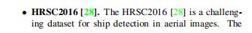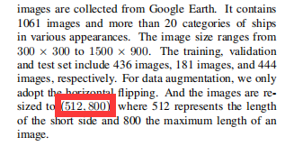

Q7: This paper lacks a qualitative analysis of different detection methods.
Response to Q7: Thanks for your constructive suggestions. As suggested by reviewer, in addition to the quantitative analysis of each method, we also supplemented the visualization results of the proposed method and the RetinaNet method on the DOTA dataset and the DOTA-GF cloud interference dataset in Sections 4.2 and 4.3 of the revised manuscript, and the qualitative analysis content has been added to make the content of the article more rigorous and rich. Some of them are as follows:
Section 4.2
The partial visual detection results of the proposed algorithm and the RetinaNet algorithm on the DOTA data set are shown in Figure 9. In order to make the comparison results clearer, some areas are enlarged.
Figure 9 DOTA dataset detection results (the first line is the proposed method, the second line is the RetinaNet method)
It can be seen from the comparison results in the first column of Figure 9 that when detecting small ships, RetinaNet has a weak ability to characterize small targets, resulting in some missed detections. In the third column of comparative experimental results, RetinaNet also has missed detections when detecting cars. However, the algorithm in this paper obtains better detection results when detecting densely arranged small ships and cars, and the positioning is more accurate. The reason is that the bidirectional multi-scale feature fusion network designed by the algorithm in this paper can improve the representation ability of small targets, and the angle information obtained by the idea of classification is also more accurate, and the sensitive feature selection network can further improve the network detection performance.

Section 4.3
The detection results of the proposed algorithm and the RetinaNet method on high-resolution images are shown in Figure 10. In order to be more eye-catching, some areas have been partially enlarged.
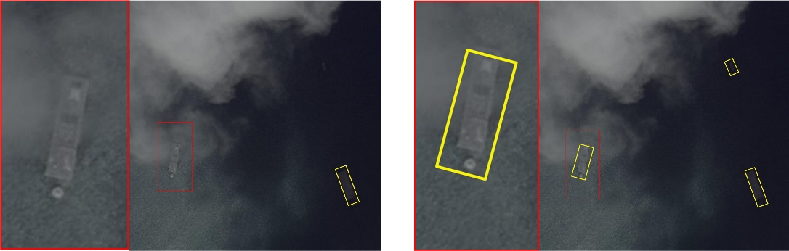
Figure 10 Detection results of ships with cloud and fog interference on the images of the DOTA-GF dataset (left: RetinaNet method, right: our proposed method).
From the comparison results in Figure 10, it can be seen that when there is cloud interference, RetinaNet cannot accurately capture the characteristics of ships, resulting in missed detection. The algorithm in this chapter has strong anti-cloud and fog interference ability, and can accurately detect ship targets covered by thin clouds.
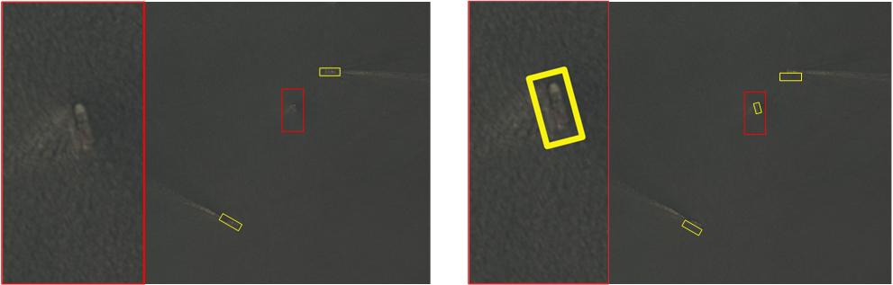
Figure 11 Comparison of detection results of small ships on DOTA-GF dataset images (left: RetinaNet method, right: our proposed method).
From the comparison results in Figure 11, it can be seen that when the ship target is relatively small, RetinaNet cannot accurately capture the ship features, resulting in missed detection. And because of the existence of the proposed FPN module, the algorithm in this paper has a stronger ability to extract small target features, and the detection results are more accurate.
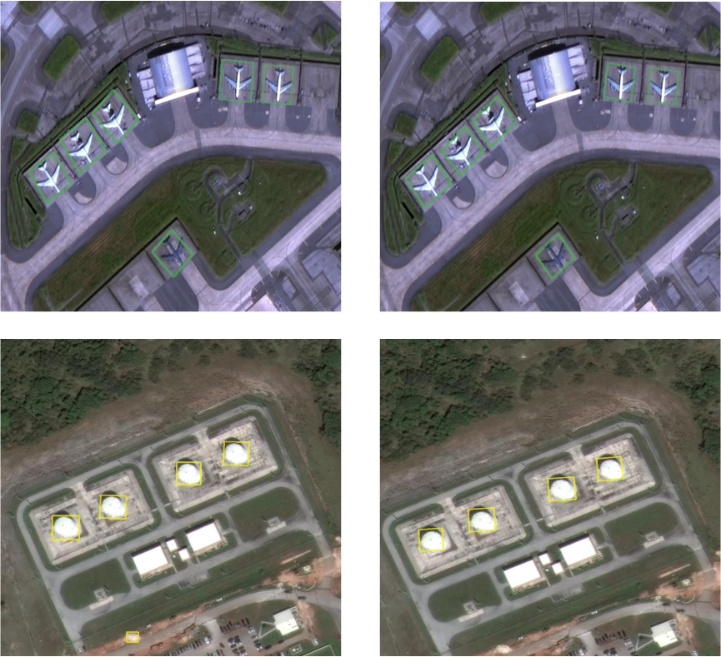
Figure 12 Comparison of large-scale target detection results in DOTA-GF dataset images (left: RetinaNet method, right: our proposed method)
From the comparison results in Figure 12, it can be seen that both the algorithm in this paper and RetinaNet have better detection results when detecting objects with large size and obvious features such as aircraft and storage tubes.

