Response to Reviewer 2 Comments

Comment 1: Major concern- The constructs used in modulating cell viability of Hep-G2 cells appear to have varying levels of impact. I assume you have checked for the efficiency of transformation of your constructs (?) but also, of more concern, have you checked for the level of expression of each of the constructs not only at 48hr and 72 hr (Fig1), and also in the subsequent experiments of apoptosis and downstream targets? This check for the presence of the construct may help explain variability and may also why there is no additive effect of MEG3 and C191. This is critical and without this information, the significance of subsequent experiments is lost as you have not shown a correlation between construct expression and affect

Response: Thanks a lot for your comments. We assume that the efficiency of transformation related to the transfection as all constructs were validated by sequencing after bacterial transformation.
For checking the efficiency of transfection of our constructs, we always use a control of pEGFP-N1 to confirm that the transfection has no problem as in the following photo.
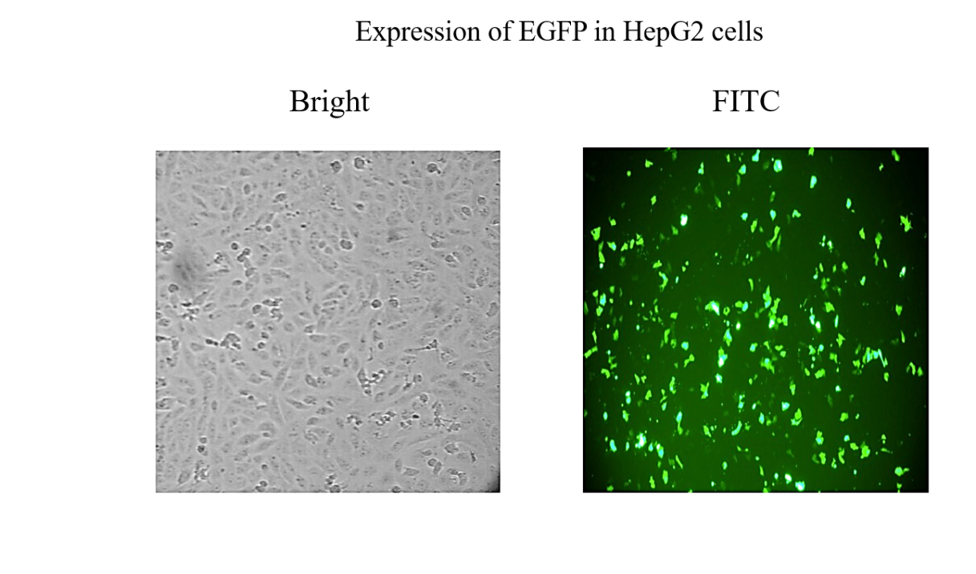

Kindly note that the transfection experiments are a rountine work in our lab and the experimental protocol is very efficient and optimized in the lab.
For the concern of the why we selected 48 and 72 h for the analysis, kindly note that we have adjusted the expression of genes under CMV promoter in many previous studies and we found that 24h is very early to detect the effect of the expressed protein and 96h is too late as cells become confluent and this may signal pathways that could interefer with our results.
In addition, we published several papers before using lipofectamine 3000 as a transfected regent, and cells were usually checked after 48 hrs, an example is
https://www.sciencedirect.com/science/article/abs/pii/S0378111921001359?via%3Dihub
Also, other previous studies collected the cells after transfection at only 48 hrs or 72 hrs.
https://onlinelibrary.wiley.com/doi/full/10.1002/cam4.3002
https://tcr.amegroups.com/article/view/36488/html

For the concern of the presence of expression after transfection, we have done qRT-PCR for the transfected genes to confirm that contructs were successfult transfected and genes were successfuly expressed.

These figures are included as supplementary data.

Comment 2: There is no explanation in the legends as to what the (Black, blue, red) horizontal lines above each of the Figures represents.
Response: Agree, we added the explanation in the legends of all the figures as shown in the revised copy with track changes.

