Response to Reviewer 2 Comments
Introduction

Point 1: “The bacterial composition in subgingival peri-implant pockets around the implant was found to be highly correlated with characteristics of the periodontal pocket microflora [4].” – in this paragraph, expand the information, rather than give the differences in the composition of the subgingival flora between the peri-implant and periodontitis. it seems to be necessary because the study used Staphyloccocus aureus and Candida albicans strains, which are not important in the etiopathogenesis of periodontitis.

Response 1:

Thank you for your suggestion, we clarified this in the text:

The bacterial composition in subgingival peri-implant pockets around the implant was found to be highly correlated with characteristics of the periodontal pocket microflora [4]. Staphylococcus aureus, although not a typical periodontal pathogen, has been listed as a key microorganism that causes peri-implantitis [5, 6]. As S. aureus has a high affinity for the titanium surface of implants, it has been recognized as an early colonizer and is strongly associated with biofilm formation on titanium implants [7]. Furthermore, the presence of high levels of S. aureus in deep peri-implant pockets has also been associated with the presence of suppuration and bleeding upon probing [8].
Unlike many bacterial species indicated to cause peri-implantitis, Candida species, which are the most commonly isolated fungi in peri-implant diseases, develop thick bio-films over the implant surface [9]. The effects of Candida species fungi have already been associated with the maintenance of periodontal inflammation in periodontitis [10].If pe-ri-implantitis is not diagnosed in time and adequately treated, implant loss may occur [11].

5. Fürst, M.M.; Salvi, G.E.; Lang, N.P.; Persson, G.R. Bacterial colonization immediately after installation on oral titanium implants. Clin. Oral Implant. Res. 2007, 18, 501–508.
6. Salvi, G.E.; Fürst, M.M.; Lang, N.P.; Persson, G.R. One-year bacterial colonization patterns of Staphylococcus aureus and other bacteria at implants and adjacent teeth. Clin. Oral Implant. Res. 2008, 19, 242–248.
7. Tillander, J.; Hagberg, K.; Hagberg, L.; Brånemark, R. Osseointegrated titanium implants for limb prostheses attachments: Infectious complications. Clin. Orthop. Relat. Res. 2010, 468, 2781–2788.
8. Cai, Z.; Li, Y.; Wang, Y.; Chen, S.; Jiang, S.; Ge, H.; Lei, L.; Huang, X. Antimicrobial effects of photodynamic therapy with antiseptics on Staphylococcus aureus biofilm on titanium surface. Photodiagnosis Photodyn. Ther. 2019, 25, 382–388.
9. Urzúa, B.; Hermosilla, G.; Gamonal, J.; Morales-Bozo, I.; Canals, M.; Barahona, S.; Cóccola, C.; Cifuentes, V. Yeast diversity in the oral microbiota of subjects with periodontitis: Candida albicans and Candida dubliniensis colonize the periodontal pock-ets. Med. Mycol. 2008, 46, 783–793.
10. De La Torre, J.; Quindós, G.; Marcos-Arias, C.; Marichalar-Mendia, X.; Gainza, M.L.; Eraso, E.; Acha-Sagredo, A.; Aguir-re-Urizar, J.M. Oral Candida colonization in patients with chronic periodontitis. Is there any relationship? Rev Iberoam Micol. 2018, 35, 134–139.

Point 2: “Adjunctive therapies have been extensively investigated in contemporary dentistry, and many in vitro, animal, and clinical studies have already shown that noninvasive photodynamic therapy (PDT) can serve as a successful and safe adjunctive therapeutic protocol for the treatment of peri-implantitis [12–14]”. I would add a sentence here regarding the precise information that PDT is adjunctive most effective in combination with prior mechanical cleaning of the implant thread surface.

Response 2:

Thank you for your suggestion, we clarified this in the text:

Adjunctive therapies have been extensively investigated in contemporary dentistry, and many in vitro, animal, and clinical studies have already shown that non-invasive photo-dynamic therapy (PDT) can serve as a successful and safe adjunctive therapeutic protocol combined with prior mechanical cleaning of the implant thread surface for the treatment of periimplantitis [18–20]

Material and methods

Point 1: “… or determination of significant differences in numerical values between measurements at the level of 0.05 and the power set to 0.8 (i.e., a large effect size of 0.8), the minimum required sample size was calculated as 20 subjects per group”. great that the strength of the statistical test was calculated.

Response 1: Thank you for your postitive comment.

Point 2: “The implants were randomly divided into four groups (n = 20), based on the planned surface treatment after contamination and biofilm formation, as follows:” In the future, I would propose to add one more group in which the impact of rubbing with sterile cotton pellet without PS and CHX would be assessed.

Response 2: Thank you for your suggestion, it will be interesting, we will consider this in future studies.

Point 3: “For the contaminated implants of the first photodynamic therapy group (PDT1), the surface was prepared using a similar procedure, a whereby 0.1% methylene blue solution (as a photosensitizer) was applied using a sterile syringe for 60 s followed by gentle washing with a sterile saline solution.” Who is the producer of MB? Was it a commercial product intended for use in dentistry? And whether the incubation time of 60 s was well chosen - for bacteria OK, but for Candida, which is a eucaryote, the incubation time of 60 s may be a bit too short. More details in DOI 10.3390/ijms222010971. It’s about TBO but it’s the same group of dye.

Response 3:

Thank you for your suggestion, we clarified this in the text:

For the contaminated implants of the first photodynamic therapy group (PDT1), the sur-face was prepared using a similar procedure, a whereby 0.1% methylene blue dye solution (as a photosensitizer) prepared in hospital pharmacy that is used in both general medicine and dentistry was applied using a sterile syringe for 60 s followed by gentle washing with a sterile saline solution.

Thank you for your suggestion, following text and reference is added:

Wiench et al. reported that due to the size of Candida cells and the presence of the cell wall, photosensitizer incubation time have impact on PDT efficacy, and suggested 7-10 minutes as a most efficient period[38]. Although those findings, application and incubation period of photosenziting solution in oral cavity with salivary flow and long clinician chairside time in the clinical practice is not presumable.

38. Wiench R, Nowicka J, Pajączkowska M, Kuropka P, Skaba D, Kruczek-Kazibudzka A, Kuśka-Kiełbratowska A, Grzech-Leśniak K. Influence of Incubation Time on Ortho-Toluidine Blue Mediated Antimicrobial Photodynamic Therapy Directed against Selected Candida Strains-An In Vitro Study. Int J Mol Sci. 2021, 22, 10971.

Point 4: “The surface was then dried with a sterile gauze and treated with laser (SiroLaser Blue, Dentsply Sirona, Bensheim, Germany) light at 660 nm (Q power = 100 mW), in continuouswave mode using an EasyTip 320 μm for 60 s moving in circles at approximately 1 mm from the implant surface. This process was carried out by a one skilled operator” It is customary to specify in the laser settings parameters: spot size, fluence, energy density. especially that while exposing the implant thread, a scanning movement was performed. Then the energy set on the laser was transferred to some specific surface, therefore these values should be precisely given so that other scientists can compare your results with their own.

Response 4:

Thank you for your suggestion, we clarified this in the text:

The surface was then dried with a sterile gauze and treated with laser (SiroLaser Blue, Dentsply Sirona, Bensheim, Germany) light at 660 nm (Q power = 100 mW), in continu-ous-wave mode using an EasyTip 320 µm, with max power density of 124.34 W/cm2 and max energy density 1240 J/cm2, for 60 s moving in circles at approximately 1 mm from the implant surface.
The treated implant surface was then radiated with a diode laser (SiroLaser Blue, Dentsply Sirona, Bensheim, Germany) at 445 nm (Q power = 100 mW), in pulsed mode of 100 Hz using an EasyTip 320 µm, with same max power density of 124.34 W/cm2 as the compared 660nm laser and different energy density of 1.24 J/cm2, for 60 s moving in circles at ap-proximately 1 mm from the implant surface.

Point 5: “The surface of the contaminated implants of the second photodynamic therapy group (PDT2) was treated with 0.1% riboflavin dye, applied using a sterile syringe and left for 60 s, followed by washing with sterile saline solution and gentle drying with a sterile gauze (Figure 4)”. Who is the producer of ryboflavin? Was it a commercial product intended for use in dentistry? Was the 0.1% concentration optimal?

Response 5:

Thank you for your suggestion, we clarified and added following text in the disscusion:

The surface of the contaminated implants of the second photodynamic therapy group (PDT2) was treated with 0.1% riboflavin dye (same concentration of methylene blue dye solution in PDT1 goup) prepared in hospital pharmacy that is used in general medicine, applied using a sterile syringe and left for 60 s, followed by washing with sterile saline solution and gentle drying with a sterile gauze (Figure 4).

Concentration of riboflavin used in the study is chosen based on a concentration used in previous studies from Bärenfaller et al Katalinic et al. Effect of different concentration that can be more adequate could be tested in further studies. In the current study, the authors observed that riboflavin dye has poor solubility; it must be well shaken prior to usage. The implementation of E101a (riboflavin-5`- phosphate) which is easier dissolved could be the answer to this problem. [19]

Point 6: “After serial dilution (10X) suspension was inoculated to blood agar plate. After an incubation period of 48 h at 37 °C, the CFUs were counted (Figure 7)”. This paragraph should be described in more detail. How many of these successive dilutions were there? What volume was plated on the blood agar plate? e.t.c

Response 6:

Thank you for your suggestion, following text is added:

Serial dilutions were performed in 96 microtiter microplates. 20 µl of suspension was added to 180 µl of nutrient broth, mixed and 20 µl was transferred to a next well. Serial dillution up to 8 dillutions were performed. From each well, we transferred 50 µl to blood agar plate. After an incubation period of 48 h at 37 °C, the CFUs were counted (Figure 7).

Point 7: “Fig 8, 9, 10, 11” - it is a pity that the images at 5000x magnification as in figure 2 were not used here. It would be much more visible to the reader.

Response 7:

Thank you for your suggestion, following higher quality pictures is added:

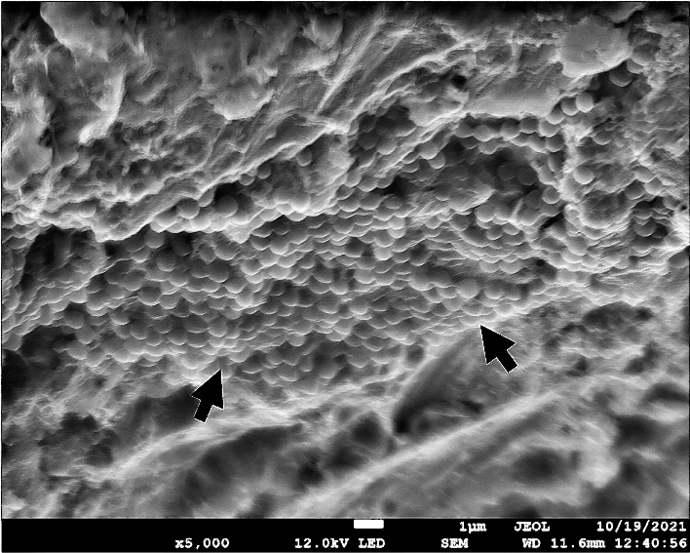

Figure 8. NC group—biofilm formation confirmed using SEM (5000×) – arrows showing micro-organism biofilm formation

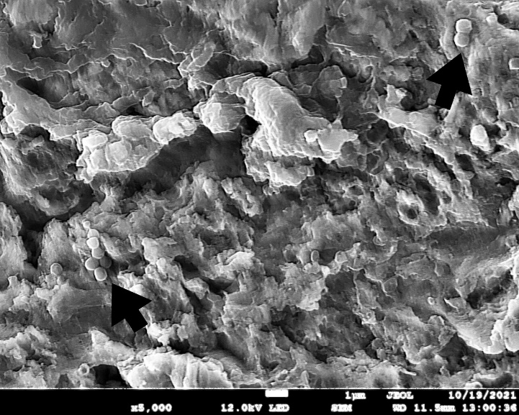

Figure 9. PC group—bacterial and fungi biofilm reduction after 0.2% CHX treatment (5000×). Microorganism cells can still be observed. (arrow)

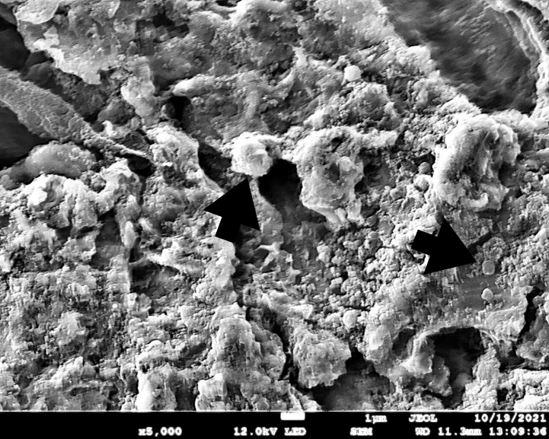

Figure 10. PDT1 group—bacterial and fungi reduction after 0.1% methylene blue and diode laser 660 nm treatment (5000×). Microorganism cells can still be observed (larger cell C. Albicans, smaller cell S. Aureus). (Arrow)

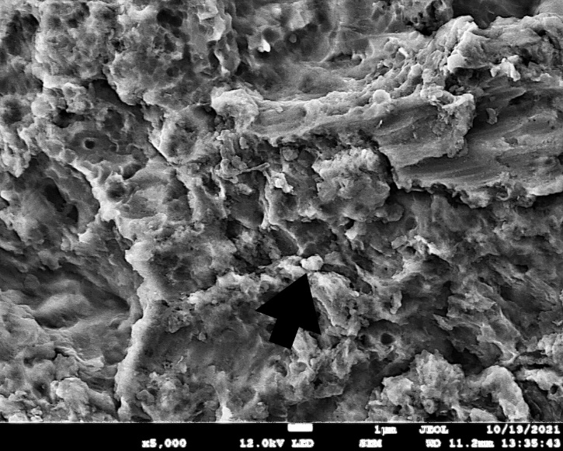

Figure 11. PDT2 group—bacterial and fungi reduction after 0.1% riboflavin and diode laser 445 nm treatment (3000×). Micro-organism cells can still be observed, but vitality of the cell cannot be discused (Arrow)

Point 8: Table 1, 2, 3 - the results could be presented much better in the form of a line and bar chart than in an unattractive table.

Response 8:

Thank you for your suggestion, following charts are added:

Figure 12. Difference in the number of Staphylococcus aureus CFUs between groups (NC, PC, PDT1, PDT2).

Figure 13. Difference in the number of Candida albicans CFUs between groups (NC, PC, PDT1, PDT2).

Discussion

Discussion It is interesting and comprehensive.

Point 1: In the sentence “In the present study, 0.2% chlorhexidine (CHX) was used as a positive control, which was applied using cotton pellets using a brushing movement, thus simulating in vivo usage” - please remove the space before the comma.

Response 1: Thank you for your suggestion, we changed this in the text.

